Supplementary information:

Fluorescence-free single-molecule microscopy via electronic resonance stimulated Raman scattering

Sumin Oh^{1,2}, Yunji Eom^{1,2}, Ha Yeon Kim¹, Ayushi Tripathi¹, Sungnam Park^{1*}, Han Young Woo^{1*}, Sang-Hee Shim^{1*}

¹Department of Chemistry, Korea University, Seoul, Korea
²These authors contributed equally: Sumin Oh, Yunji Eom
*e-mail: spark8@korea.ac.kr, hywoo@korea.ac.kr, sangheeshim@korea.ac.kr

Contents

Supplementary Figures and Table
Figure S1. ER-SRS microscopy set-up in detail 3
Figure S2. Spontaneous Raman and EPR-SRS spectra of Rho800 4
Figure S3. Synthesis scheme of RANMP, RANMP-4F, RANMP-4Cl and RANMP-T 5
Figure S4. Optical properties of RANMP, RANMP-4F, RANMP-4Cl and RANMP-T 6
Figure S5. Frontier molecular orbitals (HOMO and LUMO) and energies 7
Figure S6. Calculated natural transition orbitals (NTOs) of singlet states 8
Figure S7. Theoretical Characterization 9
Figure S8. Stokes power dependence of ER-SRS spectra of RANMP-T film 10
Figure S9. ER-SRS of film of RANMP, RANMP-4F, RANMP-4Cl and RANMP-T 11
Figure S10. Nanoprecipitation method for fabrication of Pdots 12
Figure S11. ER-SRS optimization of RANMP-4Cl Pdot 13
Figure S12. Single-molecule sample preparation 14
Figure S13. Photobleaching comparison between RANMP-T film and Rho800 film 15
Figure S14. Quantification of RANMP-T polymer dot 16
Figure S15. ¹H NMR spectrum of RANMP in chloroform 17
Figure S16. ¹H NMR spectrum of RANMP-4F in chloroform 18
Figure S17.¹H NMR spectrum of RANMP-4Cl in chloroform 19
Figure S18. ¹H NMR spectrum of RANMP-T in chloroform 20
Table S1. Analysis of CN vibrational peaks in Raman spectra 21
Table S2. Dichroic mirrors and filters used for ER-SRS optimization for all probes 22
Supplementary Note 1. Kinetic rate constants
Figure SN1. Schematic of energy-level diagram for intersystem crossing (ISC) 23
Figure SN2. Relaxation pathways of S₁ state were compared 24
Figure SN3. Optimized structures of molecules in S₀ and S₁ and transition dipole moments 25
Table SN1. Calculated radiative rate constants 26
Table SN2. Calculated kinetic rate constants 26
Supplementary References 27

Supplementary Figure

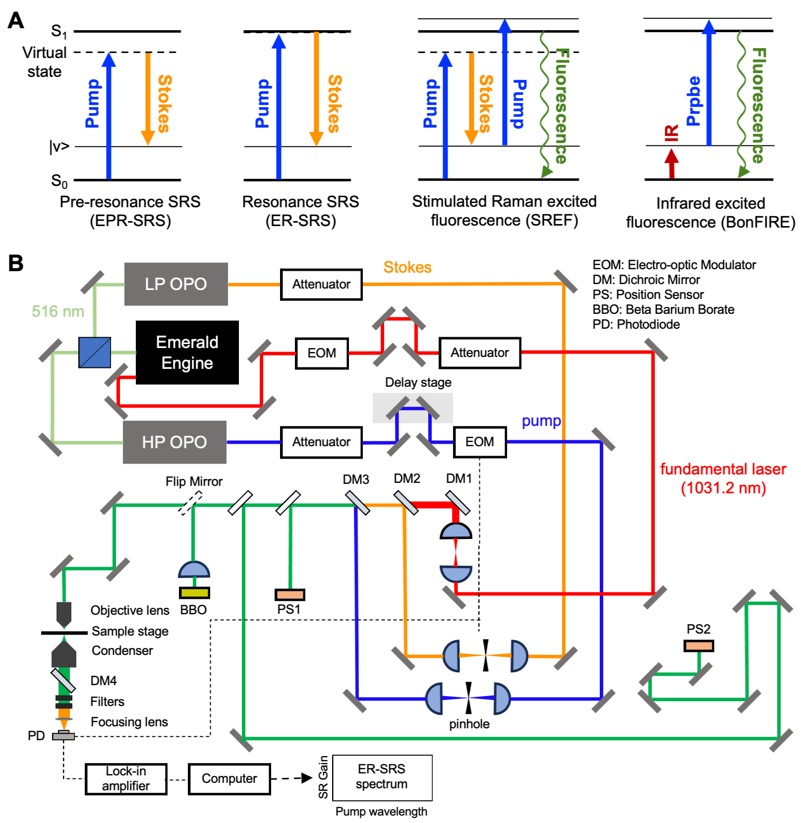
Figure S1. (A) Energy diagrams of various far-field vibrational spectroscopy methods with high sensitivity: electronic pre-resonance SRS (EPR-SRS)¹, electronic resonance SRS (ER-SRS)², stimulated Raman excited fluorescence (SREF)³ and bond-selective fluorescence-detected infrared-excited spectro-microscopy (BonFIRE)⁴. (B) ER-SRS set-up in detail. The Stokes (orange line) and pump (blue line) beams are generated from LP OPO and HP OPO, respectively. EPR-SRS of Rho800 is measured with the fundamental laser at 1,031.2 nm (Emerald Engine, red line). The temporal overlap is precisely aligned using a BBO crystal, while the spatial overlap is finely adjusted with two position sensors (PS1 and PS2). The filters and dichroic mirror placed before the photodiode are selected based on the pump and Stokes wavelengths (Supplementary Table 2). The pump beam is modulated by 10 MHz EOM and SR gain signal is amplified through lock-in amplifier.
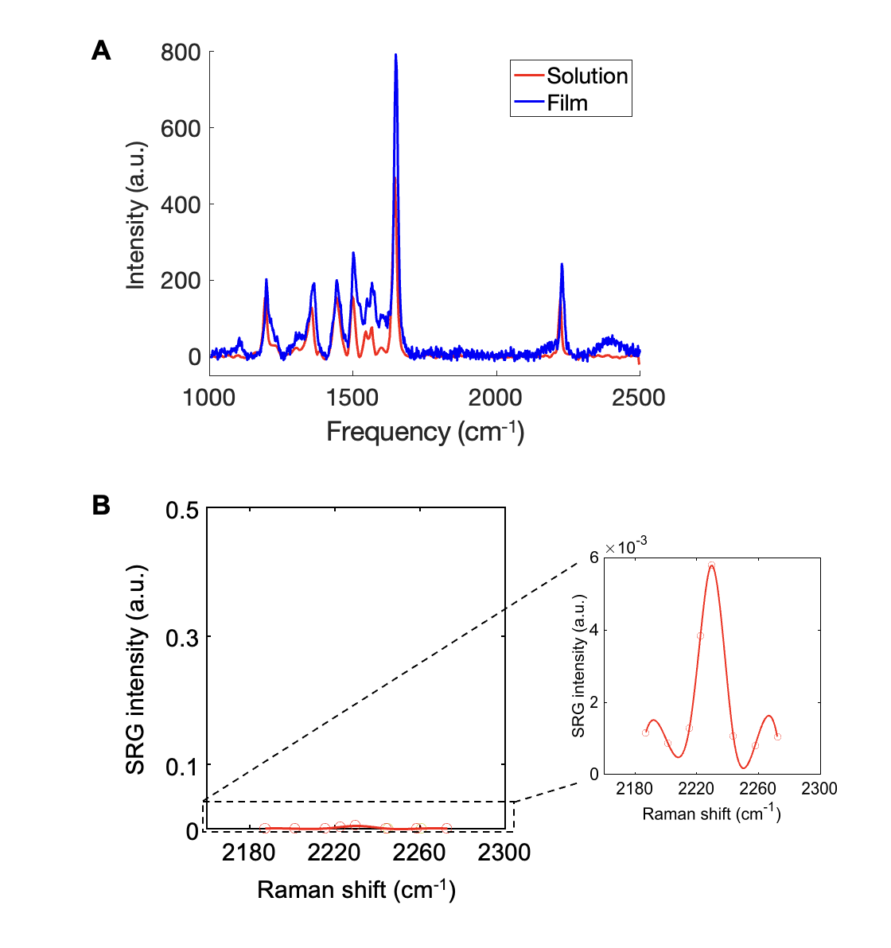
Figure S2. Rho800 Raman spectra. (A) Spontaneous Raman spectra of Rho800. The intensity observed in the film (1 mM, Chloroform) is more than 1.5 times greater than that in the solution (1 mM, DMSO). Additionally, the Raman shift at ~2,230 cm⁻¹ in the film is slightly blue shifted compared to that in the solution. (B) EPR-SRS spectra of Rho800 obtained with λ_{pump}=838.4 nm and λ_{Stokes}=1,031.2 nm, using P_{pump}=12 mW and P_{Stokes}=13 mW, respectively.

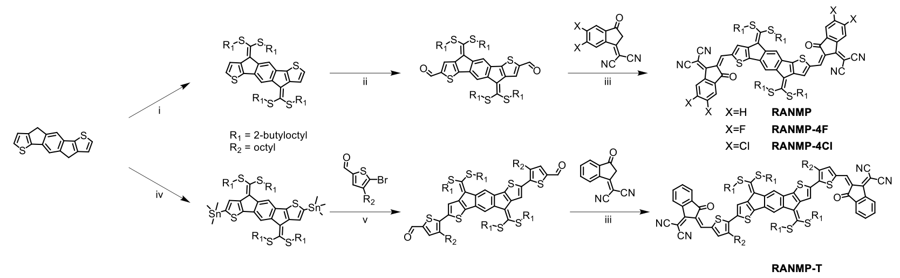

Figure S3. Synthesis scheme of RANMP, RANMP-4F, RANMP-4Cl and RANMP-T. (i) t-BuOK, CS₂, 1-bromo-2-butyloctane, DMSO, RT; (ii) DMF, POCl₃, 1,2-dichloroethane, 80°C, reflux; (iii) pyridine, chloroform, 80°C, reflux; (iv) trimethyltin chloride, 2,2,6,6-tetramethylpiperidine, n-BuLi, THF, −78°C; (v) Pd(Ph₃)₄, toluene, microwave reactor. The detailed conditions followed those reported in a previous paper⁵.

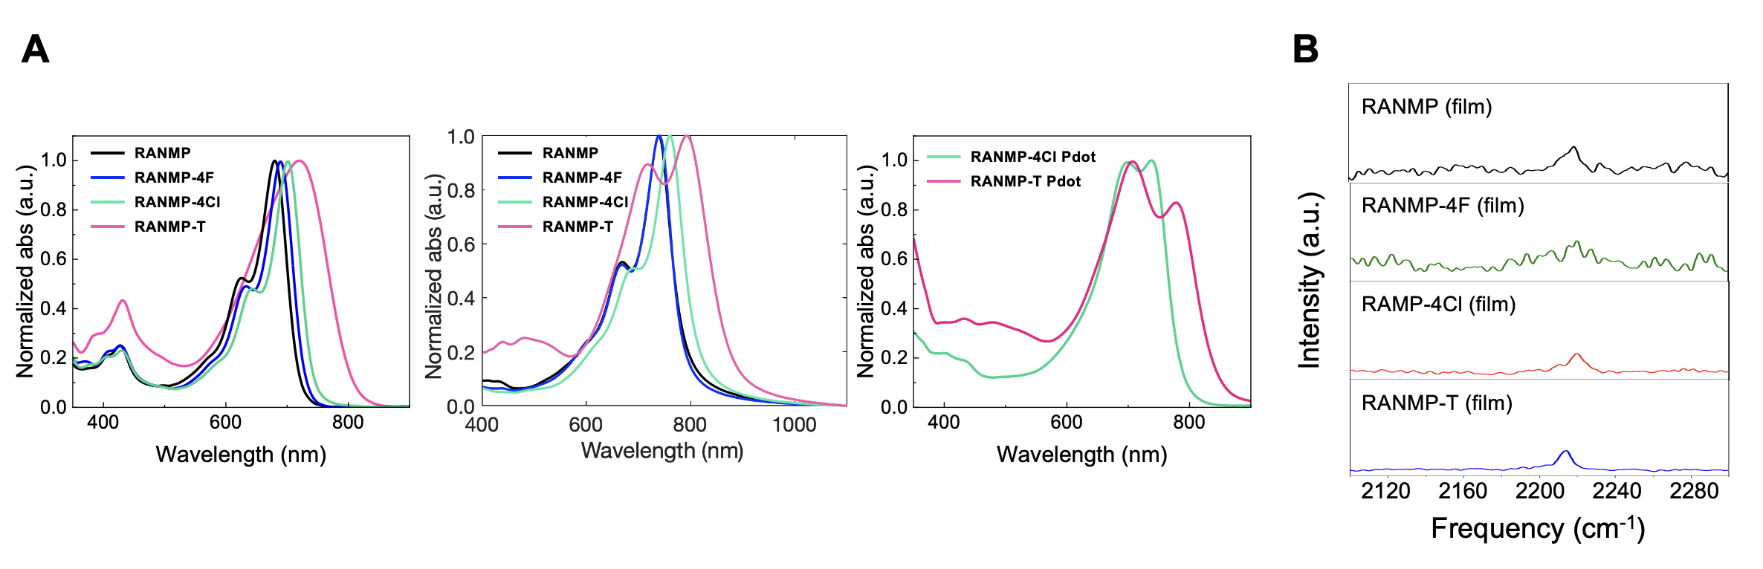

Figure S4. Spectral properties of RANMP, RANMP-4F, RANMP-4Cl and RANMP-T. (A) Normalized UV-vis absorption spectra of RANMP series in solution (left), film (middle) and in Pdots (right). (B) Raman peaks of CN modes in film samples. Raman shift frequencies are 2,218.8 cm⁻¹, 2,220.4 cm⁻¹, 2,220.0 cm⁻¹ and 2,214.2 cm⁻¹ for RANMP, RANMP-4F, RANMP-4Cl and RANMP-T, respectively.

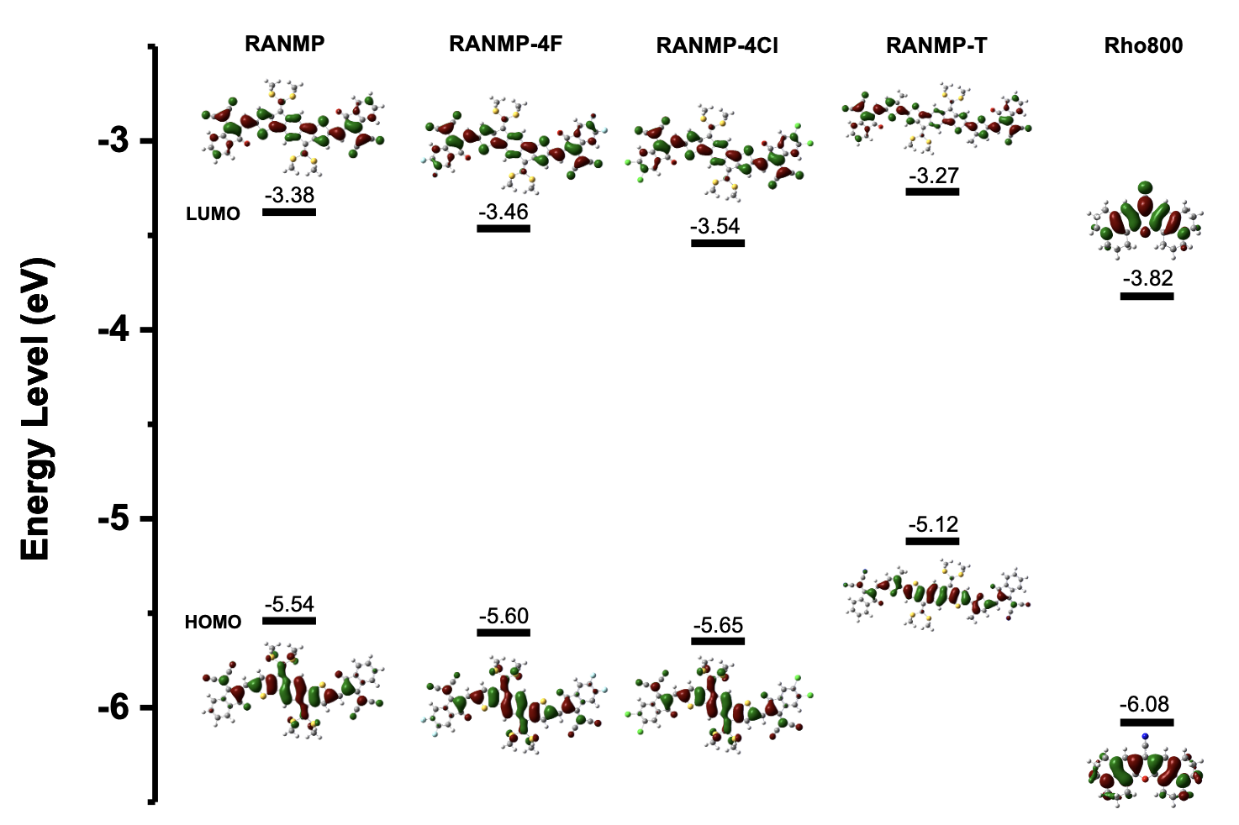

Figure S5. Frontier molecular orbitals (HOMO and LUMO) and their energies of RANMP, RANMP-4F, RANMP-4Cl, RANMP-T and Rho800 obtained by DFT calculations (B3LYP/6-31G(d,p)) in chloroform.

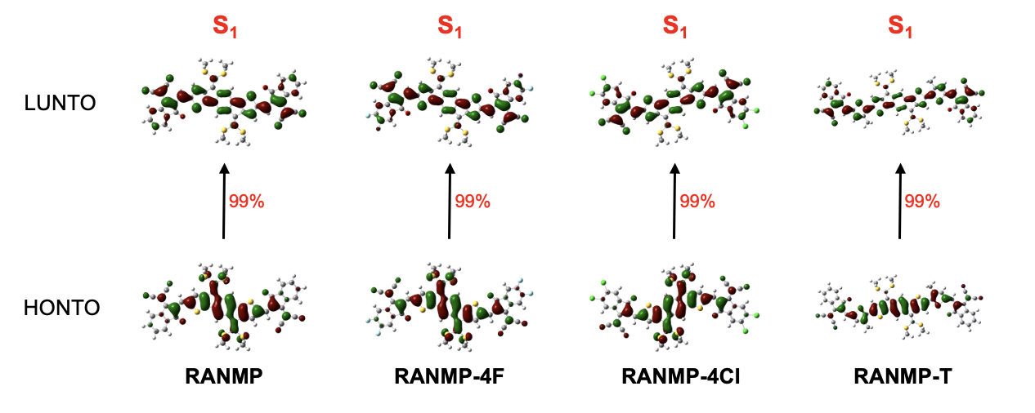

Figure S6. Calculated natural transition orbitals (NTOs) of RANMP, RANMP-4F, RANMP-4Cl and RANMP-T obtained by DFT calculations (B3LYP/6-31G(d,p)) in chloroform. The highest occupied NTO (HONTO) and lowest unoccupied NTO (LUNTO) represent the hole and electron wavefunctions upon electronic transition (S₀ → S₁ transition). The intramolecular charge transfer (ICT) from D to A in A-D-A type molecules is clearly observed.

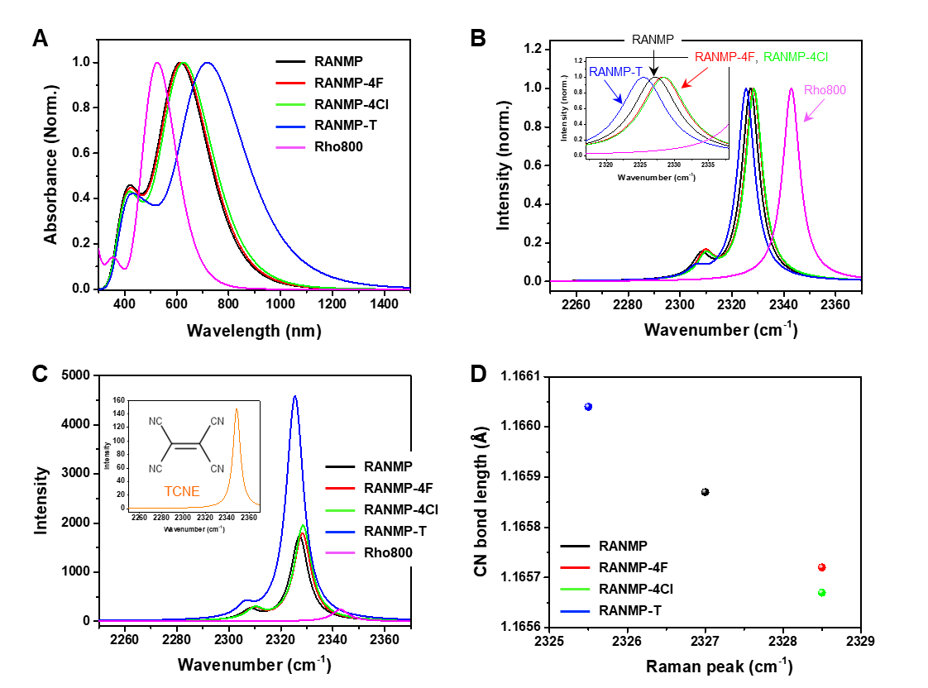

Figure S7. Theoretical characterization of RANMP series and Rho800 by DFT calculations (B3LYP/6-31G(d,p)) in chloroform. (A) Calculated electronic absorption spectra (normalized). (B) Normalized Raman spectra of CN vibrational modes. (C) Raman spectra of CN vibrational modes. Inset: Raman spectrum of tetracyanoethylene (TCNE). Relative intensities of Raman peak of CN vibrational modes of different molecules are compared. (D) Plot of CN bond length against Raman peaks of CN vibrational modes of different molecules.

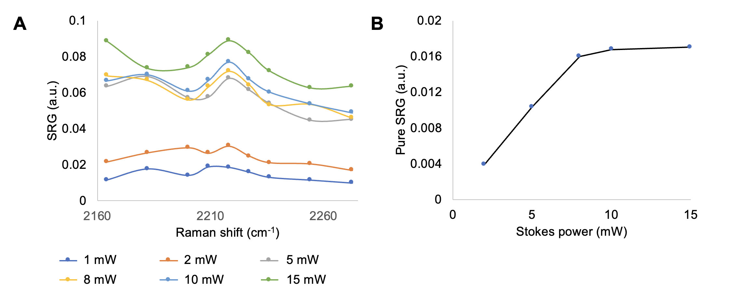
Figure S8. Stokes power dependence of ER-SRS spectra of RANMP-T film (5.8 mg/mL, THF). (A) Pump power is fixed at 1 mW. (B) Stokes power dependence of Pure SRG (SRG-background) exhibits linear dependence up to 8 mW, with saturation occurring beyond 10 mW.

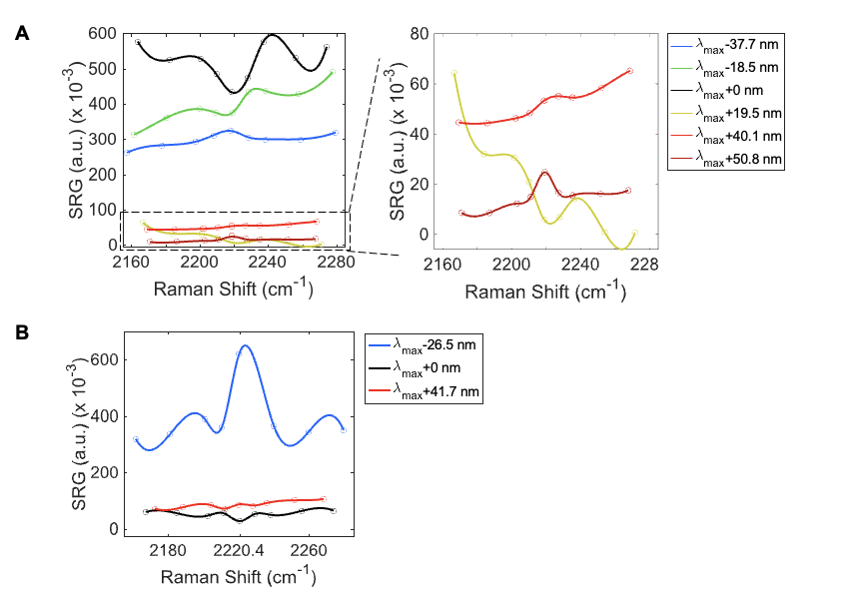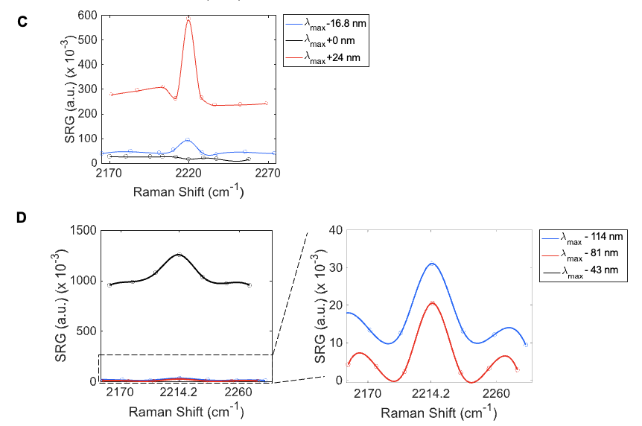

Figure S9. ER-SRS of film of RANMP (A), RANMP-4F (B), RANMP-4Cl (C), and RANMP-T (D). The SR gain signals were measured under identical conditions (pump laser power at 500 µW, Stokes power at 10 mW, and sample concentration at 10 mg/mL).

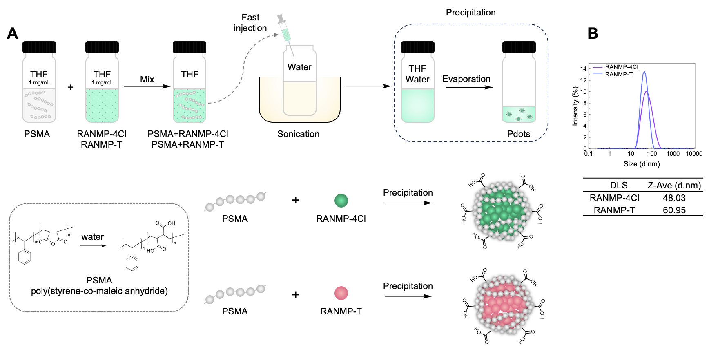

Figure S10. (A) Nanoprecipitation method for fabrication of RANMP-4Cl and RANMP-T Pdots using poly(styrene-co-maleic anhydride) (PSMA) as the surfactant. (B) Particle size distribution of Pdots measured by dynamic light scattering (DLS).

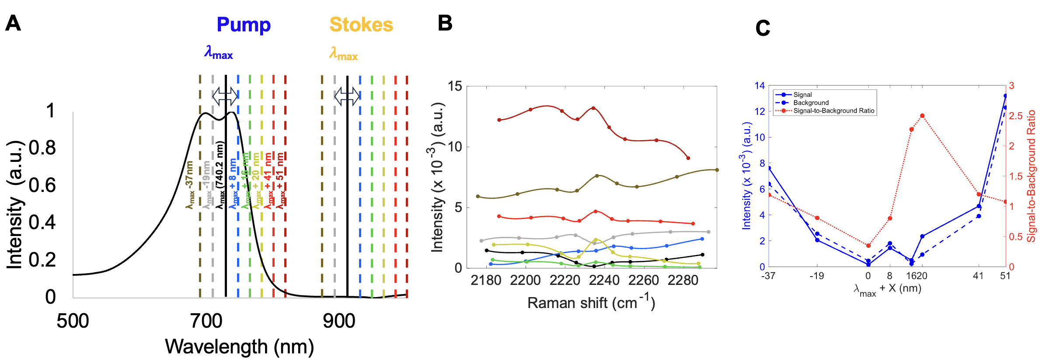

Figure S11. ER-SRS optimization of RANMP-4Cl Pdot. (A) Absorption spectrum of Pdot (black solid line) alongside the wavelength ranges of the pump and Stokes. Based on the λ_{max} (740.2 nm), potential wavelength combinations within the OPO tunable range of 660–960 nm were explored. (B) ER-SRS results obtained from the wavelength combinations identified in (A) to optimize the maximum signal-to-background ratio. (C) Signal and background intensities in the ER-SRS spectra in B plotted against the pump wavelengths. The optimization led to an increase of over two times in the signal-to-background ratio.

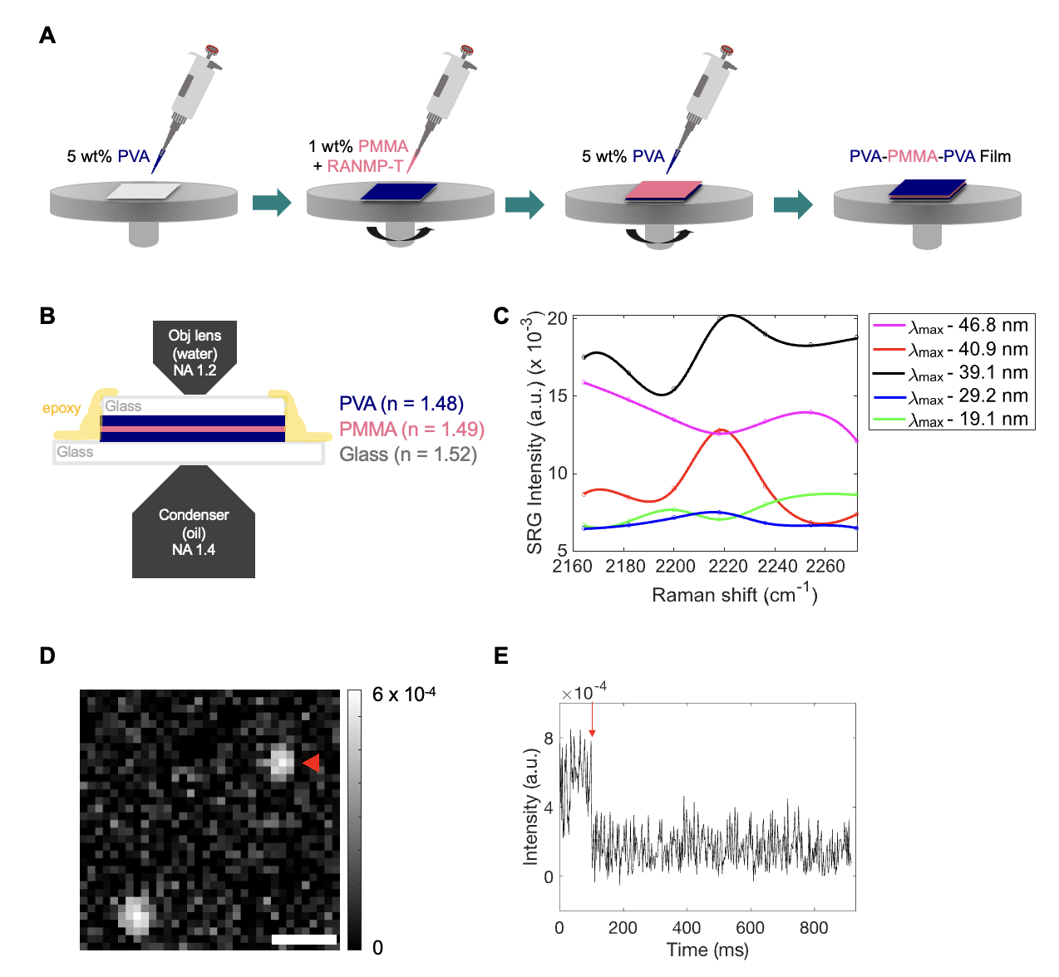
Figure S12. Single-molecule sample preparation and ER-SRS optimization results. (A) Sample preparation for single-molecule imaging. 5 wt% poly(vinyl alcohol) was spin-coated above and below a PMMA layer in order to prevent photobleaching. (B) Each layer was processed continuously layer by layer. The fabricated film was stored under the dark. Film sample was fixed by using epoxy. (C) Optimization of wavelength combinations for ER-SRS of RANMP-T embedded in PVA-PMMA-PVA film (10 nM) with powers set as P_{pump}=500 μW, P_{Stokes}=6 mW. The maximum signal-to-background ratio was observed at λ_{max}-40.9 nm, where λ_{pump}=749 nm and λ_{Stokes}=897.9 nm. (D) Single-molecule ER-SRS image of RANMP-T measured on a single PVA layer coated on a PMMA layer. (E) Time trace of single-molecule signal in D (red arrowhead). Single-step bleaching event (red arrow) indicates single-molecule nature. Scale bar: 500 nm.

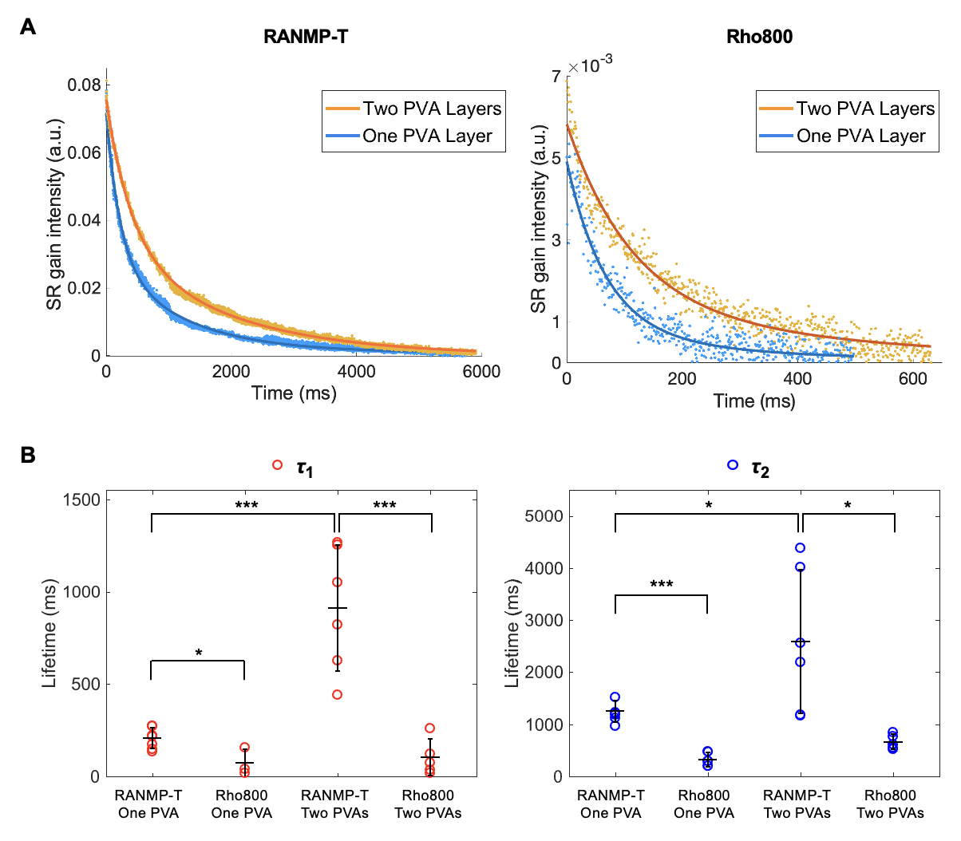

Figure S13. Photobleaching comparison between RANMP-T and Rho800 films. Photobleaching time traces of SR gain signal were measured at (1) λ_{pump}=749 nm and λ_{Stokes}=897.9 nm, corresponding to a rigorous resonance condition for RANMP-T film, and (2) λ_{pump}=749 nm and λ_{Stokes}=899.2 nm, representing a pre-resonance condition for Rho800 film. (A) Photobleaching curves as a function of exposure time, fitted to the sum of two exponential functions. P_{pump}=3 mW, P_{Stokes}=8.6 mW. The pump power was six times higher than that in other experiments (e.g. 500 μW in Fig. 2) to compensate for the low signal intensity of Rho800. (B) Comparison of the photobleaching lifetimes of RANMP-T and Rho800 films with single-PVA-layered and double-PVA-layered films. The photobleaching rates of RANMP-T is observed to be about twice as long as that of Rho800. Statistical significance of the difference was determined using a t-test, with p-values annotated as follows: * for p<0.05, ** for p<0.01, *** for p<0.001.

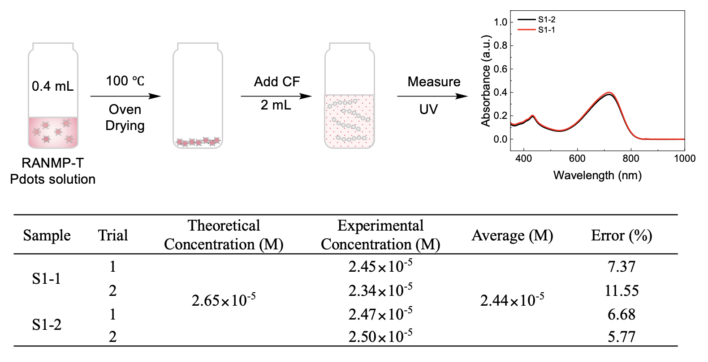
Figure S14. Quantification of RANMP-T polymer dot. 0.4 mL of RANMP-T Pdots solution was taken then dried in the oven. After dissolved in 2 mL of chloroform, UV-Vis absorption spectra were measured. From the UV-Vis absorption spectra, the concentration of RANMP-T Pdots in solution was calculated using the molar extinction coefficient.

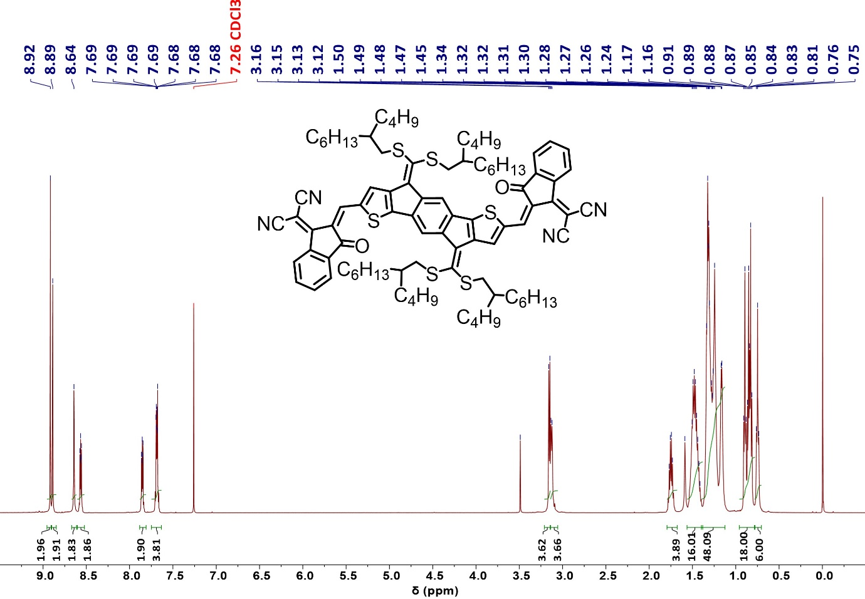

Figure S15. ¹H NMR spectrum of RANMP in chloroform.

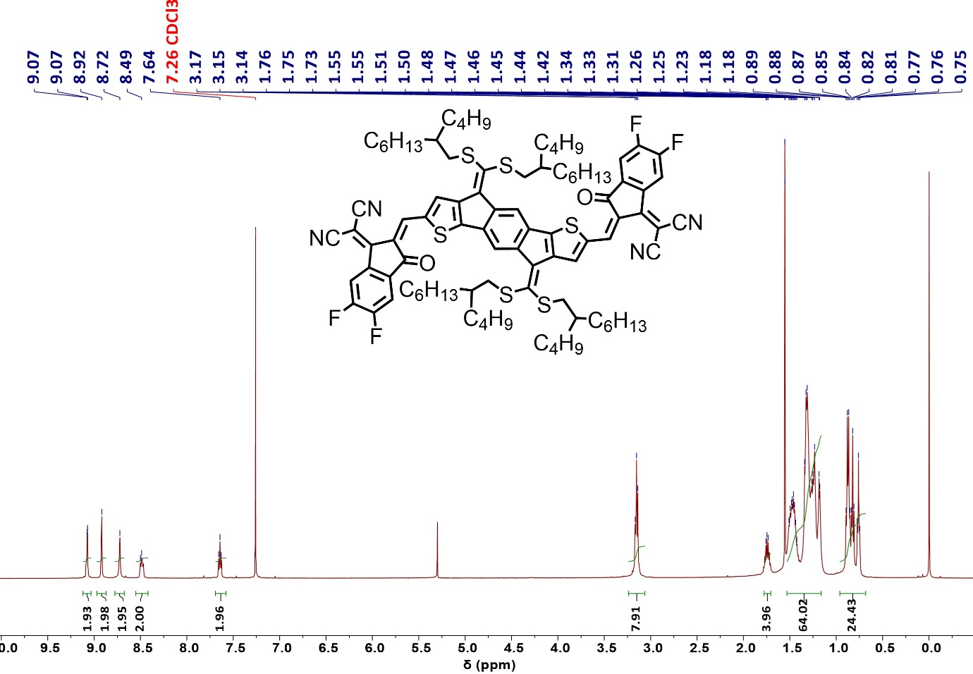

Figure S16. ¹H NMR spectrum of RANMP-4F in chloroform.

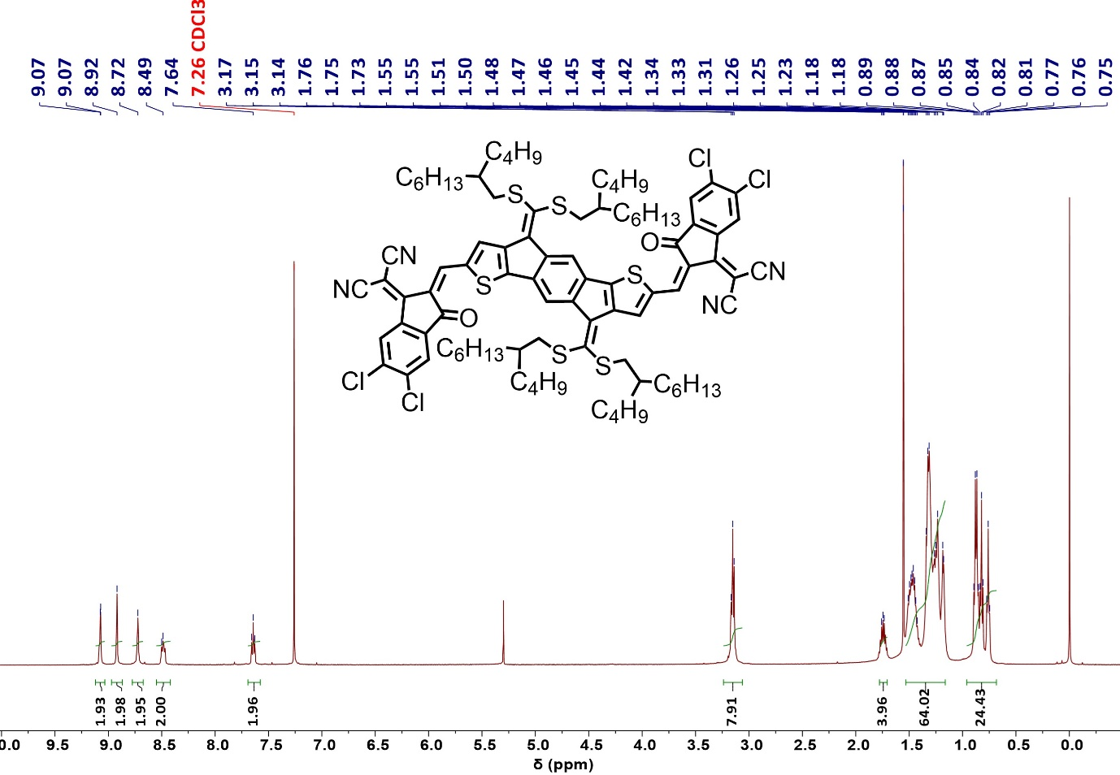

Figure S17. ¹H NMR spectrum of RANMP-4Cl in chloroform.

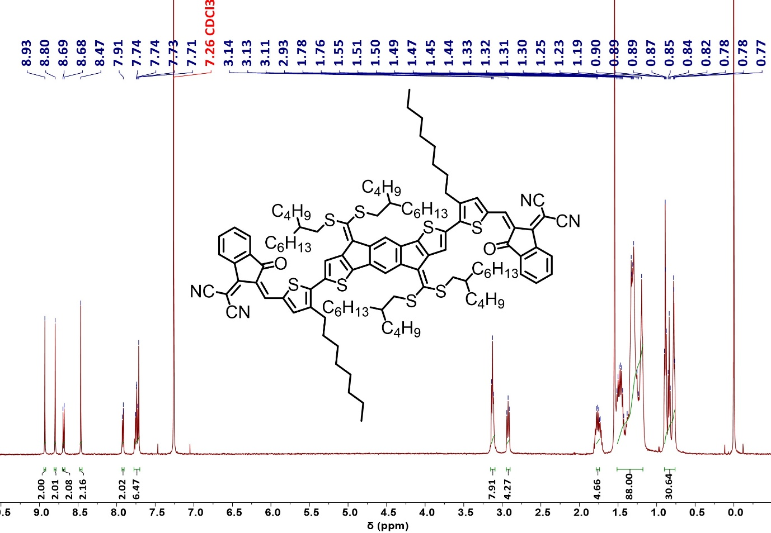

Figure S18. ¹H NMR spectrum of RANMP-T in chloroform.

Table S1. Analysis of CN vibrational peaks in Raman spectra
Molecule | Peak area | Relative intensity
RANMP | 23422.79 | 13.0
RANMP-4F | 24438.96 | 13.6
RANMP-4Cl | 26311.37 | 14.7
RANMP-T | 58463.25 | 32.6
Rho800 | 2881.45 | 1.6
TCNE | 1795.91 | 1.0

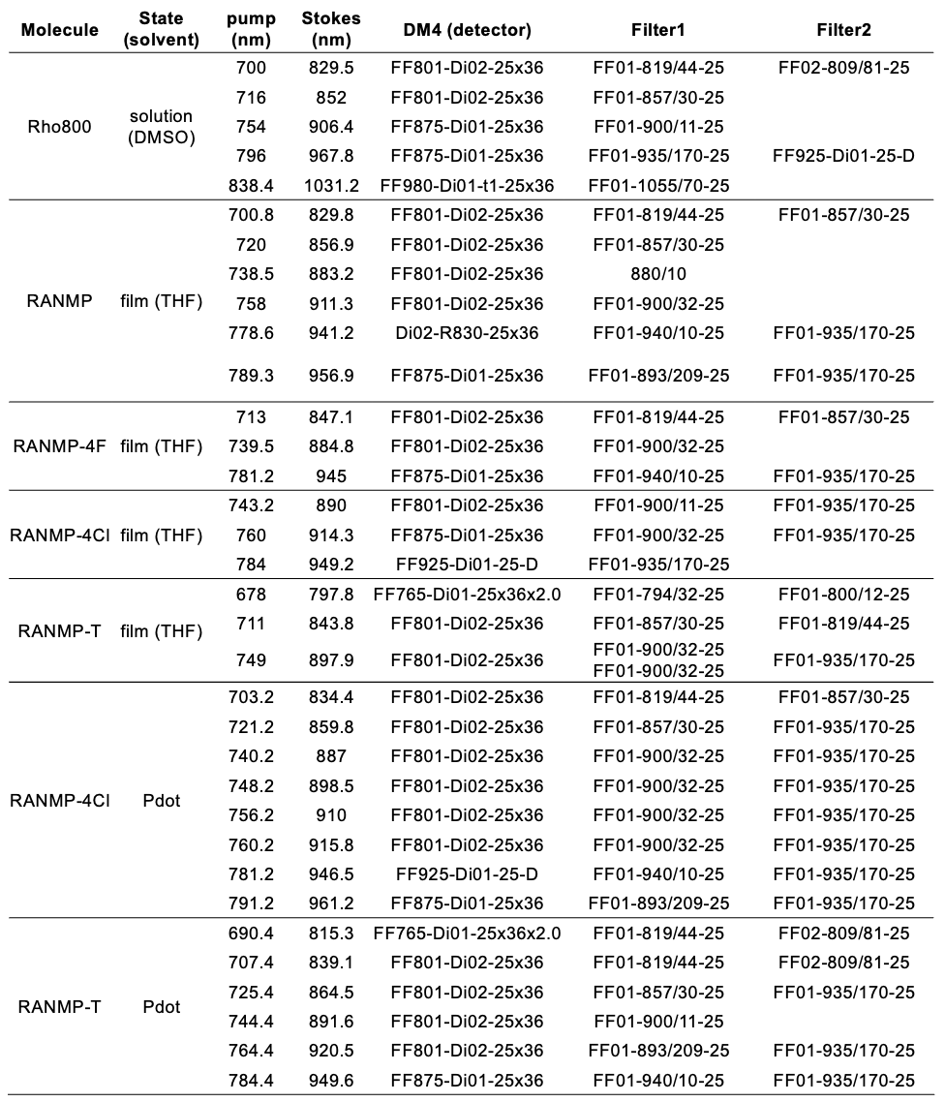
Table S2. Dichroic mirrors and filters used for ER-SRS optimization for all probes (Rho800 and RANMP series) and samples in this study. All the dichroic mirrors and filters are purchased from Semrock, except for the 880/10 filter (Edmund optics).
Supplementary Note 1. Kinetic rate constants
Intersystem crossing rate constants (k_{ISC}) were calculated based on the Marcus theory⁶ (Figure SN1),
$k_{\text{ISC}}=\frac{2π}{ℏ}\frac{{V_{\text{SOC}}}^{2}}{\sqrt{4πλ_{\text{ISC}}k_{B}T}}\exp\left[-\frac{{\left(ΔG+λ_{\text{ISC}}\right)}^{2}}{4λk_{B}T}\right]\text{ with }V_{\text{SOC}}=\left\langle S_{n}\right|{\hat{H}}_{\text{SO}}\left|T_{m}\right\rangle$ Eq. (S1)
$k_{\text{ISC, total}}=k_{\text{ISC, }{\text{S}}_{1}→T_{1}}+k_{\text{ISC, }{\text{S}}_{1}→T_{2}}+k_{\text{ISC, }{\text{S}}_{1}→T_{3}}$ Eq. (S2)
where $ℏ$, $k_{B}$, $T$, $V_{\text{SOC}}$, $λ_{\text{ISC}}$, and ΔG represent the reduced Planck constant, Boltzmann constant, temperature, spin-orbit coupling, reorganization energy of ISC process, and change in free energy, respectively. $λ_{\text{ISC}}$ is expressed as $λ_{\text{ISC}}=λ_{\text{M}}+λ_{\text{S}}$. $λ_{\text{M}}$ is the molecular reorganization energy, and $λ_{\text{S}}$ is solvent reorganization energy; the value of $λ_{\text{ISC}}$ was set to 0.15 eV. ΔG was obtained as the difference between the S₁ and various triplet states T₁, T₂, and T₃. Radiative decay rate constants (k_{r}) were calculated by
$k_{r}=\frac{{{(E}_{S_{1}})}^{3}f(n) ({μ_{01})}^{2}}{3πε_{0}ℏ^{4}c^{3}}$ Eq. (S3)
where $E_{S_{1}}$, f(n), $ε_{0}$, c, and $μ_{01}$denote the S₁ energy, local-field correction factor, vacuum permittivity, speed of light, and transition dipole moment between S₀ and the S₁ state, respectively. The local-field correction factor, $f\left(n\right)=\frac{{n\left(n+2\right)}^{2}}{9}=2.655$ accounts for the local electric field effect; n = 1.44, which corresponds to the refractive index of chloroform. The electronic transition energies (singlet and triplet states) and spin-orbit coupling (SOC) constants were obtained using the Tamm-Dancoff approximation (TDA)-DFT method implemented in ORCA.
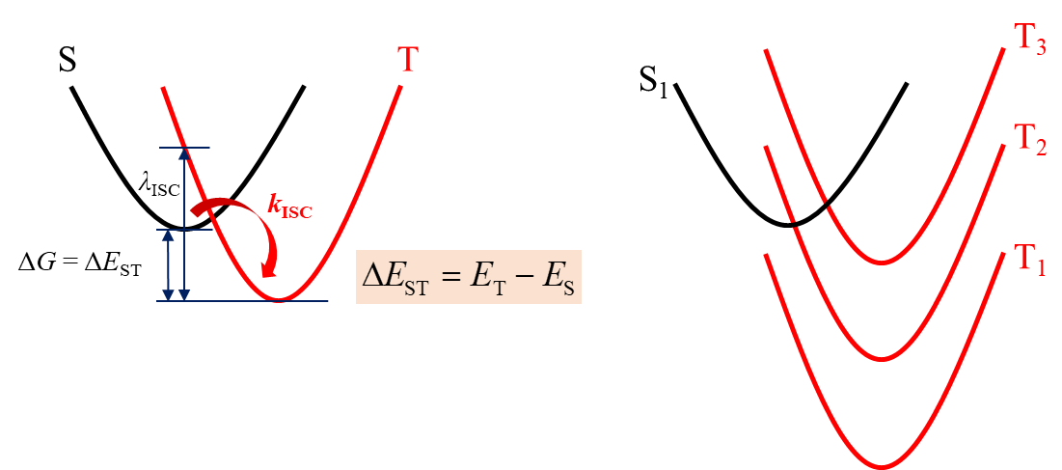

Figure SN1. Schematic of the energy-level diagram for intersystem crossing (ISC) from an initial singlet state to various lower-lying triplet states.

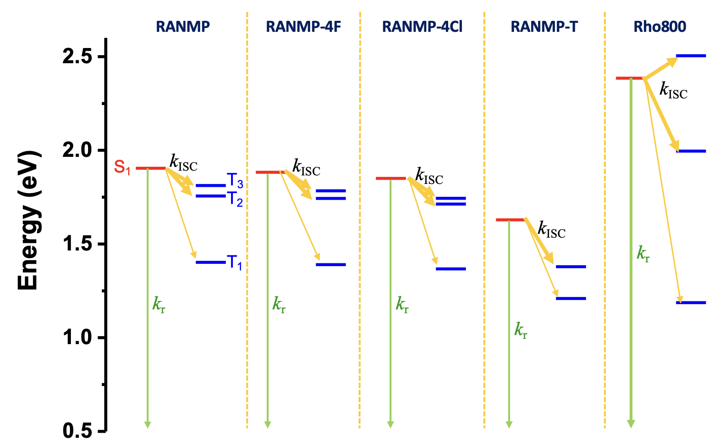
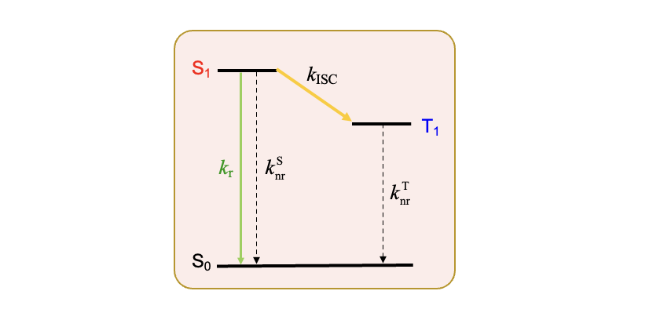
Figure SN2. Intersystem crossing (ISC) channels from S₁ state to triplet states, and radiative decay process of S₁ state. Thicker arrows indicate faster ISC rate constants. ISC process competes with radiative decay. The calculated k_{ISC} / k_{r} ratio in Table SN2 indicates that the RANMP series undergo much faster ISC to triplet states than Rho800, resulting in low PLQYs.

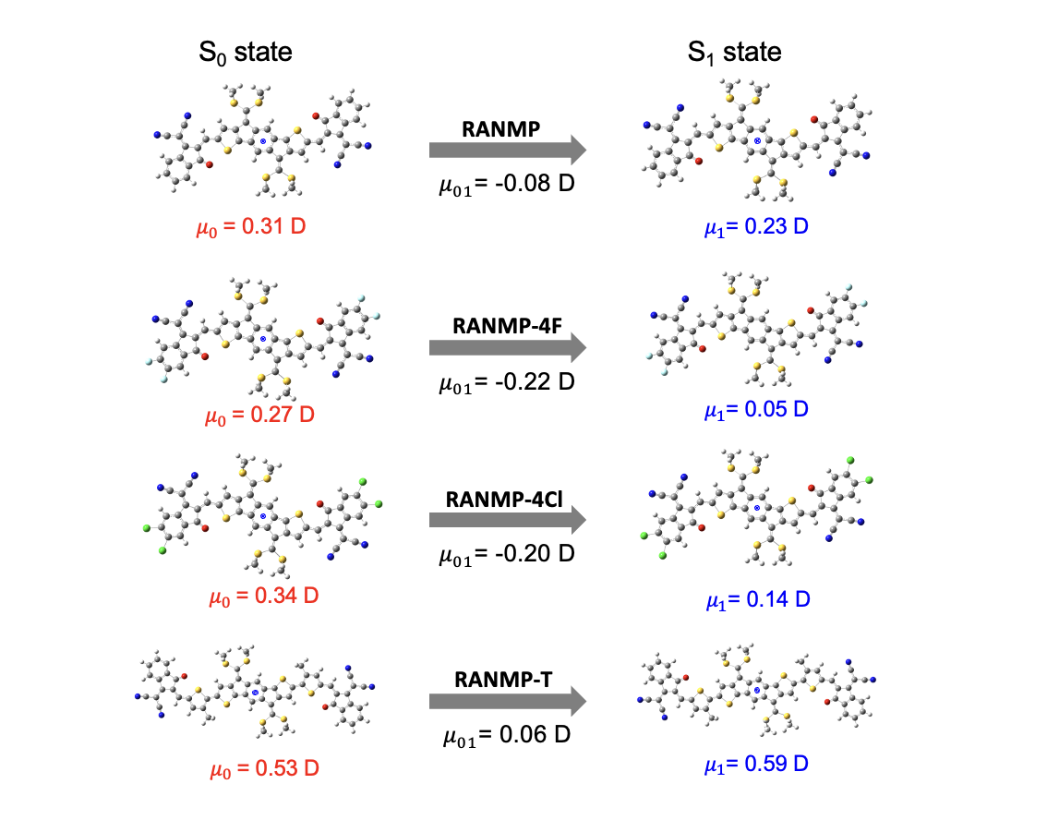Figure SN3. Optimized structures and dipole moment (μ_{i}) of molecules in S₀ and S₁, and transition dipole moments (μ₀₁) between S₀ and S₁ states in Eq. (S3).

Table SN1. Calculated radiative decay rate constants
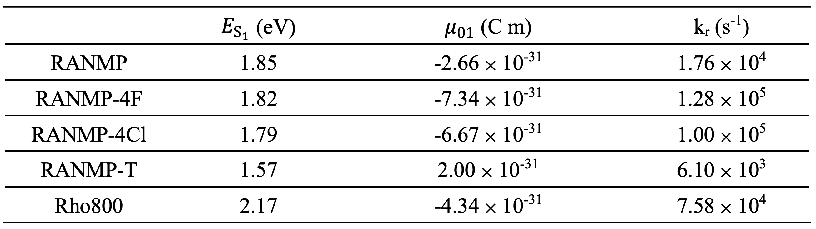

Table SN2. Calculated intersystem crossing rate constants
 | Transition | ΔE_{ST}  (eV) | SOC  (cm⁻¹) | k_{ISC}  (s⁻¹) | Weighted k_{ISC}  (s⁻¹) | Total k_{ISC}  (s⁻¹) | k_{r}  (s⁻¹) | k_{ISC} / k_{r}
RANMP | S₁↔T₁ | -0.50 | 0.090 | 1.74 × 10³ | 1.74 × 10³ | 1.61 × 10⁸ | 1.76 × 10⁴ | 9.15 × 10³
RANMP | S₁↔T₂ | -0.15 | 0.294 | 5.77 × 10⁷ | 5.76 × 10⁷ | 1.61 × 10⁸ | 1.76 × 10⁴ | 9.15 × 10³
RANMP | S₁↔T₃ | -0.09 | 0.440 | 1.04 × 10⁸ | 1.04 × 10⁸ | 1.61 × 10⁸ | 1.76 × 10⁴ | 9.15 × 10³
RANMP-4F | S₁↔T₁ | -0.49 | 0.110 | 3.90 × 10³ | 3.89 × 10³ | 1.79 × 10⁸ | 1.28 × 10⁵ | 1.40 × 10³
RANMP-4F | S₁↔T₂ | -0.14 | 0.336 | 7.48 × 10⁷ | 7.47 × 10⁷ | 1.79 × 10⁸ | 1.28 × 10⁵ | 1.40 × 10³
RANMP-4F | S₁↔T₃ | -0.10 | 0.430 | 1.04 × 10⁸ | 1.04 × 10⁸ | 1.79 × 10⁸ | 1.28 × 10⁵ | 1.40 × 10³
RANMP-4Cl | S₁↔T₁ | -0.48 | 0.130 | 8.44 × 10³ | 8.42 × 10³ | 1.91 × 10⁸ | 1.00 × 10⁵ | 1.91 × 10³
RANMP-4Cl | S₁↔T₂ | -0.14 | 0.384 | 9.74 × 10⁷ | 9.72 × 10⁷ | 1.91 × 10⁸ | 1.00 × 10⁵ | 1.91 × 10³
RANMP-4Cl | S₁↔T₃ | -0.11 | 0.400 | 9.41 × 10⁷ | 9.39 × 10⁷ | 1.91 × 10⁸ | 1.00 × 10⁵ | 1.91 × 10³
RANMP-T | S₁↔T₁ | -0.42 | 0.010 | 5.88 × 10² | 5.88 × 10² | 7.01 × 10⁵ | 6.10 × 10³ | 1.15 × 10²
RANMP-T | S₁↔T₂ | -0.25 | 0.045 | 6.97 × 10⁵ | 6.97 × 10⁵ | 7.01 × 10⁵ | 6.10 × 10³ | 1.15 × 10²
RANMP-T | S₁↔T₃ | 0.19 | 0.070 | 2.15 × 10³ | 2.15 × 10³ | 7.01 × 10⁵ | 6.10 × 10³ | 1.15 × 10²
Rho800 | S₁↔T₁ | -1.20 | 0.022 | 3.68 × 10⁻²⁶ | 3.68 × 10⁻²⁶ | 5.53 × 10⁵ | 7.58 × 10⁴ | 7.30
Rho800 | S₁↔T₂ | -0.39 | 0.167 | 4.55 × 10⁵ | 4.55 × 10⁵ | 5.53 × 10⁵ | 7.58 × 10⁴ | 7.30
Rho800 | S₁↔T₃ | 0.12 | 0.127 | 9.52 × 10⁴ | 9.52 × 10⁴ | 5.53 × 10⁵ | 7.58 × 10⁴ | 7.30

Supplementary References

- Wei, L. et al. Super-multiplex vibrational imaging. Nature 544, 465–470 (2017).
- Shi, L. et al. Electronic Resonant Stimulated Raman Scattering Micro-Spectroscopy. J. Phys. Chem. B 122, 9218−9224 (2018).
- Xiong, H. et al. Combining the best of two worlds: stimulated Raman excited fluorescence. J. Chem. Phys. 153, 210901-210907 (2020).
- Wang, H. et al. Bond-selective fluorescence imaging with single-molecule sensitivity. Nat. Photon. 17, 846–855 (2023).
- Cho, S. J. et al. A-D-A Type Semiconducting Small Molecules with Bis(alkylsulfanyl)methylene Substituents and Control of Charge Polarity for Organic Field-Effect Transistors. ACS Appl. Mater. Interfaces 12, 41842– 41851 (2020).
- Cho, E. et al. Impact of secondary donor units on the excited-state properties and thermally activated delayed fluorescence (TADF) efficiency of pentacarbazole-benzonitrile emitters. J. Chem. Phys. 153, 144708 (2020).

