Simplified Kinetic Modeling for Predicting the Stability of Complex Biotherapeutics
Mitja Zidar¹, Stefano Cucuzza², Matjaž Bončina¹, Drago Kuzman^{1*}
‡ Contributed equally to this work
¹ Novartis Pharma AG, TRD Biologics & CGT, GDD, 4002 Basel, Switzerland.
² Novartis Pharma AG, TRD Biologics & CGT, GDD, 1234 Menges, Slovenia.
* Corresponding Author

Supplementary material
Neglection of the reaction order and charge variant fitting
Reaction order $n$ in
$$\frac{dα}{dt}=A ×\exp\left(-\frac{Ea}{RT}\right) × {\left(1- α\right)}^{n}$$

can be neglected (i.e. set to $n=1)$ in the limit of small absolute changes. For small values of $α$, the term ${\left(1- α\right)}^{n}$ can be Taylor expanded into $1- nα$. For biopharmaceutical degradation processes, the value of $n$ is between 1 (degradation with a unimolecular process as a rate limiting step, e.g. deamidation) and 2 (aggregation limited purely by collision rate). By setting the $n=1$, we can see that we are making a relative error in the rate $\frac{dα}{dt}$, which is always smaller than the value of $α$ (e.g. < 5 % ), and can therefore be neglected in the context of our data.
This simplification is also valid for modeling of charge variants, where percentages are higher (e.g. $α≈ 30 \%$). Changes in chemical variants are primarily caused by simple chemical reactions, which are first order reactions, therefore $n=1$ is a valid parameter. However, individual charge variant groups (i.e. acidic, main, basic) regularly converge to values other than 0 and 1, toward an end state where the sum of all three equals 1. Because of this, we add an additional fit parameter $β$, which corresponds to the asymptotic value:
$$\frac{dα}{dt}=A ×\exp\left(-\frac{Ea}{RT}\right) × (β-α)$$
Notably, this equation works well in cases where basic variant changes are small – we acknowledge that changes in basic variants are in large part caused by the succinimide intermediate of Asp isomerization. This is inherently a reversible chemical reaction. The above model does not include reversibility, and we have shown in our previous work that the sum of basic variants is the only quality attribute that falls out of the predicted confidence interval with statistical significance.

Figure S1: Advanced kinetic models (left) and their 95% prediction intervals (right) for aggregation measured by size exclusion chromatography. Data used to validate the model are shown as empty circles and were not used for model training
Protein 1 (IgG1) | 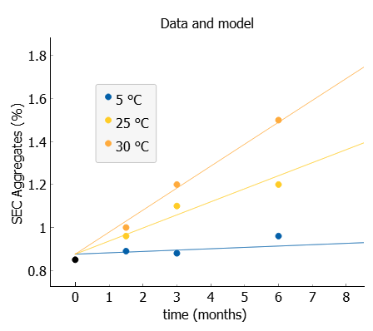 | 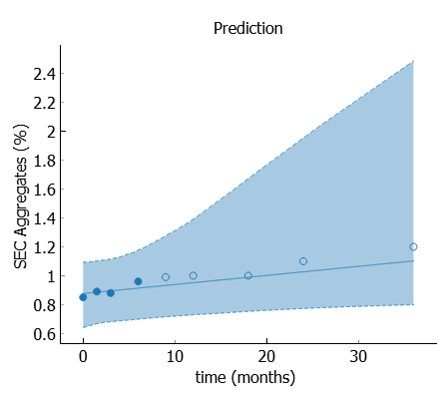
Protein 2 (IgG1) | 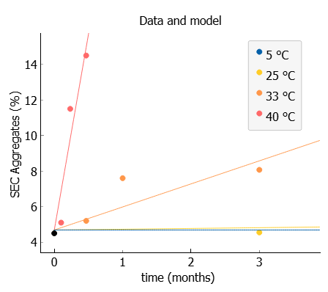 | 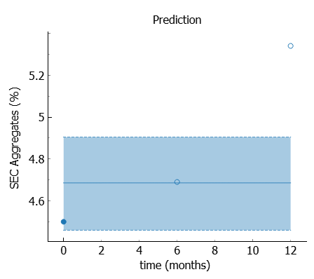
Protein 3 (IgG2)  Formulation 1 | 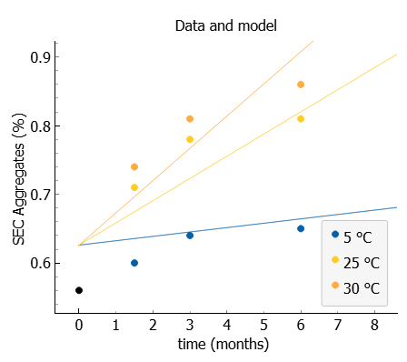 | 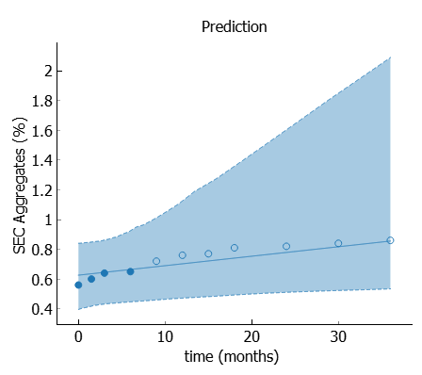
Protein 3 (IgG2)  Formulation 2 | 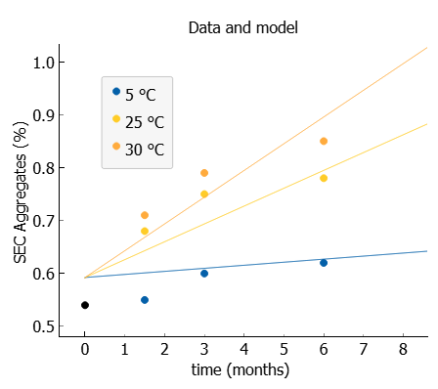 | 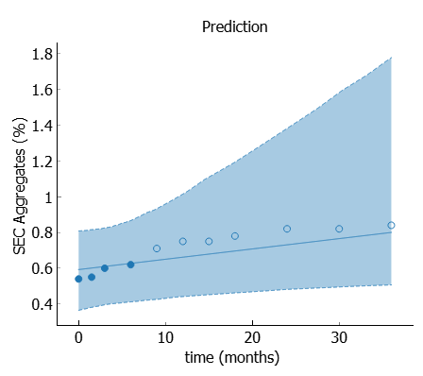
Protein 4 (Bispecific IgG) | 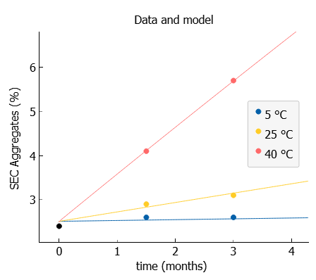 | 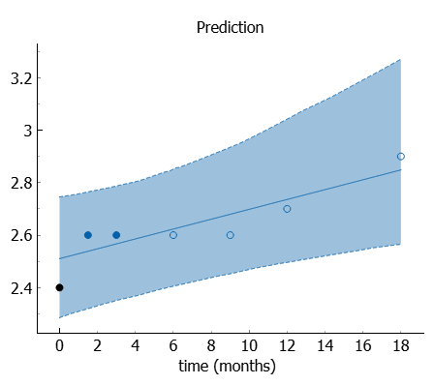
Protein 5 (Fc fusion) | 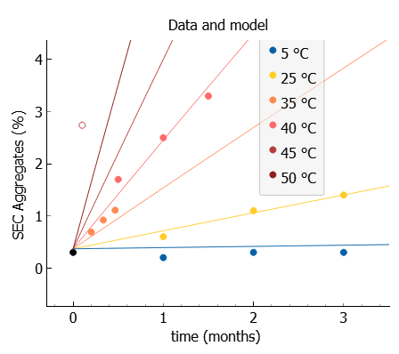 | 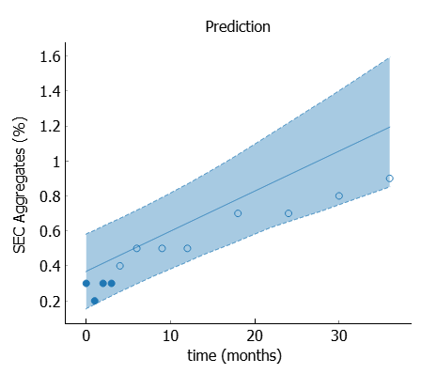
Protein 6 (scFv)  Formulation 1 | 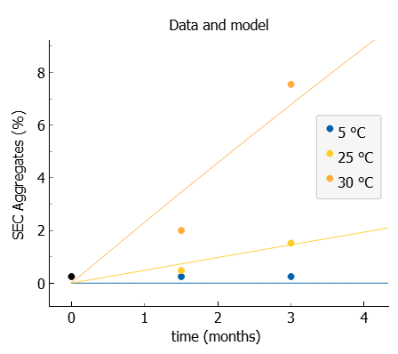 | 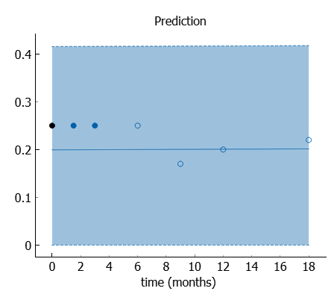
Protein 6 (scFv)  Formulation 2 | 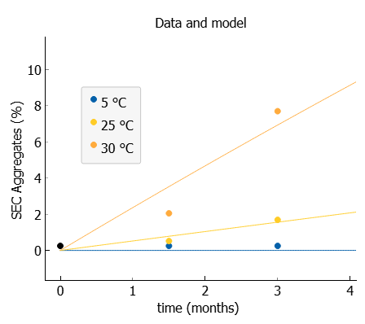 | 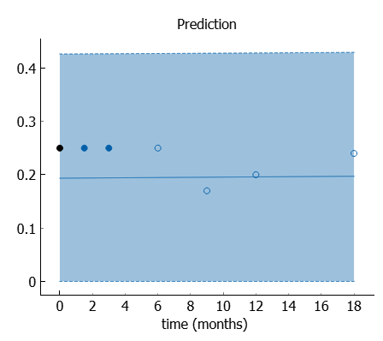
Protein 7 (Bivalent nanobody) | 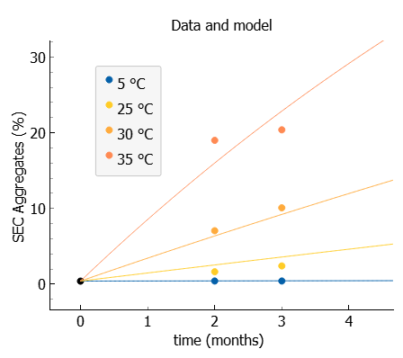 | 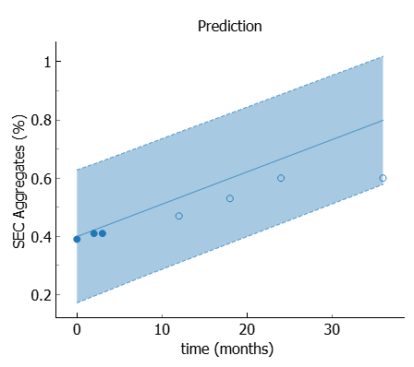
Protein 8 (DARPin)  Formulation 1 | 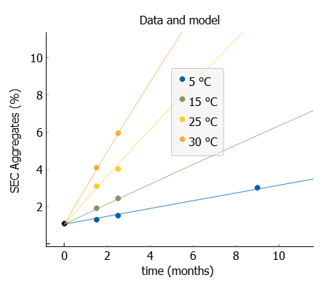 | 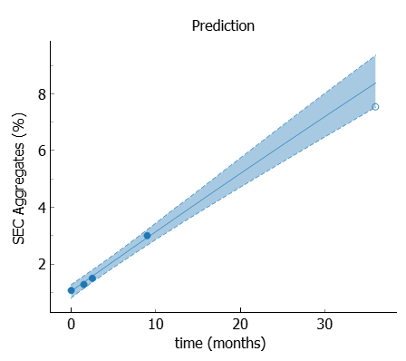
Protein 8 (DARPin)  Formulation 2 | 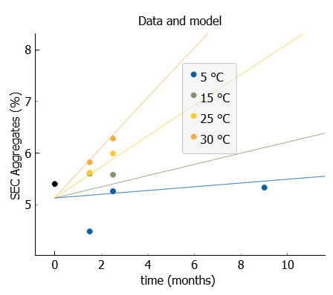 | 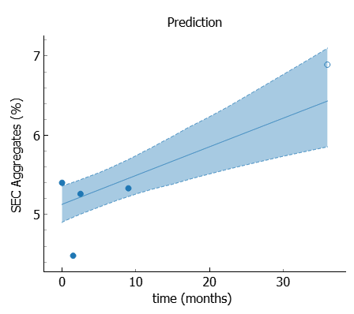
Protein 8 (DARPin)  Formulation 3 | 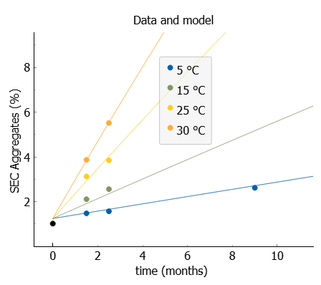 | 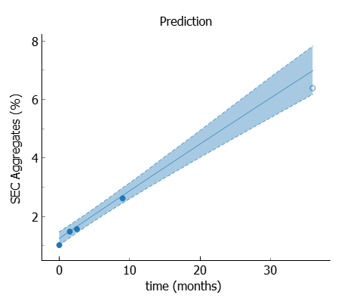
Protein 8 (DARPin)  Formulation 4 | 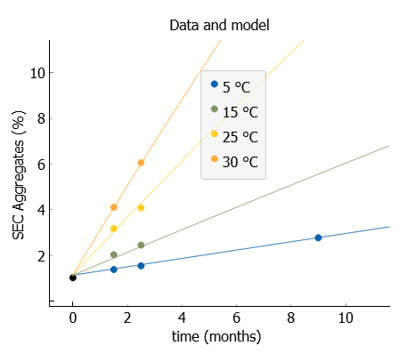 | 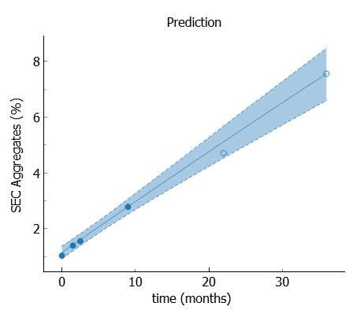

Table S1: additional fit parameters (expansion of Table 1)
Protein # | Form. # | SD (%) | 5 °C | 15 °C | 25 °C | 30 °C | 33 °C | 35 °C | 40 °C | Datapoints per model | k @ 5 °C (1/year) | Ea (kcal/mol) | R²
1 |  | 0.1 | x |  | x | x |  |  |  | 10 | 6.35E-05 | 18.69 | 0.98
2 |  | 0.1 | x |  | x |  | x |  | x | 8 | 3.75E-06 | 77.00 | 0.90
3 | 1 | 0.1 | x |  | x | x |  |  |  | 10 | 6.42E-05 | 13.38 | 0.82
3 | 2 | 0.1 | x |  | x | x |  |  |  | 10 | 5.81E-05 | 14.54 | 0.84
4 |  | 0.1 | x |  | x |  |  |  | x | 7 | 2.32E-04 | 20.00 | 1.00
5 |  | 0.1 | x |  | x | x |  |  | x | 13 | 2.31E-04 | 22.32 | 0.97
6 | 1 | 0.1 | x |  | x |  |  | x |  | 6 | 2.40E-06 | 63.31 | 1.00
6 | 2 | 0.1 | x |  | x |  |  | x |  | 6 | 1.30E-06 | 67.18 | 1.00
7 |  | 0.1 | x |  | x | x |  |  |  | 9 | 5.00E-06 | 59.13 | 1.00
8 | 1 | 0.1 | x | x | x | x |  |  |  | 10 | 2.14E-03 | 15.01 | 1.00
8 | 2 | 0.1 | x | x | x | x |  |  |  | 10 | 3.84E-04 | 17.44 | 0.65
8 | 3 | 0.1 | x | x | x | x |  |  |  | 10 | 1.66E-03 | 15.87 | 0.99
8 | 4 | 0.1 | x | x | x | x |  |  |  | 10 | 1.86E-03 | 15.97 | 1.00

SD is the estimated standard deviation used for the calculation of the confidence interval.
Temperatures used in the fit are marked.
k is the reaction rate constant (1/year) calculated at 5 °C.
Ea is the fitted activation energy.
R² of the model.

Figure S2: Advanced kinetic models (left) and 95% prediction intervals (right) for chemical degradation and fragmentation. Data used to validate the model are shown as empty circles and were not used for model training
Protein 1 (IgG1)  Chemical variants | 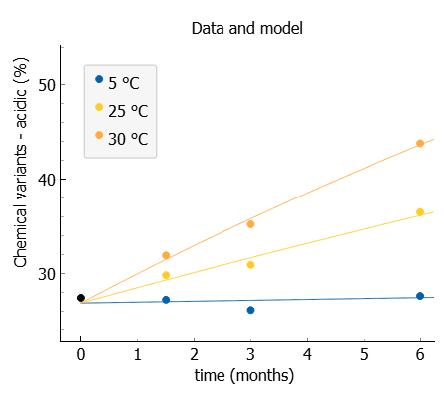 | 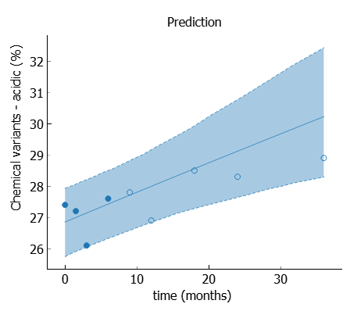
Protein 3 (IgG2)  Chemical variants | 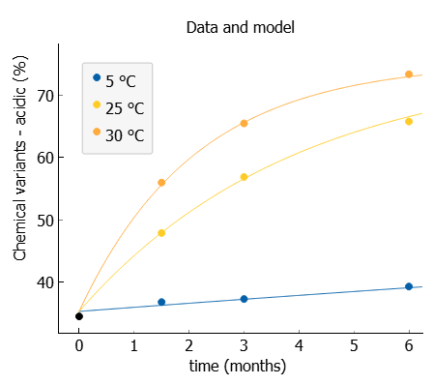 | 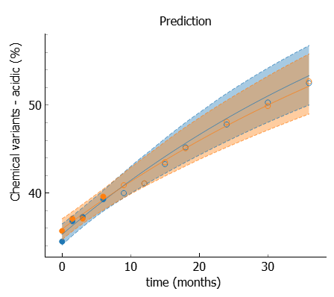
Protein 4 (Bispecific IgG)  Chemical variants | 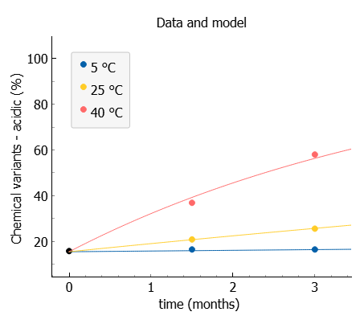 | 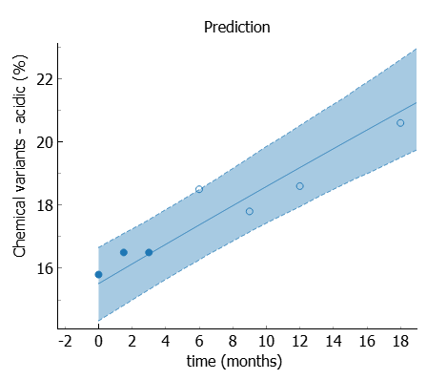
Protein 6 (scFv)  Chemical variants | 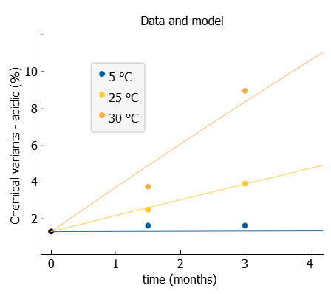 | 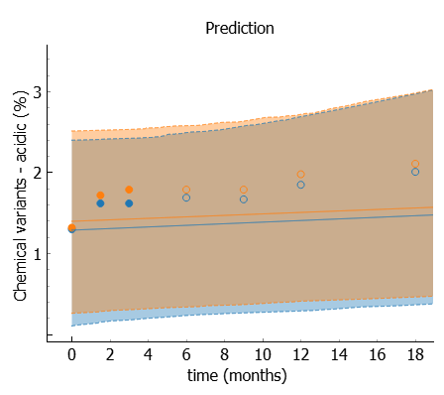
Protein 1 (IgG1)  Fragmentation | 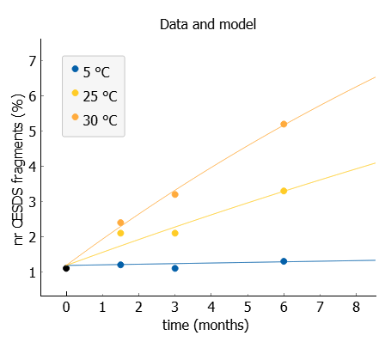 | 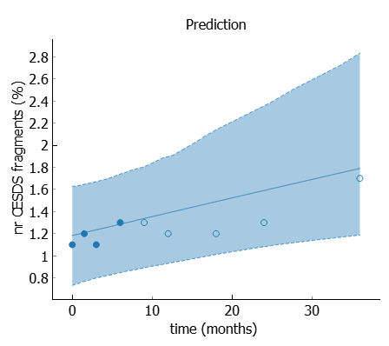
Protein 4 (Bispecific IgG)  Fragmentation | 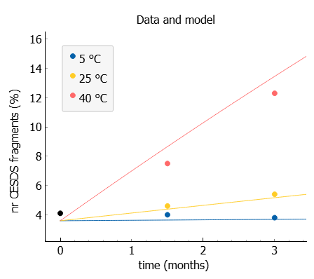 | 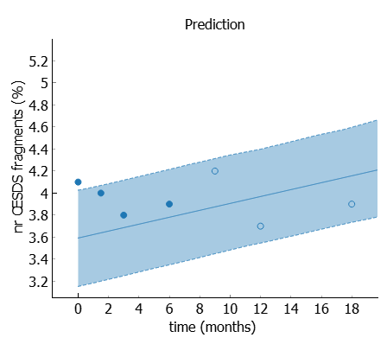

Figure S3: Typical SEC chromatogram of an IgG. Aggregates are on the left side of the main peak while degradants on the right side. Purity of the sample is defined as a ratio between area under the main peak and total area while amount of high-molecular species (aggregates) as a ratio between area under aggregates and total area.
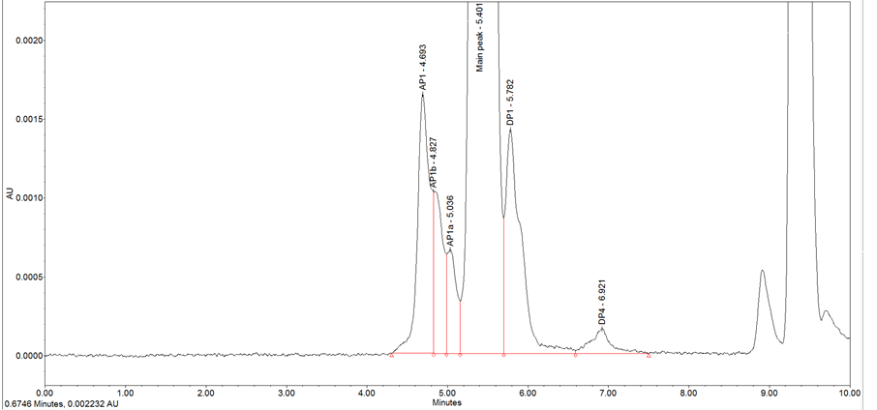

Figure S4: Comparison of 95% prediction intervals computed by AKM (blue dashed lines) and linear regression model (red dashed lines). Left figures are computed by using 3 months data, right by using 9 months stability data. In case of protein P7 since pull point at 9 months is not available, 12 months data stability data was used.
Protein 1 (IgG1) | 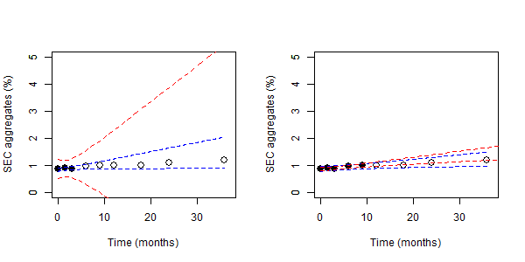
Protein 3 (IgG2) | 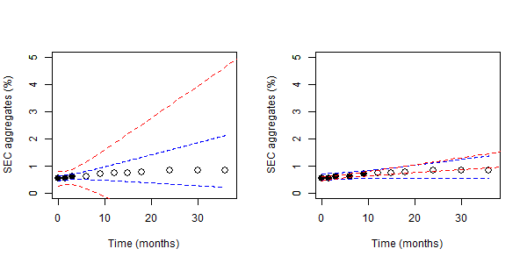
Protein 4 (Bispecific IgG) | 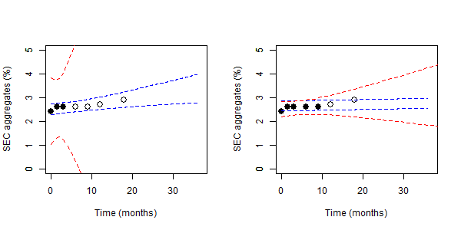
Protein 5 (Fc fusion) | 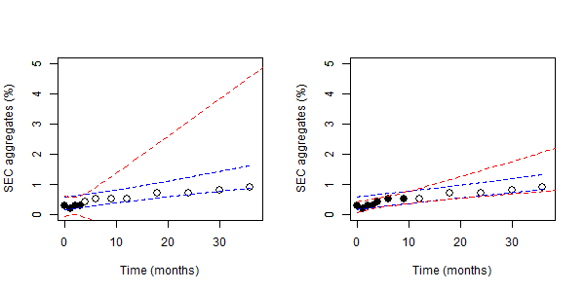
Protein 7 (Bivalent nanobody) | 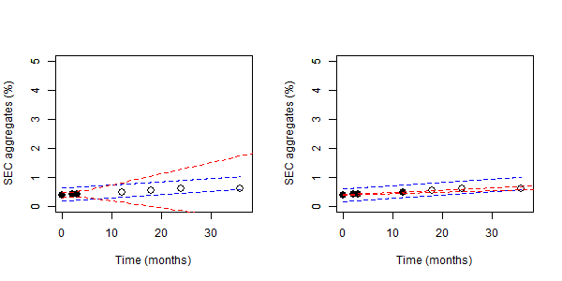
Protein 8 (DARPin) | 