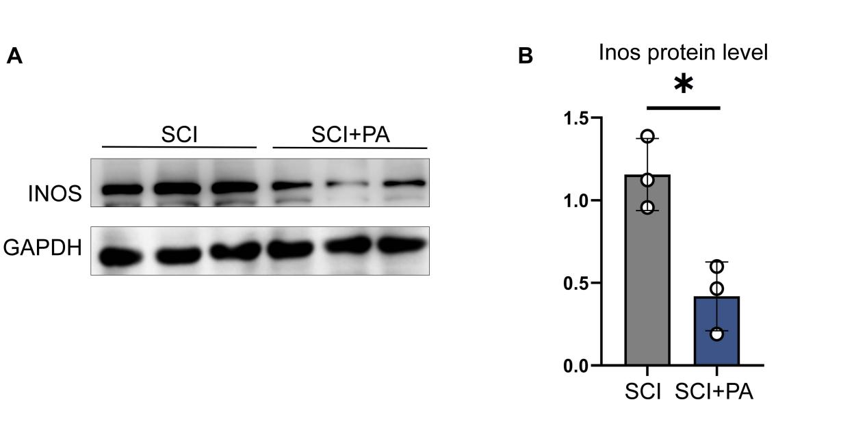
FigureS1. PA inhibits the expression of iNOS in spinal cord tissue of SCI mice.

- Representative WB images depicting the expression levels of iNOS protein in the SCI and SCI+PA groups, with GAPDH serving as the internal control protein. (B)Grayscale value analysis of WB in Figure S1A, with statistical analysis conducted using the t-test, (p < 0.05 *).

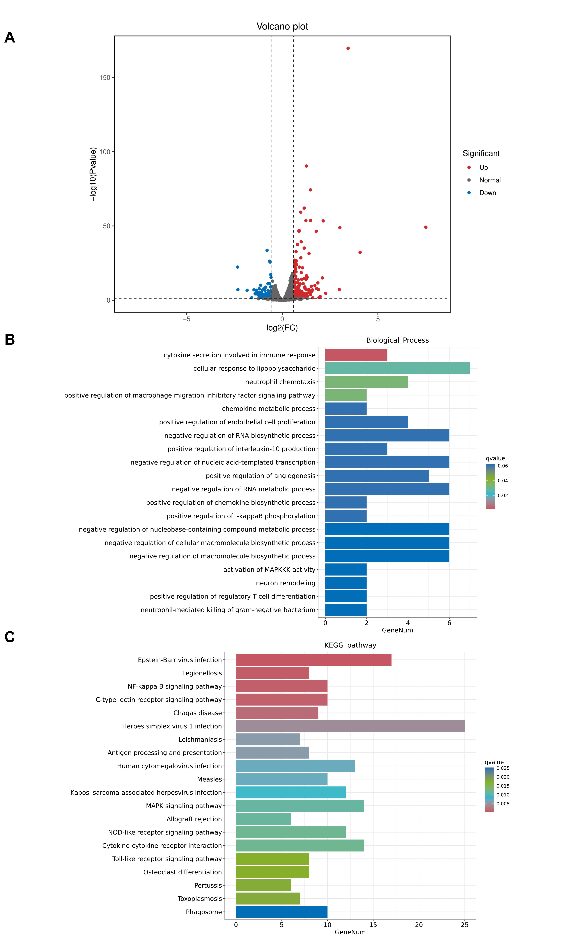
FigureS2. Transcriptome sequencing analysis of BV2 treated with TNFα.
- Volcano plot depicting the differential gene expression between the control BV2 group and the TNFα-treated BV2 group. (B) GO functional analysis (Biological Process) of differential genes between the control BV2 Group and the TNFα-Treated BV2 Group. (C) KEGG pathway analysis (Biological Process) of differential genes between the control BV2 Group and the TNFα-Treated BV2 Group.

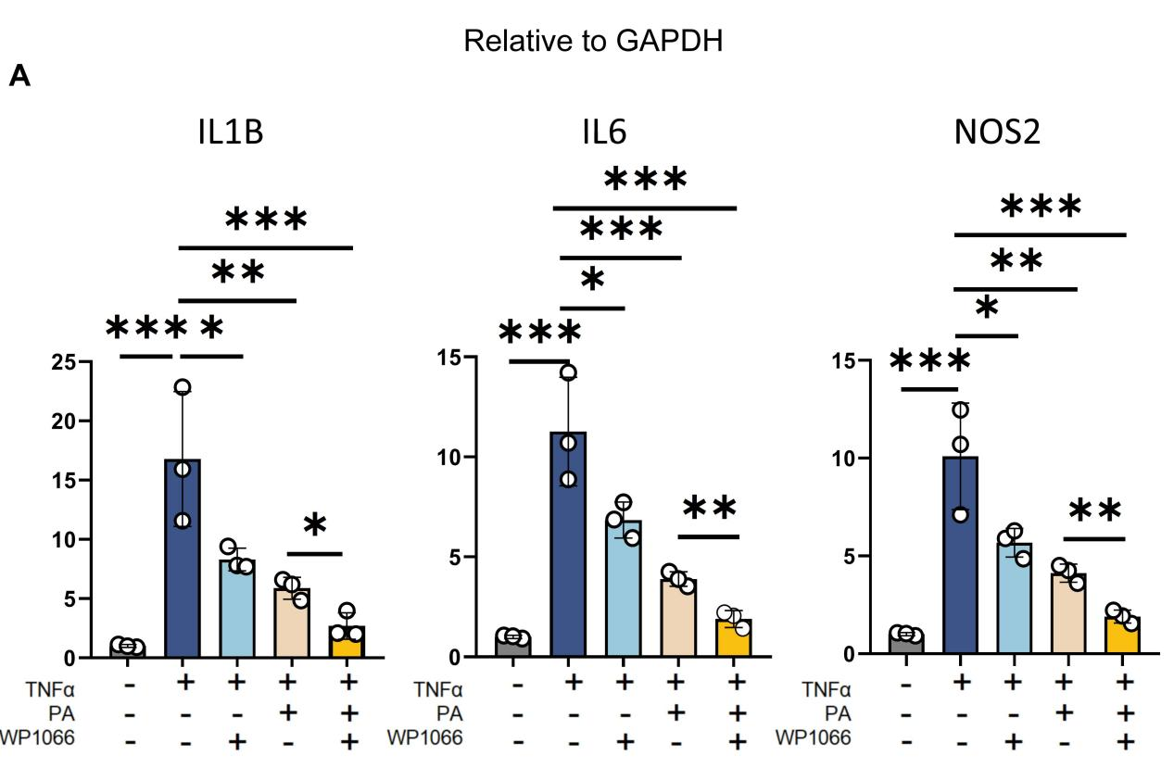

FigureS3. PA inhibits inflammatory responses in BV2 cells by regulating the JAK2/STAT3 pathway.
(A). RT-PCR analysis of IL1B, IL6, and NOS2 genes, with statistical analysis performed using one-way ANOVA, (p < 0.05 *, p < 0.01 **, p < 0.001 ***).

