Next Generation of Solid Amine Sorbent for Scalable Direct Air Capture
Material characterisation
Fourier-transform infrared (FTIR) spectroscopy analysis was used to monitor the synthesis reaction with particular focus on the consumption of TGIC, as well as the sorbent degradation under oxidative conditions. The FTIR spectrometer (Thermo Scientific Nicolet Summit) was equipped with attenuated total reflectance (ATR) correction and recorded the spectrum in the range of wavenumber 400 to 4000 cm⁻¹.
Thermogravimetric analysis-mass spectrometry (TGA-MS, Netzsch STA 449 F3 Jupiter with QMS 403 Quadro Aeolos) was employed to measure the temperature of CO₂ desorbed from 0.5DEA&0.5TEA@SAN. Approximately 20 mg of CO₂ saturated 0.5DEA&0.5TEA@SAN was loaded in an alumina crucible for the measurement. The TGA was heated in the temperature range of 35 to 110°C (heating rate of 1°C min⁻¹) under nitrogen at a flow rate of 40 mL min⁻¹. The mass signal of the desorbed CO₂ was recorded using a quadrupole mass spectrometer and the temperature at which the mass signal detected was considered as the CO₂ desorption temperature.
The BET specific area and the pore size distribution of the samples were determined by N₂ physisorption using Micromeritics ASAP2020 at -196 °C maintained by liquid nitrogen. The samples were activated in seal-frit capped tubes on the degassing port of the ASAP 2020. In the case of the SAN, the sample was degassed at 90 °C under vacuum for 5 hours, while SiO₂ was degassed at 200 °C under vacuum for 10 hours. After activation, the sample tubes were backfilled with helium to atmospheric pressure before the sorption measurements. An equilibration interval of 30 s and a relative pressure tolerance of 5% were employed in these tests.
Thermoporometry was performed to examine changes in the freezing point of the swollen liquid when confined using differential scanning calorimetry (DSC) analyses (Mettler Toledo DSC30 with “Star Software” version 16.3). The system was calibrated using the total n-octane/indium method. An empty aluminium pan served as the reference, while approximately 20 mg of sample containing 50% of water was encapsulated in another pan for the measurements. The DSC scans were conducted over a temperature range of -60 °C to 25 °C, at a heating rate of 10 °C min⁻¹, with nitrogen used as the environmental gas.

Evaluation of sorbent performance in real-world DAC
The CO₂ capture performance of the adsorbents in DAC was evaluated using an in-house built test instrument. A blank run without sorbent loading was initially performed to validate the method, giving a CO₂ uptake of 0.05 mmol g⁻¹, and therefore, the CO₂ capture capacity of the sorbents was levelized to have 0.05 mmol g⁻¹ deducted. For each measurement, the sorbent was regenerated in a fan-forced oven at 85 °C in air under ambient pressure for 1 h to remove pre-adsorbed CO₂ and moisture, and then 5 g of the dried sample was loaded into the test instrument. Humidified air contained 500 mL min⁻¹ of compressed ambient air and 500 mL min⁻¹ of water saturated air was introduced into the tube, making up a total air flow rate of 1000 mL min⁻¹ (a gas hourly space velocity, GHSV of 12000 mL min⁻¹ g⁻¹) at ambient conditions. The details of the setup and the methodology of calculating CO₂ and H₂O uptake can be found in our earlier publication (26).
Furthermore, we also evaluated the sorbent performance under real-world DAC conditions. Specifically, 15 g of dried 0.5DEA&0.5TEA@SAN was spread in a tray (100 × 100 × 5 mm), which was positioned in front of a computer fan. This setup was placed outdoor in an open area. A monocrystalline solar panel was used to power the fan at a wind speed in the range of 1.5 to 2 m s⁻¹. Samples were collected from five different spots on the tray, including the four corners and the centre, at one-hour intervals for 5 hours. These samples were then mixed and analysed using a thermalgravimetric analysis (TGA, Netzsch, STA 449 F3) coupled with a CO₂ sensor (Vaisala GMP252) at its exit. The TGA was heated up to 90 °C (heating rate of 5 °C min⁻¹) under nitrogen (99.99%) at a flow rate of 60 mL min⁻¹. The concentration of the desorbed CO₂ (ppm) was recorded by the sensor as a function of time and the amount of CO₂ was then calculated.

Evaluation of sorbent stability under accelerated ageing
The stability of the Class IV adsorbents was assessed through accelerated ageing and compared with the SiO₂ supported adsorbents. All samples were placed in a fan-forced oven at 85 °C in air for seven days. The CO₂ capture capacity of the aged samples was evaluated using the same approach as previously described. The 0.5DEA&0.5TEA@SAN and 0.5DEA&0.5MDEA@SAN samples were tested daily, while the other samples were assessed only at the end of the ageing process.

Supplementary Figure 1
Fig. S1 Schematic of solid amine net with PEI being knitted together by TGIC, which is performed at ambient conditions and completed in 10 minutes.

Supplementary Figure 2
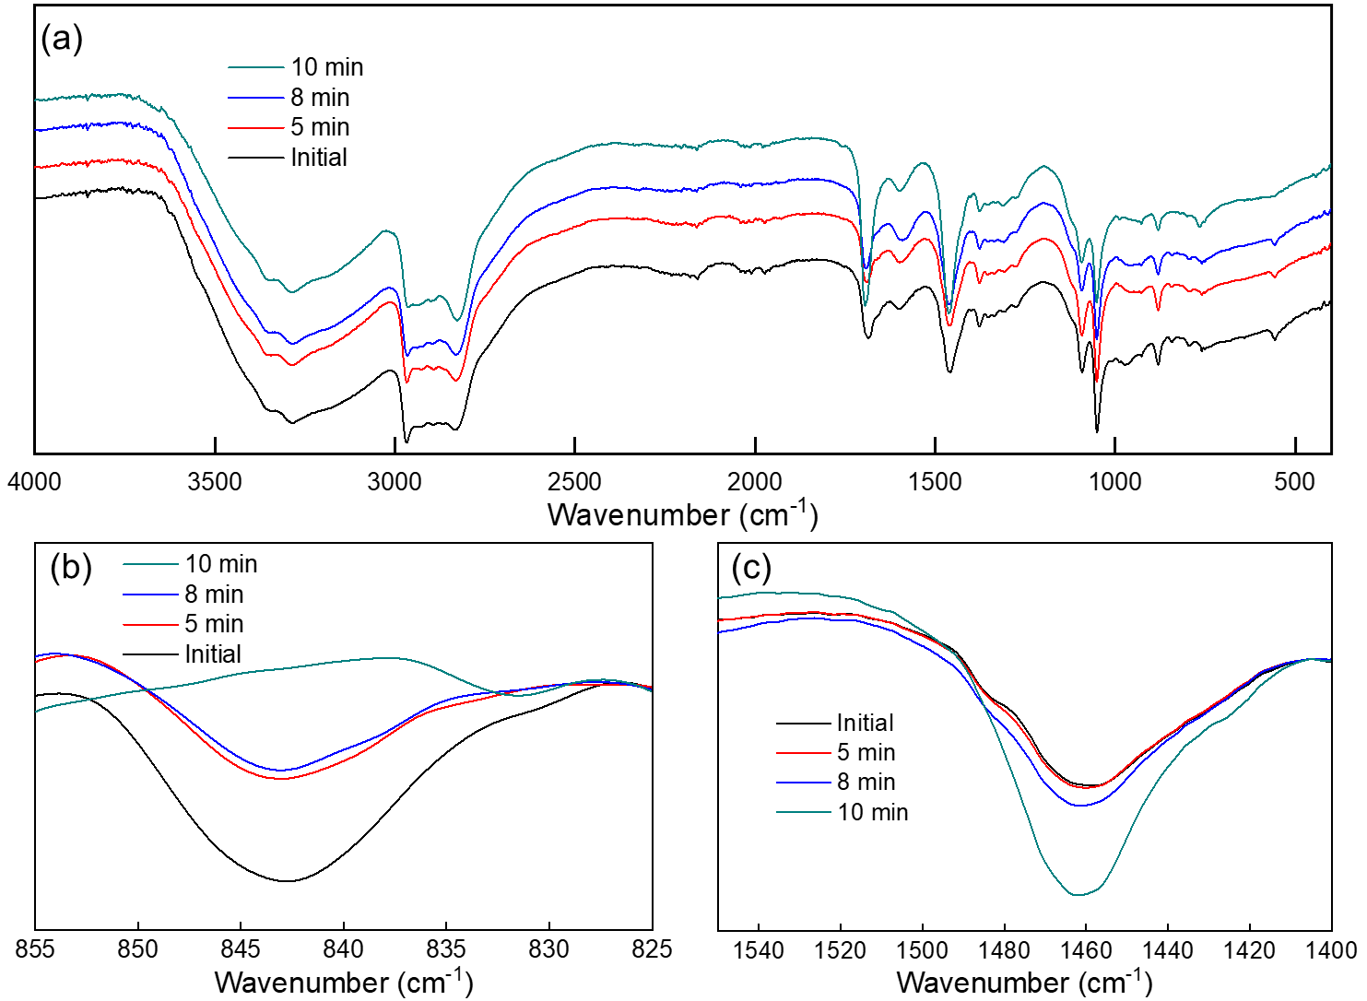
Fig. S2 Evolution of infrared (IR) absorption of functional groups during the synthesis of the SAN. (a) full IR spectra in the range of wavenumber 400–4000 cm⁻¹; (b) IR spectra for C−O−C stretching of the oxirane ring (843 cm⁻¹), which is gradually decreased in intensity and disappeared at the 10-minute mark, indicating the consumption of epoxy groups (ring opening) and completion of the reaction; (c) IR spectra for O−H bending (1460 cm⁻¹) increased in intensity was attributed to the formation of hydroxy groups formed from the ring opening (3).

Supplementary Figure 3
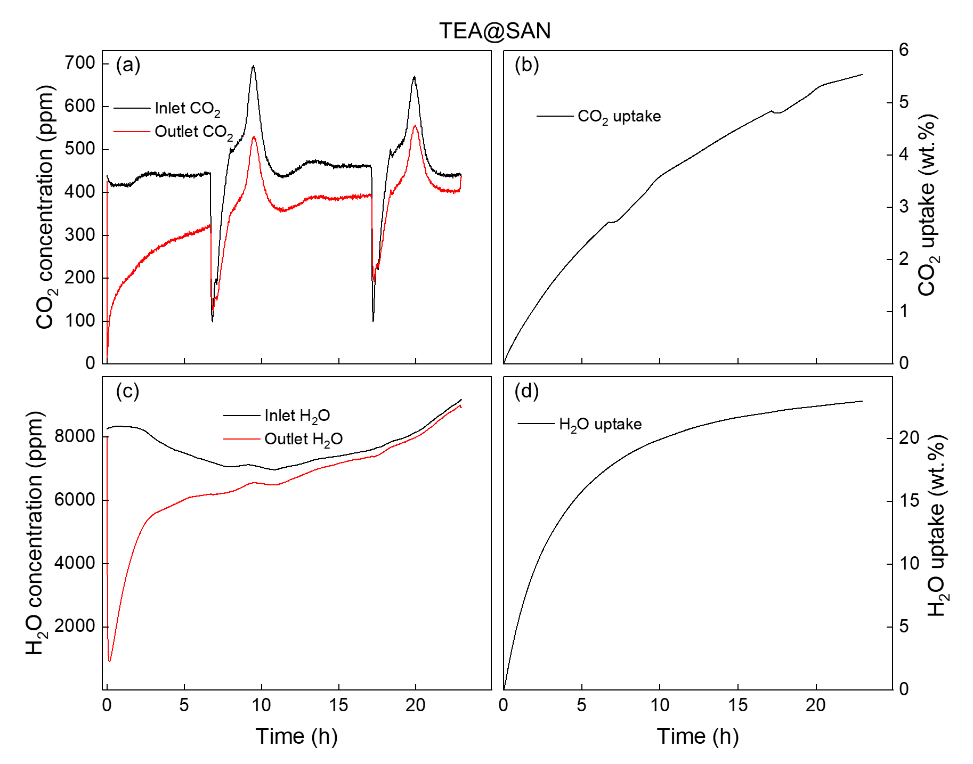
Fig. S3 The dynamic changes in CO₂ and H₂O concentrations at the inlet and outlet, as well as CO₂ and H₂O uptakes as a function of time for TEA@SAN during the DAC test: (a) CO₂ concentrations; (b) CO₂ uptake; (c) H₂O concentrations; and (d) H₂O uptake.

Supplementary Figure 4
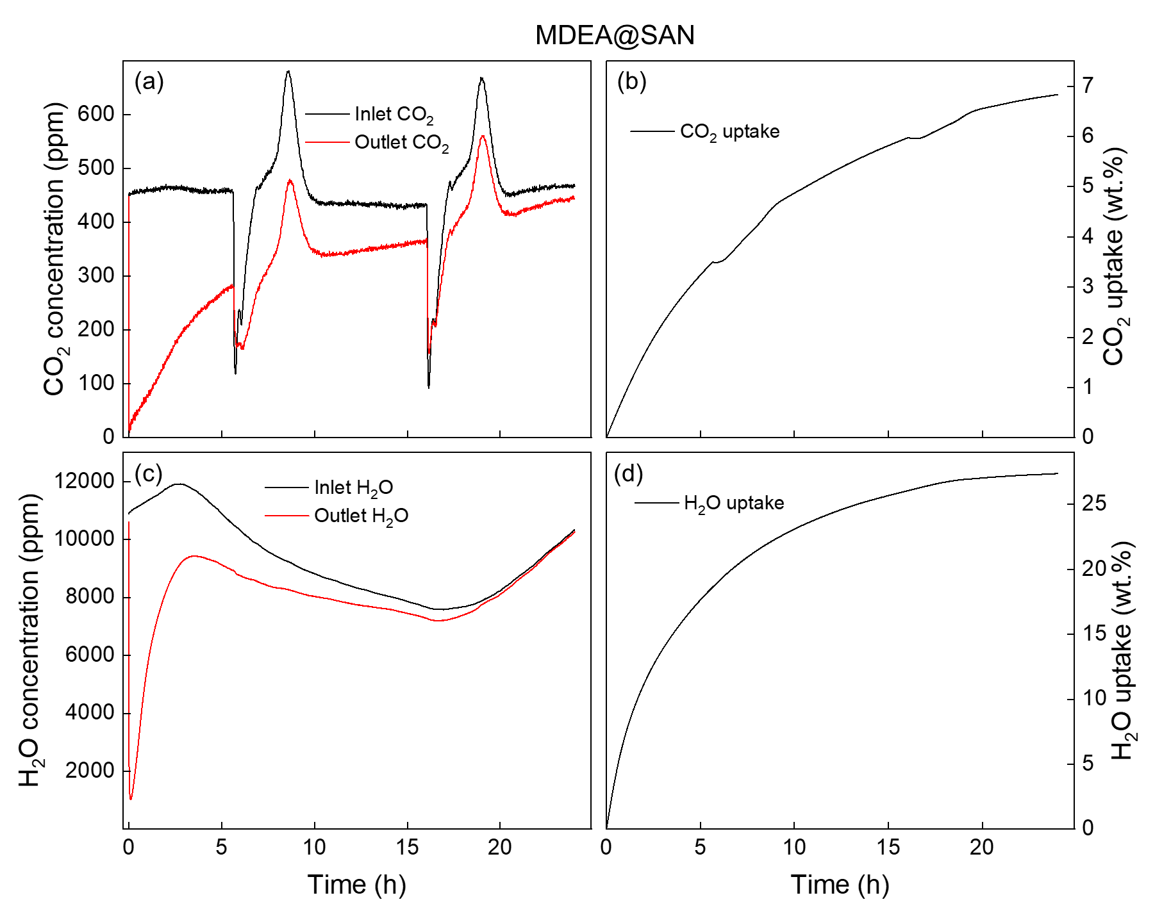
Fig. S4 The dynamic changes in CO₂ and H₂O concentrations at the inlet and outlet, as well as CO₂ and H₂O uptakes as a function of time for MDEA@SAN during the DAC test: (a) CO₂ concentrations; (b) CO₂ uptake; (c) H₂O concentrations; and (d) H₂O uptake.

Supplementary Figure 5
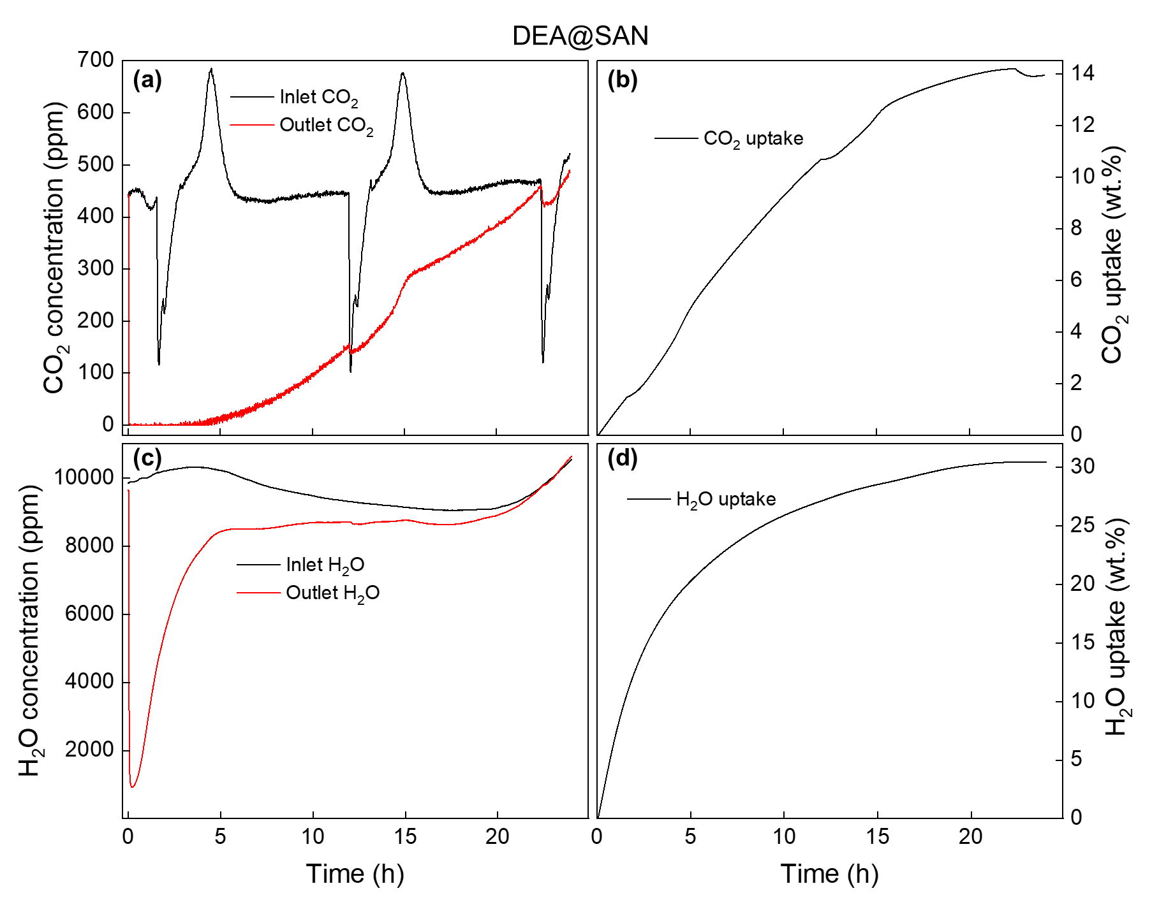
Fig. S5 The dynamic changes in CO₂ and H₂O concentrations at the inlet and outlet, as well as CO₂ and H₂O uptakes as a function of time for DEA@SAN during the DAC test: (a) CO₂ concentrations; (b) CO₂ uptake; (c) H₂O concentrations; and (d) H₂O uptake.

Supplementary Figure 6
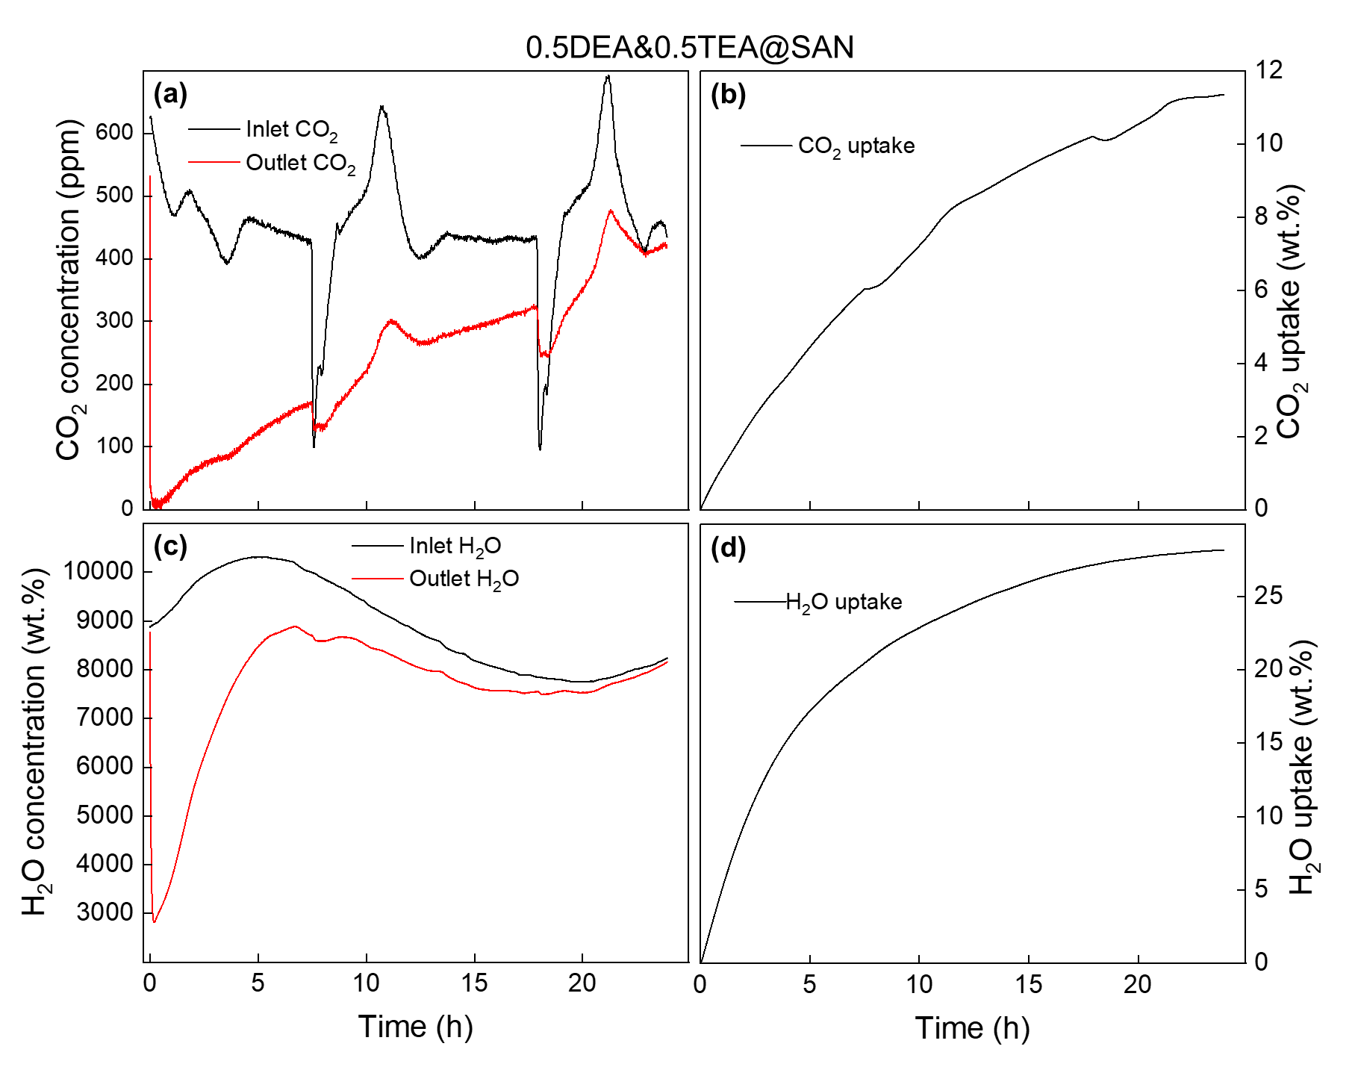
Fig. S6 The dynamic changes in CO₂ and H₂O concentrations at the inlet and outlet, as well as CO₂ and H₂O uptakes as a function of time for 0.5DEA&0.5TEA@SAN during the DAC test: (a) CO₂ concentrations; (b) CO₂ uptake; (c) H₂O concentrations; and (d) H₂O uptake.

Supplementary Figure 7
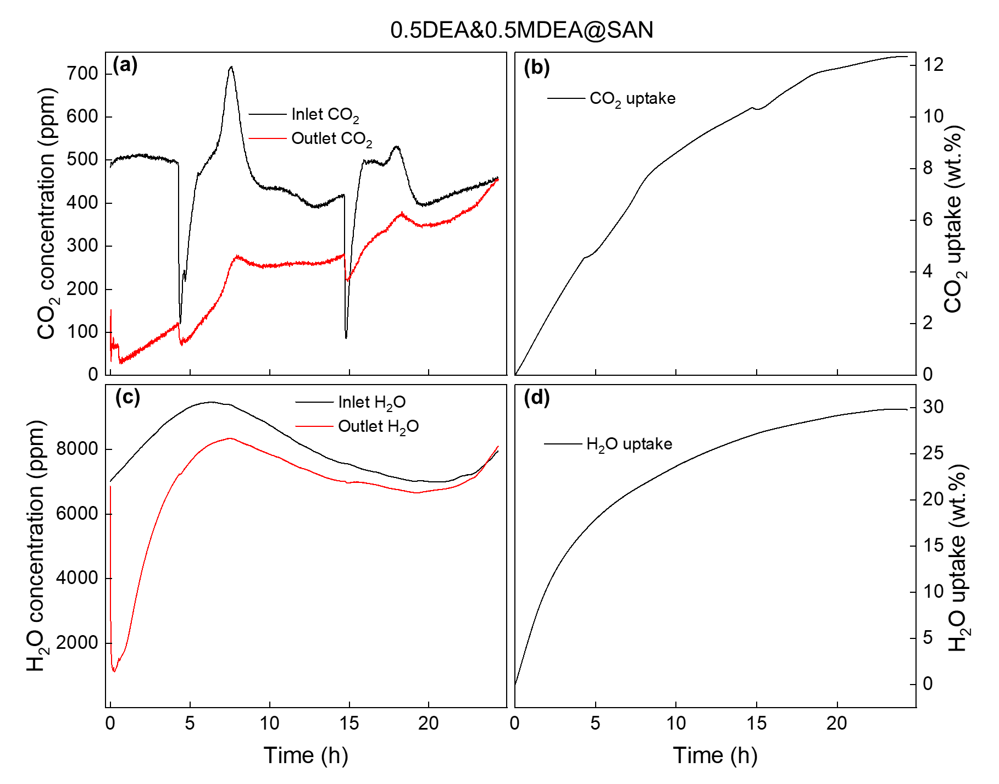
Fig. S7 The dynamic changes in CO₂ and H₂O concentrations at the inlet and outlet, as well as CO₂ and H₂O uptakes as a function of time for 0.5DEA&0.5MDEA@SAN during the DAC test: (a) CO₂ concentrations; (b) CO₂ uptake; (c) H₂O concentrations; and (d) H₂O uptake.

Supplementary Figure 8
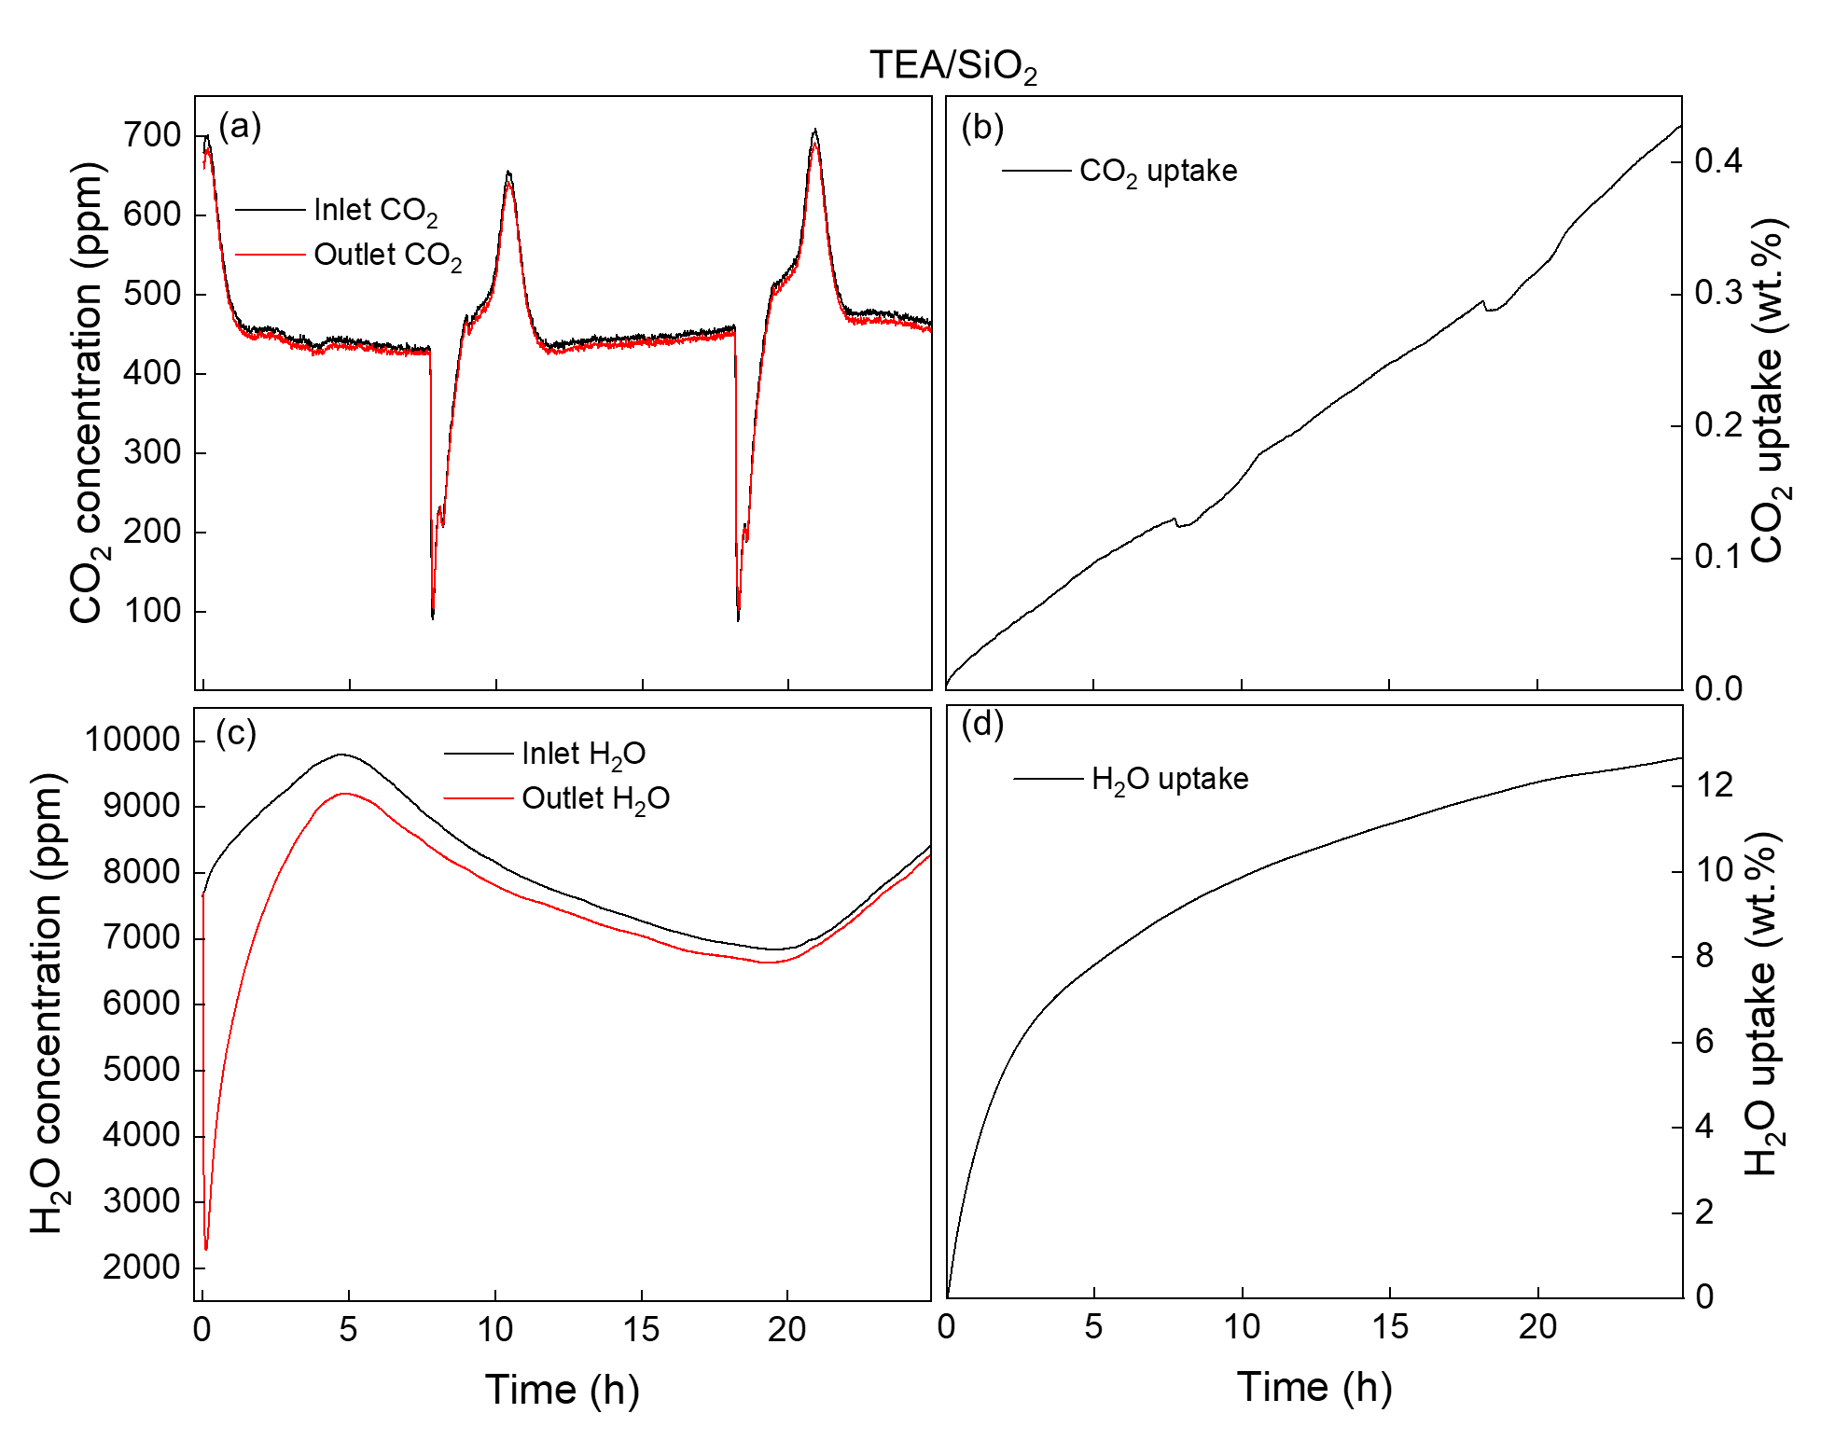
Fig. S8 The dynamic changes in CO₂ and H₂O concentrations at the inlet and outlet, as well as CO₂ and H₂O uptakes as a function of time for TEA/SiO₂ during the DAC test: (a) CO₂ concentrations; (b) CO₂ uptake; (c) H₂O concentrations; and (d) H₂O uptake.
Supplementary Figure 9
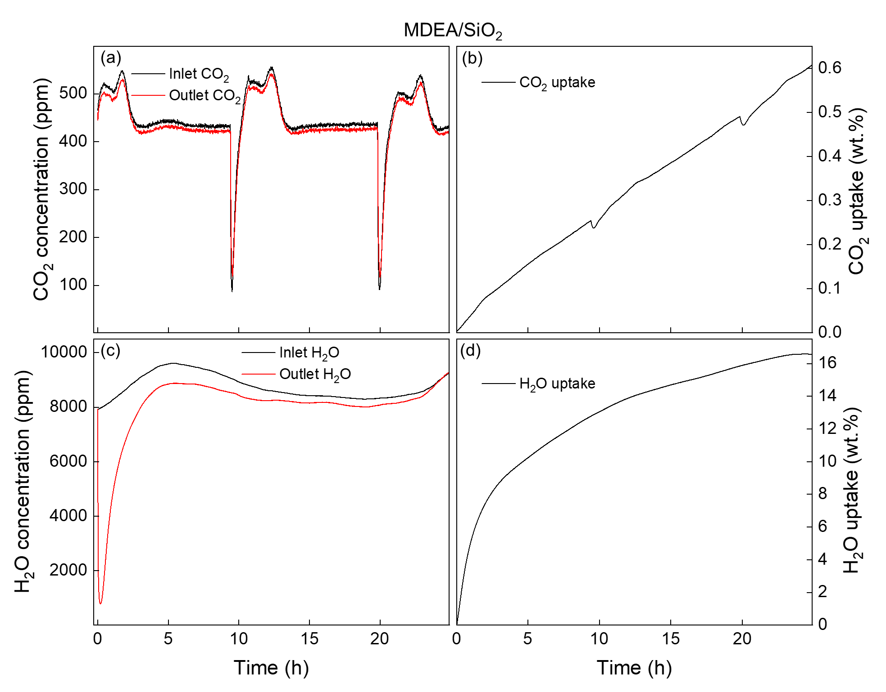
Fig. S9 The dynamic changes in CO₂ and H₂O concentrations at the inlet and outlet, as well as CO₂ and H₂O uptakes as a function of time for MDEA/SiO₂ during the DAC test: (a) CO₂ concentrations; (b) CO₂ uptake; (c) H₂O concentrations; and (d) H₂O uptake.
Supplementary Figure 10
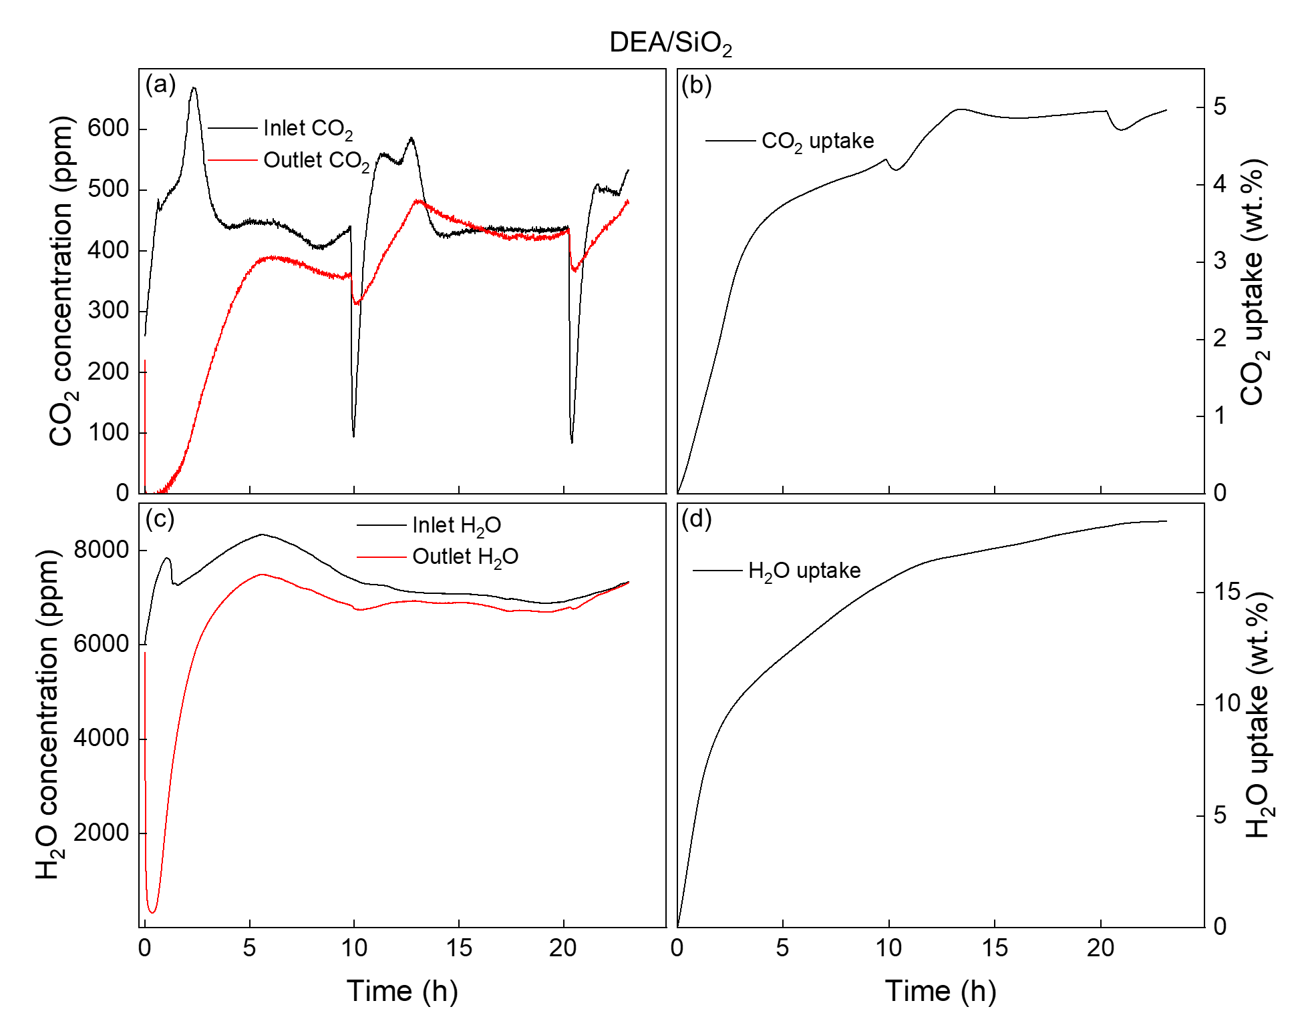
Fig. S10 The dynamic changes in CO₂ and H₂O concentrations at the inlet and outlet, as well as CO₂ and H₂O uptakes as a function of time for DEA/SiO₂ during the DAC test: (a) CO₂ concentrations; (b) CO₂ uptake; (c) H₂O concentrations; and (d) H₂O uptake.
Supplementary Figure 11
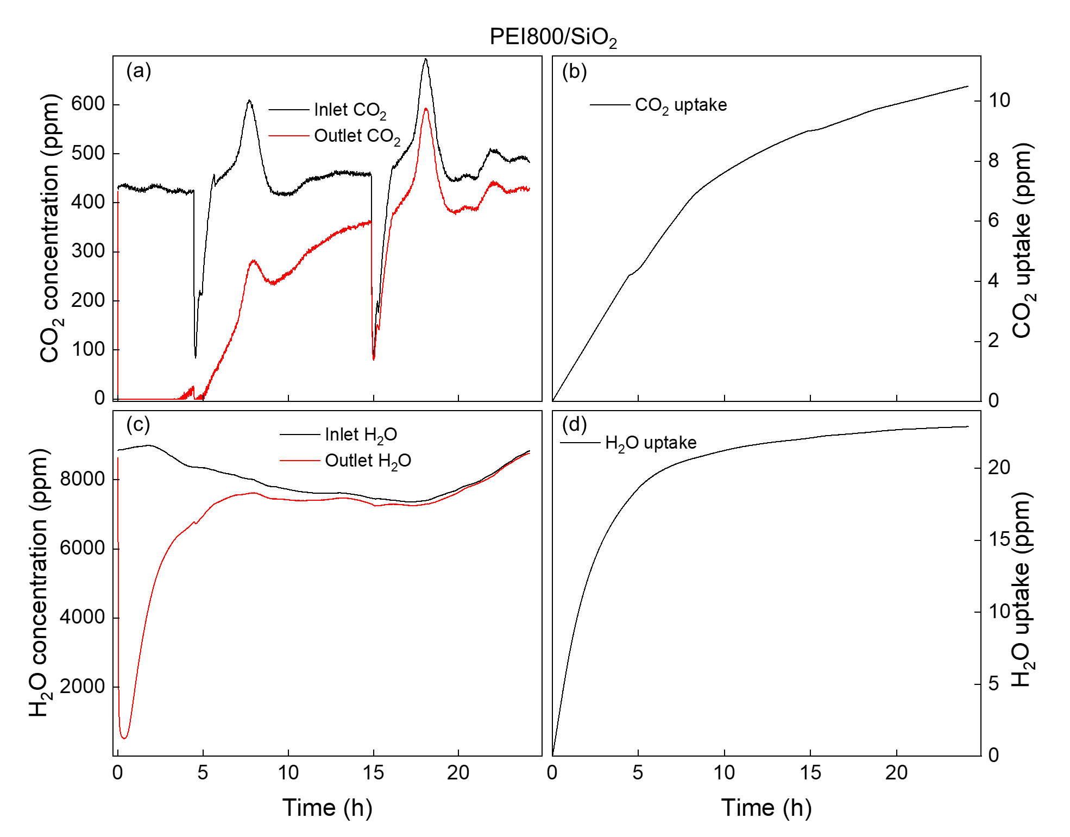
Fig. S11 The dynamic changes in CO₂ and H₂O concentrations at the inlet and outlet, as well as CO₂ and H₂O uptakes as a function of time for PEI800/SiO₂ during the DAC test: (a) CO₂ concentrations; (b) CO₂ uptake; (c) H₂O concentrations; and (d) H₂O uptake.
Supplementary Figure 12
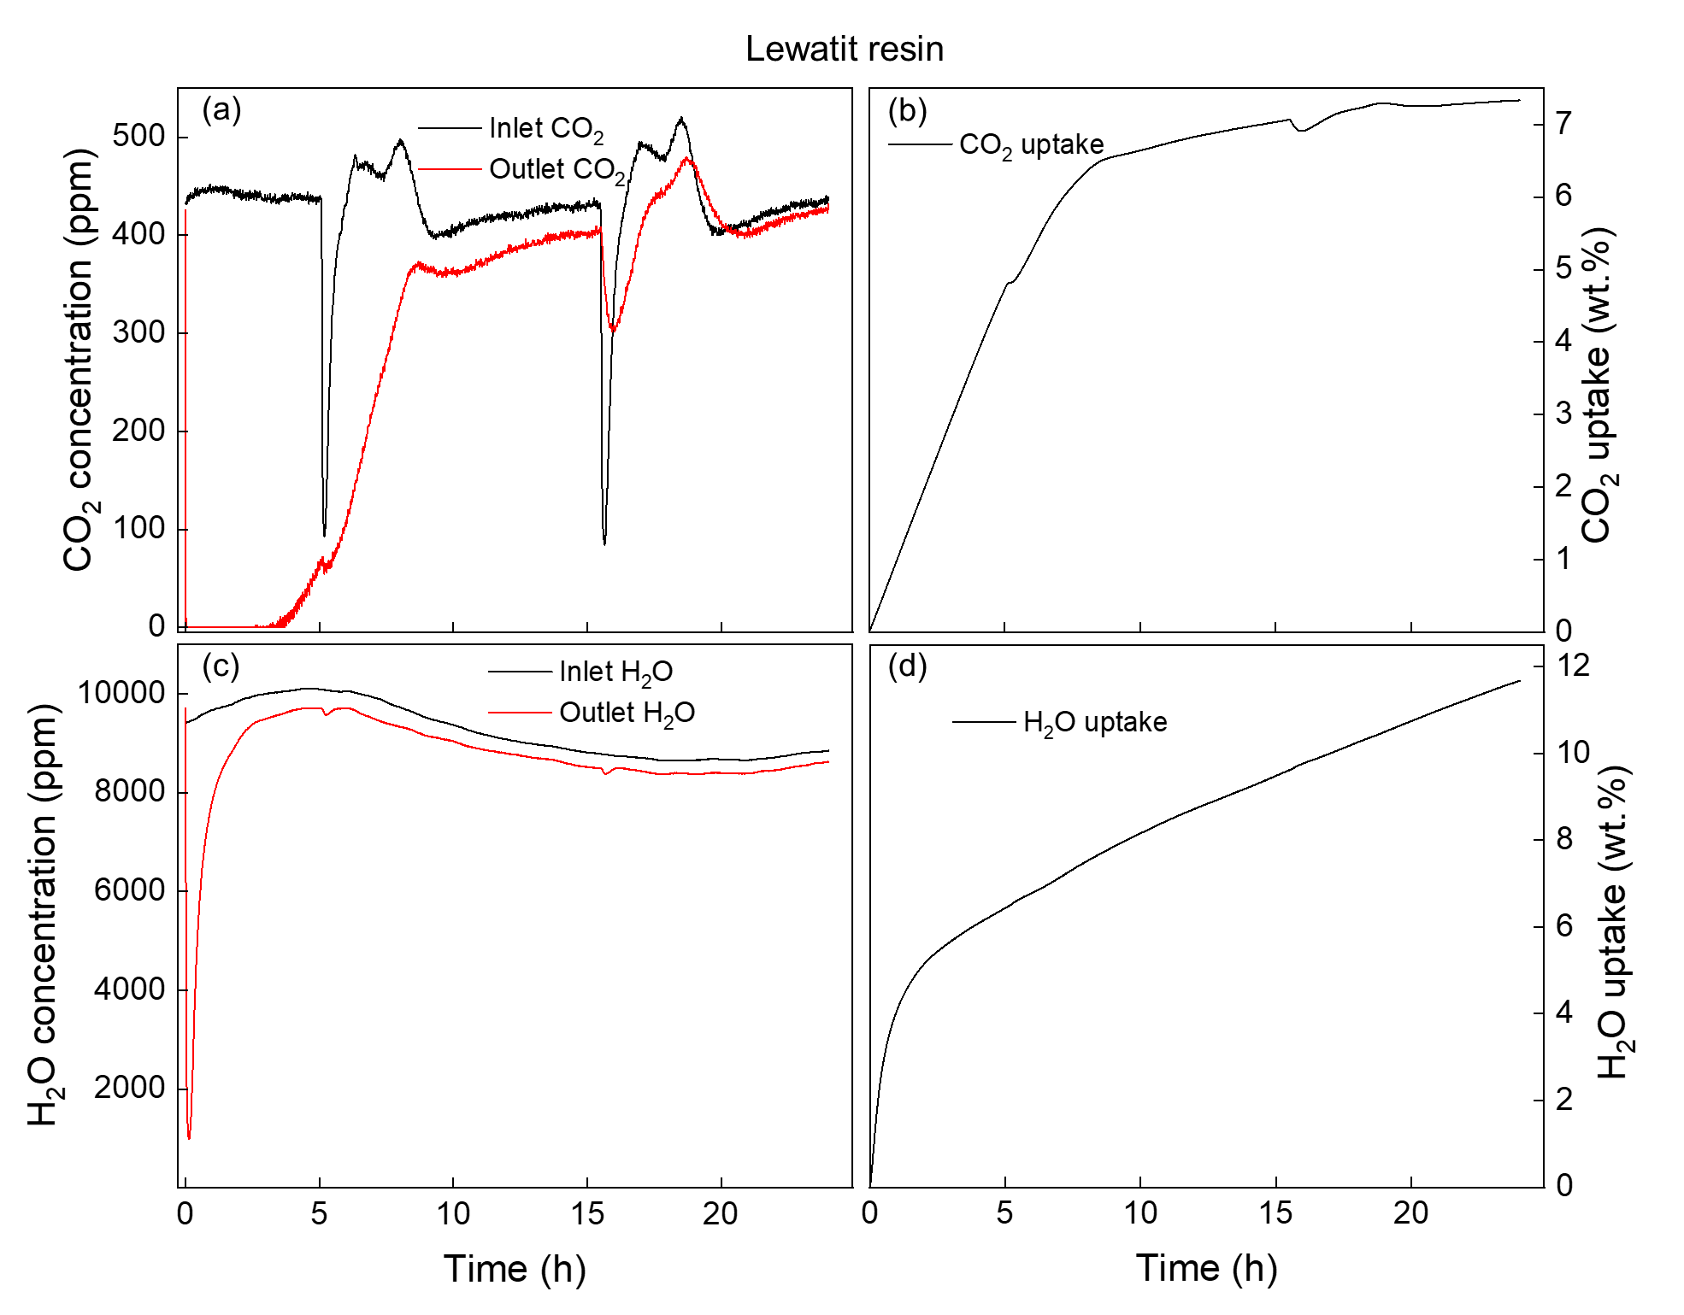
Fig. S12 The dynamic changes in CO₂ and H₂O concentrations at the inlet and outlet, as well as CO₂ and H₂O uptakes as a function of time for Lewatit resin during the DAC test: (a) CO₂ concentrations; (b) CO₂ uptake; (c) H₂O concentrations; and (d) H₂O uptake.
Supplementary Figure 13
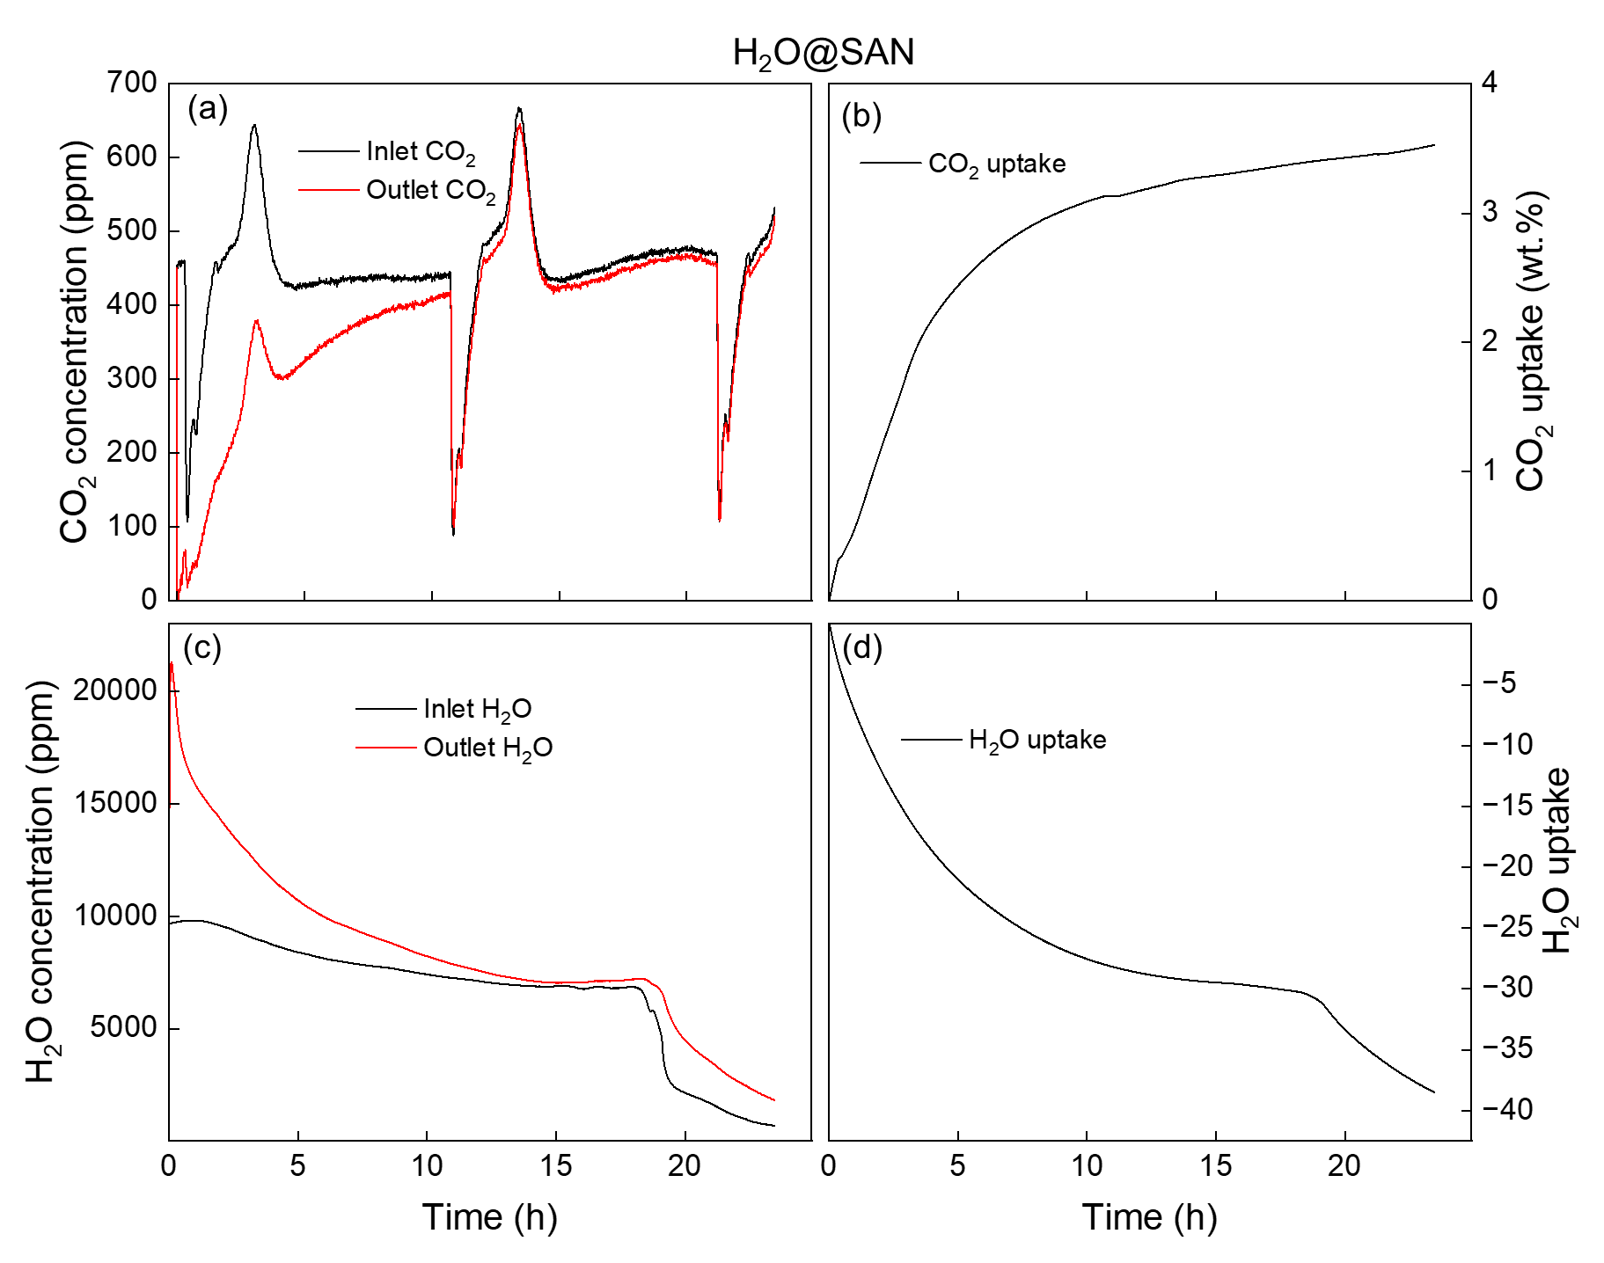
Fig. S13 The dynamic changes in CO₂ and H₂O concentrations at the inlet and outlet, as well as CO₂ and H₂O uptakes as a function of time for H₂O@SAN during the DAC test: (a) CO₂ concentrations; (b) CO₂ uptake; (c) H₂O concentrations; and (d) H₂O uptake.
Supplementary Figure 14
Fig. S14 Thermoporometry performed using DSC to measure the depression in freezing point of water when confined in SiO₂ and solid amine net (SAN) developed in this study. The depression of the water freezing point to -22.5 °C for H₂O/SiO₂ corresponds to a pore size of roughly 5 nm for SiO₂, while such depression is not observed for H₂O@SAN, suggesting stronger interactions between water molecules and the SAN.

Supplementary Figure 15
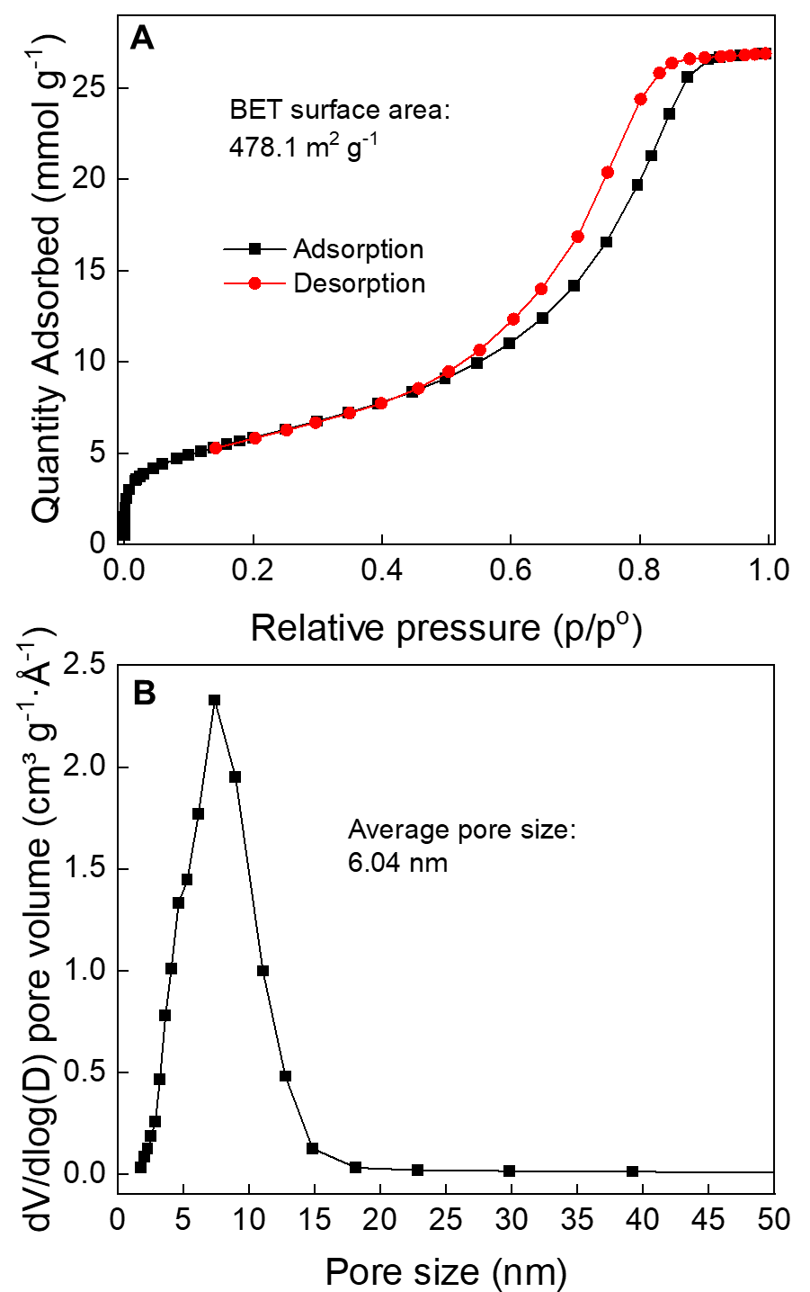
Fig. S15 Nitrogen physisorption measurement for SiO₂: (a) isotherms and (b) pore size distribution, showing SiO₂ having a BET surface area of 478.1 m² g⁻¹ and average pore size of 6.04 nm.
Supplementary Figure 16
Fig. S16 Nitrogen physisorption measurement for the solid amine net (SAN) developed in this study, the isotherms demonstrate SAN having a BET surface area of 1.4 m² g⁻¹, virtually a non-porous material.

Supplementary Figure 17
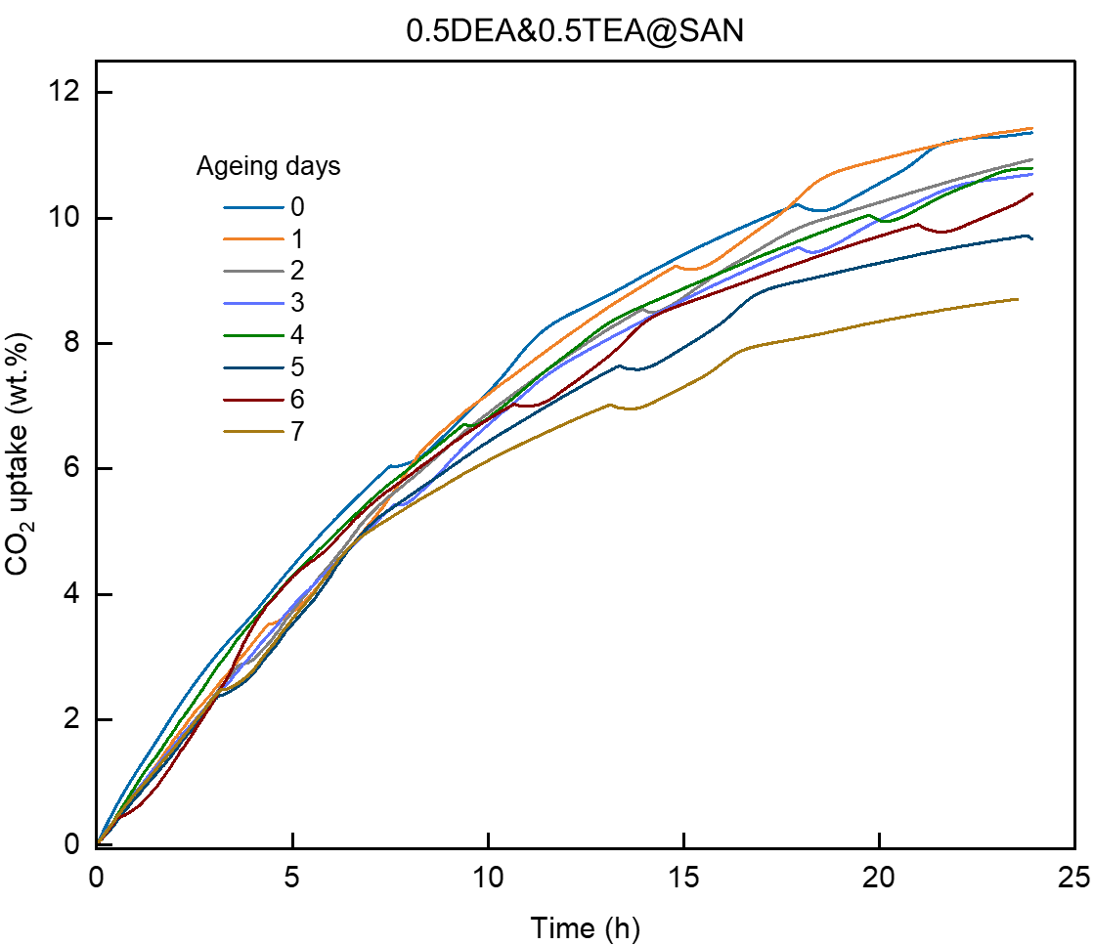
Fig. S17 CO₂ uptake as a function of time for 0.5DEA&0.5TEA@SAN at different ageing days. Accelerated ageing conditions: 85 °C in air.

Supplementary Figure 18
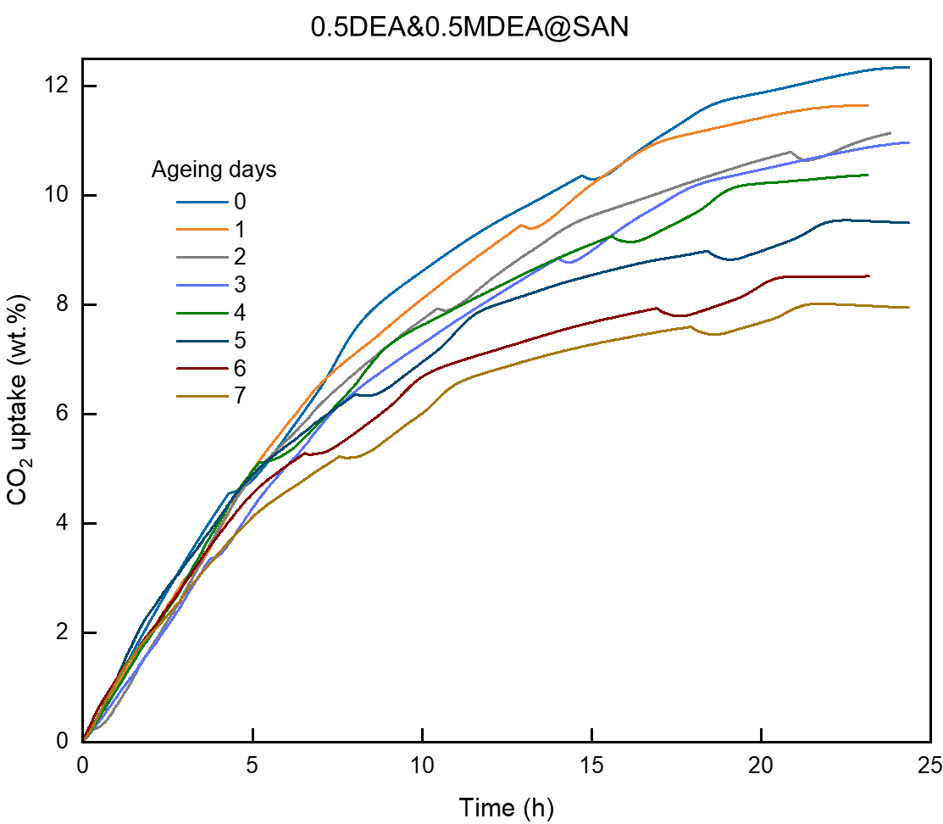
Fig. S18 CO₂ uptake as a function of time for 0.5DEA&0.5MDEA@SAN at different ageing days. Accelerated ageing conditions: 85 °C in air.

Supplementary Figure 19
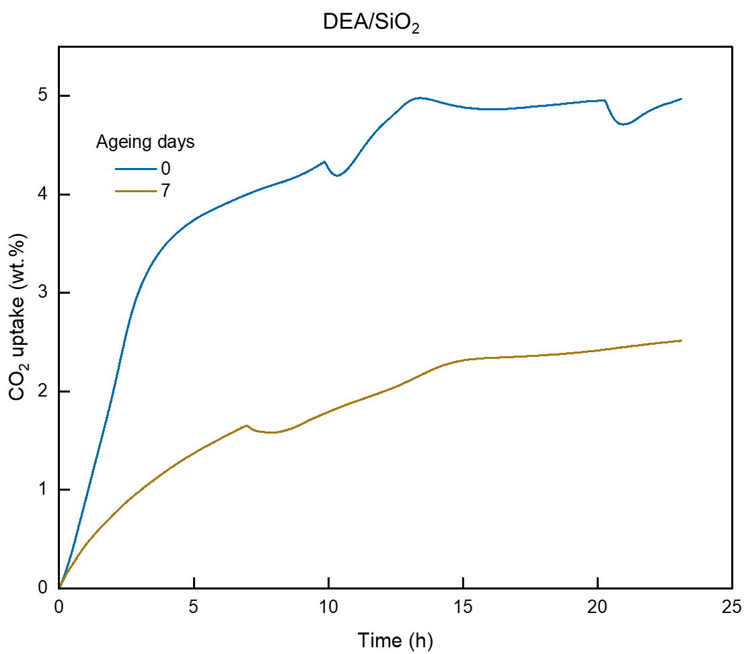
Fig. S19 CO₂ uptake as a function of time for DEA/SiO₂ at different ageing days. Accelerated ageing conditions: 85 °C in air.

Supplementary Figure 20
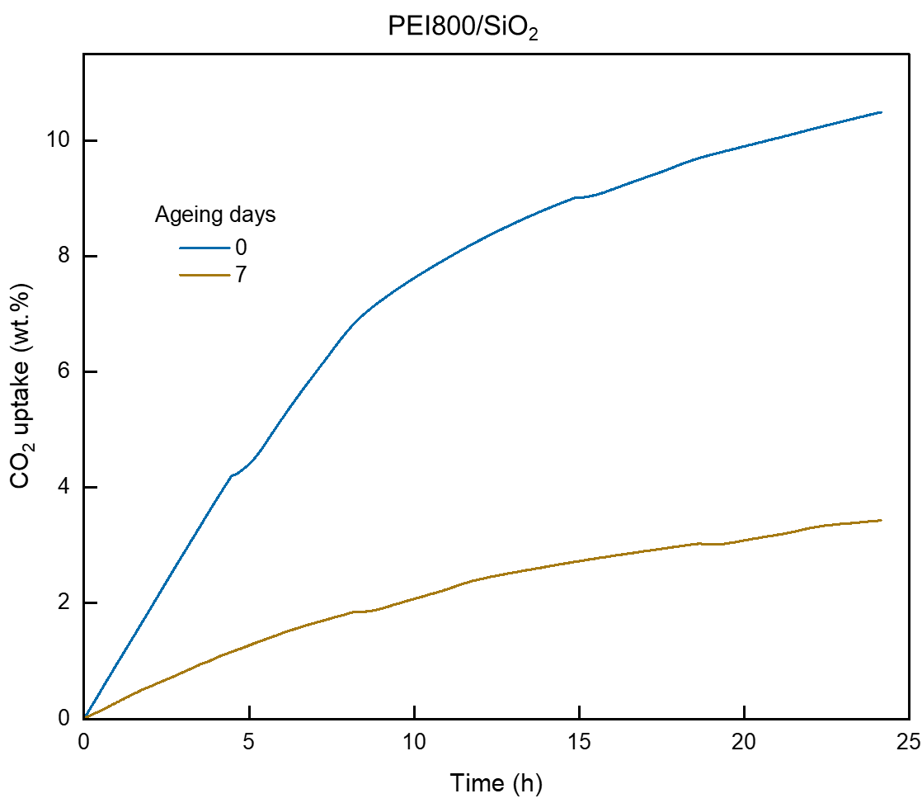
Fig. S20 CO₂ uptake as a function of time for PEI800/SiO₂ at different ageing days. Accelerated ageing conditions: 85 °C in air.

Supplementary Figure 21
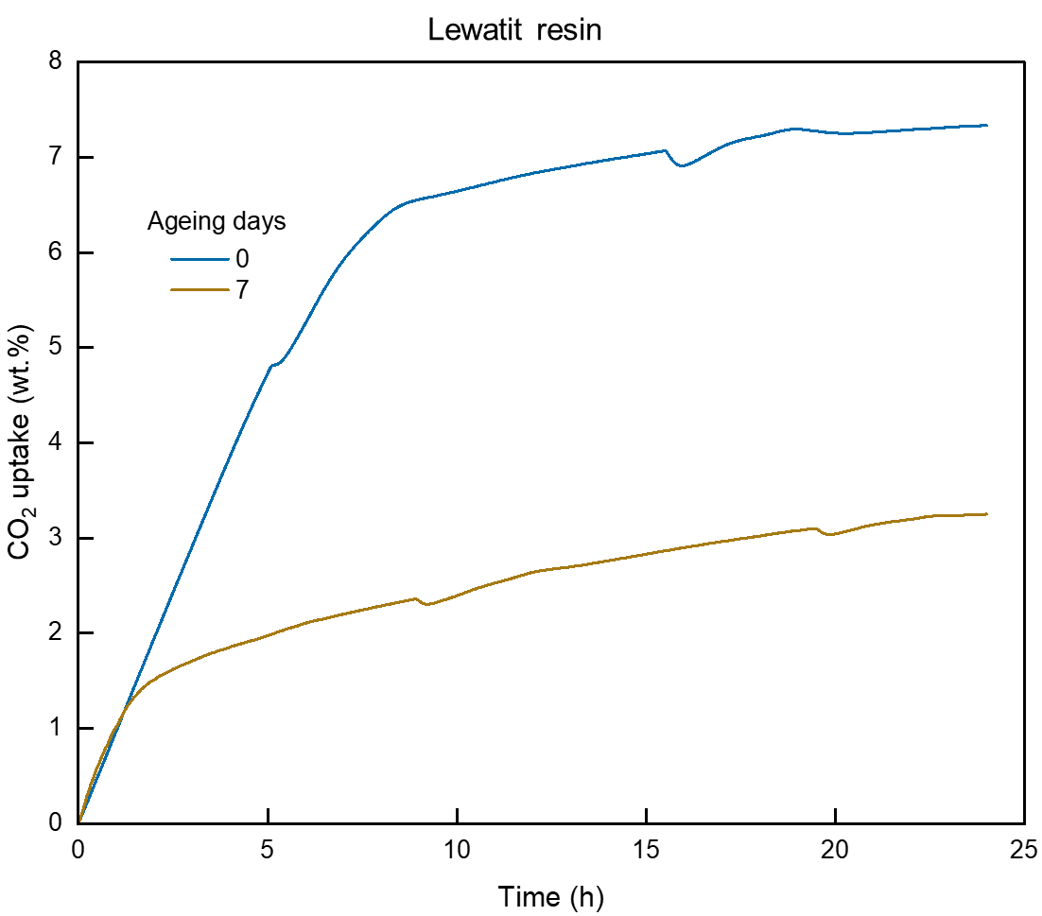
Fig. S21 CO₂ uptake as a function of time for Lewatit resin at different ageing days. Accelerated ageing conditions: 85 °C in air.

Supplementary Figure 22
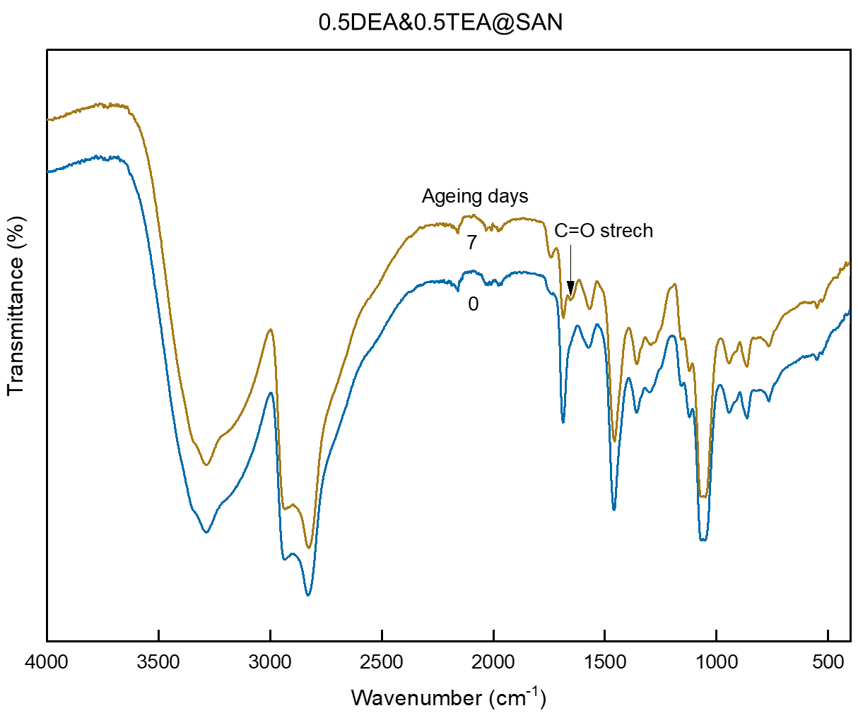
Fig. S22 Changes in IR absorption for 0.5DEA&0.5TEA@SAN at different ageing days. Accelerated ageing conditions: 85 °C in air.

Supplementary Figure 23
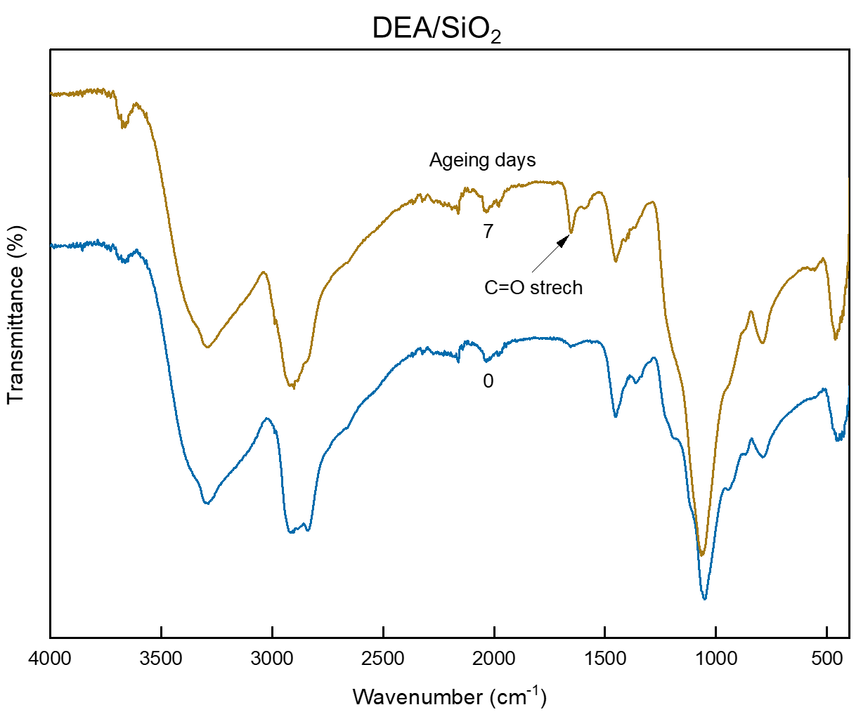
Fig. S23 Changes in IR absorption for DEA/SiO₂ at different ageing days. Accelerated ageing conditions: 85 °C in air.

Supplementary Figure 24
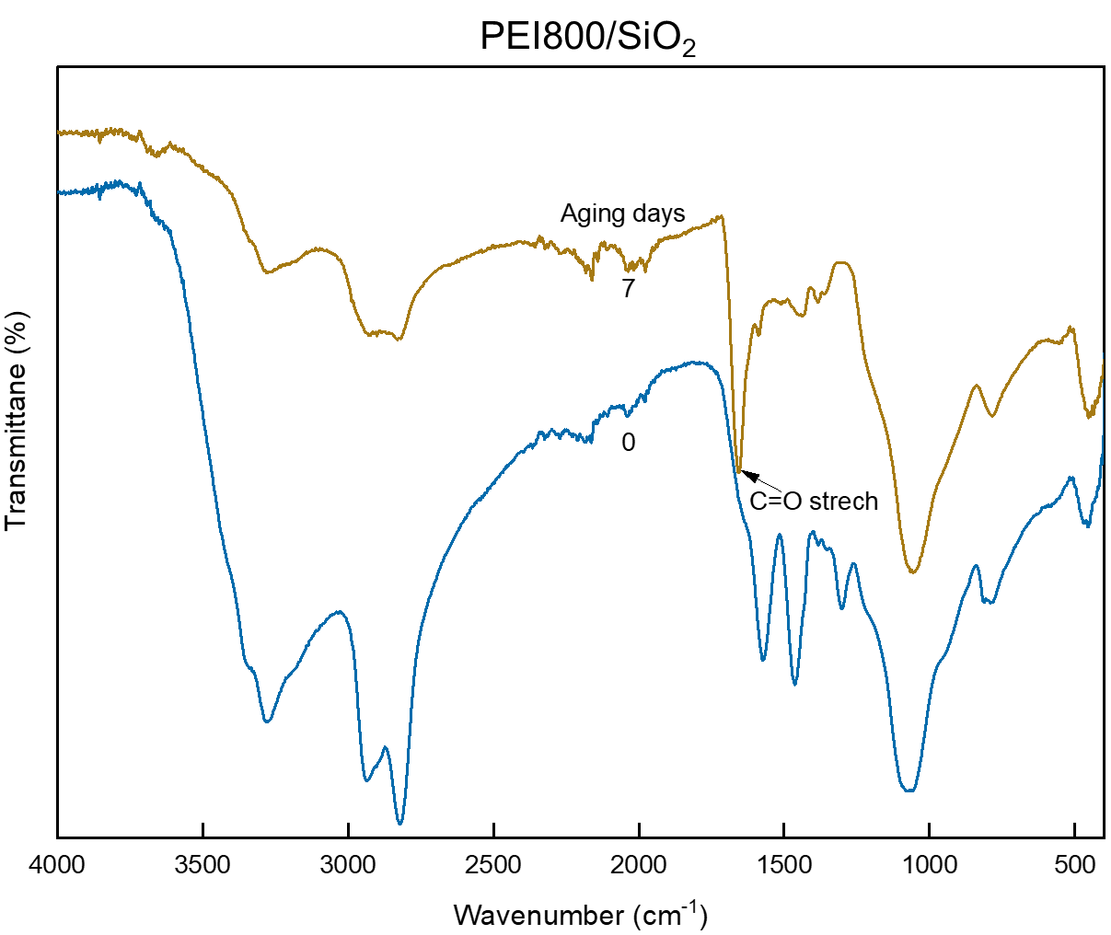
Fig. S24 Changes in IR absorption for PEI800/SiO₂ at different ageing days. Accelerated ageing conditions: 85 °C in air.

Supplementary Figure 25
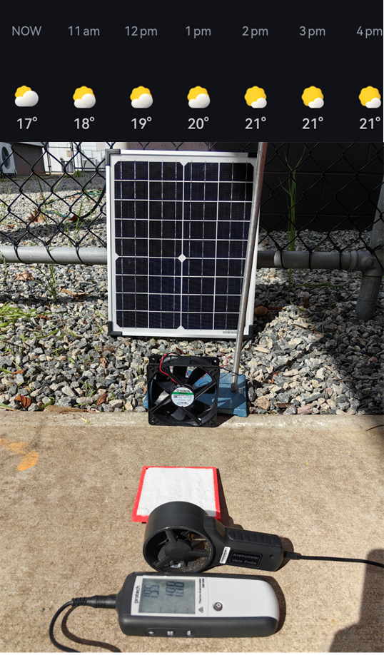
Fig. S25 Solar powered DAC under real-world conditions by exposing the sorbent (0.5DEA&0.5TEA@SAN) to outdoor ambient air for 5 hours. The weather was most sunny with temperature in the range of 17 to 21 °C and relative humidity around 70%. The setup of the DAC system consists of a solar panel to power a computer fan blowing air over 15 g of sorbents at a wind speed in the range of 1.5 to 2 m s⁻¹. This DAC process is so simple that would not be possible for liquid sorbent.
Supplementary Figure 26
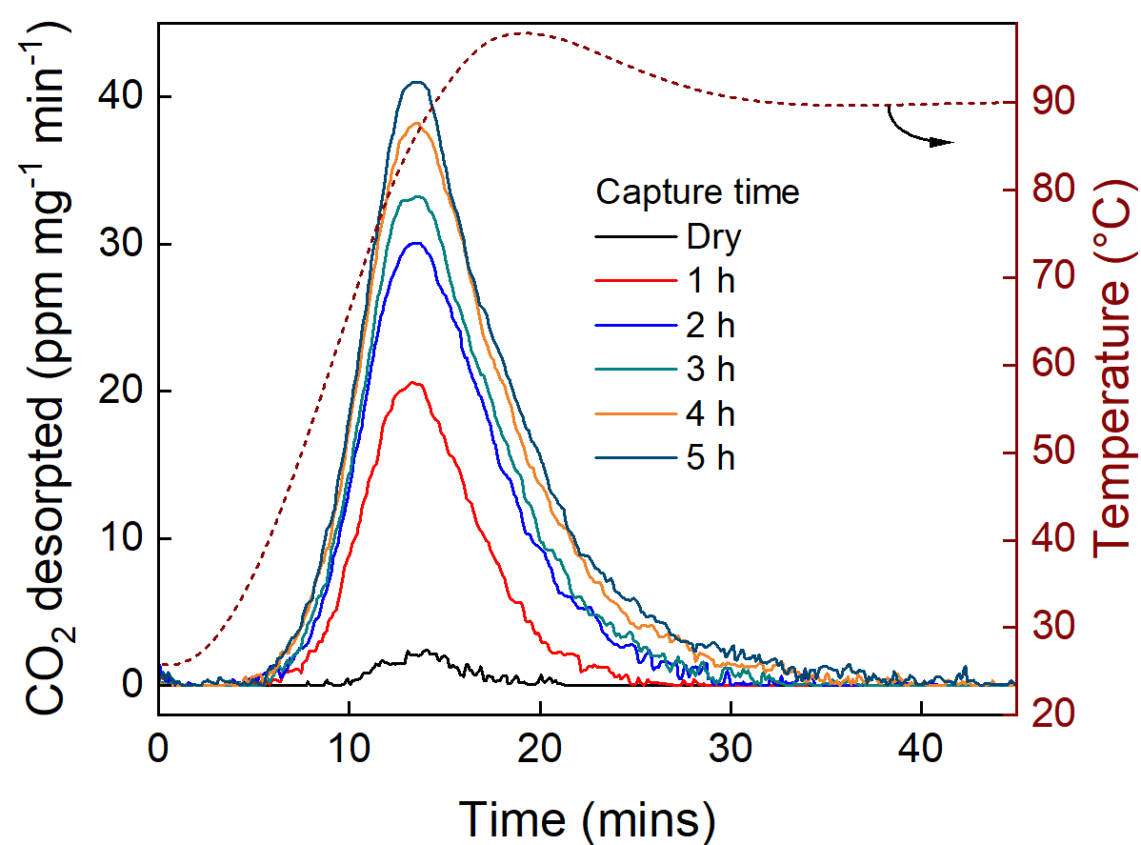
Fig. S26 Concentrations of CO₂ desorbed from the sorbents at different capture time. The desorption was performed using TGA with temperature up to 90 °C, and the released CO₂ concentrations were recorded using a Vaisala CO₂ sensor; A small amount of CO₂ was released from the freshly regenerated sample, which could be attributed to CO₂ captured during sample loading to TGA. With increasing capture time, more CO₂ was released from the sample, suggesting that more CO₂ was captured with long exposure time. It is also found that CO₂ start to desorb at temperatures as low as 40 °C, and the desorption can be completed with temperature below 90 °C, in line with the CO₂ desorption profiles measured by TGA-MS illustrated in Fig. S28. This is a significant reduction in regeneration temperature compared to 900 °C required for metal hydroxide-based sorbent, which is crucial for the deployment of DAC to substantially reduce energy consumption and cost.

Supplementary Figure 27
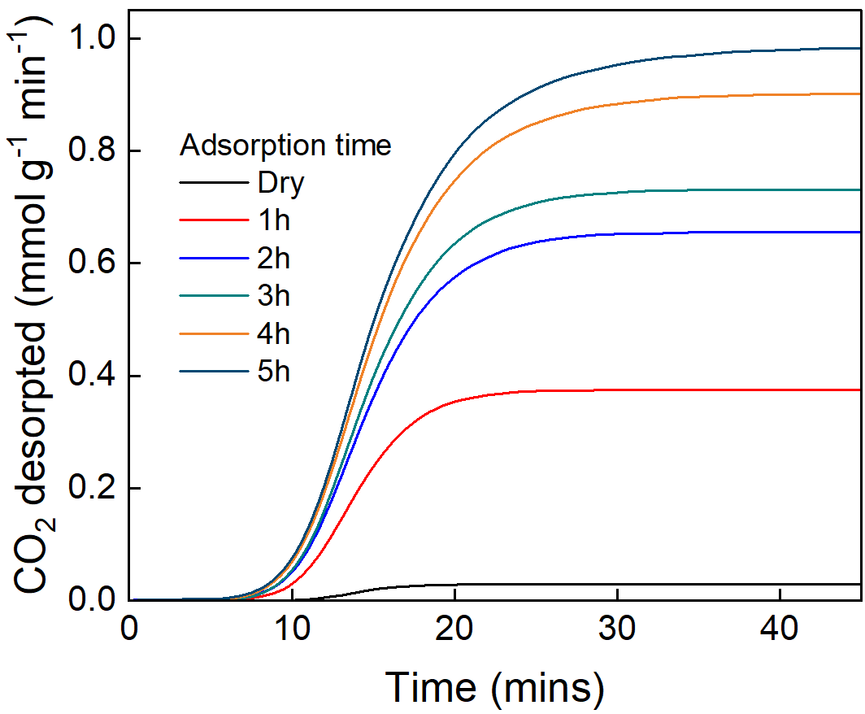
Fig. S27 Accumulated CO₂ concentrations at different capture time. 0.37 mmol g⁻¹ CO₂ was desorbed within capture time as short as 1 h, and almost 1 mmol g⁻¹ (0.98 mmol g⁻¹) CO₂ was released by 5 h adsorption, equivalent to 4.33 wt.% CO₂ captured. This closely matches with the CO₂ uptake as a function of time for 0.5DEA&0.5TEA@SAN accessed using the in-house built DAC instrument, as shown in Fig. S29, suggesting the CO₂ captured can be also readily released by thermal desorption.

Supplementary Figure 28
Fig. S28 TGA-MS analysis to measure the CO₂ desorption temperature for 0.5DEA&0.5TEA@SAN.

Supplementary Figure 29
Fig. S29 CO₂ uptake from the in-house built instrument compared with the amount of CO₂ desorbed from samples being exposed to outdoor ambient air at different durations. The sample used was 0.5DEA&0.5TEA@SAN.

Table S1 The alignment of synthesis for Class IV sorbents with the twelve principles of green chemistry

Movie S1.
Movie S1 “all-in” synthesis of TEA@SAN using triethanolamine (TEA) as the solvent, showing the reaction can be completed within 10 minutes.

Movie S2.
Movie S2 dynamic changes in CO₂ and water concentrations at the inlet and outlet for DEA@SAN

