Supplementary
Insights into the culture of Sicilian Epigravettian populations. Stratigraphy, microscopy and EDS analysis of objects, ornaments, tools and ochre, from USM3 from M Trench in San Teodoro cave (Acquedolci, Messina, Italy)
Gerlando Vita ª,*, Nunziatina Calabrese^{b}, Massimiliana Pinto Vraca^{c}, Arianna Romano^{d},
Mirko Andrea Vizzini^{e}, Luca Sineo^{d}
a,*University of Palermo, Dipartimento di Scienze della Terra e del Mare (DISTEM), Via Archirafi, 22, 90123 Palermo, Italy
bVia Dei Laghi 4, 98070 Acquedolci, Messina, Italy
cVia Montello 16, 98070 Castell’Umberto, Messina, Italy
dUniversity of Palermo, Dipartimento di Scienze e Tecnologie Biologiche, Chimiche e Farmaceutiche (STEBICEF), Palermo, Italy
eGeolab srl, Via de Spuches, Carini, Italy
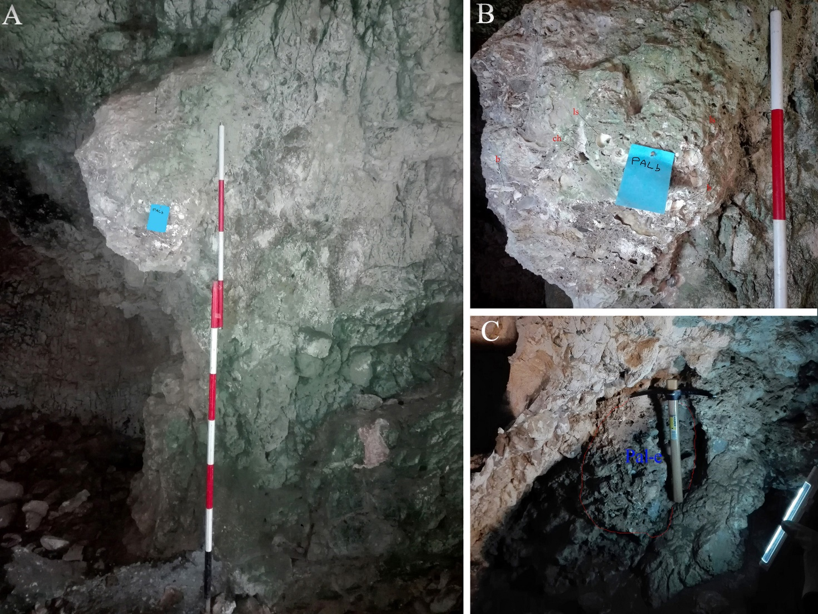
Fig. S1. A. Current height of the breach PALb concerning the present walking surface. B. Detail of the Palb breach showing chipped bones (b), land snails (ls) and charcoals (ch). C. Breccia PALe inside the niche.

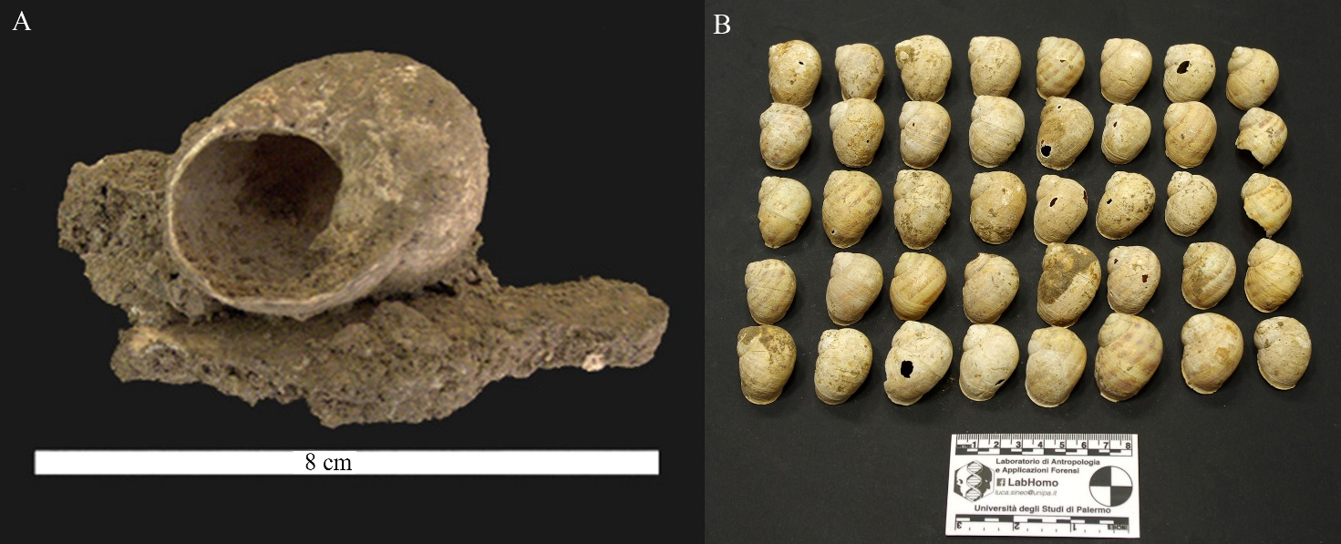
Fig. S2. Land snails found in the Trench M. A. Continental gastropod Cornu aspersum incorporated in a breccia with remains made up of chipped bones, charcoals, and fragments of waste from the lithic artefacts. B. Accumulations of terrestrial molluscs Cornu aspersum inside Trench M, within a deposit originating from meal remains.
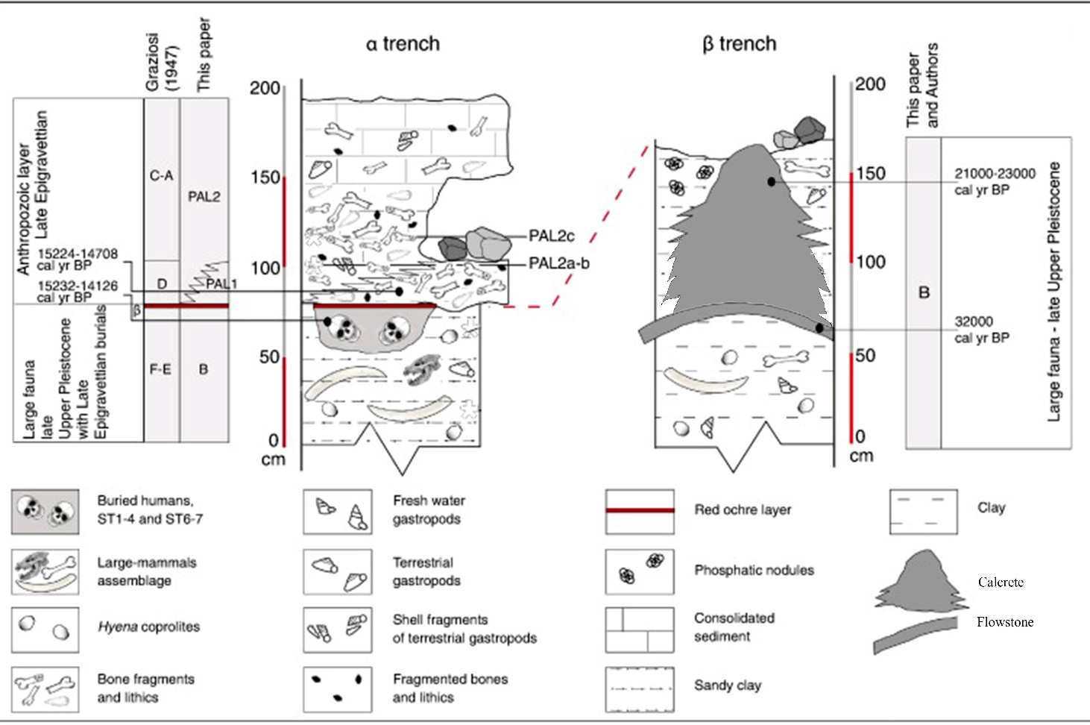
Fig. S3. Section of the San Teodoro Cave deposits (NE Sicily). Stratigraphy is as follows: Late Pleistocene layer with Pleistocene mammal fauna and late Epigravettian human burials; Anthropozoic layers with meal remains (the PAL layer of Garilli et al., 2020a). Garilli et al., 2020 modified

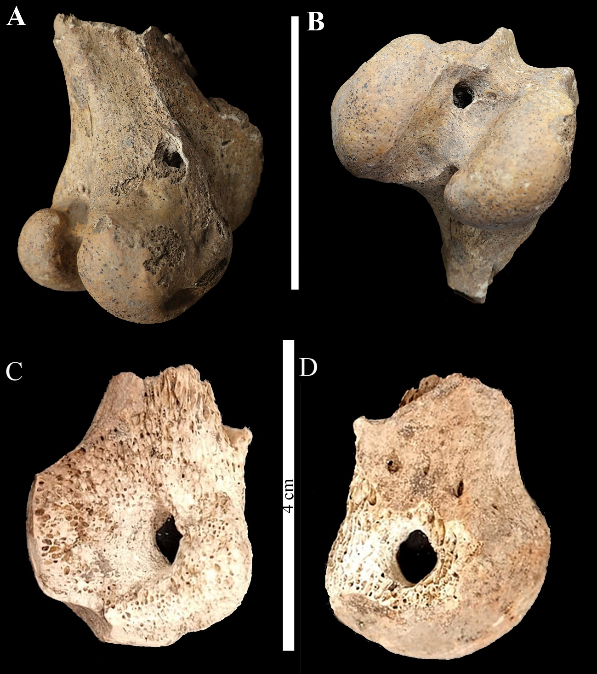
Fig. S4. A. Perforated red deer distal femur, anterior view. B. Perforated red deer distal femur, posterior view (scale bar is 8 cm). C. Perforated femur head of red deer, inferior view. D. Perforated femur head of red deer, superior view.

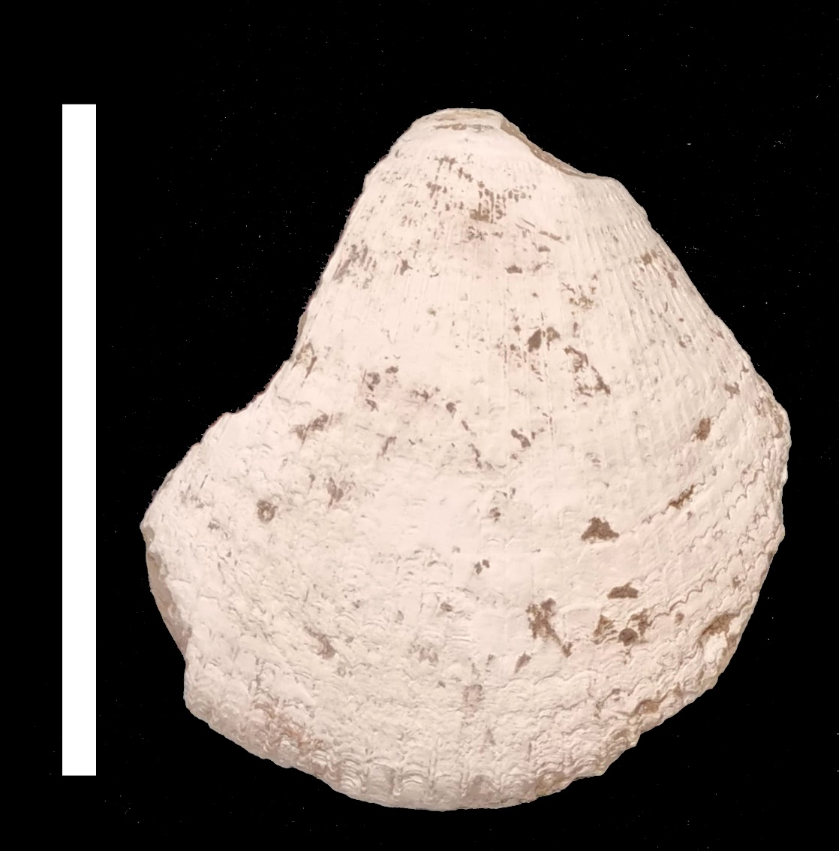
Fig. S6. Fragment of Arctica islandica valve found in trench M. (scale bar is 5 cm).

