Table 3. Cytopathic effects produced by different serotypes
FMDV infected BHK-21 cell line. The infected cells become round and flat (arrow). The intercellular bridge was broken down, and finally the cells were died. CPE increased in long time incubation of infected cells.
Control cells (Uninfected BHK-21 cells) | Serotypes | Cytopathic Effect (CPE) at 100X
Control cells (Uninfected BHK-21 cells) | Serotypes | 36 hours post inoculation | 48 hours post inoculation | 72 hours post inoculation
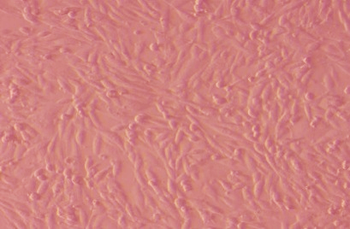 | Serotype O | 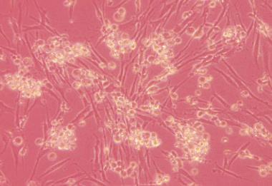 | 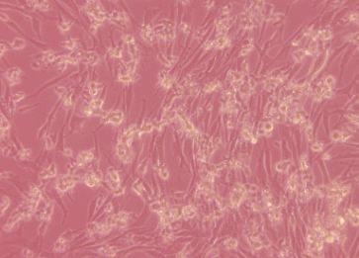 | 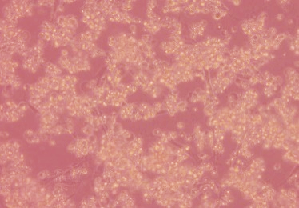
 | Serotype A | 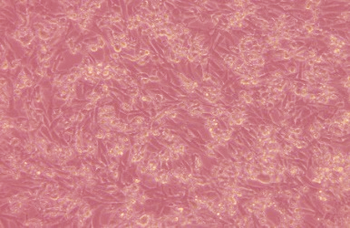 | 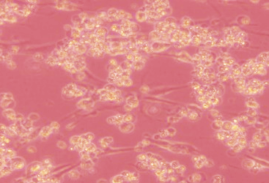 | 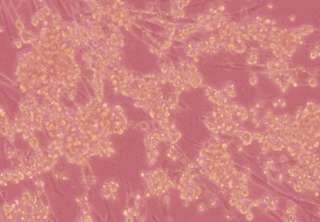
 | Serotype Asia-1 | 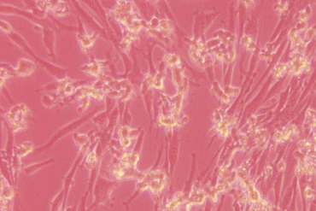 | 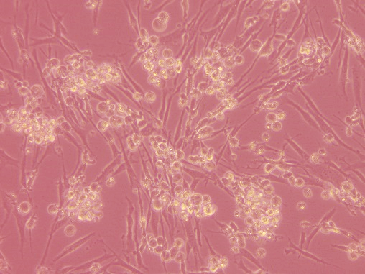 | 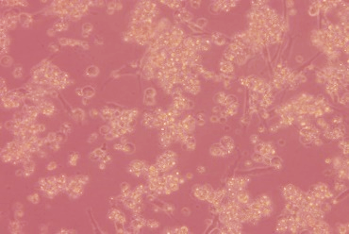
 | Mixed serotypes (O+A) | 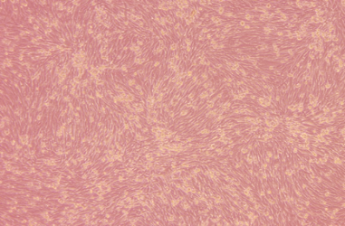 | 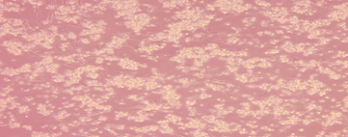 | 