Supplementary sheet

Metagenomic analysis for taxonomic and functional potential of Polyaromatic hydrocarbons (PAHs) and Polychlorinated biphenyl (PCB) degrading bacterial communities in steel industrial soil
Monika Sandhuª, Atish T. Paul^{b} and Prabhat N. Jha^{a*}
ªDepartment of Biological Sciences, Birla Institute of Technology and Science (BITS), Pilani, Pilani
^{b} Department of Pharmacy, Birla Institute of Technology and Science (BITS), Pilani Rajasthan, India
Table S1a and S1b: Barcodes used for sequencing

S.No | Sample ID | Barcode name | Sequences
1 | SO_8116_MGB2 | NB08 | ACGTAACTTGGTTTGTTCCCTGAA
2 | SO_8116_MGB3 | NB09 | AACCAAGACTCGCTGTGCCTAGTT

Table S2: The total number of unassembled and assembled reads used for downstream analyses
S.no | Dataset | MGB-2 | MGB-3
 | bp Count | 539,360,072 bp | 532,031,111 bp
2 | Sequences Count | 275,844 | 193,221
3 | Mean Sequence Length | 1,955 ± 3,850 bp | 2,753 ± 4,578 bp
4 | Mean GC percent | 58 ± 7 % | 58 ± 9 %
5 | Artificial Duplicate Reads: Sequence Count | 0 | 0
6 | Post QC: bp Count | 539,360,072 bp | 532,031,111 bp
7 | Post QC: Sequences Count | 275,844 | 193,221
8 | Post QC: Mean Sequence Length | 1,955 ± 3,850 bp | 2,753 ± 4,578 bp
9 | Post QC: Mean GC percent | 58 ± 7 % | 58 ± 9 %
10 | Processed: Predicted Protein Features | 586,053 | 514,069
11 | Processed: Predicted rRNA Features | 1,450 | 1,531
12 | Alignment: Identified Protein Features | 115,880 | 123,629
13 | Alignment: Identified rRNA Features | 403 | 382
14 | Annotation: Identified Functional Categories | undefined | undefined

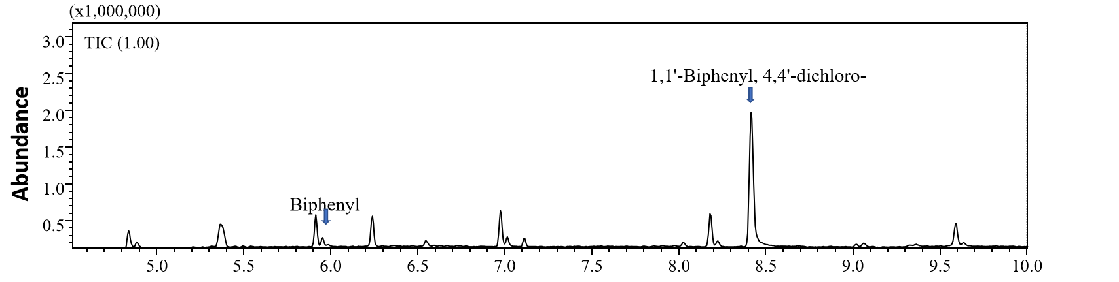
Supplemenatry Fig S1. PCB identified in MGB-2 sample

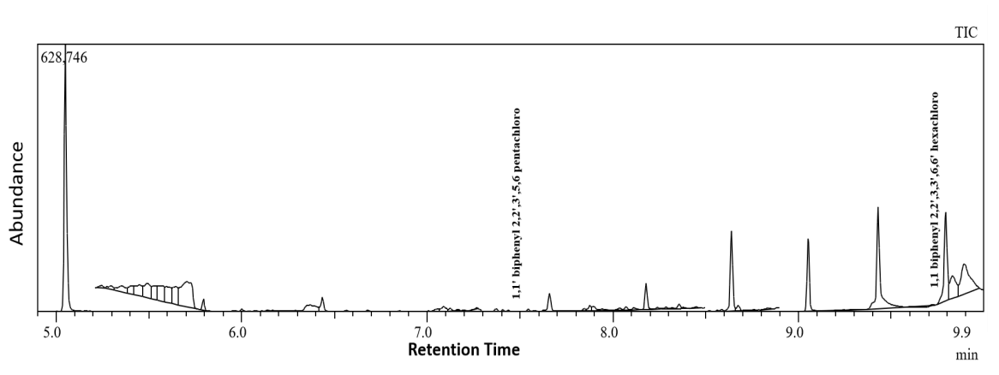
Supplemenatry Fig S2. PCB identified in MGB-3 sample

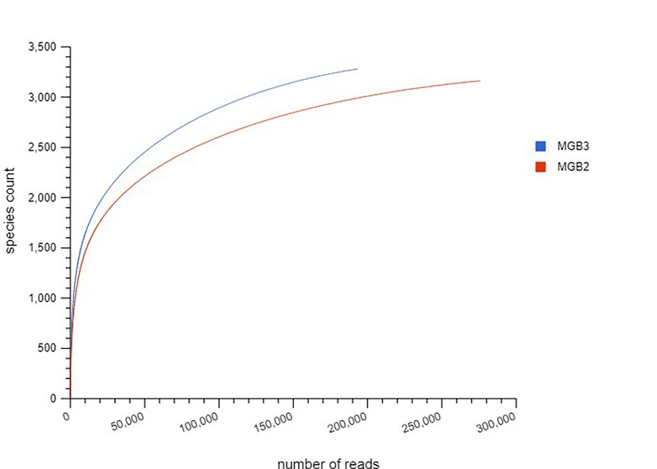
Supplemenatry Fig S3. Rarefaction curverepresented species richness indicating function of number of reads (y-axis) per MGB-2 and MGB-3 (x- axis)

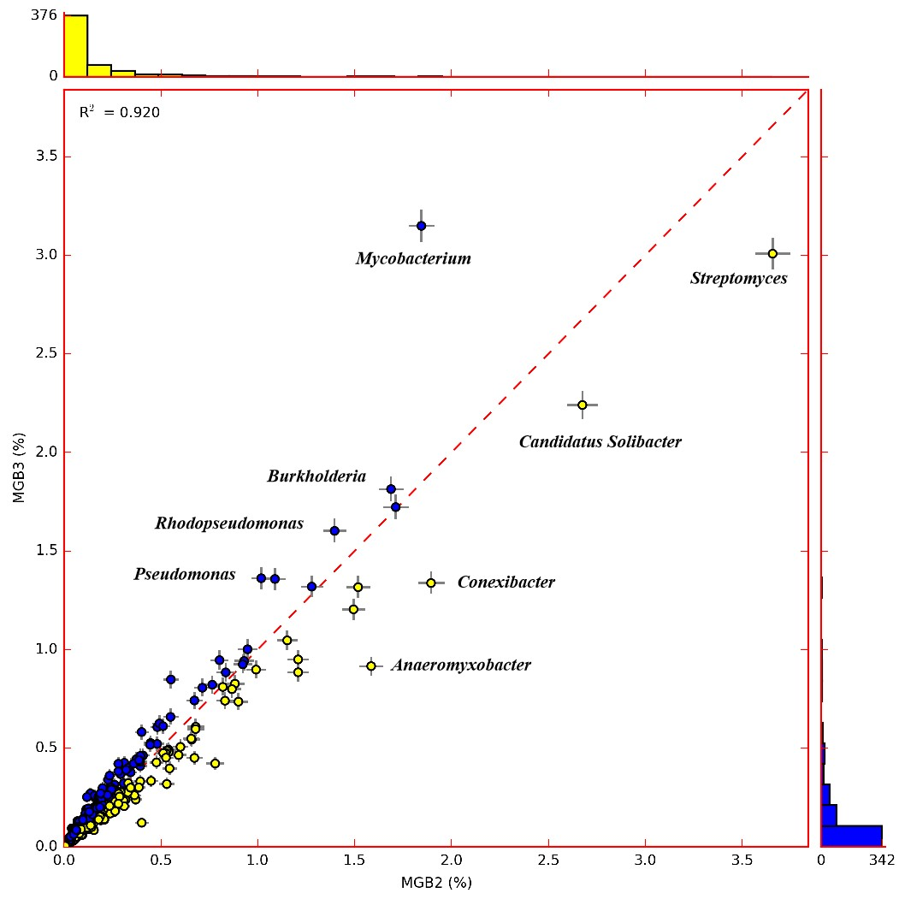

Fig. S4. The scatter plot indicated a linear relationship between MGB-2 and MGB-3

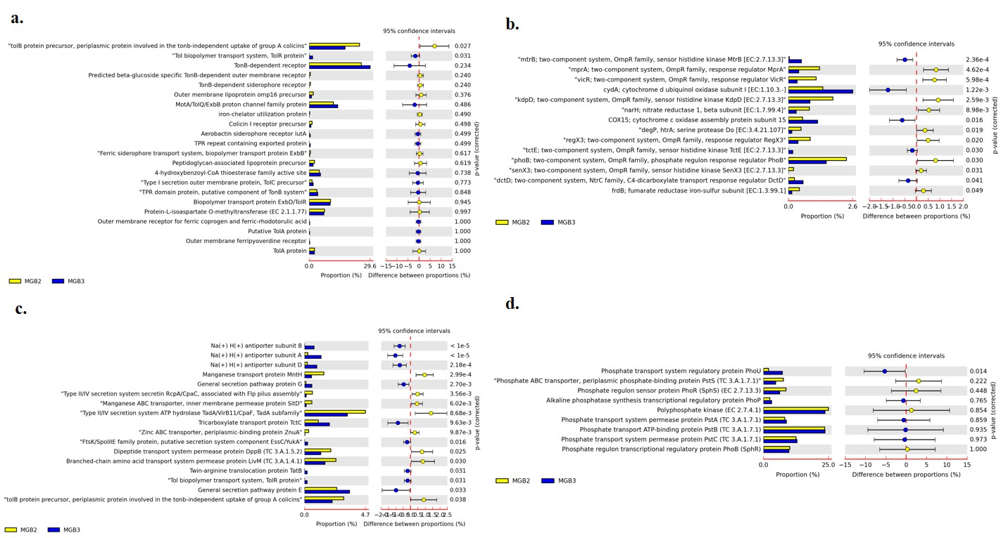 Supplemenatry Fig S5. Comparison between MGB-2 and MGB-3 of functional gene annotation using STAMP using SEED subsystem a.) Tol and Ton b.) two component system c.) membrane transport d.) Phosphate transporter

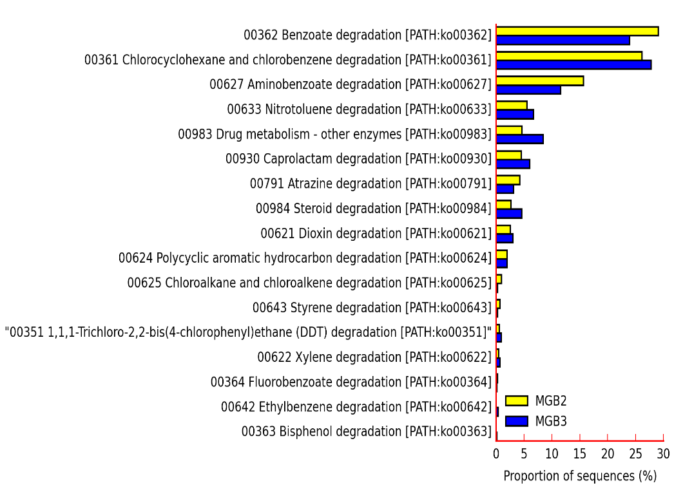

Fig. S6 Annotated pathways for xenobiotic degradation and metabolism accounted for metagenome MGB-2 and MGB-3

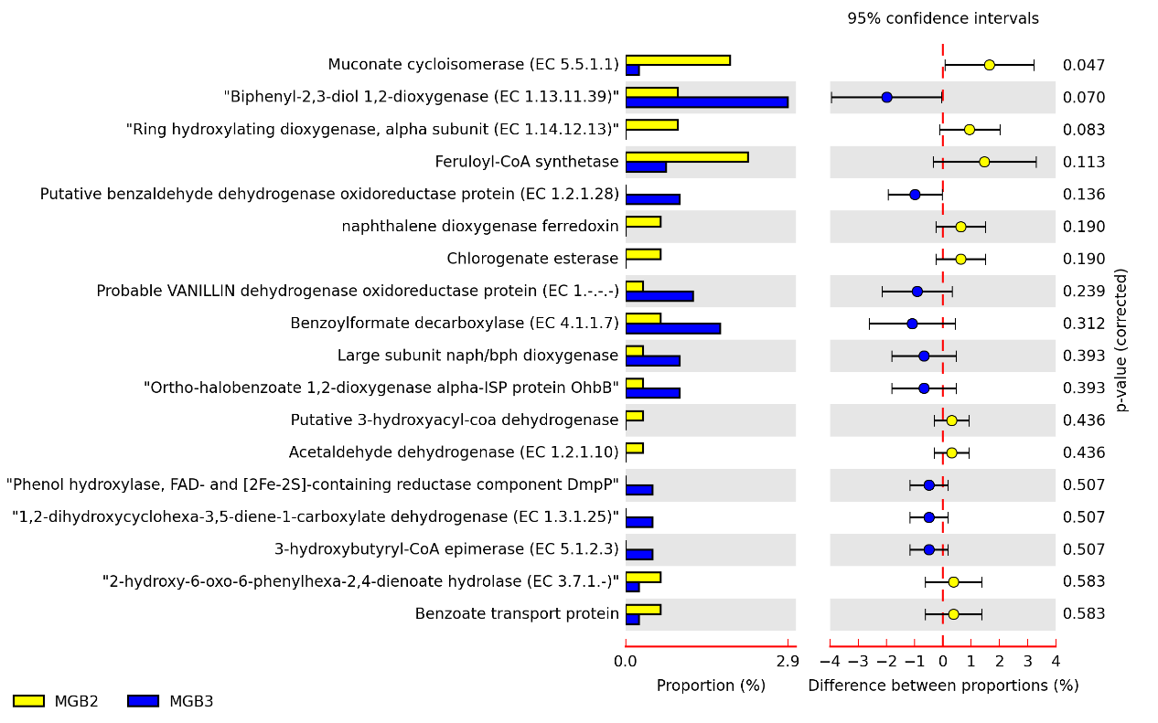

Fig. S7. Comparative analysis of metagenome MGB-2 and MGB-3 based on Peripheral aromatic degradation metabolism at SEED subsystem level by using STAMP
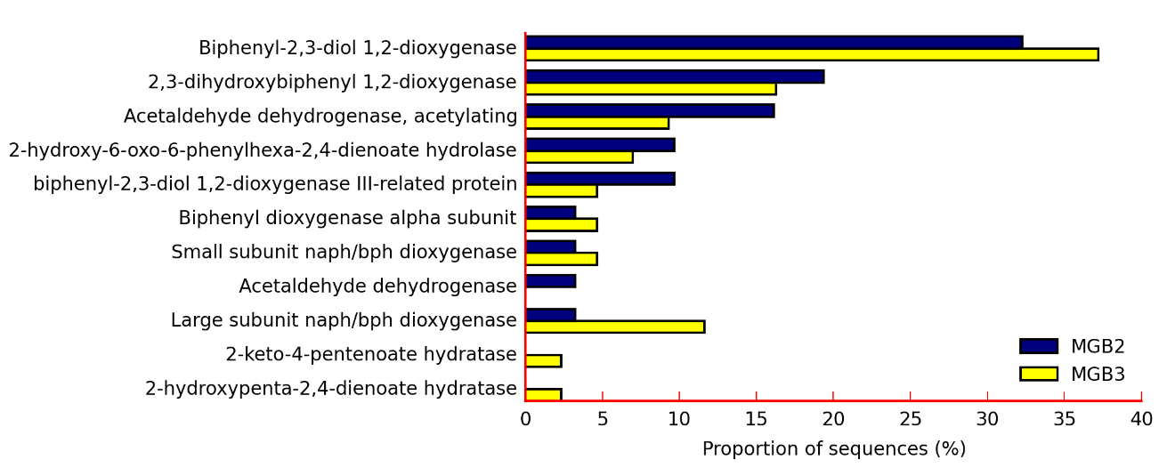
Fig. S8. Comparative analysis of metagenome MGB-2 and MGB-3 based on biphenyl degradation metabolism SEED level by using STAMP

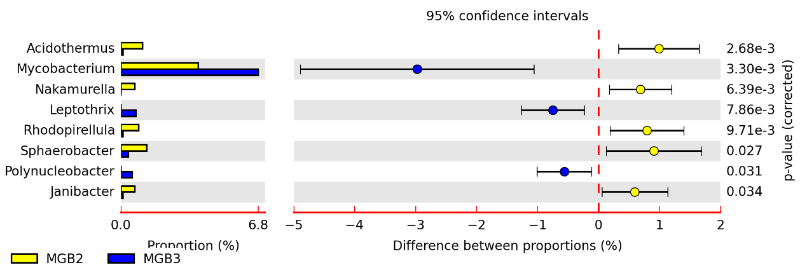 Fig. S9. Comparative analysis of metagenome MGB-2 and MGB-3 based on aromatic degradation metabolism at ReFSeq genus level by using STAMP

