Supplementary Information for:
Scanning phase imaging without stable illumination and scan position information
Tao Liu,¹ Bingyang Wang,¹ Jiangtao Zhao,² Maik Kahnt³, Fucai Zhang^{1,*}
¹Department of Electrical and Electronic Engineering, Southern University of Science and Technology, 1088 Xueyuan Avenue, Shenzhen 518055, China
²ESRF – The European Synchrotron, Grenoble, France
³MAX IV Laboratory, Lund University, 22100 Lund, Sweden
* Corresponding authors: zhangfc@sustech.edu.cn

Calculation of overlap ratio
This paper's overlap ratio is obtained by sequentially computing the overlap ratio of two adjacent waves. The overlap ratio is defined by the area of the overlapped region divided by the total area of two exit waves. We assume that the probe size in all scan positions is identical. The overlapped area is calculated according to the geometric relationship sketched in Fig.1.
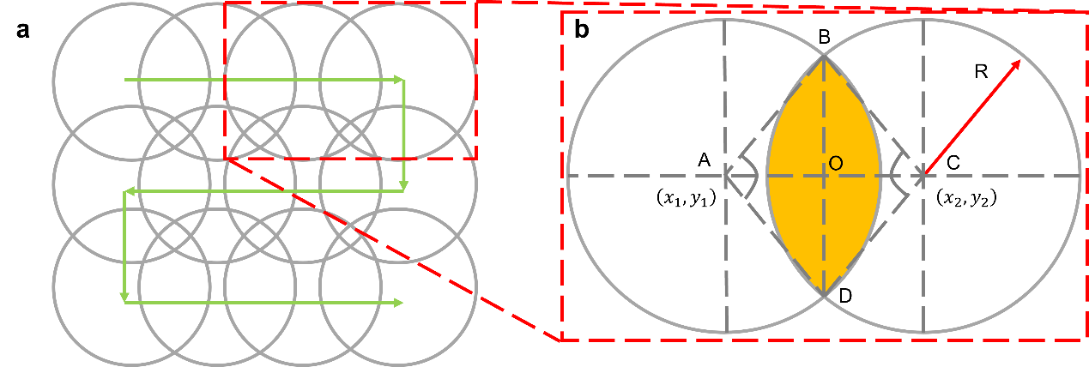
Fig.1 Illustration of overlap ratio calculation. a The scan trajectory in which the green arrows represent the movement vector and the gray circles indicate the region of each exit wave. b Illustration of overlap ratio of adjacent wavefields. The orange area represents the overlapped region of two adjacent exit waves.
The calculation of the overlap ratio of Fig.1 b is detailed as follows:

$$Overlap ratio=\frac{S_{overlap}}{S_{total}} \\ S_{overlap}=2*\left(S_{\hat{BCD}}-S_{△BCD}\right) \\ S_{\hat{BCD}}=\frac{2×∠BCO}{2× π}×π×R^{2} \\ S_{△BCD}=\frac{1}{2}×R^{2}×\sin\left(2×∠BCO\right) \\ ∠BCO=\operatorname{acos}\left(\frac{AC^{2}+R^{2}-R^{2}}{2×R×AC}\right) \\ AC=\sqrt{{\left(x_{1}-x_{2}\right)}^{2}+{\left(y_{1}-y_{2}\right)}^{2}}$$
$$S_{total}=2*πR^{2}-S_{overlap}$$
$$\frac{\sqrt{{\left(x_{1}-x_{2}\right)}^{2}+{\left(y_{1}-y_{2}\right)}^{2}}}{2R}$$
By summarizing the above equations, the final equation of the overlap ratio is stated as follows:$$Overlap ratio=(acos\left(\frac{\sqrt{{\left(x_{1}-x_{2}\right)}^{2}+{\left(y_{1}-y_{2}\right)}^{2}}}{2R}\right)-\frac{1}{2}×\sin\left(2×\operatorname{acos}\left(\frac{\sqrt{{\left(x_{1}-x_{2}\right)}^{2}+{\left(y_{1}-y_{2}\right)}^{2}}}{2R}\right)\right))/(π-\operatorname{acos}\left(\frac{\sqrt{{\left(x_{1}-x_{2}\right)}^{2}+{\left(y_{1}-y_{2}\right)}^{2}}}{2R}\right)+\frac{1}{2}×sin⁡(2×acos⁡(\frac{\sqrt{{\left(x_{1}-x_{2}\right)}^{2}+{\left(y_{1}-y_{2}\right)}^{2}}}{2R})))$$All overlap ratios of our paper are the mean overlap ratio of every two adjacent object waves. For sequentially overlapped scan trajectory, we calculate the overlap ratio of two overlapped waves sequentially and average them. If sequential overlap cannot be guaranteed, we recommend using a specific image recognition algorithm or human intervention to find the overlapped wavefronts and then measure the relative movement with registration techniques.

Imaging experiment eliminating periodic artifacts
For our method, imaging periodic samples should satisfy several conditions. First, the probe size should be smaller than the period of the target periodic structure. Secondly, a sequentially overlapped scan is needed to eliminate the potential ambiguity in positioning. Thirdly, the scan step size should be smaller than the sample period. With these considerations, we conducted imaging experiments on a periodic test sample using our proposed method and conventional ptychography. The phases recovered by both methods are presented in Fig.2 a and b, respectively. Notably, the black circle of Fig.2 b indicates the region of the scan. Results from both methods exhibit a good correlation within this region. The recovered probe shown in Fig.2 e with the size of $1.4μm$ is smaller than the period of sample $2.4 μm$. In addition, Fig. 2 f shows the deliberately randomized scan positions and trajectory that effectively mitigates periodic artifacts. Importantly, the average step size of 646 nm is well below the sample’s period, ensuring robust oversampling.
Apart from the potential artifacts introduced by the sample, the periodic signals inherent to the imaging geometry can also bring misleading artifacts in the recovered image. The imaged area of ptychography in Fig.2 b seems to extend over a larger area than the proposed method; such inconsistency may be attributed to the additional diffraction signal shown in ptychographic diffraction intensity as in Fig.2 d marked by the red box. We deduce that this signal is one of the diffraction orders introduced by the focusing component of the imaging geometry for several reasons. Firstly, the extension only occurs in horizontal and vertical directions, which don’t correlate with the scan trajectory. Secondly, the signal indicates that periodicity exists only in a horizontal direction. Thirdly, even in the averaged diffraction pattern shown in Fig.2 g, the additional diffraction signal still appears, which indicates that the signal is not correlated with the sample. Therefore, we argue that the diffraction order in the diffraction pattern introduced by the KB mirror brings an extra image period. The geometry of the KB mirror is sketched in Fig.2 h. However, our method eliminates such an effect by the random structure of the wavefront modulator, as shown in Fig.2 c.
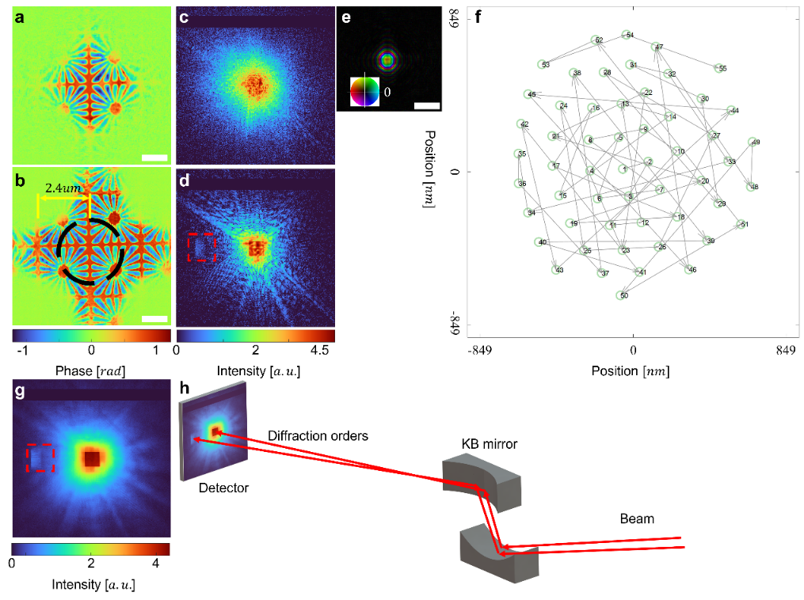
Fig.2 Imaging experiment for periodic sample. a and c The recovered sample function of the proposed method and ptychography, respectively. b and d Exemplary diffraction intensities of our method and ptychography on a logarithmic scale. e The recovered position map of the proposed method. Green dots represent the position of each scan. The red box indicates the diffraction order introduced by the KB mirror. f the averaged diffraction intensity of the ptychographic dataset. g Geometry of focusing component. The scale bar is $1.11μm$.

