TITLE PAGE

Title: An environmental scan of the immigrant-serving sector in Calgary: Core-periphery model
Abstract:
The local context of social services plays a crucial role in the transition and integration of newcomers in new places of settlement. This paper presents a summary of findings from an environmental scan that sought to examine the organizational and service landscape within the immigrant-serving sector, focusing on Calgary, Alberta as the site of study. As findings, we conceptualize Calgary’s immigrant-serving sector via a core-periphery model, whereby a small set of core organizations and service areas are prioritized, rather than more interconnections and diversity. Our preliminary empirical findings point to the sector’s strengths, but also the potential for accessing resources and collaborations that are still untapped. As an exploratory method and first step in a larger practice-based project, this environmental e-scan aims to provide an initial, approximate analysis to then prompt and raise questions for deeper empirical research and applications to practice in the future.

Keywords:
Immigrant; immigrant-serving sector; immigrant organizations; diversity; inclusion; immigrant integration
Author information
Gurleen Kaur Matharuª, Jenalyn M. Ormitaª, Katerina Palovaª & Gonzalez Benson, O. *^{b}
ª TIES Centre for Immigrant Research, Calgary, Alberta, Canada
b University of Michigan, School of Social Work, Ann Arbor, Michigan, USA

*Corresponding Author: Odessa Gonzalez Benson
University of Michigan School of Social Work, 1080 S University Ave, Ann Arbor, Michigan, USA

Statements and Declarations
All authors disclose no financial or non-financial interests that are directly or indirectly related to this research.

An environmental scan of the immigrant-serving sector in Calgary: Core-periphery model

Introduction
Immigrants take complex, dynamic trajectories as they transition, integrate and flourish in places of settlement. In Canada, immigration serves an important role, as it offers an efficient solution to the country’s aging population and resulting labor shortages [1]. Due to Canada’s reliance on immigrants as the main source of population growth, immigrants and permanent residents now account for almost one-quarter of Canada’s entire population - the highest proportion among the Group of Seven (G7) countries [2]. From 2016 to 2021, four-fifths of the labor force growth has been attributed to immigrants, demonstrating the great contributions they offer to Canada’s economy [2].
Calgary in particular is the fourth most common destination for immigrants entering Canada, with immigrants forming 31.5% of the city’s population in 2021 [3,4]. Furthermore, the proportion of immigrants in Calgary is well above the national average of 23% [3]. As these increasing immigration trends are projected to continue well into the future, it is imperative for policymakers, service providers, and other professionals in Calgary to be well-equipped to support immigrant settlement and integration into Canadian society.
In the earliest phases upon arrival, there are myriad organizations that prefigure and contextualize immigrants’ paths. Thus, application and direct relevance to practices in specific contexts of reception, such as Calgary, is warranted. This research study aims to provide an overlay of the immigrant-serving sector in Calgary, serving as an initial, approximate analysis to then prompt and raise questions for deeper empirical research. This study illustrates how organizations and services for immigrants can be understood with a core-periphery model.
Background: Immigrant-serving sector of Calgary
The immigrant-serving sector of Calgary, perhaps as other cities, includes a wide variety of organizations. In this background section, we will first review immigrant integration in Canada more broadly. After, we provide an overview of the organizational context, funding context, and structure and governance context with reference to the hub-and-spoke model.
Immigrant integration
Immigrant integration broadly refers to the interactions between immigrants and their host society [5,6]. By offering services to immigrants, various organizations and governance structures aim to achieve successful immigrant integration, which involves establishing a space in which they feel valued and equipped to engage in the social, political, and economic dimensions of the host society [7,8].
Canada has a voluminous and diverse literature on integration, especially with its multicultural policies [9], official integration strategies [10], and overall positive international reputation regarding immigration [11]. This includes exploring integration in an economic [12] and social [13] sense and focusing on specific immigrant groups such as youth [10], women [14], and racialized populations [15,16]. While some successful integration outcomes are observed among immigrants (namely, greater life satisfaction and mental health) compared to non-immigrants [17], the prevalence of systemic barriers in education, employment, and housing largely remains [15,18], underscoring the need for greater integration efforts from institutional actors.
Organizational context
Immigrant Service Organizations (ISOs). ISOs are the main actors in the settlement sector, as they are publicly funded and contracted for a set of mandated projects once they win competitive grants [19]. ISOs’ three main areas or priorities are settlement, employment, and language, which directly deal with the barriers immigrants face when settling in Canada and enable them to better adapt to Canadian culture. See Figure 1 for the list of ISOs in Calgary.
MSOs: offering mainstream services that are available to immigrants. Mainstream Service Organizations (MSOs), as termed in this paper, are organizations that serve the public at large and do not provide settlement, employment, and language as the three priorities of ISOs, but still provide some services for immigrants. Guo and Guo [1] defined six categories of settlement and integration service providers. ISOs comprise one category and the remaining five categories are MSOs: universal health organizations (i.e., YMCA and YWCA); multicultural organizations (that target immigrants of different cultural and ethnic backgrounds); Ethnicity Based Organizations (EBOs; that target specific immigrant subgroups based on ethnicity or country of origin); faith-based organizations (i.e., The Salvation Army); and special interest groups.
Organizational Networks. Knowledge of the role and impact of ISOs and MSOs on immigrant integration are largely concentrated in Canada’s top immigrant destinations: Toronto, Montréal, and Vancouver [20]. For instance, as the only diverse Canadian city that has fully embraced multiculturalism in various policies and structures, Toronto has a strong network of ISOs with services that recognize and emphasize cultural diversity [21] as well as EBOs and other MSOs established by immigrants themselves [22]. In Montréal, organizations aim to balance integration and intercultural relations by providing French language classes and anti-discrimination initiatives to support the needs of racialized, non-racialized, French-speaking, and non-French-speaking immigrants [23,24]. In Vancouver, like in other cities, ISOs play a particularly important role with language and employment services to combat high costs of living [25]. Given Calgary’s increasing popularity as an immigrant destination, more studies have explored the types of MSOs and their potential role in the immigrant-serving environment [1], however, a clearer illustration of this evolving network is warranted.
Funding context
Government as a source of funding, direction and oversight. The settlement system in Canada depends on the contributions of all levels of government: municipal, provincial, and federal [26]. Rather than providing direct services to immigrants (although there are few exceptions), the government serves as the primary source of funding, direction and oversight for ISOs [26,27].
Immigration, Refugees and Citizenship Canada (IRCC), a department of the federal government, is the largest state funder, driving a large proportion of work done by Calgary’s immigrant agencies [26]. The bulk of all IRCC funding is for language programs: LINC (Language Instruction for Newcomers to Canada) and CLIC (Cours de langue pour les immigrants au Canada) [28]. The Government of Alberta, as a secondary funding source, has increased its involvement in immigration policy through provincial nominations and temporary foreign worker programs [1]. Whereas the provincial government covers areas of need that are not prioritized by federal funding, the City of Calgary, meanwhile, tends to focus more on adopting policies that will facilitate a welcoming environment [1]. For example, the city-level Calgary Local Immigration Partnership is one of 80 IRCC-funded Local Immigration Partnerships in Canada that play a key role in facilitating intersectoral collaboration [29].
Private sector funders. Private foundations, such as Calgary Foundation, offer a variety of funding opportunities through grants with different focuses and scales. Private foundations are a link between the donors and community organizations, serving as a mediator for those with limited access to private donors. Seeking private sponsorship is heavily dependent on each individual organization and its capacity for fundraising, networking with donors and seeking sponsorship opportunities. As demonstrated by the results of this study, there is a greater dependence on governmental and grant-based funding within the immigrant-serving sector in Calgary and a lesser dependence on private entities and sponsorships.
In addition to funders, policies and institutional/organizational culture also facilitate the financial context of immigrant integration in Canada. First, through competitive calls for proposals (CFP) and some mandated programming that is implemented through annual contracts, government agencies and private sector funders specify their priorities and aims, which then incentivizes and prompts organizations’ actions and practices into alignment [30]. Second, policies provide high-level direction, while also facilitating and delimiting operations on the ground through budget and technical determinations, such as requirements for eligibility, documentation and outcome measures [30]. Third, as a more abstract level of governance, institutional/organizational culture refers to the dynamic and symbolic set of discourse, language, practices, representations, and promotions that are set forth by governments and funders [31]. Institutional culture is constituted and forged, both intentionally (top-down) and organically (bottom-up), via traditional media (print or TV), social media, leadership practices, membership practices, and everyday ways of doing work [32,33].

Structure and Governance: Hub-and-spoke model and multi-scalar governance
The governments’ (municipal, provincial, federal) and private sector funders’ provision of structure and guidance for organizations in Calgary’s immigrant-serving sector can be understood as operating through a hub-and-spoke model.
The hub-and-spoke model is a structural network design consisting of hubs, which are central nodes that facilitate connections in a network, and spokes, which are surrounding nodes that provide specialized services in a network [34]. A defining feature of this model is its heightened efficiency compared to multiple duplicated nodes since assigning specific services to certain nodes distributes the pressure that individual nodes would normally face from offering a wide array of duplicated services [35]. As a result, the hub-and-spoke model has been implemented in various industries, such as education [36], healthcare [37], and corporate businesses [38].
In the case of the immigrant-serving sector, the multi-scalar Canadian government, notably at the federal and provincial scales, have implemented a hub-and-spoke model for immigrant placement. As discussed by Elrod and Fortenberry [35], the hub-and-spoke model offers numerous benefits and risks. In addition to greater efficiency, hub-and-spoke models allow for (1) consistent service delivery due to centralized network connections, (2) enhanced quality due to pooled resources at the hubs, (3) enhanced market coverage due to the creation of multiple spokes, and (4) improved agility since different parts of the model can be adapted to address new trends and challenges [35]. The risks, however, include (1) crowding at the hubs, which affects the network’s connectivity, (2) spoke overextension, which results in insufficient connection and inadequate service delivery, (3) lack of autonomy and subsequent dissatisfaction among staff due to the subordination of spokes to hubs, and (4) transportation disruptions such as bad weather or road accidents that prevent connectivity between nodes [35].
For instance, IRCC and British Columbia implemented the hub-and-spoke model in 2015 to resettle Syrian refugees from the Greater Vancouver Area (hub) to other cities within the province (spokes) [39]. This model, which can also apply to other initiatives such as the Provincial Nominee Program (PNP), aims to simultaneously alleviate pressure on large immigrant destinations and address labor shortages in certain sectors (e.g., healthcare) or geographical areas (e.g., rural communities) [39–41].
While the responsibilities across different scales of government may seem clear-cut in theory, the dynamics between governments are much more complex and nuanced, with each level increasing or decreasing involvement over time [1,42]. Municipal governments, for one, play a key role in integration by addressing specific immigrant-related challenges in their jurisdictions [1]. However, their formal role in decision-making is largely limited, with most of the power residing in federal and, more recently, provincial authorities [1,42,43]. Notably, the centralization of federal power over immigration began shifting in the early 2000s, where three issues arose: first, the heightened concentration of immigrants in metropolitan areas; second, increasing income disparities, where immigrants began earning significantly less than the Canadian-born population; third, the need for changes in the labour market in response to increasingly unaffordable housing in metropolitan areas [44].
To address these issues, IRCC introduced the PNP, offering provincial governments (excluding Québec, who is independently responsible for their immigrant-related affairs) greater authority in accepting and fast-tracking immigrants based on their unique labour markets and economic goals [40,44]. This has further changed dynamics between the scales of government, with the federal scale implementing later changes to the PNP to reassert its power (e.g., regaining control over federally funded service delivery programs) and municipal governments taking initiative in immigrant integration by using federal and provincial funding to improve local service delivery [43,44].

Methods: Environmental Scan
This study aims to provide a current understanding of the dimensions and dynamics of the changing and growing immigrant-serving sector in Calgary. This environmental scan is the first step of a larger project intended to ameliorate immigrant services delivery and supports within the city and beyond if appropriate and applicable. Environmental scanning emerged in the field of business as a strategy for organizations to gather and investigate information about their external environment [45,46]. External factors in the environment include but are not limited to, competitors, suppliers, technology, economic conditions, and social and political change. These factors can influence and impact an organization’s stability and future trajectory [46]. Thus, an environmental scan of such external factors can provide valuable information to inform decision-making for the future needs of an organization [46]. While originally used in the field of business, environmental webscans have been used by scholars from various fields, including Al-Tabbaa et al. [47], Fiest et al. [48], Gruno and Gibbons [49], Schaefer et al. [50], and Tian et al. [51]. For our methods, we draw from Turin et al.’s [52] study, wherein researchers used an internet scan to ascertain the current resources available for supporting immigrant health professionals. Ethics, Consent to Participate, and Consent to Publish are not applicable, as the project had no human subjects.

Phase 1: Initial search for ‘known’ ISOs and MSOs
The initial step was to construct a preliminary database of organizations from three existing official lists: (1) IRCC Find Free Newcomer Services Near You list [53], (2) The City of Calgary Organizations to Help You Settle list [54], and (3) Calgary Local Immigration Partnership Newcomer Guide for Service Providers [55]. This initial database, with 75 organizations of 24 ISOs and 41 MSOs, is thus considered as the set of ‘known’ immigrant-serving organizations in Calgary.
Phase 2: Expanded search for non-SPOs serving immigrants
To widen our ‘universe of organizations’, the next step entailed an extended search using three data collection tools: (a) the HelpSeeker website [56], (b) existing online lists of specific organization types, and (c) a structured Google scan. We categorized MSOs into 11 types to target and identify additional MSOs into our sample (See Table 1).
HelpSeeker. HelpSeeker Navigi [56] is a search tool where individuals can search for a range of resources in their district such as mental health, parenting, domestic violence, and housing services. HelpSeeker Navigi network includes over 3,583 services, resources and helplines across Calgary. When conducting our search, 17 HelpSeeker Navigi filters were used to narrow our search by location (Calgary), service (e.g., community) and then by population focus (immigrant/immigrant & refugee). This search produced 20 organizations that were not on the initial three lists.
Existing online lists of specific organization types. The expanded search, focusing on MSOs, also entailed collecting data from existing online lists specific to each MSO type (see Table 1). There were five MSO types for which there were no online lists found: Community, Employment, Legal, Women, and Youth; we thus used a Structured Google Scan as a method for this expanded search, detailed in the subsection below. The religious MSO is an exception whereby we used both an existing online list and a Structured Google Scan because data from the existing online lists primarily included MSOs of Catholic and Christian faith and thus, were not sufficiently exhaustive of Calgary’s religious diversity [57].
Structured Google Scan. The Structured Google Scan followed Turin et al.’s [52] method which used keywords to identify relevant webpages. The search strategy consisted of using the Google search engine and search terms relevant to immigrant-serving organizations. Aiming to prevent bias, searches were conducted in private browsing, with the location on to keep the results specific to Calgary. The landing Google search page and the next 10 pages were screened. Organizations' websites remained the main source of data and inclusion criteria consisted of organizations being relevant to the MSO type, located in Calgary and with service(s) aimed at immigrants. When completing the search for French-speaking organizations, Google language preferences were changed to Français. Data from the Google scan yielded 1,237 MSOs in total.
Sampling
In the first phase, we used all the data (n=75), thus capturing the population from the sources as specified above. The second, expanded search, using the three tools discussed above, generated a total of 1,237 MSOs that were not in the initial list of ‘known’ organizations (see Table 1 for details). Random sampling was conducted to narrow our set of organizations for scanning. For the MSO types that generated a list of more than and fewer than 100 organizations, 5% and 10%, respectively, were randomly selected for scanning (see Table 1). As an exception, Education (K-12) was sampled per quadrant in Calgary. Quadrants with over 100 schools (NW, SW) 5% were randomly sampled, and quadrants with under 100 schools (NE, SE) 10% were randomly sampled. 94 MSOs were included for scanning, out of the total of 1,237 MSOs identified through the expanded search. The organizations that have services aimed at immigrants and newcomers were categorized into the 10 service domains and added to the MSO types of lists. Out of 94 MSOs examined via extended search, only 10 had immigrant services.

Table 1. Online lists for MSOs and details on sampling

Types of MSOs | Existing Online Lists | # of MSOs identified | # of MSOs scanned (with % randomly selected for scanning)
Education K-12 | Calgary Board of Education List, Calgary Catholic School District, Real Estate Calgary, Counsel Scolaire | 439 Total | 32 Total
Education K-12 |  | NW sample- 117 | NW sample - 6 (5%)
Education K-12 |  | NE sample - 88 | NE sample - 9 (10%)
Education K-12 |  | SW sample - 138 | SW sample - 7 (5%)
Education K-12 |  | SE sample - 96 | SE sample - 10 (10%)
Ethnicity Based Organizations (EBOs) | informAlberta.ca  Francophonie Calgary | 42 | 4 (5%)
Health services | Alberta Health Services Facilities List Francophonie Calgary | 67 | 6 (10%)
Higher education | Government of Canada Designated Learning Institute List  Francophonie Calgary | 83 | 8 (10%)
Religious organizations | Canada.Helps.org  Francophonie Calgary | 121 | 6 (5%)
Community  Employment  Legal  Women  Youth  Other | No online lists found; Google search used | 133  61  12  56  79  144

Analysis
The website's mission statements, values, description of service(s) and other online content were coded based on five elements: organizational type, service domains, language capacity, target populations, and online modalities. Coding for the elements were generated inductively or based on the data as a bottom-up approach to coding, rather than theory-based. Three coders coded the data, and questions or discrepancies were discussed and resolved during meetings with the research team. Coding as part of the environmental scan initially entailed examining funders, partners and evaluation or data collection processes, but this data was not readily available for most organizations and so was discontinued.
Methodological limitations
Environmental Webscans present some methodological limitations, thereby calling for nuance and caution when interpreting findings. First, due to the immense number of third-sector organizations in Calgary, our sample is limited, scanning only about 7.5% of all MSOs. However, our systematic, comprehensive approach to sampling for the initial phase and random sampling for the second phase strengthens the reliability of the data. Second, and importantly, data and information presented on websites are not “true” or accurate or complete representations of the real world. That is, the digital or online presence of ISOs and MSOs may not fully capture or represent the scope, range and extent of their services and organizational mission and priorities. Another potential limitation is that some organizations included in the Webscan may still be active but were considered to be passive as they may have changed their names over time. Hence, the findings may not fully capture the scope of available services. Nevertheless, the digital face or outward face of organizations is crucial for immigrants, whose first and most common access to organizations and services is often through the Internet. The online descriptions of services and the ease or difficulty of navigation and access will thus impact whether and how immigrants utilize services. As such, Environmental Webscans, although limited in capturing organizations in full, are informative insofar as it illustrates information that is in fact available to immigrants.

Results
Service domains: Most and least prioritized
Findings suggest that ISOs provide services in nine domains: Employment, Settlement, Culture and Community, Language, Education, Employment, Housing, Mental Health, Health, and Translation and Interpretation. Employment and settlement jointly account for about three-fifths of all services. These two services address the most critical aspects of newcomer settlement in Canada: securing employment and meeting basic needs, such as finding housing [58]. The least common service domains of ISOs were ‘translation and interpretation’ (2.5% of all services) and ‘health and mental health’ (3.1% of all services), which highlights a significant gap in service provision. ISOs are focused on addressing newcomers’ immediate basic needs; however, newcomers experience various health and mental health challenges throughout their settlement journey such as stress and isolation [59]. If newcomers' well-being is unaddressed this can undermine their integration process. A reduced focus on translation and interpretation may be due to funding limitations but can be useful when newcomers need language support to navigate systems in Canada.
Organizational dynamics: ISOs and MSOs
Analysis of the 75 organizations included in our final sample is based on the two types of immigrant-serving organizations: ISOs, as organizations that primarily serve immigrants, and MSOs, as organizations whose services are available to the public in general but may have services targeting immigrants.
ISOs. Data reveals 24 ISOs in Calgary’s immigrant-serving sector. Importantly, findings reveal that out of the 24 ISOs, only eight of them conducted 78% of all services (see Figure 1). The prominence of these eight ISOs reflects power dynamics within the sector, as funding and representation are concentrated among a limited number of organizations. Additionally, the eight organizations are situated in certain geographic areas, with the majority located in the Southeast and Northeast regions of Calgary.

Figure 1. Distribution of immigrant services among 24 Immigrant Service Organizations (ISOs)
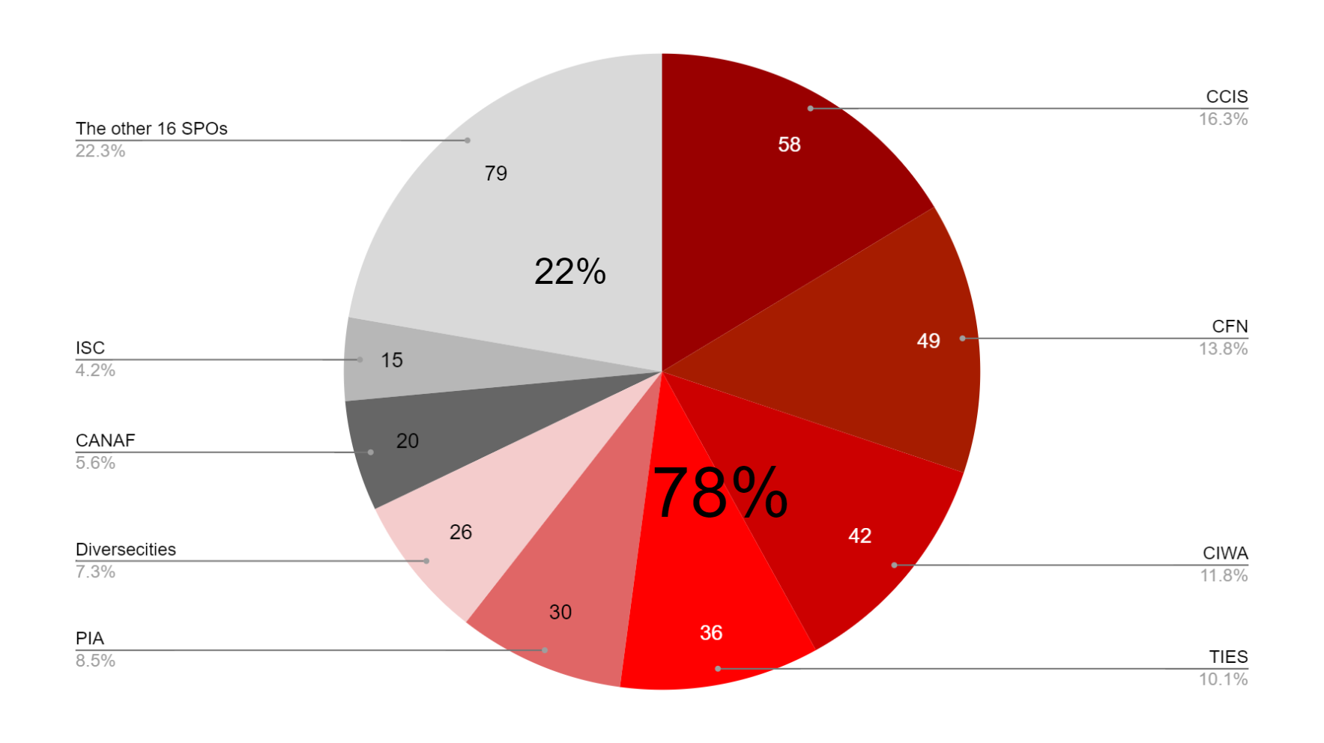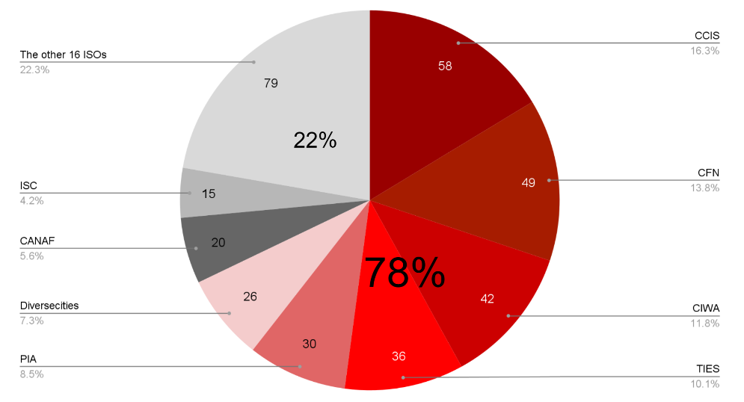
Note. ISC: Immigrant Services Calgary; CANAF: Centre d’accueil pour nouveaux arrivants francophones; PIA: Portail de l’immigrant Association; CCIS: Calgary Catholic Immigration Society; CFN: Centre for Newcomers; CIWA: Calgary Immigrant Women’s Association; TIES: The Immigrant Education Society.

MSOs. Eleven types of MSOs were used as an analytical framework, detailed in Figure 2. Out of 94 MSOs included in the expanded web scan search, only 9% provide services that specifically target newcomers. MSOs are organizations that could provide targeted services for immigrants, but findings suggested that only a small fraction are doing so. This includes 10 MSOs of four types: Ethnicity Based Organizations (n=4), K-12 Schools (n=2), Health (n=2), and Women (n=2).

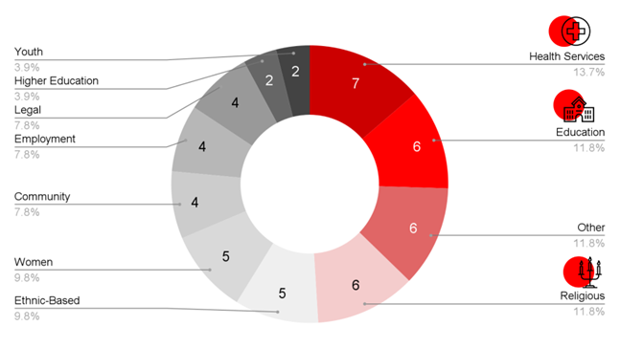
​​Figure 2. 11 types of MSOs
​​​​Language capacity
Based on 24 ISOs and 51 MSOs, more than half of all English-speaking ISOs (54.2%) and MSOs (66.7%) did not specify language capacity at all in their websites. Only about one in five organizations specified services available in specific languages other than English—25% for ISOs and 17.6% for MSOs. Following that, 20.8% of ISOs and 15.7% of MSOs mentioned capacity for language-specific services without detailing what languages they are able to offer. This may indicate that organizations are not fully utilizing or communicating their multilingual capabilities, or that there is a limited number or no multilingual services available for newcomers. Moreover, these findings perhaps reflect a wider systemic issue where Canada’s official languages (English and/or French) are being prioritized [60].

Target population
Of the 24 ISOs and 51 MSOs examined, 77 services specified target populations, with youth (18.2%) as being the most common (see Figure 3). For gender, women (10.4%) were more targeted in specified services, compared with LGBTQIA+ (1.3%) and other genders (unspecified in any services scanned). The focus on women and youth may suggest that they are more in need of targeted support compared to other groups. A potential gap in service provision is highlighted by the limited number of services specifically available for the LGBTQIA+ newcomer community, which raises concerns about inclusivity [61]. Regarding race, ethnicity or country of origin, more services were targeted to specific groups based on ethnicity or country of origin (10.4%) rather than race (5.2%). Services are designed with a cultural approach in mind and provide targeted support based on ethnic backgrounds or national identity. However, those from racialized backgrounds might be underrepresented in the services available. In terms of class or profession, professional or skilled immigrants were notably prioritized and targeted with specified services (7.8%). The greater focus on skilled or professional immigrants may reflect Canada’s immigration ethos, which prioritizes attracting economic migrants, i.e., immigrants selected based on their ability to contribute to Canada’s economy [62]. Nonetheless, this emphasis neglects other newcomer groups, such as those with lower skills and those who require additional support. While these findings detail the target populations of 77 target populations, some overlap between categories may exist beyond what was explicitly stated in the organization’s service descriptions (e.g., a service for Muslim women may be both ethnic and gender-based). In other words, our classification depended on the primary focus of the organization.

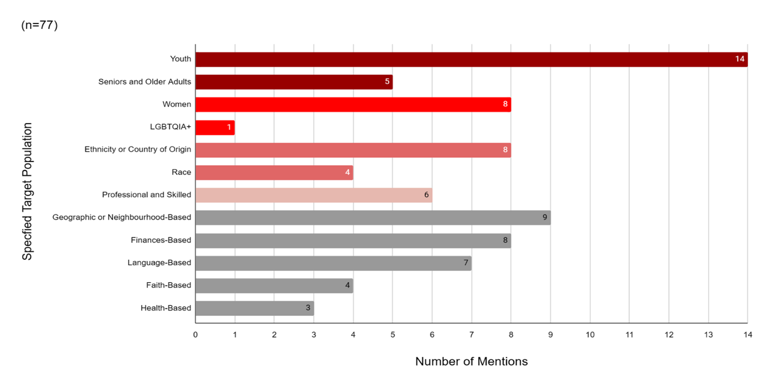
Figure 3. Target populations. ISO and MSO population categories

Online modality
Findings suggest that ISOs have three types of online delivery formats: (1) e-learning, where classes and services are delivered online, (2) hybrid, where classes and services are delivered both online and in-person, and (3) temporary, which refers to classes and services that had been preliminarily moved online due to COVID-19. Based on 24 ISOs, 62 services from these organizations specified their delivery format: 28 services were provided through e-learning, 16 services were provided through a hybrid format, and 18 services were temporarily moved online. These various delivery formats demonstrate ISOs' adaptability to respond to the diverse needs of newcomers and ensure continued support during the COVID-19 pandemic. E-learning or hybrid can benefit newcomers with additional commitments such as caring for children or work [63]. The hybrid model is likely a long-term digital strategy, and is increasingly in demand, especially in the Language Instruction for Newcomers to Canada (LINC) program [63].
Discussion
Core-Periphery in Calgary’s immigrant-serving sector: Highlighting issues of power
As a concluding theoretical point, we argue that our empirical results and insights point to issues of power and contestation (as detailed below). We further argue that Canada’s immigrant-serving sector is better described or conceptualized via a core-periphery model, vis-à-vis a hub-and-spoke model previously theorized and analyzed in existing scholarship. The hub-and-spoke model, as discussed in the background section, helps consider the connections and networked institutionality of public entities and nonprofit/ private entities in supporting immigrants. However, the hub-and-spoke model fails to sufficiently take into account and give consideration to issues of power that are inherent and constitutive of such connections and networks of governance.
A core-periphery model describes a decentralized structure without formal central authority, yet it remains centered around a core, resulting in peripheral positions [64]. The core is where decision-making, capital, and resources are concentrated, whereas the peripheral is typically less developed and has fewer resources [65]. A core-periphery model is based on the ‘galactic’ structure which has been used to analyze nations, collective action, and economic development [66,67]. The core-periphery model has been used in various fields to explain patterns of inequality and unbalanced socioeconomic development [64]. For example, a study exploring the economic interdependence between European countries applied the core-periphery model to understand the trade imbalance between have and have-not European countries. Germany was described as the core of the Eurozone, whereas Greece, Italy, Portugal and Spain represented the periphery [68].
We draw from that literature on development and apply the core-periphery model as a framework to the immigrant-serving, public-nonprofit/private sector, in presenting our findings [67]. This model can characterize Calgary’s immigrant-serving sector as its structure is largely decentralized with no formalized central authority. Nevertheless, the immigrant-serving sector functions with a core through which both the core and periphery are informally created and yield material impacts [67]. We illustrate below how a small set of organizations and services are core, while others are peripheral. These findings, drawn from online spaces rather than on-the-ground environments, raise important questions for future empirical research.
The core-periphery model is evidenced by the findings that eight ISOs conducted approximately 78% of all services for immigrants out of 16 ISOs, and only four of those eight ISOs conducted about half (52%) of all services. Further, our findings point to other actors—MSOs and EBOs specifically—that provide targeted services and programming for immigrants yet are peripheral to ISOs that are regarded as core institutions.
The centrality and visibility of these core players denote power dynamics within the sector, as funding and representation are concentrated amongst a small set of organizations, as well as in concentrated geographies and for prioritized domains of service (as discussed further below). It is not surprising that a handful of well-established organizations hold more power and dominate the settlement sector in Calgary, and our study thus lends further evidence [69]. Consequently, smaller organizations are likely to struggle to grow and develop, as they must compete with larger organizations for funding. Additionally, settlement patterns are shifting with newcomers settling in different locations beyond traditional settlement hubs. The current locations of ISOs may leave newcomers in secondary destinations without adequate access to services [69].
MSOs as peripheral organizations
Meanwhile, with regards to MSOs, only 9% of all scanned MSOs were found to offer services targeting immigrants, highlighting their unfulfilled role in services that address needs based on the intersectional identities of newcomers. Peripheral organizations are mainstream service organizations (MSOs) that do not primarily serve newcomers and only deliver one or two of ISOs’ three priority service areas. MSOs encompass the broader nonprofit sector and are vital to the immigrant-serving sector, but findings illustrate that they do not target immigrants with specific programming.
Ethnicity-Based Organizations (EBOs) emerge as untapped resources
EBOs emerged as untapped resources. Out of all MSOs, EBOs have the greatest proportion of services (75%) targeting newcomers, according to the findings. That is, out of all the mainstream organizations scanned in our study, EBOs were the organizations that offered more targeted programming for immigrants. Future research is needed on this, to better understand EBOs’ role in immigrant services, as our environmental scan yielded only preliminary data about the presence of services, thus lacking depth.
This insight into the potential of EBOs aligns with existing studies which have revealed that mainstream organizations have challenges in connecting with ethnocultural communities and developing deeper cultural understandings [70]. EBOs could potentially fill this gap as community-based entities that have close connections with newcomer communities [58,71]. EBOs may appear different and lack the scientific expertise of formal institutions, but they possess cultural expertise and knowledge that is valuable and necessary to address community needs [72]. EBOs may also assist organizations with services and outreach initiatives that are effective as well as linguistically and culturally relevant for newcomers [73]. For example, EBOs often share the same language and cultural background as newcomers. While they may be recognized and utilized by newcomers, EBOs are often dismissed as active players in the immigrant-serving sector [71]. A study by Gonzalez Benson [74] explored the disruption in organizational relations between mainstream and grassroots organizations caused by the COVID-19 pandemic. This disruption led to grassroots organizations being recognized as valuable players that possess critical cultural knowledge, that can benefit mainstream organizations. Our findings regarding EBOs services lend further evidence to their relative invisibility within Calgary’s immigrant-serving sector. Consequently, EBOs remain an underutilized resource and there is a need for further collaboration between ISOs, MOs and EBOs to holistically and effectively meet the needs of newcomers.
Implications and Conclusion
Intersectionality is a concept that can be applied to findings, insofar as mainstream organizations (MSOs) such as schools and health organizations serve the general public yet, also offer targeted programming for immigrants to address their intersectional needs. In other words, our findings provide case examples of mainstream organizations addressing complex identities of newcomers in service provision (intersections of gender, disability, religion, etc.). While our findings speak to this, our findings also clarify that only a fraction—9% of all mainstream organizations scanned—offered targeted programming for immigrants. Thus, our findings point to the need for greater application of intersectionality into policy and practice. To address the needs of newcomers from an intersectional perspective, tailoring services to specific groups would enhance effectiveness, as different positionalities and identities bring unique experiences and needs which are impacted by structural factors.
Our findings also point to the need to address unequal access, in terms of geography and domains of service. First, our findings show unequal access to services since organizations scanned operate in concentrated geographies or locations for newcomers. For example, the eight organizations delivering the majority of services primarily operate in the Southeast and Northeast of Calgary, which is beneficial given the large newcomer populations in these areas, but newcomers are increasingly settling in areas beyond traditional settlement hubs. For instance, children gain additional targeted support when enrolled in K-12 schools with immigrant-specific services, compared with those enrolled in schools without such services. Second, our findings also call for increased funding and attention to services in less prioritized domains, translation and interpretation services, and health and mental health. Attention to health and mental health is significant, as this can negatively impact newcomers' integration process. Additionally, translation and interpretation can support newcomers in navigating Canadian systems. For example, in a health and mental health context, the presence of a translator can reduce misdiagnosis and improve treatment outcomes [75]. Immigrant-serving organizations should refrain from over-prioritizing some services (particularly employment) at the expense of service provision that is more holistic, strategic, sustainable, and therefore more effective.
Finally, our findings warrant that policy and practice attend to issues of power dynamics and complex relations among organizations, given the competitive and funding-driven context of service provisions.

Funding Declaration: This project was funded by the Calgary Local Immigrant Partnership.
Ethics, Consent to Participate, and Consent to Publish declarations: Not Applicable.

References
1 Guo S, Guo Y. Immigration, Integration and Welcoming Communities: Neighbourhood-based Initiative to Facilitate the Integration of Newcomers in Calgary. Can Ethn Stud. 2016;48(3):45–67. https://doi.org/10.1353/ces.2016.0025
2 Statistics Canada. The Daily — Immigrants make up the largest share of the population in over 150 years and continue to shape who we are as Canadians [Internet]. 2022 [cited 2025 Apr 4]. Available from: https://www150.statcan.gc.ca/n1/daily-quotidien/221026/dq221026a-eng.htm
3 Statistics Canada. Profile table, Census Profile, 2021 Census of Population - Calgary, City (CY) [Census subdivision], Alberta [Internet]. 2022 [cited 2025 Apr 4]. Available from: https://www12.statcan.gc.ca/census-recensement/2021/dp-pd/prof/index.cfm?Lang=E
4 The City of Calgary. Welcome to Calgary [Internet]. https://www.calgary.ca. [cited 2025 Apr 4]. Available from: https://www.calgary.ca/content/www/en/home/communities/newcomers.html
5 Penninx R. Problems of and solutions for the study of immigrant integration. Comp Migr Stud. 2019 Apr 16;7(1):13. https://doi.org/10.1186/s40878-019-0122-x
6 Schunck R. Immigrant Integration. In: Schunck R, editor. Transnational Activities and Immigrant Integration in Germany: Concurrent or Competitive Processes? Cham: Springer International Publishing; 2014. p. 9–41. https://doi.org/10.1007/978-3-319-03928-2_2
7 Li PS. Deconstructing Canada’s discourse of immigrant integration. J Int Migr Integr. 2003 Sep;4(3):315–33.
8 Walton-Roberts M. Regional Immigration and Dispersal: Lessons from Small- and Medium-Sized Urban Centres in British Columbia. Can Ethn Stud. 2005 Jan 1;37:12–34.
9 Berry JW. Research on multiculturalism in Canada. Int J Intercult Relat. 2013 Nov 1;37(6):663–75. https://doi.org/10.1016/j.ijintrel.2013.09.005
10 Kaufmann L. Integration in Canada: A systematic review of the youth experience. Int J Intercult Relat. 2021 Sep 1;84:52–64. https://doi.org/10.1016/j.ijintrel.2021.06.010
11 May P. Immigration, Multiculturalism and Tolerance: Canada’s Two Images. In: Assessing Multiculturalism in Global Comparative Perspective. Routledge; 2022.
12 Hum D, Simpson W. Economic Integration of Immigrants to Canada: A Short Survey. Can J Urban Res. 2004;13(1):46–61.
13 Wong LL, Tézli A. Measuring Social, Cultural, and Civic Integration in Canada: The Creation of an Index and Some Applications. Can Ethn Stud. 2013;45(3):9–37. https://doi.org/10.1353/ces.2013.0039
14 Nardon L, Hari A, Zhang H, Hoselton LPS, Kuzhabekova A. Skilled immigrant women’s career trajectories during the COVID-19 pandemic in Canada. Equal Divers Incl Int J. 2021 Jun 3;41(1):112–28. https://doi.org/10.1108/EDI-09-2020-0255
15 Agyekum B, Siakwah P, Boateng JK. Immigration, education, sense of community and mental well-being: the case of visible minority immigrants in Canada. J Urban Int Res Placemaking Urban Sustain. 2021 Apr 3;14(2):222–36. https://doi.org/10.1080/17549175.2020.1801488
16 Kyeremeh E, Arku G, Mkandawire P, Cleave E, Yusuf I. What is success? Examining the concept of successful integration among African immigrants in Canada. J Ethn Migr Stud. 2021 Feb 17;47(3):649–67. https://doi.org/10.1080/1369183X.2019.1639494
17 Berry JW, Hou F. Immigrant acculturation and wellbeing in Canada. Can Psychol Psychol Can. 2016;57(4):254–64. http://dx.doi.org/10.1037/cap0000064
18 Kaushik V, Drolet J. Settlement and Integration Needs of Skilled Immigrants in Canada. Soc Sci. 2018 May;7(5):76. http://dx.doi.org/10.3390/socsci7050076
19 Immigration, Refugees and Citizenship Canada. Glossary [Internet]. 2021 [cited 2025 Apr 4]. Available from: https://www.canada.ca/en/services/immigration-citizenship/helpcentre/glossary.html
20 Hyndman J, Schuurman N, Fiedler R. Size matters: Attracting new immigrants to Canadian cities. J Int Migr Integr Rev Integr Migr Int. 2006 Dec;7(1):1–25.
21 Tossutti LS. Municipal Roles in Immigrant Settlement, Integration and Cultural Diversity. Can J Polit Sci Can Sci Polit. 2012 Sep;45(3):607–33.
22 Owusu TY. The Role of Ghanaian Immigrant Associations in Toronto, Canada. Int Migr Rev. 2000 Dec 1;34(4):1155–81. https://doi.org/10.1177/019791830003400404
23 Moing AL. Montreal’s Community Organizations and Their Approach to Integration: A System Within a Dual System. Humans. 2025 Mar;5(1):7. https://doi.org/10.3390/humans5010007
24 Chiasson M. A clarification of terms: Canadian multiculturalism and Quebec multiculturalism [Internet]. [cited 2025 Apr 4]. Available from: https://canadianicon.org/wp-content/uploads/2014/03/TMODPart1-Clarification.pdf
25 Huot S, Brower J, Tham A, Yekta AR. Cultivating social occupations, spaces, and networks: service providers’ perspectives on enabling immigrants’ social participation. Cad Bras Ter Ocupacional. 2021 May 7;29:e2184. https://doi.org/10.1590/2526-8910.ctoAO2184
26 Suva C, Palova K. Emotional Wellness, Varied Immigrant Settlement Programming in Western Canada and Service Responsiveness. In: Arrocha W, Xeni E, editors. Migrations and Diasporas. Emerald Publishing Limited; 2023. p. 185–200. https://doi.org/10.1108/978-1-83797-146-620231012
27 Au A, Silversides H, Suva C, Palova K, Goopy S. “Language alludes to everything”: A pilot study on front-line worker experience with newcomer integration. J Stud Res. 2021 Mar 31;10(1).
28 Immigration, Refugees and Citizenship Canada. Mandate - Immigration, refugees and citizenship Canada [Internet]. 2024 [cited 2025 Apr 4]. Available from: https://www.canada.ca/en/immigration-refugees-citizenship/corporate/mandate.html
29 Calgary Local Immigration Partnership. What we do [Internet]. [cited 2022 Nov 6]. Available from: https://www.calgarylip.ca/what-we-do
30 McGrath S, McGrath I. Funding matters: The maze of settlement funding in Canada and the impact on refugee services. Can J Urb Res. 2024;22(1):1-20.
31 Schmidt VA. Discursive Institutionalism: The Explanatory Power of Ideas and Discourse. Annu Rev Polit Sci. 2008 Jun 15;11(1):303–326. https://doi.org/10.1146/annurev.polisci.11.060606.135342
32 Gochhayat J, Giri VN, Suar D. Influence of Organizational Culture on Organizational Effectiveness: The Mediating Role of Organizational Communication. Glob Bus Rev. 2017 Jun 1;18(3):691–702. https://doi.org/10.1177/0972150917692185
33 Dhillon SK, Machado S, Wai RSL, Grain K. Exploring Best Practices and Tensions in Immigrant-Led Community-Based Social Service Planning Models for Immigrant and Refugee Communities. J Community Engagem Scholarsh. 2025 Jan 8;17(3):10.
34 O’Kelly ME. A geographer’s analysis of hub-and-spoke networks. J Transp Geogr. 1998 Sep 1;6(3):171–86. https://doi.org/10.1016/S0966-6923(98)00010-6
35 Elrod JK, Fortenberry JL. The hub-and-spoke organization design: an avenue for serving patients well. BMC Health Serv Res. 2017 Jul 11;17(1):457. https://doi.org/10.1186/s12913-017-2341-x
36 Cleaver K, Don C, Chojnacka I, Essex R, Weldon S, Markowski M. A systematic scoping review of undergraduate nursing hub-and-spoke placement models. Br J Nurs. 2023 Mar 9;32(5):252–258.
37 Tolchin B, Bruce L, Mercurio M, Latham SR. A Hub and Spoke Model for Improving Access and Standardizing Ethics Consultations Across a Large Healthcare System. Am J Bioeth. 2022 Apr 3;22(4):42-45. https://doi.org/10.1080/15265161.2022.2044551
38 Laker B. Why Companies Should Adopt a Hub-and-Spoke Work Model Post-Pandemic.pdf [Internet]. 2021 May 4 [cited 2025 Apr 7]. Available from: https://centaur.reading.ac.uk/98259/1/Why%20Companies%20Should%20Adopt%20a%20Hub-and-Spoke%20Work%20Model%20Post-Pandemic.pdf
39 Immigration, Refugees and Citizenship Canada. Internal Audit of the Operation Syrian Refugees (OSR) – Settlement [Internet]. 2017 [cited 2025 Apr 4]. Available from: https://www.canada.ca/en/immigration-refugees-citizenship/corporate/reports-statistics/audits/operation-syrian-refugees-settlement.html
40 Immigration, Refugees and Citizenship Canada. Immigrate as a provincial nominee [Internet]. 2018 [cited 2025 Apr 8]. Available from: https://www.canada.ca/en/immigration-refugees-citizenship/services/immigrate-canada/provincial-nominees.html
41 Government of Alberta. Alberta Advantage Immigration Program [Internet]. 2025 [cited 2025 Apr 4]. Available from: https://www.alberta.ca/alberta-advantage-immigration-program
42 Rose J, Preston V. Canadian Municipalities and Services for Immigrants: A Toronto Case Study. Can J Urban Res. 2017;26(1):29–39.
43 Schertzer R. Intergovernmental Relations in Canada’s Immigration System: From Bilateralism towards Multilateral Collaboration. Can J Polit Sci. 2015 Jun;48(2):383–412. https://doi.org/10.1017%2FS000842391500027
44 Schmidtke O. The Local Governance of Migration. DisP - Plan Rev. 2019 Jul 3;55(3):31-42. https://doi.org/10.1080/02513625.2019.1670986
45 Charlton P, Doucet S, Azar R, Nagel DA, Boulos L, Luke A, Mears K, Kelly KJ, Montelpare WJ. The use of the environmental scan in health services delivery research: a scoping review protocol. BMJ Open. 2019 Sep;9(9):e029805. https://doi.org/10.1136/bmjopen-2019-029805
46 Choo CW. The Art of Scanning the Environment. Bull Am Soc Inf Sci Technol. 1999;25(3):21–4.
47 Al-Tabbaa O, Lopez C, Konara P, Leach D. Nonprofit organizations and social-alliance portfolio size: Evidence from website content analysis. Ind Mark Manag. 2021 Feb 1;93:147–60.
48 Fiest KM, Krewulak KD, Hiploylee C, Bagshaw SM, Burns KEA, Cook DJ, et al. An environmental scan of visitation policies in Canadian intensive care units during the first wave of the COVID-19 pandemic. Can J Anesth Can Anesth. 2021 Oct 1;68(10):1474–84. https://doi.org/10.1007/s12630-021-02049-4
49 Gruno J, Gibbons S. Types of outdoor education programs for adolescents in British Columbia: an environmental scan. J Outdoor Environ Educ. 2022 Aug 1;25(2):117–44. https://doi.org/10.1007/s42322-021-00090-x
50 Schaefer I, Heneka N, Luckett T, Agar MR, Chambers SK, Currow DC, et al. Quality of online self-management resources for adults living with primary brain cancer, and their carers: a systematic environmental scan. BMC Palliat Care. 2021 Jan 23;20(1):22. https://doi.org/10.1186/s12904-021-00715-4
51 Tian PGJ, Harris JR, Seikaly H, Chambers T, Alvarado S, Eurich D. Characteristics and Outcomes of Physician-to-Physician Telephone Consultation Programs: Environmental Scan. JMIR Form Res. 2021 Feb 23;5(2):e17672. http://dx.doi.org/10.2196/17672
52 Turin TC, Chowdhury N, Ekpekurede M, Lake D, Lasker MAA, O’Brien M, Goopy S. Professional integration of immigrant medical professionals through alternative career pathways: an Internet scan to synthesize the current landscape. Hum Resour Health. 2021 Apr 17;19(1):51. https://doi.org/10.1186/s12960-021-00599-8
53 Immigration, Refugees and Citizenship Canada. Find free newcomer services near you [Internet]. 2010 [cited 2025 Apr 4]. Available from: https://ircc.canada.ca/english/newcomers/services/index.asp
54 The City of Calgary. Organizations to help you get settled in Calgary [Internet]. https://www.calgary.ca. [cited 2025 Apr 4]. Available from: https://www.calgary.ca/content/www/en/home/communities/newcomers/non-city-resources.html
55 Calgary Local Immigration Partnership. Calgary newcomer guide for service providers. 2022. [Internet]. [cited 2025 Apr 4]. Available from: https://www.tfwhub.ca/images/2022/AB/CLIPNewcomerGuide2022.pdf
56 HelpSeeker Navigi. Find Social Services [Internet]. [cited 2025 Apr 4]. Available from: https://www.helpseeker.org/navigi/find-social-services
57 Calgary Interfaith Council. A Brief History [Internet]. [cited 2025 Apr 4]. Available from: https://www.calgaryinterfaithcouncil.org/a-brief-history/
58 Praznik J, Shields DJ. An Anatomy of Settlement Services in Canada: A Guide. 2018.
59 George U, Thomson MS, Chaze F, Guruge S. Immigrant Mental Health, A Public Health Issue: Looking Back and Moving Forward. Int J Environ Res Public Health. 2015 Oct;12(10):13624–48. https://doi.org/10.3390/ijerph12101362
60 Raza K, and Chua C. Linguistic outcomes of language accountability and points-based system for multilingual skilled immigrants in Canada: a critical language-in-immigration policy analysis. J Multiling Multicult Dev. 2024 Aug 8;45(7):2605–19. https://doi.org/10.1080/01434632.2022.2060242
61 Giwa S, Chaze F. Positive enough? A content analysis of settlement service organizations’ inclusivity of LGBTQ immigrants. J Gay Lesbian Soc Serv. 2018 Jul 3;30(3):220–43. https://doi.org/10.1080/10538720.2018.1463889
62 Statistic Canada. Classification of admission category [Internet]. 2016 [cited 2025 Apr 4]. Available from: https://www23.statcan.gc.ca/imdb/p3VD.pl?Function=getVD&TVD=323293&CVD=323294&CLV=0&MLV=4&D=1
63 Cummings J, Sturm M, Avram A. Language teaching and settlement for newcomers in the digital age: A blended learning research project. Migr Lang Educ. 2020 Jun 30;1(1):31–48. https://doi.org/10.29140/mle.v1n1.261
64 Klimczuk A, Klimczuk-Kochańska M. Core-Periphery Model. In: Romaniuk S, Thapa M, Marton P, editors. The Palgrave Encyclopedia of Global Security Studies. Cham: Springer International Publishing; 2019. p. 1–8.
65 Andrew SA, Feiock RC. Core–Peripheral Structure and Regional Governance: Implications of Paul Krugman’s New Economic Geography for Public Administration. Public Adm Rev. 2010;70(3):494–9. https://doi.org/10.1111/j.1540-6210.2010.02163.x
66 Dell M, Lane N, Querubin P. The Historical State, Local Collective Action, and Economic Development in Vietnam. Econometrica. 2018;86(6):2083–121. https://doi.org/10.3982/ECTA15122
67 Tambiah SJ. The galactic polity in Southeast Asia. HAU J Ethnogr Theory. 2013 Dec;3(3):503–34. https://doi.org/10.3138/jcs-2022-0012
68 Bartlett W, Prica I. Interdependence between core and peripheries of the European economy: secular stagnation and growth in the Western Balkans. Eur J Comp Econ. 2017 Jun 1;14(1):123–39.
69 Braun J, Clément D. Immigrant Settlement and Integration in Canada: Trends in Public Funding. J Can Stud. 2023 Aug;57(2):255–79. https://doi.org/10.3138/jcs-2022-0012
70 Cortis N. Overlooked and under-served? Promoting service use and engagement among ‘hard-to-reach’ populations. Int J Soc Welf. 2012;21(4):351–60. https://doi.org/10.1111/j.1468-2397.2011.00825.x
71 Salami B, Salma J, Hegadoren K, Meherali S, Kolawole T, Diaz E. Sense of community belonging among immigrants: perspective of immigrant service providers. Public Health. 2019 Feb 1;167:28–33. https://doi.org/10.1016/j.puhe.2018.10.017
72 Gonzalez Benson O, Routte I, Yoshihama M. Organisational legitimacy and refugee-led community organisations: examining form, function and cultural vis-à-vis scientific expertise. J Ethn Migr Stud. 2024 Nov 7;50(18):4417–39. https://doi.org/10.1080/1369183X.2023.2206946
73 Couton P. Ethnocultural Community Organizations and Immigrant Integration in Canada. 2014.
74 Gonzalez Benson O, Judelsohn A, Walker APP, Mugumya F. Shifting Interorganizational Relations and the COVID-19 Pandemic as External Shock: An Analysis of Organizational Fields, Capital, and Habitus. Volunt Int J Volunt Nonprofit Organ. 2024 Aug 1;35(4):792–803. https://doi.org/10.1007/s11266-024-00648-5
75 Brisset C, Leanza Y, Rosenberg E, Vissandjée B, Kirmayer LJ, Muckle G, Xenocostas S, Laforce H. Language barriers in mental health care: a survey of primary care practitioners. J Immigr Minor Health. 2014 Dec;16(6):1238–46. https://doi.org/10.1007/s10903-013-9971-9

