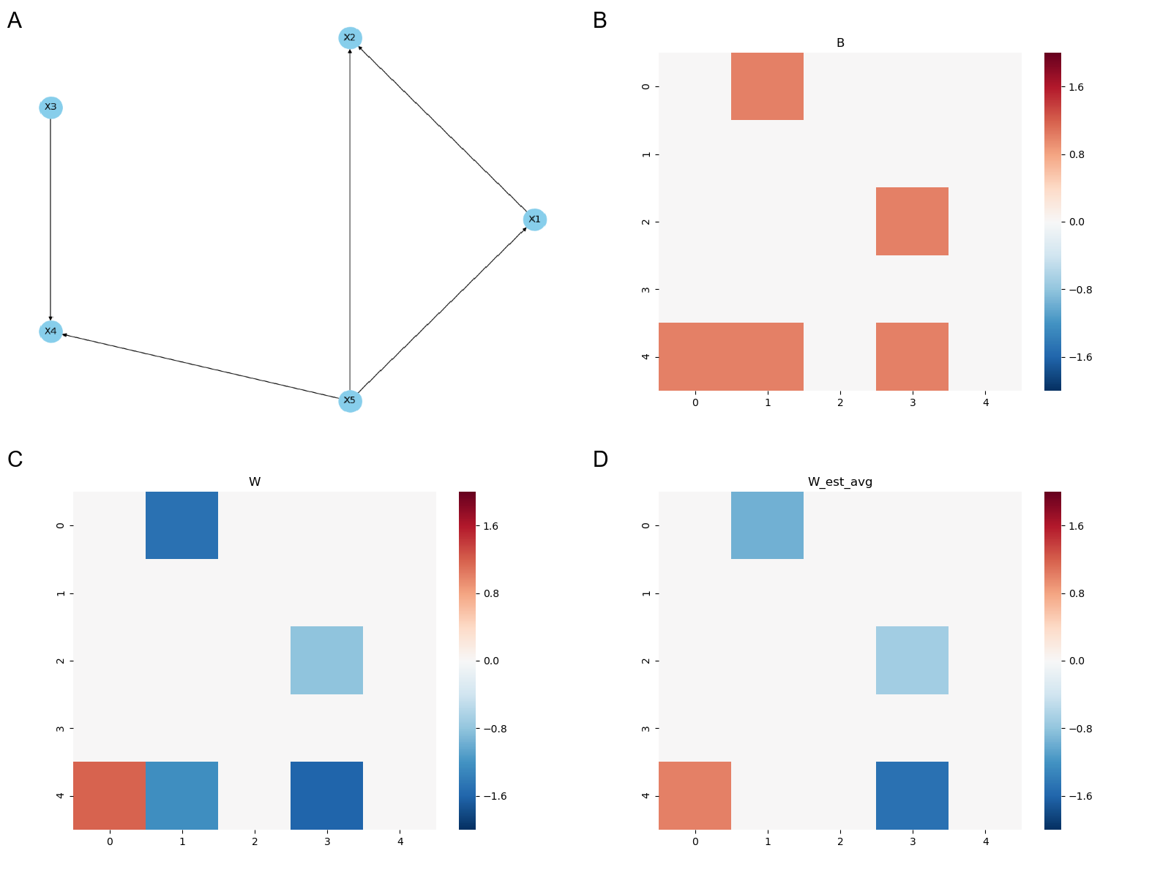
Fig. S1. Visualization of Scenario 1. In Scenario 1, node $X_{2}$ is a binary node, while the other nodes are continuous. A) True Directed Acyclic Graph (DAG). B) Adjacency matrix of the true graph. C) Weighted adjacency matrix of the true graph. D) Weighted adjacency matrix estimated by NOTEARS-M algorithm, averaged over 10 replicates.

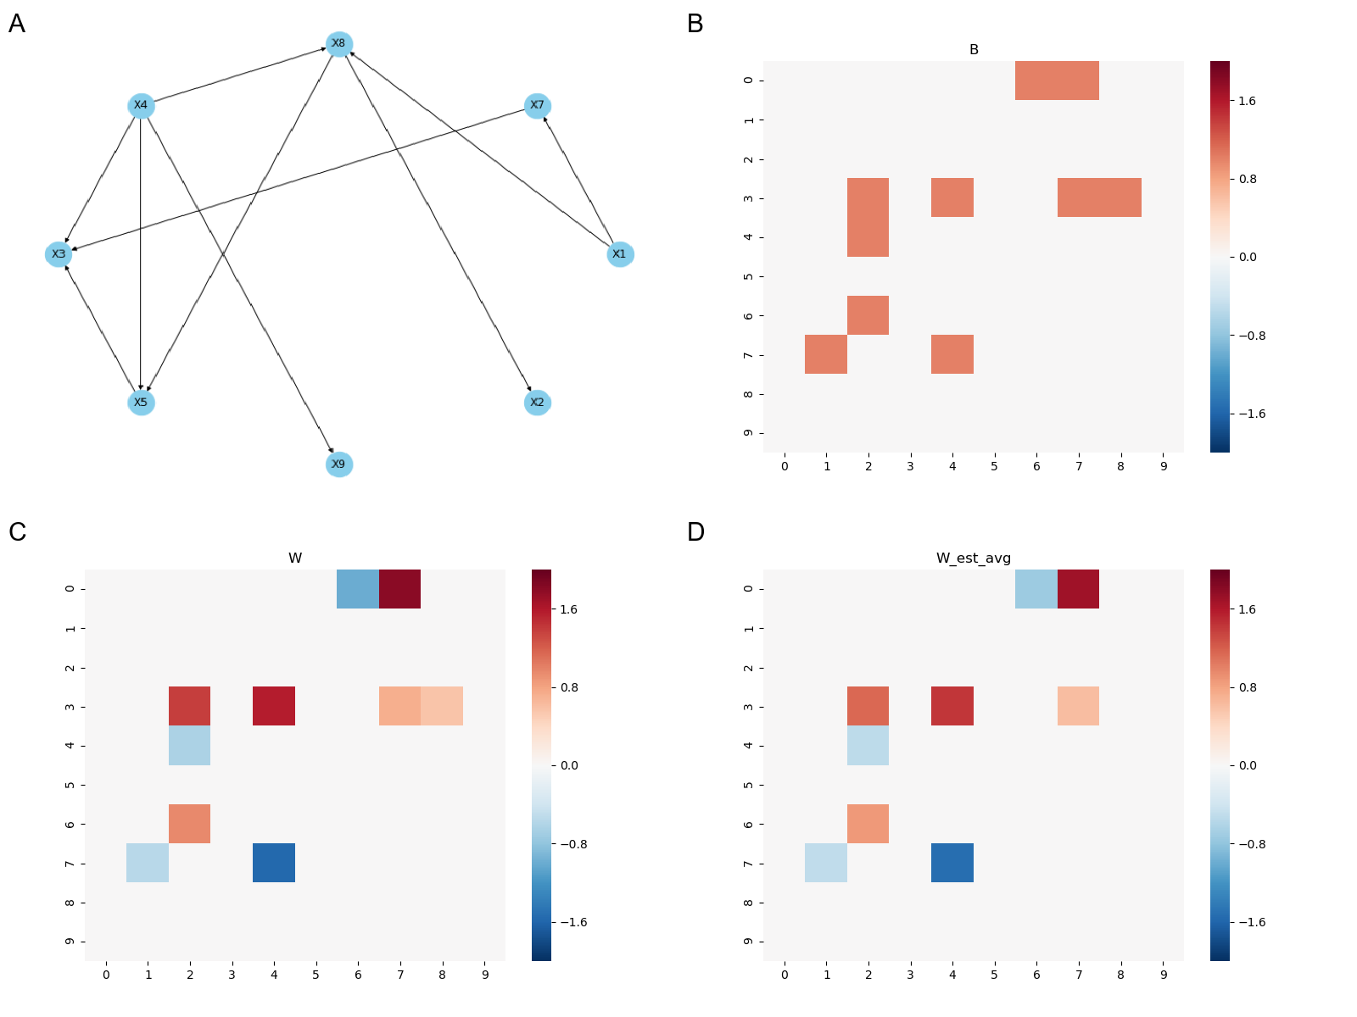
Fig. S2. Visualization of Scenario 2. In Scenario 2, node $X_{9}$ is a binary node, while the other nodes are continuous. A) True Directed Acyclic Graph (DAG). B) Adjacency matrix of the true graph. C) Weighted adjacency matrix of the true graph. D) Weighted adjacency matrix estimated by NOTEARS-M algorithm, averaged over 10 replicates.

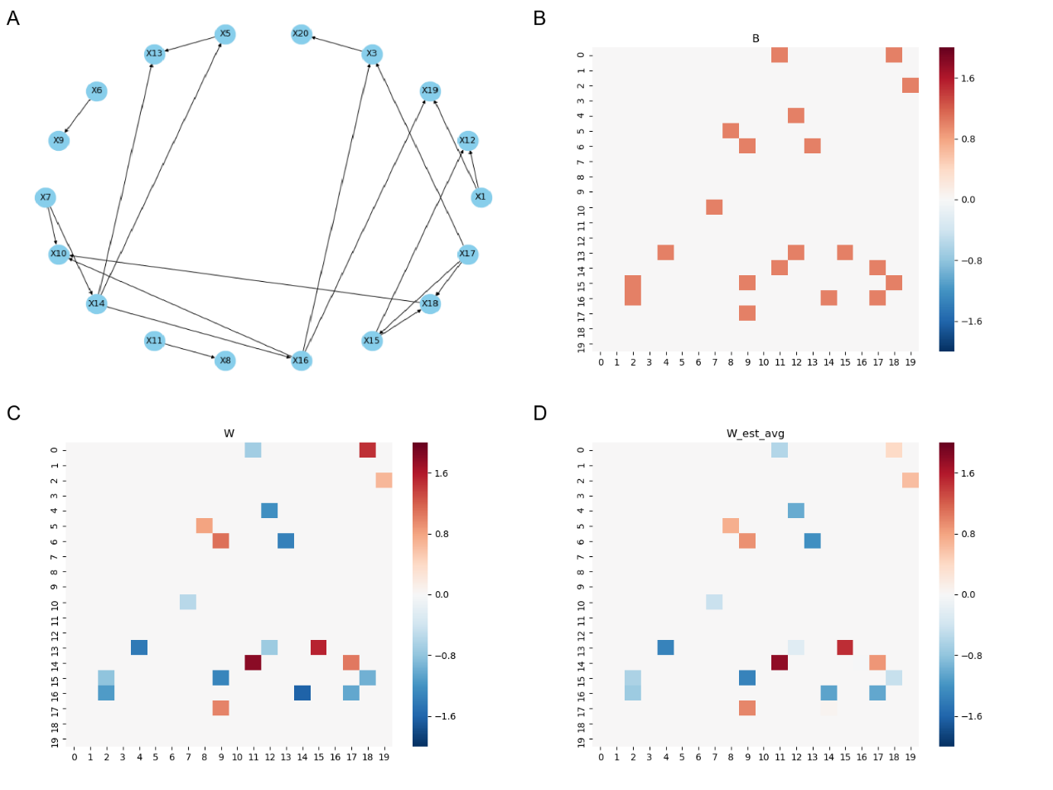
Fig. S3. Visualization of Scenario 3. In Scenario 3, node $X_{19}$ is a binary node, while the other nodes are continuous. A) True Directed Acyclic Graph (DAG). B) Adjacency matrix of the true graph. C) Weighted adjacency matrix of the true graph. D) Weighted adjacency matrix estimated by NOTEARS-M algorithm, averaged over 10 replicates.

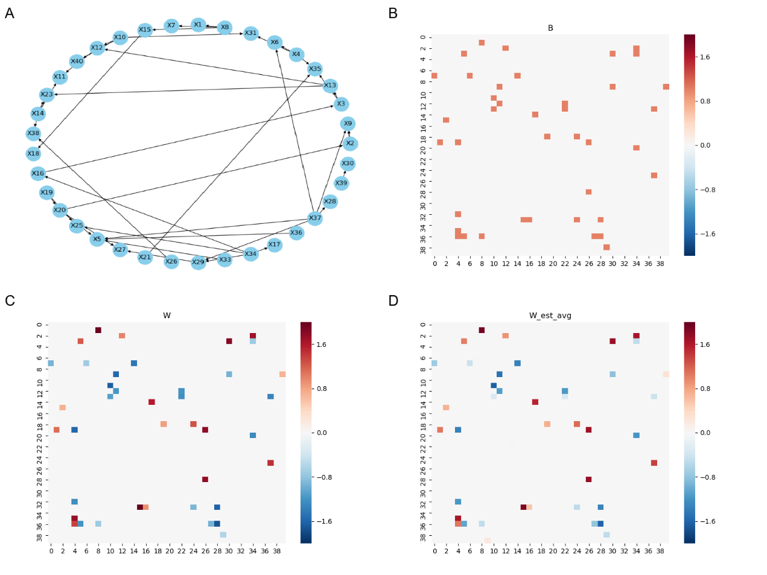
Fig. S4. Visualization of Scenario 4. In Scenario 4, node $X_{14}$ is a binary node, while the other nodes are continuous. A) True Directed Acyclic Graph (DAG). B) Adjacency matrix of the true graph. C) Weighted adjacency matrix of the true graph. D) Weighted adjacency matrix estimated by NOTEARS-M algorithm, averaged over 10 replicates.

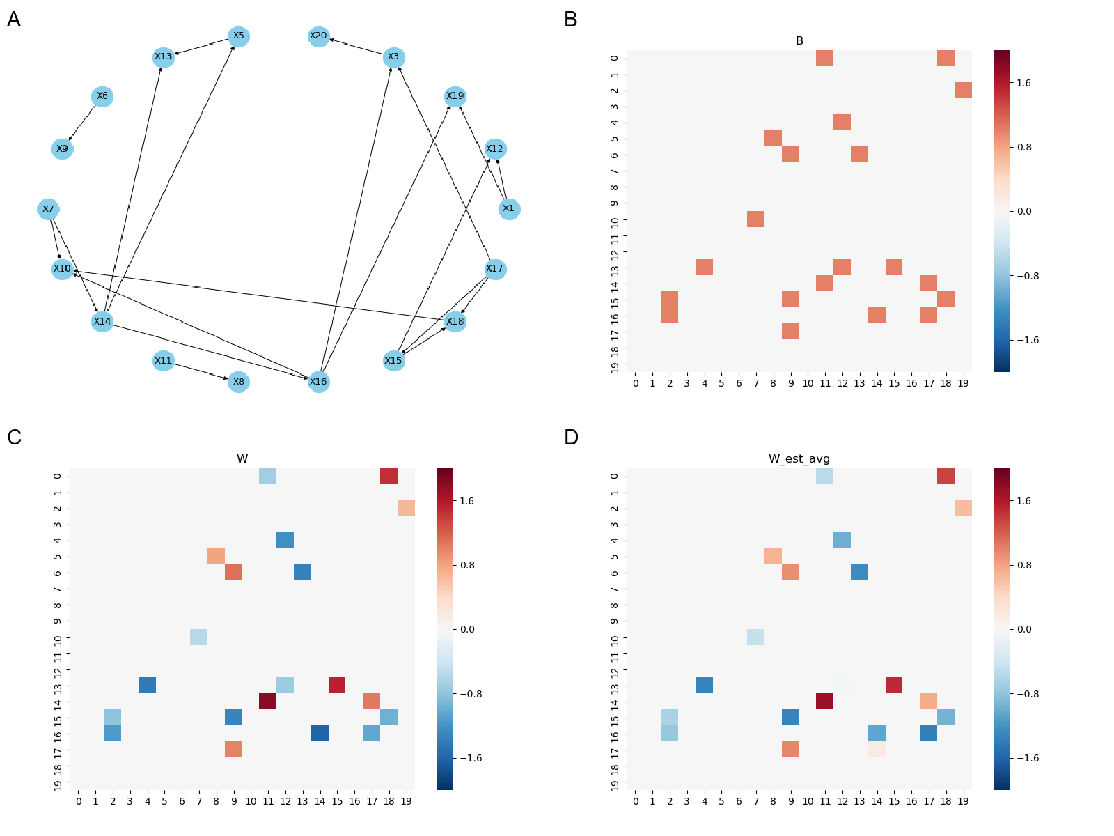
Fig. S5. Visualization of Scenario 5. In Scenario 5, all the node are continuous nodes. A) True Directed Acyclic Graph (DAG). B) Adjacency matrix of the true graph. C) Weighted adjacency matrix of the true graph. D) Weighted adjacency matrix estimated by NOTEARS-M algorithm, averaged over 10 replicates.

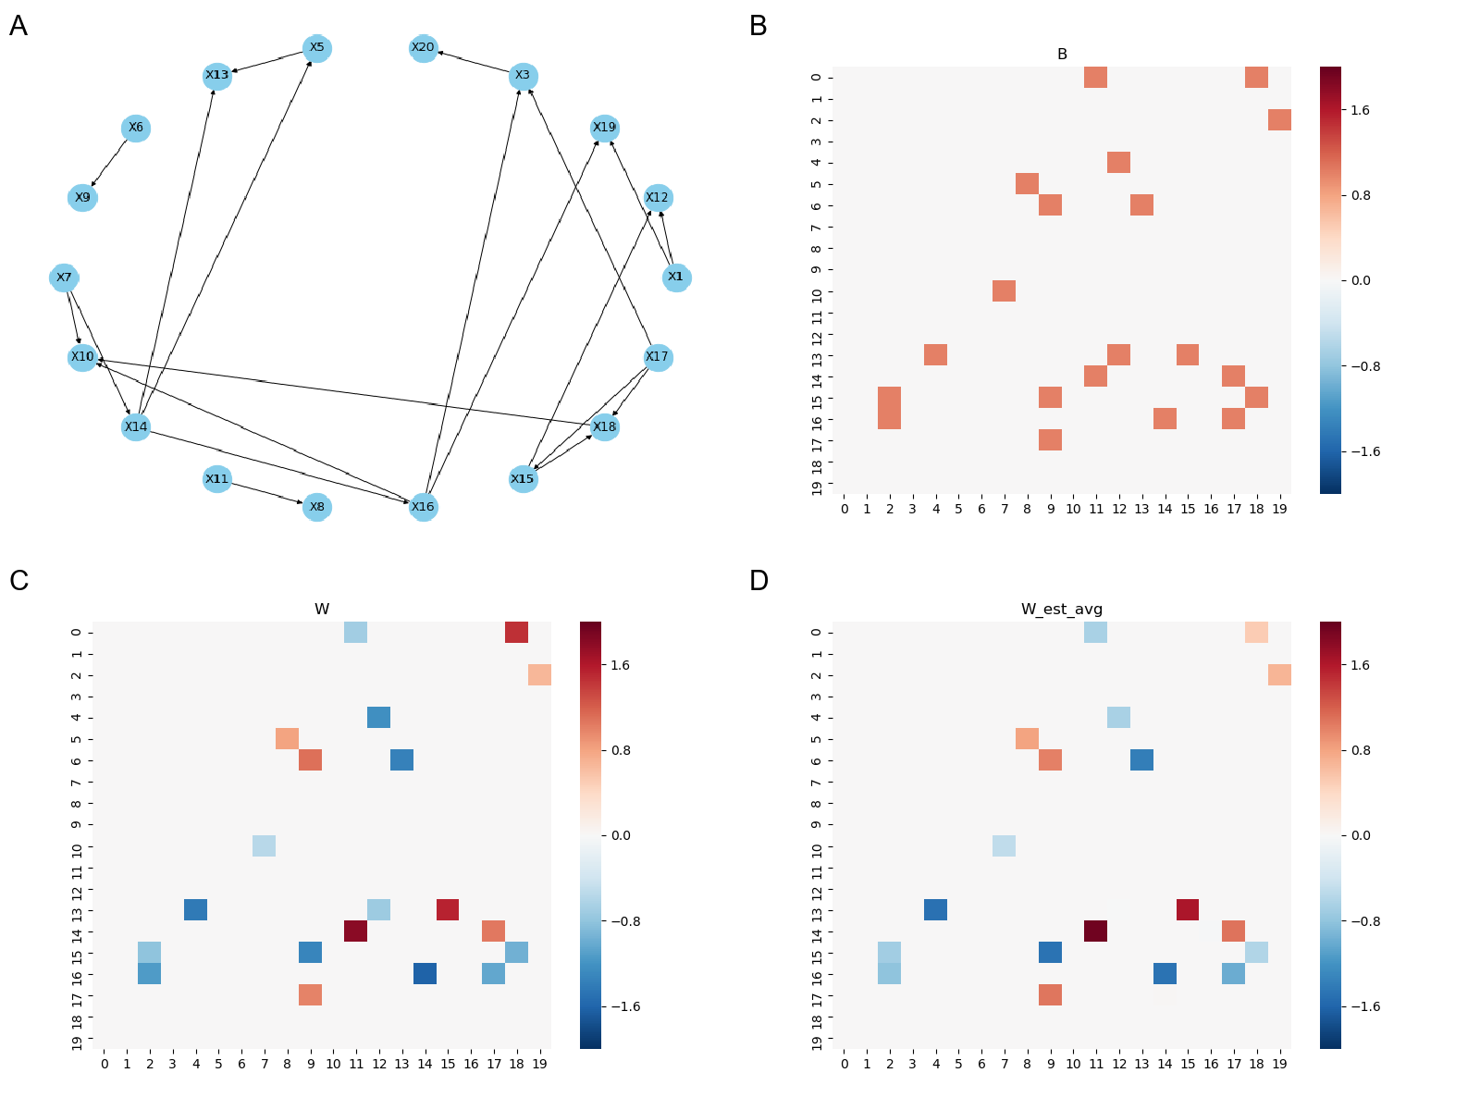
Fig. S6. Visualization of Scenario 6. In Scenario 6, node $X_{13}$ and node $X_{19}$ are binary nodes, while the other nodes are continuous. A) True Directed Acyclic Graph (DAG). B) Adjacency matrix of the true graph. C) Weighted adjacency matrix of the true graph. D) Weighted adjacency matrix estimated by NOTEARS-M algorithm, averaged over 10 replicates.

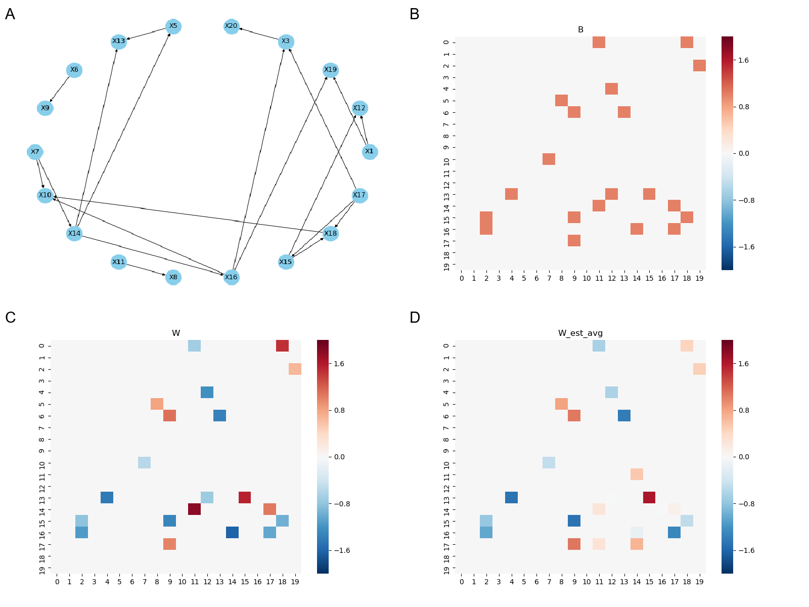
Fig. S7. Visualization of Scenario 7. In Scenario 7, node $X_{13}$, node $X_{15}$, node $X_{19}$and node $X_{20}$ are binary nodes, while the other nodes are continuous. A) True Directed Acyclic Graph (DAG). B) Adjacency matrix of the true graph. C) Weighted adjacency matrix of the true graph. D) Weighted adjacency matrix estimated by NOTEARS-M algorithm, averaged over 10 replicates.

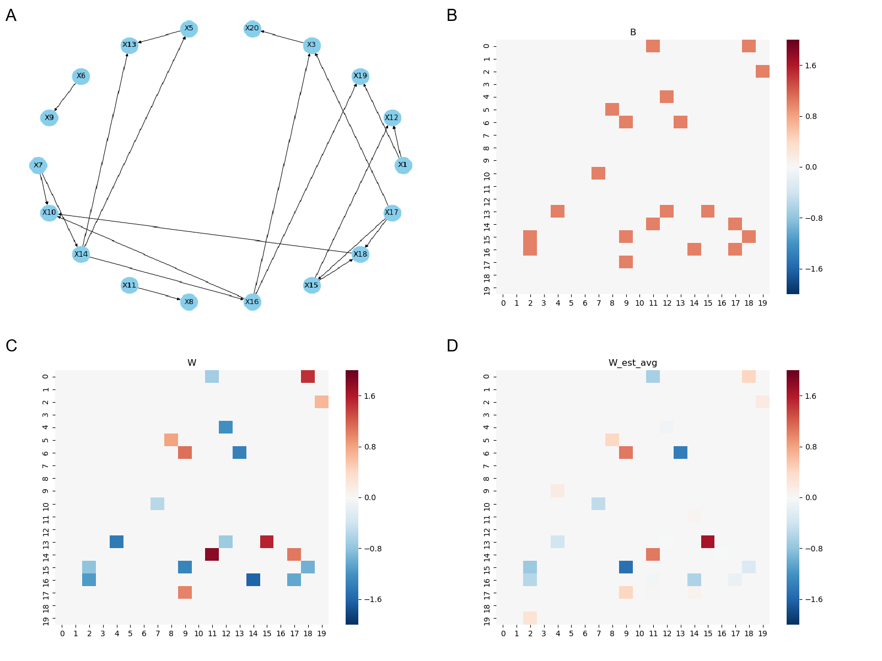
Fig. S8. Visualization of Scenario 8. In Scenario 8, $X_{2}$, $X_{4}$, $X_{5}$, $X_{9}$, $X_{13}$, $X_{15}$, $X_{17}$, $X_{18}$, $X_{19}$, and $X_{20}$ are binary nodes, while the other nodes are continuous. A) True Directed Acyclic Graph (DAG). B) Adjacency matrix of the true graph. C) Weighted adjacency matrix of the true graph. D) Weighted adjacency matrix estimated by NOTEARS-M algorithm, averaged over 10 replicates.

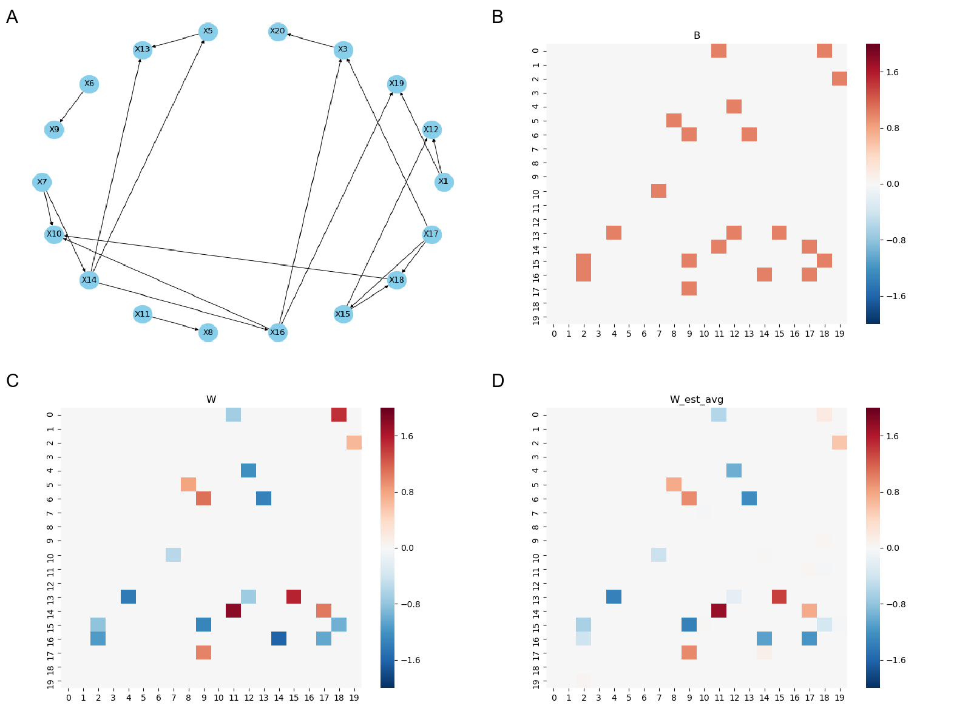
Fig. S9. Visualization of Scenario 9. In Scenario 9, node $X_{19}$ is a binary node, while the other nodes are continuous. A) True Directed Acyclic Graph (DAG). B) Adjacency matrix of the true graph. C) Weighted adjacency matrix of the true graph. D) Weighted adjacency matrix estimated by NOTEARS-M algorithm, averaged over 10 replicates.

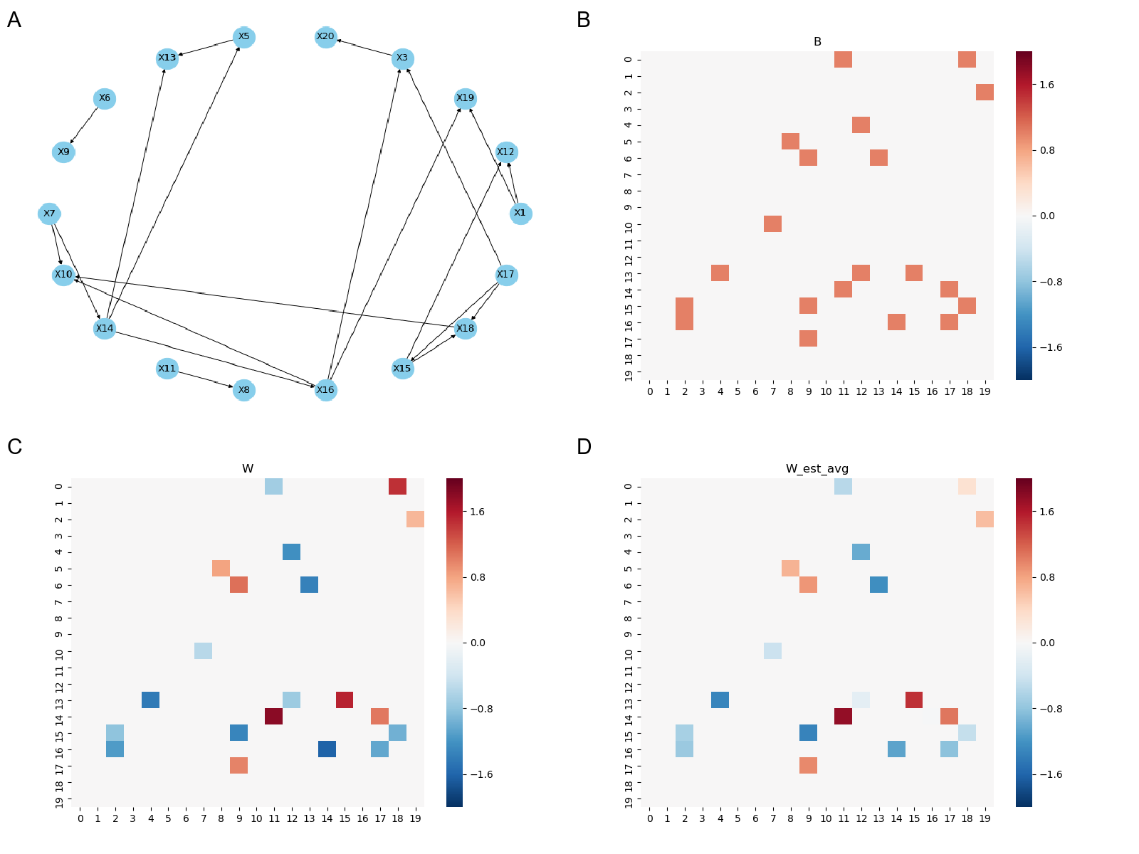
Fig. S10. Visualization of Scenario 10. In Scenario 10, node $X_{19}$ is a binary node, while the other nodes are continuous. A) True Directed Acyclic Graph (DAG). B) Adjacency matrix of the true graph. C) Weighted adjacency matrix of the true graph. D) Weighted adjacency matrix estimated by NOTEARS-M algorithm, averaged over 10 replicates.

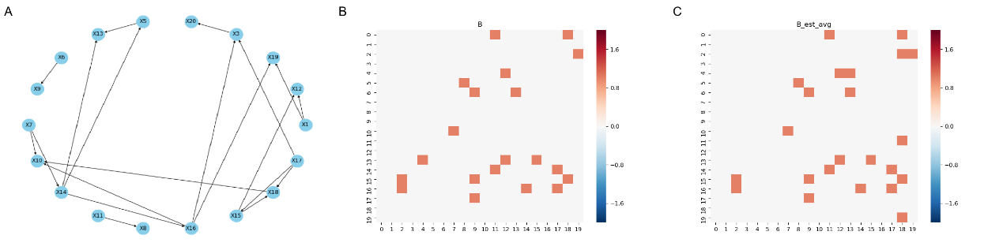
Fig. S11. Visualization of Scenario 11. In Scenario 11, node $X_{19}$ is a binary node, while the other nodes are continuous. A) True Directed Acyclic Graph (DAG). B) Adjacency matrix of the true graph. C) Adjacency matrix estimated by NOTEARS-M algorithm, averaged over 10 replicates.
* In the presence of muti-level categorical nodes (i.e. $m>2$), there are multiple weighted adjacency matrices of a DAG. Therefore, for simplicity, we only compare the adjacency matrices of the true graph and the estimated graph in this context.

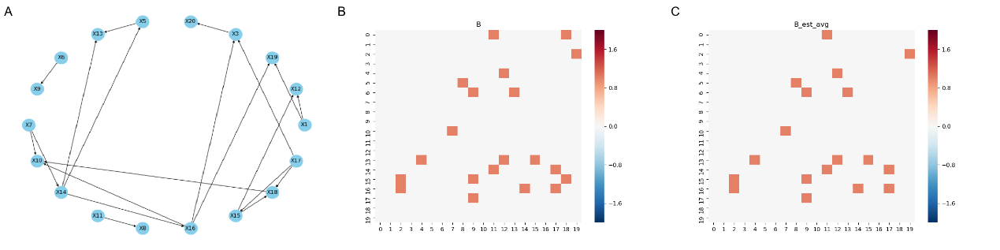
Fig. S12. Visualization of Scenario 12. In Scenario 12, node $X_{19}$ is a binary node, while the other nodes are continuous. A) True Directed Acyclic Graph (DAG). B) Adjacency matrix of the true graph. C) Adjacency matrix estimated by NOTEARS-M algorithm, averaged over 10 replicates.
*In the presence of muti-level categorical nodes (i.e. m>2), there are multiple weighted adjacency matrices of a DAG. Therefore, for simplicity, we only compare the adjacency matrices of the true graph and the estimated graph in this context.

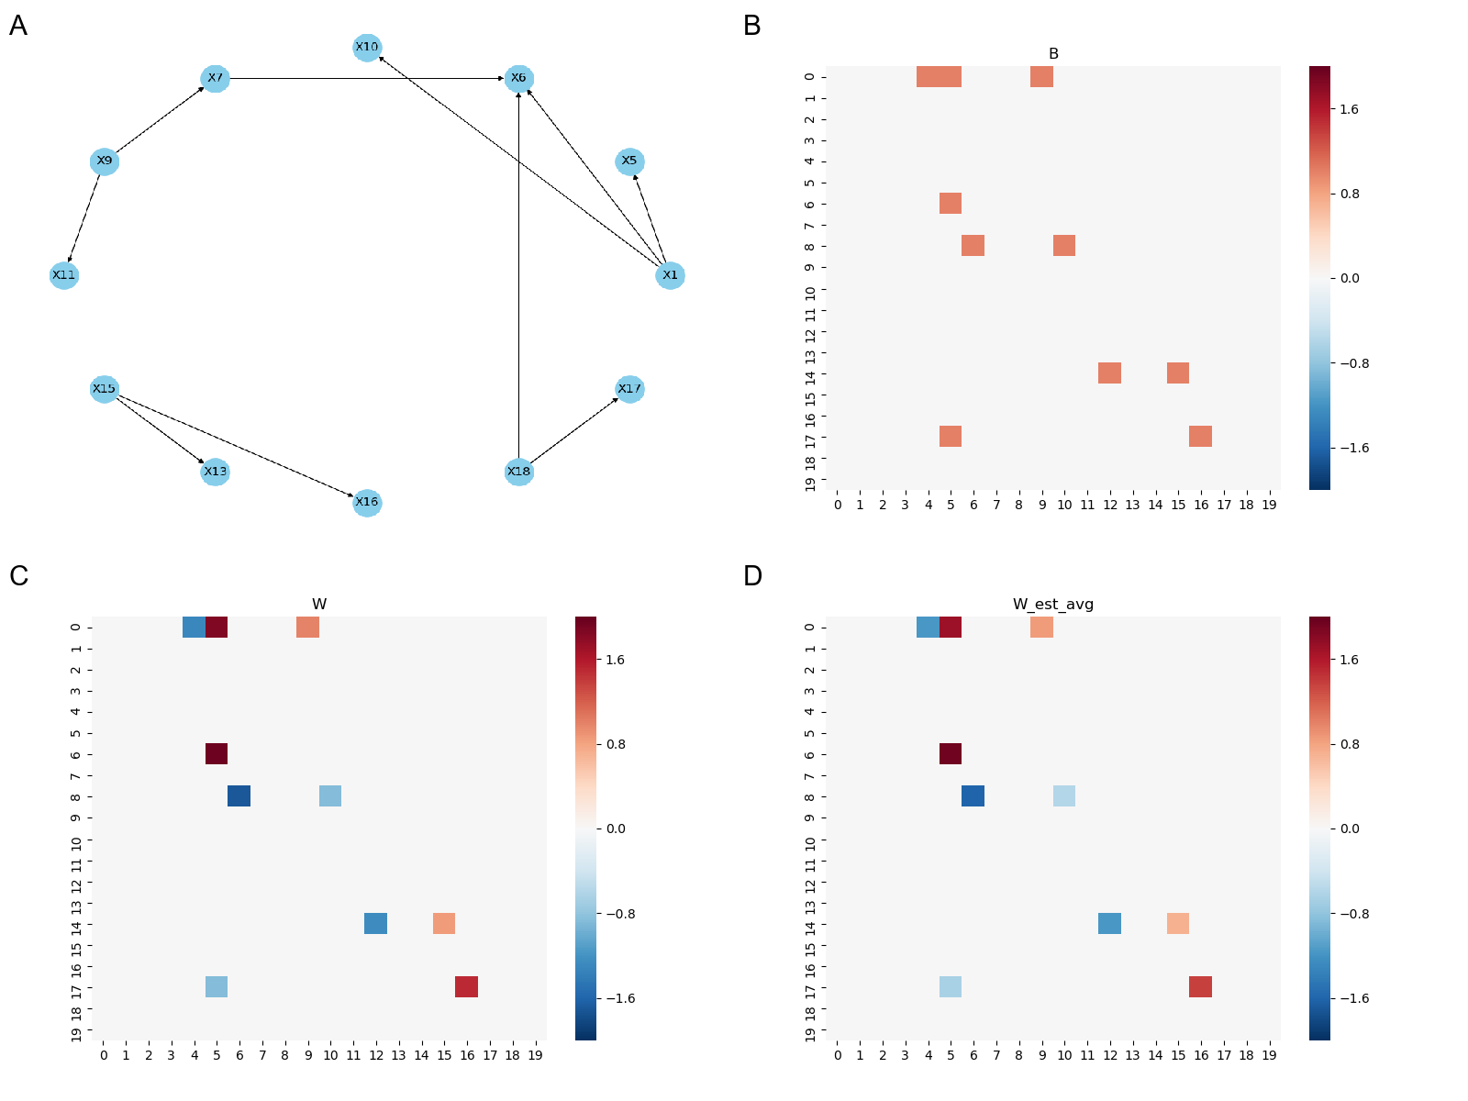
Fig. S13. Visualization of Scenario 13. In Scenario 13, node $X_{19}$ is a binary node, while the other nodes are continuous. A) True Directed Acyclic Graph (DAG). B) Adjacency matrix of the true graph. C) Weighted adjacency matrix of the true graph. D) Weighted adjacency matrix estimated by NOTEARS-M algorithm, averaged over 10 replicates.

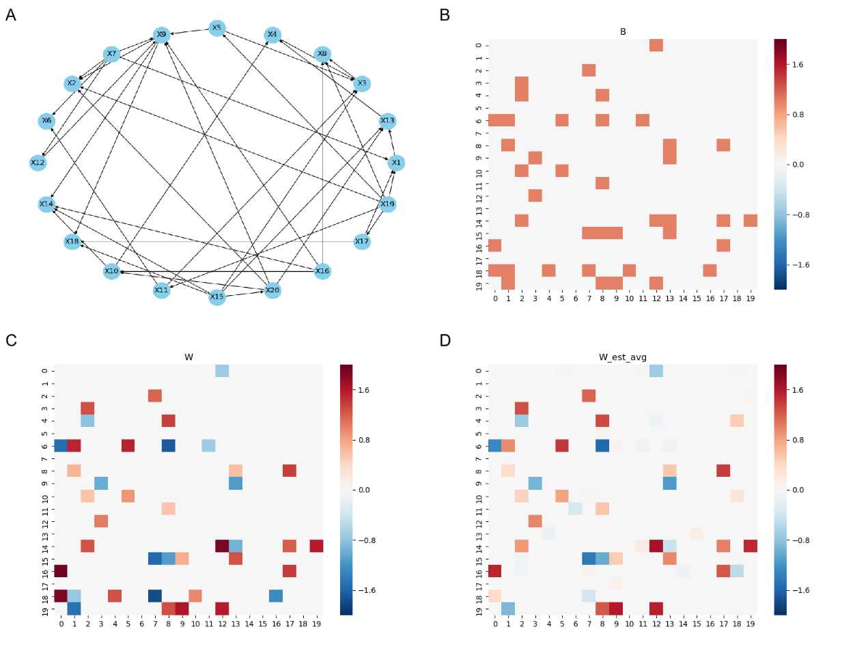
Fig. S14. Visualization of Scenario 14. In Scenario 14, node $X_{19}$ is a binary node, while the other nodes are continuous. A) True Directed Acyclic Graph (DAG). B) Adjacency matrix of the true graph. C) Weighted adjacency matrix of the true graph. D) Weighted adjacency matrix estimated by NOTEARS-M algorithm, averaged over 10 replicates.
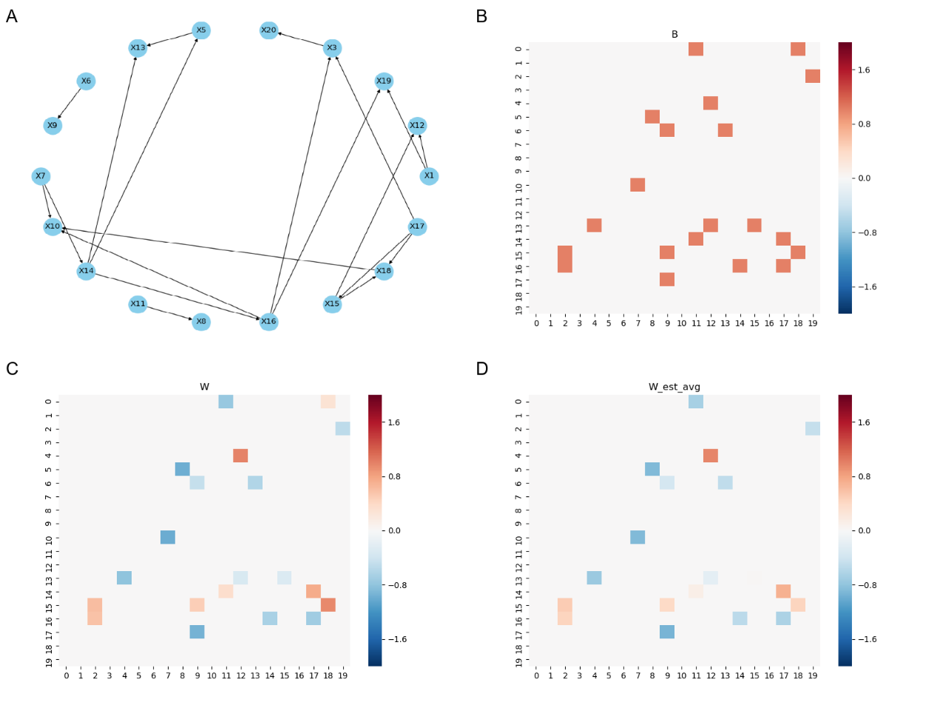
Fig. S15. Visualization of Scenario 15. In Scenario 15, node $X_{19}$ is a binary node, while the other nodes are continuous. A) True Directed Acyclic Graph (DAG). B) Adjacency matrix of the true graph. C) Weighted adjacency matrix of the true graph. D) Weighted adjacency matrix estimated by NOTEARS-M algorithm, averaged over 10 replicates.

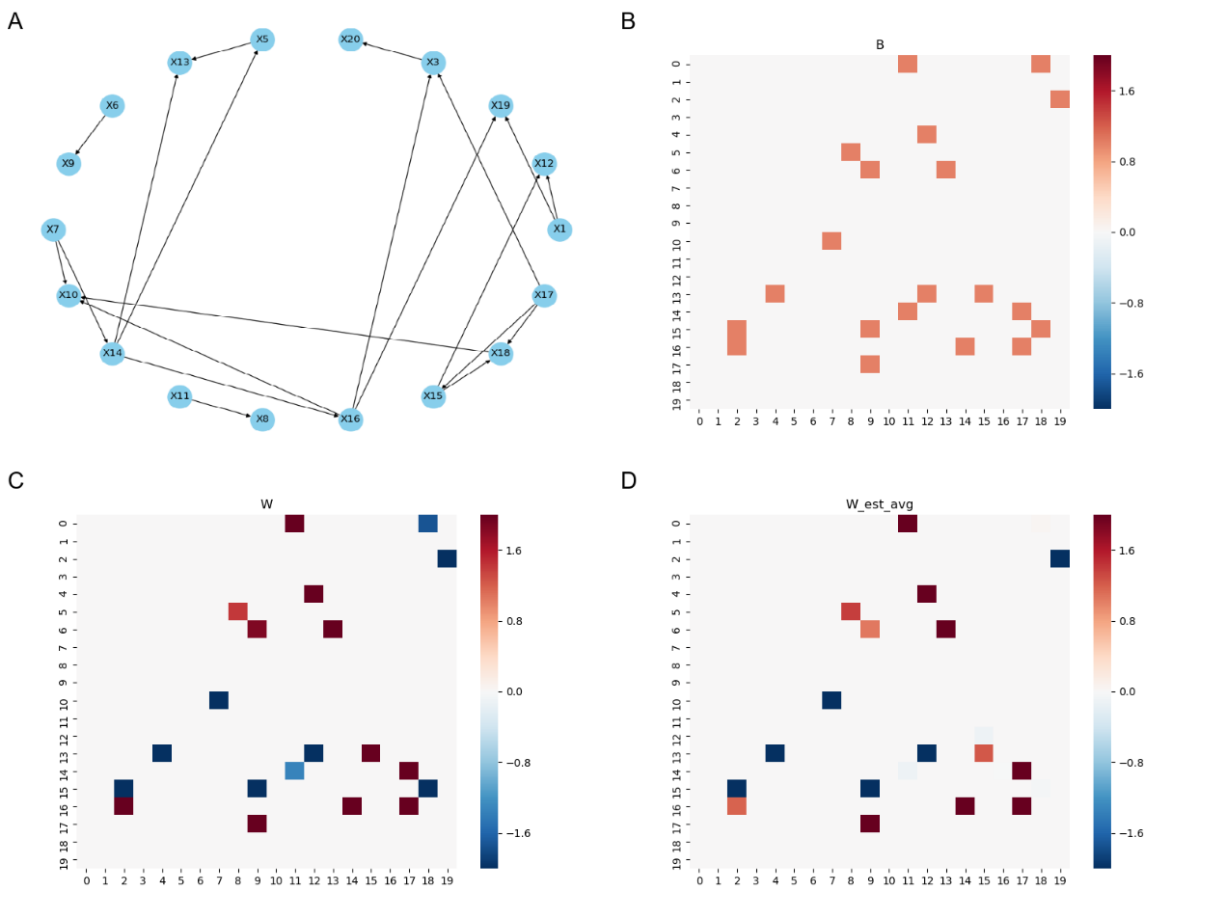
Fig. S16. Visualization of Scenario 16. In Scenario 16, node $X_{19}$ is a binary node, while the other nodes are continuous. A) True Directed Acyclic Graph (DAG). B) Adjacency matrix of the true graph. C) Weighted adjacency matrix of the true graph. D) Weighted adjacency matrix estimated by NOTEARS-M algorithm, averaged over 10 replicates.
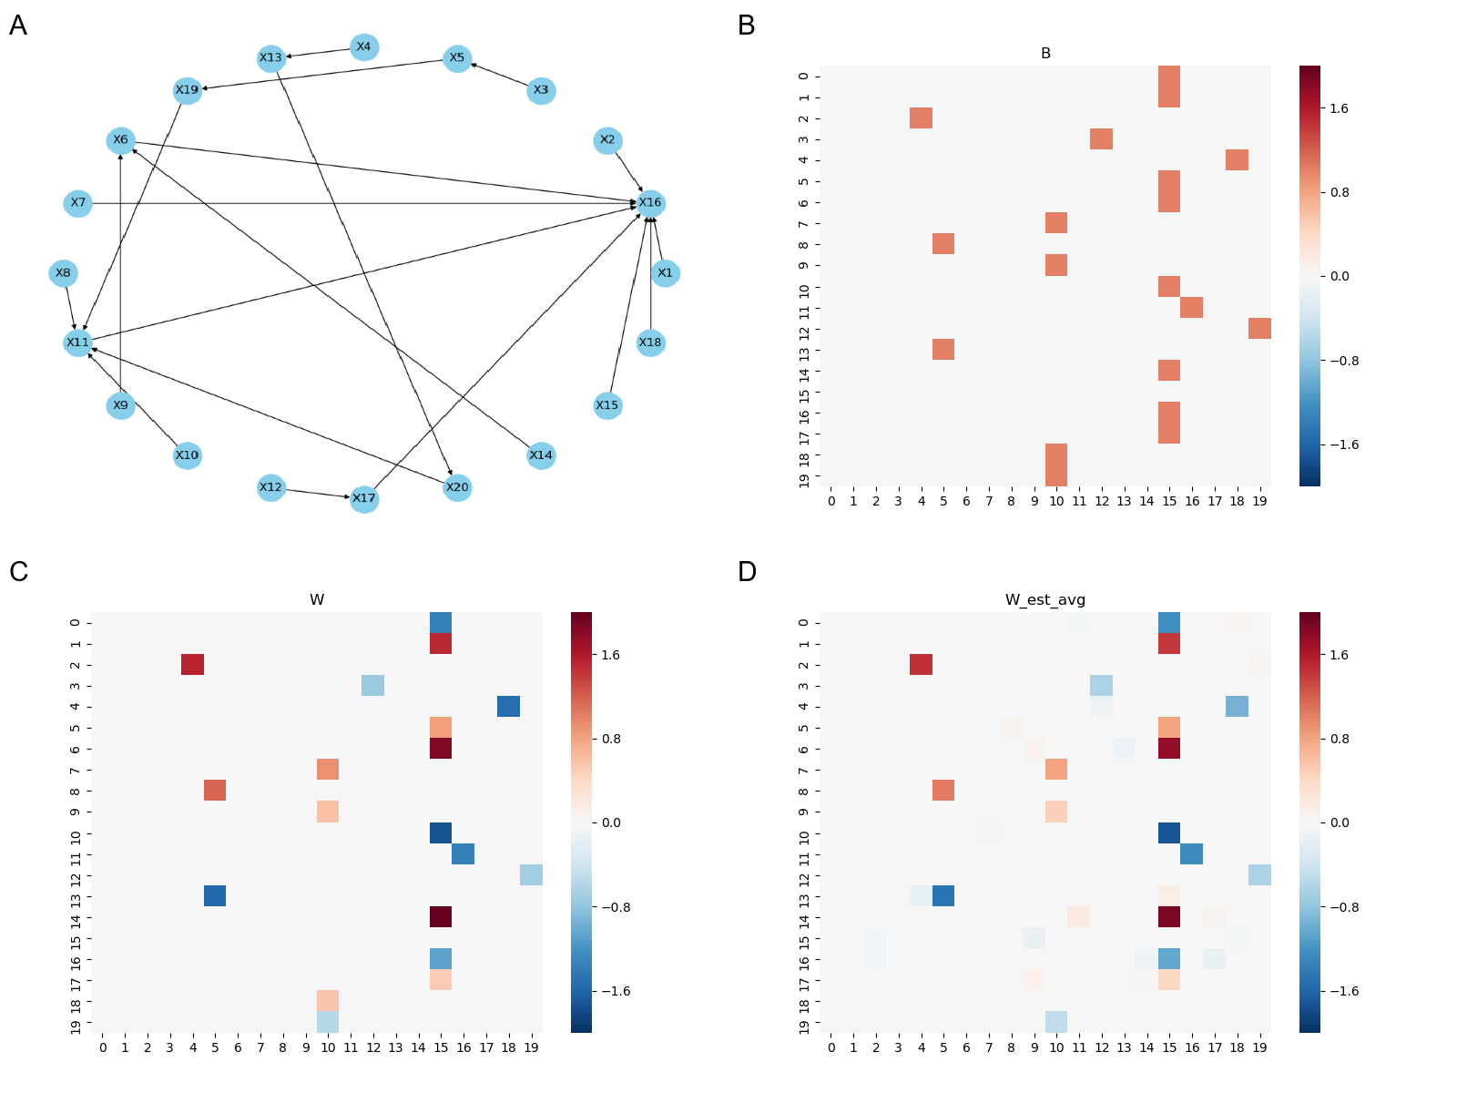
Fig. S17. Visualization of Scenario 17. In Scenario 17, node $X_{19}$ is a binary node, while the other nodes are continuous. A) True Directed Acyclic Graph (DAG). B) Adjacency matrix of the true graph. C) Weighted adjacency matrix of the true graph. D) Weighted adjacency matrix estimated by NOTEARS-M algorithm, averaged over 10 replicates.
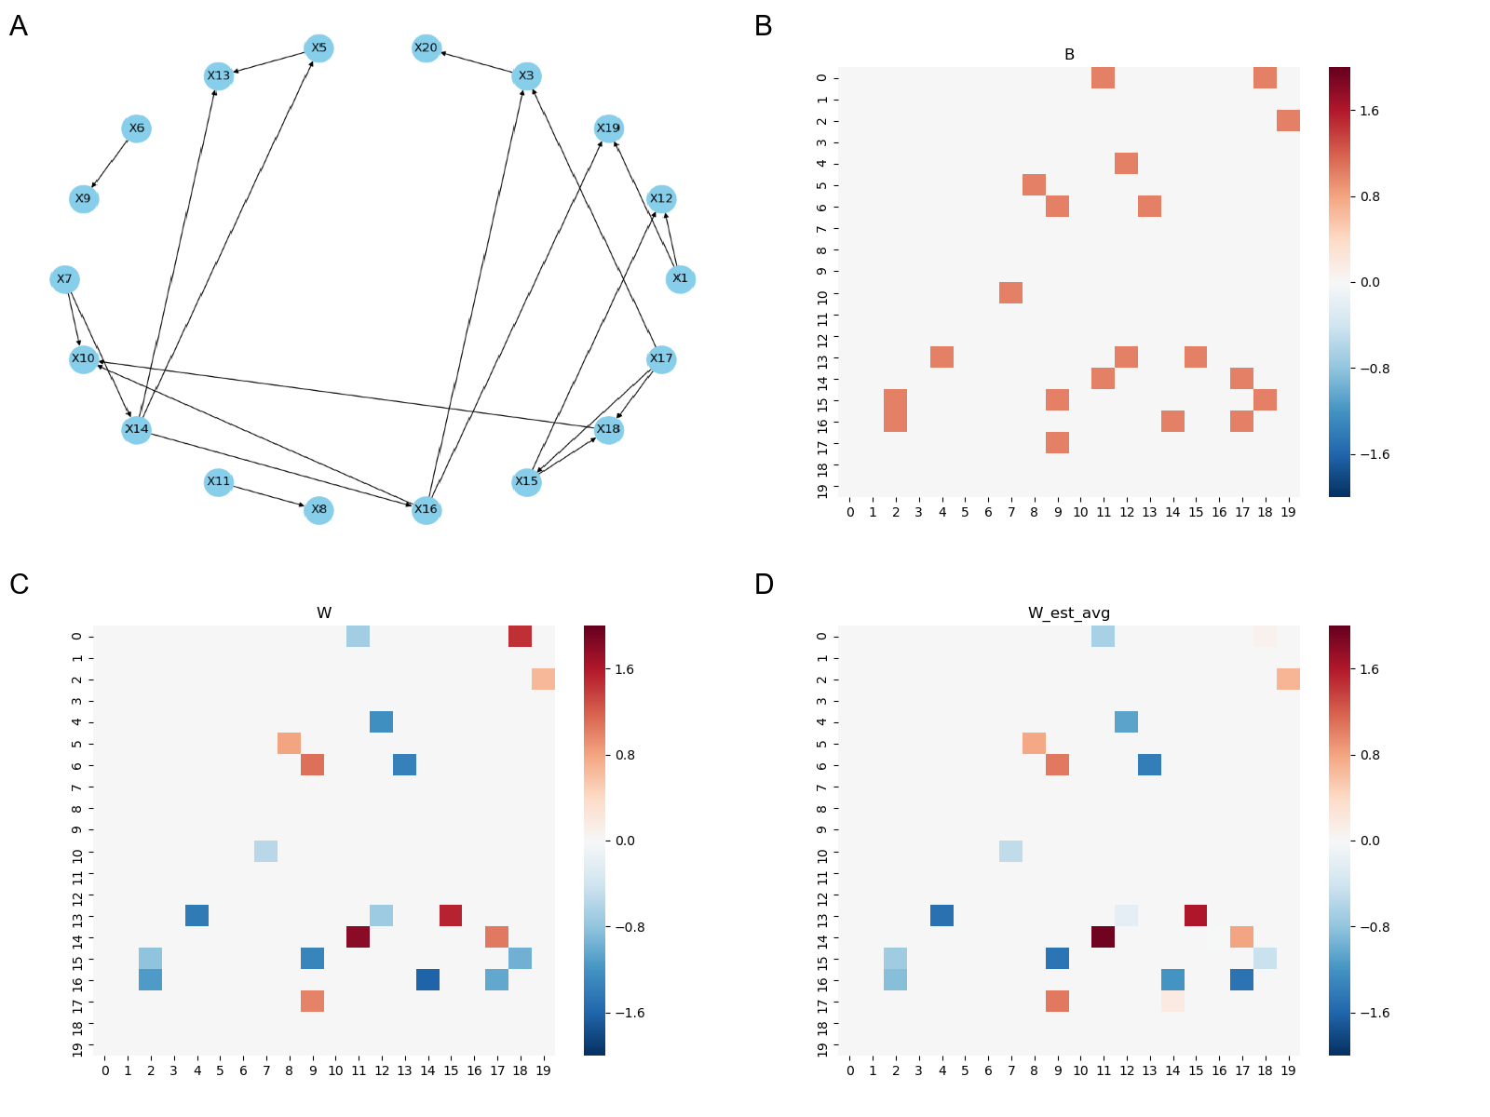
Fig. S18. Visualization of Scenario 18. In Scenario 18, node $X_{19}$ is a binary node, while the other nodes are continuous. A) True Directed Acyclic Graph (DAG). B) Adjacency matrix of the true graph. C) Weighted adjacency matrix of the true graph. D) Weighted adjacency matrix estimated by NOTEARS-M algorithm, averaged over 10 replicates.

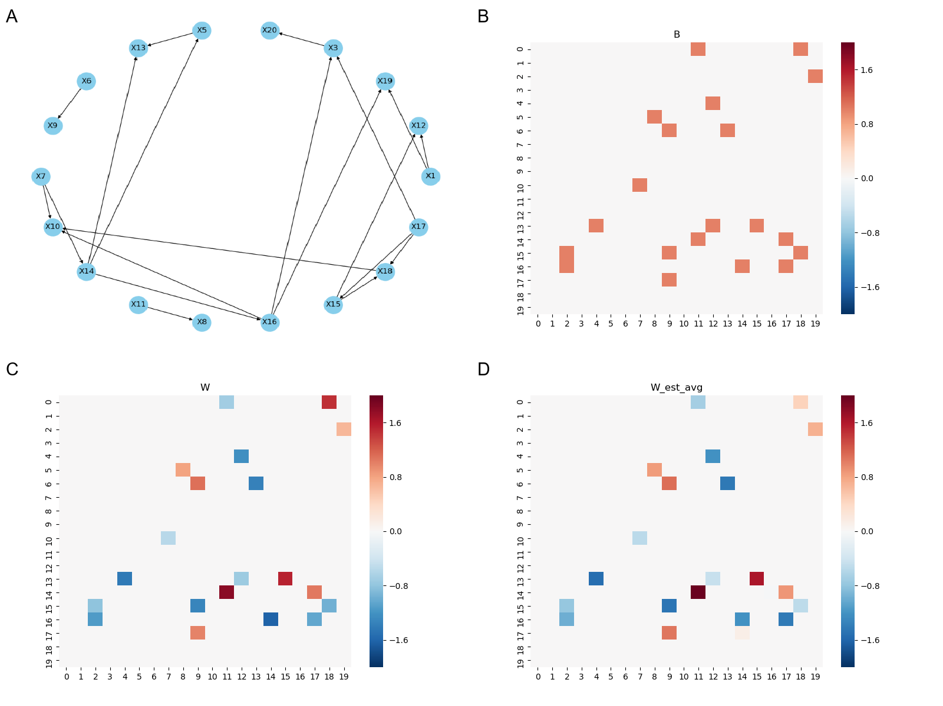
Fig. S19. Visualization of Scenario 19. In Scenario 19, node $X_{19}$ is a binary node, while the other nodes are continuous. A) True Directed Acyclic Graph (DAG). B) Adjacency matrix of the true graph. C) Weighted adjacency matrix of the true graph. D) Weighted adjacency matrix estimated by NOTEARS-M algorithm, averaged over 10 replicates.

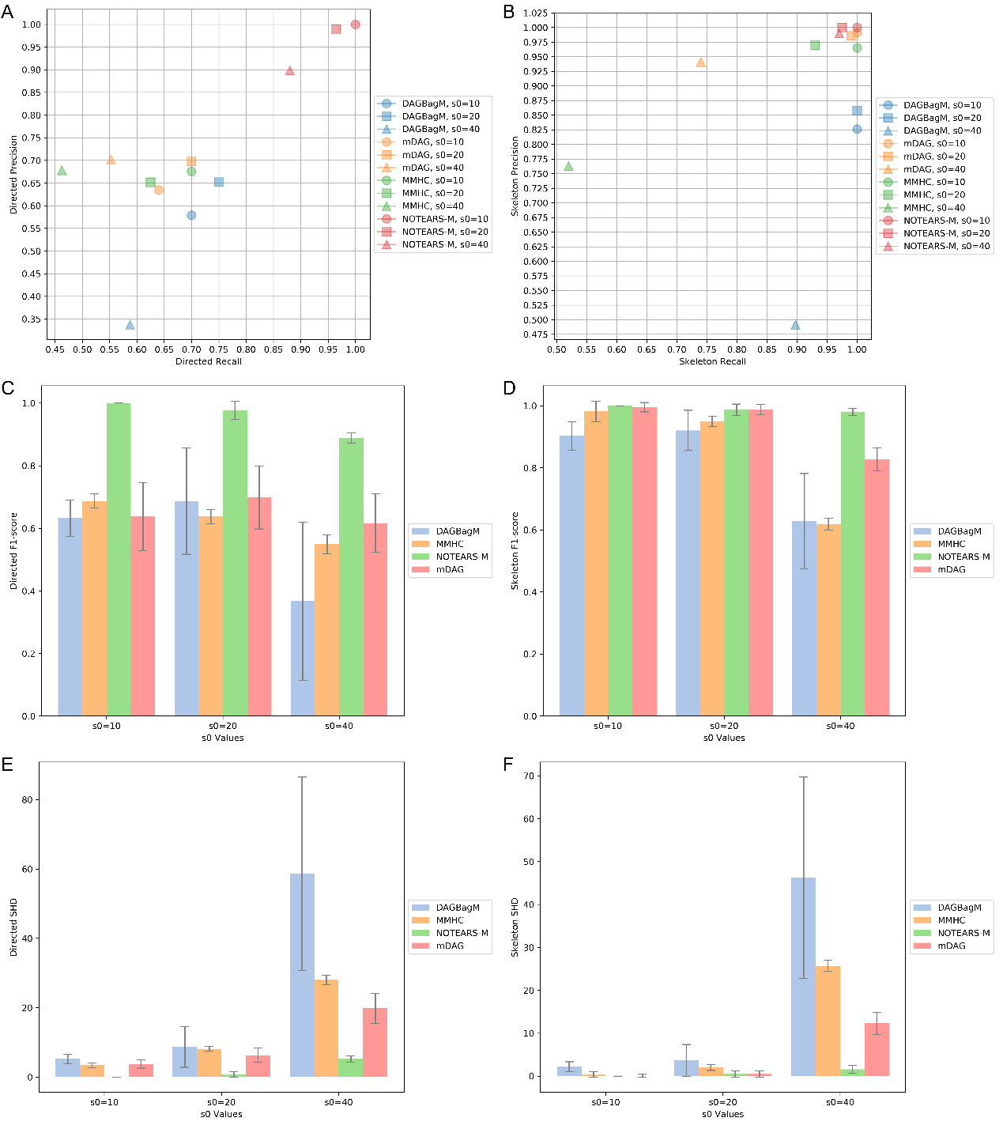
Fig. S20 Results for Simulation (v): Comparison of the performance of NOTEARS-M, MMHC, mDAG, and DAGBagM with varying edge sparsity s0/d = 0.5, 1, 2. A) Precision-Recall plot for detecting directed structures. B) Precision-Recall plot for detecting skeleton structures. C) F1-score for detecting directed structures. D) F1-score for detecting skeleton structures. E) Structural Hamming Distance (SHD) for detecting directed structures. F) SHD for detecting skeleton structures. The results are averaged over 10 replicates for each scenario. The error bars in C), D), E) and F) indicate the standard deviation of each bar.
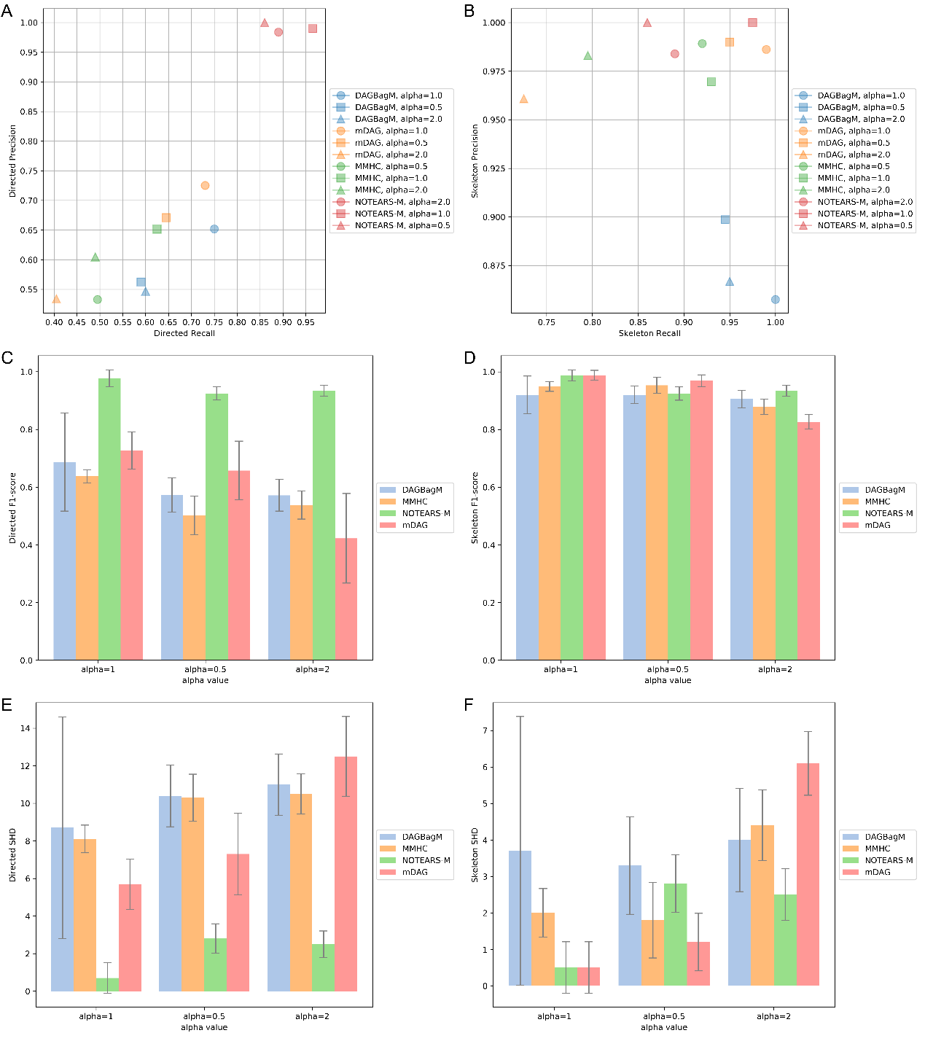
Fig. S21 Results for Simulation (vi): Comparison of the performance of NOTEARS-M, MMHC, mDAG, and DAGBagM with varying weight scale alpha= 0.5, 1, 2. A) Precision-Recall plot for detecting directed structures. B) Precision-Recall plot for detecting skeleton structures. C) F1-score for detecting directed structures. D) F1-score for detecting skeleton structures. E) Structural Hamming Distance (SHD) for detecting directed structures. F) SHD for detecting skeleton structures. The results are averaged over 10 replicates for each scenario. The error bars in C), D), E) and F) indicate the standard deviation of each bar.
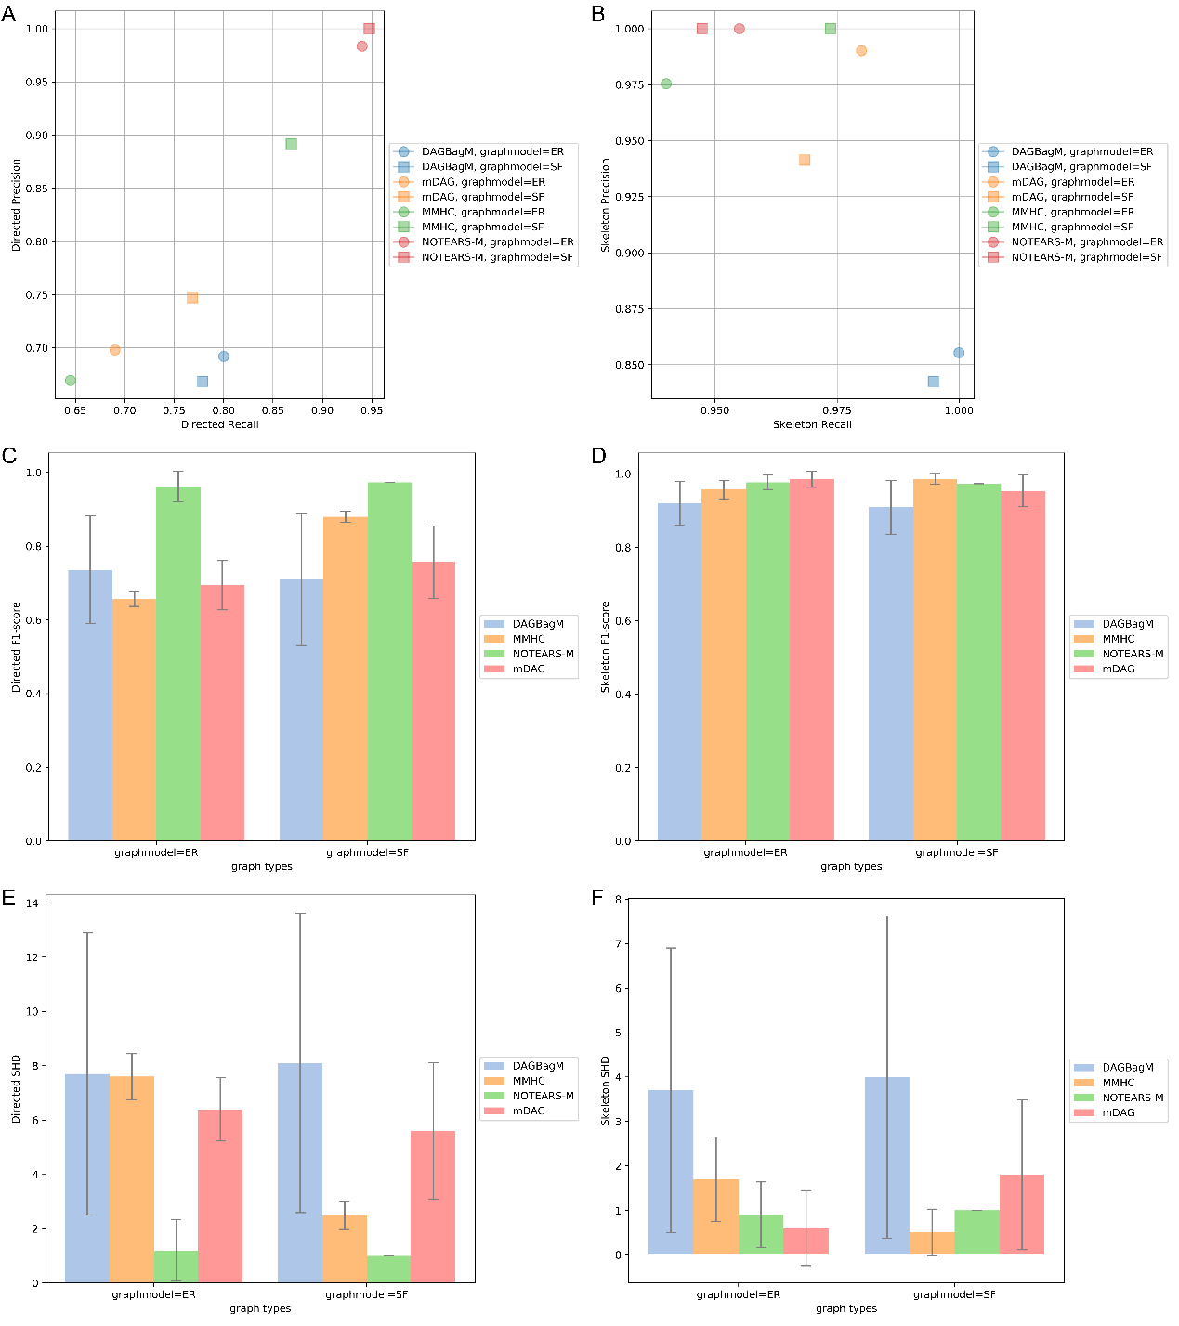
Fig. S22 Results for Simulation (vii): Comparison of the performance of NOTEARS-M, MMHC, mDAG, and DAGBagM with different graph models (ER, SF). A) Precision-Recall plot for detecting directed structures. B) Precision-Recall plot for detecting skeleton structures. C) F1-score for detecting directed structures. D) F1-score for detecting skeleton structures. E) Structural Hamming Distance (SHD) for detecting directed structures. F) SHD for detecting skeleton structures. The results are averaged over 10 replicates for each scenario. The error bars in C), D), E) and F) indicate the standard deviation of each bar.
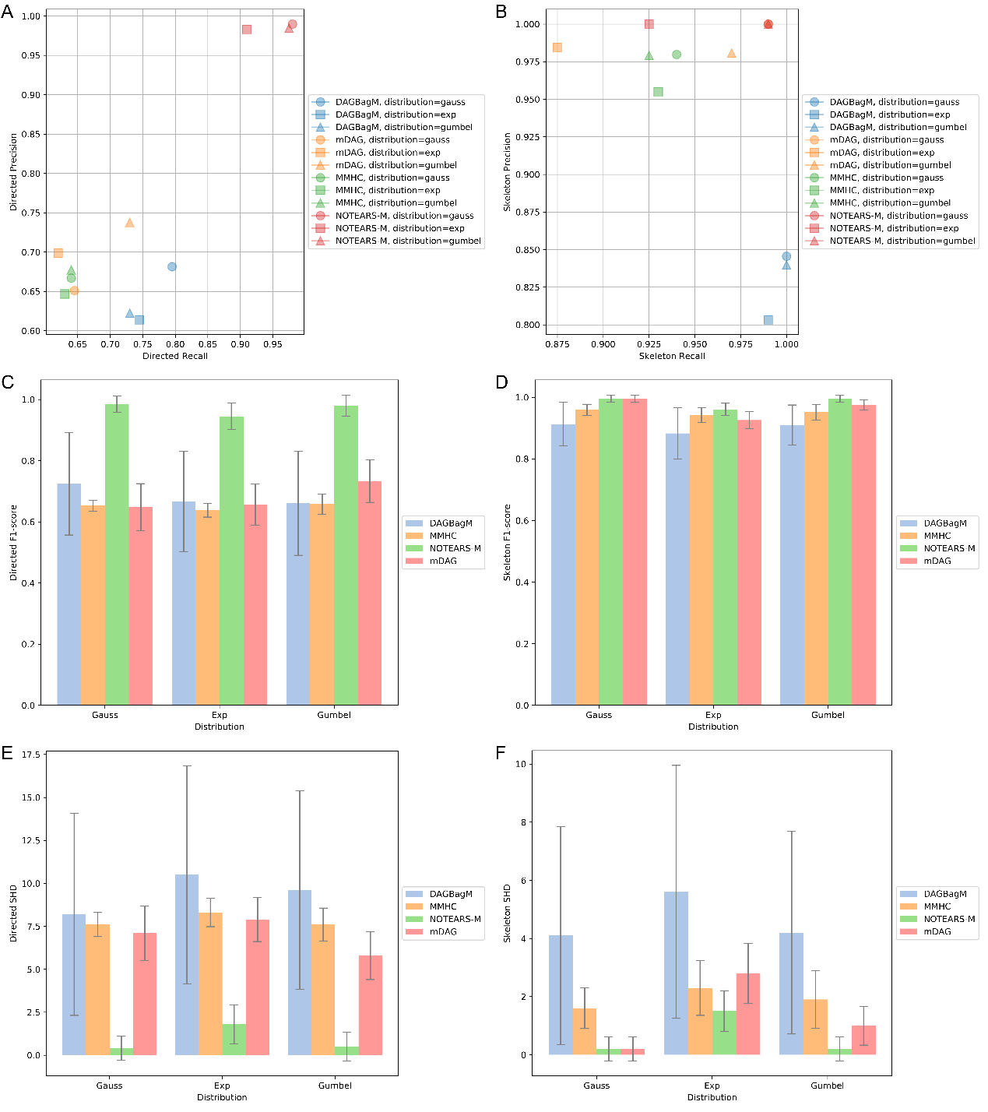
Fig. S23 Results for Simulation (viii): Comparison of the performance of NOTEARS-M, MMHC, mDAG, and DAGBagM with different noise distributions (Gauss, Exp, Gumbel). A) Precision-Recall plot for detecting directed structures. B) Precision-Recall plot for detecting skeleton structures. C) F1-score for detecting directed structures. D) F1-score for detecting skeleton structures. E) Structural Hamming Distance (SHD) for detecting directed structures. F) SHD for detecting skeleton structures. The results are averaged over 10 replicates for each scenario. The error bars in C), D), E) and F) indicate the standard deviation of each bar.

