SUPPLEMENTARY ITEMS

 | N
PAHO | 254
SEARO | 259
EURO | 784
EMRO | 459
WPRO | 326
Bosnia and Herzegovina | 885
Canada | 538
France | 337
Germany | 534
Iran | 1198
Italy | 1096
Pakistan | 1773
Poland | 1110
Spain | 972
Switzerland | 489
Turkey | 539
United States | 1864

Item S1 Number of participants per country and WHO region included in the primary assessment

Predictor |  | n | %
Gender | Male | 3235 | 25.13
Gender | Female | 9314 | 72.36
Gender | Non-binary | 92 | 0.71
Gender | Not disclosed | 92 | 0.71
Residence | Rural | 1981 | 15.39
Residence | Urban | 10666 | 82.87
Education | Compulsory | 2980 | 23.15
Education | Advanced | 9653 | 75.00
Work Status | Private employed | 2483 | 19.29
Work Status | Public employed | 2326 | 18.07
Work Status | Freelancer | 1003 | 7.79
Work Status | Unemployed | 3020 | 23.46
Medical or healthcare professional | No | 11680 | 90.75
Medical or healthcare professional | Yes | 1020 | 7.92
Remotely working from home | No | 4437 | 34.47
Remotely working from home | Yes | 8289 | 64.40
Opinion about employer response to COVID-19 | Not satisfied with employer | 1412 | 10.97
Opinion about employer response to COVID-19 | Somewhat satisfied with employer | 2369 | 18.41
Opinion about employer response to COVID-19 | Satisfied with employer | 4364 | 33.91
Opinion about state response to COVID-19 | Not satisfied with employer | 3948 | 30.67
Opinion about state response to COVID-19 | Somewhat satisfied with government | 4772 | 37.08
Opinion about state response to COVID-19 | Satisfied with government | 4009 | 31.15
Home Isolation | No home isolation | 1002 | 7.78
Home Isolation | Home isolation (alone at home) | 1063 | 8.26
Home Isolation | Home with family or partner | 10691 | 83.06
Presence of pet at home | No pet at home | 8318 | 64.63
Presence of pet at home | Pet at home | 4390 | 34.11
Interaction with family or friends | Less than usual | 4082 | 31.71
Interaction with family or friends | Minimal interaction | 3641 | 28.29
Interaction with family or friends | Like usual | 4707 | 36.57
Use of social media | Less than usual | 685 | 5.32
Use of social media | Like usual | 3635 | 28.24
Use of social media | More than usual | 8385 | 65.15
Time dedicated to physical exercise | Less than 15 minutes | 6306 | 48.99
Time dedicated to physical exercise | More than 15 minutes | 4670 | 36.28
Time dedicated to physical exercise | More than 1 hour | 1709 | 13.28
Close person positive for COVID-19 | No | 9434 | 73.30
Close person positive for COVID-19 | Yes | 3281 | 25.49
Close person demised due to COVID-19 | No | 11761 | 91.38
Close person demised due to COVID-19 | Yes | 976 | 7.58
Psychiatric Condition | No psychiatric condition | 10010 | 77.77
Psychiatric Condition | Pre-existing psychiatric condition no change | 1053 | 8.18
Psychiatric Condition | Pre-existing psychiatric condition got worse | 1693 | 13.15
Ability to share concerns with health professional | Yes | 4934 | 38.33
Ability to share concerns with health professional | No | 2929 | 22.76
Ability to share concerns with family or friends | Not at all | 1098 | 8.53
Ability to share concerns with family or friends | Less than usual | 2674 | 20.78
Ability to share concerns with family or friends | Like usual | 8924 | 69.33
Previous exposure to crisis | No | 9581 | 74.44
Previous exposure to crisis | Yes | 3116 | 24.21
Previous exposure to traumatic experiences | No | 6740 | 52.37
Previous exposure to traumatic experiences | Yes | 4330 | 33.64
Previous exposure to traumatic experiences | Yes (before the age of 17) | 1686 | 13.10
Personality | Extrovert | 5369 | 41.71
Personality | Introvert | 6652 | 51.68
Personality | Pessimist | 2060 | 16.00
Personality | Optimist | 5181 | 40.25
Personality | Realist | 5450 | 42.34
Prediction about COVID-19 outcome/  resolution | It might be the end of human race | 138 | 1.07
Prediction about COVID-19 outcome/  resolution | It will resolve after many months or years | 3819 | 29.67
Prediction about COVID-19 outcome/  resolution | It will resolve in the summer but not within a month | 7114 | 55.27
Prediction about COVID-19 outcome/  resolution | It will resolve within a month | 1038 | 8.06
Self-opinion in COVID-19 pandemic | It is not in my control at all | 471 | 3.66
Self-opinion in COVID-19 pandemic | It is not in my control but I can take precautions to protect myself | 1782 | 13.85
Self-opinion in COVID-19 pandemic | It is not in my control but I can take precautions to protect myself and also others | 10408 | 80.86

Item S2 Table showing demographics and characteristics of the participants included in the primary assessment

 | SRQ
Pre-existing Psychiatric Condition Got Worse | 5.28 *** [4.30,6.49]
Previous Exposure to Trauma | 1.95 *** [1.62,2.34]
More Usage Social Media | 1.35 [0.90,2.02]
Previous Exposure to Trauma Before 17Yrs | 1.25 [0.98,1.59]
Concern Shared with Family Less | 1.03 [0.76,1.39]
Pre-existing Psychiatric Condition | 0.64 ** [0.49,0.84]
Physical exercise/Sport 15Min | 0.65 *** [0.54,0.77]
Used Usage of Social Media | 0.64 * [0.41,0.98]
Realist | 0.56 *** [0.44,0.70]
Physical exercise/Sport 1Hour | 0.51 *** [0.39,0.67]
Optimist | 0.38 *** [0.30,0.48]
Concern Shared with Family as Usual | 0.38 *** [0.29,0.50]
N | 3635
BIC | 3790.10
*** p < 0.001; ** p < 0.01; * p < 0.05.

 | IES
Pre-existing Psychiatric Condition Got Worse | 1.60 *** [1.38,1.84]
Previous Exposure to Crisis | 1.16 ** [1.05,1.29]
Introvert | 0.96 [0.88,1.04]
Pet | 0.94 [0.85,1.03]
Pre-existing Psychiatric Condition | 0.87 [0.74,1.01]
N | 11953
BIC | 12546.98
*** p < 0.001; ** p < 0.01; * p < 0.05.

 | BDI
Pre-existing Psychiatric Condition Got Worse | 7.10 *** [6.03,8.35]
Previous Exposure to Trauma | 1.61 *** [1.46,1.76]
Previous Exposure to Trauma Before 17Yrs | 1.28 *** [1.13,1.45]
Concern Shared with Family Less | 1.23 * [1.04,1.46]
More Used Social Media | 1.04 [0.87,1.26]
Pre-existing Psychiatric Condition | 1.02 [0.89,1.18]
Usual Usage Social Media | 0.72 *** [0.59,0.88]
Realist | 0.41 *** [0.37,0.47]
Concern Shared with Family As Usual | 0.39 *** [0.33,0.45]
Optimist | 0.23 *** [0.20,0.26]
N | 12554
BIC | 14118.74
*** p < 0.001; ** p < 0.01; * p < 0.05.

Item S3 Predictors for acute general psychological disturbance, PTSD risk, and depression
Logistic regression was performed to generate odds ratios (ORs) for SRQ, IES, and BDI using the following categorization scheme; SRQ: 0 = normal (0-7 points), 1 = concern for general psychological disturbance (8-20 points); IES: 0 = normal (0-23 points), 1 = PTSD is a clinical concern (24-32 points), 2 = threshold for a probable PTSD diagnosis (33-36 points), 3 = Severe condition (high enough to induce immunosuppression) (37+ points). For generating ORs, the variables were regrouped as 0 = no concern versus any type of concern (1/2/3); BDI: 0 = These ups and downs are considered normal (1-10 points). 1 = Mild mood disturbance (11-16 points), 2 = Borderline clinical depression. (17-20 points), 3 = Moderate Depression (21-30 points), 4 = Severe Depression (31-40 points), 5 = Extreme Depression (>40 points). For generating ORs, the variables were regrouped as 0 = no concern versus any type of concern (levels 1/2/3/4/5). Only the factors that survived step BIC models comparison are listed. OR >1 indicate increased risk and OR<1 indicates protective effect.

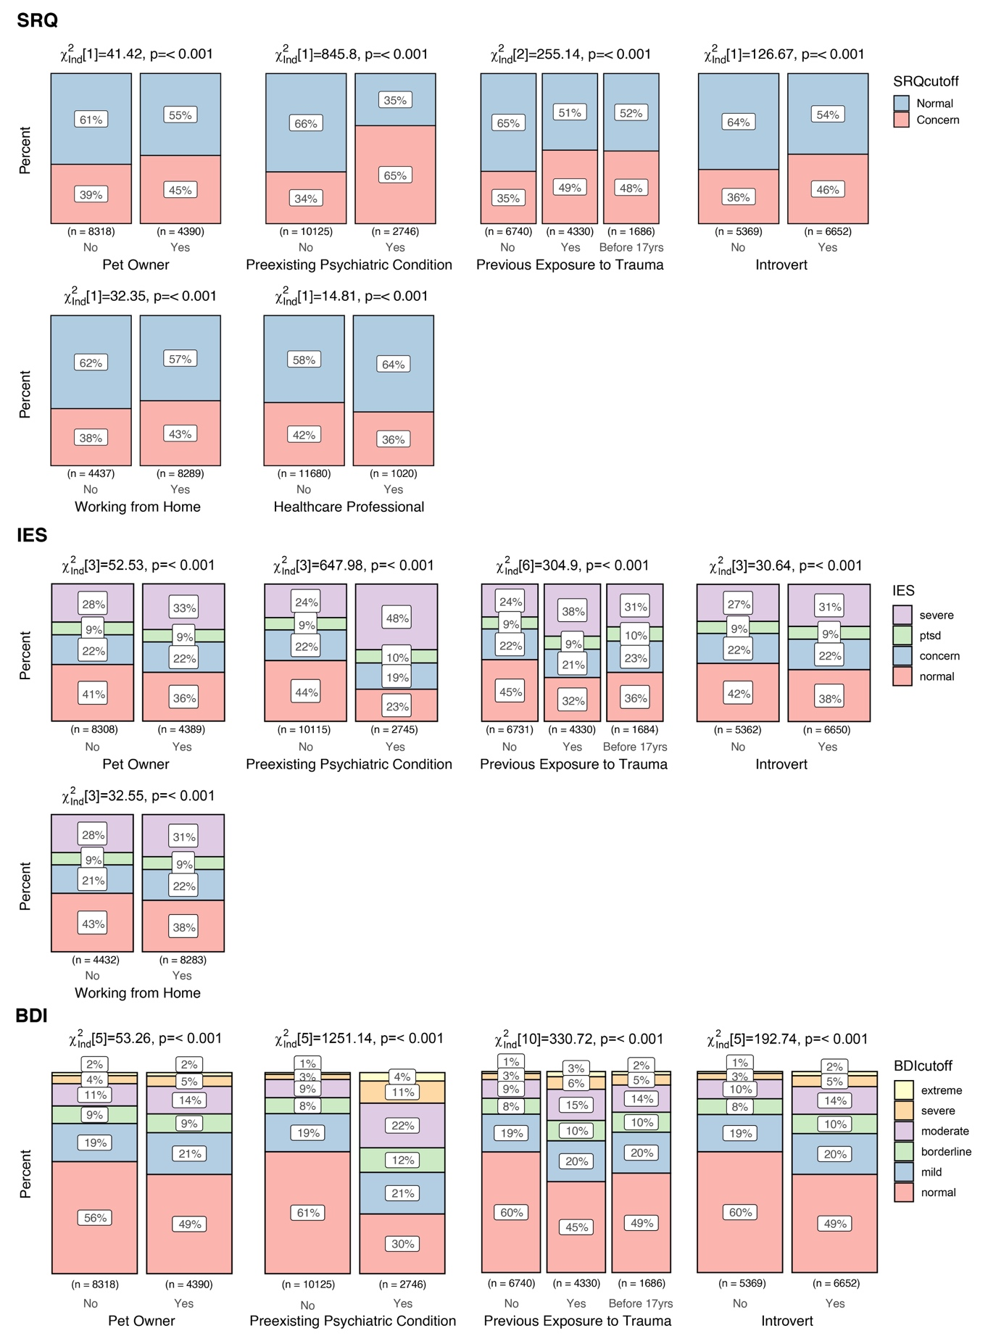

Item S4 Association of participant demographics/characteristics and categorical classifications for general psychological disturbance (SRQ), PTSD risk (IES) and depression (BDI) in the primary assessment. These tables show results from the predictors with a significant chi-square value after correcting for multiple comparisons (Bonferroni correction for 27 tests, p<0.0019). For each predictor, the bar plot indicates the participant’s distribution across the different categories of SRQ, IES, and BDI. The cut-offs used are as follows: for SRQ normal/concern (0-7, 8-20 points); for IES normal/concern/PTSD/severe (0-23, 24-32, 33-36, 37+ points); for BDI normal/mild/borderline/moderate/severe/extreme (1-10, 11-16, 17-20, 21-30, 31-40, 40+ points). The plots include the total number and %age of participants in each category and the statistical outcomes from the chi-square test.

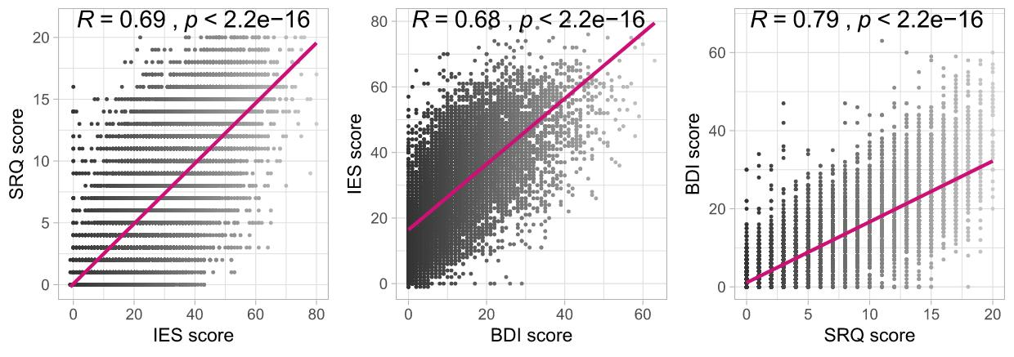

Item S5 Correlations between the SRQ, IES, and BDI scores for the primary assessment. These plots show Pearson’s correlation values for all the possible pairs of the three scales used, i.e., SRQ vs. IES, IES vs. BDI, and BDI vs. SRQ. All the correlations are statistically significant and range from 68% to 79% correlation.

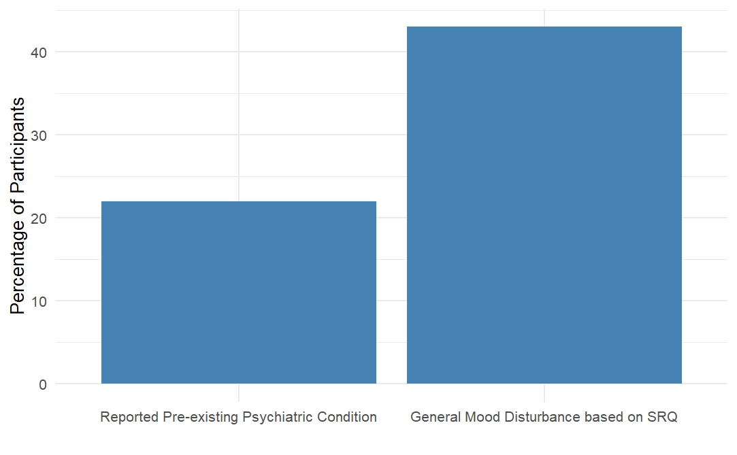
Item S5 Psychopathology potentially attributable to COVID-19. Comparison of participants reporting pre-existing psychiatric conditions (n=2,746) versus participants fulfilling the criteria for general psychological disturbance on SRQ (n=5,285).

 | BDI 11  (cut off for mild mood disturbance) | BDI 17  (cut off for borderline clinical depression) | BDI 21  (cut off for moderate depression) | Prevalence of depression  (according to WHO statistics 2017)
Bosnia and Herzegovina | 40.45% | 20.79% | 12.66% | 5.1%
Canada | 61.71% | 39.03% | 27.88% | 4.7%
France | 33.23% | 16.43% | 9.49% | 4.8%
Germany | 38.95% | 20.97% | 12.55% | 5.2%
Iran | 38.39% | 20.80% | 13.11% | 4.9%
Italy | 35.87% | 16.78% | 11.22% | 5.1%
Pakistan | 56.90% | 37.51% | 26.85% | 4.2%
Poland | 55.67% | 33.06% | 21.98% | 5.1%
Spain | 51.13% | 27.98% | 16.77% | 5.2%
Switzerland | 35.17% | 19.43% | 9.61% | 5.0%
Turkey | 39.88% | 19.10% | 12.80% | 4.4%
United States | 52.64% | 33.91% | 24.20% | 5.9%

Item S6 Psychopathology attributable to COVID-19.
Prevalence of Depression (mild mood disturbance, borderline clinical depression, and moderate depression) in the participants from the featured countries compared to previously reported prevalence according to WHO statistics from 2017 (https://www.who.int/mental_health/evidence/atlas/profiles-2017/en/)

Predictors |  | SRQ
Gender | Male | 6.03 ± 4.82
Gender | Female | 8.24 ± 4.86
Gender | Non-binary | 6.60 ± 5.25
Gender | Not disclosed | 4.50 ± 4.82
Residence | Rural | 6.98 ± 5.02
Residence | Urban | 7.08 ± 5.06
Education | Primary | 7.27 ± 2.59
Education | Secondary | 7.10 ± 5.07
Education | Bachelor | 7.23 ± 4.95
Education | Master | 7.45 ± 4.84
Education | PhD | 6.96 ± 4.44
Working position | Private employed | 6.22 ± 5.00
Working position | Public employed | 6.15 ± 4.89
Working position | Freelancer | 6.79 ± 4.45
Working position | Unemployed | 8.17 ± 5.03
Medical or healthcare professional | No | 7.32 ± 4.87
Medical or healthcare professional | Yes | 9.15 ± 4.82
Work from home | No | 7.60 ± 4.72
Work from home | Yes | 7.75 ± 4.97
Opinion on employer attitude | Not satisfied | 9.84 ± 4.83
Opinion on employer attitude | Somewhat satisfied | 7.79 ± 4.89
Opinion on employer attitude | Satisfied | 5.78 ± 4.94
Opinion on governament attitude | Not satisfied | 8.48 ± 4.84
Opinion on governament attitude | Somewhat satisfied | 7.66 ± 4.76
Opinion on governament attitude | Satisfied | 6.37 ± 5.07
Home Isolation | Not isolated | 6.85 ± 4.77
Home Isolation | Individual home isolation | 8.08 ± 4.87
Home Isolation | Home isolation with family or partner | 7.19 ± 5.49
Presence of pet at home | No pet at home | 7.39 ± 4.81
Presence of pet at home | Pet at home | 8.21 ± 4.96
Possibility to interact with family or friends | Less than usual | 7.83 ± 5.02
Possibility to interact with family or friends | Minimal interaction | 9.44 ± 4.81
Possibility to interact with family or friends | Like usual | 6.42 ± 4.75
Use of social media | Less than usual | 8.45 ± 4.74
Use of social media | Like usual | 4.98 ± 5.24
Use of social media | More than usual | 8.97 ± 4.47
Time dedicated to physical exercise | Less than 15 minutes | 8.38 ± 5.13
Time dedicated to physical exercise | More than 15 minutes | 5.95 ± 4.85
Time dedicated to physical exercise | More than 1 hour | 5.94 ± 4.71
Close person positive for COVID-19 | No | 6.62 ± 4.91
Close person positive for COVID-19 | Yes | 8.99 ± 4.82
Close person dead for COVID-19 | No | 7.28 ± 4.89
Close person dead for COVID-19 | Yes | 9.44 ± 4.73
Psychiatric Condition | Absence of psychiatric disorders | 7.25 ± 4.84
Psychiatric Condition | No changes in pre-existing psychiatric disorders | 6.86 ± 4.69
Psychiatric Condition | Worsening of pre-existing psychiatric disorders | 11.84 ± 5.12
Possibility to share concerns with professional | No | 8.67 ± 4.91
Possibility to share concerns with professional | Yes | 8.70 ± 5.04
Possibility to share concerns with family or friends | No | 9.89 ± 4.80
Possibility to share concerns with family or friends | Less than usual | 6.81 ± 4.90
Possibility to share concerns with family or friends | Like usual | 6.43 ± 4.61
Previous exposure to crisis | No | 7.68 ± 4.77
Previous exposure to crisis | Yes | 7.76 ± 5.21
Previous exposure to traumatic experiences | No | 6.88 ± 4.75
Previous exposure to traumatic experiences | Yes | 9.44 ± 5.02
Previous exposure to traumatic experiences | Yes (before 17 years old) | 7.70 ± 4.87
Personality | Extrovert | 7.14 ± 4.69
Personality | Introvert | 8.47 ± 5.06
Personality | Pessimist | 9.54 ± 5.01
Personality | Optimist | 6.07 ± 4.88
Personality | Realist | 7.38 ± 4.91
Prediction about the resolution of COVID-19 pandemic | It might be the end of human race | 7.95 ± 3.96
Prediction about the resolution of COVID-19 pandemic | It will resolve after many months or years | 8.07 ± 4.88
Prediction about the resolution of COVID-19 pandemic | It will resolve in the summer but not within a month | 6.98 ± 4.82
Prediction about the resolution of COVID-19 pandemic | It will resolve within a month | 7.43 ± 5.18
Self-opinion in COVID-19  pandemic | It is not in my control at all | 7.62 ± 4.36
Self-opinion in COVID-19  pandemic | It is not in my control but I can take precautions to protect myself | 8.00 ± 4.87
Self-opinion in COVID-19  pandemic | It is not in my control but I can take precautions to protect myself and also others | 7.78 ± 4.88

Item S7 Comparison of psychological symptoms between different participant demographics/characteristics included in the follow-up assessment. This table shows means ± standard deviations of participants’ SRQ scores divided according to different participant demographics/ characteristics and compared through unadjusted Kruskal- Wallis tests. Significant differences (p-value threshold set to <0.05) in mean scores are highlighted as bold. Each bold association indicates difference in categories reported in the predictors’ column vertically.

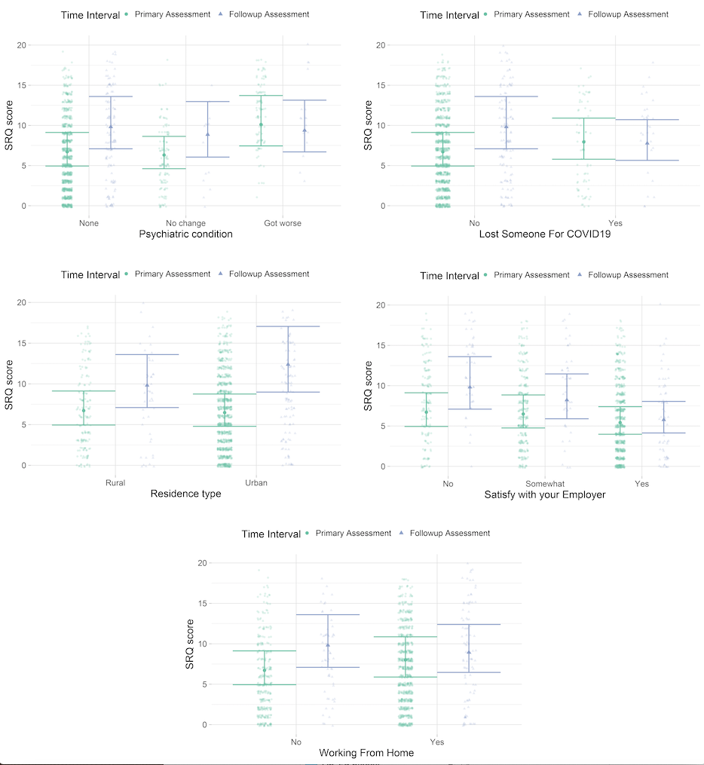

Item S8. The association between the SRQ scores and the time interval differed depending on pre-existing psychiatric condition, residence type, satisfaction with the employer, working from home and being related to someone who demised due to COVID19. These plots show the differences between the SRQ scores in the primary (in green) and follow-up assessment (in violet) for different predictors. Here, we report mean values and 95% confidence interval.

