Fig. S1 Genotyping YZHK, CY, Chinese Spring (CS, as control) and some RILs using KASP marker wMAS000003 for Yr18.
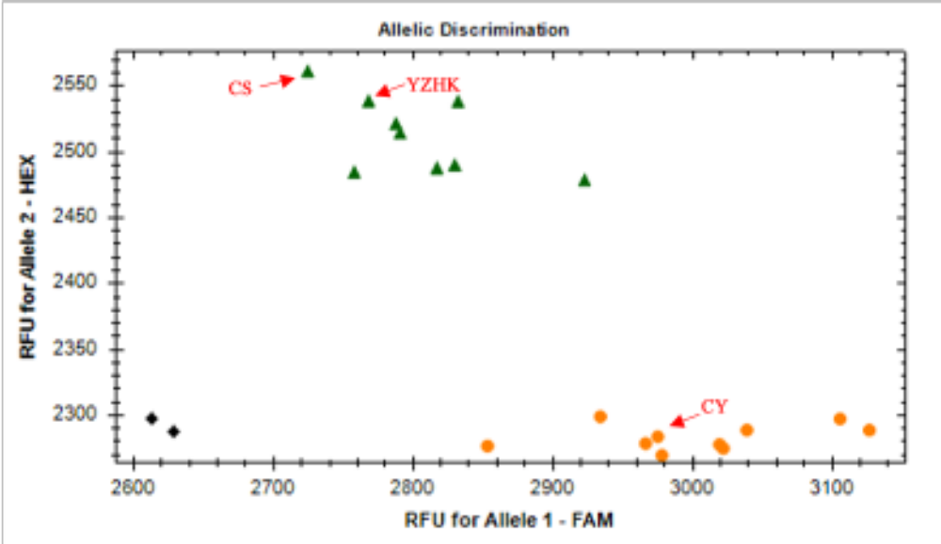
The sequence of FAM-labeled primer for KASP marker wMAS000003:
GAAGGTGACCAAGTTCATGCTCTGGTATGCCATTTAACATAATCATGAA
The sequence of HEX-labeled primer for KASP marker of wMAS000003:
GAAGGTCGGAGTCAACGGATTCTGGTATGCCATTTAACATAATCATGAT
The sequence of common primer for KASP marker of wMAS000003:
CGCATGACAATAAGTTTCACTCATGCAAA

