A candidate multi-epitope vaccine against pathogenic Chandipura vesiculovirus identified using immunoinformatics
Debashrito Deb^{1†}, Srijita Basak^{1†}, Tamalika Kar^{1†}, Utkarsh Narsaria^{1†}, Filippo Castiglione², Abhirup Paul¹, Ashutosh Pandey^{3*}, Anurag P. Srivastava^{1*}

¹Department of Life Sciences
Garden City University
Bangalore, Karnataka,
India

²Institute for Applied Computing
National Research Council of Italy
Via dei Taurini, Rome,
Italy

³National Institute of Plant Genome Research
Aruna Asaf Ali Marg, New Delhi,
India

†These authors contributed equally to this work.
* Corresponding Author
Anurag P. Srivastava: anuiitkgp@gmail.com
Phone: +91-9108720555
ORCID ID: 0000-0003-3493-1375
Ashutosh Pandey: ashutosh@nipgr.ac.in
Phone: 91-11-26741612,14,17 Ext.- 236

Supplementary Tables

Supplementary Table 1:
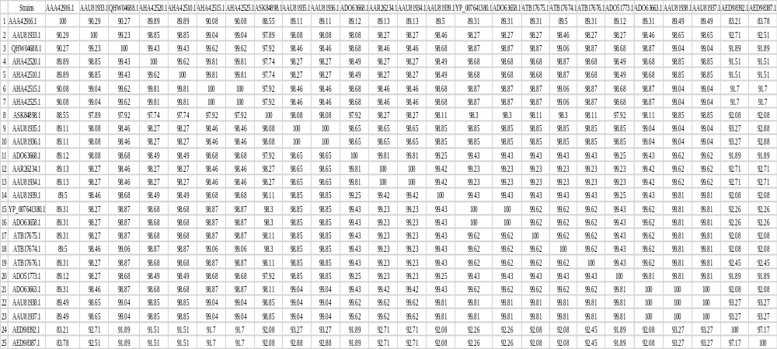
The table depicts the percentage similarity of the glycoprotein sequence retrieved from VIPR database.

Supplementary Table 2:
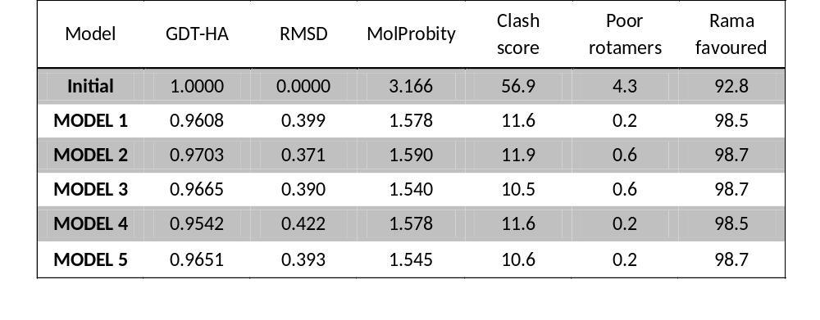
Refined models of the glycoprotein structure as predicted by GalaxyRefine server.
Supplementary Table 3:
All the CTL epitopes as predicted by NetCTL 1.2

MHC Super type | EPITOPES | PREDICTION SCORE | Antigenicity score
MHC  SUPERTYPE A1  Threshold 0.750000 | SSDIWTQWF | 2.6294 | -0.9257
MHC  SUPERTYPE A1  Threshold 0.750000 | TLSFAHTRY | 1.9245 | 1.6573
MHC  SUPERTYPE A1  Threshold 0.750000 | VTDSEFLVI | 1.7559 | 0.8977
MHC  SUPERTYPE A1  Threshold 0.750000 | VTTCDFRWY | 1.4739 | 0.7588
MHC  SUPERTYPE A1  Threshold 0.750000 | KSPGKGLAY | 1.4490 | 0.1402
MHC  SUPERTYPE A1  Threshold 0.750000 | PLSPLDLSY | 1.3424 | 2.1476
MHC  SUPERTYPE A1  Threshold 0.750000 | LILVVVLIY | 1.2476 | 0.5829
MHC  SUPERTYPE A1  Threshold 0.750000 | MTSSVTISV | 1.2084 | 0.6600
MHC  SUPERTYPE A1  Threshold 0.750000 | DCDTALASY | 1.1624 | -0.1282
MHC  SUPERTYPE A1  Threshold 0.750000 | LSEANPLDH | 1.0328 | 0.8148
MHC  SUPERTYPE A1  Threshold 0.750000 | RSDSFEMRI | 1.0281 | 0.7906
MHC  SUPERTYPE A1  Threshold 0.750000 | LISFIAPSY | 0.9910 | 0.5292
MHC  SUPERTYPE A1  Threshold 0.750000 | YASVTDSEF | 0.8097 | 1.2057
MHC  SUPERTYPE A1  Threshold 0.750000 | RSDCDTALA | 0.7949 | 0.0228
MHC  SUPERTYPE A2  Threshold 0.750000 | FIAPSYSSL | 1.2514 | 0.7870
MHC  SUPERTYPE A2  Threshold 0.750000 | MTSSVTISV | 1.1890 | 0.6600
MHC  SUPERTYPE A2  Threshold 0.750000 | YITHSIHNI | 1.1266 | 0.3353
MHC  SUPERTYPE A2  Threshold 0.750000 | FLSSTPIGA | 1.0982 | 0.6094
MHC  SUPERTYPE A2  Threshold 0.750000 | RMWIDGPVL | 1.0684 | -1.5936
MHC  SUPERTYPE A2  Threshold 0.750000 | SLAAGVVLI | 1.0375 | 0.7058
MHC  SUPERTYPE A2  Threshold 0.750000 | SVTDSEFLV | 1.0198 | 0.8494
MHC  SUPERTYPE A2  Threshold 0.750000 | LVVVLIYGV | 1.0052 | 0.3890
MHC  SUPERTYPE A2  Threshold 0.750000 | SIADDSEEI | 0.9657 | 0.1518
MHC  SUPERTYPE A2  Threshold 0.750000 | VLTSEIQRI | 0.9632 | -0.2146
MHC  SUPERTYPE A2  Threshold 0.750000 | MITPHHVGV | 0.9453 | 1.1731
MHC  SUPERTYPE A2  Threshold 0.750000 | VTISVILLI | 0.9197 | 0.6577
MHC  SUPERTYPE A2  Threshold 0.750000 | VLILVVVLI | 0.9172 | 0.5185
MHC  SUPERTYPE A2  Threshold 0.750000 | IVDNELHEL | 0.8486 | 0.2295
MHC  SUPERTYPE A2  Threshold 0.750000 | TLQSDGAQV | 0.8372 | -0.3717
MHC  SUPERTYPE A2  Threshold 0.750000 | VIMITPHHV | 0.8163 | 0.8364
MHC  SUPERTYPE A3  Threshold 0.750000 | KLDWKPVTK | 1.4391 | 2.7631
MHC  SUPERTYPE A3  Threshold 0.750000 | VTGWFTSWK | 1.3898 | -0.4720
MHC  SUPERTYPE A3  Threshold 0.750000 | YLASKSPGK | 1.3047 | 0.1730
MHC  SUPERTYPE A3  Threshold 0.750000 | ITHSIHNIK | 1.2911 | 0.5568
MHC  SUPERTYPE A3  Threshold 0.750000 | IAAGAIVFK | 1.2847 | 1.2717
MHC  SUPERTYPE A3  Threshold 0.750000 | RIFKPNNMR | 1.2529 | -1.0667
MHC  SUPERTYPE A3  Threshold 0.750000 | LLKTAGGYK | 1.2156 | -0.4223
MHC  SUPERTYPE A3  Threshold 0.750000 | LISFIAPSY | 1.1119 | 0.5292
MHC  SUPERTYPE A3  Threshold 0.750000 | TLSFAHTRY | 1.0937 | 1.6573
MHC  SUPERTYPE A3  Threshold 0.750000 | SIAFPENTK | 1.0658 | 0.7369
MHC  SUPERTYPE A3  Threshold 0.750000 | LILVVVLIY | 0.9478 | 0.5829
MHC  SUPERTYPE A3  Threshold 0.750000 | KSPGKGLAY | 0.9456 | 0.1402
MHC  SUPERTYPE A3  Threshold 0.750000 | VVLIYGVLR | 0.8758 | -0.0181
MHC  SUPERTYPE A3  Threshold 0.750000 | GLLKTAGGY | 0.8598 | -0.4448
MHC  SUPERTYPE A3  Threshold 0.750000 | SIHNIKPTR | 0.8364 | 1.2080
MHC  SUPERTYPE A3  Threshold 0.750000 | EIGPNGLLK | 0.7965 | 0.5872
MHC  SUPERTYPE A3  Threshold 0.750000 | TTCRKPKWK | 0.7965 | 0.3909
MHC  SUPERTYPE A24  Threshold 0.750000 | SYSSLSIAF | 1.8603 | 1.6016
MHC  SUPERTYPE A24  Threshold 0.750000 | GYKFPWHLI | 1.3465 | 0.4265
MHC  SUPERTYPE A24  Threshold 0.750000 | DYSLCQNTW | 1.2415 | -0.5291
MHC  SUPERTYPE A24  Threshold 0.750000 | AYTVINGTL | 1.1791 | 0.3274
MHC  SUPERTYPE A24  Threshold 0.750000 | VTISVILLI | 1.1325 | 0.6577
MHC  SUPERTYPE A24  Threshold 0.750000 | VLILVVVLI | 1.0035 | 0.5185
MHC  SUPERTYPE A24  Threshold 0.750000 | RYCPMGGEW | 0.9321 | 1.7905
MHC  SUPERTYPE A24  Threshold 0.750000 | PWHLIGMGI | 0.8353 | 1.4485
MHC  SUPERTYPE A24  Threshold 0.750000 | VWIPADQTK | 0.7803 | 0.2161
MHC  SUPERTYPE A26  Threshold 0.750000 | TVINGTLSF | 1.8952 | 0.8432
MHC  SUPERTYPE A26  Threshold 0.750000 | DIWTQWFKY | 1.7933 | -0.9288
MHC  SUPERTYPE A26  Threshold 0.750000 | EIAAGAIVF | 1.4097 | 0.9015
MHC  SUPERTYPE A26  Threshold 0.750000 | SVILLISFI | 1.3766 | 0.4922
MHC  SUPERTYPE A26  Threshold 0.750000 | DTIHNSSVW | 1.2943 | -0.3822
MHC  SUPERTYPE A26  Threshold 0.750000 | EIFFGDTGV | 1.0969 | 1.0213
MHC  SUPERTYPE A26  Threshold 0.750000 | VTISVILLI | 0.8856 | 0.6577
MHC  SUPERTYPE A26  Threshold 0.750000 | YITHSIHNI | 0.8766 | 0.3353
MHC  SUPERTYPE A26  Threshold 0.750000 | DCDTALASY | 0.8587 | -0.1282
MHC  SUPERTYPE A26  Threshold 0.750000 | SEIQRILDY | 0.7852 | -0.2312
MHC  SUPERTYPE A26  Threshold 0.750000 | FIAPSYSSL | 0.7629 | 0.7870
MHC  SUPERTYPE B7  Threshold 0.750000 | APSYSSLSI | 1.7514 | 1.1994
MHC  SUPERTYPE B7  Threshold 0.750000 | GPKYITHSI | 1.4945 | 0.0433
MHC  SUPERTYPE B7  Threshold 0.750000 | KPNNMRARV | 1.4652 | -0.2025
MHC  SUPERTYPE B7  Threshold 0.750000 | FPNGEWVSL | 1.4247 | 0.7309
MHC  SUPERTYPE B7  Threshold 0.750000 | TPSKSDGFL | 1.2884 | -0.0449
MHC  SUPERTYPE B7  Threshold 0.750000 | SPSGISSDI | 1.1195 | 0.1897
MHC  SUPERTYPE B7  Threshold 0.750000 | LASYKSGTL | 1.0988 | 0.6539
MHC  SUPERTYPE B7  Threshold 0.750000 | FIAPSYSSL | 0.9611 | 0.7870
MHC  SUPERTYPE B7  Threshold 0.750000 | TVINGTLSF | 0.9464 | 0.8432
MHC  SUPERTYPE B7  Threshold 0.750000 | TPLTVTVAY | 0.9172 | 1.1308
MHC  SUPERTYPE B7  Threshold 0.750000 | KPVTKNTRY | 0.8924 | 0.9326
MHC  SUPERTYPE B7  Threshold 0.750000 | LPLFKECPA | 0.8530 | -0.7984
MHC  SUPERTYPE B7  Threshold 0.750000 | GARTCRLSY | 0.8419 | 0.9325
MHC  SUPERTYPE B7  Threshold 0.750000 | GVSKNPVEL | 0.8009 | 0.3480
MHC  SUPERTYPE B7  Threshold 0.750000 | AGTEVRSTL | 0.7513 | 1.0448
MHC  SUPERTYPE B8  Threshold 0.750000 | FAHTRYVRM | 1.8335 | 0.8252
MHC  SUPERTYPE B8  Threshold 0.750000 | FIAPSYSSL | 1.2267 | 0.7870
MHC  SUPERTYPE B8  Threshold 0.750000 | YDKTKEIAA | 1.0473 | 0.5514
MHC  SUPERTYPE B8  Threshold 0.750000 | YASVTDSEF | 0.8677 | 1.2057
MHC  SUPERTYPE B8  Threshold 0.750000 | FKSKYHSHM | 0.8167 | 0.8414
MHC  SUPERTYPE B8  Threshold 0.750000 | VVVLIYGVL | 0.8076 | 0.1688
MHC  SUPERTYPE B8  Threshold 0.750000 | IQRILDYSL | 0.7691 | 0.1654
MHC  SUPERTYPE B27  Threshold 0.750000 | YRGHWVDPL | 1.2468 | 0.9293
MHC  SUPERTYPE B27  Threshold 0.750000 | FRWYGPKYI | 1.0466 | -0.8385
MHC  SUPERTYPE B27  Threshold 0.750000 | GRNGIKFPN | 1.0178 | 0.9769
MHC  SUPERTYPE B27  Threshold 0.750000 | VRMWIDGPV | 0.8043 | -1.9089
MHC  SUPERTYPE B27  Threshold 0.750000 | MRIFKPNNM | 0.7527 | -0.4064
MHC  SUPERTYPE B39  Threshold 0.750000 | YRGHWVDPL | 2.1666 | 0.9293
MHC  SUPERTYPE B39  Threshold 0.750000 | LQSDGAQVL | 1.6637 | -0.5963
MHC  SUPERTYPE B39  Threshold 0.750000 | TRSDCDTAL | 1.5398 | 0.0542
MHC  SUPERTYPE B39  Threshold 0.750000 | FIAPSYSSL | 1.5079 | 0.7870
MHC  SUPERTYPE B39  Threshold 0.750000 | IQEKPLLPL | 1.1610 | 1.0934
MHC  SUPERTYPE B39  Threshold 0.750000 | LAAGVVLIL | 1.0573 | 0.4718
MHC  SUPERTYPE B39  Threshold 0.750000 | FPNGEWVSL | 1.0538 | 0.7309
MHC  SUPERTYPE B39  Threshold 0.750000 | IVDNELHEL | 0.9212 | 0.2295
MHC  SUPERTYPE B39  Threshold 0.750000 | HELSEANPL | 0.9116 | 0.6151
MHC  SUPERTYPE B39  Threshold 0.750000 | SSVTISVIL | 0.7897 | 0.5525
MHC  SUPERTYPE B39  Threshold 0.750000 | ESLAAGVVL | 0.7504 | 0.6332
MHC  SUPERTYPE B44  Threshold 0.750000 | GEWFLEPGL | 1.9531 | 0.5832
MHC  SUPERTYPE B44  Threshold 0.750000 | MEIGPNGLL | 1.7131 | 1.0283
MHC  SUPERTYPE B44  Threshold 0.750000 | KEPLSPLDL | 1.6656 | 1.1289
MHC  SUPERTYPE B44  Threshold 0.750000 | HELSEANPL | 1.6626 | 0.6151
MHC  SUPERTYPE B44  Threshold 0.750000 | KECPAGTEV | 1.4376 | 0.9987
MHC  SUPERTYPE B44  Threshold 0.750000 | MEGARTCRL | 1.3731 | 0.5500
MHC  SUPERTYPE B44  Threshold 0.750000 | KEIAAGAIV | 1.2633 | 0.9591
MHC  SUPERTYPE B44  Threshold 0.750000 | VERSDSFEM | 1.2042 | 0.6748
MHC  SUPERTYPE B44  Threshold 0.750000 | QEKPLLPLF | 1.1076 | 0.4555
MHC  SUPERTYPE B44  Threshold 0.750000 | PESCGYASV | 0.8906 | 0.3084
MHC  SUPERTYPE B44  Threshold 0.750000 | SEFLVIMIT | 0.8422 | 0.6194
MHC  SUPERTYPE B44  Threshold 0.750000 | SEIQRILDY | 0.7626 | -0.2312
MHC  SUPERTYPE B58  Threshold 0.750000 | ISSDIWTQW | 1.9941 | -0.6628
MHC  SUPERTYPE B58  Threshold 0.750000 | TAGGYKFPW | 1.6909 | 0.5644
MHC  SUPERTYPE B58  Threshold 0.750000 | YASVTDSEF | 1.5850 | 1.2057
MHC  SUPERTYPE B58  Threshold 0.750000 | ISVILLISF | 1.4998 | 0.7989
MHC  SUPERTYPE B58  Threshold 0.750000 | LVTGWFTSW | 1.3961 | -0.4595
MHC  SUPERTYPE B58  Threshold 0.750000 | WVTTCDFRW | 1.3416 | 0.9221
MHC  SUPERTYPE B58  Threshold 0.750000 | RGHWVDPLF | 1.2375 | 1.2142
MHC  SUPERTYPE B58  Threshold 0.750000 | DTIHNSSVW | 1.1874 | -0.3822
MHC  SUPERTYPE B58  Threshold 0.750000 | CTTCRKPKW | 1.1801 | 1.1507
MHC  SUPERTYPE B58  Threshold 0.750000 | IAFPENTKL | 1.1198 | 0.6395
MHC  SUPERTYPE B58  Threshold 0.750000 | IADDSEEIF | 1.0769 | -0.3213
MHC  SUPERTYPE B58  Threshold 0.750000 | TVINGTLSF | 1.0452 | 0.8432
MHC  SUPERTYPE B58  Threshold 0.750000 | RYCPMGGEW | 1.0401 | 1.7905
MHC  SUPERTYPE B58  Threshold 0.750000 | LAAGVVLIL | 1.0303 | 0.4718
MHC  SUPERTYPE B58  Threshold 0.750000 | VTISVILLI | 0.9796 | 0.6577
MHC  SUPERTYPE B58  Threshold 0.750000 | TLSFAHTRY | 0.9563 | 1.6573
MHC  SUPERTYPE B58  Threshold 0.750000 | GGYKFPWHL | 0.9230 | 0.2804
MHC  SUPERTYPE B58  Threshold 0.750000 | GAIVFKSKY | 0.9180 | 1.9399
MHC  SUPERTYPE B58  Threshold 0.750000 | LISFIAPSY | 0.8680 | 0.5292
MHC  SUPERTYPE B58  Threshold 0.750000 | KGVERSDSF | 0.8649 | 0.8569
MHC  SUPERTYPE B58  Threshold 0.750000 | GVDDYRGHW | 0.8531 | 1.3094
MHC  SUPERTYPE B58  Threshold 0.750000 | RSDSFEMRI | 0.8400 | 0.7906
MHC  SUPERTYPE B58  Threshold 0.750000 | LILVVVLIY | 0.7505 | 0.5829
MHC  SUPERTYPE B62  Threshold 0.750000 | TVINGTLSF | 1.4309 | 0.8432
MHC  SUPERTYPE B62  Threshold 0.750000 | LQSDGAQVL | 1.3071 | -0.5963
MHC  SUPERTYPE B62  Threshold 0.750000 | KSPGKGLAY | 1.2963 | 0.1402
MHC  SUPERTYPE B62  Threshold 0.750000 | LISFIAPSY | 1.2121 | 0.5292
MHC  SUPERTYPE B62  Threshold 0.750000 | RMWIDGPVL | 1.1894 | -1.5936
MHC  SUPERTYPE B62  Threshold 0.750000 | EIAAGAIVF | 1.1853 | 0.9015
MHC  SUPERTYPE B62  Threshold 0.750000 | IQRILDYSL | 1.1641 | 0.1654
MHC  SUPERTYPE B62  Threshold 0.750000 | YASVTDSEF | 1.1512 | 1.2057
MHC  SUPERTYPE B62  Threshold 0.750000 | GARTCRLSY | 1.0727 | 0.9325
MHC  SUPERTYPE B62  Threshold 0.750000 | GLLKTAGGY | 1.0421 | -0.4448
MHC  SUPERTYPE B62  Threshold 0.750000 | PLSPLDLSY | 1.0400 | 2.1476
MHC  SUPERTYPE B62  Threshold 0.750000 | LILVVVLIY | 1.0357 | 0.5829
MHC  SUPERTYPE B62  Threshold 0.750000 | IQEKPLLPL | 1.0263 | 1.0934
MHC  SUPERTYPE B62  Threshold 0.750000 | ISVILLISF | 1.0211 | 0.7989
MHC  SUPERTYPE B62  Threshold 0.750000 | TLSFAHTRY | 0.9975 | 1.6573
MHC  SUPERTYPE B62  Threshold 0.750000 | LIYGVLRCF | 0.9734 | -0.2853
MHC  SUPERTYPE B62  Threshold 0.750000 | FIAPSYSSL | 0.9097 | 0.7870
MHC  SUPERTYPE B62  Threshold 0.750000 | SEIQRILDY | 0.8793 | -0.2312
MHC  SUPERTYPE B62  Threshold 0.750000 | KGVERSDSF | 0.8760 | 0.8569
MHC  SUPERTYPE B62  Threshold 0.750000 | RGHWVDPLF | 0.8272 | 1.2142
MHC  SUPERTYPE B62  Threshold 0.750000 | VGGECDQSY | 0.8128 | 0.4486
MHC  SUPERTYPE B62  Threshold 0.750000 | GAIVFKSKY | 0.7750 | 1.9399

Supplementary Table 4:
All the HTL epitopes as predicted by NetMHC II pan 3.2

Epitopes(Position) | HLA alleles II | Score | Antigenicity
SEFLVIMITPHHVGV(143) | DRB1*01:01 | 0.40 | 0.8996
SEFLVIMITPHHVGV(143) | DRB1*04:05 | 0.07 | 0.8996
SEFLVIMITPHHVGV(143) | DRB1*04:01 | 0.17 | 0.8996
SEFLVIMITPHHVGV(143) | DRB1*07:01 | 1.20 | 0.8996
SEFLVIMITPHHVGV(143) | DRB1*08:02 | 0.03 | 0.8996
SEFLVIMITPHHVGV(143) | DRB1*11:01 | 0.80 | 0.8996
SEFLVIMITPHHVGV(143) | DRB1*12:01, | 0.05 | 0.8996
SEFLVIMITPHHVGV(143) | DRB1*15:01 | 0.08 | 0.8996
SEFLVIMITPHHVGV(143) | DRB4*01:01 | 0.04 | 0.8996
SEFLVIMITPHHVGV(143) | DRB5*01:01 | 0.9 | 0.8996
EESFLSSTPIGATPS (59) | DRB1*09:01 | 1.80 | 0.6496
EESFLSSTPIGATPS (59) | DRB1*01:01 | 1.90 | 0.6496
EESFLSSTPIGATPS (59) | DQA1*05:01-DQB1*03:01 | 1.7 | 0.6496
RYVRMWIDGPVLKEM(353) | DRB1*03:01 | 1.20 | -0.8786
RYVRMWIDGPVLKEM(353) | DQA1*01:01-DQB1*05:01 | 1.40 | -0.8786
TRYVRMWIDGPVLKE(352) | DRB1*03:01 | 1.9 | -0.8019
TRYVRMWIDGPVLKE(352) | DQA1*01:01-DQB1*05:01 | 1.20 | -0.8019
DSEFLVIMITPHHVG(142) | DRB1*01:01 | 0.6 | 0.9377
DSEFLVIMITPHHVG(142) | DRB1*04:05 | 0.08 | 0.9377
DSEFLVIMITPHHVG(142) | DRB1*04:01 | 0.2 | 0.9377
DSEFLVIMITPHHVG(142) | DRB1*07:01 | 1.6 | 0.9377
DSEFLVIMITPHHVG(142) | DRB1*08:02 | 0.05 | 0.9377
DSEFLVIMITPHHVG(142) | DRB1*11:01 | 1.10 | 0.9377
DSEFLVIMITPHHVG(142) | DRB1*12:01 | 0.08 | 0.9377
DSEFLVIMITPHHVG(142) | DRB1*15:01 | 0.17 | 0.9377
DSEFLVIMITPHHVG(142) | DRB5*01:01 | 1.20 | 0.9377
DSEFLVIMITPHHVG(142) | DRB4*01:01 | 0.06 | 0.9377
TDSEFLVIMITPHHV(141) | DRB1*01:01 | 1.0 | 0.7730
TDSEFLVIMITPHHV(141) | DRB1*04:05 | 0.08 | 0.7730
TDSEFLVIMITPHHV(141) | DRB1*04:01 | 0.25 | 0.7730
TDSEFLVIMITPHHV(141) | DRB1*07:01 | 1.6 | 0.7730
TDSEFLVIMITPHHV(141) | DRB1*08:02 | 0.12 | 0.7730
TDSEFLVIMITPHHV(141) | DRB1*11:01 | 1.8 | 0.7730
TDSEFLVIMITPHHV(141) | DRB1*12:01 | 0.12 | 0.7730
TDSEFLVIMITPHHV(141) | DRB1*15:01 | 0.30 | 0.7730
TDSEFLVIMITPHHV(141) | DRB4*01:01 | 0.12 | 0.7730
TDSEFLVIMITPHHV(141) | DRB5*01:01 | 1.9 | 0.7730
EFLVIMITPHHVGVD(144) | DRB1*04:05 | 0.15 | 0.9473
EFLVIMITPHHVGVD(144) | DRB1*04:01 | 0.4 | 0.9473
EFLVIMITPHHVGVD(144) | DRB1*08:02 | 0.04 | 0.9473
EFLVIMITPHHVGVD(144) | DRB1*12:01 | 0.07 | 0.9473
EFLVIMITPHHVGVD(144) | DRB1*01:01 | 0.6 | 0.9473
EFLVIMITPHHVGVD(144) | DRB1*07:01 | 1.6 | 0.9473
EFLVIMITPHHVGVD(144) | DRB1*11:01 | 1.0 | 0.9473
EFLVIMITPHHVGVD(144) | DRB1*15:01 | 0.15 | 0.9473
EFLVIMITPHHVGVD(144) | DRB4*01:01 | 0.06 | 0.9473
EFLVIMITPHHVGVD(144) | DRB5*01:01 | 1.2 | 0.9473
VTDSEFLVIMITPHH(140) | DRB1*04:05 | 0.4 | 0.8319
VTDSEFLVIMITPHH(140) | DRB1*04:01 | 1.0 | 0.8319
VTDSEFLVIMITPHH(140) | DRB1*08:02 | 1.10 | 0.8319
VTDSEFLVIMITPHH(140) | DRB1*12:01 | 2.0 | 0.8319
VTDSEFLVIMITPHH(140) | DRB4*01:01 | 1.0 | 0.8319
FLVIMITPHHVGVDD(145) | DRB1*01:01 | 1.0 | 0.9586
FLVIMITPHHVGVDD(145) | DRB1*04:01 | 1.0 | 0.9586
FLVIMITPHHVGVDD(145) | DRB1*04:05 | 0.6 | 0.9586
FLVIMITPHHVGVDD(145) | DRB1*08:02 | 0.09 | 0.9586
FLVIMITPHHVGVDD(145) | DRB1*11:01 | 1.4 | 0.9586
FLVIMITPHHVGVDD(145) | DRB1*12:01 | 0.15 | 0.9586
FLVIMITPHHVGVDD(145) | DRB1*15:01 | 0.25 | 0.9586
FLVIMITPHHVGVDD(145) | DRB5*01:01 | 1.7 | 0.9586
FLVIMITPHHVGVDD(145) | DRB4*01:01 | 0.12 | 0.9586
VILLISFIAPSYSSL(9) | DRB1*04:05 | 1.0 | 0.6578
VILLISFIAPSYSSL(9) | DQA1*01:01-DQB1*05:01 | 0.80 | 0.6578
VILLISFIAPSYSSL(9) | DRB1*08:02 | 1.5 | 0.6578
VILLISFIAPSYSSL(9) | DRB1*12:01 | 0.6 | 0.6578
VILLISFIAPSYSSL(9) | DRB1*15:01 | 0.6 | 0.6578
ILLISFIAPSYSSLS(10) | DRB1*04:05 | 1.10 | 0.8075
ILLISFIAPSYSSLS(10) | DRB1*04:01 | 1.7 | 0.8075
ILLISFIAPSYSSLS(10) | DRB1*08:02 | 1.50 | 0.8075
ILLISFIAPSYSSLS(10) | DRB1*09:01 | 1.6 | 0.8075
ILLISFIAPSYSSLS(10) | DRB1*12:01 | 0.7 | 0.8075
ILLISFIAPSYSSLS(10) | DRB1*15:01 | 0.6 | 0.8075
ILLISFIAPSYSSLS(10) | DQA1*01:01-D QB1*05:01 | 1.30 | 0.8075
SVILLISFIAPSYSS(8) | DRB1*04:05 | 1.10 | 0.5617
SVILLISFIAPSYSS(8) | DRB1*08:02 | 1.6 | 0.5617
SVILLISFIAPSYSS(8) | DRB1*12:01 | 0.6 | 0.5617
SVILLISFIAPSYSS(8) | DRB1*15:01, | 0.7 | 0.5617
SVILLISFIAPSYSS(8) | DQA1*01:01-DQB1*05:01 | 0.80 | 0.5617
SVILLISFIAPSYSS(8) | DRB4*01:01 | 2.0 | 0.5617
LLISFIAPSYSSLSI(11) | DRB1*04:05 | 1.4 | 0.9417
LLISFIAPSYSSLSI(11) | DRB1*04:01 | 1.4 | 0.9417
LLISFIAPSYSSLSI(11) | DRB1*09:01 | 1.10 | 0.9417
LLISFIAPSYSSLSI(11) | DRB1*12:01 | 1.30 | 0.9417
LLISFIAPSYSSLSI(11) | DRB1*15:01 | 0.9 | 0.9417
LLISFIAPSYSSLSI(11) | DRB4*01:01 | 2.0 | 0.9417
ISVILLISFIAPSYS(7) | DRB1*04:05 | 1.9 | 0.6124
ISVILLISFIAPSYS(7) | DRB1*12:01 | 0.9 | 0.6124
ISVILLISFIAPSYS(7) | DRB1*15:01 | 1.2 | 0.6124
ISVILLISFIAPSYS(7) | DQA1*01:01-DQB1*05:01 | 0.80 | 0.6124
LISFIAPSYSSLSIA(12) | DRB1*04:01 | 1.5 | 0.9608
LISFIAPSYSSLSIA(12) | DRB1*09:01 | 1.3 | 0.9608
ISFIAPSYSSLSIAF(13) | DRB1*04:01 | 1.6 | 1.3966
ISFIAPSYSSLSIAF(13) | DRB1*09:01 | 1.2 | 1.3966
GTLSFAHTRYVRMWI(345) | DPA1*02:01-DPB1*01:01 | 1.20 | 0.5170
GTLSFAHTRYVRMWI(345) | DPA1*01:03-DPB1*02:01 | 1.40 | 0.5170
GTLSFAHTRYVRMWI(345) | DPA1*01:03-DPB1*04:01 | 1.20 | 0.5170
GTLSFAHTRYVRMWI(345) | DPA1*02:01-DPB1*05:01 | 1.50 | 0.5170
GTLSFAHTRYVRMWI(345) | DRB1*07:01 | 0.5 | 0.5170
GTLSFAHTRYVRMWI(345) | DRB1*09:01 | 1.20 | 0.5170
NGTLSFAHTRYVRMW(344) | DPA1*02:01-DPB1*01:01 | 1.90 | 0.5929
NGTLSFAHTRYVRMW(344) | DPA1*01:03-DPB1*04:01 | 2.0 | 0.5929
NGTLSFAHTRYVRMW(344) | DRB1*07:01, | 0.5 | 0.5929
NGTLSFAHTRYVRMW(344) | DRB1*09:01 | 1.2 | 0.5929
INGTLSFAHTRYVRM(343) | DRB1*07:01 | 0.6 | 1.0736
INGTLSFAHTRYVRM(343) | DRB1*09:01 | 1.4 | 1.0736
TLSFAHTRYVRMWID(346) | DPA1*01:03-DPB1*02:01 | 1.9 | 0.3028
TLSFAHTRYVRMWID(346) | DPA1*01:03-DPB1*04:01 | 1.6 | 0.3028
TLSFAHTRYVRMWID(346) | DRB1*07:01 | 0.9 | 0.3028
TLSFAHTRYVRMWID(346) | DPA1*02:01-DPB1*01:01 | 1.5 | 0.3028
FTSWKESLAAGVVLI(467) | DRB1*07:01 | 0.9 | 0.3585
FTSWKESLAAGVVLI(467) | DRB1*09:01 | 0.5 | 0.3585
WFTSWKESLAAGVVL(466) | DRB1*07:01 | 1.2 | 0.1022
WFTSWKESLAAGVVL(466) | DRB1*09:01 | 0.6 | 0.1022
TSWKESLAAGVVLIL(468) | DRB1*07:01 | 1.4 | 0.3906
TSWKESLAAGVVLIL(468) | DRB1*09:01 | 0.8 | 0.3906
LVIMITPHHVGVDDY(146) | DRB4*01:01 | 0.7 | 0.9713
LVIMITPHHVGVDDY(146) | DRB1*15:01 | 1.20 | 0.9713
LVIMITPHHVGVDDY(146) | DRB1*12:01 | 0.80 | 0.9713
LVIMITPHHVGVDDY(146) | DRB1*08:02 | 0.80 | 0.9713
FEMRIFKPNNMRARV(516) | DRB4*01:01 | 1.4 | -0.0981
FEMRIFKPNNMRARV(516) | DRB1*15:01 | 1.10 | -0.0981
FEMRIFKPNNMRARV(516) | DRB3*02:02 | 0.9 | -0.0981
FEMRIFKPNNMRARV(516) | DQA1*01:02-DQB1*06:02 | 0.10 | -0.0981
FEMRIFKPNNMRARV(516) | DQA1*05:01-DQB1*03:01, | 0.30 | -0.0981
KTKEIAAGAIVFKSK(214) | DPA1*02:01-DPB1*14:01 | 1.8 | 1.6029
KTKEIAAGAIVFKSK(214) | DQA1*01:02-DQB1*06:02 | 0.17 | 1.6029
KTKEIAAGAIVFKSK(214) | DPA1*02:01-DPB1*14:01 | 1.8 | 1.6029
KTKEIAAGAIVFKSK(214) | DQA1*05:01-DQB1*03:01 | 0.40 | 1.6029
KEIAAGAIVFKSKYH(216) | DQA1*05:01-DQB1*03:01 | 0.40 | 1.2815
KEIAAGAIVFKSKYH(216) | DQA1*01:02-DQB1*06:02 | 0.40 | 1.2815
DKTKEIAAGAIVFKS(213) | DQA1*05:01-DQB1*03:01 | 0.80 | 1.0547
DKTKEIAAGAIVFKS(213) | DQA1*01:02-DQB1*06:02 | 0.5 | 1.0547
EIAAGAIVFKSKYHS(217) | DQA1*03:01-DQB1*03:02 | 1.4 | 1.2401
EIAAGAIVFKSKYHS(217) | DQA1*04:01-DQB1*04:02 | 1.5 | 1.2401
APSYSSLSIAFPENT(17) | DQA1*05:01-DQB1*03:01 | 1.6 | 0.7421
APSYSSLSIAFPENT(17) | DQA1*04:01-DQB1*04:02 | 1.7 | 0.7421
IAPSYSSLSIAFPEN (16) | DQA1*03:01-DQB1*03:02 | 1.5 | 0.9365
IAPSYSSLSIAFPEN (16) | DQA1*04:01-DQB1*04:02 | 1.8 | 0.9365
FIAPSYSSLSIAFPE (15) | DQA1*01:02-DQB1*06:02 | 0.1 | 0.8800
FIAPSYSSLSIAFPE (15) | DQA1*05:01-DQB1*03:01 | 0.3 | 0.8800
TKEIAAGAIVFKSKY(215) | DQA1*05:01-DQB1*03:01 | 1.9 | 1.2855
TKEIAAGAIVFKSKY(215) | DQA1*01:02-DQB1*06:02 | 2.0 | 1.2855
IAAGAIVFKSKYHSH(218) | DQA1*05:01-DQB1*03:01 | 1.9 | 1.1593
IAAGAIVFKSKYHSH(218) | DQA1*01:02-DQB1*06:02 | 2.0 | 1.1593

Supplementary Table 5:
Overlapping HTL and CTL epitopes
Epitopes(Position) | HLA alleles II | HLA class I supertype
SEFLVIMITPHHVGV(143) | DRB1*01:01,DRB1*04:05DRB1*04:01,DRB1*07:01DRB1*08:02,DRB1*12:01,DRB1*15:01,DRB4*01:01,DRB5*01:01, | A2,B44,HLA-A*68:02,HLA-A*02:06, HLA-A*02:03,HLA-A*02:01, HLA-B*44:03
TDSEFLVIMITPHHV(141) | DRB1*01:01,DRB1*04:05,DRB1*04:01,DRB1*07:01,DRB1*08:02,DRB1*11:01,DRB1*12:01,DRB1*15:01,DRB4*01:01,DRB5*01:01 | A2,B44,HLA-B*44:03,HLA-A*02:01,HLA-A*02:03
FLVIMITPHHVGVDD(145) | DRB1*01:01,DRB1*04:01,DRB1*04:05,DRB1*08:02,DRB1*11:01,DRB1*12:01,DRB1*15:01,DRB5*01:01,DRB4*01:01 | A2,HLA-A*68:02,HLA-A*02:06,HLA-A*02:03,HLA-A*02:01
SVILLISFIAPSYSS(8) | DRB1*04:05,DRB1*08:02,DRB1*12:01,DRB1*15:01,DQA1*01:01-DQB1*05:01,DRB4*0101 | A1,A2,A3,A26,B58,B62,HLA-B*35:01,HLA-A*02:03,HLA-A*68:02,HLA-B*15:01,HLA-A*02:01,HLA-A*30:02
GTLSFAHTRYVRMWI(345) | DPA1*02:01-DPB1*01:01,DPA1*01:03-DPB1*02:01,DPA1*01:03-DPB1*04:01,DPA1*02:01-DPB1*05:01,DRB1*07:01,DRB1*09:01 | B62, B58, B8, A3, A1,HLA-A*30:01,HLA-B*08:01,HLA-A*31:01,HLA-A*33:01,HLA-A*68:01,HLA-A*11:01,HLA-A*30:02,HLA-B*35:01HLA-A*68:02
NGTLSFAHTRYVRMW(344) | DPA1*02:01-DPB1*01:01,DPA1*01:03-DPB1*04:01,DRB1*07:01,,DRB1*09:01 | A1, A3, B8, B58, B62,HLA-A*31:01,HLA-B*08:01,HLA-A*33:01,HLA-A*68:01,HLA-A*11:01,HLA-A*30:02,HLA-B*35:01
KTKEIAAGAIVFKSK(214) | DPA1*02:01-DPB1*14:01,DQA1*01:02-DQB1*06:02,DPA1*02:01-DPB1*14:01,DQA1*05:01-DQB1*03:01 | A3, B62,HLA-B*15:01,HLA-B*35:01,HLA-A*30:01,HLA-B*44:03,HLA-A*03:01,HLA-A*11:01,HLA-A*26:01,HLA-A*30:01,HLA-A*68:01HLA-B*40:01

Supplementary Table 6:
IFN Gamma Epitopes as predicted by IFN Epitope Server: The selected epitopes are shown in bold format.
IFN GAMMA EPITOPES | SCORE
LDHPQLPHAQSIADD(429) | 5
SEANPLDHPQLPHAQ(424) | 4
EANPLDHPQLPHAQS(425) | 4
ANPLDHPQLPHAQSI(426) | 4
NPLDHPQLPHAQSIA(427) | 4
PLDHPQLPHAQSIAD(428) | 4
DHPQLPHAQSIADDS(430) | 4
HPQLPHAQSIADDSE(431) | 4
PQLPHAQSIADDSEE (432) | 3
PVTKNTRYCPMGGEW(36) | 2
VTKNTRYCPMGGEWF (37) | 2
TKNTRYCPMGGEWFL(38) | 2
GKGLAYTVINGTLSF(334) | 2
KGLAYTVINGTLSFA(335) | 2
GLAYTVINGTLSFAH(336) | 2
LAYTVINGTLSFAHT(337) | 2
AYTVINGTLSFAHTR(338) | 2
YTVINGTLSFAHTRY(339) | 2
TVINGTLSFAHTRYV(340) | 2
ELSEANPLDHPQLPH(422) | 2
LSEANPLDHPQLPHA(423) | 2
ADDSEEIFFGDTGVS(441) | 2
DDSEEIFFGDTGVSK(442) | 2
DSEEIFFGDTGVSKN(443) | 2
SEEIFFGDTGVSKNP(444) | 2
EEIFFGDTGVSKNPV(445) | 2
EIFFGDTGVSKNPVE(446) | 2
IFFGDTGVSKNPVEL(447) | 2
FFGDTGVSKNPVELV(448) | 2
LDWKPVTKNTRYCPM(32) | 1
DWKPVTKNTRYCPMG(33) | 1
WKPVTKNTRYCPMGG(34) | 1
KPVTKNTRYCPMGGE(35) | 1
KNTRYCPMGGEWFLE(39) | 1
NTRYCPMGGEWFLEP(40) | 1
TRYCPMGGEWFLEPG(41) | 1
RYCPMGGEWFLEPGL(42) | 1
YCPMGGEWFLEPGLQ(43) | 1
CPMGGEWFLEPGLQE(44) | 1
DGFLCHAAKWVTTCD(75) | 1
GFLCHAAKWVTTCDF(76) | 1
FLCHAAKWVTTCDFR(77) | 1
FRWYGPKYITHSIHN(90) | 1
RWYGPKYITHSIHNI(91) | 1
WYGPKYITHSIHNIK(92) | 1
YGPKYITHSIHNIKP(93) | 1
GPKYITHSIHNIKPT(94) | 1
PKYITHSIHNIKPTR(95) | 1
CRLSYCGRNGIKFPN(238) | 1
RLSYCGRNGIKFPNG(239) | 1

Supplementary Table 7:
Population Coverage of the selected HTL and CTL epitopes.
CTL EPITOPES | Percentage coverage
FPNGEWVSL | 22.88%
MTSSVTISV | 45.20%
LISFIAPSY | 22.32%
TVINGTLSF | 29.37%
TLSFAHTRY | 2.43%
EIAAGAIVF | 21.35%

HTL EPITOPES | Percentage coverage
SVILLISFIAPSYSS | 50.04%
TDSEFLVIMITPHHV | 50.46%
SEFLVIMITPHHVGV | 58.93%
FLVIMITPHHVGVDD | 44.96%
KTKEIAAGAIVFKSK | 82.77%
NGTLSFAHTRYVRMW | 92.83%
GTLSFAHTRYVRMWI | 96.22%

Supplementary Figures
Supplementary Figure S1: Phylogenetic Tree
Phylogenetic analysis of the glycoproteins of the CHPV using maximum likelihood algorithm in the MEGA X program. The accession numbers of all glycoprotein of the different strains are indicated. At each branch, bootstrap values are given.

Supplementary Figure S2: Refined glycoprotein
S2A: RAMPAGE
Number of residues in favoured region (~98.0% expected) :521 (98.7%)
Number of residues in allowed region (~2.0% expected) :6 (1.1%)
Number of residues in outlier region :1 (0.2%)
S2B: Errat score :89.038
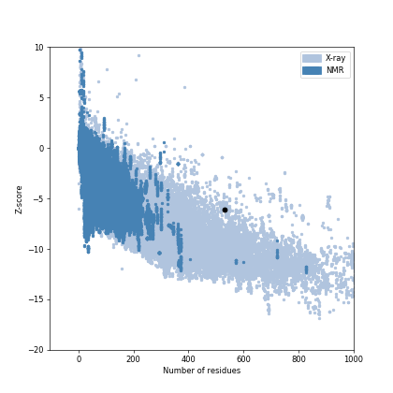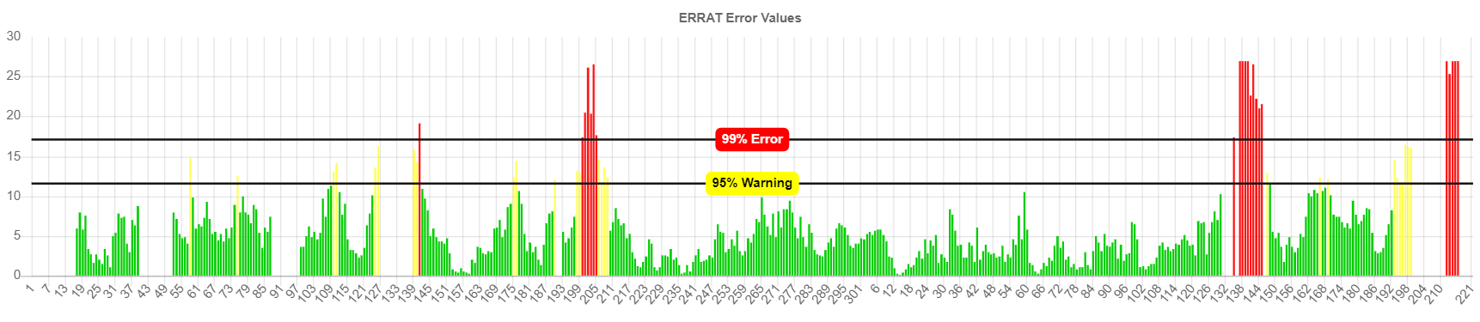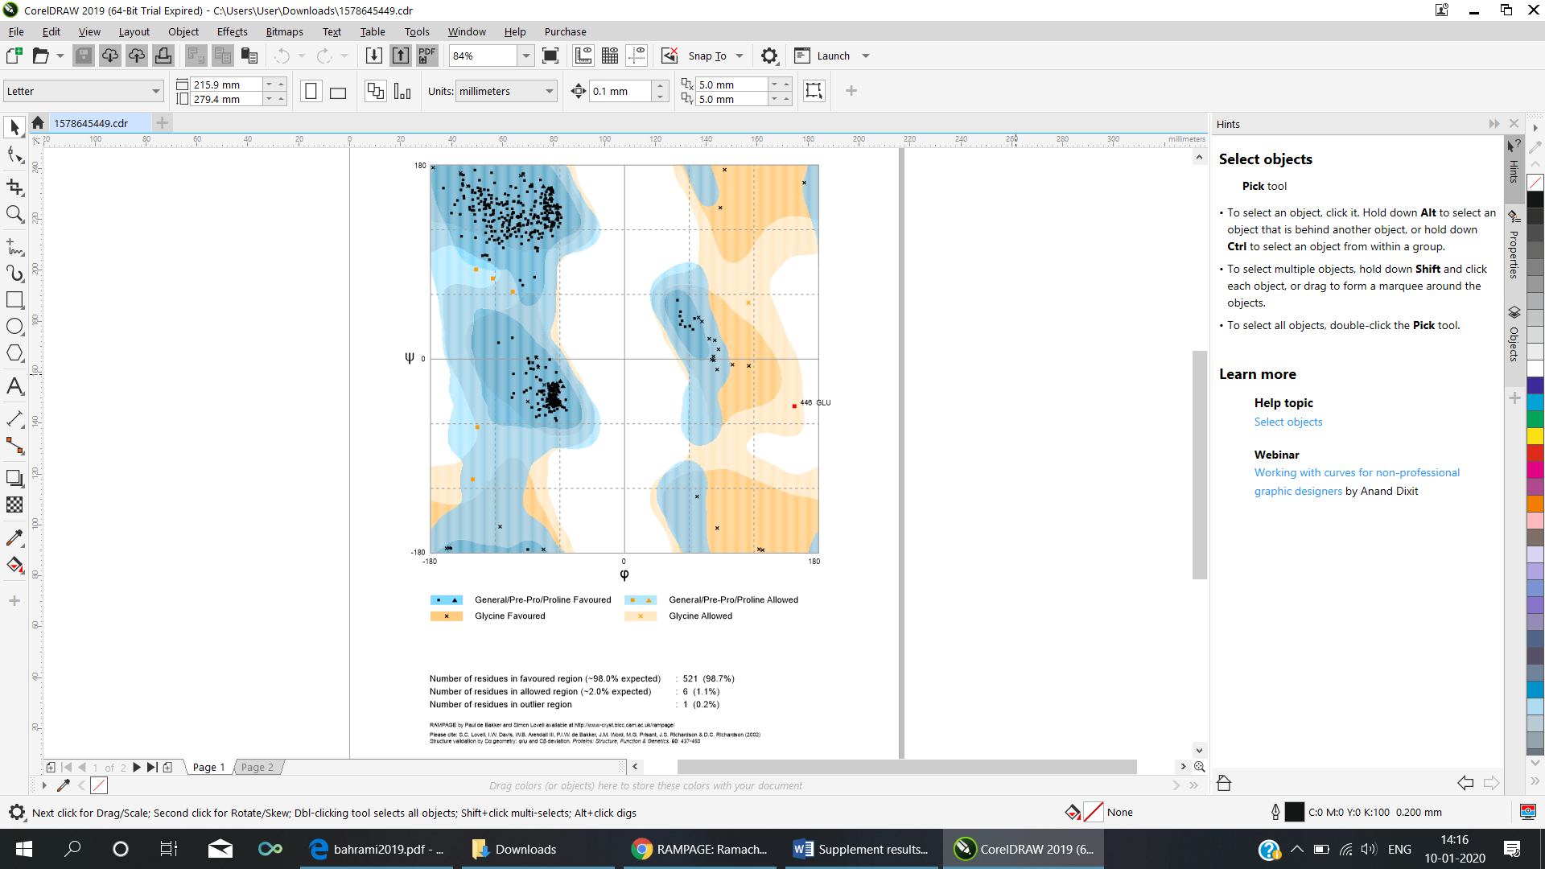S2C: PROSA Z score : -6.07

B

Supplementary Figure S3: Vaccine construct.
Errat score: 59.58
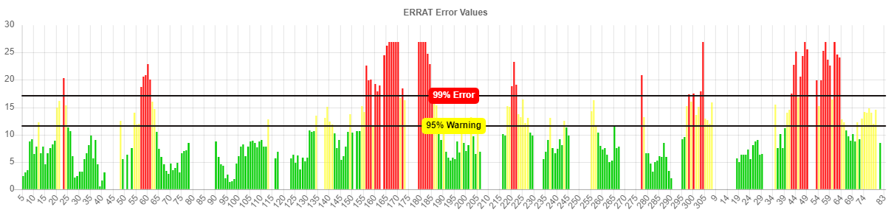
Supplementary Figure S4: Signal Peptide
Measure Position Value
max. C 19 0.107
max. Y 70 0.106
max. S 60 0.111
mean S 1-69 0.097
D 1-69 0.101 0.450 NO
Name=Sequence SP='NO' D=0.101 D-cutoff=0.450 Networks=SignalP-noTM.
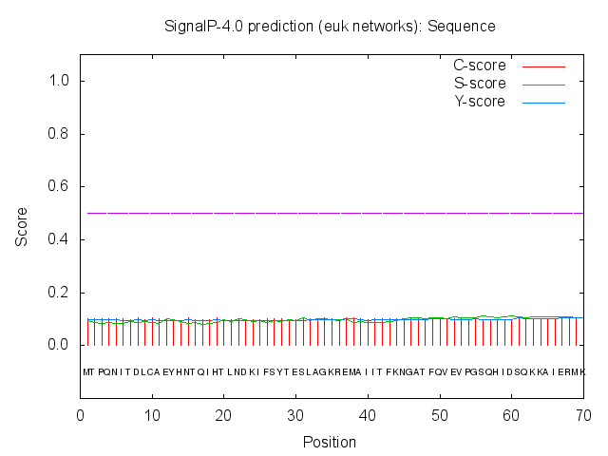

Supplementary Figure S5: TMHMM RESULTS

- Length : 388
- Number of predicted TMHs : 0
- Exp number of AAs in TMHs : 1.49429
- Exp number, first 60 AAs : 0.0001
- Total prob of N-in : 0.03382
- TMHMM2.0 outside 1 (388)
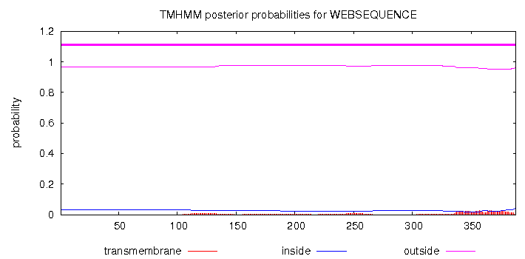

Supplementary Figure S6:
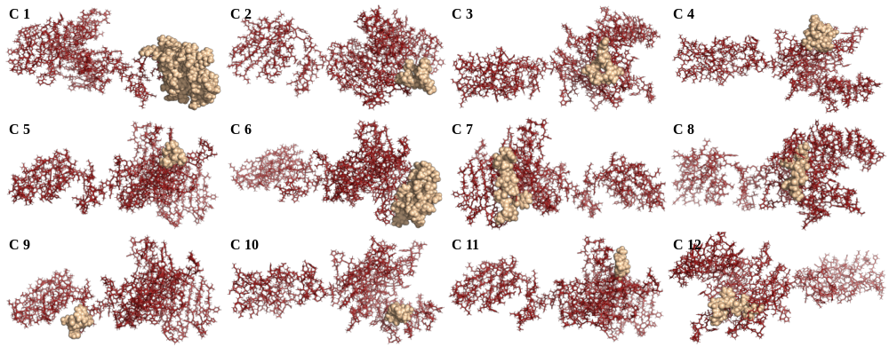
A. Continuous Epitopes predicted by ElliPro and visualized using PyMol. The epitopes are shown in spheres and the vaccine construct is shown as sticks.
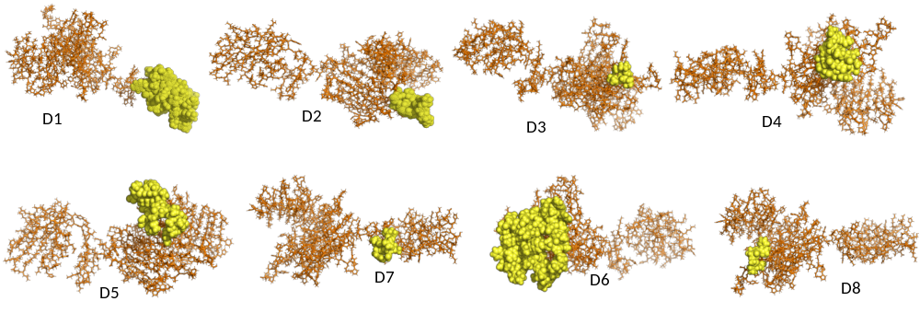
B. Discontinuous Epitopes predicted by ElliPro and visualized using PyMol. The epitopes are shown in spheres and the vaccine construct is shown as sticks.

Supplementary Figure S7: For docked complex TLR4
S7A: Rampage
Number of residues in favoured region (~98.0% expected) : 1683 ( 90.6%)
Number of residues in allowed region ( ~2.0% expected) : 156 ( 8.4%)
Number of residues in outlier region : 18 ( 1%)
S7B: PROSA Z score : -11

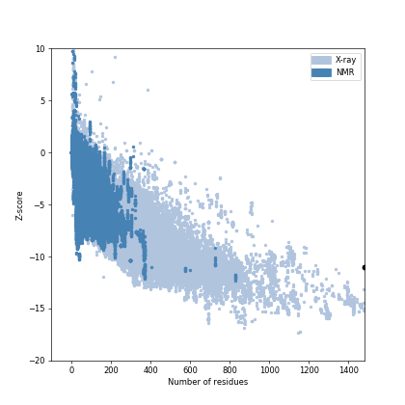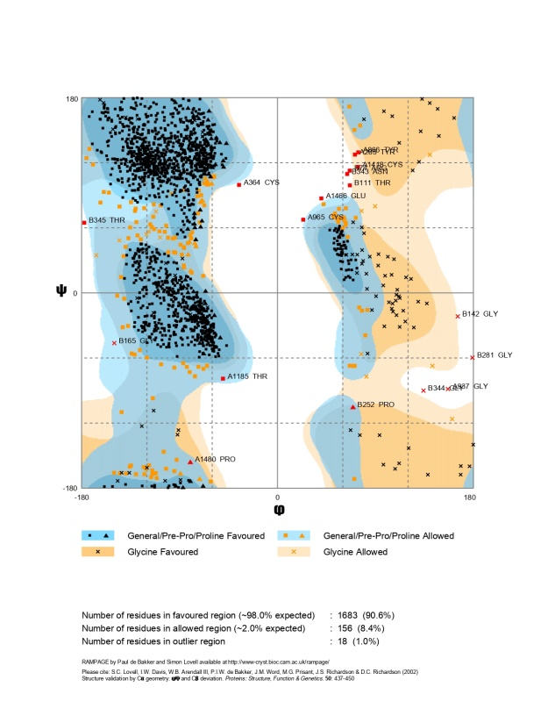
B
A

Supplementary Figure S8: Secondary structure of the docked complex of TLR4 and vaccine construct where chain A and chain B denotes the TLR4 and vaccine, respectively

CHAIN A
CHAIN B
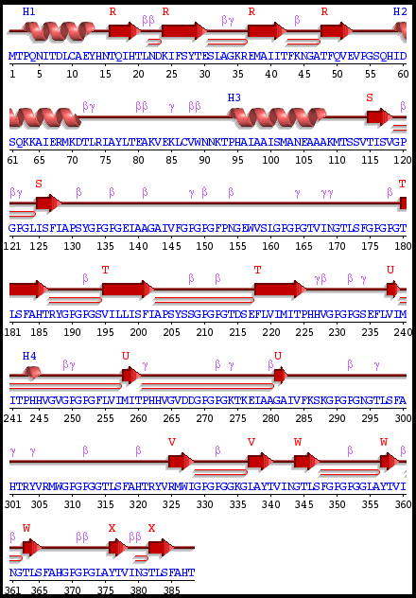
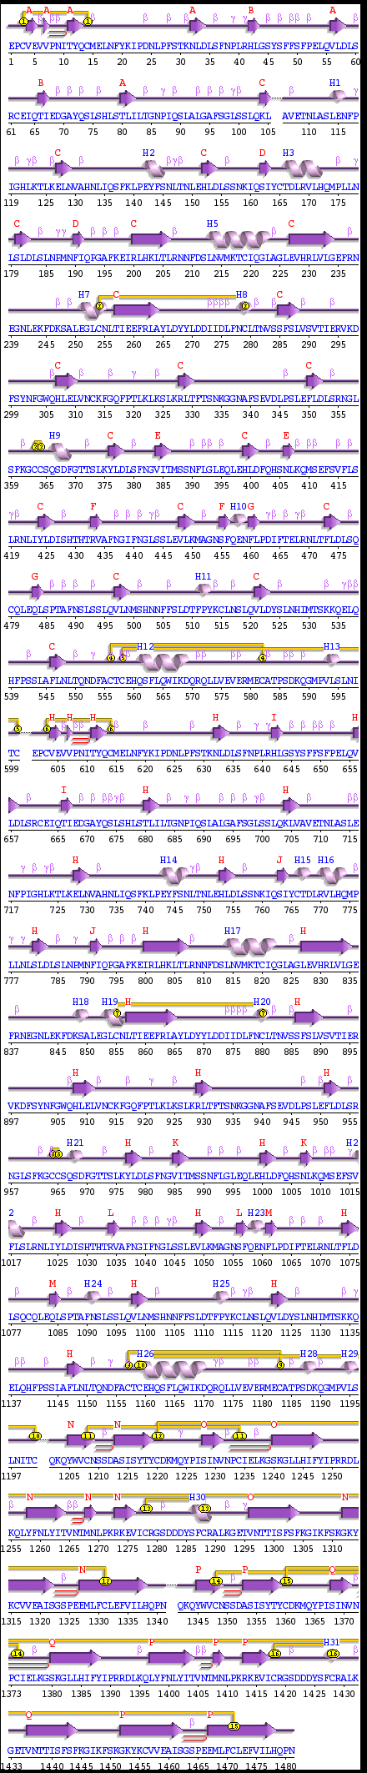

Supplementary Figure S9: The results and graphics presented below are based on HADDOCK generated water-refined models of TLR4 with vaccine construct

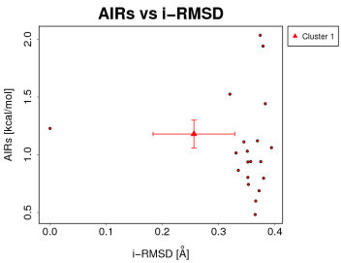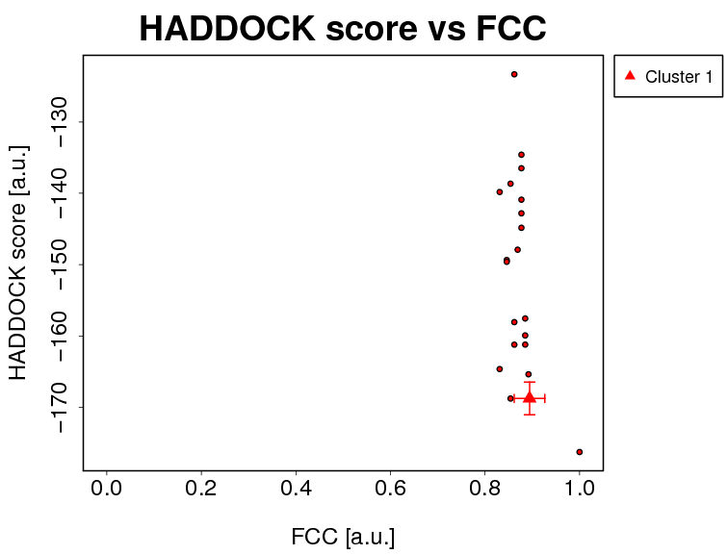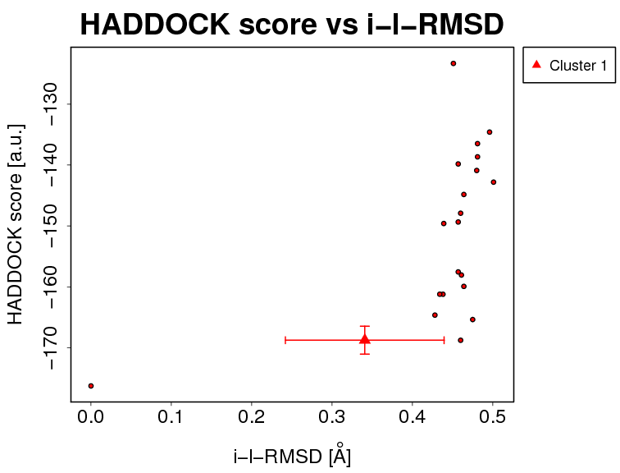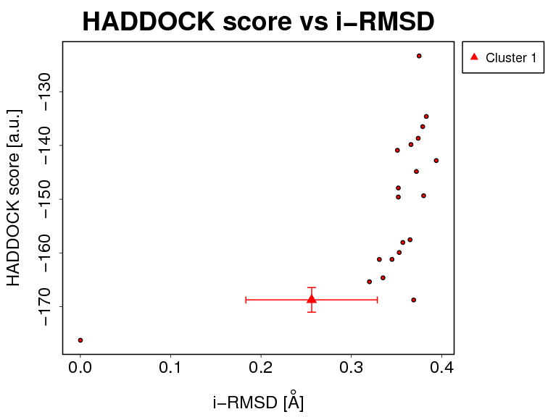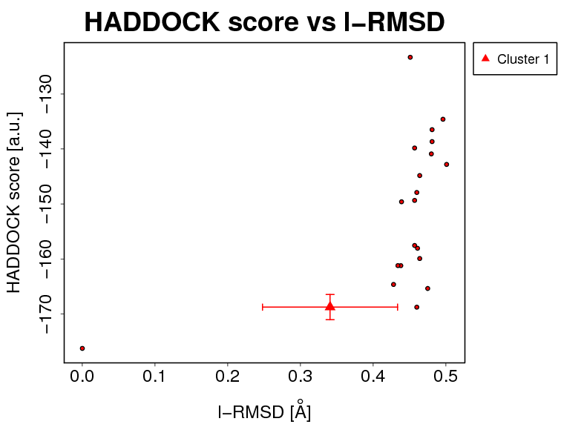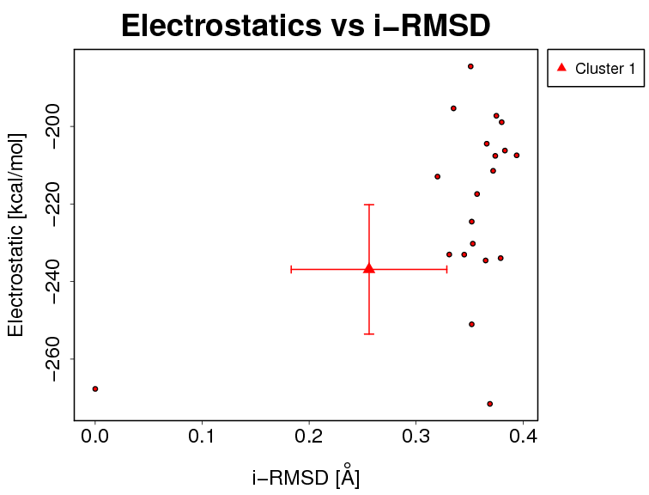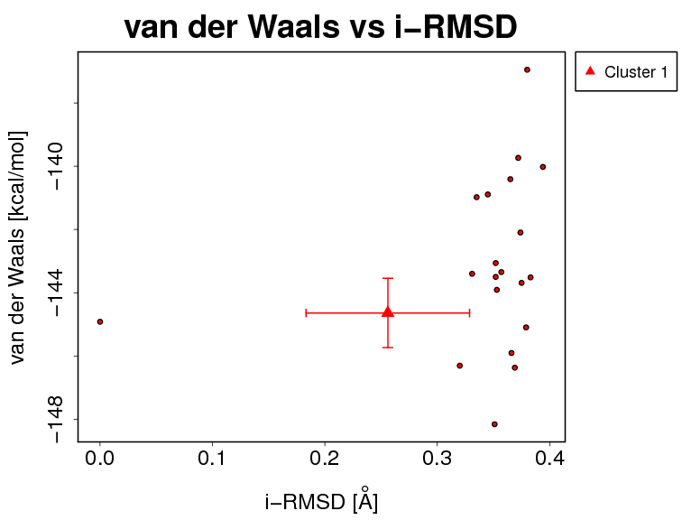

i-RMSD -> interface-RMSD calculated on the backbone (CA,C,N,O,P) atoms of all residues involved in intermolecular contact using a 10Å cutoff
l-RMSD -> ligand-RMSD calculated on the backbone atoms (CA,C,N,O,P) of all (N>1) molecules after fitting on the backbone atoms of the first (N=1) molecule
FCC -> Fraction of common contacts. The intermolecular contacts are defined based on the best HADDOCK model using a 5Å cutoff (see Rodrigues et al, Proteins 2012)
a.u. -> Arbitrary Units
The cluster averages and standard deviations are indicated by colored dots with associated error bars. The average values are calculated on the best 4 structures of each clusters (based on the HADDOCK score).

Supplementary Figure S10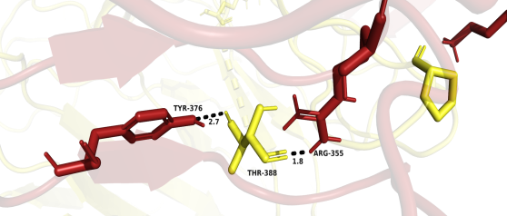: Detailed overview of the interaction of TLR4 with the vaccine construct

Supplementary Figure S11: For docked complex TLR2
S11A: Rampage
Number of residues in favoured region (~98.0% expected) : 817 ( 87.6%)
Number of residues in allowed region ( ~2.0% expected) :103 ( 11.0%)
Number of residues in outlier region : 13 ( 1.4%)
S11B: PROSA Z score : -7.51

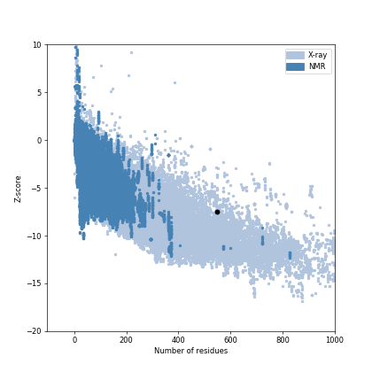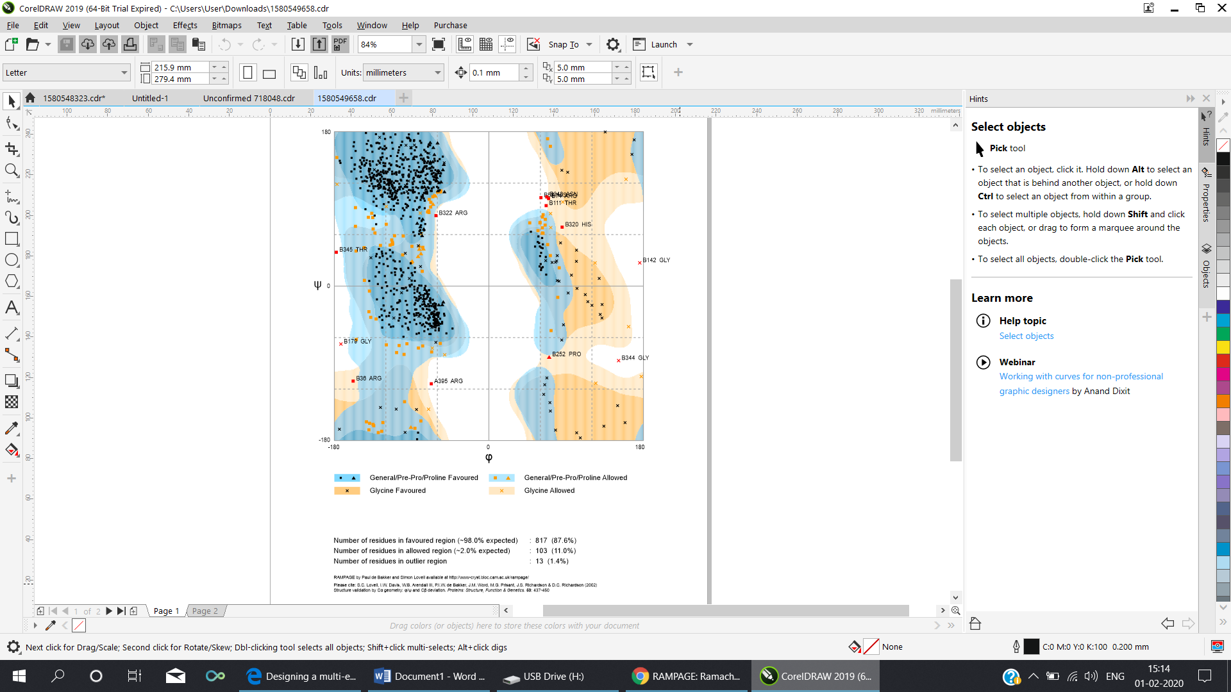
A
B

Supplementary Figure S12: Secondary structure of the docked complex of TLR2 and vaccine construct where chain A denotes TLR2 and chain B denotes the vaccine.

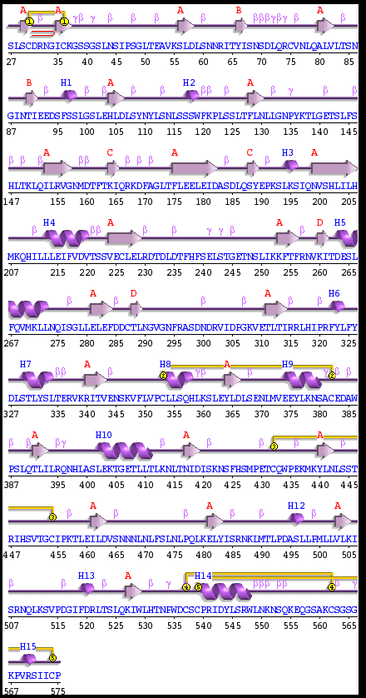
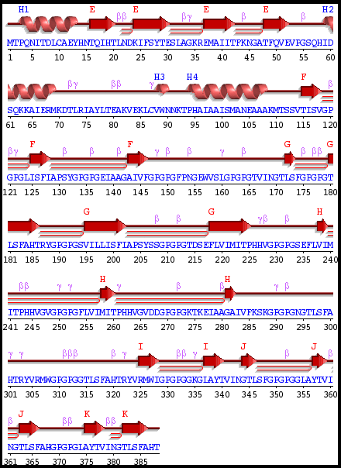
CHAIN A
CHAIN B
Supplementary Figure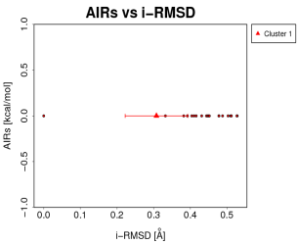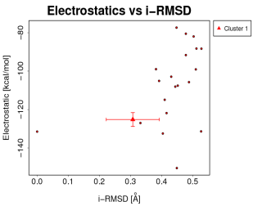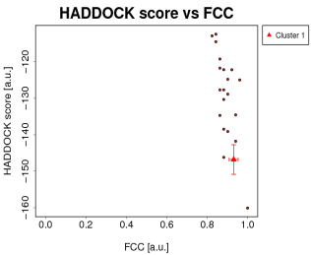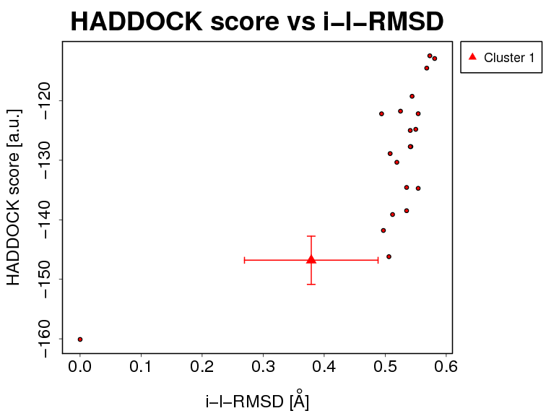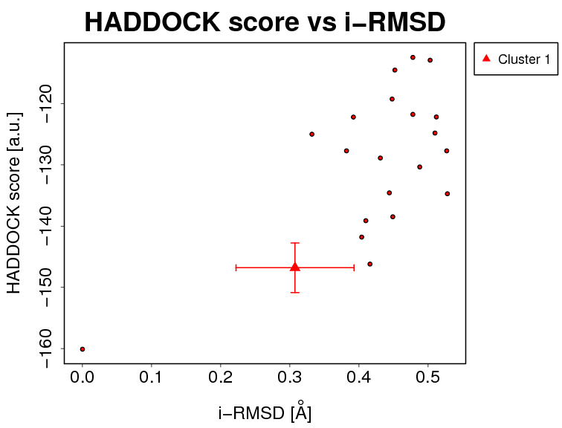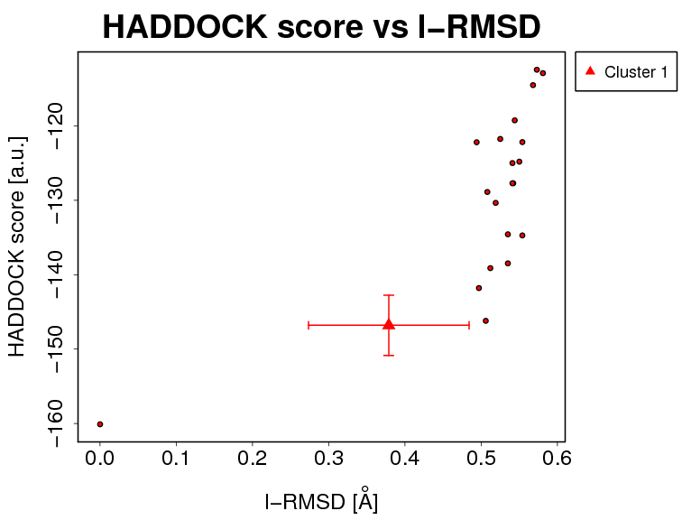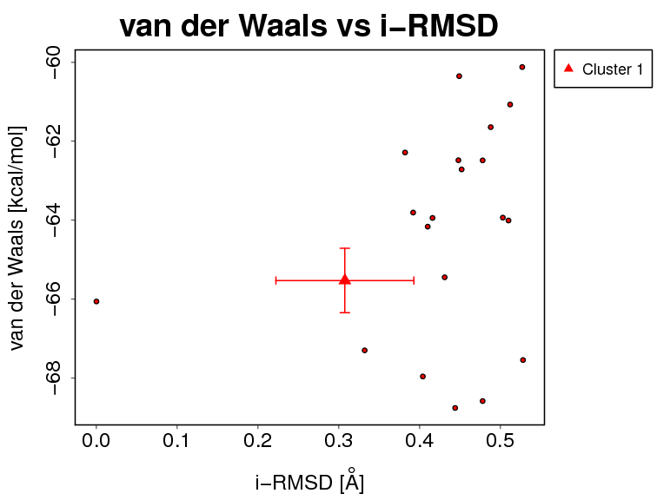 S13: The results and graphics presented below are based on HADDOCK generated water-refined models of TLR2 with vaccine construct

i-RMSD -> interface-RMSD calculated on the backbone (CA,C,N,O,P) atoms of all residues involved in intermolecular contact using a 10Å cutoff
l-RMSD -> ligand-RMSD calculated on the backbone atoms (CA,C,N,O,P) of all (N>1) molecules after fitting on the backbone atoms of the first (N=1) molecule
FCC -> Fraction of common contacts. The intermolecular contacts are defined based on the best HADDOCK model using a 5Å cutoff (see Rodrigues et al, Proteins 2012)
a.u. -> Arbitrary Units
The cluster averages and standard deviations are indicated by colored dots with associated error bars. The average values are calculated on the best 4 structures of each clusters (based on the HADDOCK score).

Supplementary Figure S14: Overview of interaction of TLR2 and vaccine

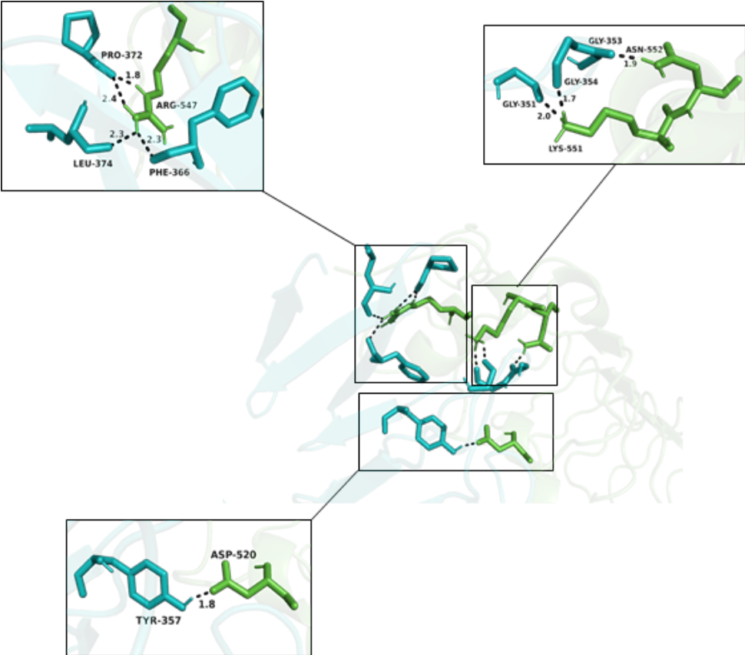
Supplementary Figure S15: For docked complex TLR1
S15A: Rampage
Number of residues in favoured region (~98.0% expected) : 810 ( 89.6%)
Number of residues in allowed region ( ~2.0% expected) : 78 ( 8.6%)
Number of residues in outlier region : 16 ( 1.8%)
S15B: PROSA Z score : -7.97
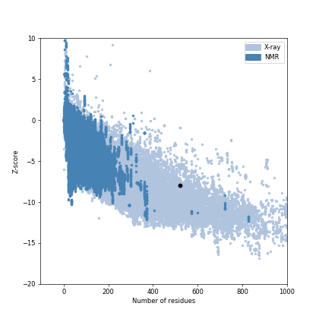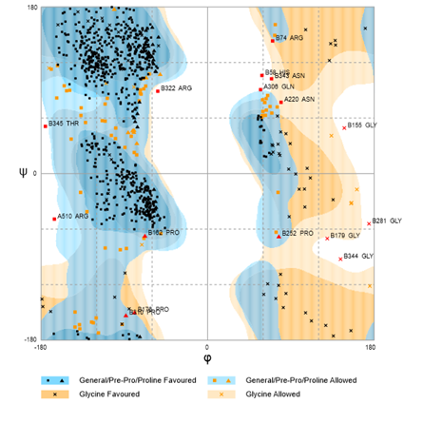
AA
BC

Supplementary Figure S16: Secondary structure of the docked complex of TLR1 and vaccine construct where chain A denotes TLR1 and chain B denotes the vaccine.

CHAIN A
CHAIN B
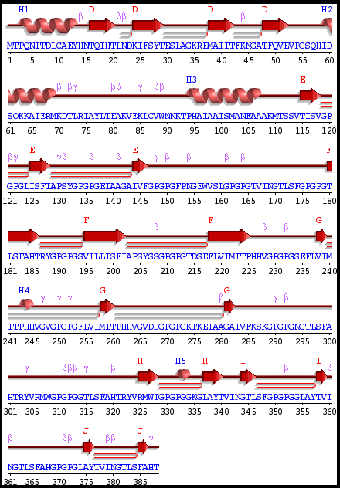
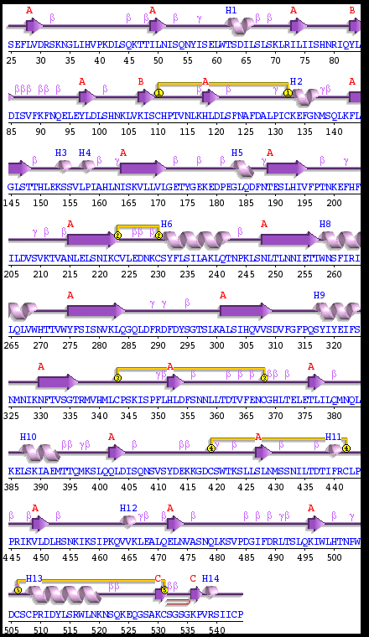

Supplementary Figure S17: The results and graphics presented below are based on HADDOCK generated water-refined models of TLR1 with vaccine construct

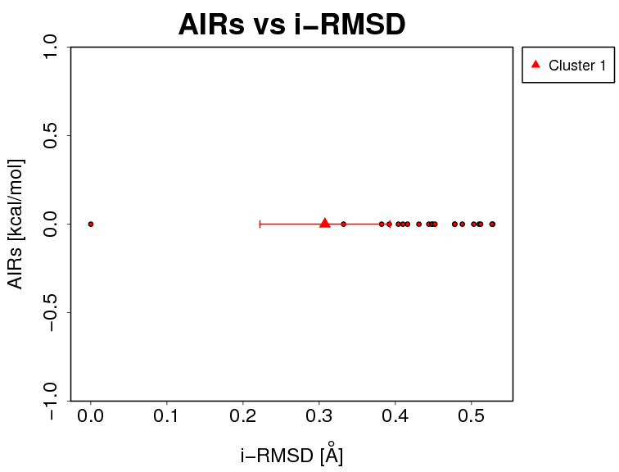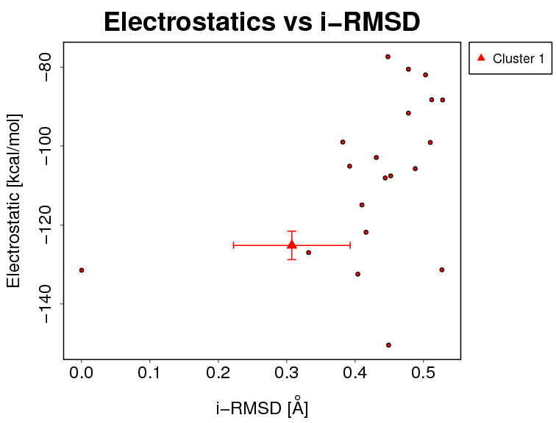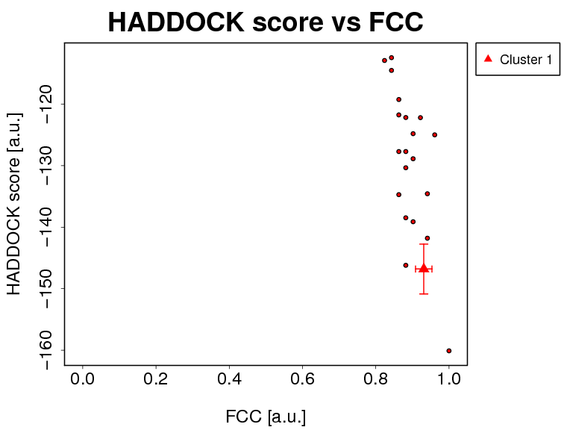
i-RMSD -> interface-RMSD calculated on the backbone (CA,C,N,O,P) atoms of all residues involved in intermolecular contact using a 10Å cutoff
l-RMSD -> ligand-RMSD calculated on the backbone atoms (CA,C,N,O,P) of all (N>1) molecules after fitting on the backbone atoms of the first (N=1) molecule
FCC -> Fraction of common contacts. The intermolecular contacts are defined based on the best HADDOCK model using a 5Å cutoff (see Rodrigues et al, Proteins 2012)
a.u. -> Arbitrary Units
The cluster averages and standard deviations are indicated by colored dots with associated error bars. The average values are calculated on the best 4 structures of each clusters (based on the HADDOCK score).
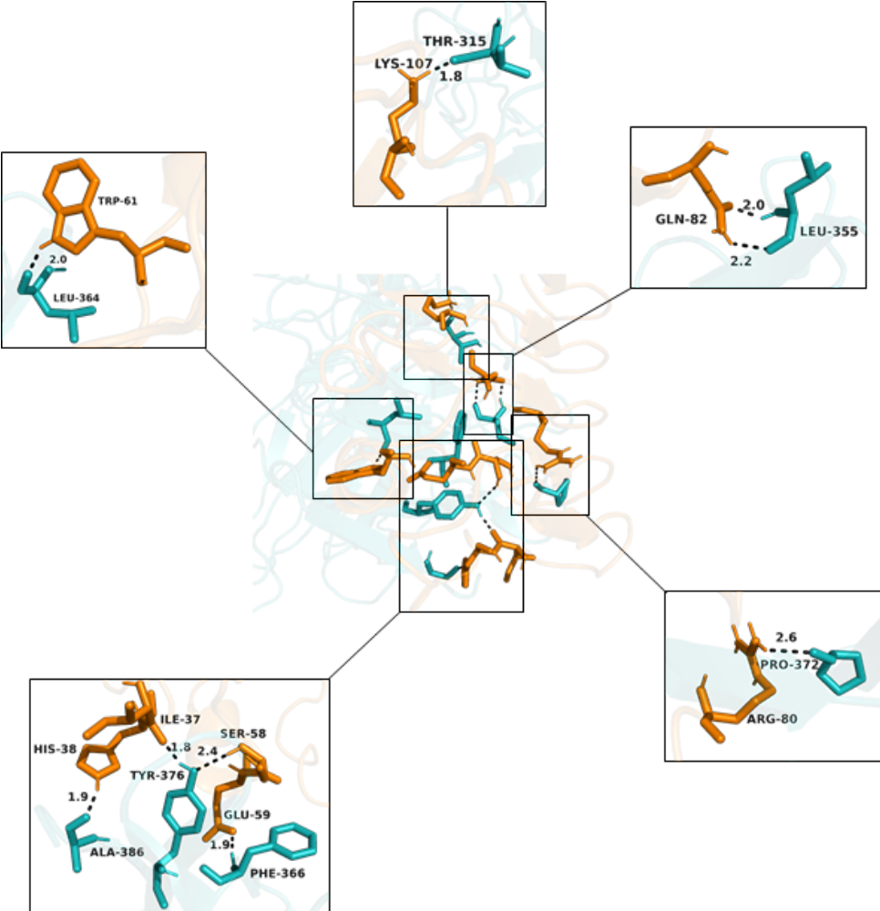
Supplementary Figure S18: Overview of interaction of TLR1 and vaccine

Supplementary Figure S19:
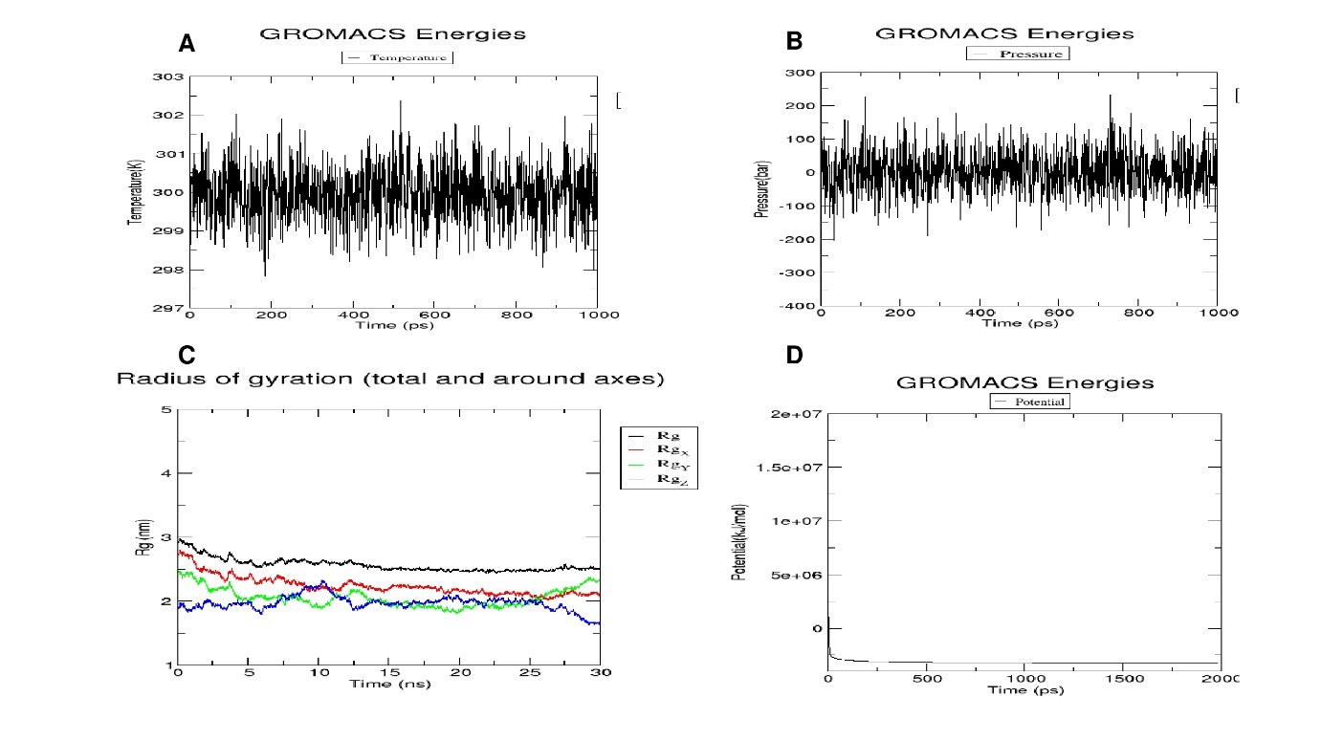
Graphs for molecular dynamics simulation of the vaccine construct.

Supplementary Figure S20:
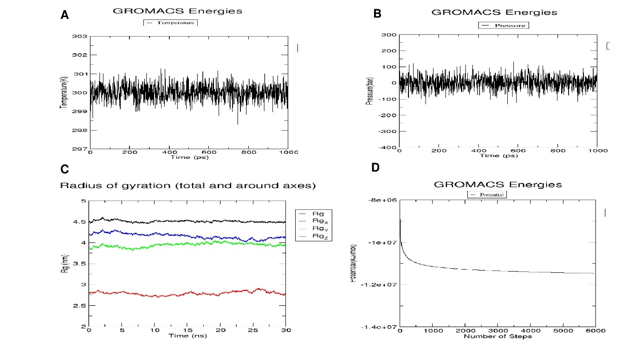
Graphs for molecular dynamics simulation of the vaccine-TLR4/MD2 complex

Supplementary Figure S21:
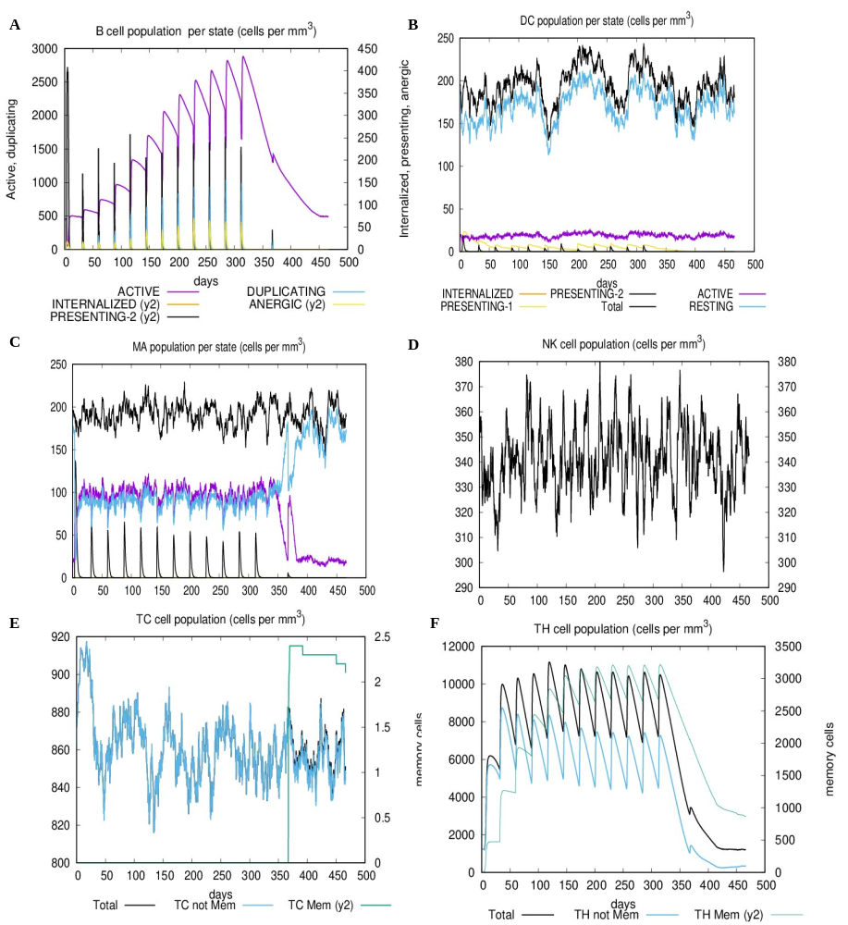
Graphs for immune simulation

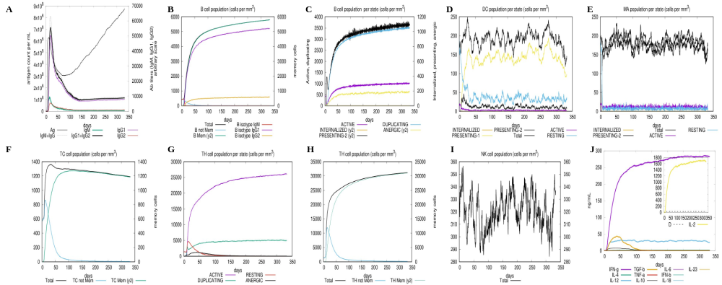
Supplementary Figure S22:
Graphs for immune simulation (control) Live virus is injected without vaccination

Supplementary materials

Supplementary material: SM 1

Physiochemical properties of vaccine
Number of amino acids: 388

Molecular weight: 40008.86

Theoretical pI: 8.73

Amino acid composition:
Ala (A) 30 7.7%
Arg (R) 8 2.1%
Asn (N) 13 3.4%
Asp (D) 7 1.8%
Cys (C) 2 0.5%
Gln (Q) 5 1.3%
Glu (E) 13 3.4%
Gly (G) 62 16.0%
His (H) 15 3.9%
Ile (I) 31 8.0%
Leu (L) 23 5.9%
Lys (K) 15 3.9%
Met (M) 10 2.6%
Phe (F) 18 4.6%
Pro (P) 39 10.1%
Ser (S) 26 6.7%
Thr (T) 32 8.2%
Trp (W) 4 1.0%
Tyr (Y) 11 2.8%
Val (V) 24 6.2%
Pyl (O) 0 0.0%
Sec (U) 0 0.0%

(B) 0 0.0%
(Z) 0 0.0%
(X) 0 0.0%

Total number of negatively charged residues (Asp + Glu): 20
Total number of positively charged residues (Arg + Lys): 23

Atomic composition:

Carbon C 1818
Hydrogen H 2801
Nitrogen N 479
Oxygen O 516
Sulfur S 12

Formula: C₁₈₁₈H₂₈₀₁N₄₇₉O₅₁₆S₁₂
Total number of atoms: 5626

Extinction coefficients:

Extinction coefficients are in units of M⁻¹ cm⁻¹, at 280 nm measured in water.

Ext. coefficient 38515
Abs 0.1% (=1 g/l) 0.963, assuming all pairs of Cys residues form cystines

Ext. coefficient 38390
Abs 0.1% (=1 g/l) 0.960, assuming all Cys residues are reduced

Estimated half-life:

The N-terminal of the sequence considered is M (Met).

The estimated half-life is: 30 hours (mammalian reticulocytes, in vitro).
>20 hours (yeast, in vivo).
>10 hours (Escherichia coli, in vivo).

Instability index:

The instability index (II) is computed to be 13.11
This classifies the protein as stable.

Aliphatic index: 79.95

Grand average of hydropathicity (GRAVY): 0.083

Supplementary material SM 2:
TLR 4 PDBsum interacting molecules
Hydrogen bonds
--------------

<----- A T O M 1 -----> <----- A T O M 2 ----->

Atom Atom Res Res Atom Atom Res Res
no. name name no. Chain no. name name no. Chain Distance
1. 306 ND2 ASN 32 A <--> 17203 OG SER 317 B 2.71
2. 743 ND1 HIS 77 A <--> 17233 NE2 HIS 320 B 2.88
3. 743 ND1 HIS 77 A <--> 17233 NE2 HIS 320 B 2.88
4. 948 O SER 101 A <--> 17258 NH2 ARG 322 B 3.07
5. 2520 NH1 ARG 262 A <--> 17775 O LEU 383 B 3.09
6. 2523 NH2 ARG 262 A <--> 17775 O LEU 383 B 2.76
7. 2995 OE2 GLU 309 A <--> 17784 N PHE 385 B 2.76
8. 3410 OD2 ASP 352 A <--> 17802 N HIS 387 B 2.97
9. 3442 NH2 ARG 355 A <--> 17822 O THR 388 B 2.81
10. 3636 OH TYR 376 A <--> 17818 OG1 THR 388 B 3.05
11. 12406 NZ LYS 1274 A <--> 17681 O PRO 372 B 2.80
12. 12458 NH2 ARG 1279 A <--> 17775 O LEU 383 B 2.86

Non-bonded contacts
-------------------

<----- A T O M 1 -----> <----- A T O M 2 ----->

Atom Atom Res Res Atom Atom Res Res
no. name name no. Chain no. name name no. Chain Distance
1. 47 CG1 VAL 6 A <--> 17173 CA GLY 313 B 3.65
2. 82 CG2 ILE 10 A <--> 17196 CD2 LEU 316 B 3.45
3. 293 CE LYS 31 A <--> 17196 CD2 LEU 316 B 3.63
4. 293 CE LYS 31 A <--> 17206 O SER 317 B 3.57
5. 294 NZ LYS 31 A <--> 17206 O SER 317 B 3.43
6. 294 NZ LYS 31 A <--> 17212 CD1 PHE 318 B 3.58
7. 304 CG ASN 32 A <--> 17203 OG SER 317 B 3.56
8. 305 OD1 ASN 32 A <--> 17196 CD2 LEU 316 B 3.83
9. 305 OD1 ASN 32 A <--> 17199 N SER 317 B 3.67
10. 305 OD1 ASN 32 A <--> 17202 CB SER 317 B 3.77
11. 305 OD1 ASN 32 A <--> 17203 OG SER 317 B 3.59
12. 306 ND2 ASN 32 A <--> 17202 CB SER 317 B 3.50
13. 306 ND2 ASN 32 A <--> 17203 OG SER 317 B 2.71
14. 516 OE2 GLU 53 A <--> 17078 NH2 ARG 303 B 3.70
15. 532 CG GLN 55 A <--> 17222 CB ALA 319 B 3.88
16. 533 CD GLN 55 A <--> 17219 N ALA 319 B 3.75
17. 533 CD GLN 55 A <--> 17222 CB ALA 319 B 3.49
18. 534 OE1 GLN 55 A <--> 17206 O SER 317 B 3.64
19. 534 OE1 GLN 55 A <--> 17209 CA PHE 318 B 3.78
20. 534 OE1 GLN 55 A <--> 17219 N ALA 319 B 3.52
21. 535 NE2 GLN 55 A <--> 17075 NH1 ARG 303 B 3.89
22. 535 NE2 GLN 55 A <--> 17219 N ALA 319 B 3.64
23. 535 NE2 GLN 55 A <--> 17222 CB ALA 319 B 3.36
24. 545 CG2 VAL 56 A <--> 17202 CB SER 317 B 3.72
25. 740 CA HIS 77 A <--> 17232 CE1 HIS 320 B 3.73
26. 749 O HIS 77 A <--> 17232 CE1 HIS 320 B 3.78
27. 742 CG HIS 77 A <--> 17233 NE2 HIS 320 B 3.79
28. 743 ND1 HIS 77 A <--> 17231 CD2 HIS 320 B 3.89
29. 743 ND1 HIS 77 A <--> 17232 CE1 HIS 320 B 3.78
30. 743 ND1 HIS 77 A <--> 17233 NE2 HIS 320 B 2.88
31. 745 CE1 HIS 77 A <--> 17233 NE2 HIS 320 B 3.70
32. 766 O SER 79 A <--> 17255 NH1 ARG 322 B 3.72
33. 762 CB SER 79 A <--> 17254 CZ ARG 322 B 3.68
34. 762 CB SER 79 A <--> 17255 NH1 ARG 322 B 3.20
35. 762 CB SER 79 A <--> 17258 NH2 ARG 322 B 3.58
36. 763 OG SER 79 A <--> 17222 CB ALA 319 B 3.29
37. 763 OG SER 79 A <--> 17254 CZ ARG 322 B 3.88
38. 763 OG SER 79 A <--> 17255 NH1 ARG 322 B 3.89
39. 763 OG SER 79 A <--> 17258 NH2 ARG 322 B 3.41
40. 948 O SER 101 A <--> 17258 NH2 ARG 322 B 3.07
41. 944 CB SER 101 A <--> 17230 ND1 HIS 320 B 3.67
42. 944 CB SER 101 A <--> 17232 CE1 HIS 320 B 3.60
43. 945 OG SER 101 A <--> 17230 ND1 HIS 320 B 3.63
44. 945 OG SER 101 A <--> 17232 CE1 HIS 320 B 3.31
45. 962 CG GLN 103 A <--> 17254 CZ ARG 322 B 3.75
46. 962 CG GLN 103 A <--> 17258 NH2 ARG 322 B 3.44
47. 963 CD GLN 103 A <--> 17254 CZ ARG 322 B 3.73
48. 963 CD GLN 103 A <--> 17258 NH2 ARG 322 B 3.53
49. 965 NE2 GLN 103 A <--> 17252 NE ARG 322 B 3.56
50. 965 NE2 GLN 103 A <--> 17254 CZ ARG 322 B 3.57
51. 965 NE2 GLN 103 A <--> 17258 NH2 ARG 322 B 3.83
52. 965 NE2 GLN 103 A <--> 17449 ND2 ASN 343 B 3.73
53. 1193 OE1 GLU 127 A <--> 17599 CA GLY 362 B 3.88
54. 1194 OE2 GLU 127 A <--> 17448 OD1 ASN 343 B 3.85
55. 1441 ND1 HIS 152 A <--> 17596 O ASN 361 B 3.87
56. 1442 CD2 HIS 152 A <--> 17596 O ASN 361 B 3.55
57. 1443 CE1 HIS 152 A <--> 17596 O ASN 361 B 3.43
58. 1444 NE2 HIS 152 A <--> 17596 O ASN 361 B 3.22
59. 1932 CE1 HIS 202 A <--> 17752 O ASN 380 B 3.45
60. 2202 CD ARG 230 A <--> 17762 OG1 THR 382 B 3.25
61. 2202 CD ARG 230 A <--> 17764 CG2 THR 382 B 3.62
62. 2203 NE ARG 230 A <--> 17762 OG1 THR 382 B 3.79
63. 2495 OE1 GLU 260 A <--> 17762 OG1 THR 382 B 3.58
64. 2519 CZ ARG 262 A <--> 17775 O LEU 383 B 3.36
65. 2520 NH1 ARG 262 A <--> 17775 O LEU 383 B 3.09
66. 2523 NH2 ARG 262 A <--> 17774 C LEU 383 B 3.67
67. 2523 NH2 ARG 262 A <--> 17775 O LEU 383 B 2.76
68. 2523 NH2 ARG 262 A <--> 17778 CA SER 384 B 3.76
69. 2523 NH2 ARG 262 A <--> 17780 OG SER 384 B 3.79
70. 2993 CD GLU 309 A <--> 17779 CB SER 384 B 3.90
71. 2993 CD GLU 309 A <--> 17784 N PHE 385 B 3.81
72. 2994 OE1 GLU 309 A <--> 17779 CB SER 384 B 3.83
73. 2994 OE1 GLU 309 A <--> 17780 OG SER 384 B 3.75
74. 2995 OE2 GLU 309 A <--> 17778 CA SER 384 B 3.23
75. 2995 OE2 GLU 309 A <--> 17782 C SER 384 B 3.44
76. 2995 OE2 GLU 309 A <--> 17779 CB SER 384 B 3.56
77. 2995 OE2 GLU 309 A <--> 17784 N PHE 385 B 2.76
78. 2995 OE2 GLU 309 A <--> 17786 CA PHE 385 B 3.79
79. 2995 OE2 GLU 309 A <--> 17787 CB PHE 385 B 3.67
80. 3011 CG1 VAL 311 A <--> 17790 CD2 PHE 385 B 3.79
81. 3210 CG2 THR 330 A <--> 17795 O PHE 385 B 3.67
82. 3228 CB THR 332 A <--> 17807 ND1 HIS 387 B 3.68
83. 3231 CG2 THR 332 A <--> 17807 ND1 HIS 387 B 3.57
84. 3409 OD1 ASP 352 A <--> 17805 CB HIS 387 B 3.79
85. 3410 OD2 ASP 352 A <--> 17802 N HIS 387 B 2.97
86. 3410 OD2 ASP 352 A <--> 17804 CA HIS 387 B 3.65
87. 3410 OD2 ASP 352 A <--> 17805 CB HIS 387 B 3.40
88. 3426 OG SER 354 A <--> 17805 CB HIS 387 B 3.58
89. 3435 CD ARG 355 A <--> 17806 CG HIS 387 B 3.65
90. 3435 CD ARG 355 A <--> 17807 ND1 HIS 387 B 3.64
91. 3435 CD ARG 355 A <--> 17808 CD2 HIS 387 B 3.68
92. 3435 CD ARG 355 A <--> 17809 CE1 HIS 387 B 3.64
93. 3435 CD ARG 355 A <--> 17810 NE2 HIS 387 B 3.67
94. 3436 NE ARG 355 A <--> 17808 CD2 HIS 387 B 3.61
95. 3438 CZ ARG 355 A <--> 17808 CD2 HIS 387 B 3.82
96. 3438 CZ ARG 355 A <--> 17822 O THR 388 B 3.59
97. 3439 NH1 ARG 355 A <--> 17805 CB HIS 387 B 3.41
98. 3439 NH1 ARG 355 A <--> 17806 CG HIS 387 B 3.74
99. 3439 NH1 ARG 355 A <--> 17814 N THR 388 B 3.86
100. 3439 NH1 ARG 355 A <--> 17822 O THR 388 B 3.64
101. 3442 NH2 ARG 355 A <--> 17664 CA PRO 370 B 3.79
102. 3442 NH2 ARG 355 A <--> 17665 CB PRO 370 B 3.50
103. 3442 NH2 ARG 355 A <--> 17821 C THR 388 B 3.72
104. 3442 NH2 ARG 355 A <--> 17822 O THR 388 B 2.81
105. 3635 CZ TYR 376 A <--> 17813 O HIS 387 B 3.83
106. 3636 OH TYR 376 A <--> 17812 C HIS 387 B 3.69
107. 3636 OH TYR 376 A <--> 17813 O HIS 387 B 2.79
108. 3636 OH TYR 376 A <--> 17816 CA THR 388 B 3.24
109. 3636 OH TYR 376 A <--> 17817 CB THR 388 B 3.48
110. 3636 OH TYR 376 A <--> 17818 OG1 THR 388 B 3.05
111. 3636 OH TYR 376 A <--> 17820 CG2 THR 388 B 3.67
112. 3653 CG ASP 378 A <--> 17814 N THR 388 B 3.85
113. 3653 CG ASP 378 A <--> 17816 CA THR 388 B 3.52
114. 3653 CG ASP 378 A <--> 17821 C THR 388 B 3.60
115. 3654 OD1 ASP 378 A <--> 17814 N THR 388 B 3.78
116. 3654 OD1 ASP 378 A <--> 17816 CA THR 388 B 3.05
117. 3654 OD1 ASP 378 A <--> 17821 C THR 388 B 3.31
118. 3655 OD2 ASP 378 A <--> 17814 N THR 388 B 3.46
119. 3655 OD2 ASP 378 A <--> 17816 CA THR 388 B 3.35
120. 3655 OD2 ASP 378 A <--> 17821 C THR 388 B 3.10
121. 3655 OD2 ASP 378 A <--> 17822 O THR 388 B 3.68
122. 3838 OE2 GLU 398 A <--> 16011 CB PRO 176 B 3.53
123. 3848 CE1 HIS 399 A <--> 17820 CG2 THR 388 B 3.61
124. 3868 OD2 ASP 401 A <--> 17821 C THR 388 B 3.12
125. 3868 OD2 ASP 401 A <--> 17822 O THR 388 B 3.16
126. 3889 OE1 GLN 403 A <--> 17665 CB PRO 370 B 3.68
127. 3889 OE1 GLN 403 A <--> 17666 CG PRO 370 B 3.60
128. 3890 NE2 GLN 403 A <--> 17665 CB PRO 370 B 3.77
129. 3890 NE2 GLN 403 A <--> 17666 CG PRO 370 B 3.87
130. 4093 CB ILE 423 A <--> 16011 CB PRO 176 B 3.81
131. 4094 CG1 ILE 423 A <--> 16010 CA PRO 176 B 3.57
132. 4095 CG2 ILE 423 A <--> 16012 CG PRO 176 B 3.68
133. 4096 CD1 ILE 423 A <--> 16010 CA PRO 176 B 3.72
134. 4325 CD GLU 447 A <--> 15997 CD1 PHE 174 B 3.84
135. 4325 CD GLU 447 A <--> 16004 N GLY 175 B 3.41
136. 4326 OE1 GLU 447 A <--> 16004 N GLY 175 B 2.92
137. 4326 OE1 GLU 447 A <--> 16006 CA GLY 175 B 3.41
138. 4326 OE1 GLU 447 A <--> 16007 C GLY 175 B 3.53
139. 4326 OE1 GLU 447 A <--> 16008 O GLY 175 B 3.77
140. 4327 OE2 GLU 447 A <--> 15994 CA PHE 174 B 3.29
141. 4327 OE2 GLU 447 A <--> 16002 C PHE 174 B 3.70
142. 4327 OE2 GLU 447 A <--> 15997 CD1 PHE 174 B 3.56
143. 4327 OE2 GLU 447 A <--> 16004 N GLY 175 B 3.11
144. 4571 OG1 THR 472 A <--> 15999 CE1 PHE 174 B 3.62
145. 4768 CB SER 493 A <--> 15867 CH2 TRP 157 B 3.85
146. 4806 CG1 VAL 497 A <--> 17362 CA GLY 333 B 3.72
147. 4806 CG1 VAL 497 A <--> 17363 C GLY 333 B 3.82
148. 4806 CG1 VAL 497 A <--> 17364 O GLY 333 B 3.20
149. 4807 CG2 VAL 497 A <--> 17364 O GLY 333 B 3.53
150. 5047 CG1 VAL 521 A <--> 17363 C GLY 333 B 3.88
151. 5047 CG1 VAL 521 A <--> 17364 O GLY 333 B 3.85
152. 12199 CE LYS 1255 A <--> 17615 CG LEU 364 B 3.80
153. 12199 CE LYS 1255 A <--> 17617 CD2 LEU 364 B 3.58
154. 12209 CB GLN 1256 A <--> 17637 CZ PHE 366 B 3.52
155. 12210 CG GLN 1256 A <--> 17635 CE1 PHE 366 B 3.65
156. 12210 CG GLN 1256 A <--> 17637 CZ PHE 366 B 3.68
157. 12213 NE2 GLN 1256 A <--> 17632 CG PHE 366 B 3.73
158. 12213 NE2 GLN 1256 A <--> 17634 CD2 PHE 366 B 3.49
159. 12213 NE2 GLN 1256 A <--> 17636 CE2 PHE 366 B 3.71
160. 12213 NE2 GLN 1256 A <--> 17692 CD1 LEU 374 B 3.23
161. 12233 CD2 TYR 1258 A <--> 17536 CD1 LEU 355 B 3.80
162. 12235 CE2 TYR 1258 A <--> 17536 CD1 LEU 355 B 3.61
163. 12404 CD LYS 1274 A <--> 17677 CB PRO 372 B 3.86
164. 12406 NZ LYS 1274 A <--> 17680 C PRO 372 B 3.84
165. 12406 NZ LYS 1274 A <--> 17681 O PRO 372 B 2.80
166. 12406 NZ LYS 1274 A <--> 17677 CB PRO 372 B 3.53
167. 12450 CG ARG 1279 A <--> 17709 CE1 TYR 376 B 3.57
168. 12450 CG ARG 1279 A <--> 17711 CZ TYR 376 B 3.80
169. 12450 CG ARG 1279 A <--> 17712 OH TYR 376 B 3.64
170. 12452 NE ARG 1279 A <--> 17709 CE1 TYR 376 B 3.71
171. 12454 CZ ARG 1279 A <--> 17775 O LEU 383 B 3.86
172. 12455 NH1 ARG 1279 A <--> 17790 CD2 PHE 385 B 3.36
173. 12458 NH2 ARG 1279 A <--> 17774 C LEU 383 B 3.69
174. 12458 NH2 ARG 1279 A <--> 17775 O LEU 383 B 2.86
175. 12458 NH2 ARG 1279 A <--> 17776 N SER 384 B 3.90
176. 12458 NH2 ARG 1279 A <--> 17778 CA SER 384 B 3.29
177. 12458 NH2 ARG 1279 A <--> 17782 C SER 384 B 3.39
178. 12458 NH2 ARG 1279 A <--> 17784 N PHE 385 B 3.29
179. 12465 CA GLY 1280 A <--> 17616 CD1 LEU 364 B 3.81
180. 12467 O GLY 1280 A <--> 17616 CD1 LEU 364 B 3.61
181. 12471 CB SER 1281 A <--> 17770 CB LEU 383 B 3.73
182. 12471 CB SER 1281 A <--> 17773 CD2 LEU 383 B 3.39
183. 12472 OG SER 1281 A <--> 17770 CB LEU 383 B 3.77
184. 12881 CA SER 1324 A <--> 17549 CB TYR 357 B 3.83
185. 12885 C SER 1324 A <--> 17549 CB TYR 357 B 3.68
186. 12885 C SER 1324 A <--> 17550 CG TYR 357 B 3.77
187. 12885 C SER 1324 A <--> 17551 CD1 TYR 357 B 3.71
188. 12886 O SER 1324 A <--> 17549 CB TYR 357 B 3.40
189. 12886 O SER 1324 A <--> 17550 CG TYR 357 B 3.55
190. 12886 O SER 1324 A <--> 17551 CD1 TYR 357 B 3.22
191. 12882 CB SER 1324 A <--> 17549 CB TYR 357 B 3.51
192. 12888 CA PRO 1325 A <--> 17551 CD1 TYR 357 B 3.77
193. 12888 CA PRO 1325 A <--> 17553 CE1 TYR 357 B 3.78
194. 12898 CG GLU 1326 A <--> 17531 N LEU 355 B 3.72
195. 12899 CD GLU 1326 A <--> 17528 CA GLY 354 B 3.44
196. 12899 CD GLU 1326 A <--> 17531 N LEU 355 B 3.77
197. 12900 OE1 GLU 1326 A <--> 17525 O GLY 353 B 3.81
198. 12900 OE1 GLU 1326 A <--> 17528 CA GLY 354 B 3.27
199. 12900 OE1 GLU 1326 A <--> 17529 C GLY 354 B 3.64
200. 12900 OE1 GLU 1326 A <--> 17531 N LEU 355 B 3.71
201. 12901 OE2 GLU 1326 A <--> 17525 O GLY 353 B 3.42
202. 12901 OE2 GLU 1326 A <--> 17528 CA GLY 354 B 3.59

Salt bridges
------------

<----- A T O M 1 -----> <----- A T O M 2 ----->

Atom Atom Res Res Atom Atom Res Res
no. name name no. Chain no. name name no. Chain Distance
1. 516 OE2 GLU 53 A <--> 17078 NH2 ARG 303 B 3.70

Number of salt bridges: 1

Number of hydrogen bonds: 12

Number of non-bonded contacts: 202

Supplementary material SM3:
TLR 2 PDBsum interacting molecules
Hydrogen bonds

<----- A T O M 1 -----> <----- A T O M 2 ----->

Atom Atom Res Res Atom Atom Res Res
no. name name no. Chain no. name name no. Chain Distance
1. 4767 OD2 ASP 516 A <--> 5445 SG CYS 10 B 2.98
2. 4864 NE2 GLN 526 A <--> 7721 O PRO 272 B 3.07
3. 5087 NH2 ARG 547 A <--> 5548 OG1 THR 20 B 3.16
4. 5087 NH2 ARG 547 A <--> 5730 SD MET 38 B 3.19
5. 5123 ND2 ASN 550 A <--> 5739 O ALA 39 B 2.80
6. 5135 NZ LYS 551 A <--> 7707 OD2 ASP 270 B 2.77
7. 5179 NZ LYS 555 A <--> 7706 OD1 ASP 270 B 2.61
8. 5324 O SER 571 A <--> 5762 OG1 THR 42 B 2.90
9. 5356 O PRO 575 A <--> 5479 N HIS 14 B 3.00

Non-bonded contacts

<----- A T O M 1 -----> <----- A T O M 2 ----->

Atom Atom Res Res Atom Atom Res Res
no. name name no. Chain no. name name no. Chain Distance
1. 4764 CB ASP 516 A <--> 5410 CG2 ILE 6 B 3.63
2. 4765 CG ASP 516 A <--> 5410 CG2 ILE 6 B 3.50
3. 4765 CG ASP 516 A <--> 5445 SG CYS 10 B 3.76
4. 4766 OD1 ASP 516 A <--> 5409 CG1 ILE 6 B 3.59
5. 4766 OD1 ASP 516 A <--> 5410 CG2 ILE 6 B 3.46
6. 4766 OD1 ASP 516 A <--> 5445 SG CYS 10 B 3.79
7. 4767 OD2 ASP 516 A <--> 5413 O ILE 6 B 3.79
8. 4767 OD2 ASP 516 A <--> 5444 CB CYS 10 B 3.80
9. 4767 OD2 ASP 516 A <--> 5445 SG CYS 10 B 2.98
10. 4772 CA GLY 517 A <--> 5409 CG1 ILE 6 B 3.81
11. 4839 O THR 523 A <--> 7708 C ASP 270 B 3.84
12. 4839 O THR 523 A <--> 7706 OD1 ASP 270 B 3.48
13. 4839 O THR 523 A <--> 7710 N GLY 271 B 3.37
14. 4839 O THR 523 A <--> 7712 CA GLY 271 B 3.13
15. 4842 CA SER 524 A <--> 7712 CA GLY 271 B 3.82
16. 4864 NE2 GLN 526 A <--> 7721 O PRO 272 B 3.07
17. 4864 NE2 GLN 526 A <--> 7724 CA GLY 273 B 3.15
18. 4998 C CYS 539 A <--> 5448 O CYS 10 B 3.62
19. 4999 O CYS 539 A <--> 5448 O CYS 10 B 3.35
20. 5002 N PRO 540 A <--> 5448 O CYS 10 B 3.50
21. 5003 CA PRO 540 A <--> 5447 C CYS 10 B 3.87
22. 5003 CA PRO 540 A <--> 5448 O CYS 10 B 3.04
23. 5003 CA PRO 540 A <--> 5444 CB CYS 10 B 3.81
24. 5007 C PRO 540 A <--> 5444 CB CYS 10 B 3.69
25. 5008 O PRO 540 A <--> 5444 CB CYS 10 B 3.74
26. 5004 CB PRO 540 A <--> 5448 O CYS 10 B 3.74
27. 5038 CB ASP 543 A <--> 5440 O LEU 9 B 3.89
28. 5038 CB ASP 543 A <--> 5443 CA CYS 10 B 3.72
29. 5039 CG ASP 543 A <--> 5440 O LEU 9 B 3.62
30. 5039 CG ASP 543 A <--> 5468 CB TYR 13 B 3.72
31. 5040 OD1 ASP 543 A <--> 5440 O LEU 9 B 3.89
32. 5040 OD1 ASP 543 A <--> 5438 CD2 LEU 9 B 3.37
33. 5040 OD1 ASP 543 A <--> 5468 CB TYR 13 B 3.34
34. 5040 OD1 ASP 543 A <--> 5469 CG TYR 13 B 3.66
35. 5040 OD1 ASP 543 A <--> 5470 CD1 TYR 13 B 3.52
36. 5041 OD2 ASP 543 A <--> 5440 O LEU 9 B 3.81
37. 5041 OD2 ASP 543 A <--> 5465 N TYR 13 B 3.43
38. 5041 OD2 ASP 543 A <--> 5467 CA TYR 13 B 3.81
39. 5041 OD2 ASP 543 A <--> 5468 CB TYR 13 B 3.31
40. 5044 N TYR 544 A <--> 5445 SG CYS 10 B 3.63
41. 5047 CB TYR 544 A <--> 5445 SG CYS 10 B 3.54
42. 5080 CD ARG 547 A <--> 5437 CD1 LEU 9 B 3.87
43. 5081 NE ARG 547 A <--> 5472 CE1 TYR 13 B 3.82
44. 5081 NE ARG 547 A <--> 5730 SD MET 38 B 3.45
45. 5083 CZ ARG 547 A <--> 5730 SD MET 38 B 3.75
46. 5084 NH1 ARG 547 A <--> 5508 CG2 THR 16 B 3.89
47. 5087 NH2 ARG 547 A <--> 5548 OG1 THR 20 B 3.16
48. 5087 NH2 ARG 547 A <--> 5730 SD MET 38 B 3.19
49. 5121 CG ASN 550 A <--> 5739 O ALA 39 B 3.54
50. 5122 OD1 ASN 550 A <--> 5739 O ALA 39 B 3.47
51. 5122 OD1 ASN 550 A <--> 5742 CA ILE 40 B 3.63
52. 5122 OD1 ASN 550 A <--> 5747 C ILE 40 B 3.64
53. 5122 OD1 ASN 550 A <--> 5749 N ILE 41 B 3.64
54. 5122 OD1 ASN 550 A <--> 5753 CG1 ILE 41 B 3.86
55. 5122 OD1 ASN 550 A <--> 5754 CG2 ILE 41 B 3.85
56. 5123 ND2 ASN 550 A <--> 5738 C ALA 39 B 3.67
57. 5123 ND2 ASN 550 A <--> 5739 O ALA 39 B 2.80
58. 5123 ND2 ASN 550 A <--> 5742 CA ILE 40 B 3.83
59. 5133 CD LYS 551 A <--> 7707 OD2 ASP 270 B 3.90
60. 5134 CE LYS 551 A <--> 7707 OD2 ASP 270 B 3.83
61. 5135 NZ LYS 551 A <--> 7705 CG ASP 270 B 3.50
62. 5135 NZ LYS 551 A <--> 7707 OD2 ASP 270 B 2.77
63. 5178 CE LYS 555 A <--> 7706 OD1 ASP 270 B 3.64
64. 5179 NZ LYS 555 A <--> 7705 CG ASP 270 B 3.73
65. 5179 NZ LYS 555 A <--> 7706 OD1 ASP 270 B 2.61
66. 5316 O ARG 570 A <--> 5752 CB ILE 41 B 3.79
67. 5316 O ARG 570 A <--> 5753 CG1 ILE 41 B 3.42
68. 5316 O ARG 570 A <--> 5754 CG2 ILE 41 B 3.44
69. 5323 C SER 571 A <--> 5755 CD1 ILE 41 B 3.78
70. 5323 C SER 571 A <--> 5762 OG1 THR 42 B 3.66
71. 5324 O SER 571 A <--> 5762 OG1 THR 42 B 2.90
72. 5325 N ILE 572 A <--> 5755 CD1 ILE 41 B 3.59
73. 5332 C ILE 572 A <--> 5755 CD1 ILE 41 B 3.84
74. 5333 O ILE 572 A <--> 5755 CD1 ILE 41 B 3.85
75. 5338 CG1 ILE 573 A <--> 5471 CD2 TYR 13 B 3.86
76. 5347 O CYS 574 A <--> 5468 CB TYR 13 B 3.36
77. 5347 O CYS 574 A <--> 5469 CG TYR 13 B 3.82
78. 5347 O CYS 574 A <--> 5471 CD2 TYR 13 B 3.45
79. 5355 C PRO 575 A <--> 5479 N HIS 14 B 3.72
80. 5355 C PRO 575 A <--> 5482 CB HIS 14 B 3.64
81. 5356 O PRO 575 A <--> 5459 CG GLU 12 B 3.73
82. 5356 O PRO 575 A <--> 5465 N TYR 13 B 3.37
83. 5356 O PRO 575 A <--> 5467 CA TYR 13 B 3.72
84. 5356 O PRO 575 A <--> 5477 C TYR 13 B 3.78
85. 5356 O PRO 575 A <--> 5468 CB TYR 13 B 3.53
86. 5356 O PRO 575 A <--> 5479 N HIS 14 B 3.00
87. 5356 O PRO 575 A <--> 5481 CA HIS 14 B 3.87
88. 5356 O PRO 575 A <--> 5482 CB HIS 14 B 3.67

Salt bridges

<----- A T O M 1 -----> <----- A T O M 2 ----->

Atom Atom Res Res Atom Atom Res Res
no. name name no. Chain no. name name no. Chain Distance
1. 5135 NZ LYS 551 A <--> 7707 OD2 ASP 270 B 2.77
2. 5179 NZ LYS 555 A <--> 7706 OD1 ASP 270 B 2.61

Number of salt bridges: 2
Number of hydrogen bonds: 9
Number of non-bonded contacts: 88

Supplementary material SM4:
TLR 1 PDBsum interacting molecule
Hydrogen bonds
--------------
<----- A T O M 1 -----> <----- A T O M 2 ----->

Atom Atom Res Res Atom Atom Res Res
no. name name no. Chain no. name name no. Chain Distance
1. 128 O ILE 37 A <--> 8375 OH TYR 376 B 2.72
2. 137 NE2 HIS 38 A <--> 8464 O ALA 386 B 2.80
3. 330 N SER 58 A <--> 8375 OH TYR 376 B 3.26
4. 344 OE1 GLU 59 A <--> 8291 N PHE 366 B 2.88
5. 364 NE1 TRP 61 A <--> 8282 O LEU 364 B 2.89
6. 557 NH1 ARG 80 A <--> 8344 O PRO 372 B 3.20
7. 580 OE1 GLN 82 A <--> 8194 N LEU 355 B 2.86
8. 581 NE2 GLN 82 A <--> 8202 O LEU 355 B 2.86
9. 841 NZ LYS 107 A <--> 7852 O THR 315 B 2.78

Non-bonded contacts
-------------------

<----- A T O M 1 -----> <----- A T O M 2 ----->

Atom Atom Res Res Atom Atom Res Res
no. name name no. Chain no. name name no. Chain Distance
1. 128 O ILE 37 A <--> 8372 CE1 TYR 376 B 3.86
2. 128 O ILE 37 A <--> 8374 CZ TYR 376 B 3.66
3. 128 O ILE 37 A <--> 8375 OH TYR 376 B 2.72
4. 123 CB ILE 37 A <--> 8354 CG LEU 374 B 3.53
5. 123 CB ILE 37 A <--> 8356 CD2 LEU 374 B 3.62
6. 125 CG2 ILE 37 A <--> 8356 CD2 LEU 374 B 3.62
7. 126 CD1 ILE 37 A <--> 8355 CD1 LEU 374 B 3.79
8. 133 CG HIS 38 A <--> 8450 CB PHE 385 B 3.78
9. 133 CG HIS 38 A <--> 8451 CG PHE 385 B 3.80
10. 133 CG HIS 38 A <--> 8452 CD1 PHE 385 B 3.75
11. 134 ND1 HIS 38 A <--> 8452 CD1 PHE 385 B 3.52
12. 135 CD2 HIS 38 A <--> 8372 CE1 TYR 376 B 3.86
13. 135 CD2 HIS 38 A <--> 8450 CB PHE 385 B 3.41
14. 136 CE1 HIS 38 A <--> 8452 CD1 PHE 385 B 3.76
15. 136 CE1 HIS 38 A <--> 8464 O ALA 386 B 3.56
16. 136 CE1 HIS 38 A <--> 8469 CG HIS 387 B 3.79
17. 136 CE1 HIS 38 A <--> 8470 ND1 HIS 387 B 3.83
18. 136 CE1 HIS 38 A <--> 8471 CD2 HIS 387 B 3.66
19. 136 CE1 HIS 38 A <--> 8472 CE1 HIS 387 B 3.71
20. 136 CE1 HIS 38 A <--> 8473 NE2 HIS 387 B 3.60
21. 137 NE2 HIS 38 A <--> 8450 CB PHE 385 B 3.71
22. 137 NE2 HIS 38 A <--> 8463 C ALA 386 B 3.54
23. 137 NE2 HIS 38 A <--> 8464 O ALA 386 B 2.80
24. 320 O TYR 56 A <--> 8344 O PRO 372 B 3.71
25. 323 CA ILE 57 A <--> 8375 OH TYR 376 B 3.79
26. 330 N SER 58 A <--> 8375 OH TYR 376 B 3.26
27. 336 C SER 58 A <--> 8297 CD2 PHE 366 B 3.70
28. 337 O SER 58 A <--> 8297 CD2 PHE 366 B 3.20
29. 337 O SER 58 A <--> 8299 CE2 PHE 366 B 3.04
30. 334 OG SER 58 A <--> 8344 O PRO 372 B 3.50
31. 338 N GLU 59 A <--> 8373 CE2 TYR 376 B 3.72
32. 338 N GLU 59 A <--> 8374 CZ TYR 376 B 3.81
33. 338 N GLU 59 A <--> 8375 OH TYR 376 B 3.53
34. 341 CB GLU 59 A <--> 8371 CD2 TYR 376 B 3.85
35. 341 CB GLU 59 A <--> 8372 CE1 TYR 376 B 3.78
36. 341 CB GLU 59 A <--> 8373 CE2 TYR 376 B 3.52
37. 341 CB GLU 59 A <--> 8374 CZ TYR 376 B 3.48
38. 343 CD GLU 59 A <--> 8282 O LEU 364 B 3.87
39. 343 CD GLU 59 A <--> 8285 CA SER 365 B 3.46
40. 343 CD GLU 59 A <--> 8291 N PHE 366 B 3.77
41. 343 CD GLU 59 A <--> 8368 CB TYR 376 B 3.78
42. 343 CD GLU 59 A <--> 8369 CG TYR 376 B 3.53
43. 343 CD GLU 59 A <--> 8371 CD2 TYR 376 B 3.46
44. 344 OE1 GLU 59 A <--> 8283 N SER 365 B 3.76
45. 344 OE1 GLU 59 A <--> 8285 CA SER 365 B 3.14
46. 344 OE1 GLU 59 A <--> 8289 C SER 365 B 3.48
47. 344 OE1 GLU 59 A <--> 8291 N PHE 366 B 2.88
48. 344 OE1 GLU 59 A <--> 8297 CD2 PHE 366 B 3.32
49. 344 OE1 GLU 59 A <--> 8369 CG TYR 376 B 3.81
50. 344 OE1 GLU 59 A <--> 8371 CD2 TYR 376 B 3.30
51. 344 OE1 GLU 59 A <--> 8373 CE2 TYR 376 B 3.79
52. 345 OE2 GLU 59 A <--> 8282 O LEU 364 B 3.40
53. 345 OE2 GLU 59 A <--> 8285 CA SER 365 B 3.04
54. 345 OE2 GLU 59 A <--> 8286 CB SER 365 B 3.38
55. 345 OE2 GLU 59 A <--> 8368 CB TYR 376 B 3.14
56. 345 OE2 GLU 59 A <--> 8369 CG TYR 376 B 3.37
57. 345 OE2 GLU 59 A <--> 8371 CD2 TYR 376 B 3.71
58. 361 CG TRP 61 A <--> 8435 CD1 LEU 383 B 3.72
59. 362 CD1 TRP 61 A <--> 8282 O LEU 364 B 3.63
60. 362 CD1 TRP 61 A <--> 8435 CD1 LEU 383 B 3.88
61. 364 NE1 TRP 61 A <--> 8282 O LEU 364 B 2.89
62. 364 NE1 TRP 61 A <--> 8392 CG1 VAL 378 B 3.53
63. 366 CE2 TRP 61 A <--> 8392 CG1 VAL 378 B 3.76
64. 367 CE3 TRP 61 A <--> 8433 CB LEU 383 B 3.89
65. 368 CZ2 TRP 61 A <--> 8268 CB THR 363 B 3.51
66. 368 CZ2 TRP 61 A <--> 8271 CG2 THR 363 B 3.54
67. 368 CZ2 TRP 61 A <--> 8392 CG1 VAL 378 B 3.41
68. 368 CZ2 TRP 61 A <--> 8428 C THR 382 B 3.75
69. 368 CZ2 TRP 61 A <--> 8429 O THR 382 B 3.81
70. 368 CZ2 TRP 61 A <--> 8430 N LEU 383 B 3.83
71. 369 CZ3 TRP 61 A <--> 8420 O GLY 381 B 3.79
72. 369 CZ3 TRP 61 A <--> 8430 N LEU 383 B 3.83
73. 370 CH2 TRP 61 A <--> 8271 CG2 THR 363 B 3.64
74. 370 CH2 TRP 61 A <--> 8418 CA GLY 381 B 3.86
75. 370 CH2 TRP 61 A <--> 8419 C GLY 381 B 3.25
76. 370 CH2 TRP 61 A <--> 8420 O GLY 381 B 3.30
77. 370 CH2 TRP 61 A <--> 8421 N THR 382 B 3.45
78. 370 CH2 TRP 61 A <--> 8423 CA THR 382 B 3.74
79. 370 CH2 TRP 61 A <--> 8428 C THR 382 B 3.50
80. 370 CH2 TRP 61 A <--> 8430 N LEU 383 B 3.47
81. 564 O ARG 80 A <--> 8200 CD2 LEU 355 B 3.38
82. 552 CG ARG 80 A <--> 8200 CD2 LEU 355 B 3.73
83. 553 CD ARG 80 A <--> 8343 C PRO 372 B 3.66
84. 553 CD ARG 80 A <--> 8344 O PRO 372 B 3.13
85. 553 CD ARG 80 A <--> 8340 CB PRO 372 B 3.69
86. 554 NE ARG 80 A <--> 8344 O PRO 372 B 3.70
87. 554 NE ARG 80 A <--> 8340 CB PRO 372 B 3.80
88. 556 CZ ARG 80 A <--> 8344 O PRO 372 B 3.74
89. 557 NH1 ARG 80 A <--> 8344 O PRO 372 B 3.20
90. 570 CG2 ILE 81 A <--> 8299 CE2 PHE 366 B 3.82
91. 570 CG2 ILE 81 A <--> 8300 CZ PHE 366 B 3.76
92. 574 N GLN 82 A <--> 8298 CE1 PHE 366 B 3.45
93. 574 N GLN 82 A <--> 8300 CZ PHE 366 B 3.26
94. 577 CB GLN 82 A <--> 8298 CE1 PHE 366 B 3.78
95. 579 CD GLN 82 A <--> 8194 N LEU 355 B 3.52
96. 579 CD GLN 82 A <--> 8202 O LEU 355 B 3.56
97. 580 OE1 GLN 82 A <--> 8191 CA GLY 354 B 3.45
98. 580 OE1 GLN 82 A <--> 8192 C GLY 354 B 3.55
99. 580 OE1 GLN 82 A <--> 8194 N LEU 355 B 2.86
100. 580 OE1 GLN 82 A <--> 8196 CA LEU 355 B 3.79
101. 580 OE1 GLN 82 A <--> 8202 O LEU 355 B 3.67
102. 581 NE2 GLN 82 A <--> 8194 N LEU 355 B 3.82
103. 581 NE2 GLN 82 A <--> 8201 C LEU 355 B 3.68
104. 581 NE2 GLN 82 A <--> 8202 O LEU 355 B 2.86
105. 581 NE2 GLN 82 A <--> 8214 CD1 TYR 357 B 3.35
106. 581 NE2 GLN 82 A <--> 8216 CE1 TYR 357 B 3.59
107. 586 N TYR 83 A <--> 8298 CE1 PHE 366 B 3.87
108. 586 N TYR 83 A <--> 8300 CZ PHE 366 B 3.39
109. 599 O TYR 83 A <--> 8279 CD1 LEU 364 B 3.59
110. 599 O TYR 83 A <--> 8300 CZ PHE 366 B 3.80
111. 589 CB TYR 83 A <--> 8212 CB TYR 357 B 3.84
112. 589 CB TYR 83 A <--> 8213 CG TYR 357 B 3.84
113. 589 CB TYR 83 A <--> 8215 CD2 TYR 357 B 3.72
114. 591 CD1 TYR 83 A <--> 8237 CG2 VAL 359 B 3.82
115. 592 CD2 TYR 83 A <--> 8215 CD2 TYR 357 B 3.80
116. 592 CD2 TYR 83 A <--> 8217 CE2 TYR 357 B 3.83
117. 838 CG LYS 107 A <--> 7866 OG SER 317 B 3.63
118. 839 CD LYS 107 A <--> 7866 OG SER 317 B 3.59
119. 840 CE LYS 107 A <--> 7852 O THR 315 B 3.38
120. 840 CE LYS 107 A <--> 7866 OG SER 317 B 3.42
121. 841 NZ LYS 107 A <--> 7852 O THR 315 B 2.78

Number of hydrogen bonds: 9
Number of non-bonded contacts: 121

