Supp. Table 1. Sites of the field investigation of the leaf holes by pests. GZ (Guangzhou City), BY (Baiyun District of Guangzhou), ZS (Zhongshan City), NL (Nanlang Town of Zhongshan), HP (Huangpu District of Guangzhou), TH (Tianhe District of GZ), ID. refers to the number of each sample site on the map (Supp. Figure 1)
Types | Site | Latitude and Longitude | Invasive Plants | Native Plants
Orchard | Lijia Tang village, BY, GZ | N23°40′22.22″  E113°23′3.66″ | Sphagneticola trilobata (L.) Pruski Bidens alba L.  Ipomoea cairica (L.) Sweet  Mikania micrantha Kunth | Clausena lansium (Lour.) Skeels  Litchi chinensis Sonn.  Ipomoea nil (L.) Roth  Alocasia macrorrhiza (L.) Schott  Bauhinia purpurea L.  Polygonum hydropiper L.  Ipomoea batatas (L.) Lam.  Perilla frutescens (L.) Britt.
Cropland | Baiqi village, NL, ZS | N22°48′90.31″  E113°50′61.23″ | S. trilobata  B. alba  I. cairica  M. micrantha | Ricinus communis L.  P. frutescens  Hibiscus tiliaceus L.  B. purpurea
Wasteland | Changzhou Island, HP, GZ | N23°07′66.65″  E113°43′61.03″ | S. trilobata  B. alba  I. cairica  M. micrantha | Hibiscus rosa-sinensis L.  Lagerstroemia speciosa (L.) Pers.  Cinnamomum camphora (L.) Presl  B. purpurea  Hibiscus tiliaceus L.
Forest | Huolushan Forest Park, TH, GZ | N23°10'35.71''  E113°23'4.48'' | S. trilobata  B. alba  I. cairica  M. micrantha | B. purpurea  Acacia mangium Willd.  Alchornea rewioides  Psychotria rubra (Lour.) Poir.

Supp. Figure 1. Field surveys and leaf punching methods for invasive plants. A) and B) Invasive plants coexisting in the same habitat, C) Geographic locations of four field survey sites, D) and E) Diagrams illustrating the relationship between flower counts and the number of leaf tunnels caused by pests in invasive plants, F) The leaf punching method used for the invasive plant Sphagneticola trilobata.

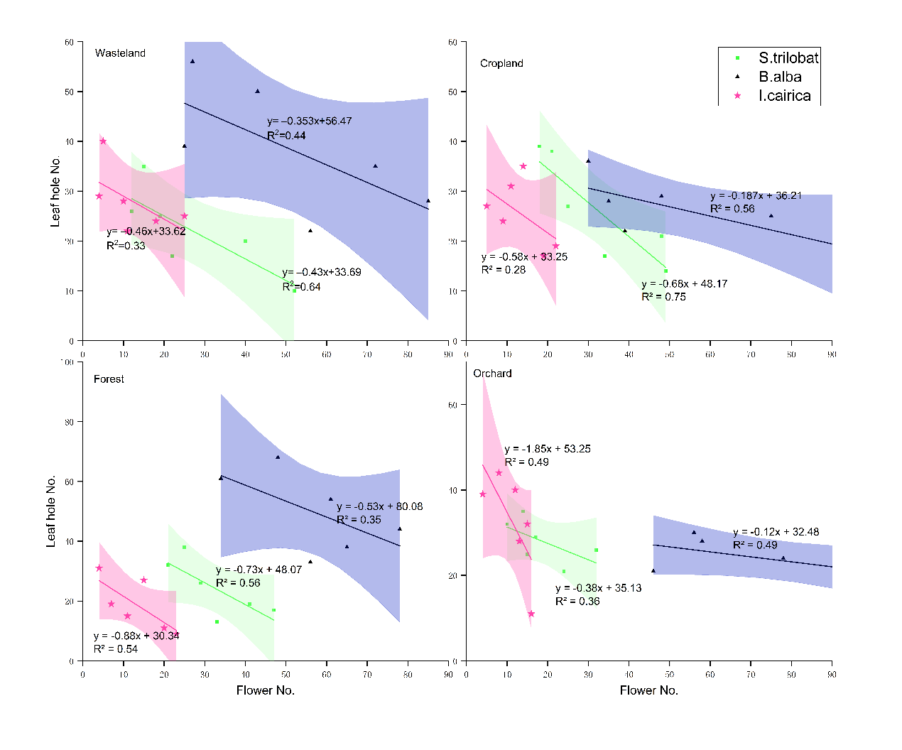
Supp. Figure 2. Correlation between the number of flowers (x-values) and the number of leaf holes (y-values) of three invasive plants across four natural habitats (Wasteland, Cropland, Forests, and Orchards), illustrated with linear regression (n=6). The shaded areas represent the 95% confidence intervals (CIs).

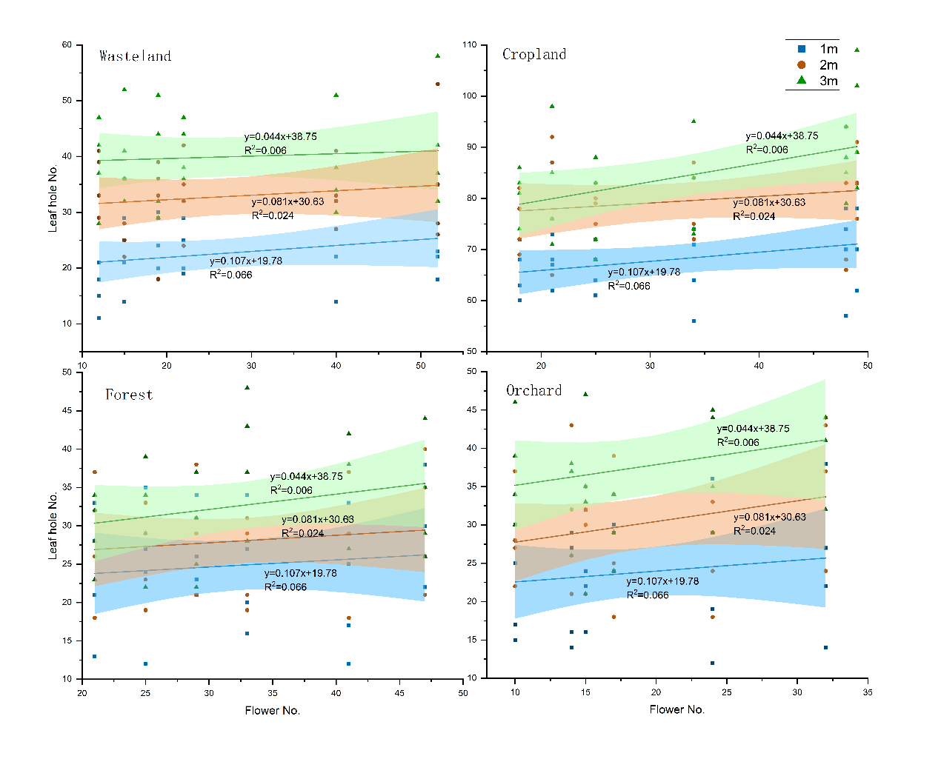
Supp. Figure 3. Correlation between the number of flowers (x-values) of invasive plant S. trilobata and the number of leaf holes (y-values) in native plants within three distances (1m, 2m, and 3m) across four natural habitats (Wasteland, Croplands, Forests, and Orchards), illustrated with linear regression (n=24). The shaded areas represent the 95% confidence intervals (CIs).

