A new experimental paradigm to manipulate psychological pressure as a spectrum using consecutive successes

Kagari Yamada^{1*}, Kohei Miyata^{1,2}, Kazutoshi Kudo^{1*}

¹ Graduate School of Arts and Sciences, The University of Tokyo
² Center for Brain Science, RIKEN
*Corresponding author
E-mail:
kudo@idaten.c.u-tokyo.ac.jp
kagari-marines@g.ecc.u-tokyo.ac.jp

Supplementary Information

We tested whether the number of consecutive successes predicted changes in heart rate of the limited participants who achieved 10 consecutive successful attempts in Experiment 1. A linear mixed model, with the number of consecutive successes as a fixed effect yielded an ordinary R² of 0.92 and adjusted R² of 0.92. The effect of the number of consecutive successes was statistically significant (β = 2.43 95%CI [1.53, 3.32], p < 0.001). We also tested whether the number of consecutive successes linearly predicted the performance of the participants achieving 10 consecutive successful attempts. A linear mixed model, with the number of consecutive successes as a fixed effect yielded an ordinary R² of 0.21 and adjusted R² of 0.20. The effect of the number of consecutive successes was also statistically significant (β = -0.62$×$10⁻¹ 95%CI [-0.91$×$10⁻¹ -0.33$×$10⁻¹], p < 0.001).
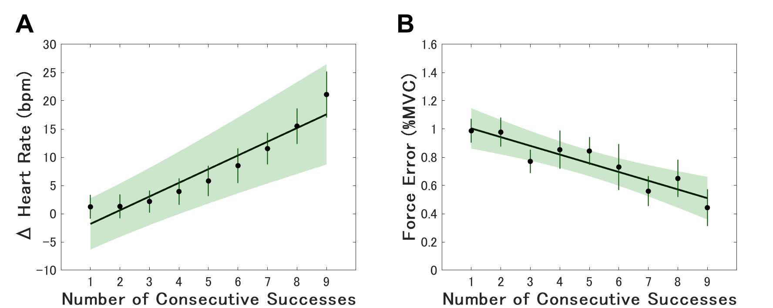
Supplementary Figure 1. Heart rate difference from resting (A) and performance (B) as a function of consecutive success in Experiment 1 for the limited participants who achieved 10 consecutive successful attempts. Linear regression lines are shown because the fixed-effects coefficients are significant (shading reflects confidence intervals). Vertical bars represent between-participant standard error.

We tested whether the number of consecutive successes predicted changes in heart rate of the limited participants who did not achieve 10 consecutive successful attempts in Experiment 1. A linear mixed model, with the number of consecutive successes as a fixed effect yielded an ordinary R² of 0.86 and adjusted R² of 0.86. The effect of the number of consecutive successes was not statistically significant (β = 0.85 95%CI [-0.58, 2.27], p = 0.24). We also tested whether the number of consecutive successes linearly predicted the performance of the participants not achieving 10 consecutive successful attempts. A linear mixed model, with the number of consecutive successes as a fixed effect yielded an ordinary R² of 0.06 and adjusted R² of 0.04. The effect of the number of consecutive successes was not statistically significant (β = -0.33$×$10⁻¹ 95%CI [-0.83$×$10⁻² 0.17$×$10⁻²], p < 0.001). Although because of the small sample size the results are not statistically significant, the estimated β (regression coefficient) exhibited a similar trend to the β inferred from the data of participants who achieved 10 consecutive successes in Experiment 1.
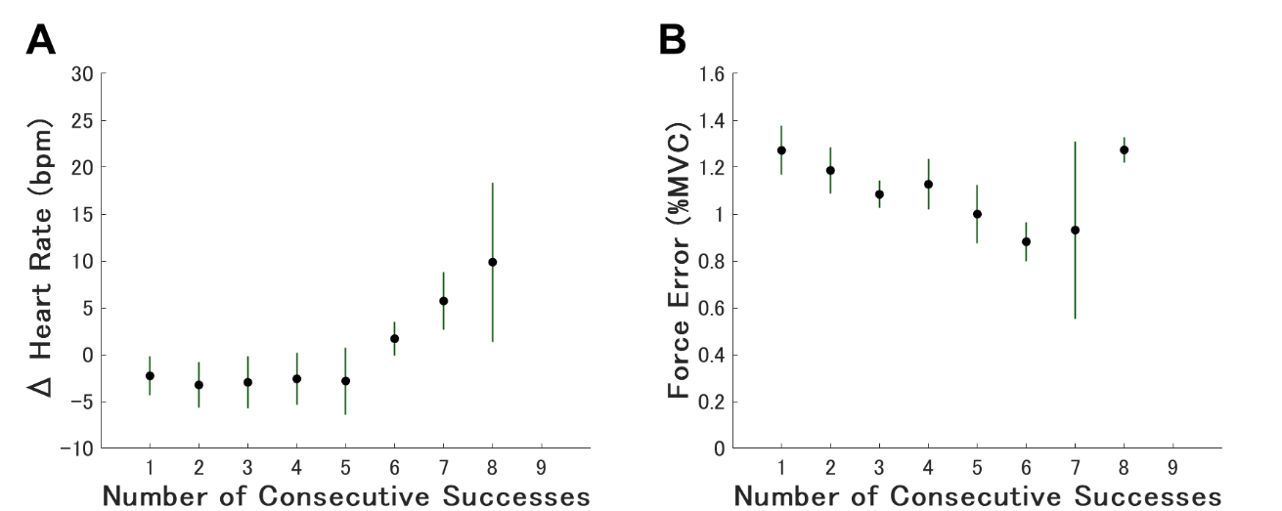
Supplementary Figure 2. Heart rate difference from resting (A) and performance (B) as a function of consecutive success in Experiment 1 for the limited participants who did not achieve 10 consecutive successful attempts. Vertical bars represent between-participant standard error.

In the linear mixed-effects model (LMM) employed in this study, we assumed the presence of random effects for each participant, reflecting the characteristics of individual participant. We further examined the relationship between the random effects from the model assessing the association between consecutive successes and heart rate and those from the model evaluating the association between consecutive successes and performance. Participants in Experiment 1 who exhibited greater increases in heart rate tended to show greater performance improvements (i.e., fewer errors) as the number of consecutive successes increased (r = -0.59, p < 0.05). This trend was observed in both the participants who achieved 10 consecutive successes and those who did not. However, compared to the participants who did not achieve 10 consecutive successes, the participants who achieved 10 consecutive successes showed a greater increase in heart rate and a more pronounced improvement in performance under pressure.
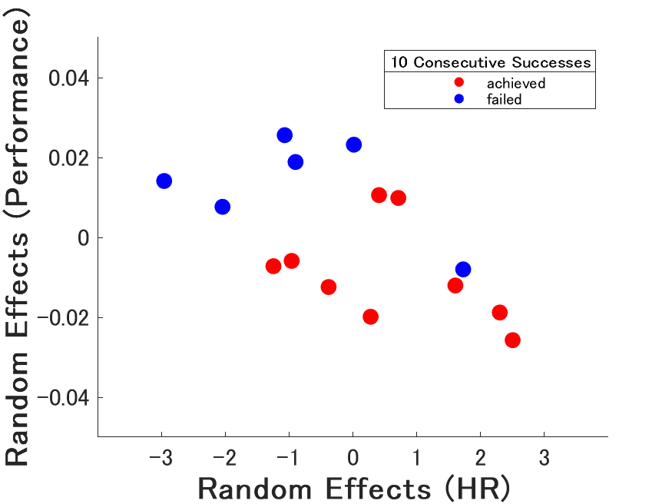
Supplementary Figure 3. These scatter plots illustrate the correlation between the random effects of heart rate and performance. Each random effect is derived from the model presented in the Results section. The red dots represent participants who achieved 10 consecutive successes, while the blue dots represent those who did not. The "Random Effects" indicate the extent to which an individual deviates from the overall trend. Importantly, a negative random effect for heart rate does not necessarily imply that heart rate decreased as the number of consecutive successes increased.

In an environment with a goal of achieving 10 consecutive successes (Experiment 1), participants' heart rates increased as the number of consecutive successes increased. While we hypothesized that the limited number of trials at each number of consecutive successes induced pressure, it is also possible that the proximity to the goal of 10 consecutive successes itself triggered this pressure. To further investigate this, we examined whether heart rate, a physiological indicator of pressure, increased as participants approached the target of 100 total successes in Experiment 2, where the goal was to achieve a total of 100 successes. The results showed no significant increase in heart rate as the total number of successes increased (β = −0.54 × 10⁻¹, 95% CI [−1.23, 0.15], p = 0.12). This finding does not support the notion that pressure naturally increases as participants approach the goal in this experimental setting.
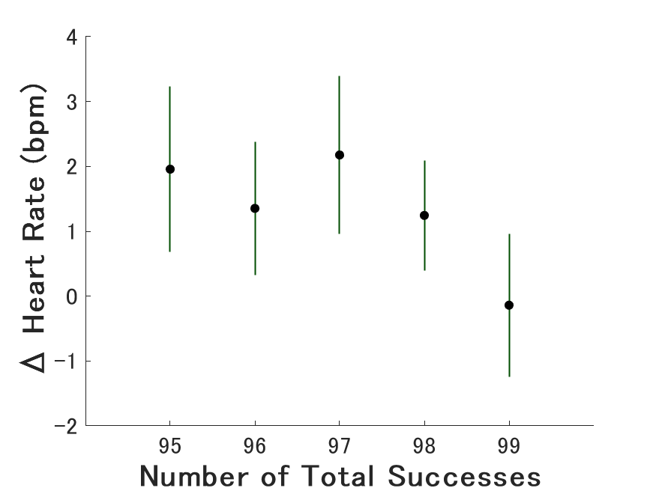
Supplementary Figure 4. Heart rate difference from resting as a function of total success (from 94 to 99) in Experiment 2. Vertical bars represent between-participant standard error.

We plotted the change in success rate across all trials in Experiment 1. Minimal learning effects were observed during the experiment. It is likely that pressure increased due to consecutive successes occurring by chance, which in turn led to an improvement in performance.
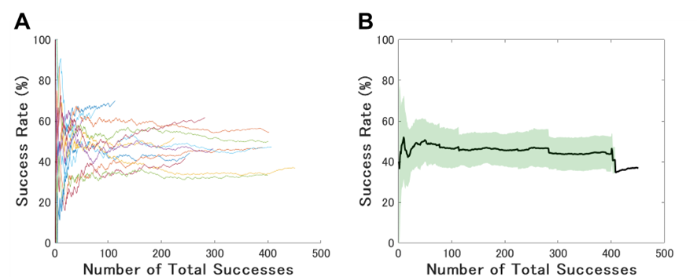
Supplementary Figure 5. The change in success rate for each participant (A) and all participants (B) in Experiment 1. In panel B, black lines represent the grand averages of all participants, and green shading indicates the standard deviation.

Supplementary Table 1. Increased heart rate induced by psychological pressure in previous studies.
We listed studies that manipulated psychological pressure. The “HR Difference (bpm)” is the difference in mean heart rate between conditions with and without pressure. The right side of the table shows the method used by experimenters to induce pressure on participants.

