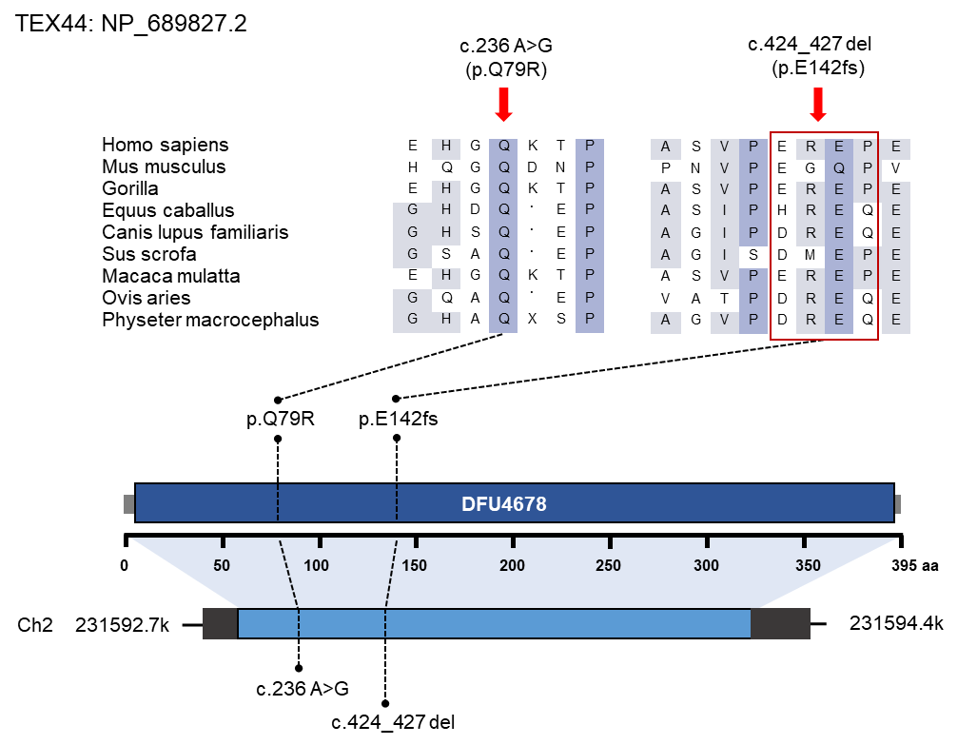
Figure S1. Schematic representation of the TEX44 structure and location of identified variants. Conservation of the mutated amino acids is indicated by the alignment of nine species.
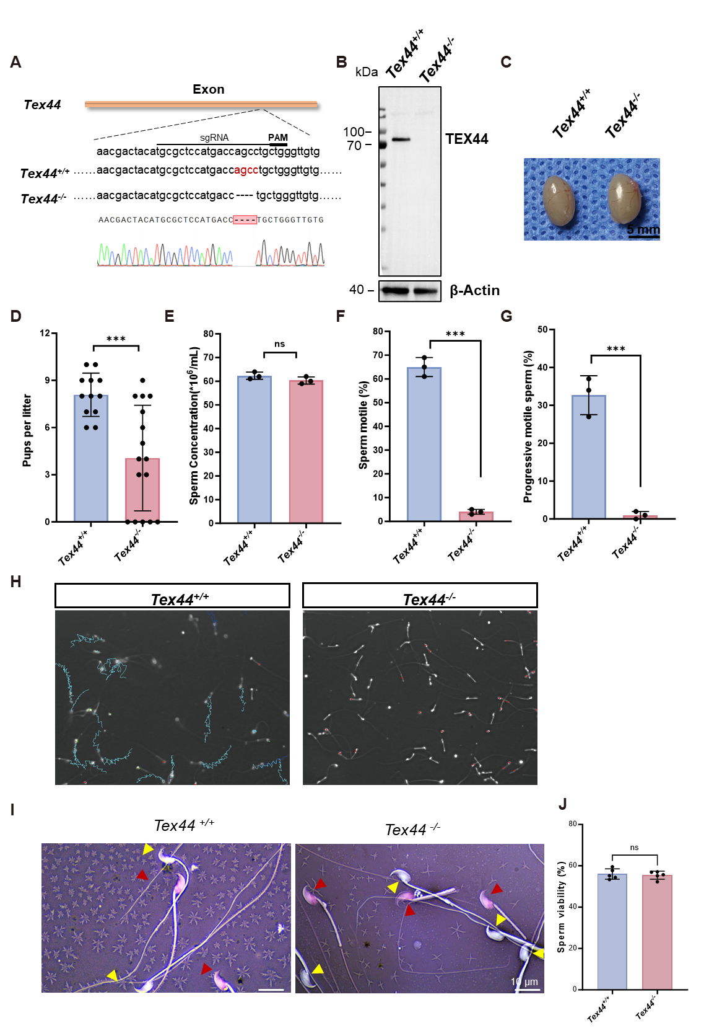
Figure S2. Sperm motility is impaired in TEX44-deficient mice.
(A) Schematic diagram of CRISPR/Cas9 targeting strategy for Tex44 knockout.
(B) Western blot confirming the absence of TEX44 expression in the testis of Tex44^{-/-} male mice compared to the expression observed in male Tex44^{+/+} mice. β-Actin was used as a loading control.
(C) 8-week-old male Tex44^{+/+} and Tex44^{-/-} mice exhibited comparable testis size measurements.
(D) Fertility analysis for adult Tex44^{+/+} and Tex44^{-/-} mice.
(E) Sperm concentrations were compared for Tex44^{+/+} and Tex44^{-/-} mice (ns, not signiﬁcant. n =3).
(F) Comparisons of sperm motility between Tex44^{+/+} and Tex44^{-/-} mice (*** P < 0.001, n =3).
(G) Comparisons of sperm progressive motility between Tex44^{+/+} and Tex44^{-/-} mice (*** P <0.001, n= 3).
(H) CASA (computer-aided sperm analysis) tracks for sperm from male Tex44^{+/+}and Tex44^{-/-} mice. Individual spermatozoa paths are represented by cyan lines, whereas red dots mark dead or immobile sperm.
- Representative images of sperm from Tex44^{+/+} and Tex44^{-/-} mice stained with eosin-nigrosine. Live sperm appear unstained (yellow arrowheads), while dead sperm are stained red (red arrowheads).
(J) Quantification of sperm viability. No significant difference was observed between Tex44^{+/+} and Tex44^{-/-} mice (ns, not signiﬁcant. n =5).For D, E, F, G, and J, data are mean ±s.e.m. P values were determined using two-tailed Student's t-tests. n values represent the number of biologically independent animals.
Figure S3. TEX44 deficiency leads to abnormal mitochondrial sheath.
- The morphological characteristics of Tex44^{+/+} and Tex44^{-/-} spermatozoa were compared, revealing that while Tex44^{-/-} spermatozoa exhibited normal head morphologies, the mitochondrial sheath region was consistently short and disordered, in line with the clinical phenotypes observed in human males harboring biallelic TEX44 variants.
- Abnormal mitochondrial sheath ratio of Tex44^{+/+} and Tex44^{-/-}. (**** P<0.0001, n =5).
- Sperm tail length measurements between Tex44^{+/+} and Tex44^{-/-} mice. ns, not signiﬁcant (ns, not signiﬁcant. n =5).
(D) Representative images showing sperm flagellar abnormalities in Tex44^{+/+} and Tex44^{-/-} mice. The sperm abnormalities were classified into three categories: MP-PP disjunction (separation between the midpiece and principal piece), Partial Bent (localized bending at angles less than 180°), and Complete Bent (180° curvature of the flagellum). The dashed boxes indicate areas with angle measurement. Scale bar: 10 µm.
(E) Quantification of sperm abnormalities in different regions of the epididymis (Caput, Corpus, and Cauda) in Tex44^{+/+} and Tex44^{-/-} mice. Sperm abnormalities were classified as normal (white), MP-PP disjunction (light red), Partial Bent (red), and Complete Bent (dark red) (n =3).
(F) Immunofluorescence assessment of TEX44 localization in Tex44^{+/+} and Tex44^{-/-} spermatozoa using TOMM20 (magenta) to stain the mitochondrial sheath and Hoechst (blue) to stain the nuclei. Scale bar: 10 μm.
(G) Quantification of mitochondrial sheath length based on TOMM20 fluorescence signals shows a significant shortening of the mitochondrial sheath in Tex44^{-/-} mice (**** P<0.0001, n =3).
(H) SEM images of Tex44⁺/⁺ and Tex44⁻/⁻ spermatozoa from the cauda epididymis, indicating regions absent of mitochondria (red arrows) and the annulus (white arrows). Scale bars: 10 μm (left), 2 μm (middle), 3 μm (right).
(I) TEM images of longitudinal sections of Tex44^{+/+} and Tex44^{-/-} sperm midpiece regions. The mitochondrial sheath is marked using red arrows. Scale bar: 1 μm.
(J) Immunofluorescent of SEPT4 (green) in spermatozoa from Tex44^{+/+} and Tex44^{-/-} mice. Hoechst(blue) was used for nuclear counterstaining in the indicated images, and brightfield images are also presented. SEPT4 labels the annulus. Scale bar: 10 μm.
(K) Immunofluorescence images showing the localization of TEX44 (green) and SEPT4 (magenta) in mouse spermatozoa. No colocalization was observed between TEX44 and SEPT4. Scale bar: 10 μm.
(L) Fluorescence intensity profiles of TEX44 (green line) and SEPT4 (magenta line) along the defined axis indicated by the white line in (K). The intensity plots show distinct localization of TEX44 and SEPT4 with no significant overlap, further confirming their spatial segregation. For B, C, and G, data are mean ±s.e.m. P values were determined using two-tailed Student's t-tests. n values represent the number of biologically independent animals.

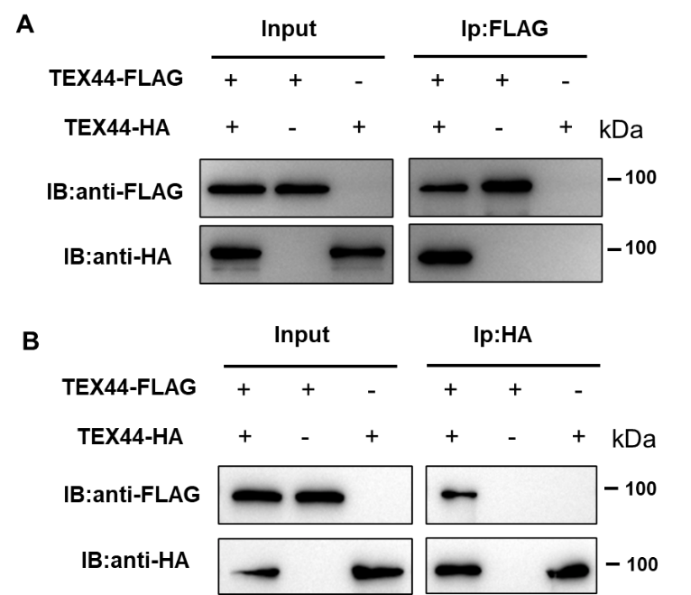
Figure S4. TEX44 forms homodimers in HEK293T cells.
(A–B) Co-immunoprecipitation assays in HEK293T cells co-expressing TEX44-FLAG and TEX44-HA. Immunoprecipitation was performed with anti-FLAG (A) or anti-HA (B) antibodies, followed by immunoblotting with tag-specific antibodies. Reciprocal pulldown confirms that TEX44 can form homodimers in cells.
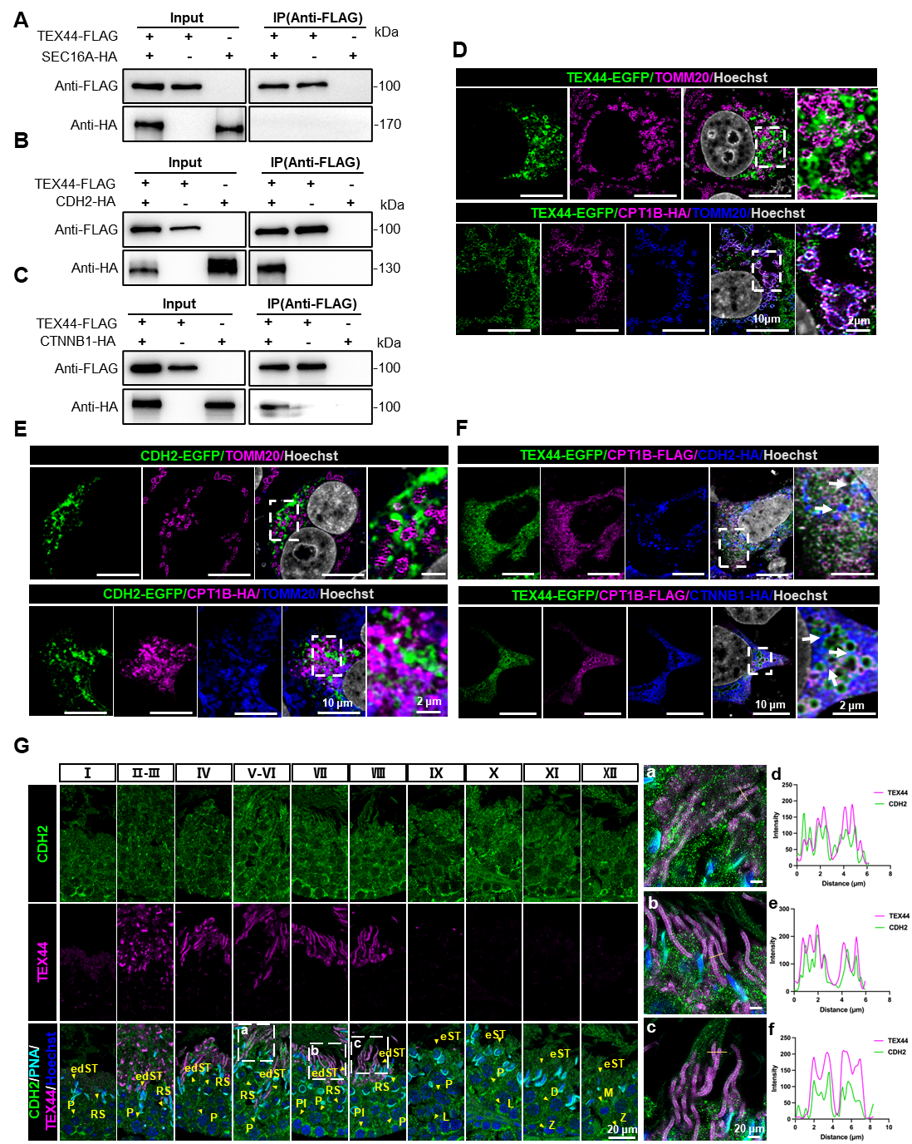
Figure S5. TEX44 coordinates with CDH2 and CTNNB1 to meditate mitochondria linkage.
(A-C) Co-immunoprecipitation assays showing interactions between TEX44-FLAG and SEC16A-HA (A) or CDH2-HA (B) or CTNNB1-HA (C) in HEK293T cells. Immunoprecipitation was performed using an anti-FLAG antibody, and both input and immunoprecipitated samples were analyzed by western blot using anti-FLAG and anti-HA antibodies.
(D) Immunofluorescence of HeLa cells transfected with TEX44-EGFP alone (upper) or with CPT1B-HA (lower). TEX44 (green), TOMM20 (magenta in upper, blue in lower), and nuclei (Hoechst, grey) were detected with corresponding antibodies. Insets show enlarged views of the regions outlined with white dashed boxes. TEX44 alone fails to localize to mitochondria, while co-expression with CPT1B promotes co-localization with TOMM20. Scale bars: 10 μm (main), 2 μm (inset).
(E) Immunofluorescence analysis of HeLa cells expressing CDH2-EGFP alone (upper) or co-expressing CDH2-EGFP and CPT1B-HA (lower). TOMM20 (magenta in upper; blue in lower) and nuclei (Hoechst, grey) were also stained. Insets show enlarged views of boxed regions. CDH2 localizes between mitochondria regardless of CPT1B expression. Scale bars: 10 μm (main), 2 μm (inset).
(F) Immunofluorescence analysis of HeLa cells co-expressing TEX44-EGFP and CPT1B-FLAG, together with CDH2-HA (upper) or CTNNB1-HA (lower). TEX44–EGFP (green), CPT1B–FLAG (magenta), and CDH2–HA or CTNNB1–HA (blue) was detected using tag-specific antibodies, and nuclei were counterstained with Hoechst (grey). Insets show enlarged views of the regions outlined by dashed boxes. Arrows indicate inter-mitochondrial localization of CDH2 or CTNNB1. Scale bars: 10 μm (main), 2 μm (inset).
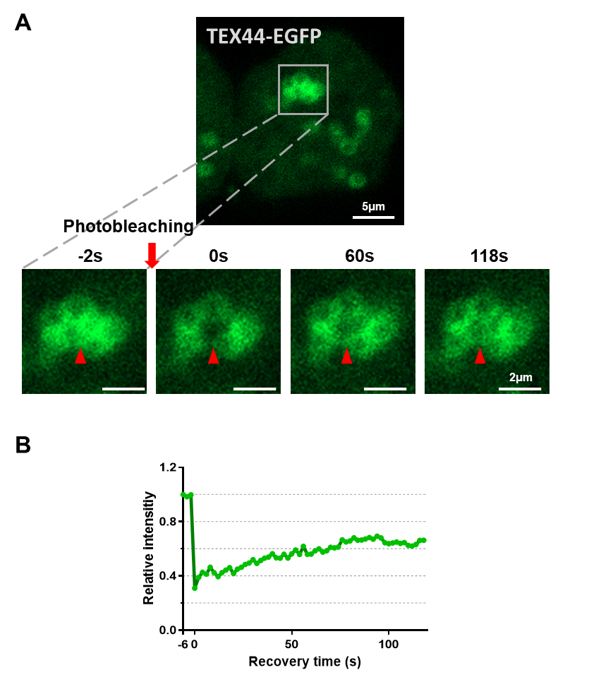
(G) Immunofluorescence analysis of TEX44 and CDH2 in adult wild-type mouse testes. Sections were co-stained with antibodies against TEX44 (magenta) and CDH2 (green), and labeled with PNA (grey) and Hoechst (blue). Spermiogenesis stages (I–XII) are indicated. The regions highlighted by white dashed boxes in the left panels of the three groups are shown at higher magnification in the corresponding middle panels (a–c). The right panels (d–f) present fluorescence intensity profiles corresponding to the areas indicated by the yellow lines. Abbreviations: edST, elongated spermatid; eST, elongating spermatid; RS, round spermatid; Pl, Preleptotene spermatocyte; P, pachytene spermatocyte; L, leptotene spermatocyte; Z, zygotene spermatocyte; D, Diplotene spermatocyte; M, Metaphase spermatocyte. Scale bars: 20 μm.
Figure S6. TEX44 protein exhibits liquid-liquid phase separation properties.
(A) Fluorescence recovery after photobleaching analysis of TEX44-EGFP signal in Hela cells. The grey box highlights the punctum undergoing targeted bleaching. Scale bars: 5 μm (upper), 2 μm (lower).
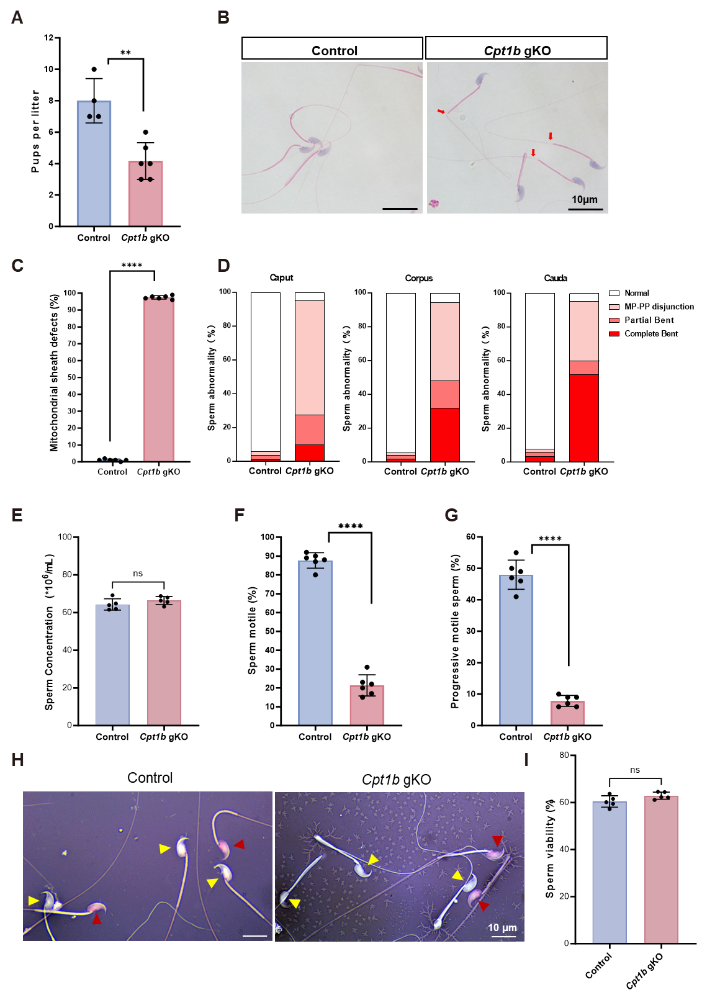
(B) Fluorescence intensity analysis of FRAP data.
Figure S7. Cpt1b gKO mice exhibit impaired sperm motility and mitochondrial sheath defects.
(A) Fertility analysis for adult control and Cpt1b gKO mice. (**P < 0.01, n =6).
(B) Hematoxylin and Eosin staining of spermatozoa from control and Cpt1b gKO mice. Scale bars: 10 μm.
(C) Quantification of of mitochondrial sheath defects of Cpt1b gKO sperm tail. (**** P < 0.0001, n =6).
(D) Quantification of sperm abnormalities in different regions of the epididymis (Caput, Corpus, and Cauda) in Control and Cpt1b gKO mice. Sperm abnormalities were classified as normal (white), MP-PP disjunction (light red), Partial Bent (red), and Complete Bent (dark red) (n =3).
(E) Quantification of sperm concentration from control and Cpt1b gKO mice. (ns, not significant, n =5).
(F) Sperm motility from control and Cpt1b gKO mice. (**** P < 0.0001, n =6).
(G) Progressive sperm rate of sperm from control and Cpt1b gKO mice. (**** P < 0.0001, n =6).
(H) Representative images of sperm from control and Cpt1b gKO mice stained with eosin-aniline black. Live sperm appear unstained (yellow arrowheads), while dead sperm are stained red (red arrowheads).
(I) Quantification of sperm viability. No significant difference was observed between control and Cpt1b gKO mice (ns, not significant, n =5). For A, C, E, F, G and I, data are mean ±s.e.m. P values were determined using two-tailed Student's t-tests. n values represent the number of biologically independent animals.

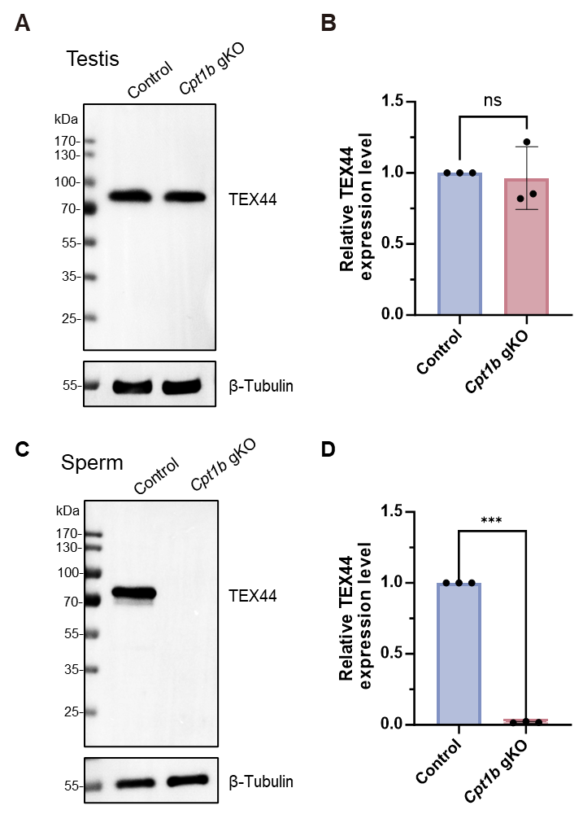
Figure S8. TEX44 protein is present in the testes but absent in spermatozoa of Cpt1b gKO mice.
(A) Western blot analysis of TEX44 expression in testicular lysates from control and Cpt1b gKO mice. β-Tubulin served as a loading control.
(B) Quantification of TEX44 expression in testis, normalized to β-Tubulin (ns, not significant, n =3).
(C) Western blot analysis of TEX44 expression in spermatozoa collected from the cauda epididymis of control and Cpt1b gKO mice. TEX44 is undetectable in spermatozoa from Cpt1b gKO mice.
(D) Quantification of TEX44 expression in spermatozoa, normalized to β-Tubulin (***P < 0.001, n =3). For B and D, data are mean ±s.e.m. P values were determined using two-tailed Student's t-tests. n values represent the number of biologically independent animals.

 | Table S1. Mean Semen Parameters and Sperm Morphology in Patients
Subjects |  | Patients (n=673, Mean ± SD) | Reference value
Semen parameters
Sperm concentration (10⁶/mL) |  | 11.96 ± 24.93 | ≥15
Sperm count (10⁶/ejaculate) |  | 33.24 ± 73.61 | ≥39
Progressive motility (%) |  | 8.96 ± 9.24 | ≥32
Motility (%) |  | 15.95 ± 13.77 | ≥40
Sperm morphology
Normal morphology (%) |  | 1.86 ± 1.30 | ≥4
Figure S9. Gating strategy for flow cytometry. Representative data for the mitochondrial ROS assay (corresponding to Fig. 7B). FSC-A/SSC-A gate was used to exclude debris and Hoechst positive gate was used to identify spermatozoa.

Table S2. Bi-allelic Variants of TEX44 Identified in Asthenozoospermia-Affected Subjects
Subjects | Family1 Ⅳ-1 | Family2 Ⅱ-2 | Family3 Ⅱ-2 | Family4 Ⅱ-1 | Family5 Ⅱ-1 | Family6 Ⅱ-1
TEX44 Variants
Affected  Allele | c.424_427del | c.424_427del | c.424_427del | c.424_427del | c.424_427del | c.236A>G
Protein Alteration | p.E142fs | p.E142fs | p.E142fs | p.E142fs | p.E142fs | p.Q79R
Mutation Type | frameshift | frameshift | frameshift | frameshift | frameshift | missense
Zygosity | homozygous | homozygous | homozygous | homozygous | homozygous | homozygous
Allele Frequency In Population
gnomAD | 0.008368 | 0.008368 | 0.008368 | 0.008368 | 0.008368 | 0.01392
1000GP | 0.0124 | 0.0124 | 0.0124 | 0.0124 | 0.0124 | 0.0361422
Functional prediction
SIFT | NA | NA | NA | NA | NA | Deleterious
PolyPhen-2 | NA | NA | NA | NA | NA | Damaging
MutationTaster | Disease causing | Disease causing | Disease causing | Disease causing | Disease causing | Disease causing
NCBI accession number of TEX44 is NM_152614.3. Abbreviations are as follows: 1000GP, gnomAD, the Genome Aggregation Database
NA not available

Table S3. Candidate pathogenic variations identified by WES
Patient | Gene | Type | Variation | Gnomad_exome_AF | 1000g2015aug_all | ExAC_ALL | SIFT | Polyphen2 | MutationTaster | Inherited pattern
Family1 Ⅳ 1 | TEX44 | frameshift deletion | ENSG00000177673:ENST00000313965:exon1:c.424_427del:p.E142fs | 0.0087 | 0.0123802 | 0.0083 | NA | NA | D | homozygous
Family2 Ⅱ 2 | TEX44 | frameshift deletion | ENSG00000177673:ENST00000313965:exon1:c.424_427del:p.E142fs | 0.0087 | 0.0123802 | 0.0083 | NA | NA | D | homozygous
Family2 Ⅱ 2 | C11orf21 | frameshift insertion | ENSG00000110665:ENST00000456145:exon4:c.357dupC:p.T120fs | 0.0028 | 0.00499201 | 0.002 | NA | NA | NA | homozygous
Family3 Ⅱ 1 | TEX44 | frameshift deletion | ENSG00000177673:ENST00000313965:exon1:c.424_427del:p.E142fs | 0.0087 | 0.0123802 | 0.0083 | NA | NA | D | homozygous
Family3 Ⅱ 1 | DMBT1 | frameshift insertion | ENSG00000187908:ENST00000368955:exon7:c.576_577insA:p.G192fs | 0.0006 | 0.00139776 | 0.0006 | NA | NA | NA | heterozygous
Family3 Ⅱ 1 | DMBT1 | nonsynonymous SNV | ENSG00000187908:ENST00000368955:exon7:c.C577A:p.H193N | 0.0006 | 0.00139776 | 0.0006 | D | D | D | heterozygous
Family3 Ⅱ 1 | DMBT1 | nonsynonymous SNV | ENSG00000187908:ENST00000368955:exon45:c.G5873A:p.R1958Q | 0.0016 | 0.00499201 | 0.0016 | T | D | N | heterozygous
Family4 Ⅱ 1 | TEX44 | frameshift deletion | ENSG00000177673:ENST00000313965:exon1:c.424_427del:p.E142fs | 0.0087 | 0.0123802 | 0.0083 | NA | NA | D | homozygous
Family5 Ⅱ 1 | TEX44 | frameshift deletion | ENSG00000177673:ENST00000313965:exon1:c.424_427del:p.E142fs | 0.0087 | 0.0123802 | 0.0083 | NA | NA | D | homozygous
D (SIFT), Deleterious; T (SIFT), Tolerated; D (Polyphen2), Damaging;
D (MutationTaster), Disease causing; N (MutationTaster), Polymorphism.

Table S4. Semen characteristics of individuals harbouring the TEX44 variants.
Subjects | Family1 Ⅳ-1 | Family2 Ⅱ-2 | Family3 Ⅱ-2 | Family4 Ⅱ-1 | Family5 Ⅱ-1 | Family6 Ⅱ-1 | Reference Values
Semen Parameters
Sperm volume (mL) | 5.4 | 1.8 | 2 | 4.6 | 1.8 | 3 | ≥1.5
Seminal PH | 7.2 | 7.2 | 7.2 | 7.2 | 7.2 | 7.2 | ≥7.2
Concentration(mill/mL) | 2.5ª | 8.3ª | 0.4ª | 5.1ª | 0.1ª | 15 | ≥15
Total motility(%) | 0ª | 0ª | 0ª | 33.9ª | 0ª | 6ª | ≥40.0
Progressive motility(%) | 0ª | 0ª | 0ª | 25.4ª | 0ª | 1ª | ≥32.0
Normal Morphology (%) | 0ª | 0ª | 0ª | 0ª | 0ª | 2.0ª | ≥4
Head Defects (%) | 12 | 22 | 17 | 25 | 13 | 30 | -
Neck and midpiece defects (%) | 91 | 90 | 92 | 93 | 89 | 60.5 | -
Tail Defects (%) | 12 | 19 | 20 | 11 | 18 | 14 | -
Lower and upper reference limits according to the World Health Organization Standardss 5th
ªAbnormal values.

Table S5. Potential TEX44 interacting proteins identified by IP-Ms
Gene symbol | Accession |  | Description |  |  |  |  | Peptides |  | Unique Peptides |  | AAs | Abundance IgG-1 |  | Abundance IgG-2 |  |  | Abundance IgG-3
Tex44 | Q9DA60 |  | Testis-expressed protein 44 OS=Mus musculus OX=10090 GN=Tex44 PE=2 SV=2 |  |  |  |  | 16 |  | 16 |  | 530 | Not detected |  | 12767.9902 |  |  | 39573.9961
Cpt1b | Q924X2 |  | Carnitine O-palmitoyltransferase 1, muscle isoform OS=Mus musculus OX=10090 GN=Cpt1b PE=1 SV=1 |  |  |  |  | 15 |  | 15 |  | 772 | Not detected |  | Not detected |  |  | Not detected
Ctnnb1 | Q02248 |  | Catenin beta-1 OS=Mus musculus OX=10090 GN=Ctnnb1 PE=1 SV=1 |  |  |  |  | 9 |  | 8 |  | 781 | 111116.443 |  | 163173.639 |  |  | 93435.7813
Sec16a | E9QAT4 |  | Protein transport protein Sec16A OS=Mus musculus OX=10090 GN=Sec16a PE=1 SV=1 |  |  |  |  | 4 |  | 4 |  | 2357 | Not detected |  | Not detected |  |  | Not detected
Cdh2 | P15116 |  | Cadherin-2 OS=Mus musculus OX=10090 GN=Cdh2 PE=1 SV=2 |  |  |  |  | 2 |  | 2 |  | 906 | Not detected |  | 19740.1797 |  |  | 19976.6602
Gene symbol |  | Abundance TEX44-1 |  | Abundance TEX44-2 | Abundance TEX44-3 | IgG-1 | IgG-2 |  | IgG-3 |  | TEX44-1 |  |  | TEX44-2 |  | TEX44-3 | FDR Confidence
Tex44 |  | 7604092.22 |  | 12003881.5 | 13431156.9 | Not Found | Peak Found |  | Peak Found |  | High |  |  | High |  | High | High
Cpt1b |  | 1180312.29 |  | 2479747.59 | 2822732.97 | Not Found | Not Found |  | Not Found |  | High |  |  | High |  | High | High
Ctnnb1 |  | 707513.898 |  | 1167568.08 | 1379513.04 | Peak Found | Peak Found |  | Peak Found |  | High |  |  | High |  | High | High
Sec16a |  | 119747.27 |  | 135412.711 | 121732.566 | Not Found | Not Found |  | Not Found |  | High |  |  | High |  | High | High
Cdh2 |  | 146155.141 |  | 194724.273 | 203939.461 | Not Found | Peak Found |  | Peak Found |  | High |  |  | High |  | High | High
IP-MS, immunoprecipitation-mass spectrometry; OS, organism name; GN，gene name; PE, protein existence; SV, sequence version.

