Title
Descriptive Study for Mobility Device Use and Two-Year Disability Occurrence in Community-Dwelling Older Adults
Author information
Masanori Morikawa^{1,2}, Kenji Harada¹, Satoshi Kurita^{1,3}, Chiharu Nishijima¹, Kazuya Fujii¹, Daisuke Kakita¹, and Hiroyuki Shimada¹
Affiliations
1 Department of Preventive Gerontology, Center for Gerontology and Social Science, National Center for Geriatrics and Gerontology, Obu, Aichi 474-8511, Japan
2 Japan Society for the Promotion of Science, Tokyo, 102-0083, Japan
3 School of Psychology, Faculty of Science, the University of New South Wales, Sydney, 2052 Australia
Corresponding author
Masanori Morikawa
Center for Gerontology and Social Science, National Center for Geriatrics and Gerontology Obu, Aichi 474-8511, Japan.
Email address: morikawa@ncgg.go.jp
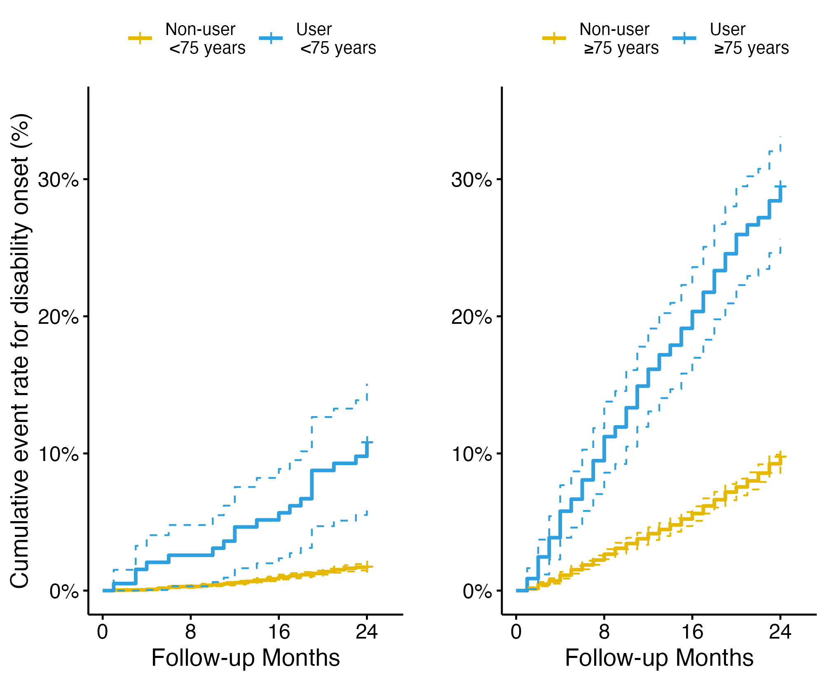
Supplemental Figure. 1 Kaplan-Meier survival curves from disability occurrence by cane usage (non-users and users) by age group (left: <75 years; right: ≥75 years). Solid and dotted lines are used to represent the survival rate and the 95% confidence interval. The yellow and blue lines show the curves for the non-users and the users.

