Supplementary information

Ultrafast Preliminary Screening of COVID-19 by Machine Learning Analysis of Exhaled NO
Li Yang^{1,#}, Jing Ma^{2,#}, Wei Zhou¹, Lei Sun^{1,*}, Dong Zhai¹, Guoqing Ren¹, Tie Yu¹, Jie Chen², Jinping Zhang², Morong Wang², Jie Wang², Weiqiao Deng¹
¹ Institute of Molecular Sciences and Engineering, Institute of Frontier and Interdisciplinary Science, Shandong University, Qingdao 266237, China.
² Department of Critical Care Medicine, Liyuan Hospital, Tongji Medical College, Huazhong University of Science and Technology, Wuhan 430070, China.
# These authors contributed equally to this work.
Corresponding Authors
* Lei Sun: slei@sdu.edu.cn

Participants details
1. Hypothesis
Considering that SARS-CoV-2 and SARS-CoV disease have similarities, we hypothesized that the FeNO concentration plays a crucial role in the preliminary diagnosis of COVID-19 and using the machine learning algorithms analysis FeNO can preliminary screen COVID-19.
2. Purpose of the study
This study is designed to test the hypothesis that FeNO combine with other features can be used to preliminary screen COVID-19 and develop a rapid, economical and non-invasive method for COVID-19 preliminary screening.
3. Recruitment of subjects
Potential participants will be identified within 14 days before the test.
3.1 Inclusion criteria
This study was approved by the Medical Ethics Committee of Liyuan Hospital, Tongji Medical College, Huazhong University of Science and Technology
3.1.1 All Patients and healthy subjects or family members have signed informed consent and agreed to accept the FeNO detection and personal information including age, gender, height, weight and anamnesis collection;
3.1.2 Age 20 or older;
3.1.3 Body mass index between 18.5 and 29.9 (according to national criteria).
3.2 Exclusion criteria
Patients will be excluded if they meet any of the following criteria.
3.2.1 Hard to do FeNO test;
3.2.2 Subjects eating three hours before the FeNO test;
3.2.3 Subjects who smoked or drank alcohol one hour before the FeNO test;
3.2.4 Subjects who exercise vigorously one hour before the FeNO test;
3.2.5 Subjects who have undergone other lung function tests one hour before the FeNO test.
3.3 Criteria of drop out
3.3.1 Withdrawal of consent by the participants themselves;
3.3.2 Subjects who cannot provide complete information.
For drop out cases, the detailed reasons will be recorded. The Case Report Form (CRF) of these cases will be preserved for future reference.
3.4 Criteria of Rejection
Enrolled cases who meet any of the following criteria will be excluded from further per protocol analysis.
3.4.1 FeNO value collection is unsuccessful;
3.4.2 Unable to evaluate the information collected is true;
3.4.3 Cases whose cause cannot be determined.
For rejected cases, the detailed reasons will be recorded and CRFs will be preserved for reference. The results of these cases will be excluded in analysis of therapeutic effects.
3.5 Criteria of Study Interruption
Study will be interrupted in the following situations:
3.5.1 Severe safety issues occurred during the study;
3.5.2 Serious mistakes found in the protocol;
3.5.3 Fund or management problem of the investigators;
3.5.4 Study terminated by the administrative authority.
Study interruption may be transient or permanent. All recorded CRFs will be preserved for reference in case of study interruption.
4. Study design
4.1 Type of the study
The study is a prospective trial. We only need to detect the FeNO values of participants, and collect data on the age, sex, anamnesis (tuberculosis, COPD, lung cancer, allergic rhinitis, pharyngitis, heart disease, diabetes, and stomach disease) and symptoms (including the presence or absence of fever, nasal congestion, cough and/or sputum) of the subjects.
4.2 Sample size calculation
We need collect as much data as possible
5. Data collection
5.1 Determine patient’s eligibility based on the inclusion and exclusion criteria;
5.2 Demographic data, body size, anamnesis and symptoms;
5.3 FeNO values.
6. Outcomes
FeNO values, demographic data, body size, anamnesis and symptoms.
Supplementary Methods
ML model
We developed random forest classifiers based on the FeNO, age, sex, height, weight, BMI, and body area of each subject. We fine-tuned the hyperparameters of the random forest classifier on the training and validation sets and evaluated the model on the test set. Ten-fold cross-validation was used in this study. The number of estimators and “class_weight” was tuned. The ML model was selected because of the highest AUC score on the validation set. We used the Scikit-learn¹ package to train and evaluate these models.
Feature engineering
. Feature engineering is firstly used to evaluate the feature correlation. Pearson correlation coefficient matrices are calculated to identify the positive and negative correlations between pairs of features (Supplementary Figure 1). Body mass index (BMI) and body area are highly related to weight and height. At the same time, age and FeNO show low linear correlations with other features. The low linear correlations for age and FeNO features indicate that it would better keep them in the ML model construction process. The redundant feature should be removed, which will improve the performance of the ML model.
Data set split
We randomly split the subjects into two sets: the training set and the test set (Fig. 2). The training set contained 70 healthy subjects and 34 COVID-19 patients. The test set comprised 10 non-COVID-19 subjects with asthma, gastric disorders, pharyngitis and hypertension, 23 healthy subjects, and 12 COVID-19 patients. The 23 healthy subjects and 12 COVID-19 patients in the test set were selected according to a 2:1 ratio of healthy to COVID-19 subjects, and they made up 25% percent of the total number of healthy and COVID-19 subjects. 10-fold cross-validation (CV) was performed to improve our prediction of the “out-of-sample” error.
Machine-learning classifiers
We investigated other feature combinations for classifying the COVID-19. Supplementary Figure 2 and 3 show the ML model built by using the feature combinations of ['Age’, 'FeNO'] and ['Height', 'Weight', 'Age', 'FeNO']. As shown in figure S1 and S2, feature combinations of ['Age’, 'FeNO'] and ['Height', 'Weight', 'Age', 'FeNO'] cause a high false positive rate of 21.7% and 17.4% in test cohort when only consider the classification of healthy subjects and COVID-19 patients. And the AUCs of the tow feature combinations in test cohort are both lower than the feature combination of [ 'Age', 'BMI', 'Body Area' and 'FeNO']. In addition to the same sensitivity as feature combination of [ 'Age', 'BMI', 'Body Area' and 'FeNO'], other classification evaluation metrics are worse. The two feature combination shows similar prediction for subjects with asthma, pharyngitis, hypertension and gastric disorder as shown in Supplementary Figure 1 C and 2 C. All five pharyngitis subjects are classified as healthy non-COVID-19. This result indicates that disease like pharyngitis which has little effect on FeNO value will be classified as healthy subjects. All the two asthma patients were identified as COVID-19 patients with a high possibility rate. Both of the model classified 3 of the gastric disorder and hypertension subjects as COVID-19 patients. From the three models, we can conclude that diseases such as asthma, gastric disorder and hypertension which significantly affect the FeNO value will be classified as COVID-19 patients. Therefore, the investigation of past medical history is very important for this machine learning model.

Figure S1. Correlation of the features. The heat map of the Pearson correlation coefficient matrix among the features is shown.
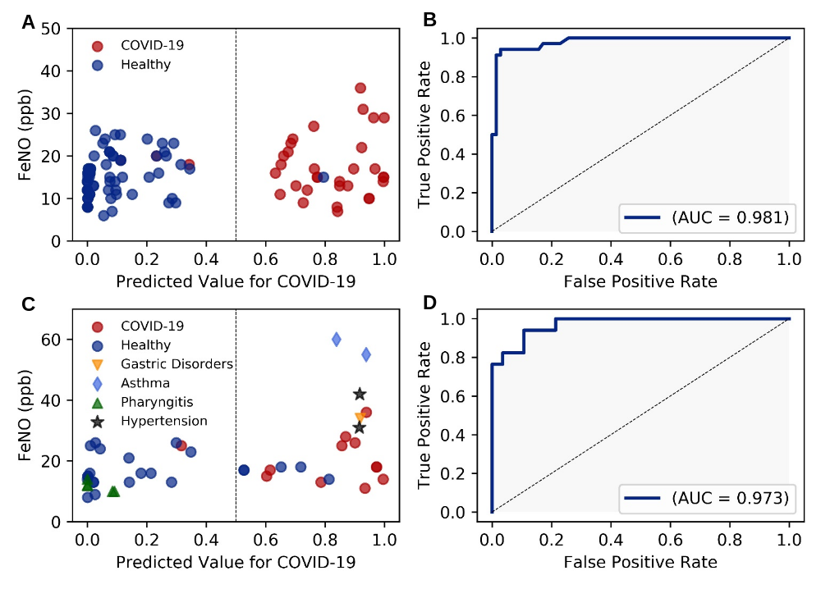
Figure S2. Receiver operating characteristic (ROC) curve performance of the ML model. (A) The performance of the model in the training cohort. (B) ROC curve in the training cohort. AUC is 0.981. (C) The performance of the model in the test cohort. (D) ROC curve of test cohort. AUC is 0.973. For the classification of healthy subjects and COVID-19 patients, the ML model achieved an AUC of 0.953, accuracy of 0.829, sensitivity of 0.917, specificity of 0.783, precision of 0.687 and F1 score of 0.786.
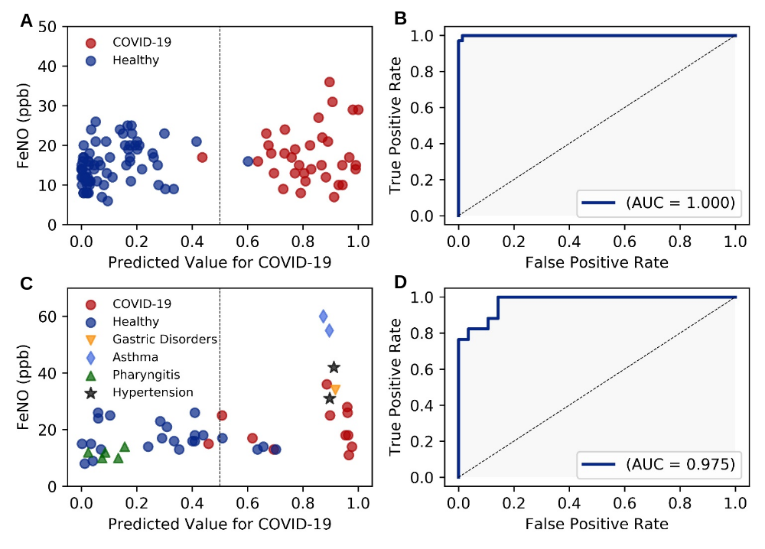
Figure S3. Receiver operating characteristic (ROC) curve and performance the ML model. (A) The performance of the model in the training cohort. (B) ROC curve in the training cohort. AUC is 1.000. (C) The performance of the model in the test cohort. (D) ROC curve of test cohort. AUC is 0.975. For the classification of healthy subjects and COVID-19 patients, the ML model achieved an AUC of 0.957, accuracy of 0.857, sensitivity of 0.917, specificity of 0.826, precision of 0.733 and F1 score of 0815.

Reference
1. Pedregosa F, Varoquaux G, Gramfort A, et al. Scikit-learn: machine learning in Python. J Mach Learn Res 2011; 12: 2825-2830.

