Supplementary information

Ultrafast Screening of COVID-19 by Machine Learning Analysis of Exhaled NO
Li Yang^{1,#}, Wei Zhou^{1,#}, Jing Ma^{2,#}, Lei Sun^{1,*}, Dong Zhai¹, Guo-Qing Ren¹, Tie Yu¹, Wei-Qiao Deng^{1, *}

Supplementary Table 1. Demographics and Baseline Characteristics of COVID-19 Patients and Non-COVID-19 in the Current Study.
Variables | Non-COVID-19 |  |  |  | COVID-19 (N=46)
Variables | Healthy Control (N=93) | Asthma (N=2) | Pharyngitis (N=5) | Hypertension /Gastric Disorder(N=3) | COVID-19 (N=46)
Sex (number) (%)
Male | 38 (40.86) | 0 (0.00) | 4 (80.00) | 0 (0.00) | 24 (52.17)
Female | 55 (59.14) | 2 (100.00) | 1 (20.00) | 3 (100.00) | 22 (47.83)
Age (year)
Mean±SD | 37.5 ± 12.6 | 28.0 ± 9.9 | 31.6 ± 7.7 | 49.0 ± 2.0 | 61.5 ± 15.3
Range | 21.0-65.0 | 21.0-35.0 | 25.0-41.0 | 47.0-51.0 | 32.0-89.0
Height (cm)
Mean±SD | 166.66 ± 6.82 | 158.50 ± 4.95 | 172.20 ± 8.32 | 163.33 ± 5.77 | 165.70 ± 7.06
Range | 150.0-183.0 | 155.0-162.0 | 162.0-183.0 | 160.0-170.0 | 148.0-180.0
Weight (Kg)
Mean±SD | 64.24 ± 11.71 | 43.00 ± 2.83 | 66.60 ± 7.44 | 65.00 ± 13.23 | 64.86 ± 10.59
Range | 41.0-95.0 | 41.0-45.0 | 55.0-75.0 | 55.0-80.0 | 40.0-85.0
BMI
Mean±SD | 23.04 ± 3.44 | 17.18 ± 2.20 | 22.47 ± 2.17 | 24.20 ± 3.17 | 23.56 ± 3.15
Range | 15.4-31.2 | 15.6-18.7 | 19.4-24.2 | 21.5-27.7 | 16.0-29.4
Body Area (m²)
Mean±SD | 1.69 ± 0.18 | 1.36 ± 0.01 | 1.75 ± 0.13 | 1.68 ± 0.20 | 1.69 ± 0.16
Range | 1.3-2.2 | 1.4-1.4 | 1.5-1.9 | 1.5-1.9 | 1.3-2.0
FeNO (ppb)
Mean±SD | 15.66 ± 5.07 | 57.50 ± 3.54 | 11.60 ± 1.67 | 35.67 ± 5.69 | 18.35 ± 7.08
Range | 6.0-26.0 | 55.0-60.0 | 10.0-14.0 | 31.0-42.0 | 7.0-36.0

Supplementary Methods
Machine-learning classifiers. We investigated other feature combinations for classifying the COVID-19. Figure S1 and S2 show the ML model built by using the feature combinations of ['Age’, 'FeNO'] and ['Height', 'Weight', 'Age', 'FeNO']. As shown in figure S1 and S2, feature combinations of ['Age’, 'FeNO'] and ['Height', 'Weight', 'Age', 'FeNO'] cause a high false positive rate of 21.7% and 17.4% in test cohort when only consider the classification of healthy subjects and COVID-19 patients. And the AUCs of the tow feature combinations in test cohort are both lower than the feature combination of [ 'Age', 'BMI', 'Body Area' and 'FeNO']. In addition to the same sensitivity as feature combination of [ 'Age', 'BMI', 'Body Area' and 'FeNO'], other classification evaluation metrics are worse. The two feature combination shows similar prediction for subjects with asthma, pharyngitis, hypertension and gastric disorder as shown in figure S1 C and S2 C. All five pharyngitis subjects are classified as healthy non-COVID-19. This result indicates that disease like pharyngitis which has little effect on FeNO value will be classified as healthy subjects. All the two asthma patients were identified as COVID-19 patients with a high possibility rate. Both of the model classified 3 of the gastric disorder and hypertension subjects as COVID-19 patients. From the three models, we can conclude that diseases such as asthma, gastric disorder and hypertension which significantly affect the FeNO value will be classified as COVID-19 patients. Therefore, the investigation of past medical history is very important for this machine learning model.
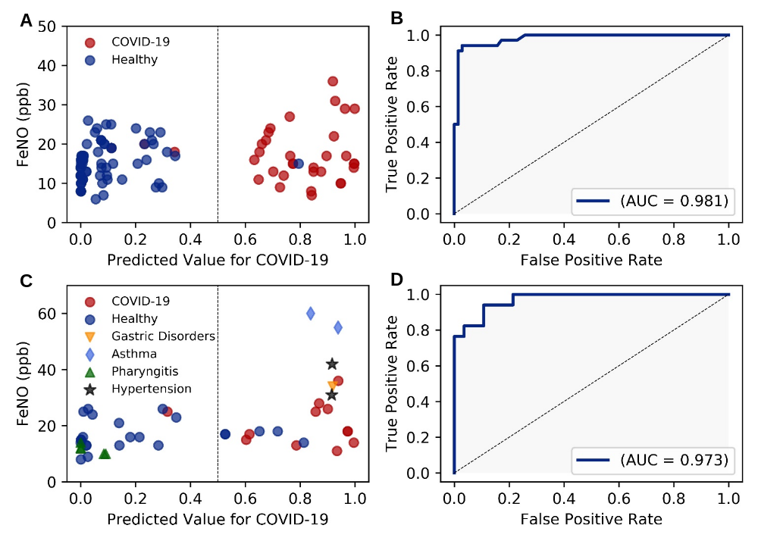
Supplementary Figure 1. Receiver operating characteristic (ROC) curve performance of the ML model. (A) The performance of the model in the training cohort. (B) ROC curve in the training cohort. AUC is 0.981. (C) The performance of the model in the test cohort. (D) ROC curve of test cohort. AUC is 0.973. For the classification of healthy subjects and COVID-19 patients, the ML model achieved an AUC of 0.953, accuracy of 0.829, sensitivity of 0.917, specificity of 0.783, precision of 0.687 and F1 score of 0.786.
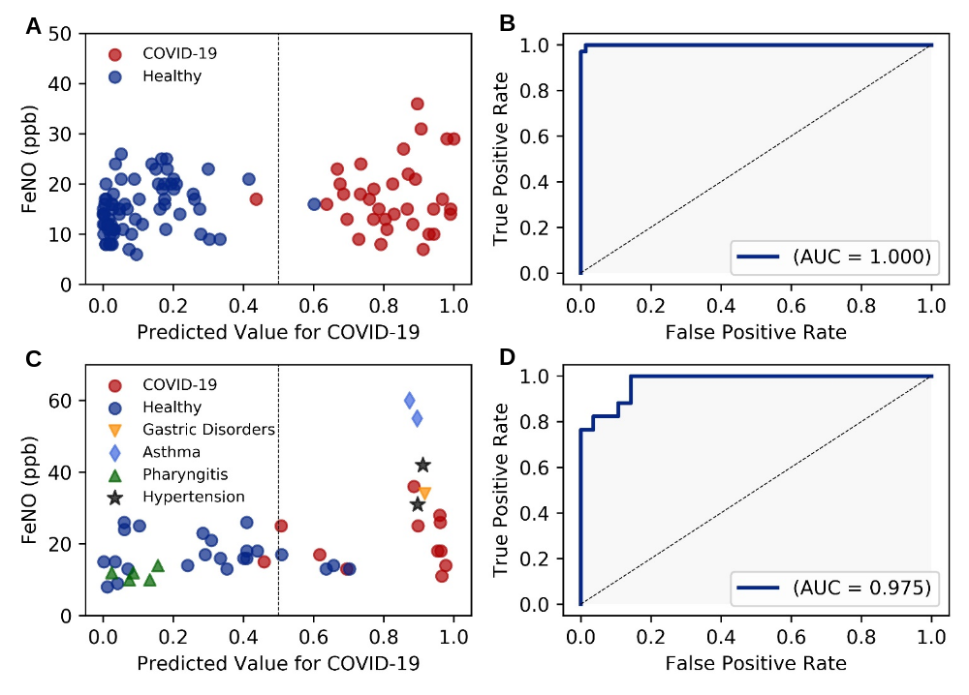
Supplementary Figure 2. Receiver operating characteristic (ROC) curve and performance the ML model. (A) The performance of the model in the training cohort. (B) ROC curve in the training cohort. AUC is 1.000. (C) The performance of the model in the test cohort. (D) ROC curve of test cohort. AUC is 0.975. For the classification of healthy subjects and COVID-19 patients, the ML model achieved an AUC of 0.957, accuracy of 0.857, sensitivity of 0.917, specificity of 0.826, precision of 0.733 and F1 score of 0815.

