Supplementary Materials

Supplementary material includes –
Number of pages: I – VIII
Number of tables: 3
Number of figures: 2
SUPPLEMENTARY SECTION A
ENUMERATION OF POSITIVE ISOLATES DURING SCREENING
1. Primary Screening with Sudan Black B
Table 1: Distribution of Sudan Black B positive bacterial isolates
Sample Type | Sample Site | Sample code | Number of positive  isolates | Total isolate
Soil | Hetauda | Ht | 10 | 39
Soil | Simle | Sm | 7 | 39
Soil | Butwal | Cg | 8 | 39
Soil | Ghandruk | Gh | 11 | 39
Soil | Syangja | Sy | 3 | 39
Compost | Imadol | Im | 5 | 32
Compost | Kaushaltar | Ks | 3 | 32
Compost | Budhanilkantha | Bn | 2 | 32
Compost | Butwal | Bt | 12 | 32
Compost | Nakkhu | Nk | 10 | 32
Landfill Site | Manohara | Mn | 18 | 46
Landfill Site | Balaju | Bl | 6 | 46
Landfill Site | Nayabasti | Nb | 2 | 46
Landfill Site | Gothatar | Sb | 11 | 46
Landfill Site | Jorpati | Nz | 9 | 46
Sewage Sediments | Thankot | Kr | 20 | 72
Sewage Sediments | Tarkeshwor | Tk | 12 | 72
Sewage Sediments | Dhungedhara | Dg | 16 | 72
Sewage Sediments | Jorpati | Jr | 14 | 72
Sewage Sediments | Gothatar | Gt | 10 | 72

2. Secondary Screening with Nile Blue A
Table 2: Distribution of Nile Blue A positive bacterial isolates in sample
Sample Type | Sample Site | Sample code | Number of positive isolates | Total isolates
Soil | Hetauda | Ht | 8 | 18
Soil | Simle | Sm | 3 | 18
Soil | Butwal | Cg | 5 | 18
Soil | Ghandruk | Gh | 0 | 18
Soil | Syangja | Sy | 2 | 18
Compost | Imadol | Im | 0 | 17
Compost | Kaushaltar | Ks | 2 | 17
Compost | Budhanilkantha | Bn | 2 | 17
Compost | Butwal | Bt | 7 | 17
Compost | Nakkhu | Nk | 6 | 17
Landfill Site | Manohara | Mn | 9 | 15
Landfill Site | Balaju | Bl | 2 | 15
Landfill Site | Nayabasti | Nb | 0 | 15
Landfill Site | Gothatar | Sb | 3 | 15
Landfill Site | Jorpati | Nz | 1 | 15
Sewage Sediments | Thankot | Kr | 11 | 31
Sewage Sediments | Tarkeshwor | Tk | 4 | 31
Sewage Sediments | Dhungedhara | Dg | 8 | 31
Sewage Sediments | Jorpati | Jr | 5 | 31
Sewage Sediments | Gothatar | Gt | 3 | 31

SUPPLEMENTARY SECTION B
GRAM MORPHOLOGY OF THE POSITIVE STRAINS
Table 3: Characteristics of Gram stained positive isolates
Sample | Isolates | Shape | Color | Inference
Soil | Sm3e | Rods | Purple | Gram Positive
Soil | Sm3f | Rods | Purple | Gram Positive
Soil | Sm5a | Rods | Red | Gram Negative
Soil | Ht3a | Rods | Purple | Gram Positive
Soil | Ht3b | Rods | Purple | Gram Positive
Soil | Ht3c | Rods | Purple | Gram Positive
Soil | Ht3d | Rods | Purple | Gram Positive
Soil | Ht3f | Cocci | Purple | Gram Positive
Soil | Ht3g | Rods | Purple | Gram Positive
Soil | Ht5a | Rods | Purple | Gram Positive
Soil | Ht5f | Cocci | Purple | Gram Positive
Soil | Cg3c | Rods | Purple | Gram Positive
Soil | Cg5a | Rods | Purple | Gram Positive
Soil | Cg1a | Cocci | Purple | Gram Positive
Soil | Cg1b | Rods | Purple | Gram Positive
Soil | Cg1c | Small Rods | Purple | Gram Positive
Soil | Sy3a | Rods | Purple | Gram Positive
Soil | Sy3b | Rods in chains | Purple | Gram Positive
Compost | Ks3a | Rods | Purple | Gram Positive
Compost | Ks3b | Rods | Purple | Gram Positive
Compost | Bn6a | Rods | Purple | Gram Positive
Compost | Bn6b | Rods | Purple | Gram Positive
Compost | Bt3b | Large Rods | Purple | Gram Positive
Compost | Bt3c | Rods | Purple | Gram Positive
Compost | Bt3e | Cocci | Purple | Gram Positive
Compost | Bt3g | Rods | Red | Gram Negative
Compost | Bt3h | Rods | Purple | Gram Positive
Compost | Bt3l | Rods | Purple | Gram Positive
Compost | Bt3m | Rods, chains | Purple | Gram Positive
Compost | NK3a | Cocci, cluster | Red | Gram Negative
Compost | NK3c | Rods | Red | Gram Negative
Compost | NK3e | Rods | Purple | Gram Positive
Compost | NK3f | Rods | Red | Gram Negative
Compost | NK3g | Rods | Red | Gram Negative
Compost | NK3i | Rods | Purple | Gram Positive
Landfill | Mn3a | Cocci, cluster | Purple | Gram Positive
Landfill | Mn3d | Cocci, cluster | Purple | Gram Positive
Landfill | Mn3e | Cocci | Purple | Gram Positive
Landfill | Mn3f | Cocci, cluster | Purple | Gram Positive
Landfill | Mn5e | Cocci, cluster | Purple | Gram Positive
Landfill | Mn7a | Cocci, cluster | Purple | Gram Positive
Landfill | Mn7b | Cocci | Purple | Gram Positive
Landfill | Mn7c | Cocci, cluster | Purple | Gram Positive
Landfill | Mn7d | Cocci, cluster | Purple | Gram Positive
Landfill | Bl3a | Cocci | Purple | Gram Positive
Landfill | Bl3d | Cocci, cluster | Purple | Gram Positive
Landfill | Sb3a | Cocci | Purple | Gram Positive
Landfill | Sb3c | Cocci cluster | Purple | Gram Positive
Landfill | Nz7a | Rods, chain | Purple | Gram Positive
Landfill | Sb3j | Small Rods | Purple | Gram Positive
Sewage | Kr3a | Cocci, cluster | Purple | Gram Positive
Sewage | Kr3d | Cocci, cluster | Purple | Gram Positive
Sewage | Kr3e | Small Rods | Purple | Gram Positive
Sewage | Kr3f | Small Rods | Purple | Gram Positive
Sewage | Kr3g | Rods | Purple | Gram Positive
Sewage | Kr3m | Rods | Red | Gram Negative
Sewage | Kr3o | Small Rods | Purple | Gram Positive
Sewage | Kr3p | Rods | Purple | Gram Positive
Sewage | Kr3r | Rods | Purple | Gram Positive
Sewage | Kr3u | Rods | Purple | Gram Positive
Sewage | Kr3x | Rods | Purple | Gram Positive
Sewage | Tk3c | Rods | Purple | Gram Positive
Sewage | Tk3g | Rods | Purple | Gram Positive
Sewage | TK3h | Rods | Purple | Gram Positive
Sewage | Tk3j | Rods | Purple | Gram Positive
Sewage | Dg3a | Rods | Purple | Gram Positive
Sewage | Dg3d | Rods | Purple | Gram Positive
Sewage | Dg3j | Rods | Purple | Gram Positive
Sewage | Dg3k | Rods | Purple | Gram Positive
Sewage | Dg3l | Rods | Purple | Gram Positive
Sewage | Dg3n | Rods, chain | Purple | Gram Positive
Sewage | Dg5b | Rods | Purple | Gram Positive
Sewage | Dg5c | Rods | Purple | Gram Positive
Sewage | Gt3b | Rods | Purple | Gram Positive
Sewage | Gt5a | Cocci, cluster | Purple | Gram Positive
Sewage | Gt5b | Rods | Purple | Gram Positive
Sewage | Jr3a | Cocci, cluster | Purple | Gram Positive
Sewage | Jr3f | Rods | Purple | Gram Positive
Sewage | Jr3h | Rods | Red | Gram Negative
Sewage | Jr5c | Rods | Red | Gram Negative
Sewage | Jr5e | Cocci, cluster | Purple | Gram Positive

SUPPLEMENTARY SECTION C
IDENTIFICATION FLOWCHART ACCORDING TO BERGEY’S MANUAL OF DETERMINATIVE BACTERIOLOGY
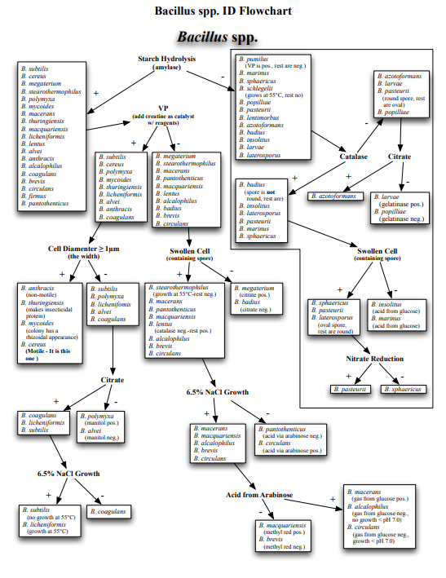
1. For Bacillus spp. (Gram positive rods)

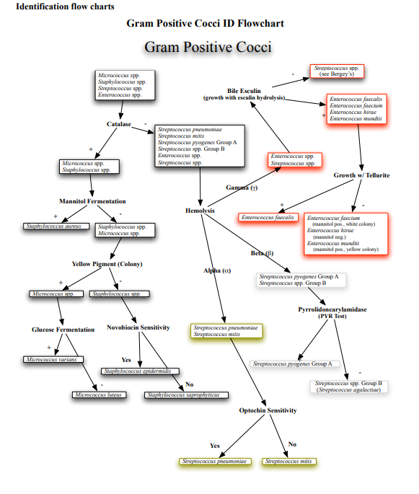
2. For Gram positive cocci

