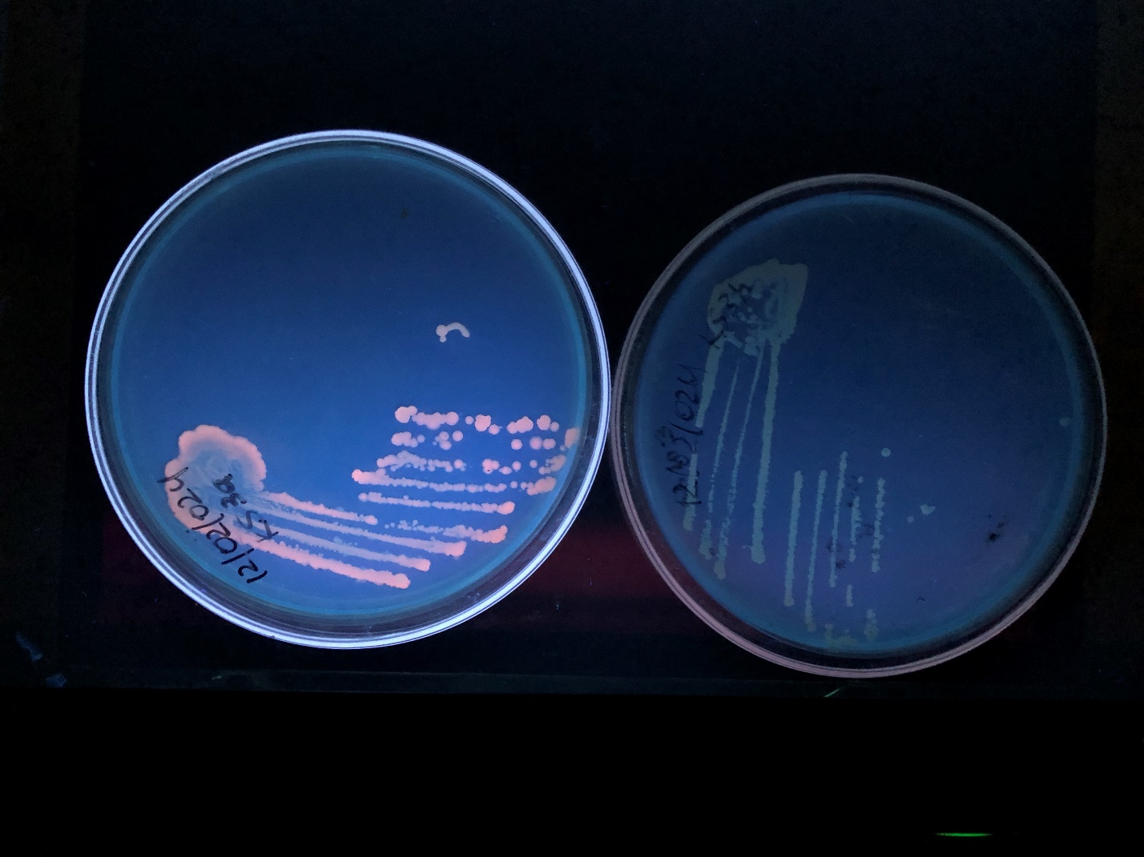
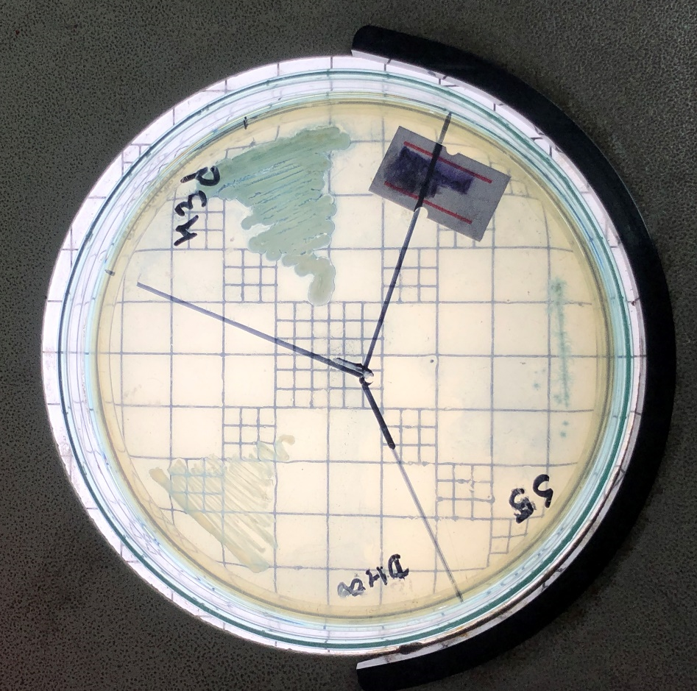
Photograph 2: Secondary screening of isolate Ks3a with Nile Blue A
Photograph 1: Primary screening of isolate Ht3d with Sudan Black B
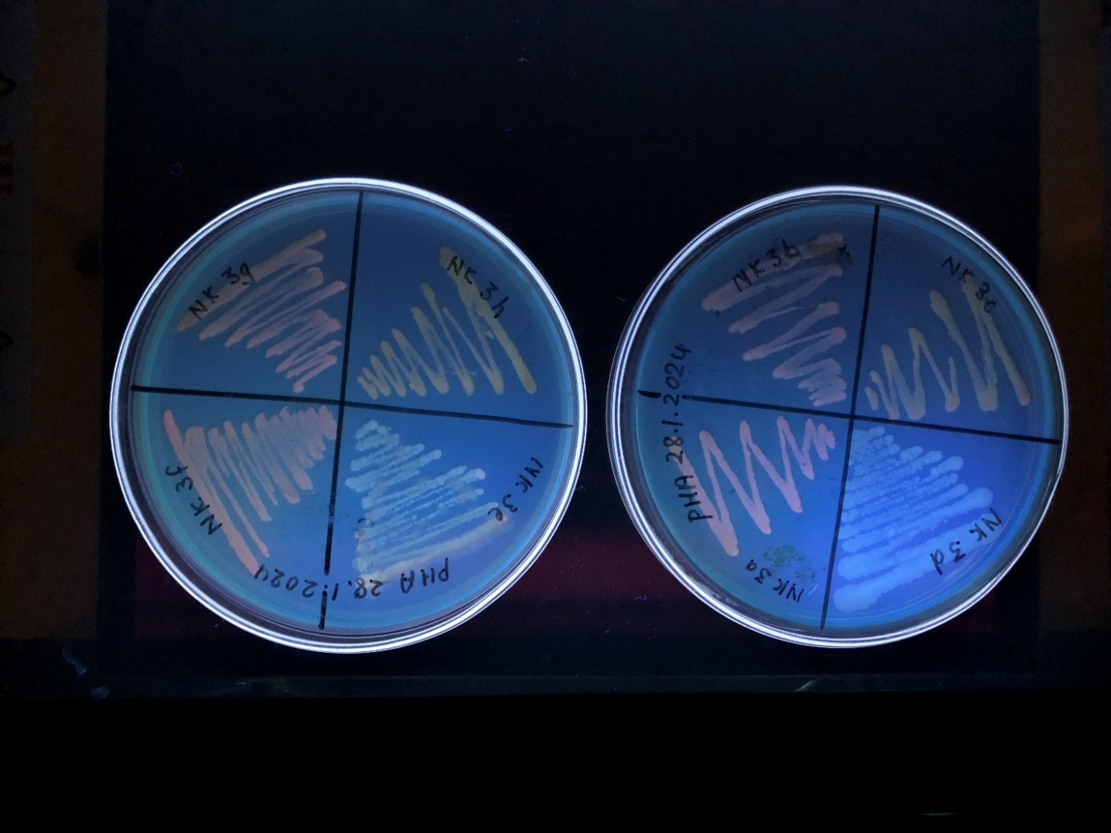
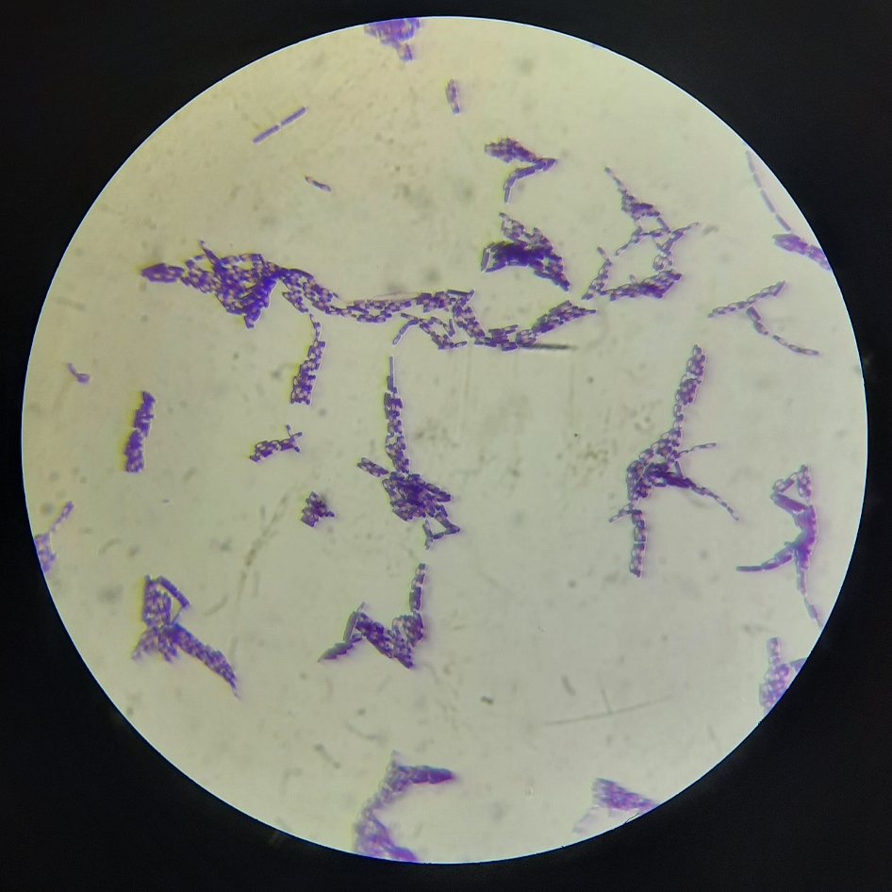
Photograph 3: Differential UV fluorescence of compost isolates on PHA detecting agar
Photograph 4: Gram staining of isolate Ht3d
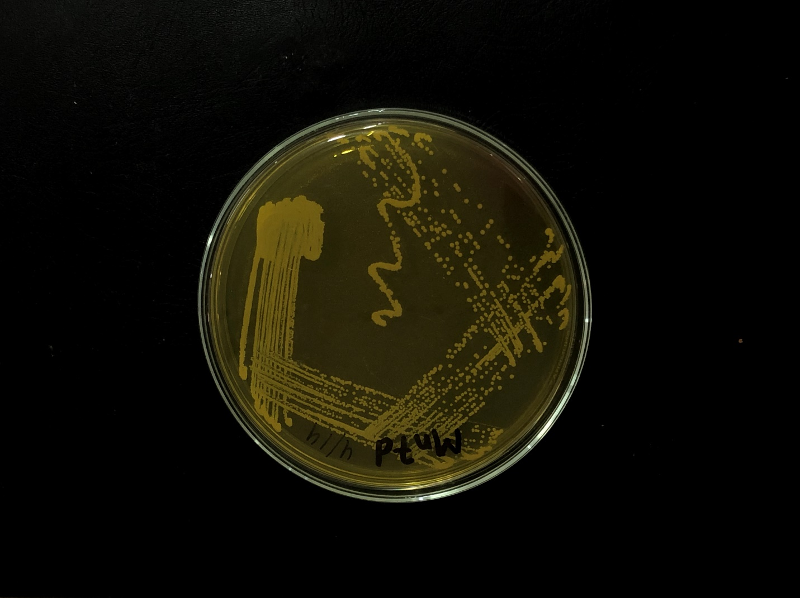
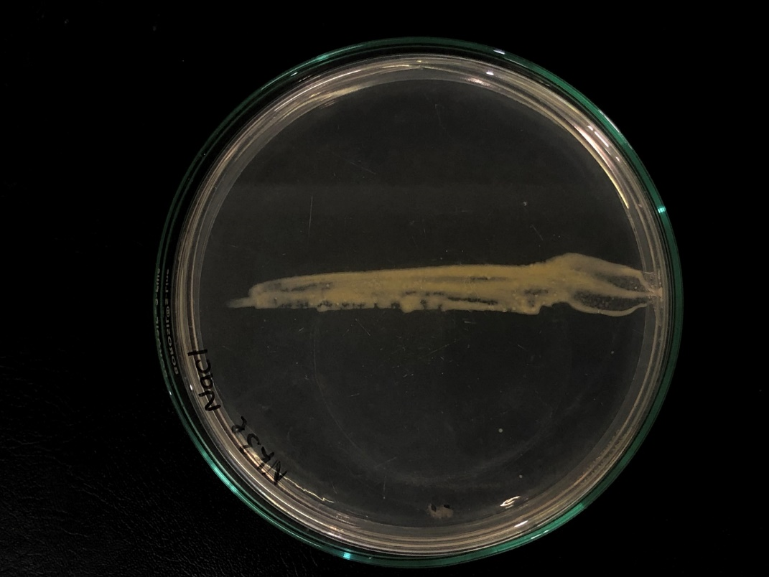
Photograph 6: Growth of isolate Mn7d on Mannitol Salt Agar
Photograph 5: Growth of isolate Nk3e on 6.5 % NaCl medium
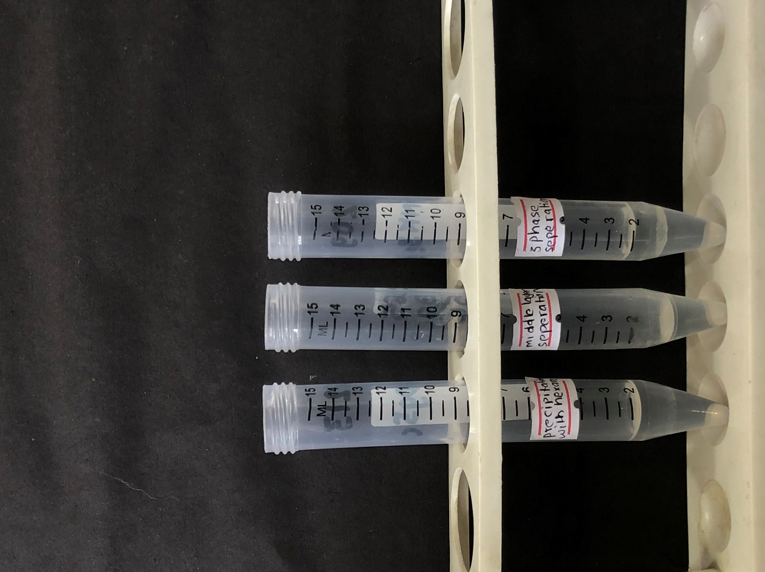
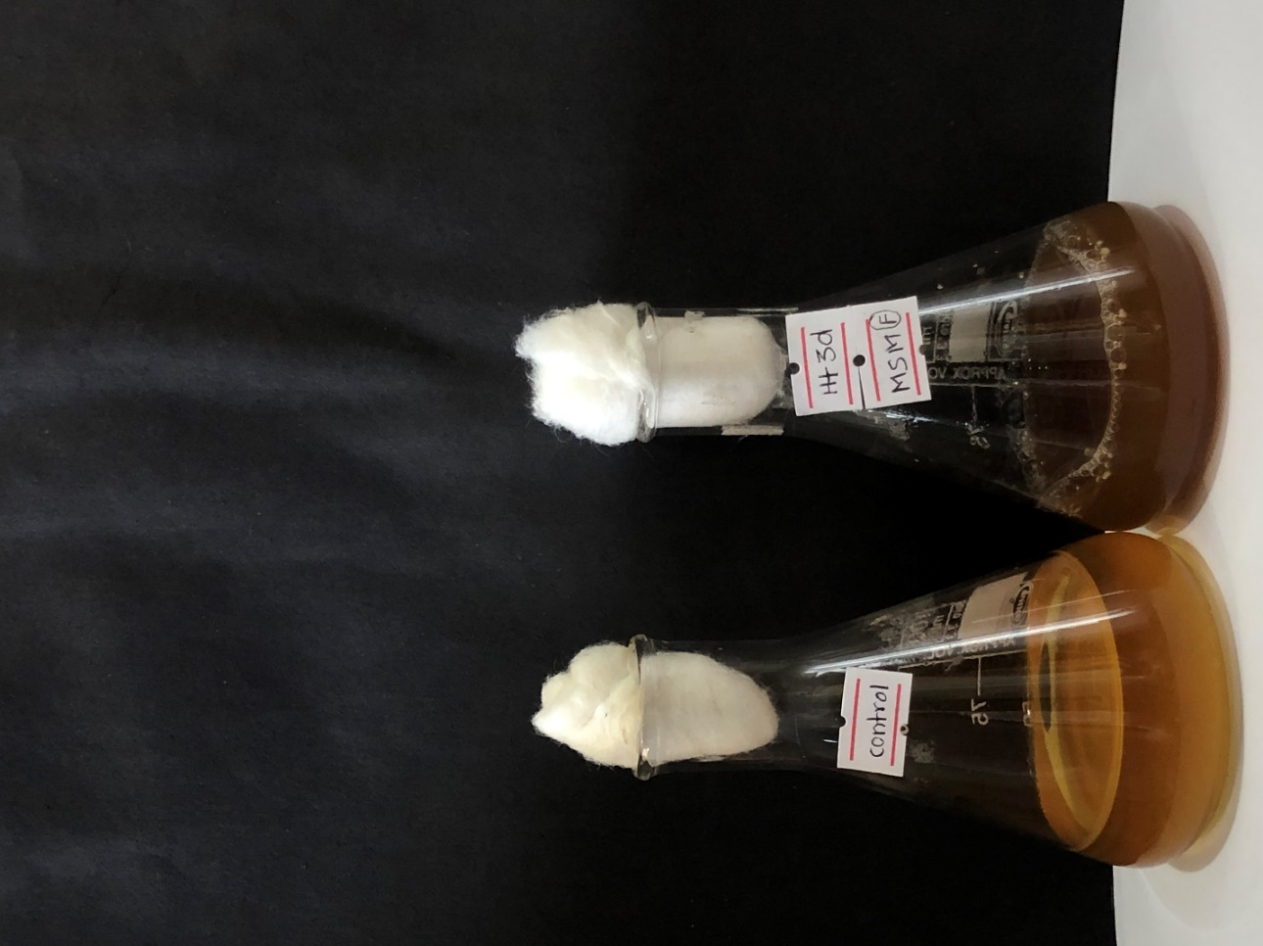
Photograph 8: Precipitation of PHA during extraction process
Photograph 7: Fermentation for PHA production using isolate Ht3d
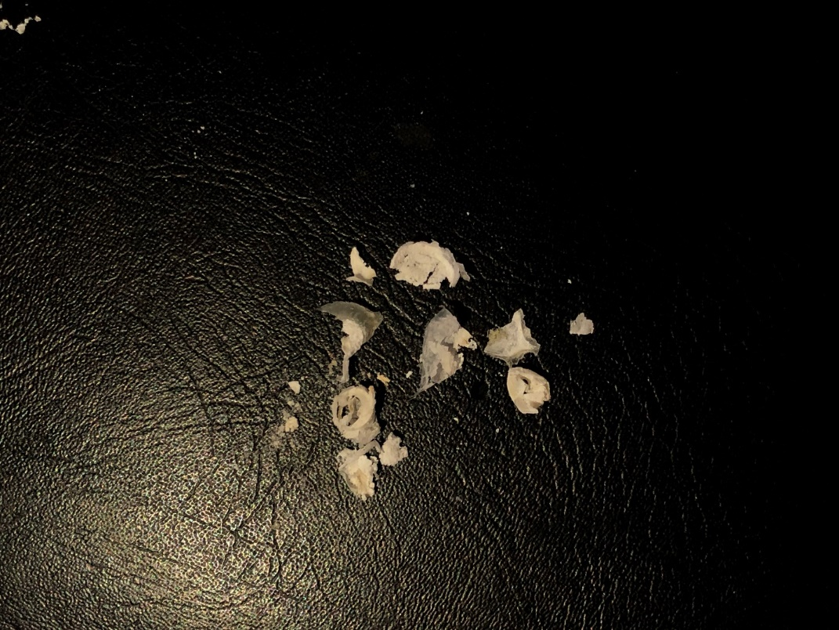
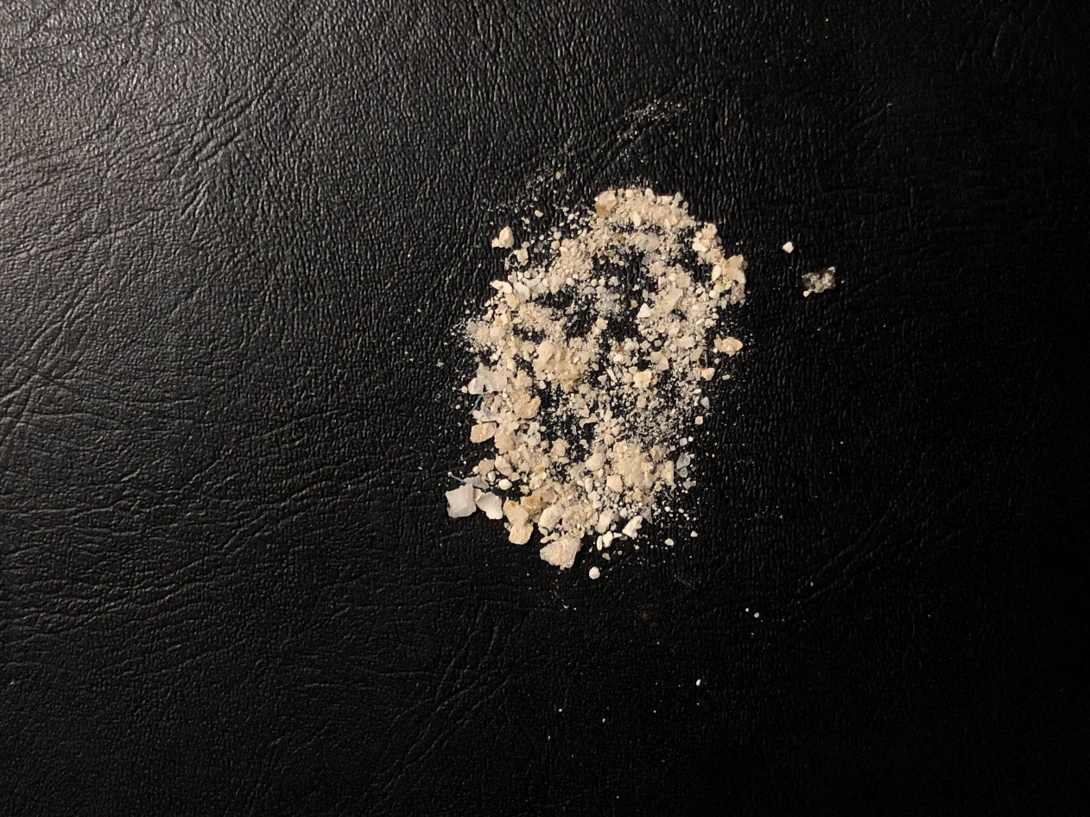
Photograph 9: PHA powder obtained after extraction process
Photograph 10: Preparation of PHA film

