Extended Data Figures
2020
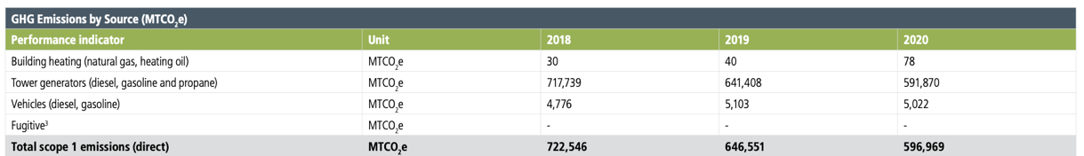

2021

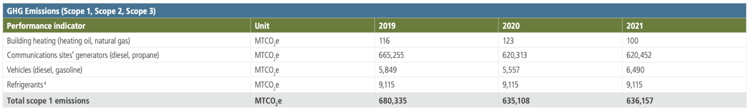

2022

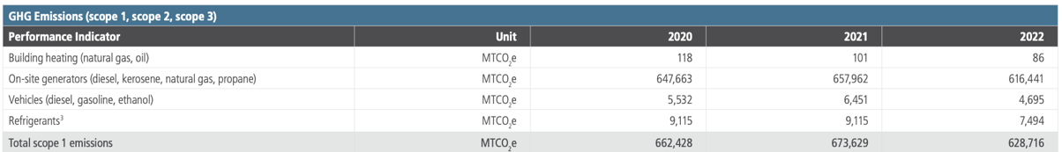
Fig. S1.
American Tower’s reported emissions, 2020-2022.

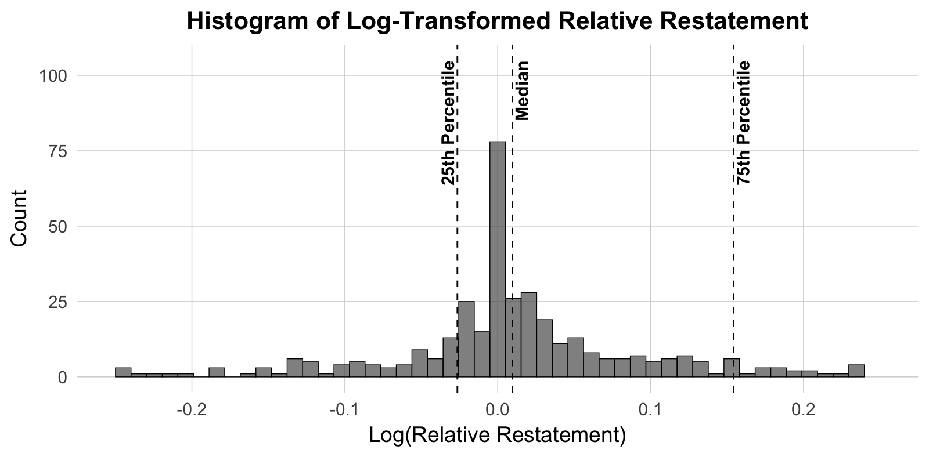
Fig. S2.
Distribution of the logged difference between restated and original scope 1 emissions numbers for all restating firms, truncated at -0.25 and 0.25.

2018
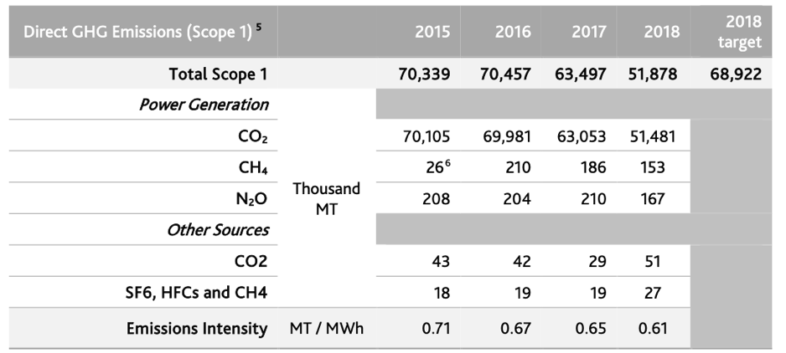
2019
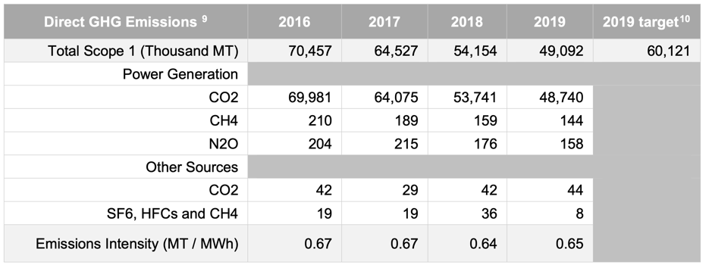
2020
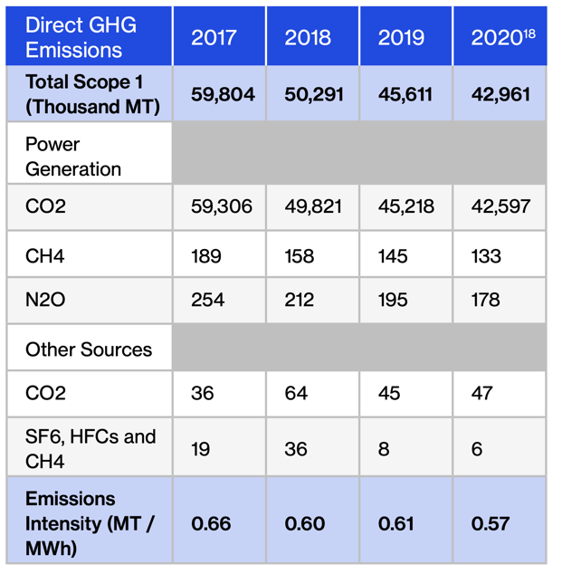
Fig. S3.
AES’s reported emissions, 2018-2020.

Page 89
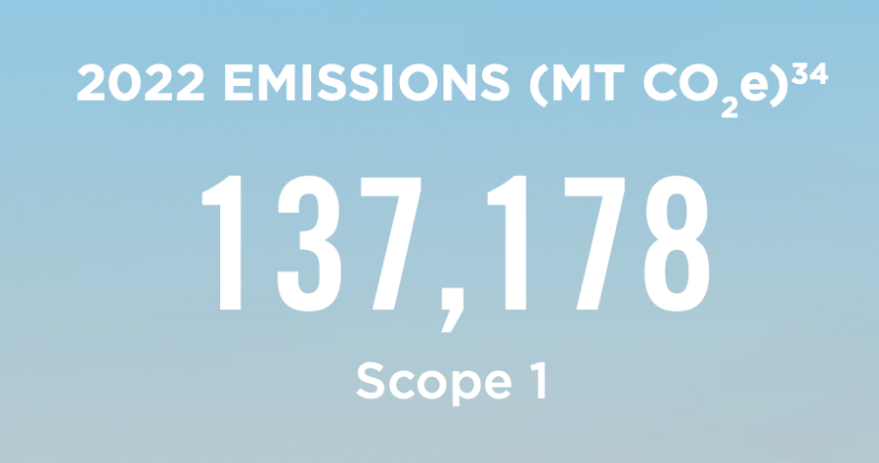
page 108
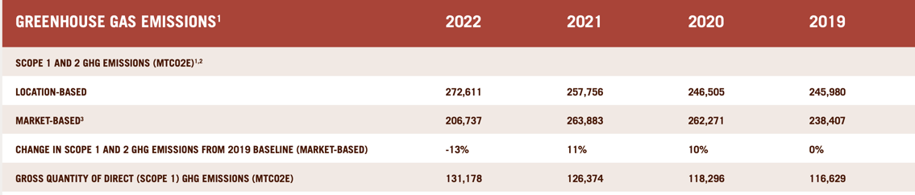
Fig. S4.
Chipotle Mexican Grill’s reported emissions, 2022

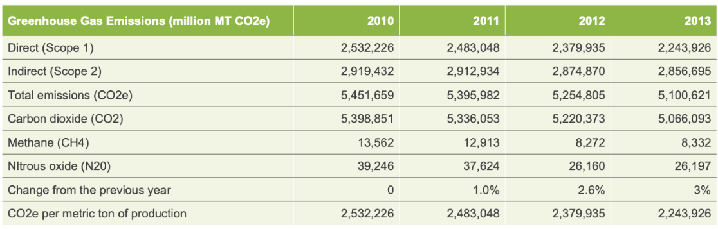
Fig. S5.
Kimberly-Clark’s reported emissions, 2013

