Species | Order | Count | CTMax (Median + SE) (˚C) | CTmin (Median + SE) (˚C) | Scope (Median + SE) (˚C) | Length (Median + SE) (mm)
Araneae sp. | Araneae | 2 | 40.4 ± 5.4 | -- | -- | 4.85 ± 0.35
Araneus groenlandica | Araneae | 1 | -- | - 6.2 | -- | 3.3
Dictyna major | Araneae | 11 | 49.05 ± 0.26 | - 5.11 ± 0.34 | 54.39 ± 0.68 | 2.1 ± 0.2
Emblyna borealis | Araneae | 5 | 51.21 ± 0.09 | - 0.62 ± 0.73 | 51.83 ± 0.52 | 1.2 ± 0.1
Haplodrassus signifer | Araneae | 1 | 44.31 | -- | -- | 8.5
Ohlertidion sp. | Araneae | 1 | 47.13 | -- | -- | 2.8
Pardosa furcifera | Araneae | 3 | 46.21 | - 6.05 ± 0.15 | 52.26 ± 0.10 | 8.0 ± 0.60
Pardosa groenlandica | Araneae | 4 | 47.09 ± 0.04 | - 1.86 | 48.95 ± 0.05 | 9.65 ± 0.74
Tetragnatha extensa | Araneae | 1 | 43.79 | -- | -- | 8.5
Theridion ohlerti | Araneae | 1 | -- | - 5.82 | -- | 2.5
Xysticus sp. | Araneae | 27 | 49.08 ± 0.25 | - 4.0 ± 0.41 | 53.08 ± 0.54 | 3.45 ± 0.27
Lamyctes emarginatus | Chilopoda | 1 | 42.03 | -- | -- | 6.5
Lamyctes sp. | Chilopoda | 2 | 42.8 ± 0.44 | -- | -- | 6.1 ± 0.4
Bembidion grapii | Coleoptera | 3 | 40.97 ± 0.02 | -- | -- | 4.2 ± 0.12
Byrrhus fasciatus | Coleoptera | 1 | 45.02 | -- | -- | 7.0
Coccinella  transversoguttata | Coleoptera | 4 | 49.3 ± 0.13 | -3.16 ± 0.12 | 52.45 ± 0.12 | 5.55 ± 0.26
Gyrinus opacus | Coleoptera | 3 | 37.23 ± 0.2 | -- | -- | 6.0 ± 0.37
Hydrophorus  morio* | Coleoptera | 1 | 38.71 | -- | -- | 3.8
Nebria rufescens | Coleoptera | 3 | 38.31 + 0.0 | -- | -- | 5.50 ± 0.17
Otiorhynchus  arcticus | Coleoptera | 2 | 45.04 ± 0.0 | -- | -- | 6.55 ± 0.45
Otiorhynchus  nodosus | Coleoptera | 3 | 42.18 ± 0.0 | 3.79 | 38.39 ± 0.0 | 8.0 ± 0.17
Patrobus septentrionis | Coleoptera | 2 | 41.27 ± 1.2 | -- | -- | 8.5 ± 0.5
Botanophila profuga | Diptera | 9 | 41.23 ± 0.1 | -4.56 ± 0.07 | 45.79 ± 0.11 | 5.4 ± 0.22
Botanophila sp. | Diptera | 9 | 41.11 ± 0.38 | -2.52 ± 1.52 | 43.63 ± 2.15 | 4.95 ± 0.13
Bradysia sp. | Diptera | 1 |  | -3.63 |  | 1.2
Calliphora uralensis | Diptera | 2 | 26.12 ± 3.85 |  |  | 13.5 ± 0.5
Delia echinata | Diptera | 2 | 43.14 | -6.01 | 49.15 ± 0.00 | 4.45 ± 0.05
Delia fabricii | Diptera | 33 | 42.92 ± 0.14 | -3.18 ± 0.52 | 46.12 ± 0.52 | 6.20 ± 0.13
Delia platura | Diptera | 1 | 22.78 | -- | -- | 4.20
Dolichopus  groenlandicus | Diptera | 1 | -- | -1.00 | -- | 5.10
Dolichopus plumipes | Diptera | 1 | -- | -4.63 | -- | 5.30
Eupeodes sp. | Diptera | 1 | 32.75 | -- | -- | 9.50
Exechia sp. | Diptera | 1 | 35.57 | -- | -- | 4.0
Fannia sp. | Diptera | 1 | 42.70 | -- | -- | 4.0
Forcipomyia sp. | Diptera | 1 | 35.23 | -- | -- | 2.1
Halocladius  variabilis | Diptera | 3 | 37.10 ± 1.74 | -- | -- | 3.1 ± 0.33
Hydrobaenus  fusistylus | Diptera | 1 | -- | -3.96 | -- | 3.0
Macrocera sp. | Diptera | 1 | 34.10 | -- | -- | 4.7
Muscidae sp. | Diptera | 16 | 38.82 ± 0.22 | - 1.47 ± 2.91 | 40.29 ± 4.47 | 5.0 ± 0.20
Mycetophila sp. | Diptera | 1 | 35.18 | -- | -- | 4.7
Pegomya notabilis | Diptera | 2 | -- | -2.24 ± 0.26 | -- | 6.75 ± 0.75
Pegomya sp. | Diptera | 4 | 37.40 | -1.36 ± 0.44 | 38.76 ± 0.56 | 5.40 ± 0.27
Pegomya zonata | Diptera | 1 | -- | -2.43 | -- | 5.80
Protophormia  terranovae | Diptera | 6 | 34.81 ± 1.08 | -1.37 ± 1.1 | 36.18 ± 1.43 | 10.00 ± 1.08
Scathophaga litorea | Diptera | 1 | 40.12 | -- | -- | 7.0
Scathophaga sp. | Diptera | 2 | 38.82 ± 0.06 | -- | -- | 6.4 ± 0.6
Scathophagidae sp. | Diptera | 2 | 37.96 | -5.81 | 43.77 ± 0.00 | 5.4 ± 0.6
Sciaridae sp. | Diptera | 2 | 37.09 ± 0.07 | -- | -- | 2.05 ± 0.05
Simulium sp. | Diptera | 5 | 42.33 ± 0.39 | -- | -- | 2.70 ± 0.09
Simulium vittatum | Diptera | 2 | 42.03 ± 0.26 | -- | -- | 2.55 ± 0.25
Sphaerophoria sp. | Diptera | 1 | -- | -2.42 | -- | 10.0
Spilogona arctica | Diptera | 3 | 33.75 | -3.71 ± 0.12 | 37.46 ± 0.08 | 5.50 ± 0.54
Spilogona sp. | Diptera | 1 | 40.41 ± 0.11 | -- | -- | 5.30 ± 1.00
Syrphidae sp. | Diptera | 4 | 41.94 ± 0.63 | 7.55 | 34.39 ± 0.8 | 7.50 ± 0.29
Tachina ampliforceps | Diptera | 2 | 43.43 ± 0.44 | -- | -- | 16.0 ± 3.0
Lepidocyrtus sp. | Entomobryomorpha | 1 | -- | -5.52 | -- | 1.50
Aphididae sp. | Hemiptera | 2 | 43.11 | 0.67 | 42.44 ± 0.00 | 1.75 ± 0.25
Cavariella sp. | Hemiptera | 4 | 40.33 ± 0.05 | -- | -- | 1.50 ± 0.15
Euceraphis  punctipennis | Hemiptera | 7 | 40.96 | -3.41 ± 0.28 | 44.37 ± 0.49 | 2.80 ± 0.18
Euceraphis sp. | Hemiptera | 1 | -- | -2.89 | -- | 3.90
Myzodium  modestum | Hemiptera | 1 | -- | - 2.65 | -- | 1.70
Nabis  flavomarginatus | Hemiptera | 41 | 45.07 ± 0.2 | -4.72 ± 0.14 | 49.80 ± 0.32 | 8.0 ± 0.09
Nysius  groenlandicus | Hemiptera | 50 | 49.62 ± 0.09 | -2.14 ± 0.22 | 51.82 ± 0.33 | 3.90 ± 0.05
Psammotettix  lividellus | Hemiptera | 14 | 48.19 ± 0.18 | -4.28 ± 0.38 | 52.45 ± 0.45 | 3.30 ± 0.1
Psyllidae sp. | Hemiptera | 10 | 42.36 ± 0.28 | -2.71 | 45.07 ± 0.26 | 1.80 ± 0.11
Pterocomma sp. | Hemiptera | 1 | -- | -2.27 | -- | 2.30
Utamphorophora sp. | Hemiptera | 1 | -- | -3.02 | -- | 2.0
Brachonidae sp. | Hymenoptera | 1 | -- | -1.23 | -- | 2.50
Campoletis  horstmanni | Hymenoptera | 1 | -- | -5.81 | -- | 6.5
Campopleginae sp. | Hymenoptera | 3 | 43.37 | 5.12 ± 1.09 | 48.49 ± 0.77 | 5.0 ± 0.52
Hymenoptera sp. | Hymenoptera | 1 | 42.84 | -- | -- | 2.5
Hyposoter frigidus | Hymenoptera | 2 | -- | -4.45 ± 0.57 | -- | 6.05 ± 0.25
Hyposoter sp. | Hymenoptera | 1 | -- | -5.05 | -- | 9.0
Ichneumon  sarcitorius | Hymenoptera | 9 | 43.80 ± 0.06 | -4.37 ± 0.70 | 48.17 ±0.85 | 12.0 ± 0.17
Ichneumonidae sp. | Hymenoptera | 5 | 45.91 ± 0.61 | -3.81 ± 0.47 | 42.11 ± 0.25 | 5.0 ± 0.1
Meteorus rubens | Hymenoptera | 1 | -- | -4.71 | -- | 4.0
Pantisarthrus  lubricus | Hymenoptera | 1 | -- | -2.30 | -- | 4.50
Protapanteles  fulvipes | Hymenoptera | 2 | 40.44 | -3.87 | 44.31 ± 0.00 | 3.60 ± 0.40
Tenthredinidae sp. | Hymenoptera | 8 | 43.69 ± 0.33 | - 4.69 | 48.38 ± 0.53 | 4.70 ± 0.46
Acleris caryosphena | Lepidoptera | 1 | 42.88 | -- | -- | 7.0
Autographa gamma | Lepidoptera | 2 | 46.06 | -0.30 | 46.36 ± 0.00 | 15.50
Eurois occulta | Lepidoptera | 9 | 43.51 ± 0.30 | -5.43 ± 0.1 | 48.94 ± 0.58 | 4.80 ± 0.57
Mniotype adusta | Lepidoptera | 4 | 43.60 ± 0.48 | 0.58 | 43.02 ± 0.61 | 12.00 ± 1.68
Scythris noricella | Lepidoptera | 2 | 41.55 ± 8.9 | -- | -- | 6.10 ± 0.1
Spaelotis clandestina | Lepidoptera | 1 | 46.09 | -- | -- | 18.0
Syngrapha borea | Lepidoptera | 1 | 45.17 | -- | -- | 3.60
Tortricidae sp. | Lepidoptera | 44 | 43.73 ± 0.29 | -4.38 ± 0.27 | 48.13 ± 0.47 | 7.0 ± 0.13
Hemerobius ovalis | Neuroptera | 1 | 42.29 | -- | -- | 5.80
Wesmaelius nervosus | Neuroptera | 1 | -- | -4.82 | -- | 4.70
Limnephilus kennicotti | Trichoptera | 1 | -- | -5.27 | -- | 7.0
Limnephilus sp. | Trichoptera | 2 | -- | -4.3 ± 0.11 | -- | 10.0 ± 0.0
Anystidae sp. | Trombidiformes | 4 | 40.22 | -2.34 ± 0.42 | 42.56 ± 0.55 | 1.15 ± 0.05
Appendix 2. Table S1: CT_{max}, CT_{min}, thermal scope and length measures of all species of which at least one measure of thermal limit was recorded. Asterisk indicate species of which image was not obtained. No SE is noted for single measures.

Araneae

Araneae sp.
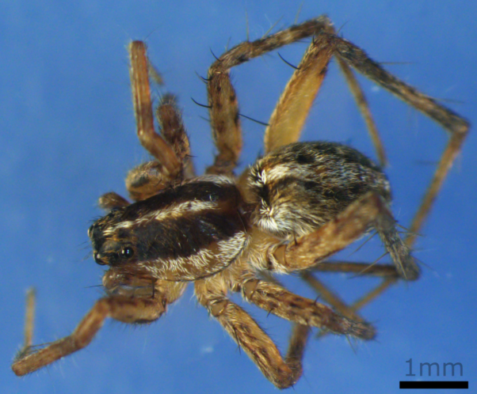

Araneus groenlandica
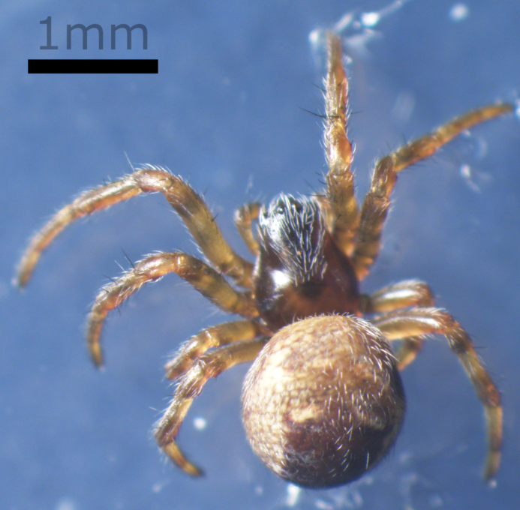

Dictyna major
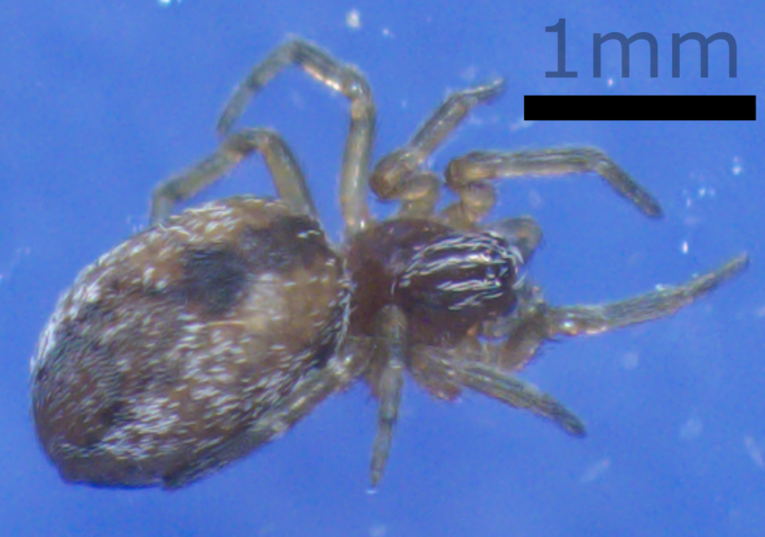

Emblyna borealis
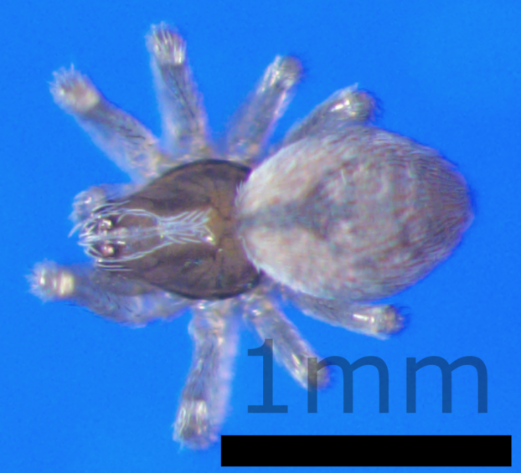

Haplodrassus signifier
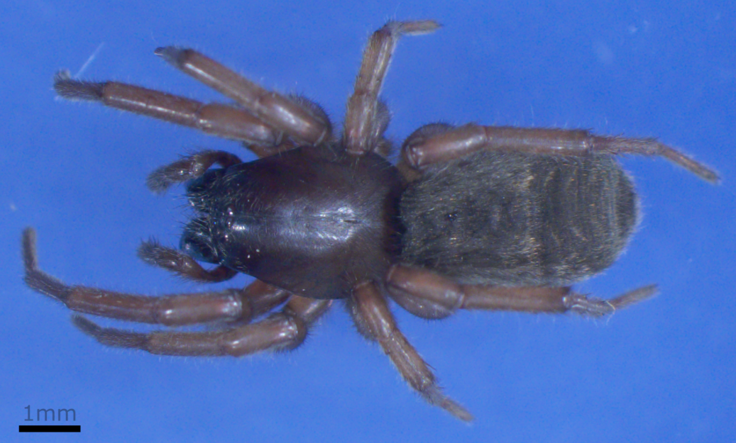

Ohlertidion sp.
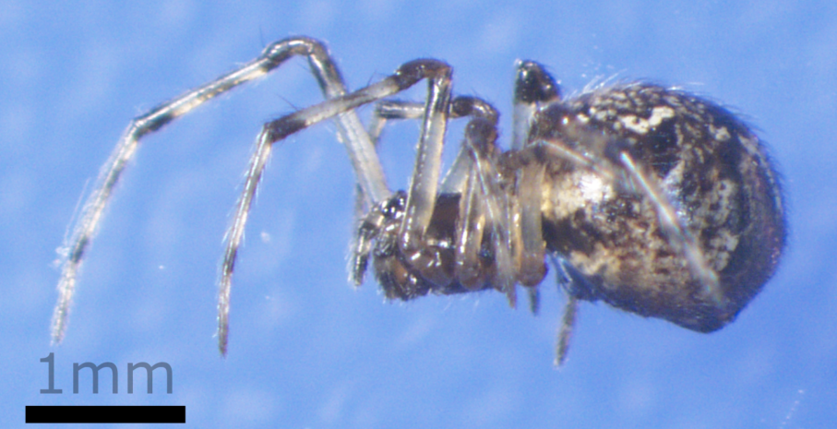

Pardosa furcifera
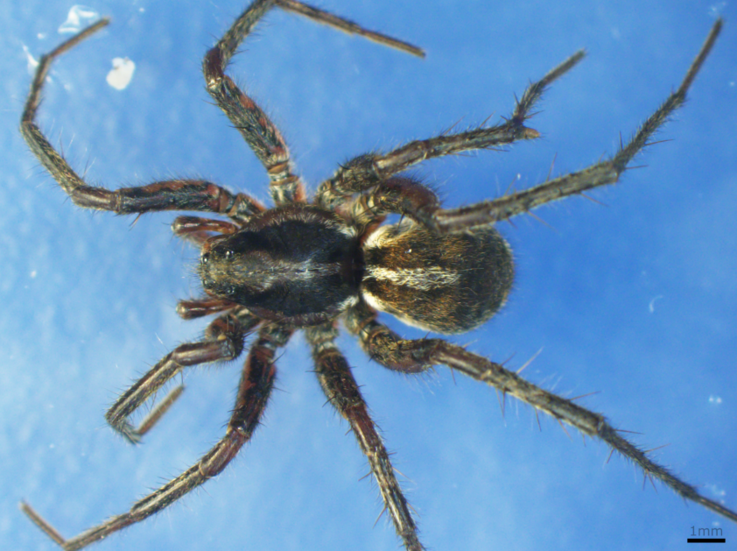

Pardosa groenlandica
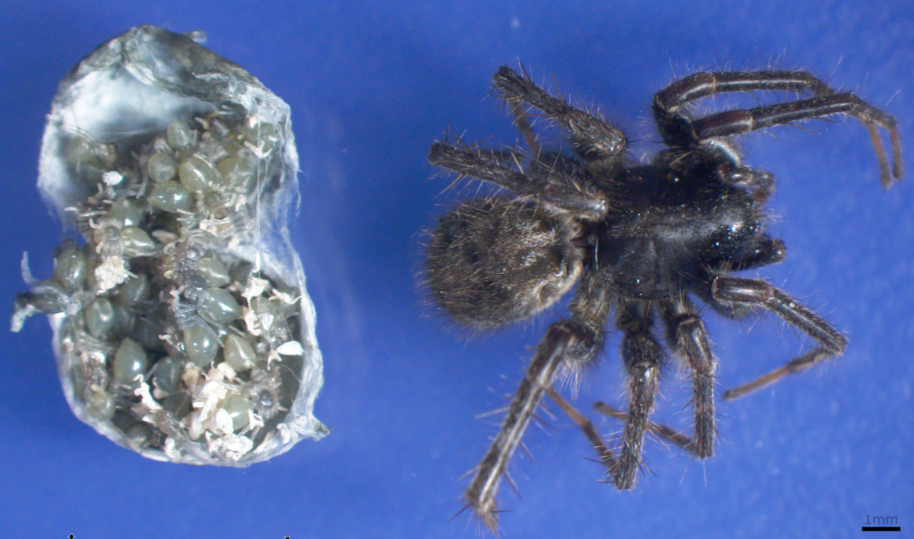

Tetragnatha extensa
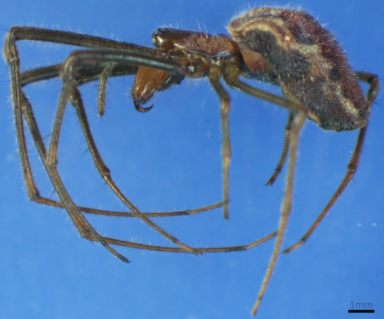

Theridion ohlerti
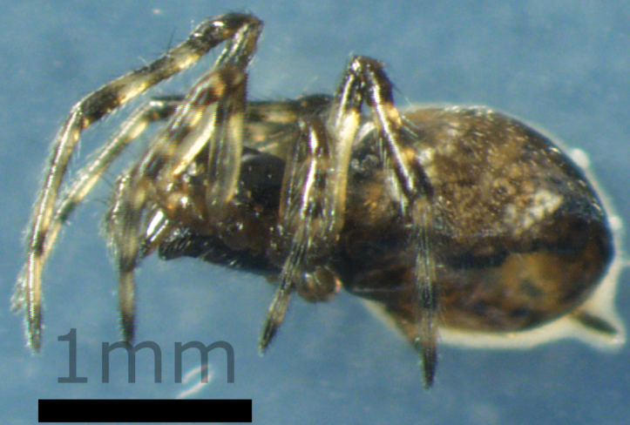

Xysticus sp.

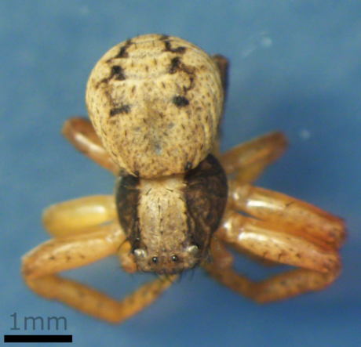

Chilopoda

Lamyctes emarginatus
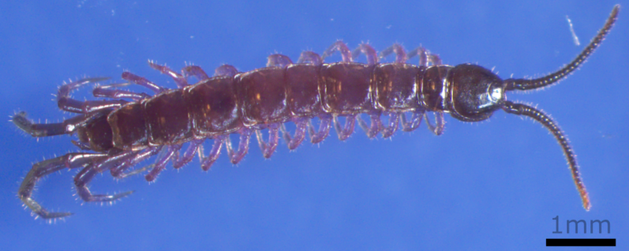

Lamyctes sp.
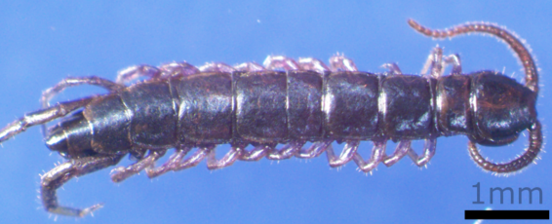

Coleoptera

Bembidion grapii
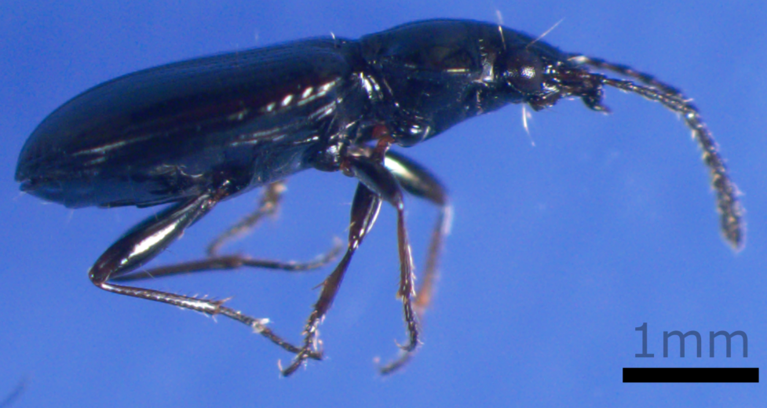

Byrrhus fasciatus
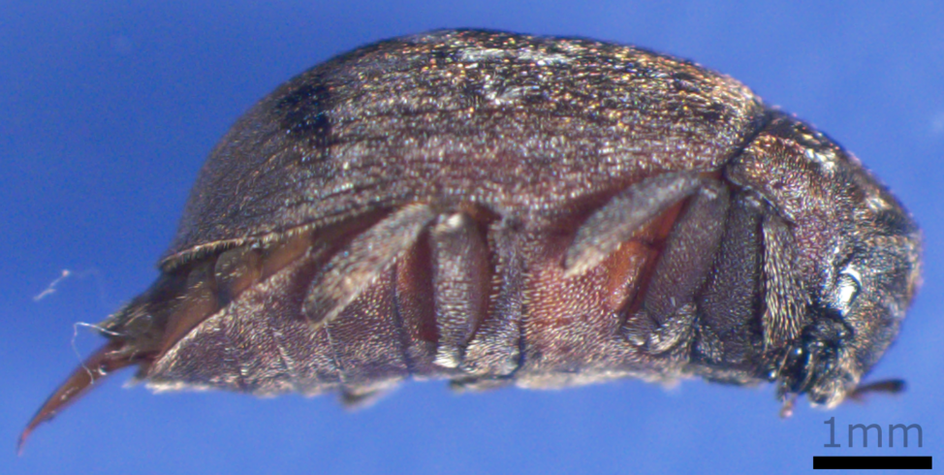

Coccinella transversoguttata
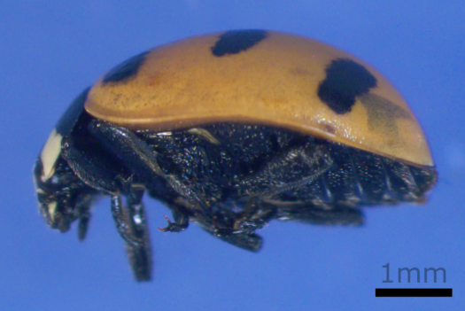

Gyrinus opacus
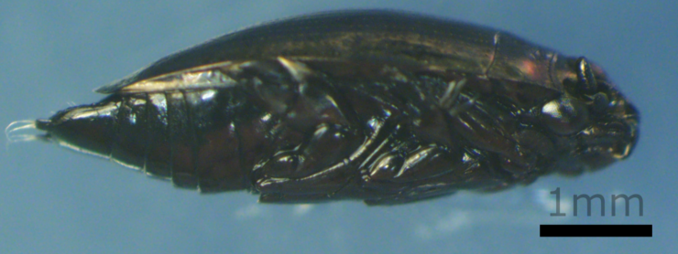

Hydrophorus morio
No image was captured.

Nebria rufescens
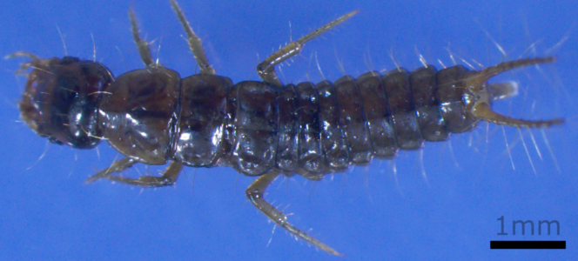

Otiorhynchus arcticus
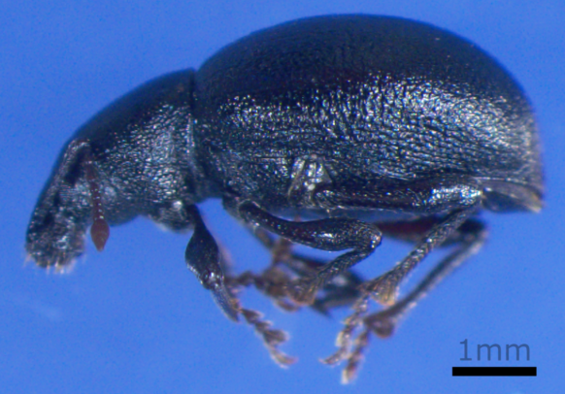

Otiorhynchus nodosus
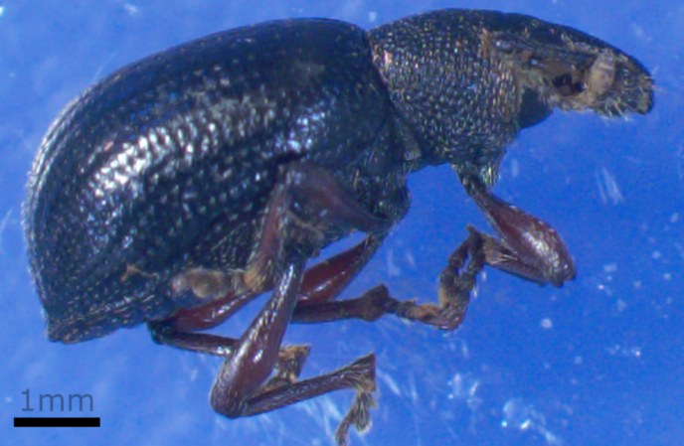

Patrobus septentrionis

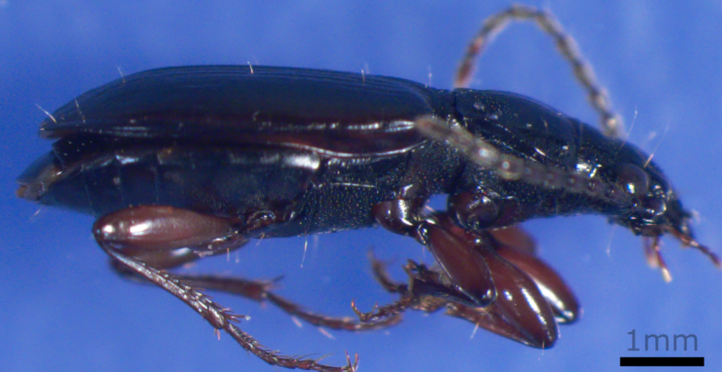

Diptera

Botanophila profuga
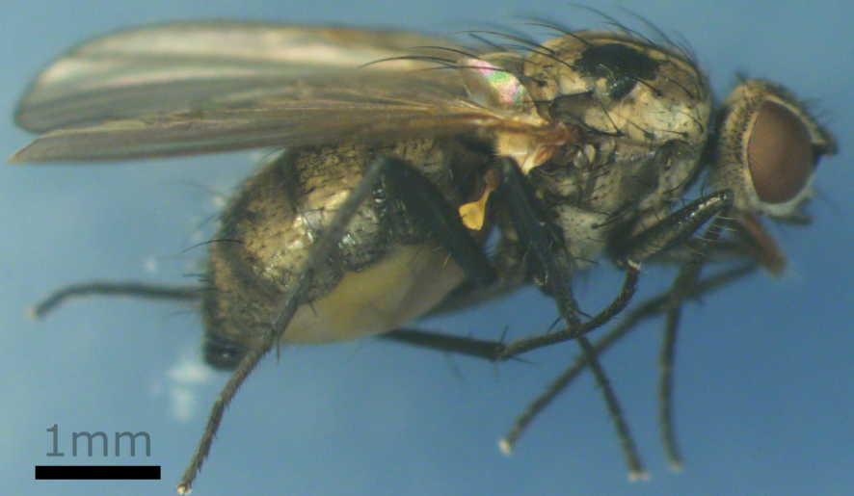

Botanophila sp.
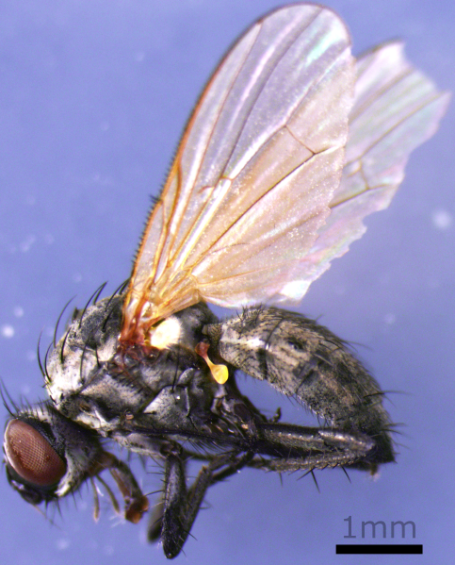

Bradysia sp.
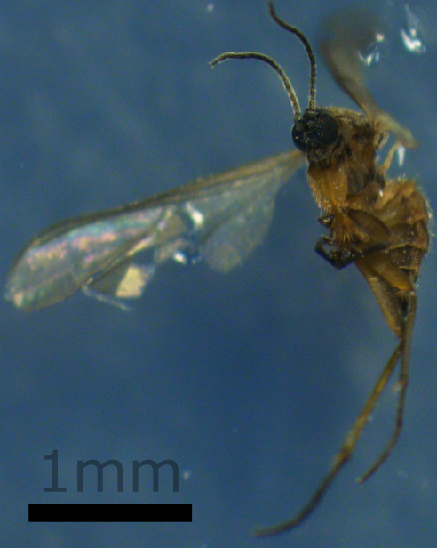

Calliphora uralensis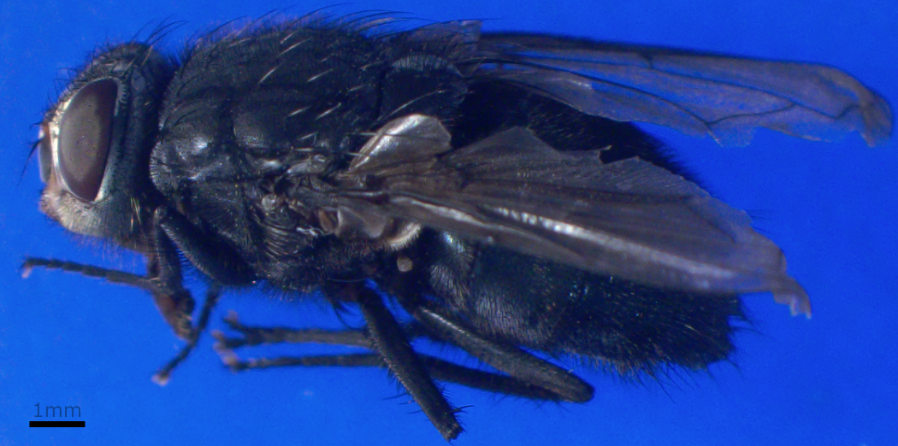

Delia echinata
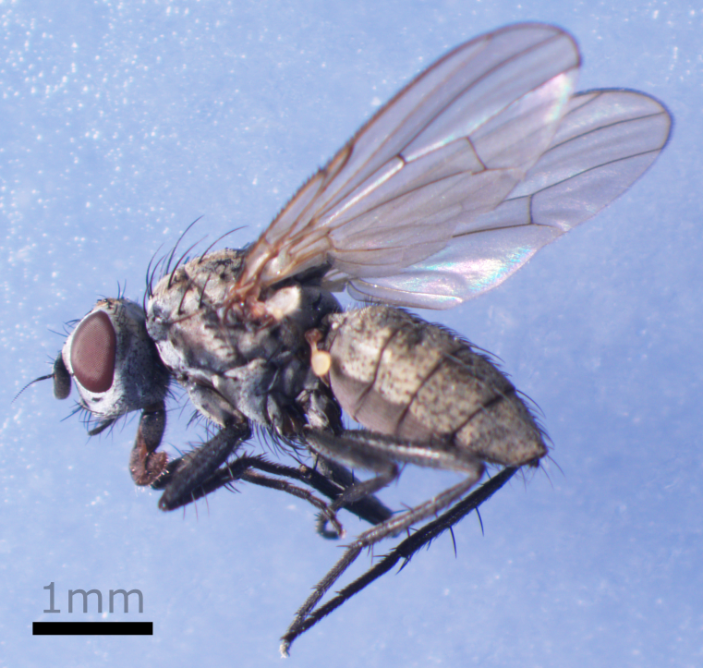

Delia fabricii
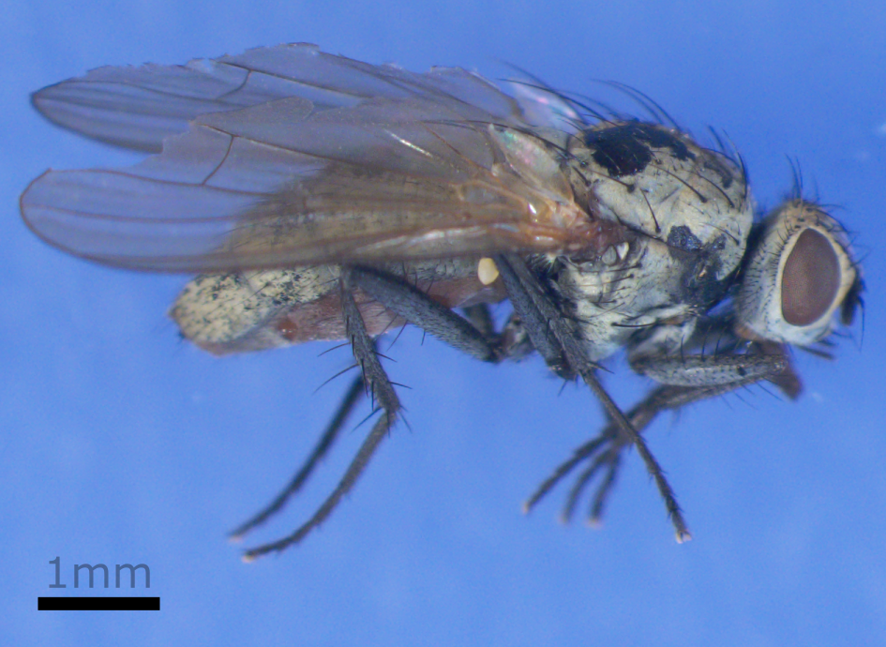

Delia platura
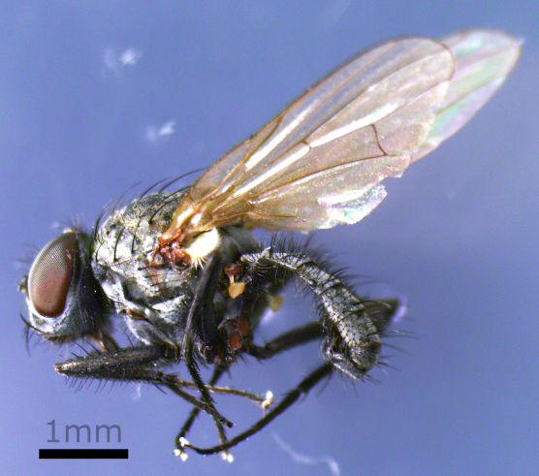

Dolichopus groenlandicus
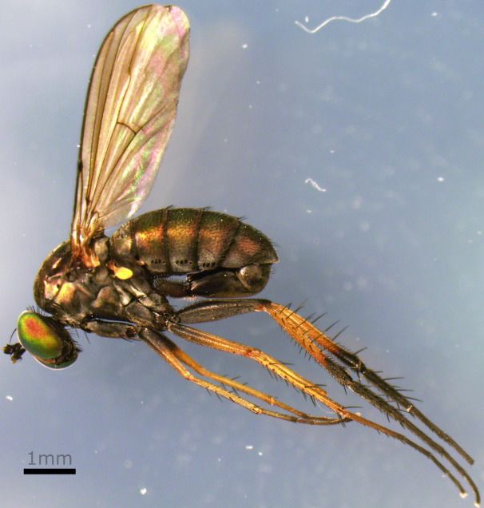

Dolichopus plumipes
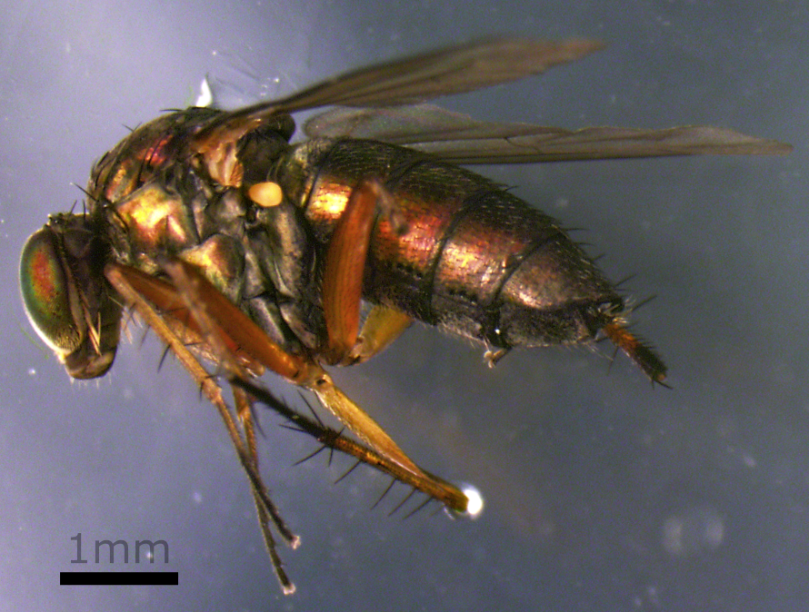

Eupeodes sp.
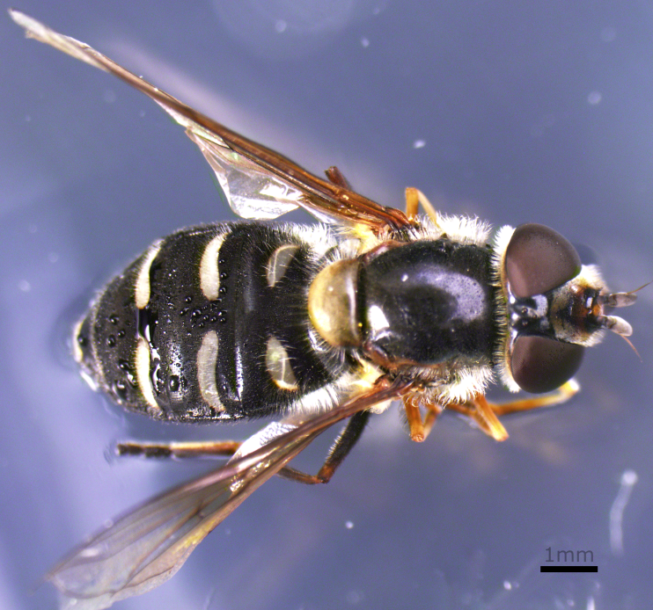

Exechia sp.
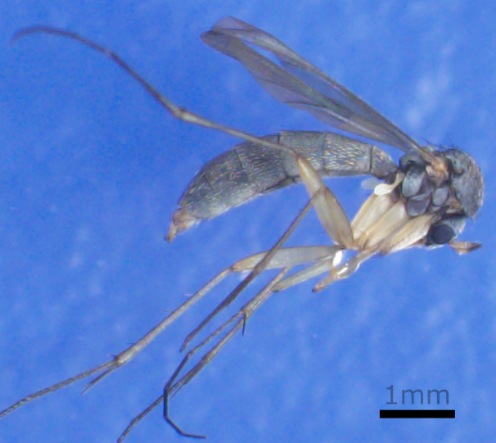

Fannia sp.
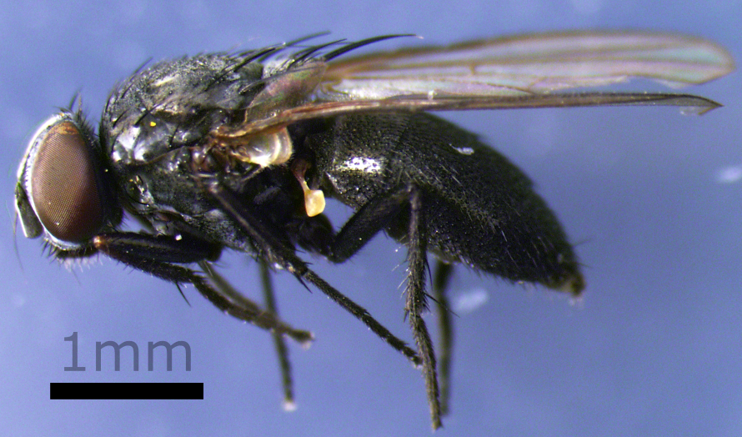

Forcipomyia sp.
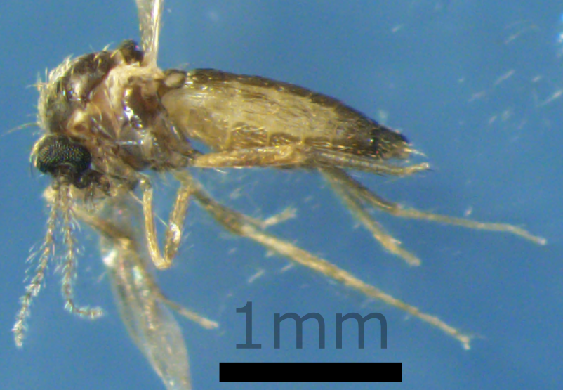

Halocladius variabilis
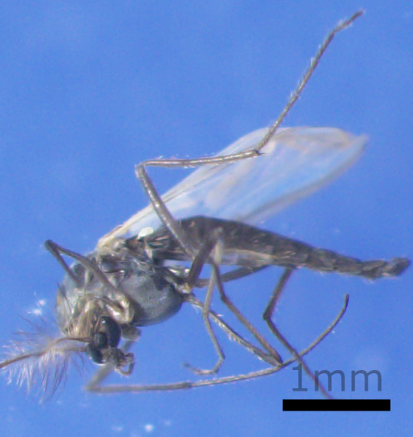

Hydrobaenus fusistylus
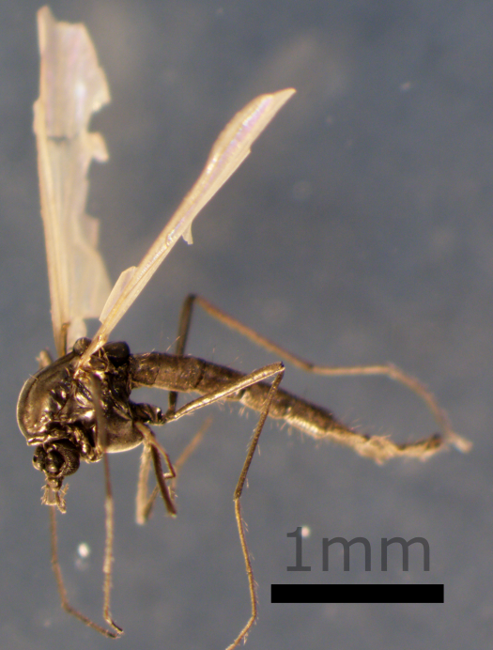

Macrocera sp.
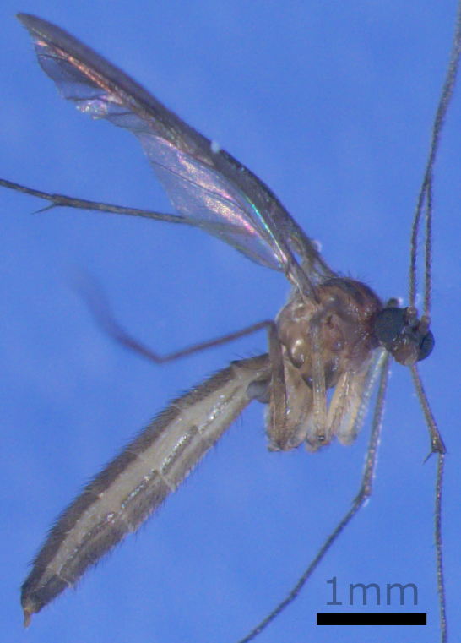

Muscidae sp.
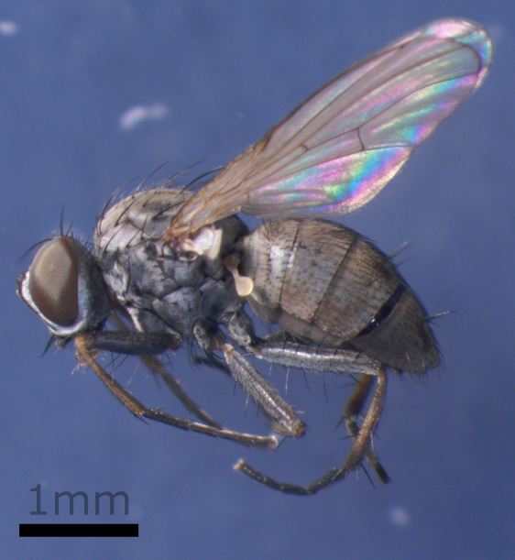

Mycetophila sp.
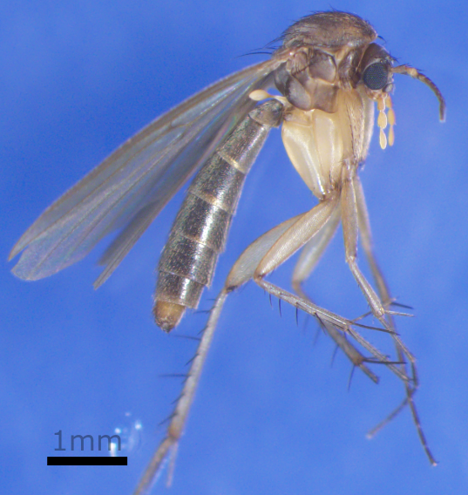

Pegomya notabilis
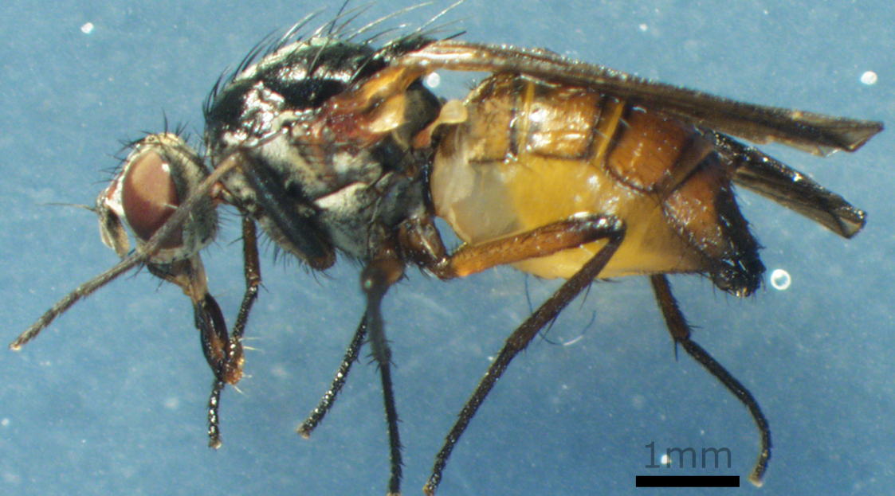

Pegomya sp.
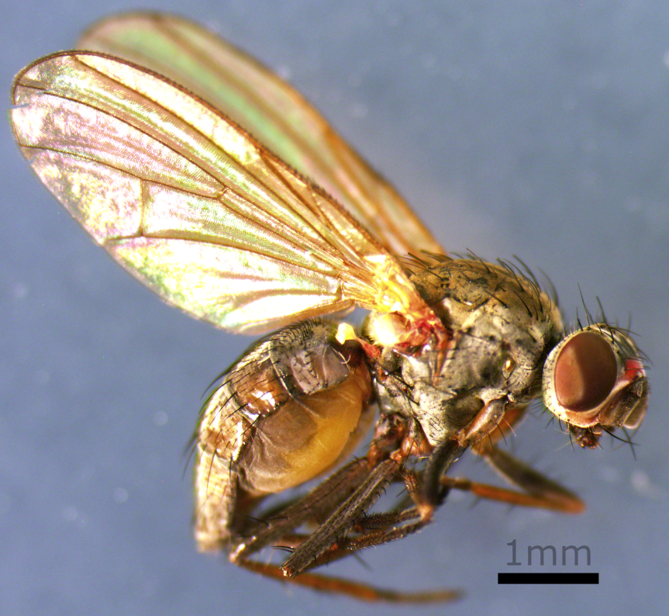

Pegomya zonata
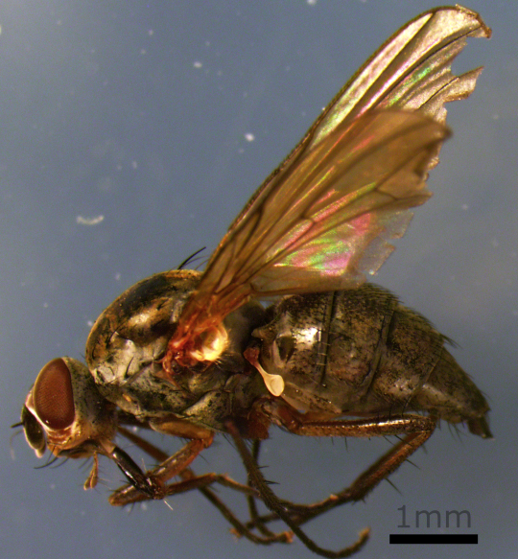

Piophila sp.
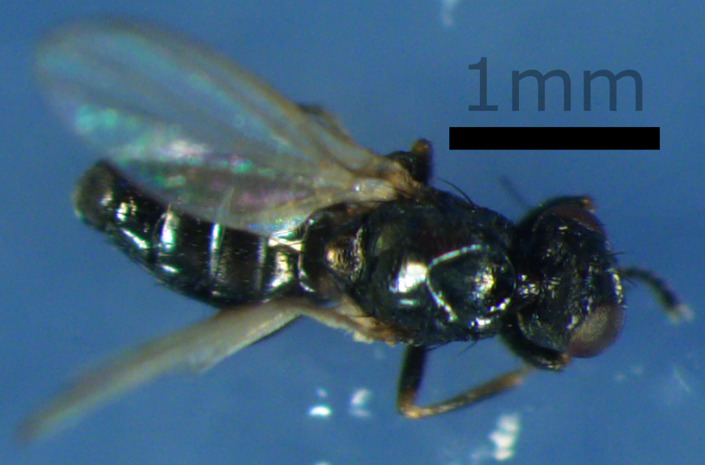

Protophormia terranovae
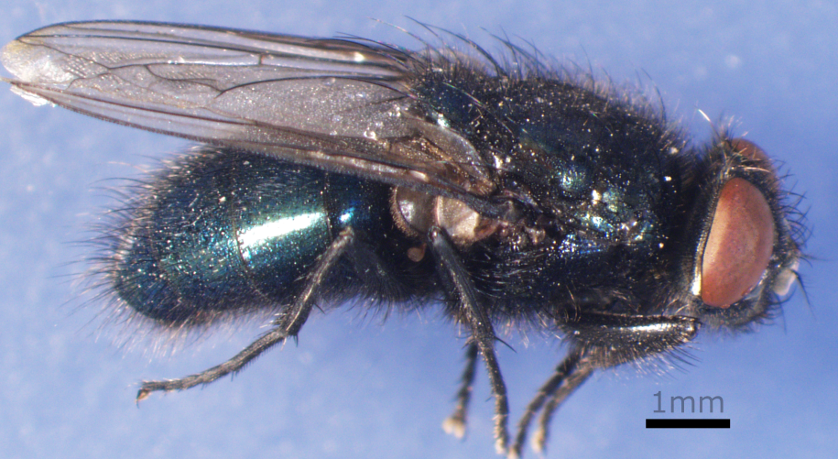

Scathophaga litorea
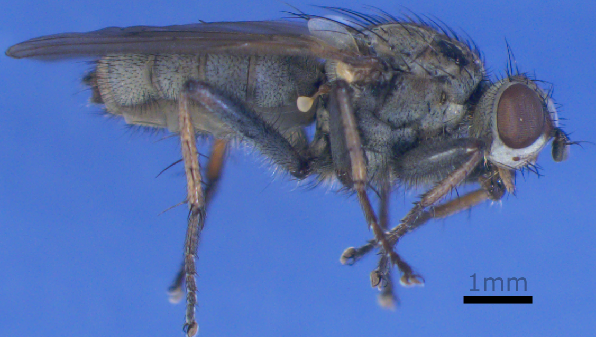

Scathophaga sp.
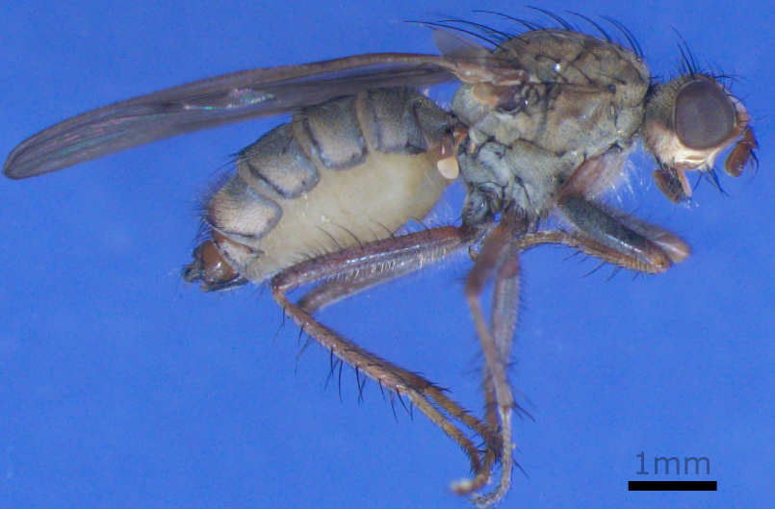

Scathophagidae sp.
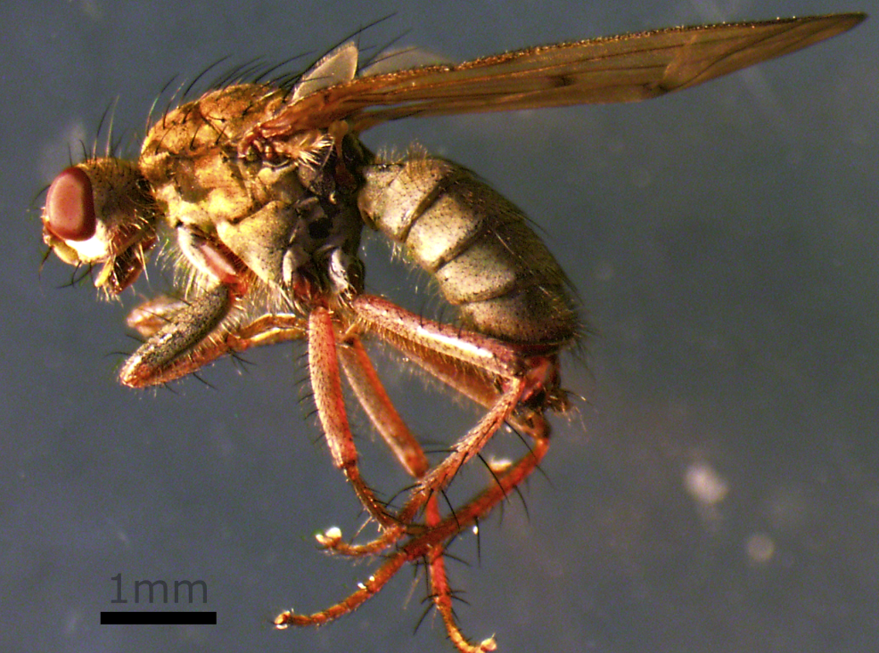

Sciaridae sp.
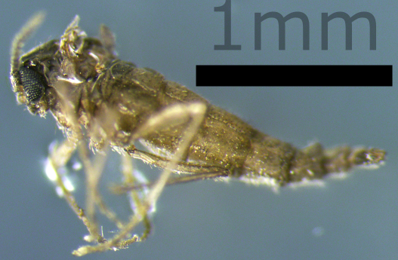

Simulium sp.
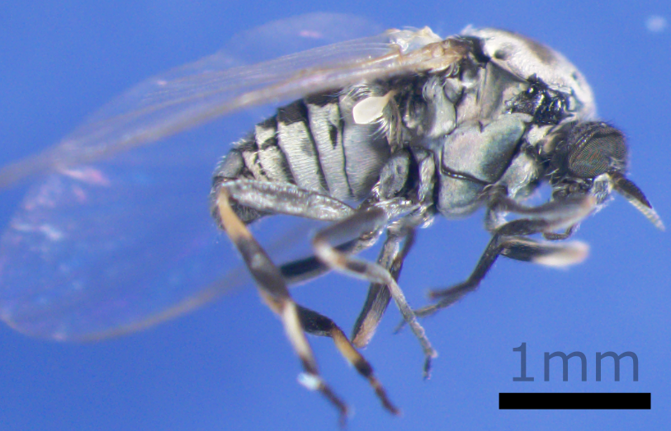

Simulium vittatum
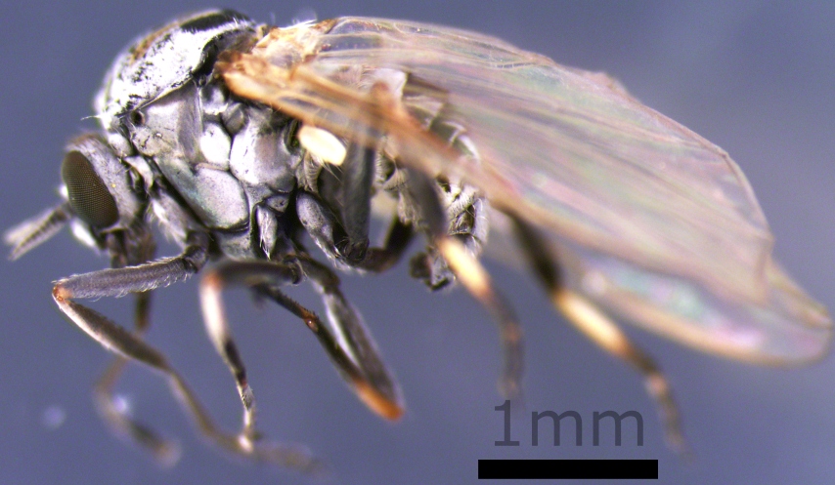

Sphaerophoria sp.
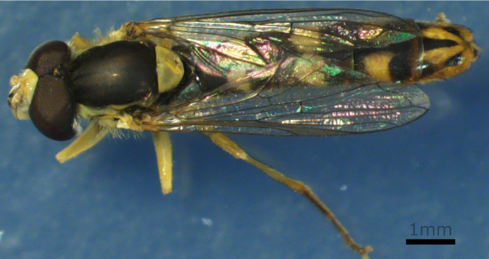

Spilogona arctica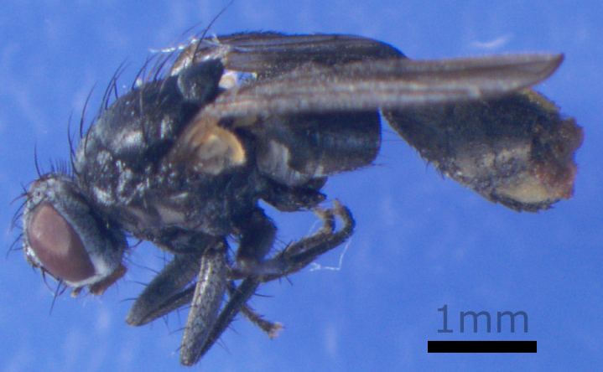

Spilogona sp.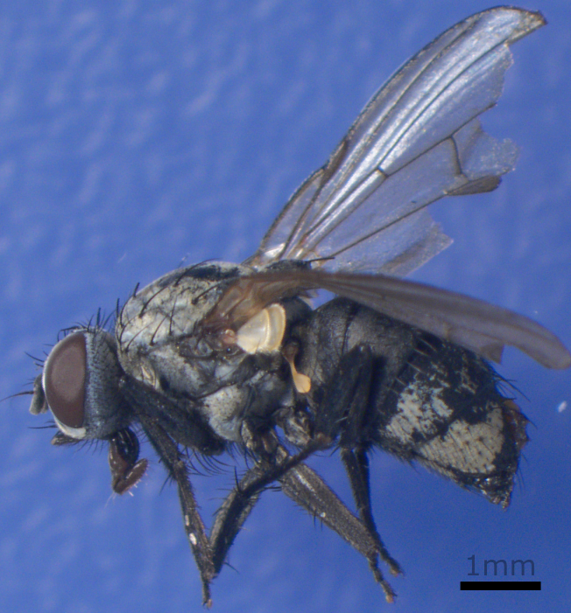

Syrphidae sp.
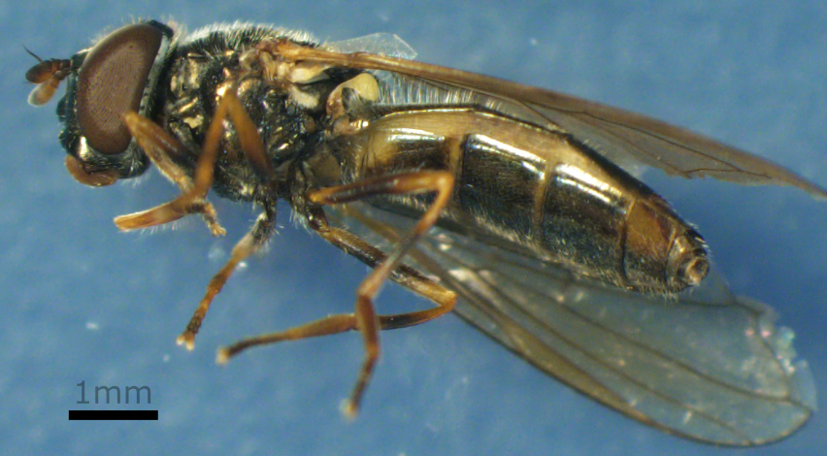

Tachina ampliforceps
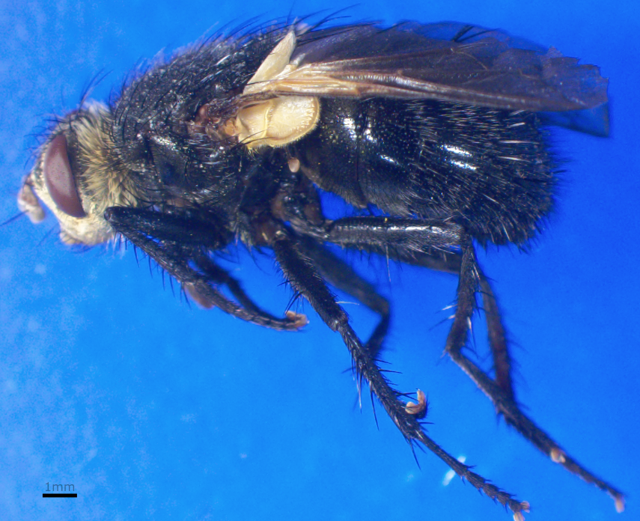

Entomobryomorpha

Lepidocyrtus sp.
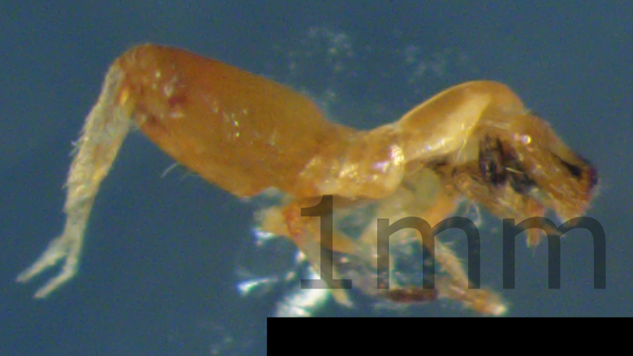

Hemiptera

Aphididae sp.
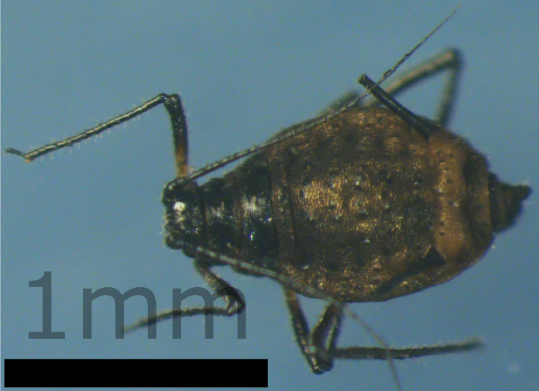

Cavariella sp.
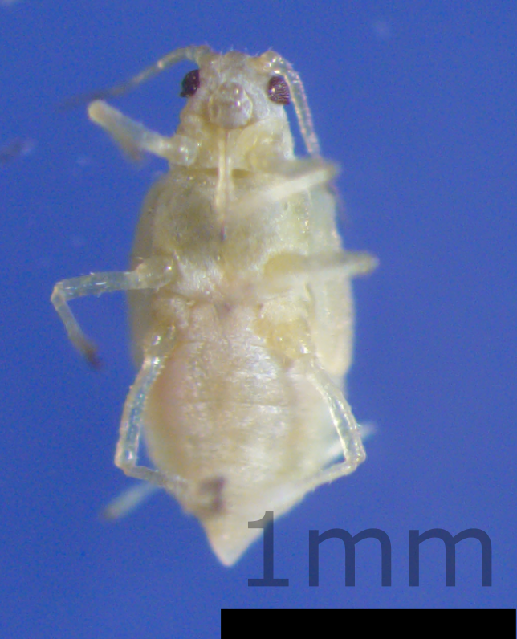

Euceraphis punctipennis
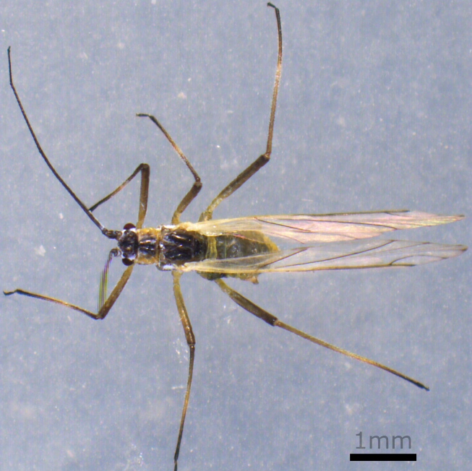

Euceraphis sp
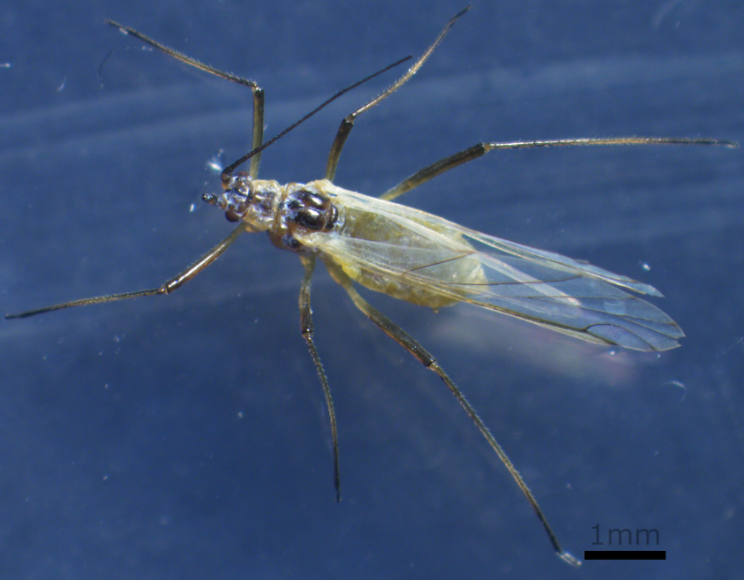

Myzodium modestum
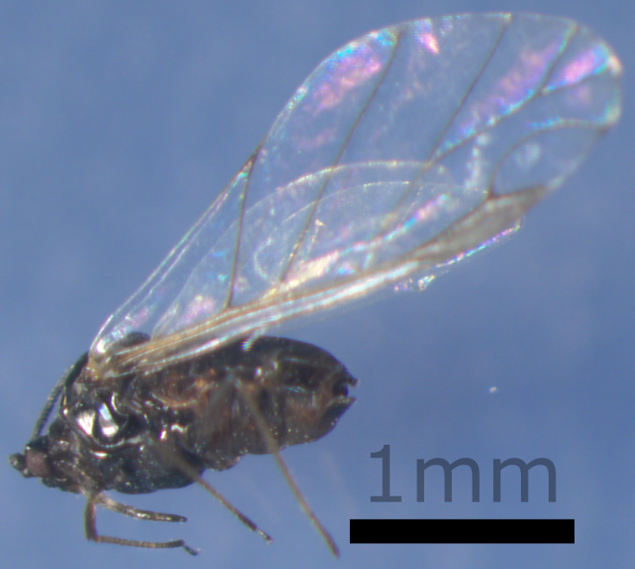

Nabis flavomarginatus
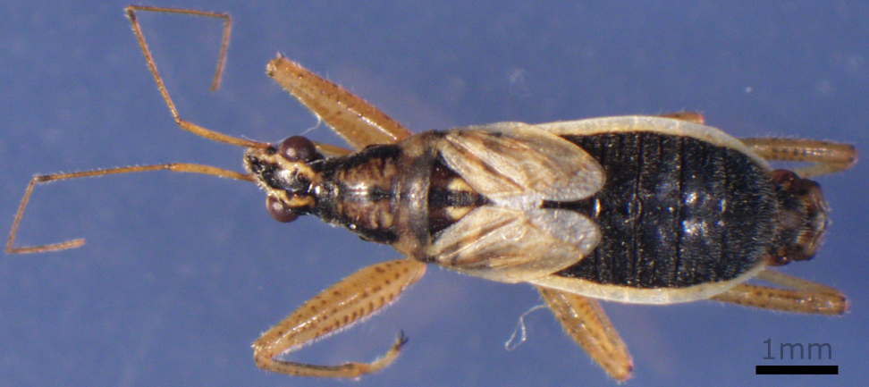

Nysius groenlandicus
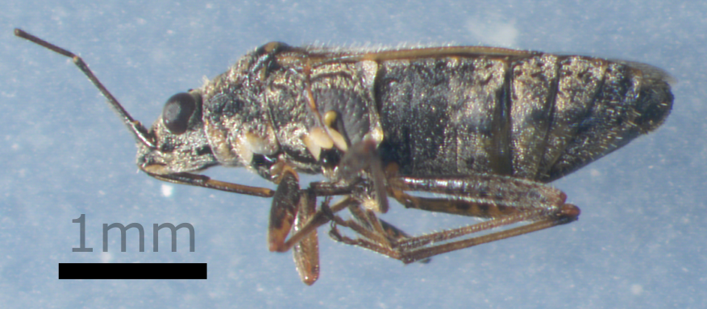

Psammotettix lividellus
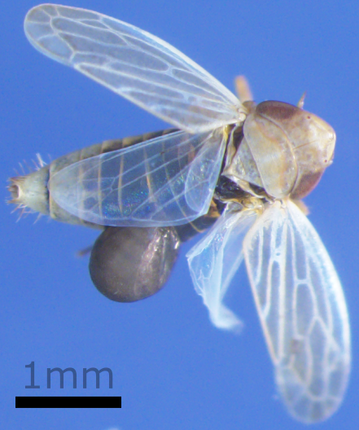

Psyllidae sp.
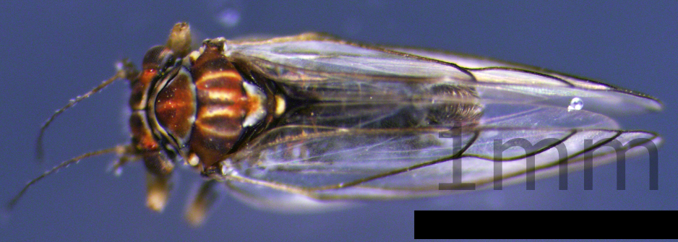

Pterocomma sp.
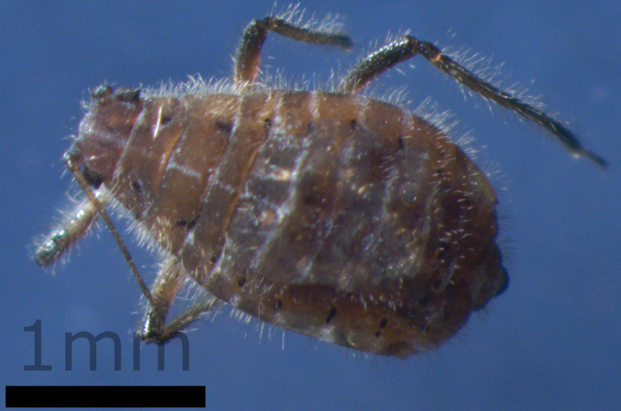

Utamphorophora sp.
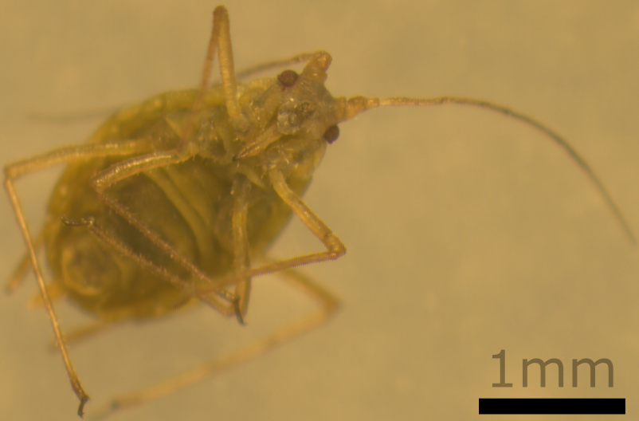

Hymenoptera

Brachonidae sp.
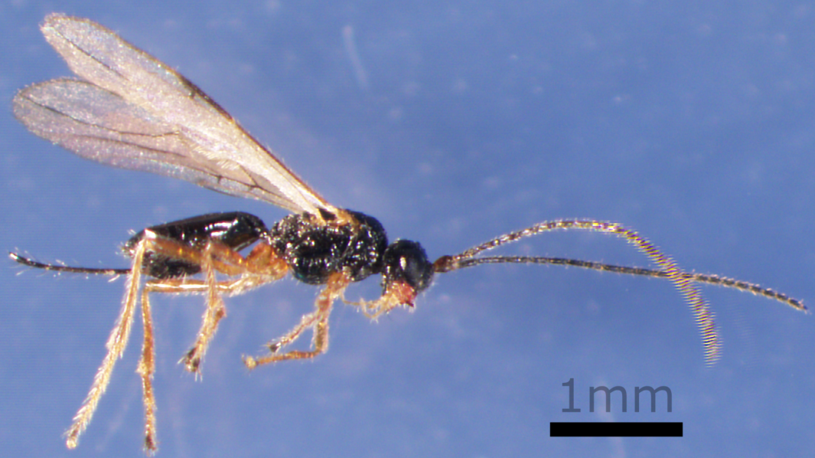

Campoletis horstmanni
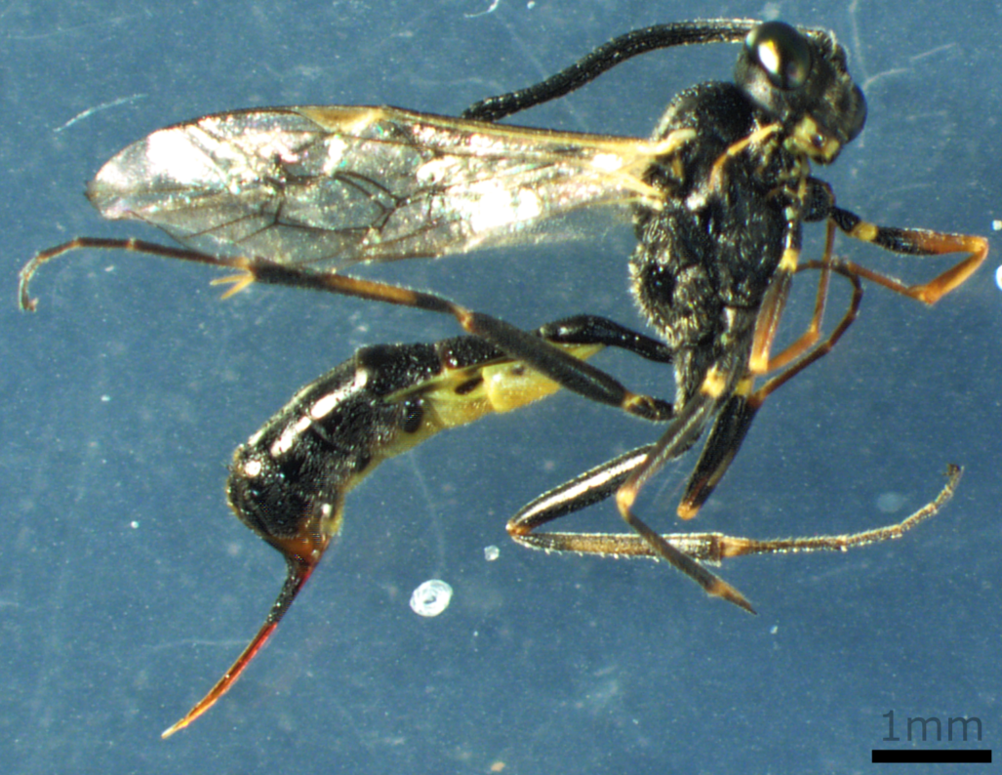

Campopleginae sp.
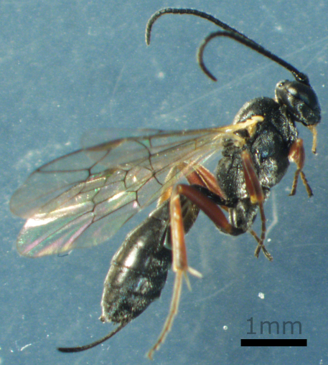

Hymenoptera sp.
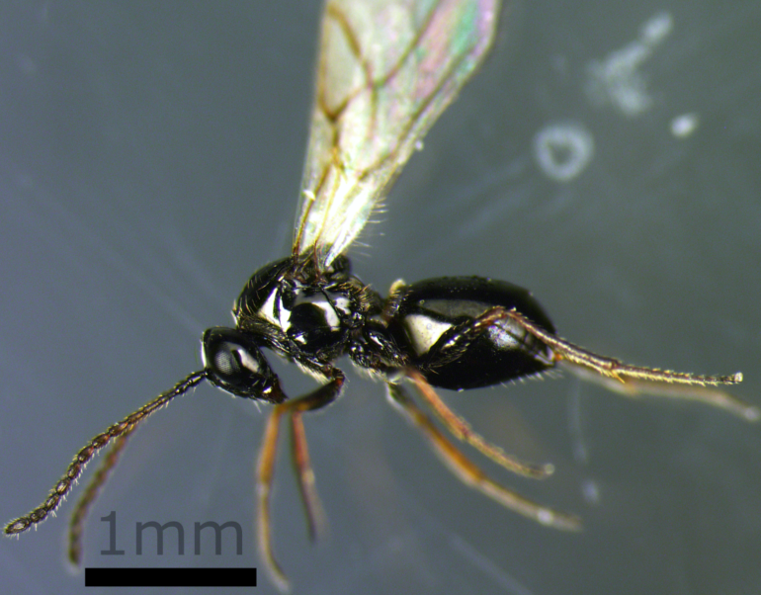

Hyposoter frigidus
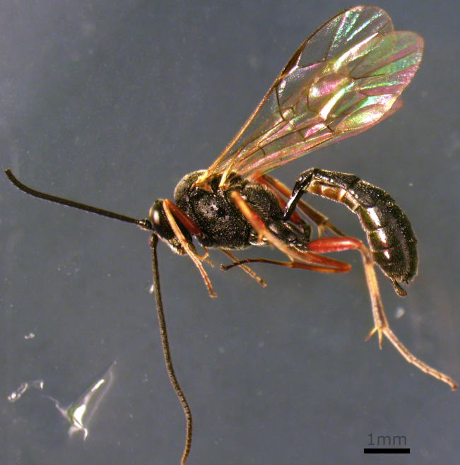

Hyposoter sp.
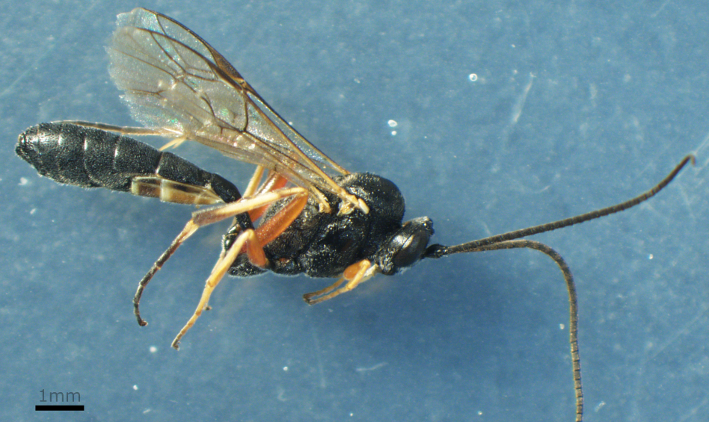

Ichneumon sarcitorius
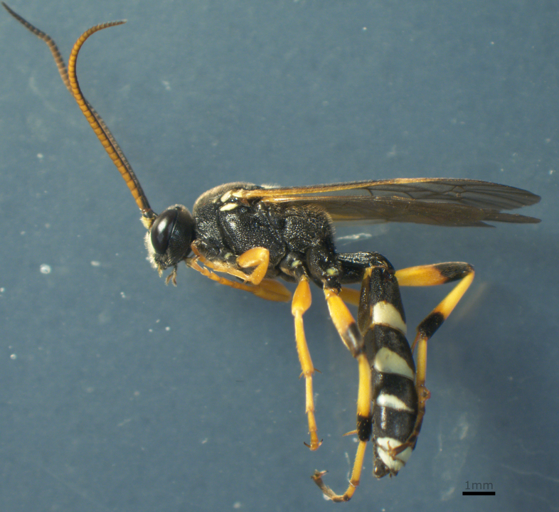

Ichneumonidae sp.
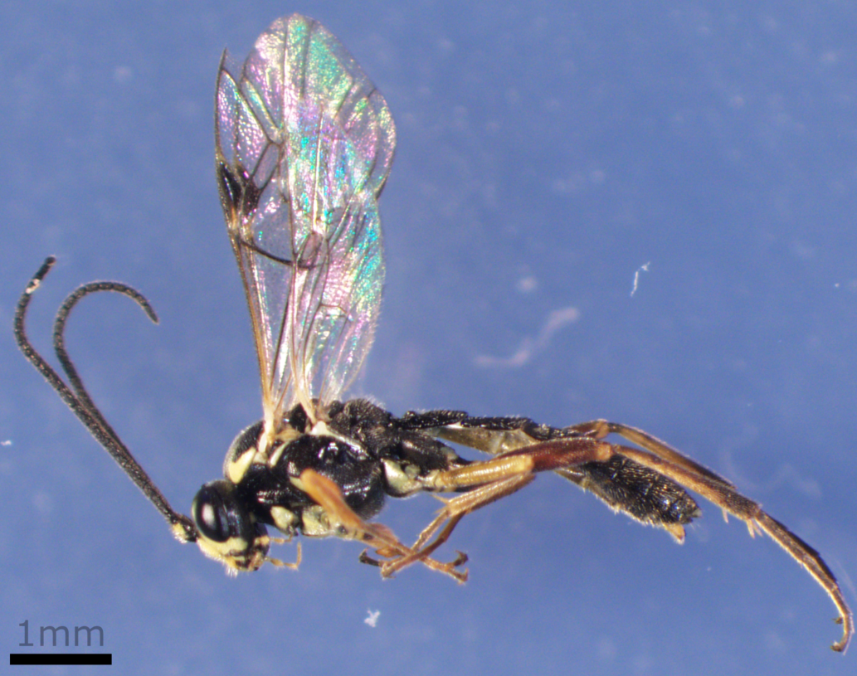

Meteorus rubens
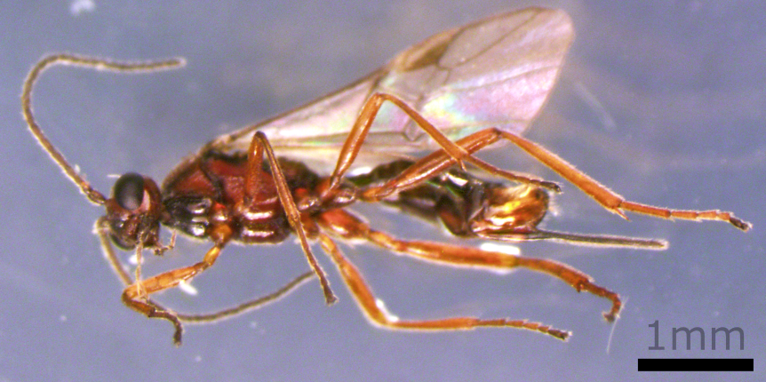

Panthisarthrus lubricus
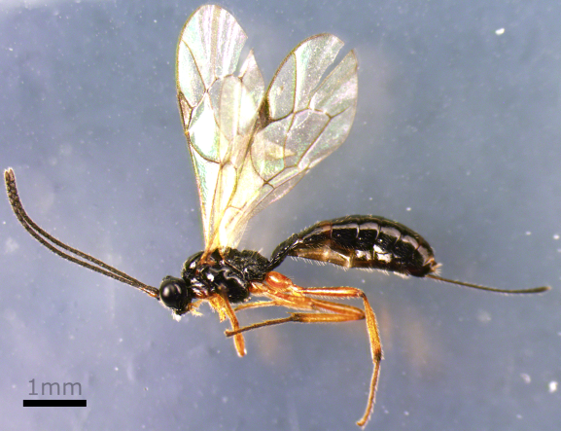

Protopanatales fulvipes
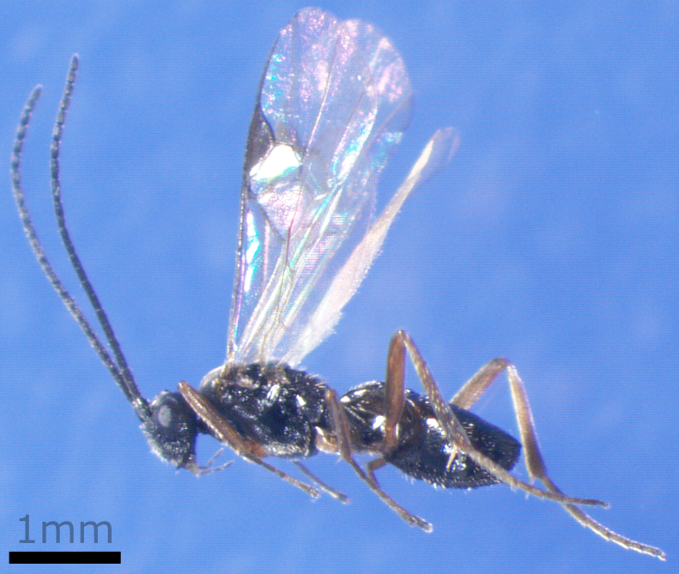

Tenthredinidae sp.
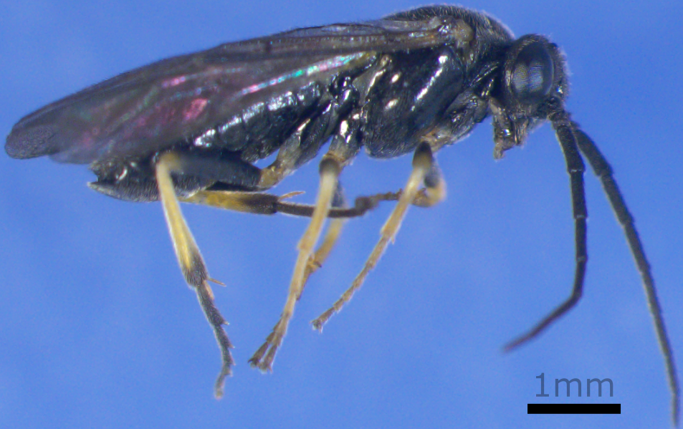

Lepidoptera

Acleris caryosphena
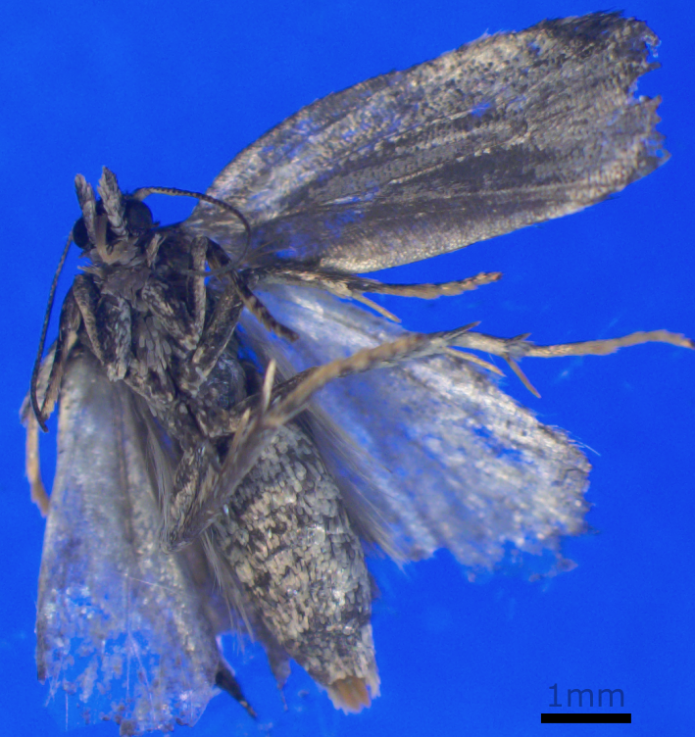

Autographa gamma
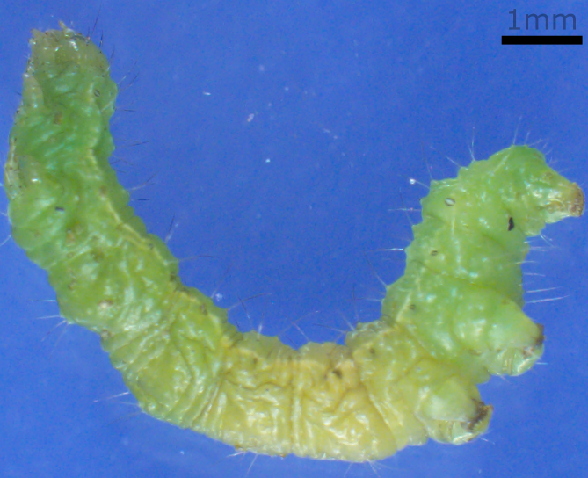

Eurois occulta
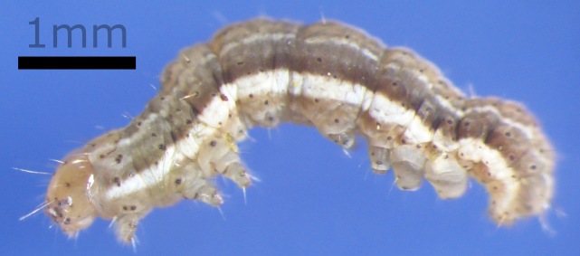

Mniotype adusta
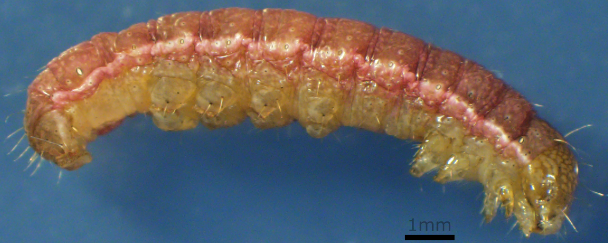

Scythris noricella
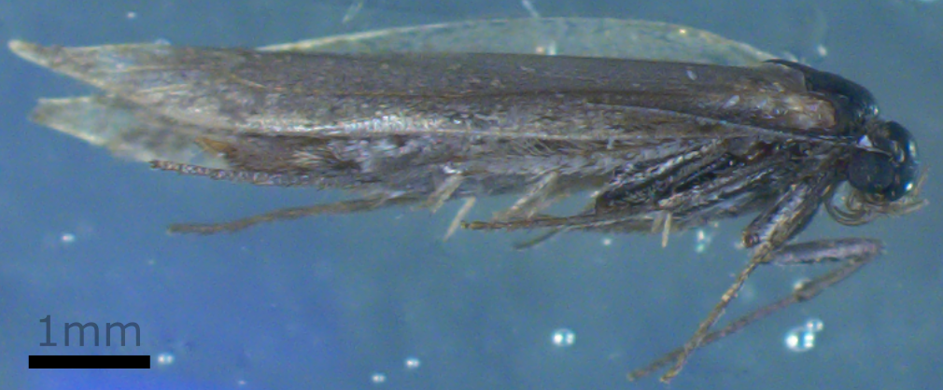

Spaelotis clandestine
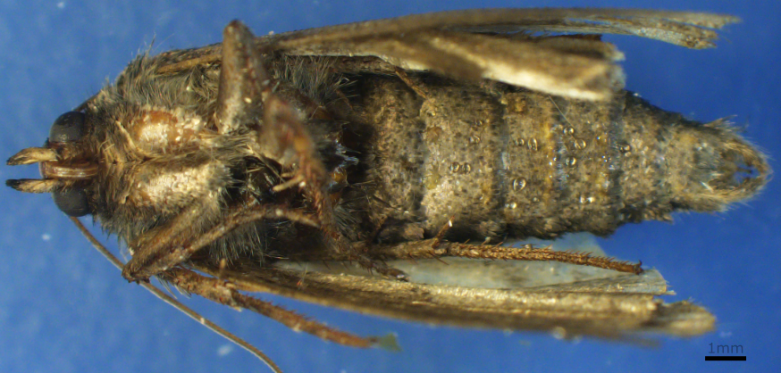

Syngrapha borea
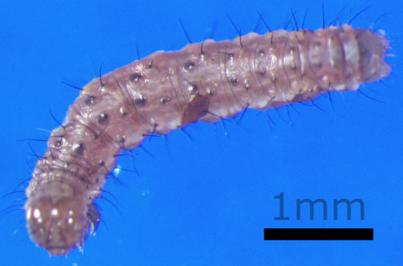

Torticidae sp.
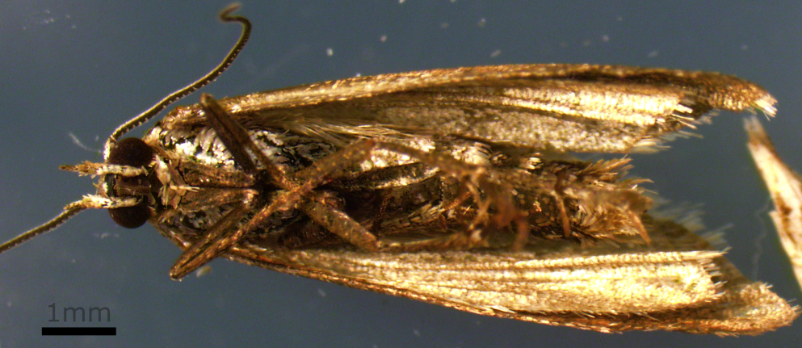

Neuroptera

Hemerobius ovalis
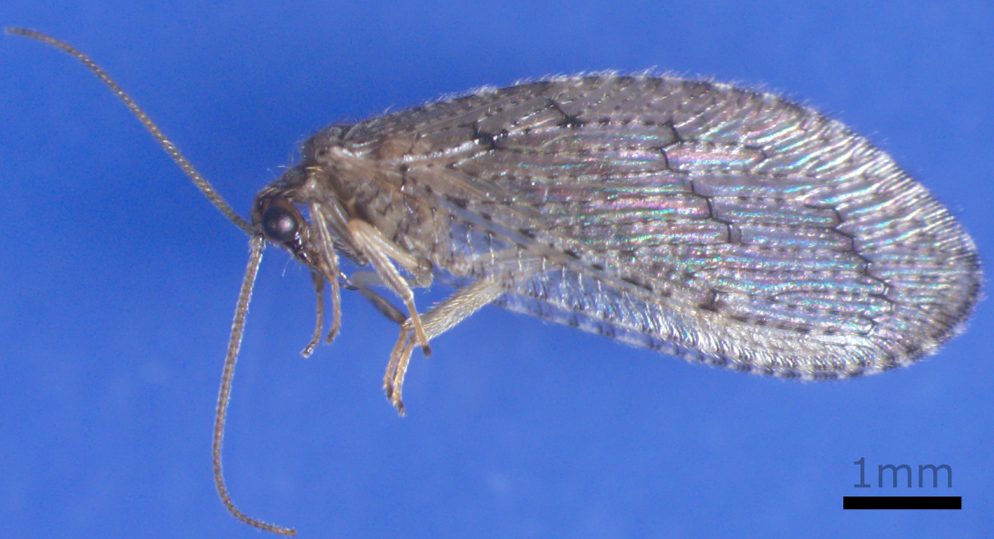

Wesmaelius nervosus
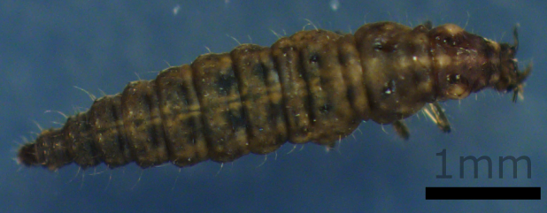

Trichoptera

Limnephilus kennicotti
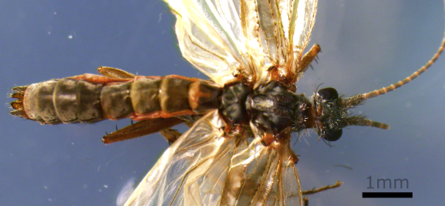

Limnephilus sp.
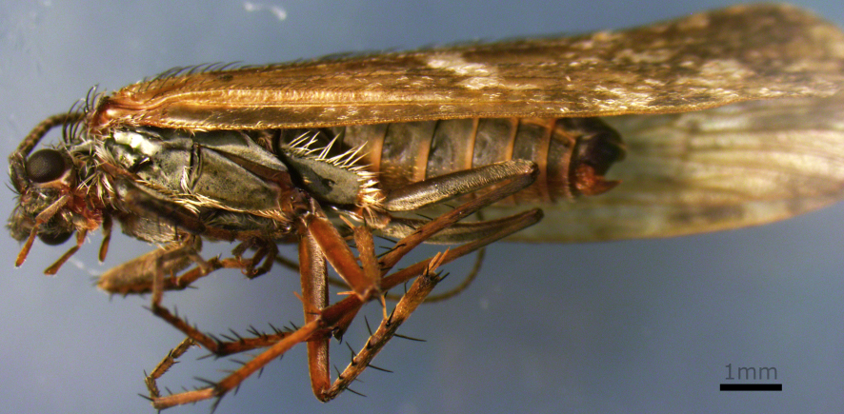

Trombidiformes

Anystidae sp.
