Supplementary Materials for
Beyond Canopy Cover: How Tree Distribution Shapes Cloud Formation Across Africa
Di Xie^{1,2}, Luca Caporaso^{3,4}, Markus Reichstein², Deyu Zhong^{1, *}, Gregory Duveiller^{2, *}
1. State Key Laboratory of Hydroscience and Engineering, Key Laboratory of Hydrosphere Sciences of the Ministry of Water Resources, Department of Hydraulic Engineering, Tsinghua University, Beijing, China
2. Max Planck Institute for Biogeochemistry, Jena, Germany
3. European Commission, Joint Research Centre, Ispra, Italy
4. National Research Council of Italy, Institute of BioEconomy, Rome, Italy

*Correspendence:zhongdy@tsinghua.edu.cn; gduveiller@bgc-jena.mpg.de

This supplementary materials includes:
Figure S1. Regression coefficient for average tree cover, Rao’s Q and their interaction terms across Africa in 2019.
Figure S2. Biophysical sensitivity of cloud cover to tree cover across Africa in 2019.
Figure S3. Biophysical sensitivity of different variables to tree covers for Africa in daytime.
Figure S4. Biophysical sensitivity of different variables to tree covers for Africa at nighttime.
Figure S5. Estimation of nighttime cloud cover to change of tree cover and heterogeneity change by 20%.
Figure S6. Processed distribution of Rao’s Q in Africa.

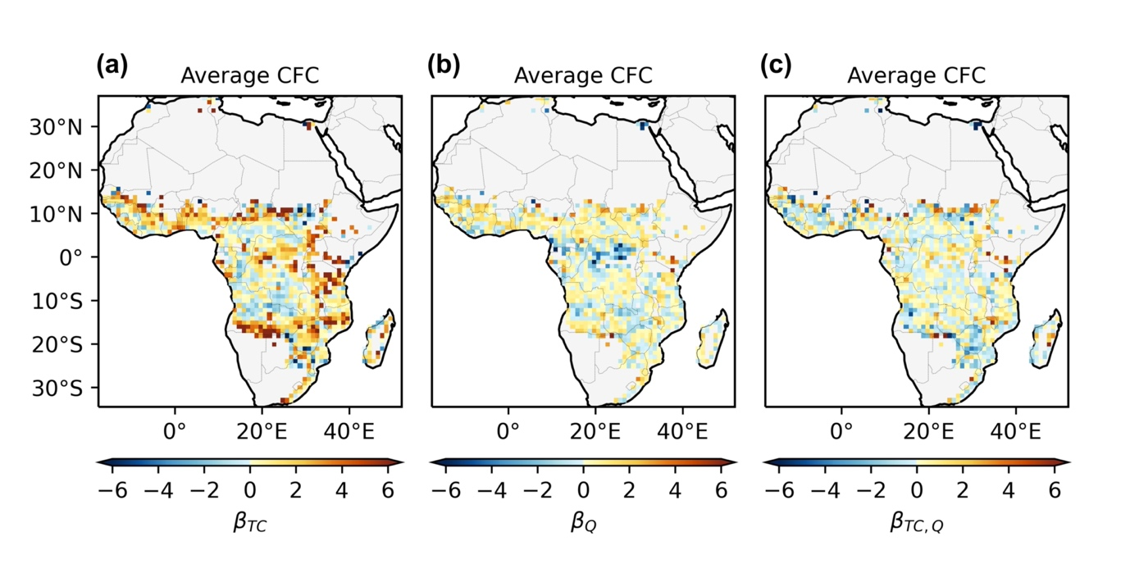
Figure S1. Regression coefficient for average tree cover, Rao’s Q and their interaction terms across Africa in 2019. (a) Spatial map for average cloud sensitivity to tree cover. (b) Spatial map for average cloud sensitivity to Rao’s Q. (c) Spatial map for average cloud sensitivity to interaction term for tree cover and heterogeneity.

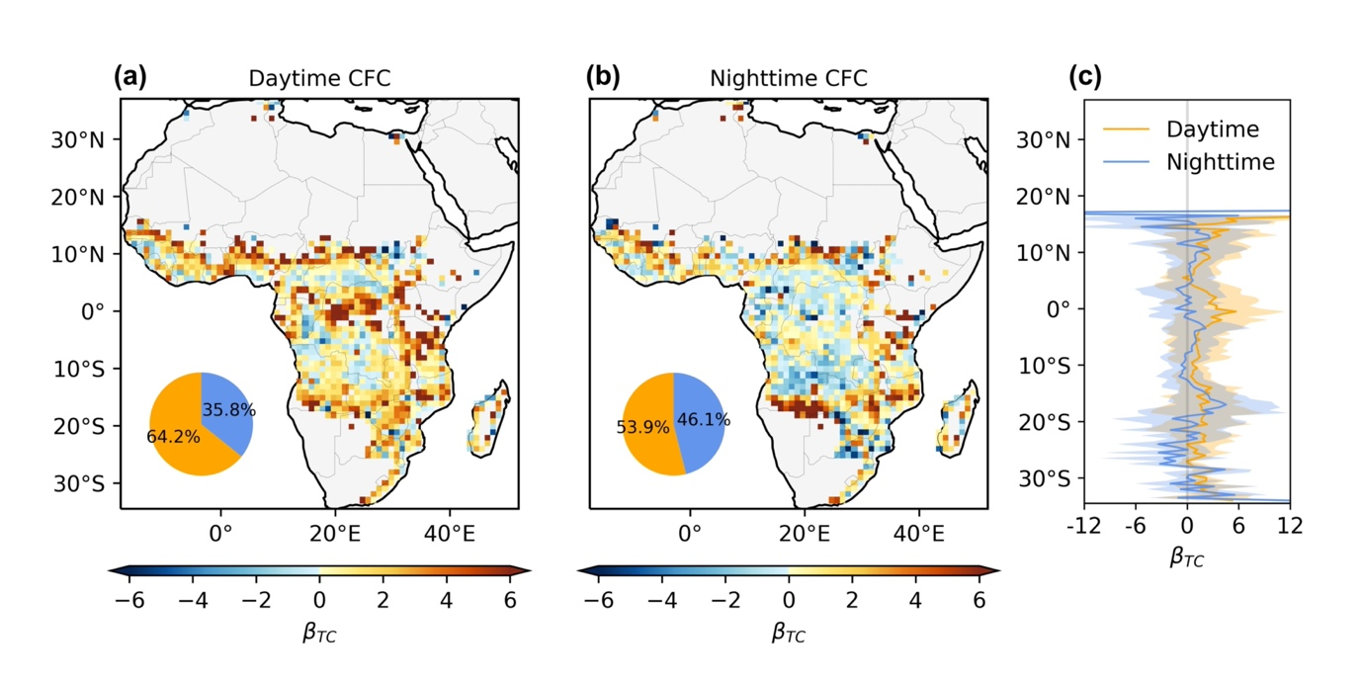
Figure S2. Biophysical sensitivity of cloud cover to tree cover across Africa in 2019. (a) Spatial map of annual average daytime (6:00 -18:00, local time) cloud sensitivity to tree cover. (b) Spatial map of annual average nighttime (18:00 - 6:00, local time) cloud sensitivity to tree cover. The original result at a resolution of 0.05° has been aggregated to 1° for display. The pie chart in (a) and (b) shows the proportion of positive and negative values at the original 0.05° resolution. (c) Latitudinally averaged changes in both daytime and nighttime sensitivities. The regression was conducted using the Ordinary Least Squares (OLS) function from the statsmodels library in Python, and only values with a p-value less than 0.05 were included.

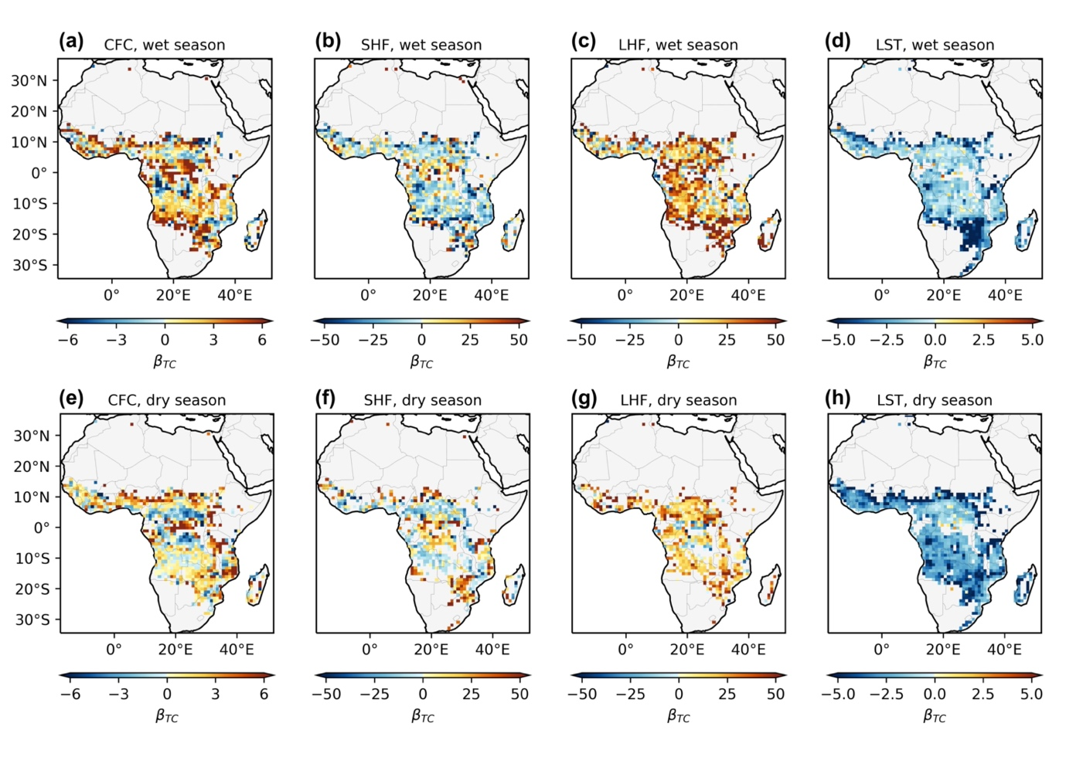
Figure S3. Biophysical sensitivity of different variables to tree covers for Africa in daytime. Spatial map for daytime (a) cloud, (b) SHF, (c) LHF and (d) LST sensitivity in the wet season. (e), (f), (g), (h) represents the sensitivity for the same variable as (a), (b), (c), (d) correspondingly but in the dry season.

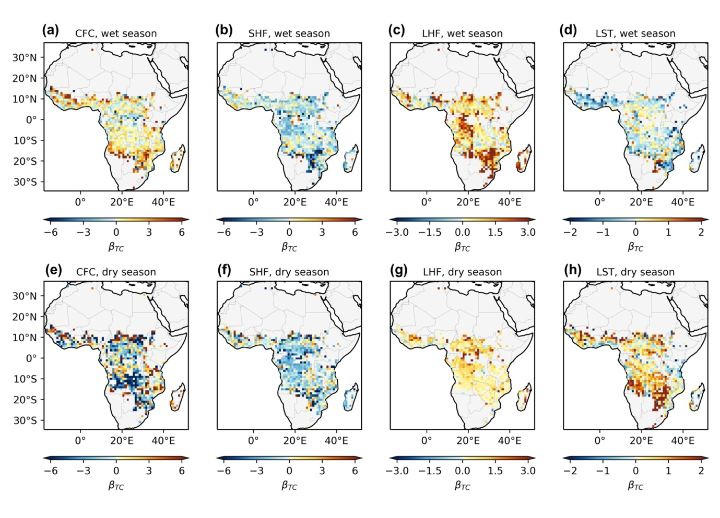
Figure S4. Biophysical sensitivity of different variables to tree covers for Africa at nighttime. Spatial map for nighttime (a) cloud, (b) SHF, (c) LHF and (d) LST sensitivity in the wet season. (e), (f), (g), (h) represents the sensitivity for the same variable as (a), (b), (c), (d) correspondingly but in the dry season.
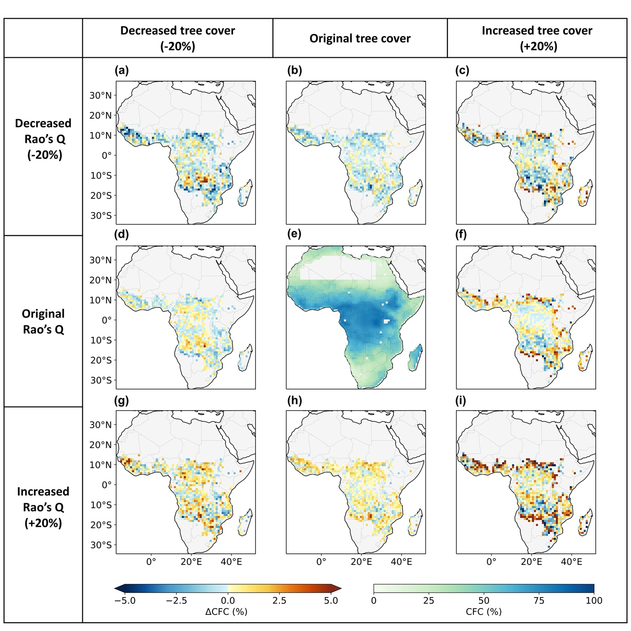
Figure S5. Estimation of nighttime cloud cover to change of tree cover and heterogeneity change by 20%. (a) Distribution of cloud cover change with decreased Rao’s Q and decreased tree cover. (b)-(d) and (f)-(i) are the same as (a) but with different combinations of change conditions, which is indicated by the text before each column and row. (e) indicates the average daytime cloud cover condition in Africa. The color bar on the left indicates the cloud change induced by tree cover and heterogeneity change, which is shared by (a)-(d) and (f)-(i), while the right one is for the cloud cover shown in (e).

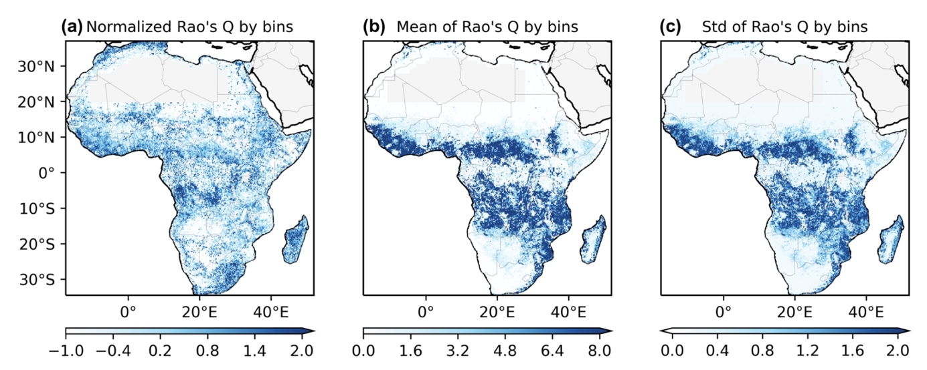
Figure S6. Processed distribution of Rao’s Q in Africa. (a) Spatial map for Rao’s Q normalized by 1% tree cover bins. (b) Spatial map for average Rao’s Q calculated by 1% tree cover bins. (c) Spatial map for standard deviation of Rao’s Q calculated by 1% tree cover bins.

