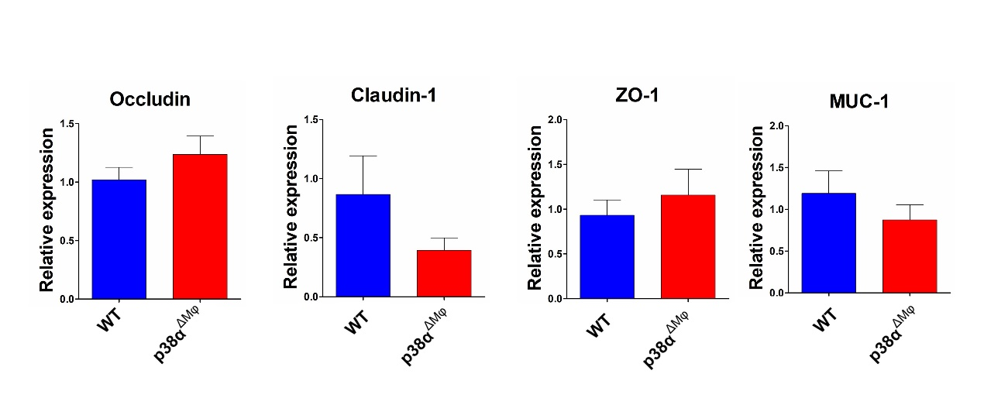
Supplementary 1
qRT-PCR analysis of the relative mRNA expression of occludin, ZO-1, claudin-1, and muc-1 in colonic tissues of WT and p38α^{ΔMφ} mice.

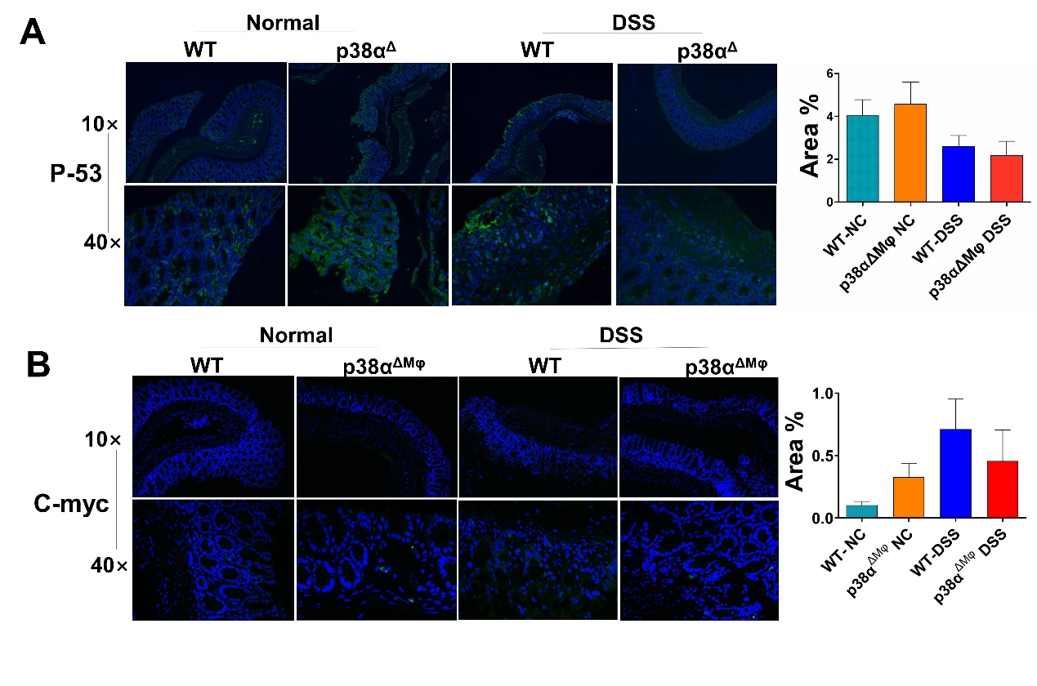
Supplementary 2
(A,B) The expression of P-53 and C-myc in WT and p38α^{ΔMφ} mice was detected by immunofluorescence.

