Supplementary Material

Hydrogel Lego based on rehydrated laminate assembly for standardized production and customized integration of multifunctional hydrogel sensors
Xiaowei Xu, ª Lei Hu, ^{b} Jie Pang, ^{a,} * and Shuyi Wu ^{b,} *
ª College of Food Science, Fujian Agriculture and Forestry University, Fuzhou, 350002, P. R. China
^{b} College of Transportation and Civil Engineering, Fujian Agriculture and Forestry University, Fuzhou 350108, China
Corresponding author. E-mail address: pang3721941@163.com; wushuyi@fafu.edu.cn

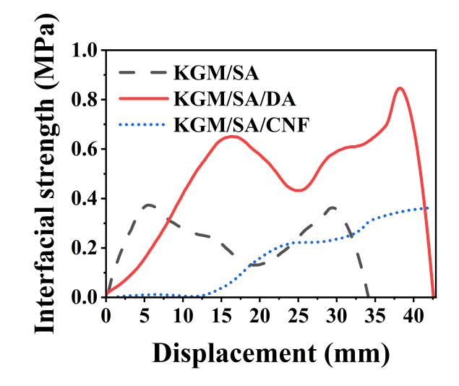
Figure S1. Interfacial strength of bilayered KGM/SA, KGM/SA/DA and KGM/SA/CNF hydrogels.
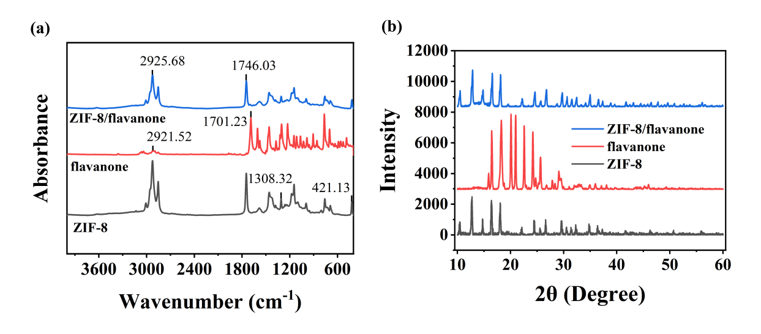
Figure S2. (a) FTIR pattern and (d) XRD pattern of ZIF-8, flavanone and ZIF-8/Flavanone.

