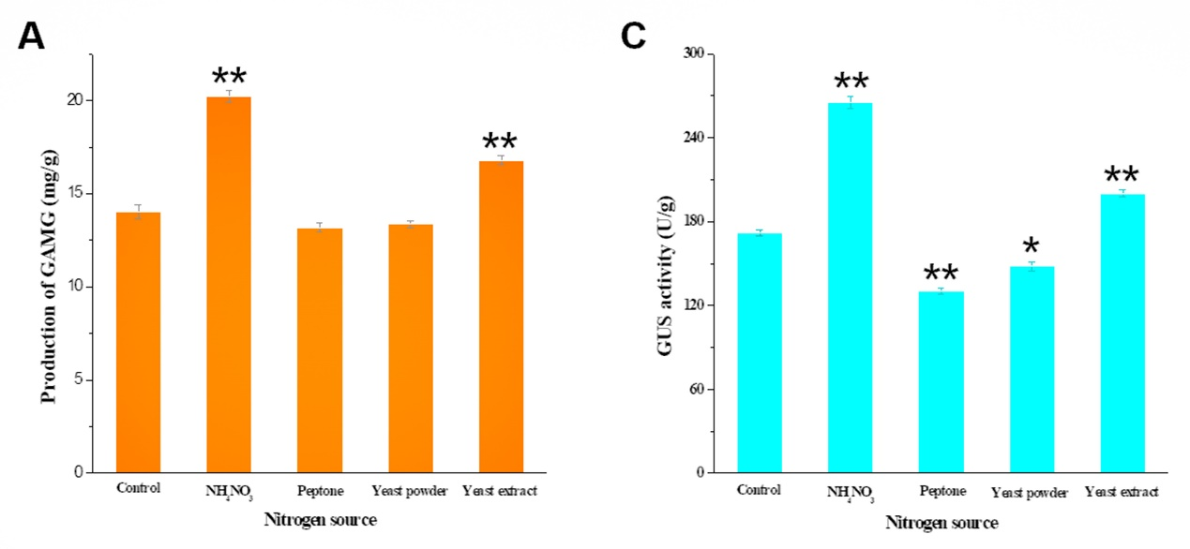
S Fig. 1 Optimization of nitrogen source, including NH₄NO₃, peptone, yeast powder, and yeast extract. NH₄NO₃ and yeast extract can significantly increase the production of GAMG (A) and GUS activity (B) during SSF by C. globosum DX-THS3. **: p<0.01, *: p<0.05.

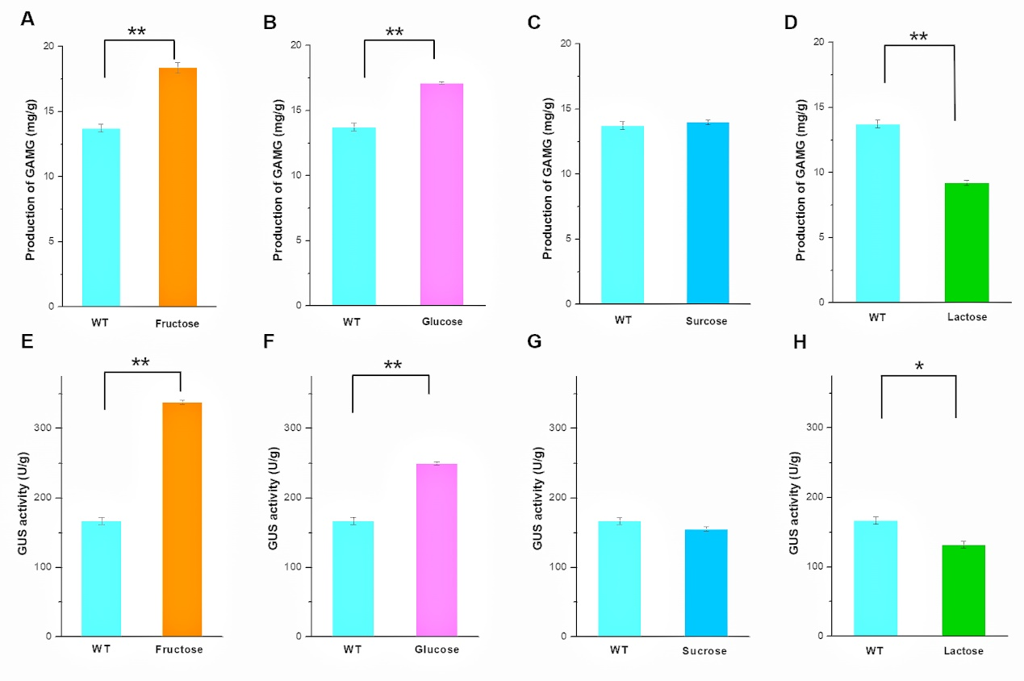
S Fig. 2 Effect of carbon sources, including fructose, glucose, sucrose, and lactose, on the production of GAMG (A–D) and GUS activity (E–H) after 20 days of SSF using C. globosum DX-THS3. **: p<0.01, *: p<0.05.

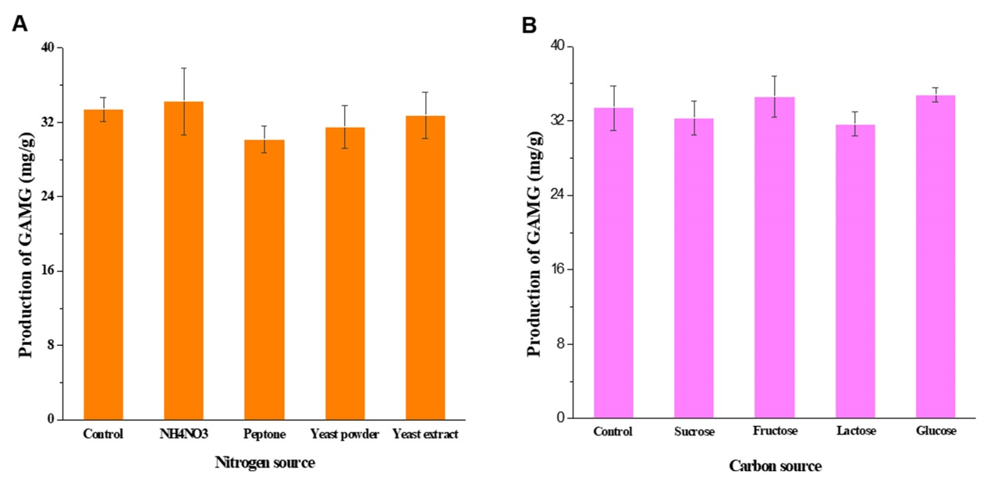
S Fig. 3 Effect of nitrogen and carbon sources on GAMG production.

