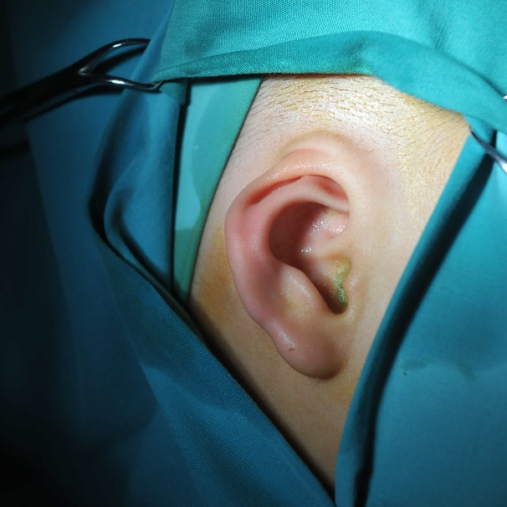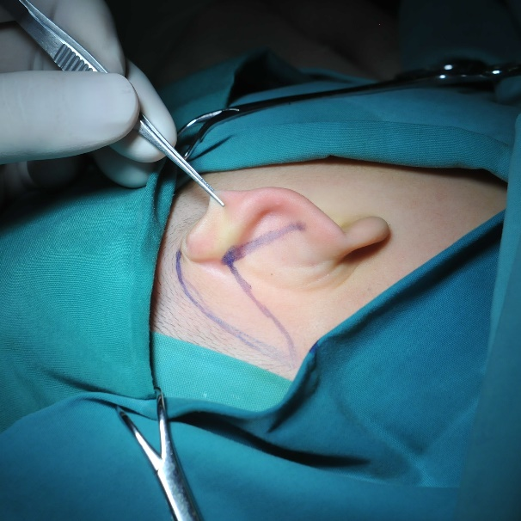
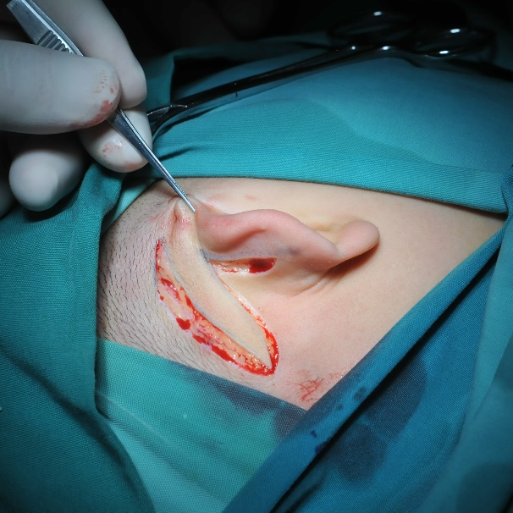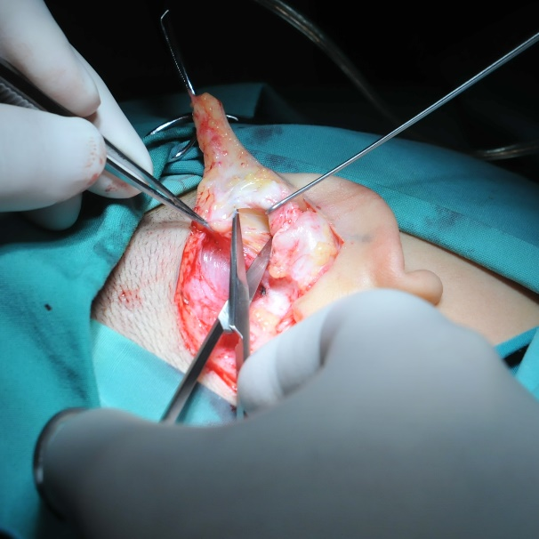
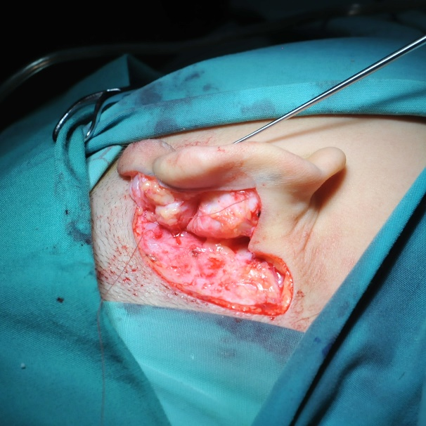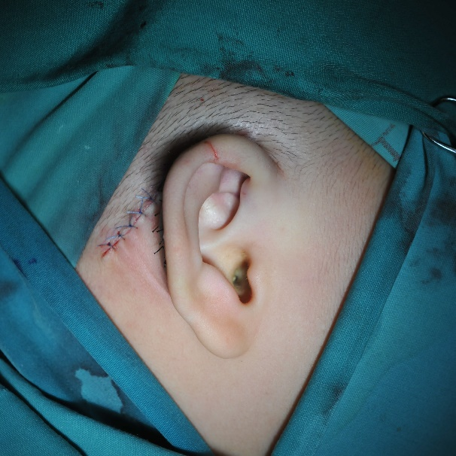
Supplementary figure S1. Intraoperative photographs of a 2-year-old male patient with right cryptotia. (a) The preoperative photograph of the affected ear. (b) A Z-shaped incision designed along the retroauricular edge of hairline, auriculocephalic sulcus, to the dorsum of the superior crus of antihelix. (c) Incised retroauricular skin. (d) Release of abnormal fibrous adhesions. (e) Fixation of the auricular cartilage to the retroauricular facial flap. (f) Corrected auricle immediately after the surgery.

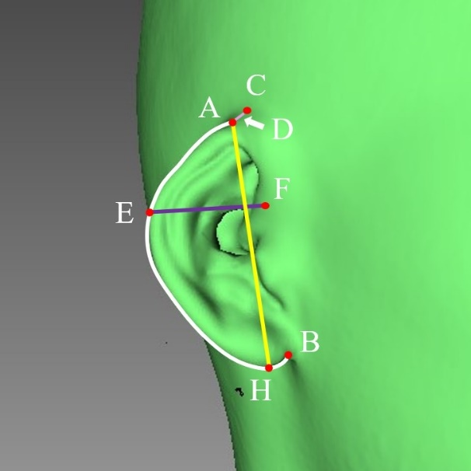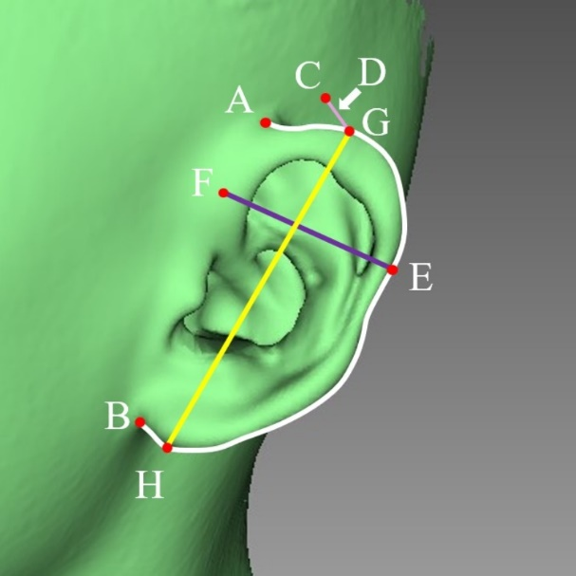
Supplementary figure S2. The reconstructed scanning image of auricles with measuring points and measuring indicators. White line: perimeter of the ear. Purple line: width of the ear. Yellow line: length of the ear. Pink line: the vertical distance from the highest point of the helix to the skull (D).

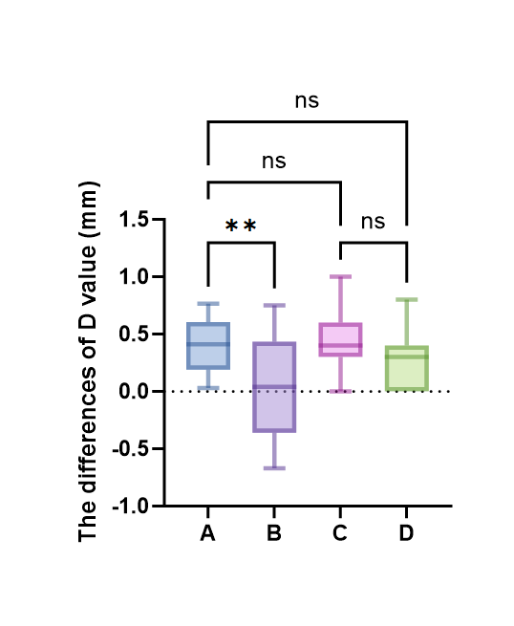
Supplementary figure S3. The comparison of the differences of D value between groups and subgroups. The x axis: A, subgroup A of the experimental group. B, subgroup A of the control group. C, subgroup B of the experimental group. D, subgroup B of the control group.

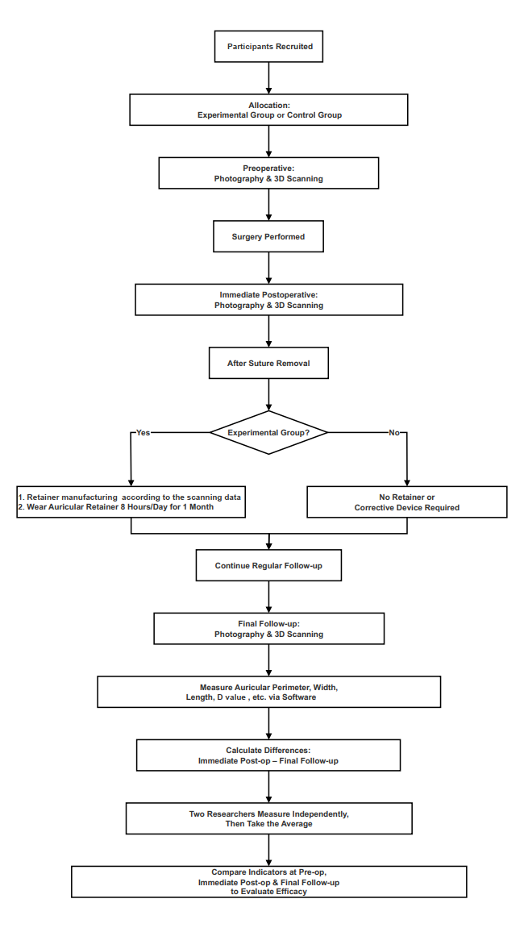
Supplementary figure S4. A flow chart of the study procedures and personalized 3D retainer utilization.

