Supporting Information: Photoluminescence Enhancement in Two-Dimensional Semiconductors via Spacer-Free Metallic Screening
Hafiz Muhammad Shakir^{1*}, Abdulsalam Aji Suleiman^{2*}, Kübra Nur Kalkan², Doruk Pehlivanoğlu¹, Amir Parsi², Uğur Başçı¹, Mehmet Atıf Durmuş², Ahmet Osman Ölçer², Hilal Korkut², Cem Sevik^{3,4}, İbrahim Sarpkaya², Talip Serkan Kasırga²⁺
¹ Department of Physics, Bilkent University, Ankara 06800 Turkey
² Bilkent University UNAM – Institute of Materials Science and Nanotechnology, Ankara, 06800 Turkey
³ Department of Physics and NANOLab Center of Excellence, University of Antwerp, Groenenborgerlaan 171, B-2020 Antwerp, Belgium
⁴ Department of Mechanical Engineering, Faculty of Engineering, Eskişehir Techical University, Eskişehir 26555 Turkey
* Equal contribution
⁺ Corresponding email: kasirga@unam.bilkent.edu.tr
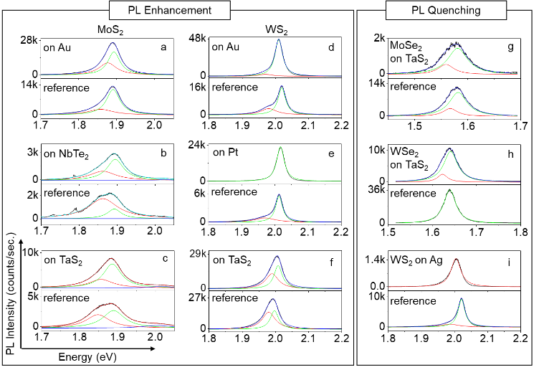
- Photoluminescence enhancement and quenching in various metal-semiconductor junctions
Figure S1 The left panel shows a collection of PL spectra with enhancement (or no quenching) and the right panel shows a collection of PL spectra with quenching for various TMDC-metal heterojunctions. a. MoS₂/Au, b. MoS₂/NbTe₂, c. MoS₂/TaS₂, d. WS₂/Au, e. WS₂/Pt, f. WS₂/TaS₂, g. MoSe₂/TaS₂, h. WSe₂/TaS₂, i. WS₂/Ag. For bulk metals, reference PL spectra are collected from the TMDC on PDMS stamp. The red, green, and blue lines are Lorentzian fits corresponding to $A^{*}$, $A^{0}$, and $B$, respectively. The sum of the fits is represented by cyan line.
- Optical enhancement factor calculations
In the case for photoluminescence spectrum intensity measurements of heterostructures, optical interference effects must be taken into account to truly understand PL phenomenon[1]. This is because the incident laser beam passing through a material is reflected multiple times inside each layer of the heterostructure. These multiple internal reflections at each interface between layers with different refractive indices affect the PL intensity of the material[1,2].
Our sample is made of WS₂ (0.78nm) onto hBN/Au heterostructure with 40nm and 90nm thicknesses, respectively. To estimate PL response of our sample due to optical interference effects, we calculated an enhancement factor by taking the ratio of emission intensities for monolayer WS₂ on-substrate and freestanding WS₂[3].
  - Freestanding WS₂

d
Air

WS₂

Air

Figure S2 Freestanding WS₂ with thickness d.
  - Absorption Coefficient Freestanding WS₂ (λ = 532 nm):

x
0 (Air)

1 (WS₂)

2 (Air)

Figure S3 Absroption of laser beam at a depth x in suspended WS₂.

Refractive index of WS₂ (medium-1) at λ=532 nm is $n_{a}\left({WS}_{2}\right)≡n_{1}=4-0.9i[2]$. As the beam of light passes through any medium, there occurs a geometric phase difference $β_{i}= \frac{2πn_{i}d_{i}}{λ}$
$$β_{1}= \frac{2πn_{1}d_{1}}{λ} and β_{x}= \frac{2πn_{1}x}{λ}$$
where β₁ and β_{x} are geometric phases for medium-1 with thickness d₁ and x. Fresnel reflection and transmission coefficients are written to describe reflection and transmission of beam of light travelling from medium-i to medium-j; $r_{ij}=\frac{n_{i}-n_{j}}{n_{i}+n_{j}} ,t_{ij}=\frac{2n_{i}}{n_{i}+n_{j}}[3,4]$
 | $$\begin{matrix}t_{01}=\frac{2n_{0}}{n_{0}+n_{1}}, & r_{01}=\frac{n_{0}-n_{1}}{n_{0}+n_{1}}, & r_{12}=\frac{n_{1}-n_{2}}{n_{1}+n_{2}}\end{matrix} where n_{0}=n_{2}=1 (Air)$$ | 1
where t₀₁ is the transmission coefficient for the beam from medium-0(Air) to medium-1 (WS₂), r₀₁ and r₁₂ are reflection coefficients for the beam from medium-0(Air) to medium-1 (WS₂) and from medium-1 (WS₂) to medium-2 (Air), respectively.
To calculate the absorption coefficient at depth x, we consider each line passing through the point at d=x, and we make summation to find the total absorption at depth x [1,5]:

$$\begin{matrix}a_{1}=e^{-iβ_{x}}t_{01} \\ a_{2}=e^{-iβ_{1}}t_{01}e^{-i\left(β_{1}-β_{x}\right)}r_{12}=t_{01}r_{12}e^{-i\left({2β}_{1}-β_{x}\right)}\end{matrix} \\ \begin{matrix}a_{3}=e^{-iβ_{1}}t_{01}e^{-iβ_{1}}r_{12}e^{-iβ_{x}}r_{10}=a_{1}\left(r_{12}r_{10}e^{-2iβ_{1}}\right) \\ a_{4}=e^{-iβ_{1}}t_{01}e^{-iβ_{1}}r_{12}e^{-iβ_{1}}r_{10}e^{-i\left(β_{1}-β_{x}\right)}r_{12}=a_{2}\left(r_{12}r_{10}e^{-2iβ_{1}}\right) \end{matrix} \\ ⋮$$
In general,
 | $$a_{2n+1}=a_{1}{\left(r_{12}r_{10}e^{-2iβ_{1}}\right)}^{n},$$ | 2
 | $$a_{2n+2}=a_{2}{\left(r_{12}r_{10}e^{-2iβ_{1}}\right)}^{n}.$$ | 3

The total amount of absorption at x can be expressed as a summation of all coefficients defined at d=x
 | $$F_{abs}=\sum_{n≥0}{[}e^{-iβ_{x}}t_{01}+e^{-i\left({2β}_{1}-β_{x}\right)}t_{01}r_{12}]{\left(r_{12}r_{10}e^{-2iβ_{1}}\right)}^{n}$$ | 4
The second part of the right-hand side in Eqn(4) is written in terms of geometric sum
 | $$F_{abs}=t_{01}\frac{e^{-iβ_{x}}+r_{12}e^{-i(2β_{1}-β_{x})}}{1-r_{10}r_{12}e^{-2iβ_{1}}} .$$ | 5

Recalling Stoke’s relations between Fresnel reflection and transmission coefficients [4] $(r_{ij}=-r_{ji}$ and $1=t_{ij}t_{ji}-r_{ij}r_{ji})$
 | $$F_{abs}=t_{01}\frac{e^{-iβ_{x}}+r_{12}e^{-i(2β_{1}-β_{x})}}{1+r_{01}r_{12}e^{-2iβ_{1}}}.$$ | 6

  - Scattering Coefficient Freestanding WS₂ (λ’ = 615 nm):
Figure S4 Scattering of laser beam at a depth x in suspended WS₂.
x
0 (Air)

1 (WS₂)

2 (Air)

Refractive index of WS₂ (medium-1) at λ’=615 nm is $n_{s}\left({WS}_{2}\right)≡n_{1}^{'}=4-1.8i$ [2]. The geometric phase differences at λ’=615 nm for medium-1 with thickness d₁ and x
$$β_{1}^{'}= \frac{2πn_{1}^{'}d_{1}}{λ^{'}} , β_{x}^{'}= \frac{2πn_{1}^{'}x}{λ^{'}} .$$
Corresponding Fresnel reflection and transmission coefficients can be written as
$$\begin{matrix}t_{10}=\frac{2n_{1}^{'}}{n_{1}^{'}+n_{0}}, & r_{10}^{'}=\frac{n_{1}^{'}-n_{0}}{n_{1}^{'}+n_{0}}, & r_{12}^{'}=\frac{n_{1}^{'}-n_{2}}{n_{1}^{'}+n_{2}}\end{matrix} where n_{0}=n_{2}=1 \left(Air\right).$$
Similar to the absorption coefficient calculation, we consider each point at depth x and we make summation for the total scattering coefficient at depth x.
$$\begin{matrix}b_{1}= e^{-iβ_{x}^{'}}t_{10} \\ b_{2}=e^{-iβ_{1}^{'}}t_{10}e^{-i\left(β_{1}^{'}-β_{x}^{'}\right)}r_{12}^{'}\end{matrix} \\ \begin{matrix}b_{3}=e^{-iβ_{1}^{'}}t_{10}e^{-iβ_{1}^{'}}r_{12}^{'}e^{-iβ_{x}^{'}}r_{10}^{'}=b_{1}\left(r_{12}^{'}r_{10}^{'}e^{-i{2β}_{1}^{'}}\right) \\ b_{4}=e^{-iβ_{1}^{'}}t_{10}{e^{-iβ_{1}^{'}}r}_{12}^{'}e^{-iβ_{1}^{'}}r_{10}^{'}e^{-i\left(β_{1}^{'}-β_{x}^{'}\right)}r_{12}^{'}=b_{2}\left(r_{12}^{'}r_{10}^{'}e^{-i{2β}_{1}^{'}}\right)\end{matrix} \\ ⋮$$
 | $$b_{2n+1}=b_{1}{\left(r_{12}^{'}r_{10}^{'}e^{-i{2β}_{1}^{'}}\right)}^{n}$$ | 7
 | $$b_{2n+2}=b_{2}{\left(r_{12}^{'}r_{10}^{'}e^{-i{2β}_{1}^{'}}\right)}^{n}$$ | 8

By summing over scattering coefficients at depth x, the total amount of scattering coefficient becomes
 | $$F_{sc}=\sum_{n≥0}{[t_{10}e^{-iβ_{x}^{'}}}+t_{10}r_{12}^{'}e^{-i\left({2β}_{1}^{'}-β_{x}^{'}\right)}]{\left(r_{12}^{'}r_{10}^{'}e^{-i{2β}_{1}^{'}}\right)}^{n}$$ | 9
 | $$⟹ F_{sc}= t_{10}\frac{e^{-iβ_{x}^{'}}+r_{12}^{'}e^{-i\left({2β}_{1}^{'}-β_{x}^{'}\right)}}{1+r_{10}^{'}r_{12}^{'}e^{-i{2β}_{1}^{'}}}$$ | 10

The last step for freestanding WS₂ is to calculate its intensity using both total absorption and scattering coefficients [1]
 | $$I_{WS_{2}}^{susp}=\int_{0}^{d_{1}}{{\left|F_{abs}⋅F_{sc}\right|}^{2}dx}$$ | 11

  - On-substrate WS₂

Figure S5 Schematic diagram of the beam of light passing through WS₂ on-substrate hBN/Au.
d₂

d₁

_{d}
Air

WS₂

hBN

Au

d₃

_{d}
1 +
2 + …
= r_{eff}
In the case of WS₂ on-substrate (Figure S5), considering bottom layers of WS₂ as effective medium the effective Fresnel reflection coefficient is derived to define multiple reflections for absorption and scattering coefficients at depth x in medium-1[1]. For this reason, each term is written in terms of corresponding reflection and transmission coefficients including geometric phase differences
 | $$c_{1}=r_{12}$$ | 12
 | $$c_{2}=t_{12}e^{-iβ_{2}}r_{23}e^{-iβ_{2}}t_{21}$$
 | $$c_{3}=t_{12}e^{-iβ_{2}}r_{23}e^{-iβ_{2}}r_{21}e^{-iβ_{2}}r_{23}e^{-iβ_{2}}t_{21}=t_{12}t_{21}r_{23}e^{-2iβ_{2}}(r_{21}r_{23}e^{-2iβ_{2}})$$
 | $$⋮$$
 | $c_{n}=c_{2}{(r_{21}r_{23}e^{-2iβ_{2}})}^{n-2}$. | 13
Then the effective Fresnel reflection is written in terms of effective coefficients stated above
 | $$r= r_{12}+t_{12}t_{21}r_{23}e^{-2iβ_{2}}\sum_{n≥3}{{(r_{21}r_{23}e^{-2iβ_{2}})}^{n-2}}$$ | 14
Recalling geometric sum formulation, Equation 14 becomes
 | $$r=r_{12}+\frac{t_{12}t_{21}r_{23}e^{-2iβ_{2}}}{1-r_{21}r_{23}e^{-2iβ_{2}}} .$$ | 15
Similarly, considering reflection and transmission coefficients’ relation (Stoke’s relations) ($r_{ij}=-r_{ji}$and $t_{ij}t_{ji}=1-r_{ij}^{2}$) [3,4],
 | $$r=\frac{r_{12}+r_{23}e^{-2iβ_{2}}}{1+r_{12}r_{23}e^{-2iβ_{2}}}$$ | 16
where β₂ is geometric phase difference related to medium-2.
  - Absorption Coefficient WS₂-on-substrate (λ = 532 nm):
0 (Air)

1(WS₂ )

x

_{d}
Figure S6 Schematic diagram of light beam passing through a sample with WS₂ (medium-1), hBN (medium-2) and Au (medium-3). Dots on the dashed line represent the points of absorption at depth x.
Refractive indices of WS₂, hBN and Au at λ=532 nm and corresponding geometric phase differences for medium-1 and medium-2 are expressed as
$$n\left({WS}_{2}\right)|_{abs}≡n_{1}=4-0.9i, n\left(hBN\right)|_{abs}≡n_{2}=1.85, n\left(Au\right)|_{abs}≡n_{3}= 0.55-i2.2,$$
$$β_{1}= \frac{2πn_{1}d_{1}}{λ} , β_{x}= \frac{2πn_{1}x}{λ}, β_{2}= \frac{2πn_{2}d_{2}}{λ} .$$
As we will define the effective Fresnel reflection coefficient for both absorption and scattering cases, we start with the effective reflection for absorption (λ=532nm) ($r→r^{'})$
 | $$r^{'}=\frac{r_{12}^{abs}+r_{23}^{abs}e^{-2iβ_{2}}}{1+r_{12}^{abs}r_{23}^{abs}e^{-2iβ_{2}}}$$ | 17
where $r_{12}^{abs}=\frac{n_{1}-n_{2}}{n_{1}+n_{2}}$ and $r_{23}^{abs}=\frac{n_{2}-n_{3}}{n_{2}+n_{3}}$.
Similar to the freestanding case, we take into account each line passing through the point at $d=x$in order to find total absorption coefficient
$$\begin{matrix}a_{1}^{on-subs}=e^{-iβ_{x}}t_{01} \\ a_{2}^{on-subs}=e^{-iβ_{1}}t_{01}e^{-i\left(β_{1}-β_{x}\right)}r^{'} \\ \begin{matrix}a_{3}^{on-subs}=e^{-iβ_{1}}t_{01}e^{-iβ_{1}}r^{'}e^{-iβ_{x}}r_{10}=a_{1}^{on-subs}\left(r^{'}r_{10}e^{-2iβ_{1}}\right) \\ a_{4}^{on-subs}=e^{-iβ_{1}}t_{01}e^{-iβ_{1}}r^{'}e^{-iβ_{1}}r_{10}e^{-i\left(β_{1}-β_{x}\right)}=a_{2}^{on-subs}\left(r^{'}r_{10}e^{-2iβ_{1}}\right)\end{matrix}\end{matrix} \\ \begin{matrix}⋮ \\ ⇒\end{matrix}$$
 | $$a_{2n+1}^{on-subs}=a_{1}^{on-subs}{(r^{'}r_{10}e^{-2iβ_{1}})}^{n}$$ | 18
 | $$a_{2n+2}^{on-subs}=a_{2}^{on-subs}{(r^{'}r_{10}e^{-2iβ_{1}})}^{n}$$ | 19
It is important to note that t₀₁, r₁₀, β₁ and β_{x} are the same as the case for freestanding WS₂.
For on-substrate WS₂, the total amount of absorption
 | $$F_{abs}^{on-subs}=\sum_{n≥0}{[t_{01}e^{-iβ_{x}}+t_{01}r'}e^{-i(2β_{1}-β_{x})}]{(r^{'}r_{10}e^{-2iβ_{1}})}^{n}$$ | 20
 | $$F_{abs}^{on-subs}=t_{01}\frac{{e^{-iβ_{x}}+r'e}^{-i(2β_{1}-β_{x})}}{1+r^{'}r_{10}e^{-2iβ_{1}}}$$ | 21

  - Scattering Coefficient WS₂-on-substrate (λ’ = 615 nm):
Refractive indices of WS₂, hBN and Au at λ’=615 nm and corresponding geometric phase differences for medium-1 and medium-2 are written as
$n\left({WS}_{2}\right)|_{sc}≡n_{1}^{'}=4-1.8i, n\left(hBN\right)|_{sc}≡n_{2}=1.85, n\left(Au\right)|_{abs}≡n_{3}^{'}=0.23-i3.1,$ [2]
$$β_{1}^{'}= \frac{2πn_{1}^{'}d_{1}}{λ^{'}} , β_{x}^{'}= \frac{2πn_{1}^{'}x}{λ^{'}}, β_{2}^{'}= \frac{2πn_{2}d_{2}}{λ^{'}} .$$
The effective Fresnel reflection for scattering $r^{''}$ $(r→r^{''})[1]$
 | $$r^{''}=\frac{r_{12}^{sc}+r_{23}^{sc}e^{-2iβ_{2}^{'}}}{1+r_{12}^{sc}r_{23}^{sc}e^{-2iβ_{2}^{'}}}$$ | 22
where $r_{12}^{sc}=\frac{n_{1}^{'}-n_{2}}{n_{1}^{'}+n_{2}}$ and $r_{23}^{sc}=\frac{n_{2}-n_{3}^{'}}{n_{2}+n_{3}^{'}}$.
Figure S7 Scattering of laser beam at a depth x in WS₂ on hBN/Au substrate. hBN/Au substrate is considered as the effective medium.
0 (Air)

1(WS₂)

x
Total amount of scattering at depth x:
$$\begin{matrix}b_{1}^{on-subs}=e^{-iβ_{x}^{'}}t_{10} \\ b_{2}^{on-subs}=e^{-i\left(β_{1}^{'}-β_{x}^{'}\right)}r''e^{-iβ_{1}^{'}}t_{10} \\ \begin{matrix}b_{3}^{on-subs}=e^{-iβ_{1}^{'}}t_{10}e^{-iβ_{1}^{'}}r^{''}e^{-iβ_{x}^{'}}r_{10}^{'}=b_{1}^{on-subs}\left(r^{''}r_{10}^{'}e^{-2iβ_{1}^{'}}\right) \\ b_{4}^{on-subs}=e^{-iβ_{1}^{'}}t_{10}e^{-iβ_{1}^{'}}r^{''}e^{-iβ_{1}^{'}}r_{10}^{'}e^{-i\left(β_{1}^{'}-β_{x}^{'}\right)}r''=b_{2}^{on-subs}\left(r^{''}r_{10}^{'}e^{-2iβ_{1}^{'}}\right)\end{matrix}\end{matrix} \\ \begin{matrix}⋮ \\ ⇒\end{matrix}$$
 | $$b_{2n+1}^{on-subs}=b_{1}^{on-subs}{(r^{''}r_{10}^{'}e^{-2iβ_{1}^{'}})}^{n}$$ | 23
 | $$b_{2n+2}^{on-subs}=b_{2}^{on-subs}{(r^{''}r_{10}^{'}e^{-2iβ_{1}^{'}})}^{n}$$ | 24
where t₁₀, r’₁₀, β’₁ and β’_{x} are the same as the case for freestanding WS₂.
For on-substrate WS₂, the total amount of scattering becomes
 | $$F_{sc}^{on-subs}=\sum_{n≥0}{[t_{10}e^{-iβ_{x}^{'}}}+t_{10}r^{''}e^{-i\left({2β}_{1}^{'}-β_{x}^{'}\right)}]{(r^{''}r_{10}^{'}e^{-2iβ_{1}^{'}})}^{n}$$ | 25
 | $F_{sc}^{on-subs}=t_{10}\frac{e^{-iβ_{x}^{'}}+r''e^{-i\left({2β}_{1}^{'}-β_{x}^{'}\right)}}{1+r^{''}r_{10}^{'}e^{-2iβ_{1}^{'}}} where r_{01}^{'}={-r}_{10}^{'}$. | 26
Similar to Equation 11, the intensity of WS₂ on-substrate is
 | $$I_{WS_{2}}^{on-subs}=\int_{0}^{d_{1}}{{\left|F_{abs}^{on-subs}⋅F_{sc}^{on-subs}\right|}^{2}dx}.$$ | 27

The last step is to define the enhancement factor by taking a ratio of Equation 27 and Equation 11 [2,5]
 | $$Γ=\frac{I_{WS_{2}}^{on-subs}}{I_{WS_{2}}^{susp}} .$$ | 28

With the help of the enhancement factor expression stated above, we calculated the enhancement factor (Γ) for hBN thickness $d_{2}=40nm$:
$$Γ|_{d_{2}=40nm}=\frac{I_{WS_{2}}^{on-subs}}{I_{WS_{2}}^{susp}}=7.32427392.$$
Also, we calculated the enhancement factor as a function of the hBN thickness in nm $\left(1≤ d_{2}≤55\right)$:
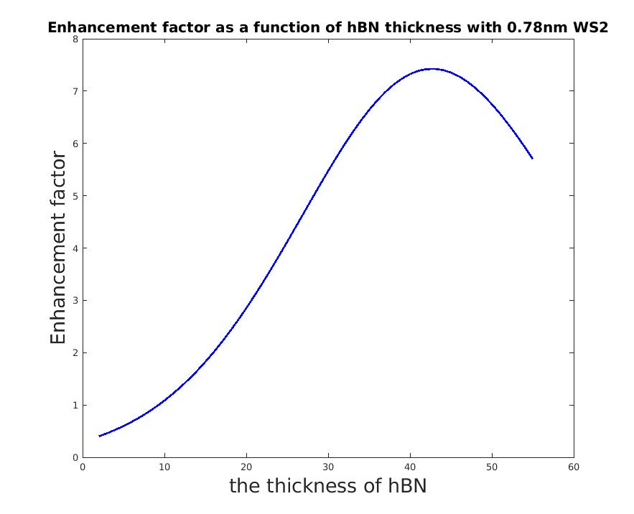
Figure S8 Enhancement Factor as a function of hBN thickness[6].
- Gate dependent PL experiments
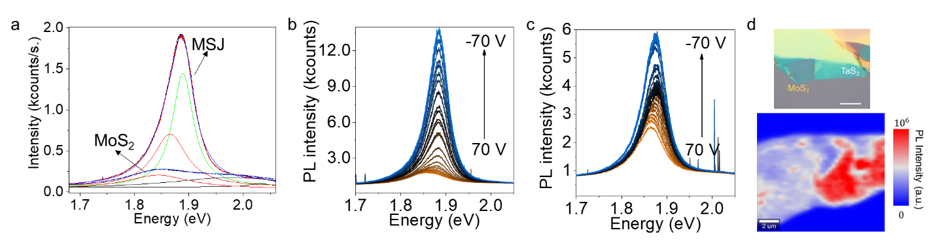
Figure S9. Gate dependent PL measurements. a. Gate dependent PL at 150 and 200 V for the sample presented in the main text. Fits to the PL spectra are also provided. b. PL spectra from 70 to -70 V gate voltage for bare MoS₂ and c. for TaS₂/MoS₂ on SiO₂/Si substrate. d. The optical microscope image and the PL intensity map is provided. The scale bar for the optical upper panel is 10 µm.

- AFM Height Trace of Bilayer WS₂ Before and After Thermal Annealing
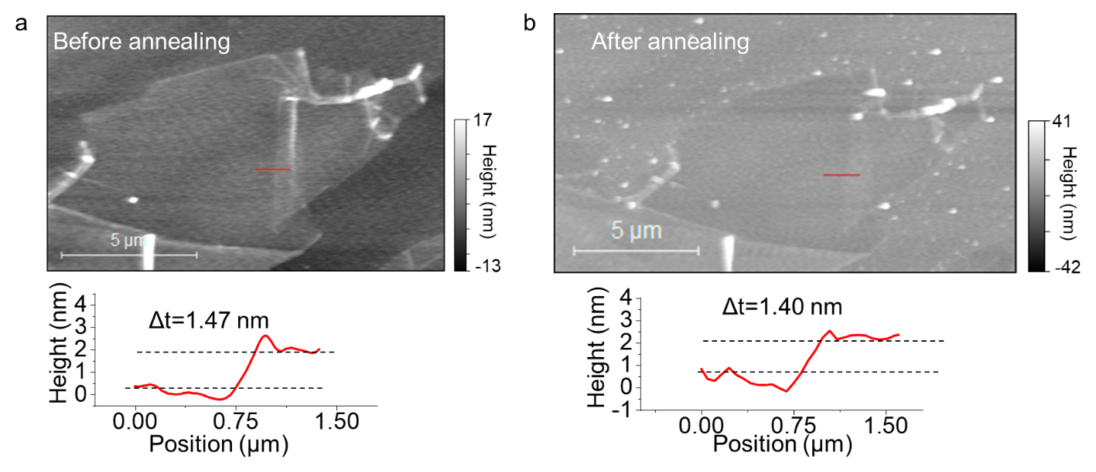
Figure S10 | AFM Height Trace of Folded Part of monolayer WS₂. a. AFM height trace from the folded part of the monolayer crystal shows 1.47 nm thickness over the monolayer and b. after annealing, the height trace from the bilayer region shows minimal change while the monolayer part height decreases by 0.50 nm.
- XPS Measurements
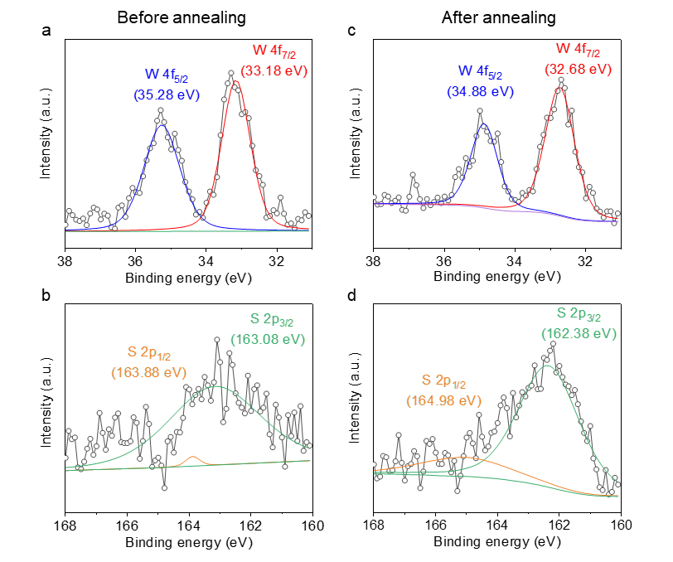
Figure S11 Effect of annealing on the MSJ. The XPS spectra of WS₂ multilayer a. W4f and b. S2p survey before annealing and c. W4f and d. S2p survey after annealing. The W peaks shift by 0.4 eV due to the charge transfer across the metal and the WS₂.
- Temperature Dependent PL Measurements
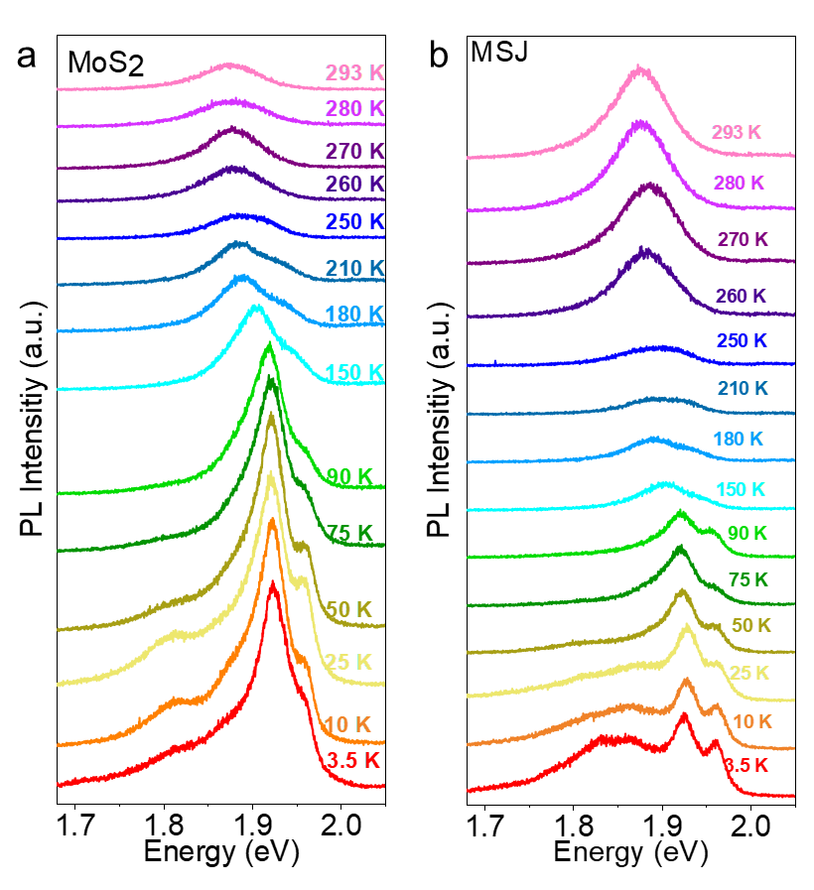
Figure S12 | Temperature Dependent PL Spectra. a. Temperature-dependent PL spectra for monolayer MoS₂ and b. MoS₂/TaS₂ heterostructure. Below 250 K, enhancement disappears. As discussed in the main text, this can be attributed to the decrease in the van der Waals gap height as a result of the shrinkage of the hydrocarbon and water molecules between the layers. The PL spectra is shifted for viewing convenience. All spectra have the same absolute scale.
- DFT Results
Before conducting the multi-layer investigation, we initially computed the electronic properties of the single-layer MoS₂, as illustrated in Figure S13a. As anticipated, the GW correction significantly affects the electronic energies, owing to the robust effective dielectric screening that alters the functional nature of the Coulomb interaction. The calculated band-gap value of 2.571 eV at the high-symmetry K point for this direct band-gap monolayer aligns well with prior calculations[7]. Additionally, the calculated quasiparticle peak energies, 1.96 and 2.10 eV are consistent with previous investigations[8] and the values obtained in our measurements.
Due to the substantial mismatch between the equilibrium in-plane lattice constants of TaS₂ and MoS₂, we initially examine the hetero-bilayer MoS₂-TaS₂ structure with MoS₂'s in-plane lattice parameters, while allowing all ions to relax along out-of-plane directions. In this context, we assume that our approach to synthesizing this hetero-bilayer structure without annealing does not create significant strain on the MoS₂ layer. Within the hetero-bilayer arrangement, the higher-lying valence states of the MoS₂ layer are located approximately 400 meV below the Fermi level, potentially enhancing exciton intensity, see Figure S13b. Surprisingly, the direct GW band gap corresponding to the MoS₂ layer reduces to 1.965 eV. Given this observation, one might anticipate a significant redshift in the direct exciton energy, yet we predict only minor meV redshifts in photoluminescence (PL) measurements. Generally, we would expect a noticeable alteration in the semiconductor layer due to the metallic screening around the Fermi level induced by the metallic substrate, whereas the observed reduction is significant. This prompt questioning the validity of the plasmon-pole approximation employed in our GW calculations. While this method typically performs well for semiconductors, its application to this hybrid structure (metal/semiconductor) may underestimate the band gap of the MoS₂ layer. Alternatively, the van der Waals distance between the MoS₂ and TaS₂ after direct transfer, without annealing, may be considerably greater than theoretical predictions.
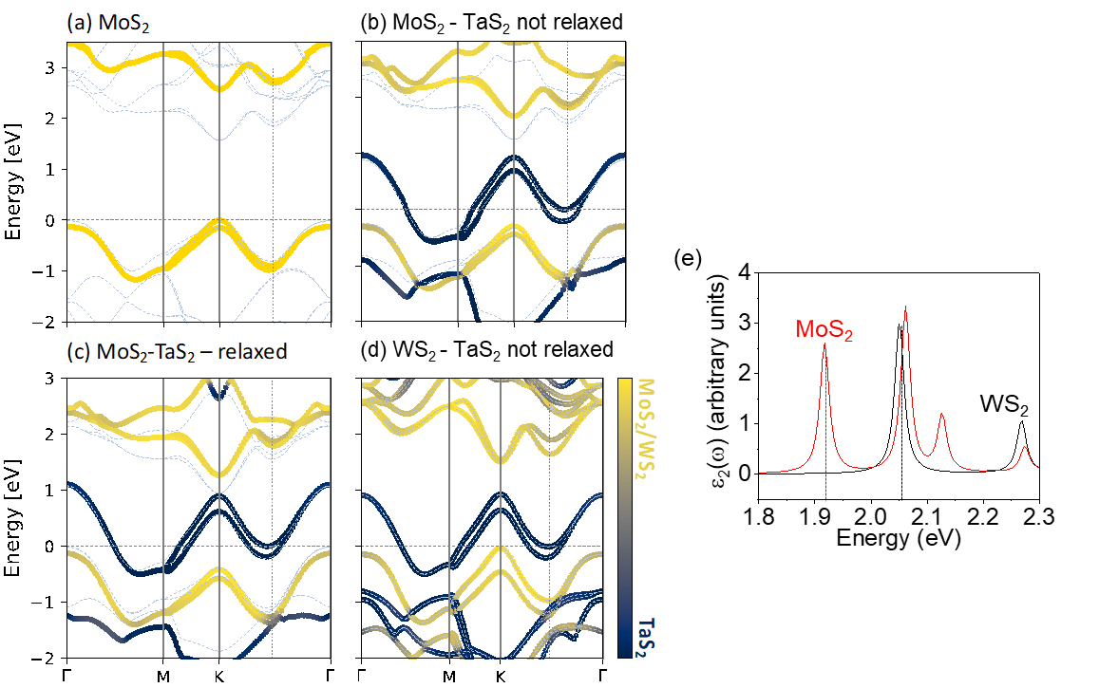
Figure S13 | ab initio calculations. The calculated band structures of (a) single layer MoS₂, (b) MoS₂-TaS₂ heterobilayer with single layer MoS₂ in-plane lattice constant, (c) MoS₂-TaS₂ heterobilayer with PBE relaxed lattice constants, and (d) WS₂-TaS₂ heterobilayer with single layer WS₂ in-plane lattice constant. The color bar represents the layer contributions to the corresponding electronic state. For MoS₂ structures, the dashed linesa and symbols represent the G₀W₀ and PBE calculations. For WS₂, only PBE results are presented. (e) The optical emission spectra for MoS₂ and WS₂ are given by the imaginary part of the excitonic macroscopic dielectric function $ϵ_{2}$. Direct transition energy for excitons are 1.917 and 2.049 eV for MoS₂ and WS₂, respectively.
- Photoluminescence Quantum Yield Measurements
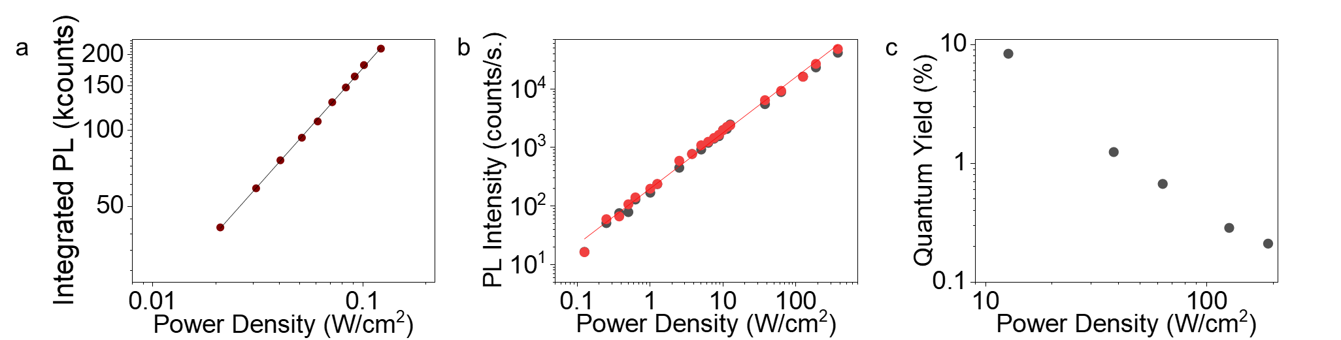
Figure S14 | Quantum yield measurements. a. Integrated PL counts vs. power density are given for R6G-embedded PMMA film on a glass substrate. PL spectra are collected using an integrating sphere. The laser beam is focused on a mm² sized Gaussian spot. As a result, lower power densities are achieved than the tightly focused beam. b. PL intensity vs. power density measurements collected from a WS₂ monolayer on Au substrate. Red and grey dots represent PL intensity counts collected from different parts of the sample. c. Quantum yield calculations were performed for the sample provided in b using the calibration data from the R6G crystals and the calibration data. All PL spectra is collected with 532 nm excitation laser.

- References
[1] Buscema M, Steele G A, van der Zant H S J and Castellanos-Gomez A 2014 The effect of the substrate on the Raman and photoluminescence emission of single-layer MoS2 Nano Res 7 561–71
[2] Lee Y, Forte J D S, Chaves A, Kumar A, Tran T T, Kim Y, Roy S, Taniguchi T, Watanabe K, Chernikov A, Jang J I, Low T and Kim J 2021 Boosting quantum yields in two-dimensional semiconductors via proximal metal plates Nat Commun 12
[3] Born M and Wolf E 1980 Principles of optics: Electromagnetic theory of propagation, interference and diffraction of light (Elsevier Science Limited)
[4] Pedrotti F L, Pedrotti L S and Pedrotti L M 2007 Introduction to Optics (Cambridge University Press)
[5] Yoon D, Moon H, Son Y-W, Choi J S, Ho Park B, Cha Y H, Kim Y D and Cheong H Interference effect on Raman spectrum of graphene on SiO 2 /Si
[6] The MathWorks Inc. 2021 MATLAB R2021b
[7] Guandalini, A., D’Amico, P., Ferretti, A. & Varsano, D. Efficient GW calculations in two dimensional materials through a stochastic integration of the screened potential. npj Comput. Mater. 9, 44 (2023).
[8] Chernikov, A. et al. Exciton Binding Energy and Nonhydrogenic Rydberg Series in Monolayer WS₂ Phys. Rev. Lett. 113, 76802 (2014).

