Pyrrolnitrin biosynthesis from rhizospheric Serratia spp. with antifungal activity and binding interactions of PrnF with ligands

Shraddha Pawar and Ambalal Chaudhari*
School of Life Sciences, Kavayitri Bahinabai Chaudhari North Maharashtra University, Jalgaon 425001, India.

Author’s information
Shraddha Pawar
School of Life Sciences, Kavayitri Bahinabai Chaudhari North Maharashtra University, Jalgaon 425001, India.
E-mail: pawarshraddha1989@gmail.com ORCID: 0000-0002-5967-104X
*Corresponding author (✉)
Ambalal Chaudhari
School of Life Sciences, Kavayitri Bahinabai Chaudhari North Maharashtra University, Jalgaon 425001, India.
E-mail: ambchasls@gmail.com ORCID: 0000-0003-0533-1768
Address:
School of Life Sciences, Kavayitri Bahinabai Chaudhari North Maharashtra University, Jalgaon 425001, India. Tel: +91-257-2257421 Fax: +91-257-2258403.

Supplementary Information:
Fig. S1: a] 16S rRNA gene sequence with accession no. submitted to GenBank (a) M-11: Brevibacillus parabrevis KY800454 (b) M-2: Enterobacter spp. KY800455(c) TW-3: Serratia marcescens KY800456 (d) TO-2: Serratia nematodiphila KY800457(e) KMB: Stenotrophomonas rhizophila KY800458.
b] prnF gene NADPH dependent FMN reductase sequence with accession no. submitted to the GenBank (a) Serratia marcescens TW-3 (KY867430) (b) Serratia nematodiphila TO-2 (KY867431)
A]
(a)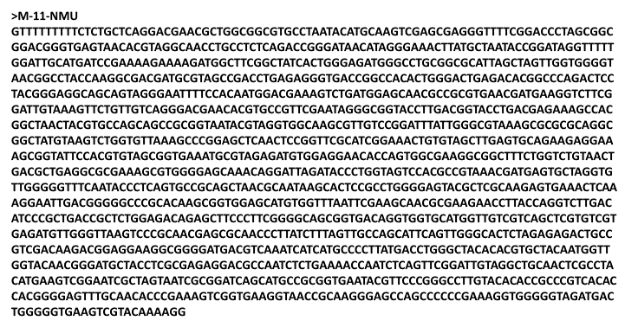
(b)
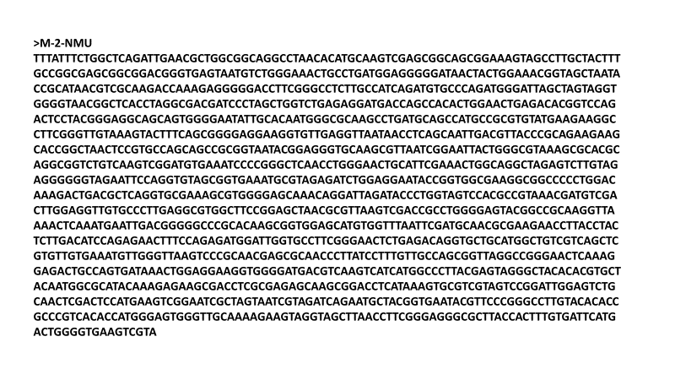
(c)
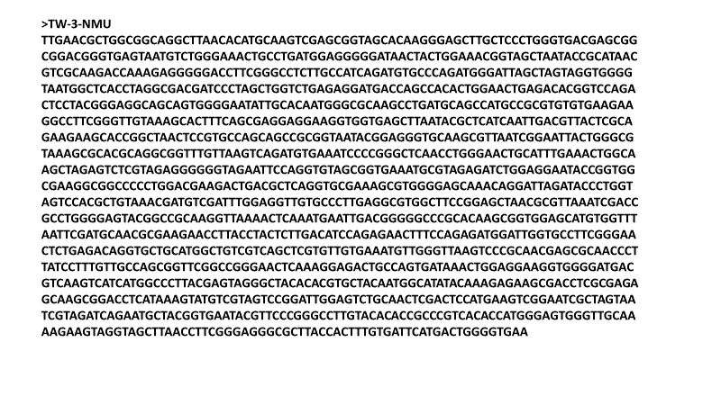
(d)
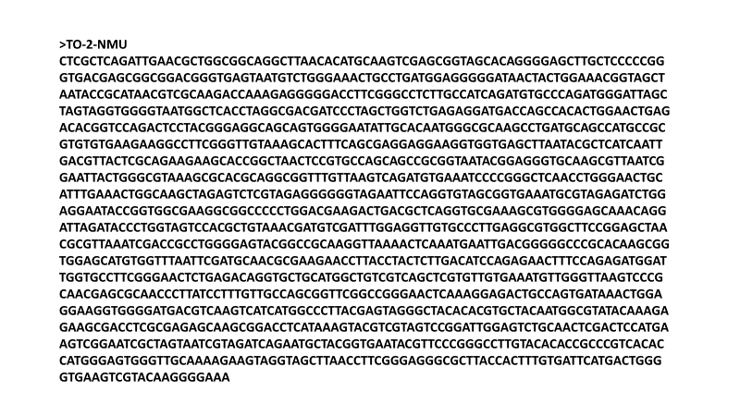
(e)
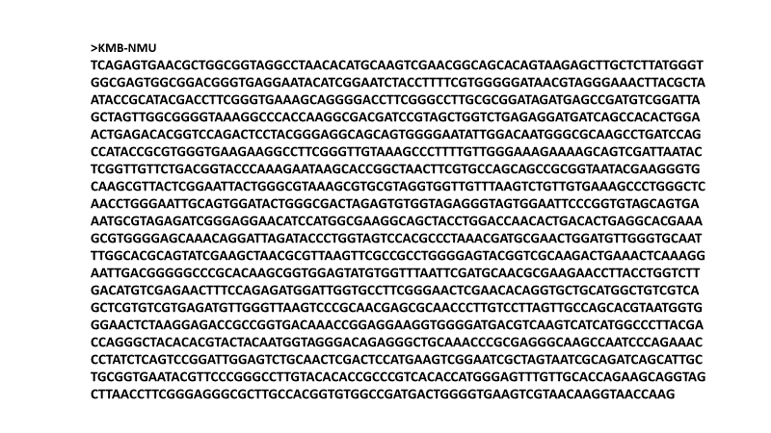
B]
(a)
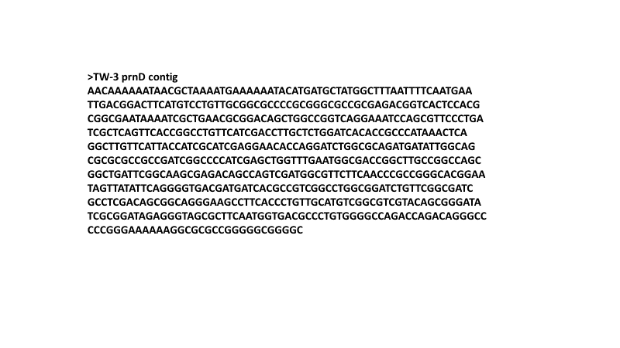
(b)
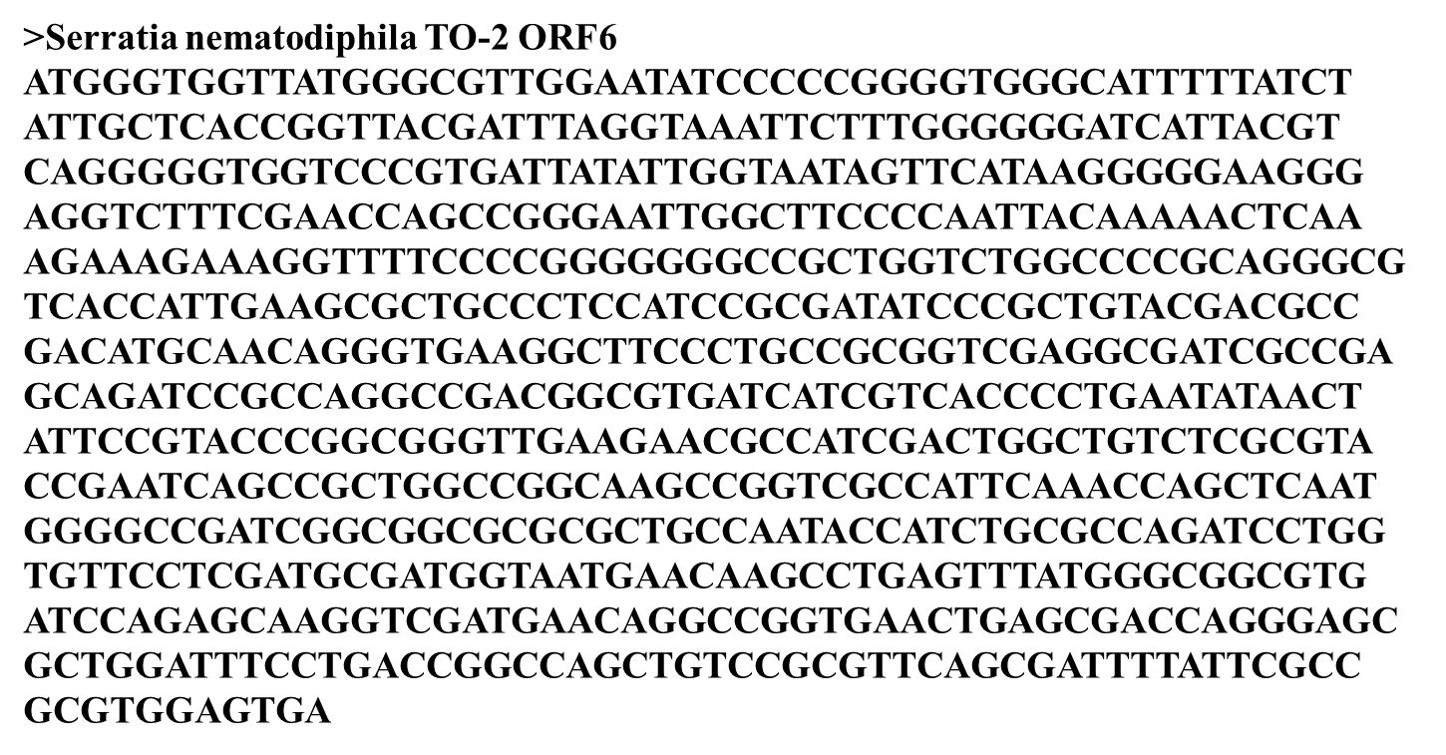

Fig. S2: PrnF structures using (a) Verify 3D score profile of the homology model of PRN proteins from rhizobacterial strains of S. marcescens TW-3, (b) (ProSA) calculates Z-score for groups of structures from different sources (X-ray, NMR) distinguished by different colour X-ray NMR in the plot ProSA-web z-scores of all protein chains in PDB determined by X-ray crystallography (light blue) or NMR spectroscopy (dark blue) with respect to their length to check whether the z-score of the input structure is within the range of scores typically found for native proteins of similar size. and z-scores of targeted protein sequences highlighted as big black dots.
a)
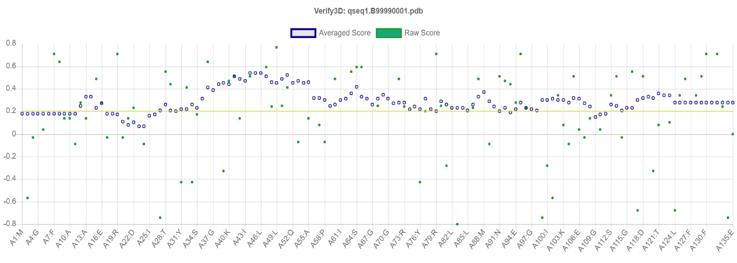
b)
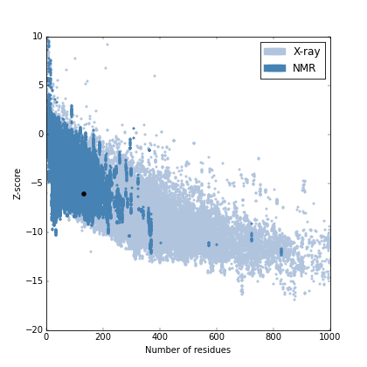
Z-score = - 6.07

Fig. S3: Binding of the ligand (FMN) to receptor (PrnF). (a) Binding site of the FMN to PrnF such that re face of that isoalloxazine ring is exposed to the solvent. (b) 2D structure of FMN to PrnF where hydrogen bonds indicated in green dashed lines with distance in Å. FMN molecule in the stick model where amino acid residues are in coloured circles. Violet coloured dashed lines represented Pi-Sigma while light pink colour dashed lined used for the alkyl bonds with distances (Å).
a)
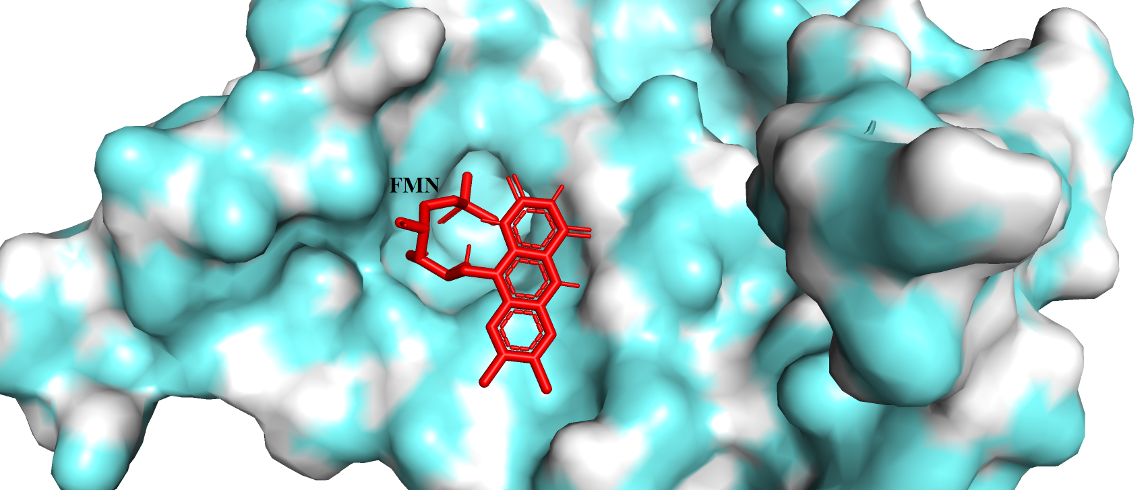
b)
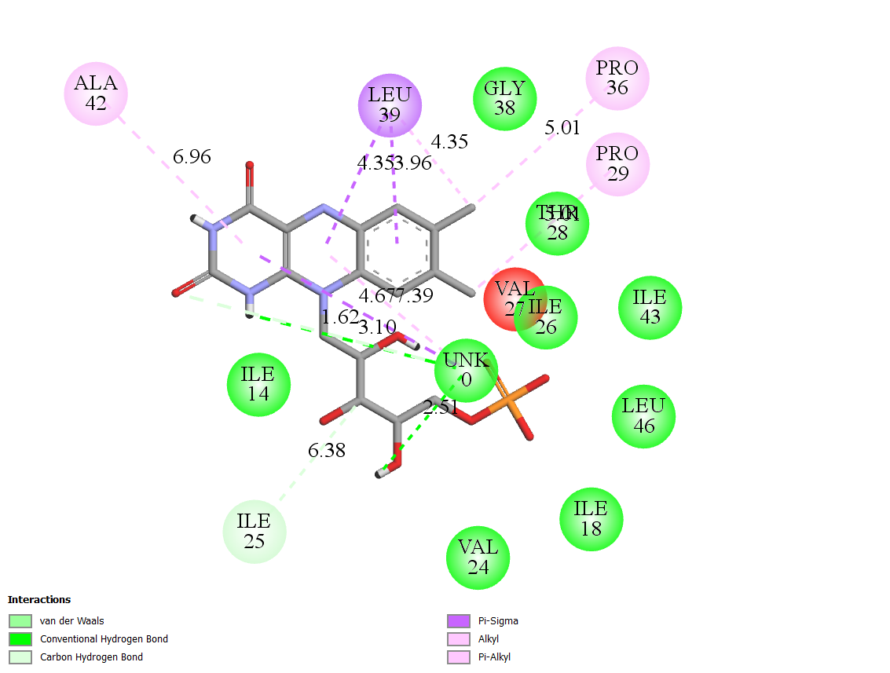

Fig. S4: 2D image of the NADPH to PrnF where hydrogen bonds indicated in green dashed lines with distance in Å. NADPH molecule in the stick model where amino acid residues are in coloured circles. Violet coloured dashed lines represented Pi-Sigma while light pink colour dashed lined used for the alkyl bonds with distances (Å).
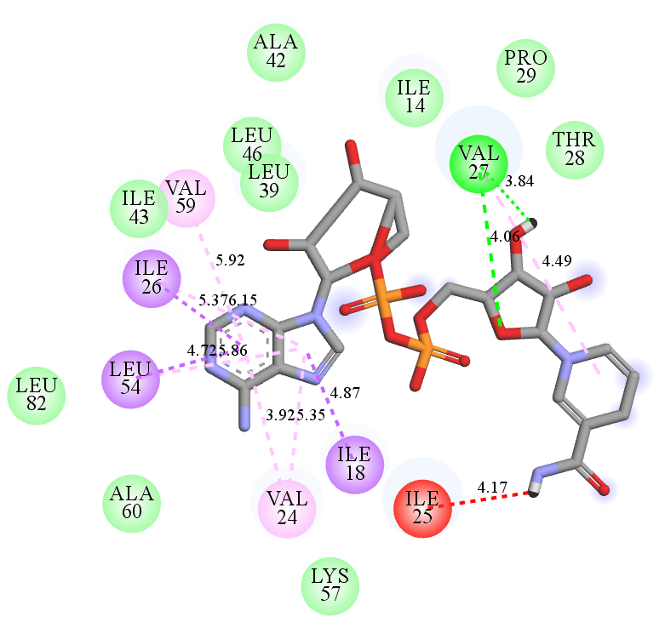
Table S1: Summary of 16S rRNA gene sequencing of five rhizospheric bacterial strains and prn gene sequencing of two bacteria
Isolate | Rhizosphere habitat | Nucleotide (bp) | Similarity  (% ) | Bacteria | NCBI Genbank accession number
16S rRNA sequences
TW-3 | Radish | 1465 | 99 | Serratia marcescens | KY800456
TO-2 | Radish | 1492 | 99 | Serratia nematodiphila | KY800457
M-2 | Rice | 1489 | 99 | Enterobacter spp. | KY800455
M-11 | Rice | 1501 | 99 | Brevibacillus parabrevis | KY800454
KMB | Rice | 1495 | 100 | Stenotrophomonas rhizophila | KY800458
prnF gene sequences
TW-3 | Radish | 408 |  | Serratia marcescens | KY867430
TO-2 | Radish | 489 |  | Serratia nematodiphila | KY867431

Table S2: (a) Pattern of utilization of carbohydrates and sugars with control to study biochemical profile of bacteria isolates KMB, M-2, M-11, TW-3 and TO-2 isolated from radish rhizosphere soil
S.N. | CARBOHYDRATE | RESULT
S.N. | CARBOHYDRATE | KMB | M-2 | M-11 | TW-3 | TO-2
1. | Lactose | + | + | - | - | +
2. | Xylose | + | + | - | + | +
3. | Maltose | + | + | + | + | +
4. | Fructose | + | - | - | + | -
5. | Dextrose | + | - | - | + | -
6. | Galactose | + | - | - | + | -
7. | Raffinose | + | + | - | - | -
8. | Trehalose | - | - | + | + | -
9. | Melibiose | - | - | - | + | -
10. | Sucrose | - | + | + | - | -
11. | L-arabinose | + | + | - | - | -
12. | Mannose | - | + | - | + | -
13. | Inulin | + | + | - | + | -
14. | Sodium Gluconate | - | - | - | - | -
15. | Glycerol | + | + | + | - | +
16. | Salicin | + | + | - | + | +
17. | Dulcitol | + | + | - | + | -
18. | Inositol | - | - | - | + | +
19. | Sorbitol | - | - | - | + | -
20. | Mannitol | - | - | + | + | -
21. | Adonitol | - | - | - | + | -
22. | Arabitol | - | - | - | + | -
23. | Erythrital | - | - | - | + | -
24. | α-methyl-D-Glucoside | - | - | - | + | -
25. | Rhamnose | - | - | - | - | -
26. | Cellobiose | - | - | + | - | -
27. | Melezitose | - | - | - | - | -
28. | α-methyl-D-Mannoside | - | - | - | - | +
29. | Xylitol | - | - | - | - | -
30. | ONPG | - | - | + | - | +
31. | Esculin | + | + | + | + | +
32. | D-Arabinose | - | - | - | - | -
33. | Citrate | - | - | + | - | +
34. | Malonate | + | - | - | - | +
35. | Sorbose | + | + | - | - | -

(b) Details of biochemical identification tests carried out by using Vitek-2 system
Particulars | TW-3 | TO-2
Alla-Phe-Pro-Arylamidase | - | -
Adonitol | + | +
L-Pyrrolydonyl-Arylamidase | + | +
L-Arabitol | + | +
D-Cellobiose | - | -
β-Galactosidase | - | -
H₂S Production | - | -
β -N-Acetylglucosaminidase | + | +
Glutamyl ArylamidasePna | - | -
D-Glucose | + | +
γ-Glutamyltransferase | + | -
Fermentation/Glucose | + | +
β -Glucosidase | + | +
D-Maltose | - | -
D-Mannitol | + | +
D-Mannose | + | +
β -Xylosidase | - | -
β-Alanine ArylamidasePna | - | -
L-Proline Arylamidase | + | +
Lipase | - | -
Palatinose | - | -
Tyrosine Arylamidase | - | -
Urease | - | -
D-Sorbitol | + | +
Saccharose/Sucrose | + | +
D-Tagatose | - | -
D-Trehalose | + | +
Citrate (Sodium) | + | +
Malonate | - | -
5-Keto-D-Gluconate | + | +
L-Lactate Alkalinisation | + | +
α-Glucosidase | - | -
Succinate Alkalinisation | + | -
β-N-Acetylgalactosamanidase | + | +
α-Galactosidase | - | -
Phosphate | + | +
Glycine Arylamidase | - | -
Ornithine Decarboxylase | + | +
Lysine Decarboxylase | + | +
L-Histidine Assimilation | - | -
Coumarate | + | +
β-Glucoronidase | - | -
0/129 Resistance | + | +
Glu-Gly-Arg-Arylamidase | + | +
L-Malate Assimilation | - | -
Ellman | - | -
L-Lactate Assimilation | - | -

