Supplementary
Contents
Supplementary method 1. WSIs preparation 2
Supplementary method 2. Pathological segmentation model development 2
Supplementary method 3: Quantitative Feature Extraction 4
Supplementary method 4. Single-Cell Profiling with Morphology and Topology Insights 4
Supplementary method 5. System and Environment 5
Table S1 7
Figure S1 8
Figure S2 9

Supplementary method 1. WSIs preparation
Hematoxylin and eosin (H&E)-stained histopathological slides of surgically resected tumors were retrieved from the archives of the pathology department. These slides were then scanned into WSIs using a Hamamatsu NanoZoomer S60 scanner (Hamamatsu Healthcare, Tokyo, Japan) at a magnification of 40×. To ensure image quality, sections that did not meet our standards were either rescanned or excluded from subsequent analyses. Specifically, any slides exhibiting defects such as air bubbles beneath the coverslip, suboptimal staining, noticeable fading, tissue folding, or scanning artifacts (such as out-of-focus regions) were not used. Furthermore, we ensured that all patients included in the study had complete clinical and pathological data, with no instances of missing information.

Supplementary method 2. Pathological segmentation model development
Image Preprocessing: To prepare pathological slide data for deep learning, high-resolution images were cropped to match the input size of the segmentation model (256 × 256 pixels). Image enhancement techniques such as normalization, denoising, and histogram equalization were applied to optimize model performance. Additionally, rigorous data validation was performed to ensure consistent label counts and precise alignment between masks and image dimensions.
Histopathological Annotation: WSIs, often several gigabytes in size, presented significant challenges for comprehensive annotation. To overcome this, the WSIs were divided into smaller, manageable patches of 256 × 256 pixels. A pathologist selected 70 WSIs from the training set by simple random sampling and identified representative regions of interest (ROIs) containing tumors and stroma for slicing. This process yielded a total of 9,200 patches. Two junior pathologists used the Labelme tool (version 5.0.1) [available at https://github.com/wkentaro/Labelme] to annotate the tumor boundaries, ensuring that the annotations tightly enclosed the tumor cells without overlapping into the tumor-stroma regions. Each pathologist annotated a total of 3,890 patches. An experienced pathologist with over 15 years of expertise reviewed the annotations, particularly for cases with ambiguous tumor boundaries. After the annotation process, multi-class masks were generated, assigning a class value to each pixel: 1 for tumor, 0 for background, and 2 for stroma. The annotated patches and their corresponding masks were exported and stored in PNG format, with separate folders for the original patches and mask files.
Patch-level Segmentation Model Development: Leveraging the data derived from the previously described WSIs, we developed a semantic segmentation model based on DeepLab-v3+.¹ The training process utilized the Stochastic Gradient Descent (SGD) optimizer. The initial learning rate was set to 0.01, and a polynomial learning rate decay strategy was applied, progressively reducing the learning rate to converge to 0. The batch size was set to 16. To enhance generalization, data augmentation techniques such as random flipping, random scaling (0.5x to 2x range), and random cropping were implemented. The pixel-wise classification was optimized using the cross-entropy loss function, and the mean Intersection over Union (MIoU) was computed on the validation set to evaluate segmentation performance. If the MIoU falls below 0.80, a senior pathologist will correct the dataset. The model will be retrained iteratively until the MIoU reaches or exceeds 0.80. Once this threshold is achieved, further dataset corrections will cease, and the model will be designated as the optimal semantic segmentation model.
WSI-level Segmentation Integration: The individual patch segmentations were integrated into a unified segmentation map for the entire whole slide image (WSI). (a) The location information for each patch was obtained by recording the starting coordinates, as the patch size is fixed at 256 × 256 pixels. (b) The patient WSI metadata was extracted using the OpenSlicer software package (https://github.com/OpenSlicer/OpenSlicer). After obtaining the necessary metadata, a blank matrix matching the WSI size was created. This matrix will be used to store the processing results of each patch, ultimately constructing a comprehensive view of the entire WSI. (c) Patches were mapped to the WSI matrix based onto their coordinate information. Each patch was accurately aligned, ensuring no overlap or omission, ultimately forming a complete image. (d) All patches were integrated to achieve the overall segmentation of the target tissue components. The classification and segmentation results from the different patches were combined to identify specific tissue structures. Additional data processing techniques were applied to address boundary ambiguity or classification inconsistencies, ensuring the accuracy and reliability of the final results.

Supplementary method 3: Quantitative Feature Extraction
Utilizing the segmentation outcomes, we proceed to quantify the size and area of tumor tissue, tumor bed, and stromal tissue. The area was calculated using the following formula: S = P-i,*,S-x, *,S-y. Here, P-i represents the total number of pixels in the target component, S-x represents the pixel spacing in the x-axis direction, and S-y represents the pixel spacing in the y-axis direction. In essence, the area of the target component was determined by multiplying its total number of pixels by the actual space size occupied by each pixel in the x and y directions. The image processing tool used was OpenCV 4.8.0 (https://github.com/opencv/opencv/releases/tag/4.8.0).

Supplementary method 4. Single-Cell Profiling with Morphology and Topology Insights
Nuclear segmentation and classification: We employ a pre-trained HoVer-Net model for simultaneous nuclear segmentation and classification, including tumor cells, connective cells, inflammatory cells, and other cell types.² The model is pre-trained on the PanNuke dataset and utilizes the horizontal and vertical distances of nuclear pixels to their center of mass to separate clustered units.³ By inputting the WSI file, the model outputs the corresponding .json file, which contains all the information regarding nuclear segmentation and classification for each sample. The color of the nuclear boundary indicates the type of nucleus: green represents inflammatory cells, red represents tumor cells, and blue represents connective cells.
Cell-level Feature extraction: Subsequently, we performed feature analysis on tumor cells, inflammatory cells, and stromal cells, which are the primary components of the tumor ecosystem. A pathologist delineated the ROI using ImageScope software (version 12.4.6) and generated the corresponding .xml file. The WSI files, .xml files, and the corresponding .json files generated during the segmentation step were then used as input. For each example, features were extracted using WSI Graph, resulting in a folder containing four .csv data files.⁴ For each cell type (tumor cells, inflammatory cells, and stromal cells), three .csv files store the properties of all cells of that type, with each cell identified by a unique cell ID and its centroid coordinates. Another .csv file stored the edge information for the example, representing each edge by the connected cell IDs. Finally, we extracted 378 pathological features from each WSI. These features were categorized into three groups: (a) morphological features, describing the shape and contour of the nuclei; (b) texture features, characterizing the local pixel distribution patterns within the nuclear contour; and (c) topological features, depicting cell-cell relationships based on graph algorithm principles.
Visualization of the nuclear segmentation results and nuclear graph: Finally, based on the provided WSI files, the feature files generated from the feature extraction step, and the .xml files defining the ROI, the resulting visualization will be saved in the annotation file and can be viewed using ImageScope software.

Supplementary method 5. System and Environment
Packages and versions: We utilized the Scikit-image package (version 0.19.2) on the Python 3.7 platform for preprocessing and extracting morphological features from pathological images. Additionally, we used python-igraph (version 0.10.2) to construct network models between cells and analyze their topological properties. Based on the positional relationships between cells, we generated a topological network of cells and calculated network characteristic indices such as node degree, clustering coefficient, and path length. These analyses reveal patterns of interaction between cells and are supplemented by intuitive network visualization using the matplotlib (version 3.6.2) tool, deepening our understanding of the spatial structure of cells. Other python packages are provided in Supplementary Methods 1-4.
Hardware: The experiments were conducted on an Intel Xeon Platinum 8488C processor with a Windows 10 64-bit operating system. The Hover-Net model requires an SSD with at least 100GB of storage for caching purposes. The amount of required RAM depends on the data size, but we recommend a minimum of 128GB for optimal performance. The code has been tested on a system equipped with a GeForce GTX 3080 Ti NVIDIA GPU and 128GB of RAM.

References
1. Chen L C PG, Schroff F. Rethinking Atrous Convolution for Semantic Image Segmentation. arXiv e-prints 2017: arXiv.1706.05587.
2. Graham S, Vu QD, Raza SEA, et al. Hover-Net: Simultaneous segmentation and classification of nuclei in multi-tissue histology images. Med Image Anal 2019; 58: 101563.
3. Gamper J, Alemi Koohbanani. PanNuke Dataset Extension, Insights and Baselines. arXiv e-prints 2020: arXiv:2003.10778.
4. Zhao S, Chen DP, Fu T, et al. Single-cell morphological and topological atlas reveals the ecosystem diversity of human breast cancer. Nat Commun 2023; 14(1): 6796.

Table S1
Tumor gland related parameters | Tumor bed related parameters | Tumor-stroma ratio related parameters
Count(all) | Count(all) | Tumor-stoma rate (max,min,mean)
Total area | Tumor-bed total area | Each count Dead (max,min,mean)
Size (max,min,mean) | Size (max,min,mean) | Each count Connective (max,min,mean)
Area (max,min,mean) | Area (max,min,mean) | Each count Neoplastic (max,min,mean)
 | Perimeter (max,min,mean) | Each count Epithelial (max,min,mean)
 | Angle (max,min,mean)
 | Aspect ratio (max,min,mean)
 | Solidity (max,min,mean)
 | Equi diameter (max,min,mean)
 | Each count lbxb (max,min,mean)
Table S1: Quantified parameters.

Figure S1
Development and validation of the clinical and pathomics models. (A) The nomogram of the clinical model, (B) The nomogram of the pathomics model.
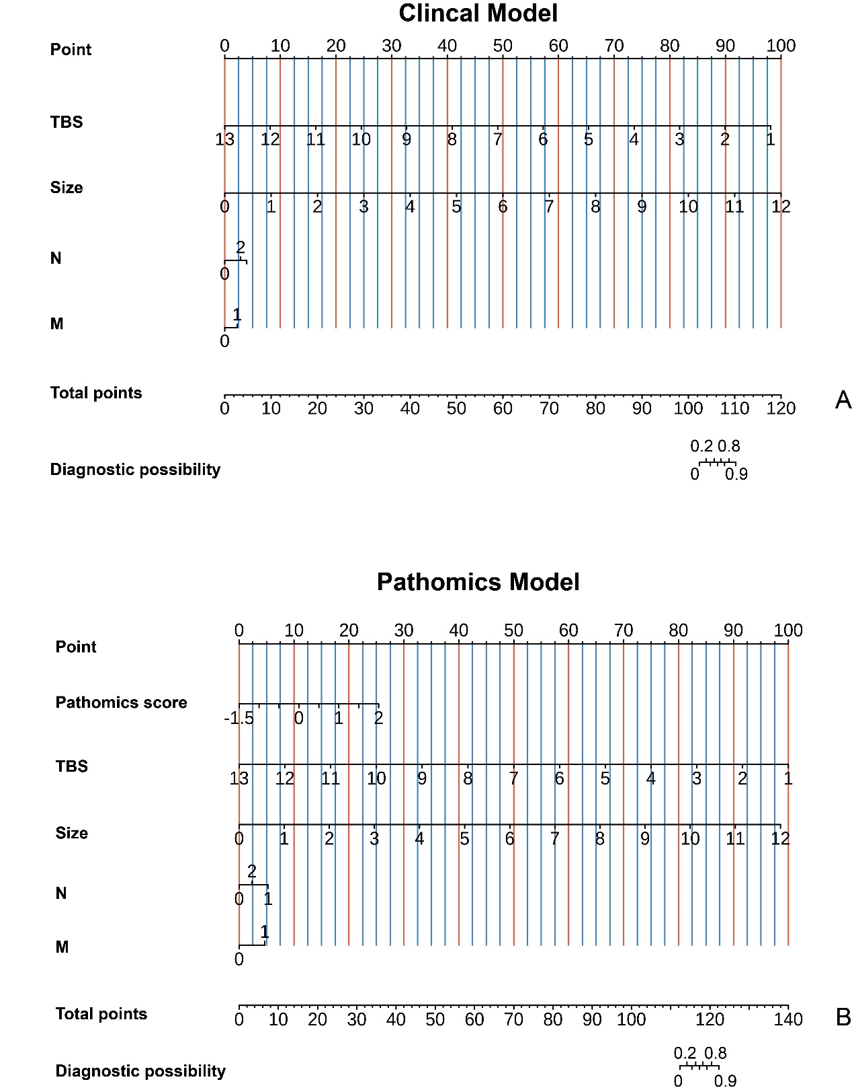

Figure S2
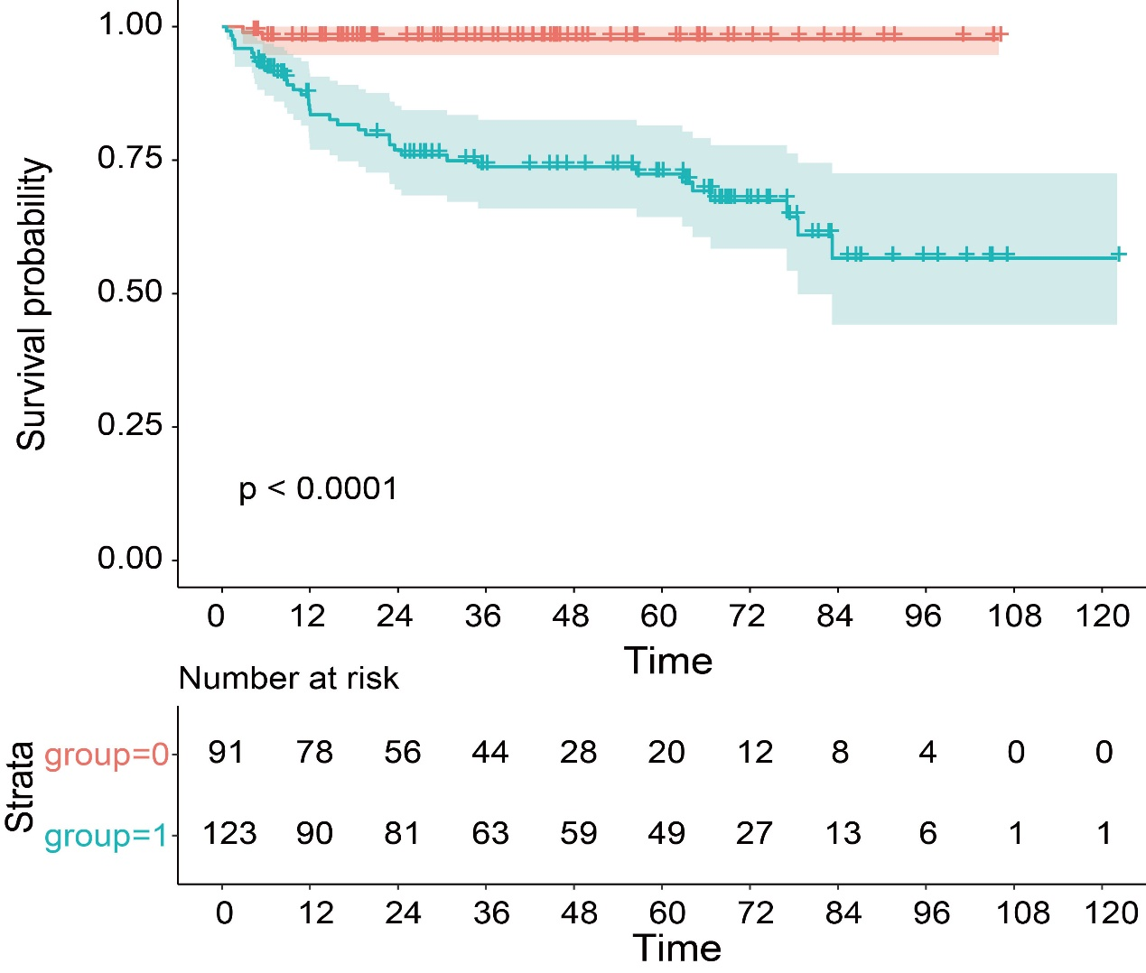
Comparison of progression-free survival predicted by pathomics model: high risk and low risk.

