Table 1: Descriptive statistics
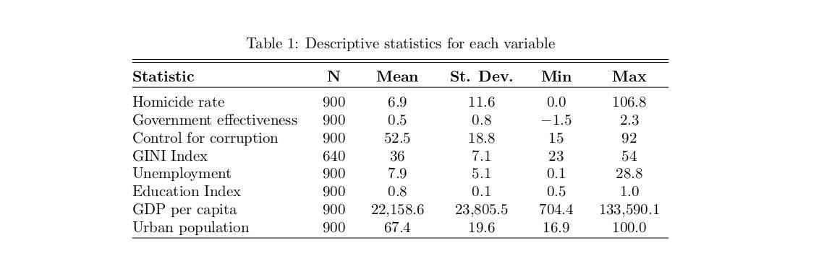
Table 2: Correlation matrix of independent variables and their global relationship with homicides (n = 64 countries)
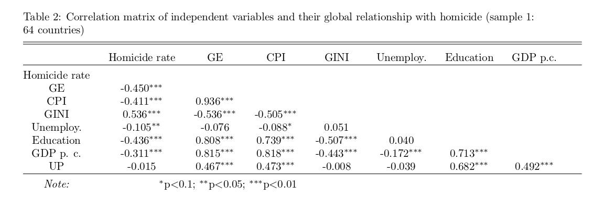

Table 3: Correlation matrix of independent variables and their global relationship with homicides (n = 94 countries, without GINI)
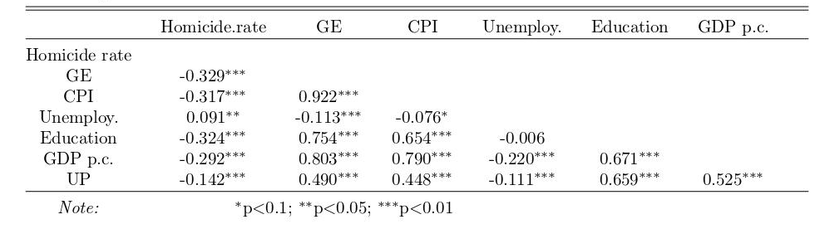

Table 4: Regression panel
