Appendices
Appendix A: A list of all packages used to analyze the data using the grateful (Caleb Lareau, 2023) package in R
Package | Version | Citation
base | 4.3.2 | R Core Team (2023)
car | 3.1.2 | Fox and Weisberg (2019)
chemodiv | 0.3.0 | Petrén, Köllner, and Junker (2023)
ComplexHeatmap | 2.18.0 | Gu et al. (2016)
dendextend | 1.17.1 | Galili (2015)
devtools | 2.4.5 | Wickham et al. (2022)
ecole | 0.9.2021 | Smith (2021)
egg | 0.4.5 | Auguie (2019)
fasterize | 1.0.5 | Ross (2023)
geosphere | 1.5.18 | Hijmans (2022)
ggbreak | 0.1.2 | Shuangbin Xu et al. (2021)
ggeasy | 0.1.4 | Carroll, Schep, and Sidi (2023)
ggh4x | 0.2.8 | van den Brand (2024)
ggpubr | 0.6.0 | Kassambara (2023)
ggrepel | 0.9.5 | Slowikowski (2024)
ggsignif | 0.6.4 | Constantin and Patil (2021)
glue | 1.6.2 | Hester and Bryan (2022)
gridExtra | 2.3 | Auguie (2017)
lme4 | 1.1.35.3 | Bates et al. (2015)
mobr | 2.0.2 | McGlinn et al. (2021)
multcomp | 1.4.25 | Hothorn, Bretz, and Westfall (2008)
nlme | 3.1.163 | Pinheiro J, Bates D, DebRoy S, Sarkar D, (2023)
patchwork | 1.2.0 | Pedersen (2024)
plotly | 4.10.4 | Sievert (2020)
plotrix | 3.8.4 | J (2006)
plyr | 1.8.9 | Wickham (2011)
raster | 3.6.26 | Hijmans (2023)
rdryad | 1.0.0 | Ram, Chamberlain, and Boettiger (2020)
remotes | 2.5.0 | Csárdi et al. (2024)
scales | 1.3.0 | Wickham, Pedersen, and Seidel (2023)
sf | 1.0.16 | Pebesma (2018)
terra | 1.7.78 | Hijmans (2024)
tidyverse | 2.0.0 | Wickham et al. (2019)
vegan | 2.6.6.1 | Oksanen et al. (2024)
VennDiagram | 1.7.3 | Chen (2022)

Appendix B: Traditional Community Analyses
Poisson distribution was applied for count-based variables (species richness and abundance), while normal distribution was used for evenness and Fisher's alpha. The models included land unit as a fixed factor, along with one of the following explanatory variables: 1) Corrected patch perimeter area ratio (CPA) as an edge effect index; 2) Distance to the nearest patch (edge to edge in meters) as a measure of isolation; 3) Connectivity index, accounting for both distances to the three nearest patches and their corresponding areas (Munguía-Rosas and Montiel, 2014). The connectivity index was calculated using the following formula: $Patch connectivity =\sum_{j}^{N}{\frac{A_{j}}{{Dist}_{j}}}$
where ‘A’ is the area of the next patch closest to the focal patch and ‘Dist’ is the edge-to-edge distance (m) between the focal patch and the next patch in its surroundings. Higher values of this index indicate decreased patch isolation. Each patch was originally sampled according to its size category, with an increasing number of samples as areas increased. Interactions are shown only when there is statistical significance. To account for variation in sampling intensities, the size category of each patch was included as a random factor in all models, except the models where the patch area was the leading explanatory variable because the sampling effect is correlated with the patch area. All spatial variables were derived from digital cartography using ArcGIS Pro (Esri 2024).
We used a SIMPER analysis to identify the percentage contribution of different spider species to the observed differences in community composition (Anderson 2001). A heatmap of the top 24 most influencing taxa was created using the ComplexHeatmap package (Gu et al. 2016). Since the response of spider species to habitat fragmentation is often related to hunting strategy and dispersal ability, we calculated the relative occurrences of all individuals when classified (at the family level) into four different hunting strategies: ambush, pursue, stalker, and web-building. The classification was based on the guidelines provided in the books Spiders of Britain and Northern Europe, African Spiders: An Identification Manual, Spider Families of the World, and Spiders of North-America (Roberts 1995, Dippenaar-Schoeman and Jocqué 1997, Jocqué and Dippenaar-Schoeman 2006, Rose 2022, respectively). We used the chi-square test of independence to determine if the frequencies or proportions of occurrences differed significantly across the three land units.

Results: Traditional Community Analyses
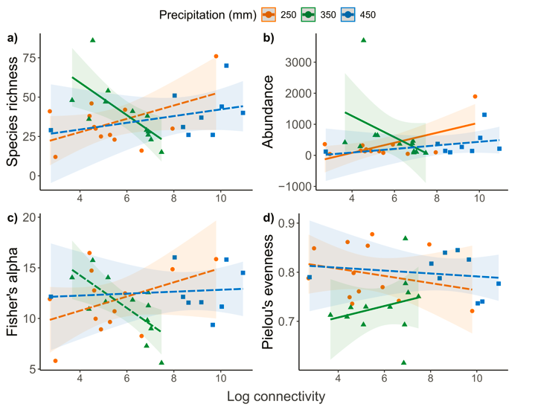
Fig. S1: a) Spiders’ species richness, b) abundance, c) Fisher’s alpha, and d) Pielou’s evenness as a function of connectivity in the three sites with different precipitation levels (orange for low precipitation level - 250 mm, green for moderate precipitation level - 350 mm, and blue for high precipitation level - 450 mm). The line represents the linear regression fit, solid for significant and dashed for non-significant trends.
Spider species richness was higher in the moderate precipitation level (350 mm) than in the high precipitation level land unit (450 mm) (Fig. S5a, Table S1: z = 2.38, p = 0.017). Species richness in the high precipitation level land unit did not vary significantly with connectivity (z = -0.11, p = 0.909), and no significant differences were detected between the low precipitation level (250 mm) and high precipitation level land units (z = -1.16, p = 0.246). The relationship between connectivity and species richness was consistent between the low and high-precipitation level land units (non-significant interaction term, z = 1.14, p = 0.255) but not between the moderate and high-precipitation level land units (a significant interaction term, z = -2.75, p = 0.006). Specifically, species richness in the high and low-precipitation level land units increased with increasing connectivity, but this pattern was more pronounced in the low-precipitation level land unit. In contrast, species richness was negatively correlated with connectivity in the moderate precipitation level land unit.
Spider abundance was significantly higher in the moderate precipitation level (350 mm) than in the high precipitation level land unit (450 mm) (z = 12.99, p < 0.001). However, it was lower in the low precipitation (250 mm) compared to the high precipitation level unit (Fig. S1b, Table S1: z = -2.06, p = 0.040). Spider abundance in the high precipitation level land unit did not vary significantly with connectivity (z = 0.6, p = 0.549). The relationship between connectivity and spider abundance varied significantly between the high precipitation level land unit and the two other land units (significant interaction terms, low precipitation site: z = 3.32, p = 0.001; moderate precipitation site: z = -11.44, p < 0.001). Specifically, spider abundance in the high and low-precipitation level land units increased with increasing connectivity, but this pattern was more potent in the low-precipitation level land unit. In contrast, spider abundance was negatively correlated with connectivity in the moderate precipitation level land unit.
The species evenness was significantly lower in the moderate precipitation (350 mm) than in the high precipitation level land unit (450 mm) (Table S2: t = -2.60, p = 0.015). However, evenness did not vary significantly as a function of connectivity in the high precipitation level land unit (t = -0.43, p = 0.671), and it did not differ between the low (250 mm) and high precipitation level land units (t = -0.23, p = 0.823). Fisher's alpha diversity in the high precipitation level land unit did not vary significantly with connectivity (Table S2: t = -0.33, p = 0.744), nor between the high precipitation level land unit and the other two land units (low precipitation site: t = -0.76, p = 0.456; moderate precipitation site: t = -1.20, p = 0.242).

Table S1: Generalized mixed model by maximum likelihood (Family: Poisson) of species richness and abundance of the spider community in the three land units with Gat (450 mm) as the reference level and log connectivity as fixed factors.
 | Species richness |  |  |  |  | Abundance
 | Estimate | Std. Error | z -value | p-value |  | Estimate | Std. Error | z - value | p-value
Log Connectivity | -0.003 | 0.028 | -0.11 | 0.909 |  | 0.007 | 0.012 | 0.6 | 0.549
Dvir (250 mm) | -0.331 | 0.286 | -1.16 | 0.246 |  | -0.252 | 0.122 | -2.06 | 0.040
Lachish (350 mm) | 0.861 | 0.361 | 2.38 | 0.017 |  | 1.936 | 0.149 | 12.99 | < 0.001
Log Connectivity × Dvir (250 mm) | 0.041 | 0.036 | 1.14 | 0.255 |  | 0.044 | 0.013 | 3.32 | 0.001
Log Connectivity × Lachish (350 mm) | -0.143 | 0.052 | -2.75 | 0.006 |  | -0.232 | 0.020 | -11.44 | < 0.001

Table S2: Linear mixed-effects model fitted by REML for Fisher’s alpha diversity and evenness of the spider community in the three land units with Gat (450 mm) as the reference level and log connectivity as fixed factors.
 | Fisher’s alpha diversity |  |  |  |  | Evenness
 | Estimate | Std. Error | t-value | p-value |  | Estimate | Std. Error | t-value | p-value
Log Connectivity | -0.079 | 0.238 | -0.33 | 0.744 |  | -0.002 | 0.005 | -0.43 | 0.671
Dvir (250 mm) | -0.989 | 1.307 | -0.76 | 0.456 |  | -0.007 | 0.029 | -0.23 | 0.823
Lachish (350 mm) | -1.490 | 1.245 | -1.20 | 0.242 |  | -0.072 | 0.028 | -2.60 | 0.015

Community composition:
Pairwise comparisons (Table S3) showed significant differences in community composition among all land units as follows: the high and low precipitation level land units (R² = 0.243, p = 0.003); the high and moderate precipitation level land units (R² = 0.131, p = 0.006), and the moderate and low precipitation level land units (R² = 0.113, p = 0.021).
The SIMPER analysis results are listed in Table S4. The species that generated 20% of the dissimilarity in community composition were Salticidae sp. 9 (jumping spider, 2.4%), Salticidae ballus (2.4%), Salticidae synageles sp. 1 (2.4%), Theridiidae theridion sp. 2 (2.2%), Dictinidae sp. 2 (dictynid spider, 2.1%), Xysticus sp. 3 (crab spider, 2.1%), Xysticus sp. 2 (2.1%), Trachelas sp. 1 (1.9%), Salticidae sp. 5 (1.8%), and Theridiidae sp. 2 (1.8%). Only one taxon emerged as unique to the low precipitation level land unit; three were mutual to the high and moderate precipitation level land units, and 13 were mutual to the low and high precipitation level land units (visualized by a Venn diagram, Fig. S11). Section D lists all the morphospecies and their corresponding guild.
The taxa that contributed to the dissimilarities in community composition and were also mutual between the high (450 mm) and low precipitation level land units (250 mm) were Philodromus sp 2 (running crab spiders, ambush), Theridion musivum (tangle-web spiders, web), Ozyptila sp 1 (crab spider, ambush), Xysticus sp 3 (ground crab spiders, ambush), and Trachelas minor (ground sac spiders, pursue).
When examining spider functional guilds, occurrences varied significantly among the three land units (χ2 = 17.049, df = 6, p = 0.009, Fig. S10). These differences arose from a higher proportion of web-building and a smaller proportion of ambush spiders in the moderate (350 mm) and high precipitation level land units (450 mm) relative to the low precipitation level land unit (250 mm). In addition, the proportion of stalker spiders was higher in the high-precipitation level land unit than in the moderate and low-precipitation level land units.
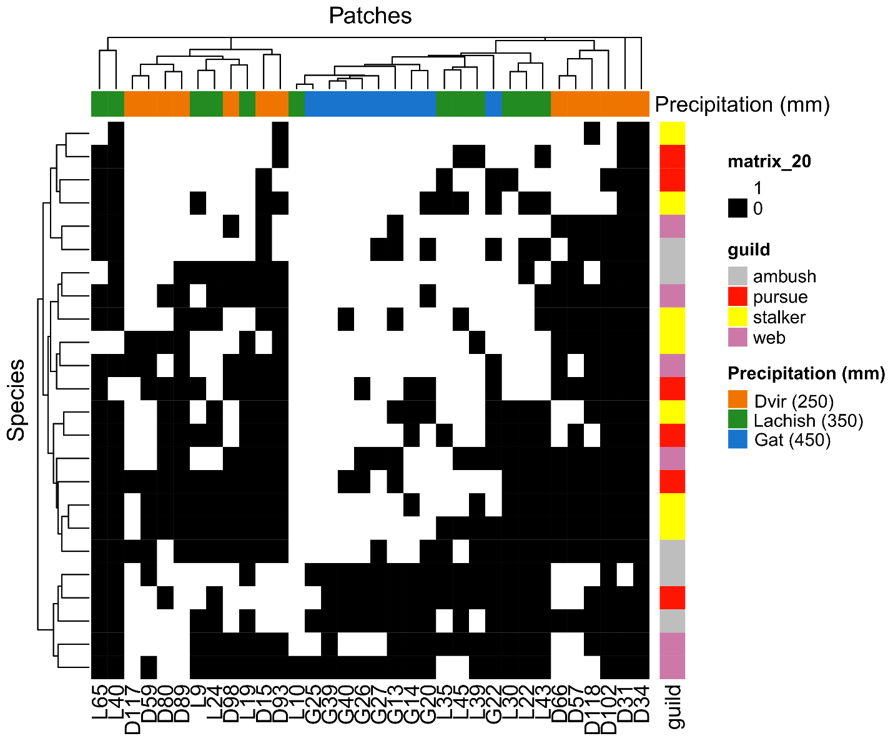

Fig. S2: Heatmap of the spider community presence-absence data for the most abundant (i.e., top 23) species by sampling patches. Dendrograms are constructed based on the Jaccard index. The right-hand scale shows the species with their associated guild.

Table S3: Pairwise comparisons between all groups of the PERMANOVA test
Pairs | SS | F. model | R² | p-value | p – adj.
Dvir vs Lachish | 0.330 | 2.927 | 0.113 | 0.007 | 0.021
Dvir vs Gat | 0.643 | 6.409 | 0.243 | 0.001 | 0.003
Lachish vs Gat | 0.252 | 2.870 | 0.131 | 0.002 | 0.006

Table S4: SIMPER analysis results for community composition dissimilarities in Southern Judea Lowlands
 | average | sd | ratio | ava | avb | cumsum | p
SALTICIDAE.m.9 | 0.012855 | 0.006714 | 1.9146 | 1 | 0.1538 | 0.024 | 0.001
SALTICIDAE.Ballus.s.1 | 0.012499 | 0.006591 | 1.8962 | 0.8889 | 0.0769 | 0.048 | 0.001
SALTICIDAE.Synageles.s.1 | 0.012499 | 0.006591 | 1.8962 | 0.8889 | 0.0769 | 0.072 | 0.001
THERIDIIDAE.theridion.s.2 | 0.011711 | 0.00726 | 1.613 | 0.8889 | 0.1538 | 0.094 | 0.001
DICTYNIDAE.m.2 | 0.011433 | 0.007215 | 1.5845 | 0.8889 | 0.1538 | 0.115 | 0.001
THOMISIDAE.Xysticus.s.3 | 0.011098 | 0.006937 | 1.5998 | 0 | 0.7692 | 0.136 | 0.002
THOMISIDAE.Xysticus.s.2 | 0.010916 | 0.00804 | 1.3578 | 1 | 0.3077 | 0.157 | 0.004
CORINNIDAE.Trachelas.minor | 0.010166 | 0.008043 | 1.264 | 0.6667 | 0 | 0.176 | 0.001
SALTICIDAE.m.5 | 0.009494 | 0.008317 | 1.1416 | 0.7778 | 0.3077 | 0.194 | 0.016
THERIDIIDAE.m.2 | 0.009279 | 0.008376 | 1.1078 | 0.8889 | 0.3846 | 0.212 | 0.017
THOMISIDAE.Xysticus.s.4 | 0.009204 | 0.00758 | 1.2143 | 0.6667 | 0.0769 | 0.229 | 0.003
ZORIDAE.m.1 | 0.008928 | 0.007597 | 1.1752 | 0.2222 | 0.6923 | 0.246 | 0.045
SALTICIDAE.m.12 | 0.008754 | 0.007411 | 1.1812 | 0.6667 | 0.1538 | 0.263 | 0.008
CLUBIONIDAE.m.2 | 0.008594 | 0.008032 | 1.07 | 0.7778 | 0.3846 | 0.279 | 0.035
GNAPHOSIDAE.Aphantaulax.s.1 | 0.008469 | 0.008055 | 1.0513 | 0.6667 | 0.3077 | 0.295 | 0.099
ZODARIIDAE.Zodarion.s.1 | 0.008301 | 0.00734 | 1.131 | 0.1111 | 0.6154 | 0.311 | 0.035
ARANEIDAE.Argiope.lobata | 0.008037 | 0.008062 | 0.9969 | 0.5556 | 0.1538 | 0.326 | 0.025
OXYOPIDAE.m.3 | 0.007991 | 0.008072 | 0.9899 | 0.5556 | 0.1538 | 0.341 | 0.155
THERIDIIDAE.m.5 | 0.007893 | 0.007939 | 0.9942 | 0.5556 | 0.1538 | 0.356 | 0.109
SALTICIDAE.Pellenes.moderianus | 0.007799 | 0.008051 | 0.9687 | 0.2222 | 0.5385 | 0.371 | 0.351
THERIDIIDAE.kochiura.s.1 | 0.007687 | 0.008009 | 0.9597 | 0.6667 | 0.4615 | 0.385 | 0.319
OXYOPIDAE.Oxyopes.s.1 | 0.007677 | 0.007418 | 1.035 | 0.5556 | 0.0769 | 0.4 | 0.246
PISAURIDAE.Rothus.s.1 | 0.007482 | 0.00769 | 0.973 | 0.5556 | 0.3077 | 0.414 | 0.031
THOMISIDAE.Heriaeus.s.1 | 0.007446 | 0.007926 | 0.9394 | 0.5556 | 0.5385 | 0.428 | 0.557
DICTYNIDAE.Dictyna.s.1 | 0.007421 | 0.008321 | 0.8918 | 0.8889 | 0.5385 | 0.442 | 0.052
LIOCRANIDAE.unidentified | 0.007416 | 0.007387 | 1.004 | 0.1111 | 0.5385 | 0.456 | 0.116
SALTICIDAE.Heliophanus.s.1 | 0.007411 | 0.007282 | 1.0177 | 0.5556 | 0.1538 | 0.47 | 0.041
SALTICIDAE.Phlegra.s.1 | 0.007351 | 0.008023 | 0.9162 | 0.5556 | 0.6154 | 0.484 | 0.438
GNAPHOSIDAE.Micaria.s.1 | 0.007348 | 0.007586 | 0.9686 | 0.3333 | 0.5385 | 0.498 | 0.17
THOMISIDAE.Ozyptila.s.1 | 0.007324 | 0.007233 | 1.0126 | 0 | 0.5385 | 0.512 | 0.045
MIMETIDAE.Ero.s.1 | 0.007322 | 0.007441 | 0.9841 | 0.5556 | 0.3846 | 0.525 | 0.295
THOMISIDAE.Thomisus.s.1 | 0.007229 | 0.0081 | 0.8925 | 0.5556 | 0.6923 | 0.539 | 0.397
PHILODROMIDAE.Philodromus.s.2 | 0.007169 | 0.007049 | 1.0171 | 0 | 0.5385 | 0.553 | 0.392
SALTICIDAE.Pseudicius.s.1 | 0.007169 | 0.007943 | 0.9025 | 0.4444 | 0.3846 | 0.566 | 0.367
GNAPHOSIDAE.m.1 | 0.007166 | 0.008286 | 0.8648 | 0.5556 | 0.9231 | 0.58 | 0.054
SALTICIDAE.m.11 | 0.007161 | 0.008192 | 0.8741 | 0.6667 | 0.6154 | 0.593 | 0.581
AGELENIDAE.Agelena.s.1 | 0.007074 | 0.007439 | 0.9509 | 0.4444 | 0.4615 | 0.607 | 0.1
ARANEIDAE.Hypsosinga.s.1 | 0.007072 | 0.008051 | 0.8784 | 0.4444 | 0.2308 | 0.62 | 0.67
ARANEIDAE.Glyptogona.sextuberculata | 0.006991 | 0.007657 | 0.913 | 0.3333 | 0.4615 | 0.633 | 0.439
THOMISIDAE.Ozyptila.s.2 | 0.006771 | 0.00817 | 0.8287 | 0.7778 | 0.6154 | 0.646 | 0.52
SALTICIDAE.m.10 | 0.006552 | 0.008008 | 0.8182 | 0.3333 | 0.3077 | 0.659 | 0.432
THOMISIDAE.Xysticus.s.7 | 0.006545 | 0.007769 | 0.8425 | 0.4444 | 0.0769 | 0.671 | 0.085
SALTICIDAE.m.4 | 0.006532 | 0.008442 | 0.7737 | 0.7778 | 0.6923 | 0.683 | 0.897
LYCOSIDAE.unidentified | 0.006484 | 0.008383 | 0.7735 | 0.7778 | 0.6923 | 0.696 | 0.529
MITURGIDAE.Cheiracanthium.s.2 | 0.006383 | 0.008439 | 0.7563 | 0.6667 | 0.8462 | 0.708 | 0.367
THERIDIIDAE.theridion.musivum | 0.006139 | 0.006981 | 0.8794 | 0 | 0.4615 | 0.719 | 0.144
ZORIDAE.m.2 | 0.006065 | 0.007201 | 0.8423 | 0.4444 | 0.0769 | 0.731 | 0.44
PHILODROMIDAE.Thanatus.s.2 | 0.006026 | 0.006627 | 0.9093 | 0.1111 | 0.4615 | 0.742 | 0.694
GNAPHOSIDAE.Zelotes.unidentified | 0.005995 | 0.008521 | 0.7036 | 0.8889 | 0.6923 | 0.753 | 0.701
SALTICIDAE.Evarcha.s.1 | 0.005964 | 0.007441 | 0.8015 | 0.1111 | 0.3846 | 0.765 | 0.362
THOMISIDAE.Monaeses.israeliensis | 0.005858 | 0.00788 | 0.7434 | 0.6667 | 0.8462 | 0.776 | 0.072
SALTICIDAE.Salticus.s.1 | 0.005642 | 0.00881 | 0.6403 | 1 | 0.6923 | 0.786 | 0.262
PHOLCIDAE.Pholcus.s.1 | 0.005422 | 0.006995 | 0.7752 | 0.2222 | 0.3077 | 0.797 | 0.504
MITURGIDAE.Prochora.s.1 | 0.005319 | 0.006637 | 0.8013 | 0.3333 | 0.2308 | 0.807 | 0.095
ARANEIDAE.Araneus.s.1 | 0.005307 | 0.007344 | 0.7226 | 0.3333 | 0.1538 | 0.817 | 0.485
GNAPHOSIDAE.Minosia.s.1 | 0.005302 | 0.007124 | 0.7443 | 0 | 0.3846 | 0.827 | 0.132
THOMISIDAE.Xysticus.s.1 | 0.00523 | 0.006509 | 0.8035 | 0.1111 | 0.3846 | 0.837 | 0.415
PALPIMANIDAE.Palpimanus.s.1 | 0.005152 | 0.006711 | 0.7677 | 0.2222 | 0.3077 | 0.847 | 0.336
SALTICIDAE.Mogrus.s.1 | 0.004938 | 0.006916 | 0.714 | 0.3333 | 0.0769 | 0.856 | 0.088
ZODARIIDAE.Ranops.expers | 0.004912 | 0.006922 | 0.7097 | 0.1111 | 0.3077 | 0.865 | 0.272
SALTICIDAE.Mogrus.neglectus | 0.004875 | 0.006919 | 0.7045 | 0.1111 | 0.3077 | 0.874 | 0.969
SALTICIDAE.m.8 | 0.004825 | 0.006336 | 0.7615 | 0.3333 | 0.1538 | 0.883 | 0.472
ZODARIIDAE.Zodarion.s.2 | 0.004465 | 0.006358 | 0.7023 | 0.2222 | 0.2308 | 0.892 | 0.368
GNAPHOSIDAE.unidentified | 0.004393 | 0.008317 | 0.5282 | 1 | 0.7692 | 0.9 | 0.912
THOMISIDAE.Xysticus.s.5 | 0.004103 | 0.006485 | 0.6328 | 0 | 0.3077 | 0.908 | 0.713
PISAURIDAE.Rothus.s.2 | 0.0041 | 0.006033 | 0.6795 | 0.3333 | 0 | 0.916 | 0.098
ZODARIIDAE.Zodarion.lutipus | 0.003958 | 0.006521 | 0.6069 | 0.1111 | 0.2308 | 0.923 | 0.993
THOMISIDAE.Thomisus.onustus | 0.003714 | 0.00577 | 0.6436 | 0.2222 | 0.1538 | 0.93 | 0.899
ARANEIDAE.Hypsosinga.s.2 | 0.003704 | 0.005788 | 0.6399 | 0.2222 | 0.1538 | 0.937 | 0.801
THERIDIIDAE.m.4 | 0.003567 | 0.005824 | 0.6124 | 0.1111 | 0.2308 | 0.944 | 0.901
CLUBIONIDAE.m.1 | 0.003368 | 0.005828 | 0.5779 | 0.2222 | 0.0769 | 0.951 | 0.175
GNAPHOSIDAE.Setaphis.unidentified | 0.003177 | 0.005932 | 0.5356 | 0 | 0.2308 | 0.957 | 0.901
SCYTODIDAE.Scytodes.s.1 | 0.003047 | 0.005245 | 0.581 | 0.2222 | 0.0769 | 0.962 | 0.163
THERIDIIDAE.Euryopis.acuminata | 0.003047 | 0.005245 | 0.581 | 0.2222 | 0.0769 | 0.968 | 0.422
ULOBORIDAE.Uloborus.s.1 | 0.002997 | 0.005678 | 0.5279 | 0.1111 | 0.1538 | 0.974 | 0.965
GNAPHOSIDAE.Leptodrassus.s.1 | 0.002639 | 0.004975 | 0.5305 | 0 | 0.2308 | 0.979 | 0.769
SALTICIDAE.m.6 | 0.001929 | 0.005626 | 0.3429 | 0.8889 | 1 | 0.982 | 0.024
ZODARIIDAE.Trygetus.sexoculatus | 0.001825 | 0.004505 | 0.4051 | 0 | 0.1538 | 0.986 | 0.596
ZODARIIDAE.Zodarion.nitidum | 0.001702 | 0.004138 | 0.4114 | 0 | 0.1538 | 0.989 | 0.943
OONOPIDAE.Oonops.s.1 | 0.001695 | 0.003775 | 0.4489 | 0.1111 | 0.0769 | 0.992 | 0.902
THOMISIDAE.Ozyptila.s.3 | 0.001627 | 0.003921 | 0.4149 | 0 | 0.1538 | 0.995 | 0.414
THERIDIIDAE.Kochiura.aulica | 0.001125 | 0.003228 | 0.3486 | 0.1111 | 0 | 0.997 | 0.93
OXYOPIDAE.m.2 | 0.00069 | 0.002414 | 0.2857 | 0 | 0.0769 | 0.999 | 0.973
THERIDIIDAE.theridion.negebense | 0.00069 | 0.002414 | 0.2857 | 0 | 0.0769 | 1 | 0.997

Table S5: Occurrences of the different functional guilds by land unit
Land unit | Ambush | Pursue | Stalker | Web
Gat – 450 mm | 81 | 91 | 110 | 72
Lachish – 350 mm | 115 | 136 | 117 | 103
Dvir – 250 mm | 127 | 139 | 107 | 63

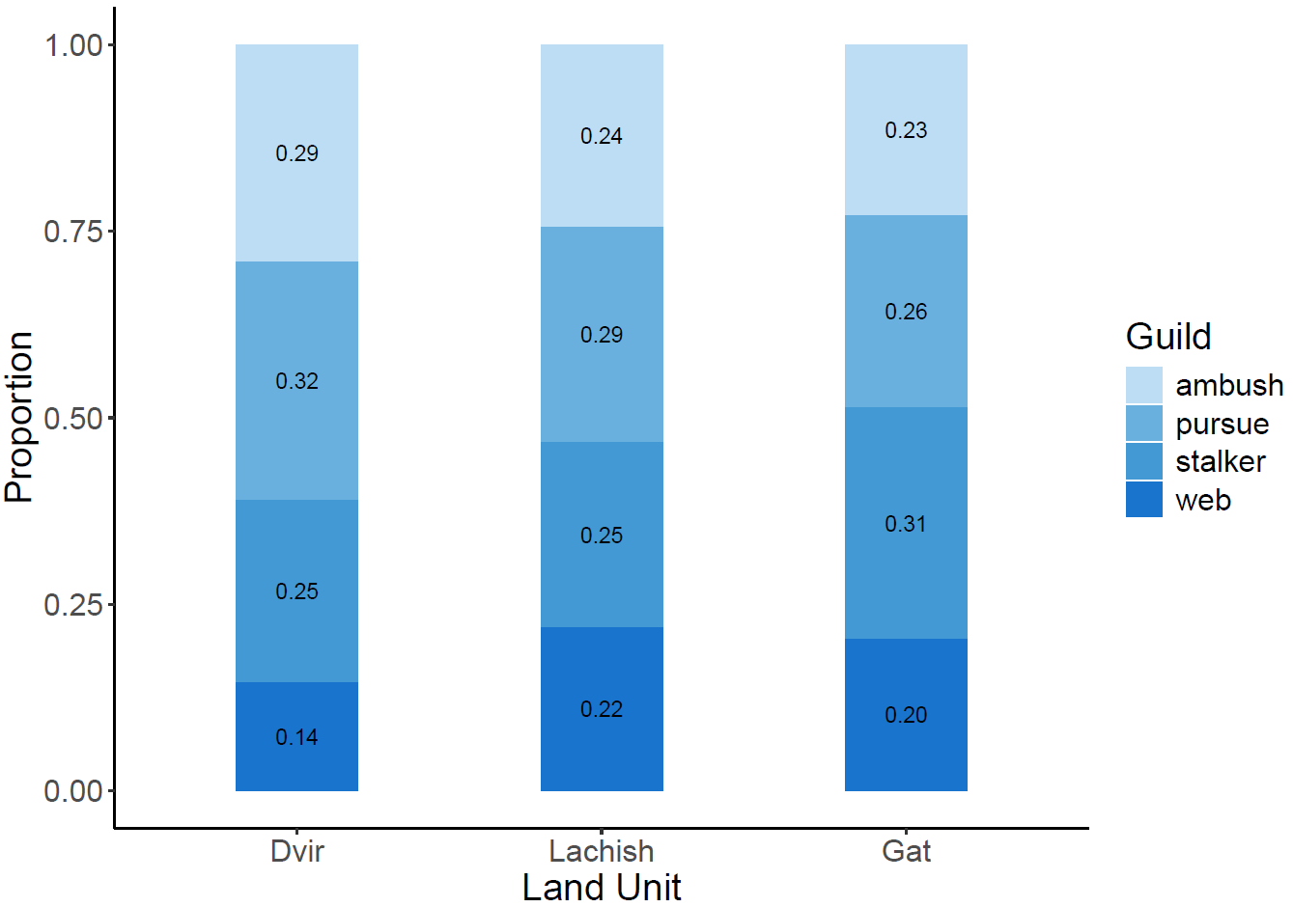
Fig. S3: Proportional occurrences of spider functional guilds (web-builders, stalkers, pursuers, and ambush predators) across the three precipitation level land units: low precipitation level - 250 mm, moderate precipitation level - 350 mm, and high precipitation level - 450 mm. Each bar shows the relative proportion of occurrences of the four functional guilds within the community of a particular precipitation-level land unit.

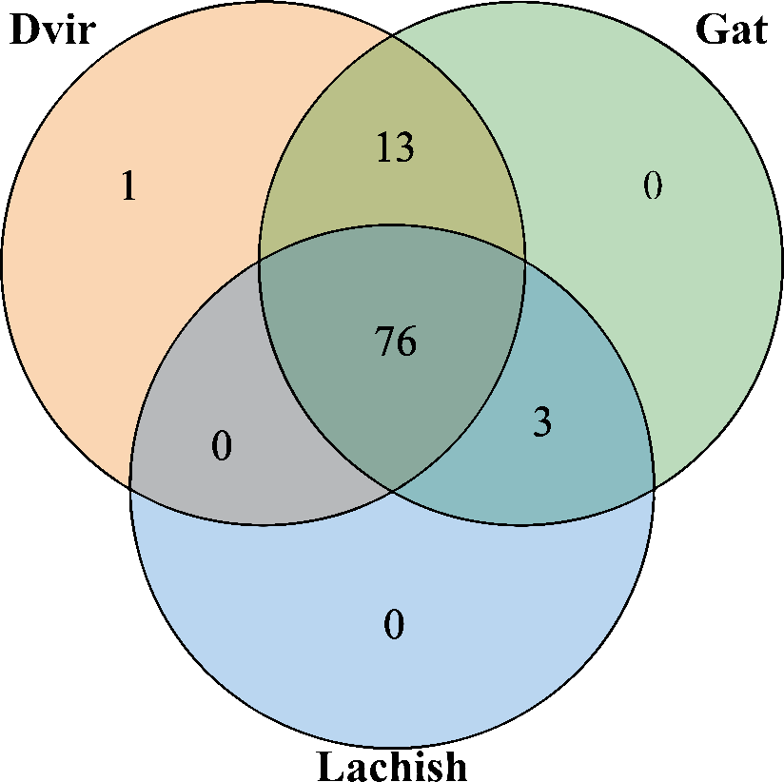
Fig. S4: Venn diagram showing the amount of shared and distinct morphospecies between the three land units along the climate gradient (orange for Dvir (250 mm), green for Lachish (350 mm), and Gat (450 mm)).

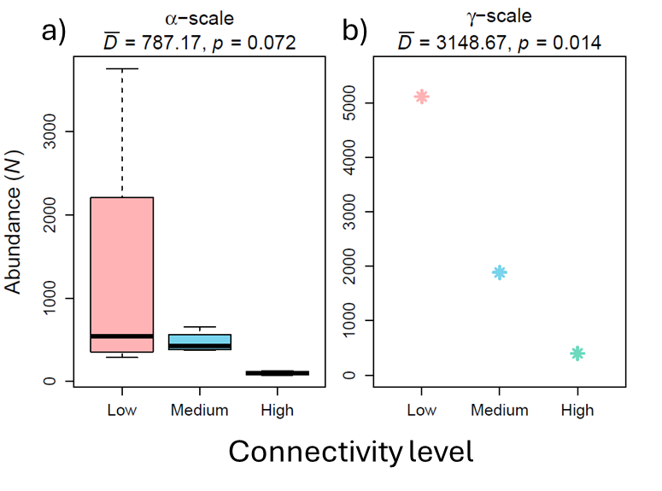
Fig. S5: The abundance of spider individuals in the Lachish land unit (350 mm) at low, medium, and high levels of connectivity at a) the α (i.e., single patch) and b) the γ (i.e., all patches) scales.
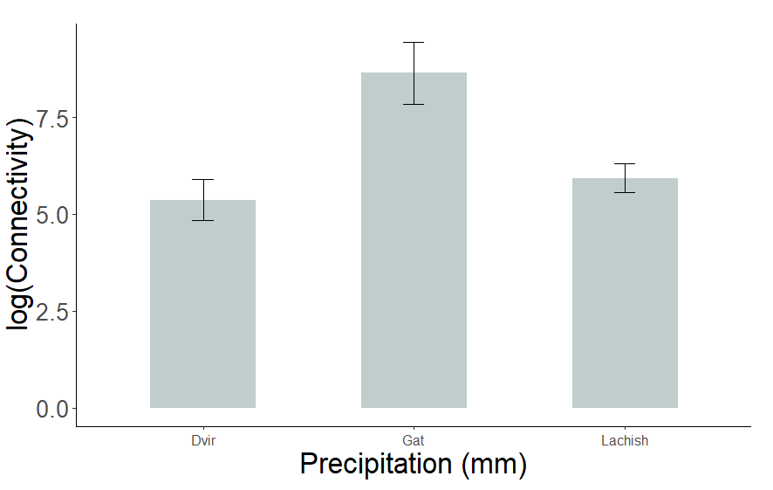

Fig. S6: Log connectivity levels in the different land units: Dvir (250 mm), Lachish (350 mm), and Gat (450 mm).

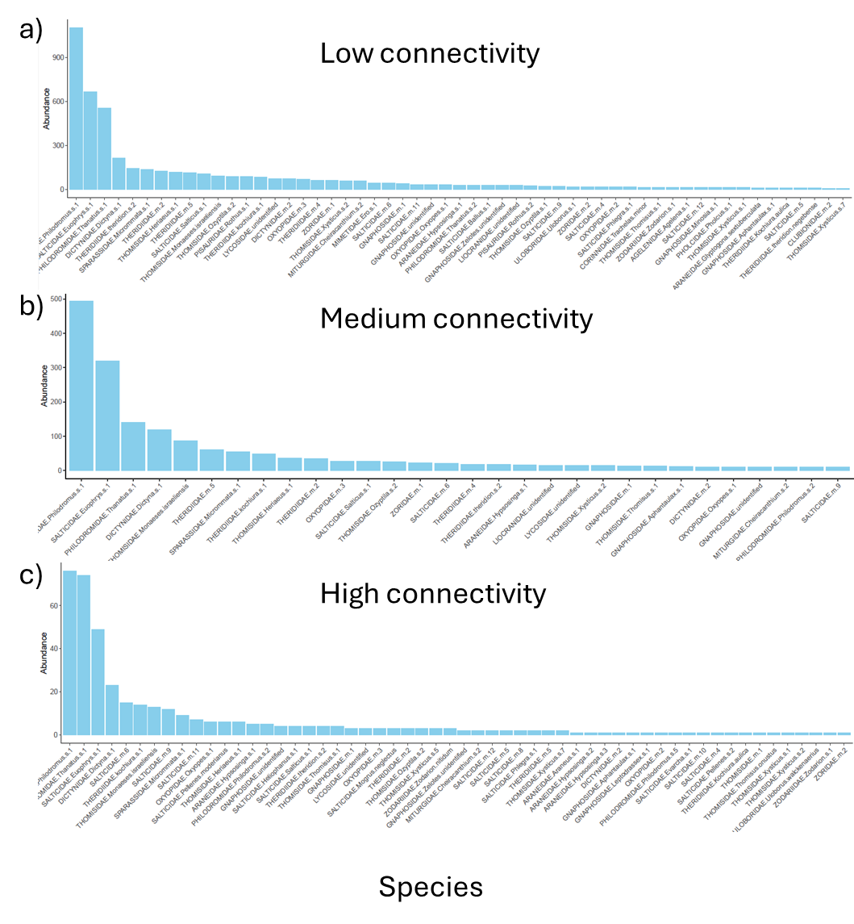
Fig. S7: Histograms showing the abundances of the different species in the different patches in the Lachish (350 mm) according to their a) low, b) medium, and c) high connectivity levels.
Appendix C: Details on the Measurements of Biodiversity Package
In this study, we used the freely available R package mobr (https://github.com/MoBiodiv/mobr) (McGlinn et al. 2018, 2020). MoB constructs and synthesizes three types of rarefaction curves to quantify the contribution of each of the following three components to changes in biodiversity along the climate and fragmentation gradients (Fig. 5a-c):
- Spatial, sample-based rarefaction (sSBR) accumulates species by collecting the closest sampling plots first. All possible focal samples are considered, and the resulting curves are averaged over. This curve reflects information on aggregation, N, and the SAD.
- Nonspatial, sample-based rarefaction (nsSBR) shows the number of species given k sampling plots in which all N individuals are randomly reassigned to these plots while maintaining observed individual density. This curve reflects variation in both N and the SAD.
- Individual-based rarefaction (IBR) is the number of species given a random sample of N individuals out of N total individuals. It reflects variation only in the SAD. Individuals are randomly sampled from either the SAD of one (to create the alpha scale) or all plots (to create the gamma scale). The curve is constructed by first pooling individuals across all plots within each land unit along the focal gradient and then randomly sampling individuals without replacement.
Next, we calculated the differences between each pair of curves at each site along the gradient (Fig. 5d-f): N effect = nsSBR - IBR; aggregation effect = sSBR - nsSBR. The SAD effect is calculated directly from the IBR. In the next step, the package models the relationship between the gradient and the estimates of the SAD, N, and aggregation effects. Then, we examined how the rate of change in the gradient and the effect (by creating a slope of the model) vary with sampling effort. Lastly, the observed results were compared to randomization-based null models (Fig. 5g-i) (McGlinn et al. 2018). Testing the significance of the SAD effect requires a null model where the gradient does not show changes in communities' SADs. This is achieved by first computing the across-gradient SAD as the total abundance for each species across all plots, including all plots along the gradient. In each simulation, one sample of size N is drawn with replacement from the across-gradient regional SAD for each point along the focal gradient t, which is then used to construct the individual rarefaction curve.
Testing the significance of the density effect requires a permutation-based null model where the gradient does not show a change in density. In each simulation, the plot-level abundances are shuffled across all plots, including all the points along the focal gradient. The simulated species abundances in each plot are obtained by sampling with replacement of the number of individuals specified by the shuffled abundance from the observed SAD for the corresponding point along the focal gradient.
Finally, testing the significance of the aggregation effect requires a null model where aggregation is removed. In each simulation, a random sample of size N for each plot is drawn with a replacement from the observed SAD for the corresponding point along the gradient.
Table S6: Definitions and interpretations of the summary statistics for the two-scale analysis as presented in the supplementary information of McGlinn et al. (2018)

Metric | Definition | Interpretation
${}_{}^{γ}S$, ${}_{}^{α}S$ | Observed species richness at the γ- scale(i.e., all plots in a treatment) or α-scale (i.e., a single plot in a treatment) respectively. | Number of species or the effective number of species of order 0 (Jost 2006 p. 200).
N | Total abundance across all species | Measure of density of individuals
${}_{}^{γ}{S_{n}}$, ${}_{}^{α}{S_{n}}$ | The expected richness for n randomly sampled individuals at the γ- and α-scales respectively (Hurlbert 1971). | Estimate of richness after controlling for differences due to aggregation or number of individuals (i.e., only reflects SAD)
${}_{}^{γ}{PIE}$, ${}_{}^{α}{PIE}$ | Probability of intraspecific encounter, PIE = $S_{n=2}-S_{n=1}$ at the γ- and α-scales respectively (Hurlbert 1971, Olszewski 2004). This is the bias-corrected version of PIE that is computed with sampling without replacement. | Measure of evenness, slope at base of the rarefaction curve, and sensitive to common species
${}_{}^{γ}{S_{PIE}}$, ${}_{}^{α}{S_{PIE}}$ | Number of equally abundant species needed in a hypothetical community to yield PIE using sampling with replacement: ${}_{}^{k=2}{\hat{E}}$ of Dauby & Hardy (2012); ${}_{}^{2}{\hat{D}}\left(∞\right)$ of Chao, Chiu, and Jost (2014) at the γ- and α-scales respectively. | Effective number of species of PIE that is easier to compare with S = 1 / (1 – PIE). It is an asymptotic estimator of effective number of species of order 2 (Jost 2006).
β_{S} | $=\frac{{}_{}^{γ}S}{{}_{}^{α}S}=\frac{{}_{}^{γ}{S_{n=N_{t,+}}}}{{}_{}^{α}{S_{n=N_{t, k}}}}$ where $N_{t,+}$ is the total abundance across treatment t and $N_{t, k}$is the total abundance in treatment t at plot k (Whittaker 1960). | More species turnover results in larger β_{S} which may be due to increases in spatial aggregation, N, and/or unevenness of the SAD. Because S is sensitive to rare species this metric of turnover is more sensitive to rare species than β_{PIE} for example.
$${\text{β}}_{{\text{S}}_{\text{n}}}$$ | $=\frac{{}_{}^{γ}{S_{n=n}}}{{}_{}^{α}{S_{n=n}}}$ where n = [5, min(N_{t,k})](Chase et al. 2018). | This metric of β-diversity reflects primarily spatial aggregation of species because it controls for numbers of individuals and somewhat for differences in the SAD. If there was no spatial aggregation the γ- and α-scale SADs would be functionally similar though not identical (Green and Plotkin 2007).
$${\text{β}}_{\text{PIE}}$$ | $=\frac{{}_{}^{γ}{PIE}}{{}_{}^{α}{PIE}}=\frac{{}_{}^{γ}{S_{n=2}}-{}_{}^{γ}{S_{n=1}}}{{}_{}^{α}{S_{n=2}-{}_{}^{α}{S_{n=1}}}}=\frac{{}_{}^{γ}{S_{n=2}}-1}{{}_{}^{α}{S_{n=2}}-1}$ Ratio of total treatment and plot PIE (Olszewski 2004) | Like β_{S} but emphasizes the base of the rarefaction curve and thus is more influenced by the difference in degree of evenness in common species at the γ- and α-scales.
$${\text{β}}_{{\text{S}}_{\text{PIE}}}$$ | $=\frac{{}_{}^{γ}{S_{PIE}}}{{}_{}^{α}{S_{PIE}}}=\frac{1/{(1-{}_{}^{γ}{PIE})}}{1/{(1-{}_{}^{α}{PIE})}}=\frac{1-{}_{}^{α}{PIE}}{1-{}_{}^{γ}{PIE}}$ which simplifies to the ratio of the probability of intra-specific (rather than inter-specific) encounter at the α- and γ-scales.

Appendix D: A list of all the morphospecies, their classification in the Venn diagram (presented in SI, section B), and their guilds
morphospecies | Venn. location | guild
AGELENIDAE.Agelena.sp.1 | Mutual to all | web
ARANEIDAE.Araneus.sp.1 | Mutual to all | web
ARANEIDAE.Argiope.lobata | Mutual to all | web
ARANEIDAE.Glyptogona.sextuberculata | Mutual to all | web
ARANEIDAE.Hypsosinga.sp.1 | Mutual to all | web
ARANEIDAE.Hypsosinga.sp.2 | Mutual to all | web
CLUBIONIDAE.sp.1 | Mutual to all | pursue
CLUBIONIDAE.sp.2 | Mutual to all | pursue
CLUBIONIDAE.sp.3 | Mutual to all | pursue
CORINNIDAE.Trachelas. minor | Mutual to Gat and Lachish | pursue
DICTYNIDAE.Dictyna.sp.1 | Mutual to all | web
DICTYNIDAE.sp.2 | Mutual to all | web
GNAPHOSIDAE.Aphantaulax.sp.1 | Mutual to all | pursue
GNAPHOSIDAE.Leptodrassus.sp.1 | Mutual to Dvir and Lachish | pursue
GNAPHOSIDAE.Micaria.sp.1 | Mutual to all | pursue
GNAPHOSIDAE.Minosia.sp.1 | Mutual to Dvir and Lachish | pursue
GNAPHOSIDAE.Poecilochora.sp.1 | Mutual to all | pursue
GNAPHOSIDAE.Setaphis.unidentified | Mutual to Dvir and Lachish | pursue
GNAPHOSIDAE.sp.1 | Mutual to all | pursue
GNAPHOSIDAE.unidentified | Mutual to all | pursue
GNAPHOSIDAE.Zelotes.soltitialis | Mutual to Dvir and Lachish | pursue
GNAPHOSIDAE.Zelotes.unidentified | Mutual to all | pursue
LIOCRANIDAE.unidentified | Mutual to all | pursue
LYCOSIDAE.unidentified | Mutual to all | pursue
MIMETIDAE.Ero.sp.1 | Mutual to all | stalker
MITURGIDAE.Cheiracanthium.sp.2 | Mutual to all | pursue
MITURGIDAE.Prochora.sp.1 | Mutual to all | pursue
OONOPIDAE.Oonops.sp.1 | Mutual to all | pursue
OXYOPIDAE.Oxyopes.sp.1 | Mutual to all | pursue
OXYOPIDAE.sp.2 | Mutual to Dvir and Lachish | pursue
OXYOPIDAE.sp.3 | Mutual to all | pursue
PALPIMANIDAE.Palpimanus.sp.1 | Mutual to all | pursue
PHILODROMIDAE.Philodromus.sp.1 | Mutual to all | ambush
PHILODROMIDAE.Philodromus.sp.2 | Mutual to Dvir and Lachish | ambush
PHILODROMIDAE.Thanatus.sp.1 | Mutual to all | ambush
PHILODROMIDAE.Thanatus.sp.2 | Mutual to all | ambush
PHOLCIDAE.Pholcus.sp.1 | Mutual to all | web
PISAURIDAE.Rothus.sp.1 | Mutual to all | ambush
PISAURIDAE.Rothus.sp.2 | Mutual to Gat and Lachish | ambush
SALTICIDAE.Ballus.sp.1 | Mutual to all | stalker
SALTICIDAE.Euophrys.sp.1 | Mutual to all | stalker
SALTICIDAE.Euophrys.sp.2 | Mutual to all | stalker
SALTICIDAE.Evarcha.sp.1 | Mutual to all | stalker
SALTICIDAE.Heliophanus.sp.1 | Mutual to all | stalker
SALTICIDAE.Mogrus.neglectus | Mutual to all | stalker
SALTICIDAE.Mogrus.sp.1 | Mutual to all | stalker
SALTICIDAE.Pellenes.moderianus | Mutual to all | stalker
SALTICIDAE.Phlegra.sp.1 | Mutual to all | stalker
SALTICIDAE.Pseudicius.sp.1 | Mutual to all | stalker
SALTICIDAE.Salticus.sp.1 | Mutual to all | stalker
SALTICIDAE.sp.10 | Mutual to all | stalker
SALTICIDAE.sp.11 | Mutual to all | stalker
SALTICIDAE.sp.12 | Mutual to all | stalker
SALTICIDAE.sp.4 | Mutual to all | stalker
SALTICIDAE.sp.5 | Mutual to all | stalker
SALTICIDAE.sp.6 | Mutual to all | stalker
SALTICIDAE.sp.8 | Mutual to all | stalker
SALTICIDAE.sp.9 | Mutual to all | stalker
SALTICIDAE.Synageles.sp.1 | Mutual to all | stalker
SCYTODIDAE.Scytodes.sp.1 | Mutual to all | pursue
SPARASSIDAE.Micrommata.sp.1 | Mutual to all | ambush
THERIDIIDAE.Euryopis.acuminata | Mutual to all | web
THERIDIIDAE.Kochiura.aulica | Mutual to Gat and Lachish | web
THERIDIIDAE.kochiura.sp.1 | Mutual to all | web
THERIDIIDAE.sp.2 | Mutual to all | web
THERIDIIDAE.sp.4 | Mutual to all | web
THERIDIIDAE.sp.5 | Mutual to all | web
THERIDIIDAE.theridion.musivum | Mutual to Dvir and Lachish | web
THERIDIIDAE.theridion.negebense | Mutual to Dvir and Lachish | web
THERIDIIDAE.theridion.sp.2 | Mutual to all | web
THERIDIIDAE.unidentified | Mutual to all | web
THOMISIDAE.Heriaeus.sp.1 | Mutual to all | ambush
THOMISIDAE.Monaeses.israeliensis | Mutual to all | ambush
THOMISIDAE.Ozyptila.sp.1 | Mutual to Dvir and Lachish | ambush
THOMISIDAE.Ozyptila.sp.2 | Mutual to all | ambush
THOMISIDAE.Ozyptila.sp.3 | Unique to Dvir | ambush
THOMISIDAE.Thomisus.onustus | Mutual to all | ambush
THOMISIDAE.Thomisus.sp.1 | Mutual to all | ambush
THOMISIDAE.Xysticus.sp.1 | Mutual to all | ambush
THOMISIDAE.Xysticus.sp.2 | Mutual to all | ambush
THOMISIDAE.Xysticus.sp.3 | Mutual to Dvir and Lachish | ambush
THOMISIDAE.Xysticus.sp.4 | Mutual to all | ambush
THOMISIDAE.Xysticus.sp.5 | Mutual to Dvir and Lachish | ambush
THOMISIDAE.Xysticus.sp.7 | Mutual to all | ambush
ULOBORIDAE.Uloborus.sp.1 | Mutual to all | web
ZODARIIDAE.Ranops.expers | Mutual to all | pursue
ZODARIIDAE.Trygetus.sexoculatus | Mutual to Dvir and Lachish | pursue
ZODARIIDAE.Zodarion.lutipus | Mutual to all | pursue
ZODARIIDAE.Zodarion.nitidum | Mutual to Dvir and Lachish | pursue
ZODARIIDAE.Zodarion.sp.1 | Mutual to all | pursue
ZODARIIDAE.Zodarion.sp.2 | Mutual to all | pursue
ZORIDAE.sp.1 | Mutual to all | pursue
ZORIDAE.sp.2 | Mutual to all | pursue

Appendix E: Measurements of Biodiversity (MoB) along fragmentation gradient in Dvir (250 mm) and Gat (450 mm) land units.
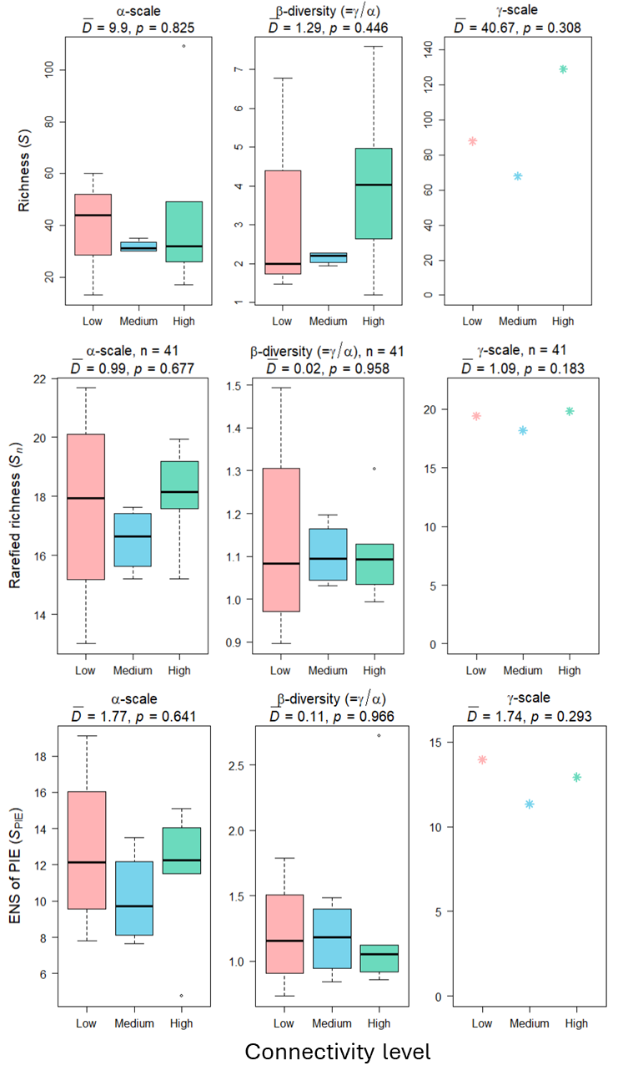

Fig. S12: Two-scale analysis for diversity metrics across scales at the Dvir (250 mm) land unit.

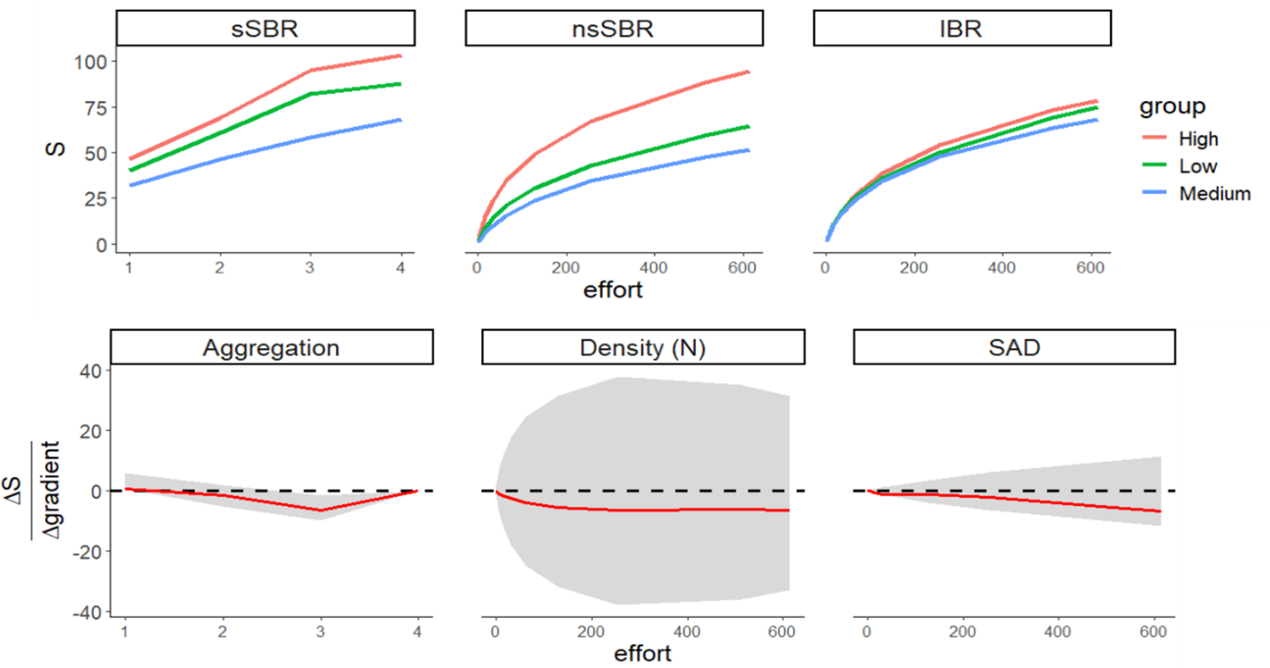
Fig. S13: Multiscale analysis for different connectivity levels across scales in the Dvir (250 mm) land unit.
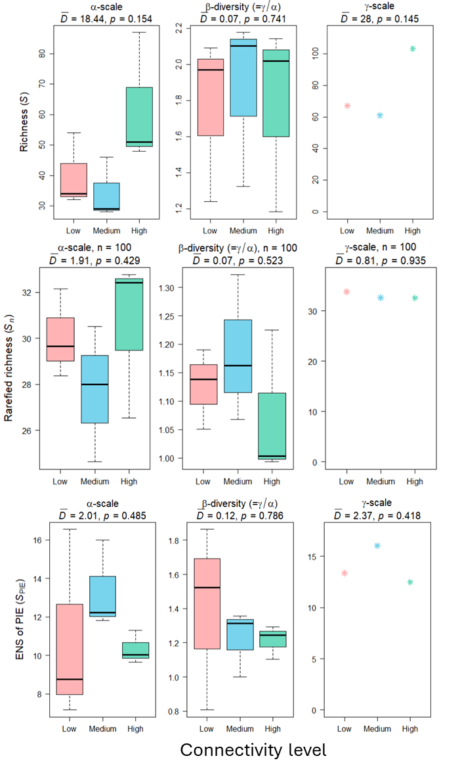
Fig. S14: Two-scale analysis for diversity metrics across scales at the Gat (450 mm) land unit.
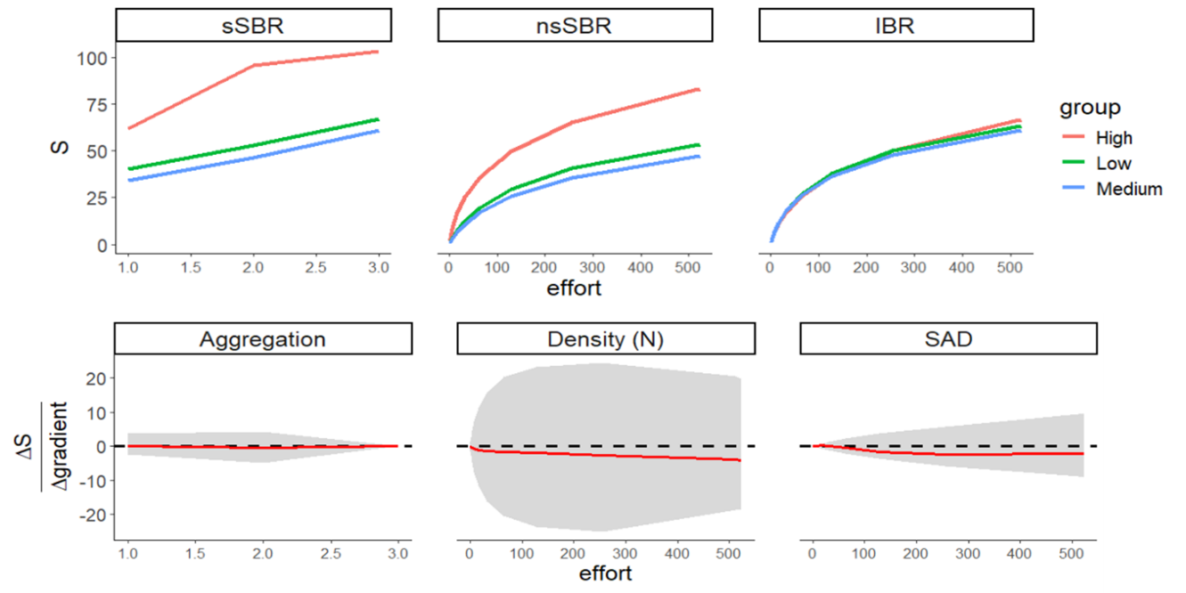
Fig. S15: Multiscale analysis for different connectivity levels across scales in the Gat (450 mm) land unit.

References
Allaire, JJ, Yihui Xie, Christophe Dervieux, Jonathan McPherson, Javier Luraschi, Kevin Ushey, Aron Atkins, et al. 2024. rmarkdown: Dynamic Documents for r. https://github.com/rstudio/rmarkdown.
Auguie, Baptiste. 2017. gridExtra: Miscellaneous Functions for “Grid” Graphics. https://CRAN.R-project.org/package=gridExtra.
———. 2019. egg: Extensions for “ggplot2”: Custom Geom, Custom Themes, Plot Alignment, Labelled Panels, Symmetric Scales, and Fixed Panel Size. https://CRAN.R-project.org/package=egg.
Bates, Douglas, Martin Mächler, Ben Bolker, and Steve Walker. 2015. “Fitting Linear Mixed-Effects Models Using lme4.” Journal of Statistical Software 67 (1): 1–48. https://doi.org/10.18637/jss.v067.i01.
Carroll, Jonathan, Alicia Schep, and Jonathan Sidi. 2023. ggeasy: Easy Access to “ggplot2” Commands. https://CRAN.R-project.org/package=ggeasy.
Chao, Anne, Nicholas J. Gotelli, T. C. Hsieh, Elizabeth L. Sander, K. H. Ma, Robert K. Colwell, and Aaron M. Ellison. 2014. “Rarefaction and Extrapolation with Hill Numbers: A Framework for Sampling and Estimation in Species Diversity Studies.” Ecological Monographs 84: 45–67.
Chen, Hanbo. 2022. VennDiagram: Generate High-Resolution Venn and Euler Plots. https://CRAN.R-project.org/package=VennDiagram.
Constantin, Ahlmann-Eltze, and Indrajeet Patil. 2021. “ggsignif: R Package for Displaying Significance Brackets for ‘ggplot2’.” PsyArxiv. https://doi.org/10.31234/osf.io/7awm6.
Csárdi, Gábor, Jim Hester, Hadley Wickham, Winston Chang, Martin Morgan, and Dan Tenenbaum. 2024. remotes: R Package Installation from Remote Repositories, Including “GitHub”. https://CRAN.R-project.org/package=remotes.
Fox, John, and Sanford Weisberg. 2019. An R Companion to Applied Regression. Third. Thousand Oaks CA: Sage. https://socialsciences.mcmaster.ca/jfox/Books/Companion/.
Galili, Tal. 2015. “dendextend: An r Package for Visualizing, Adjusting, and Comparing Trees of Hierarchical Clustering.” Bioinformatics. https://doi.org/10.1093/bioinformatics/btv428.
Gu, Zuguang. 2022. “Complex Heatmap Visualization.” iMeta. https://doi.org/10.1002/imt2.43.
Gu, Zuguang, Roland Eils, and Matthias Schlesner. 2016. “Complex Heatmaps Reveal Patterns and Correlations in Multidimensional Genomic Data.” Bioinformatics. https://doi.org/10.1093/bioinformatics/btw313.
Hesselbarth, Maximilian H. K., Marco Sciaini, Kimberly A. With, Kerstin Wiegand, and Jakub Nowosad. 2019. “landscapemetrics: An Open-Source r Tool to Calculate Landscape Metrics.” Ecography 42: 1648–57.
Hester, Jim, and Jennifer Bryan. 2022. glue: Interpreted String Literals. https://CRAN.R-project.org/package=glue.
Hijmans, Robert J. 2022. geosphere: Spherical Trigonometry. https://CRAN.R-project.org/package=geosphere.
———. 2023. raster: Geographic Data Analysis and Modeling. https://CRAN.R-project.org/package=raster.
———. 2024. terra: Spatial Data Analysis. https://CRAN.R-project.org/package=terra.
Hothorn, Torsten, Frank Bretz, and Peter Westfall. 2008. “Simultaneous Inference in General Parametric Models.” Biometrical Journal 50 (3): 346–63.
Hsieh, T. C., K. H. Ma, and Anne Chao. 2024. iNEXT: Interpolation and Extrapolation for Species Diversity. http://chao.stat.nthu.edu.tw/wordpress/software_download/.
J, Lemon. 2006. “Plotrix: A Package in the Red Light District of r.” R-News 6 (4): 8–12.
Kassambara, Alboukadel. 2023. ggpubr: “ggplot2” Based Publication Ready Plots. https://CRAN.R-project.org/package=ggpubr.
McGlinn, Daniel, Xiao Xiao, Brian McGill, Felix May, Thore Engel, Caroline Oliver, Shane Blowes, et al. 2021. mobr: Measurement of Biodiversity. https://CRAN.R-project.org/package=mobr.
Neuwirth, Erich. 2022. RColorBrewer: ColorBrewer Palettes. https://CRAN.R-project.org/package=RColorBrewer.
Oksanen, Jari, Gavin L. Simpson, F. Guillaume Blanchet, Roeland Kindt, Pierre Legendre, Peter R. Minchin, R. B. O’Hara, et al. 2024. vegan: Community Ecology Package. https://CRAN.R-project.org/package=vegan.
Pebesma, Edzer. 2018. “Simple Features for R: Standardized Support for Spatial Vector Data.” The R Journal 10 (1): 439–46. https://doi.org/10.32614/RJ-2018-009.
Pebesma, Edzer, and Roger Bivand. 2023. Spatial Data Science: With applications in R. Chapman and Hall/CRC. https://doi.org/10.1201/9780429459016.
Pedersen, Thomas Lin. 2024. patchwork: The Composer of Plots. https://CRAN.R-project.org/package=patchwork.
Petrén, Hampus, Tobias G. Köllner, and Robert R. Junker. 2023. “Quantifying Chemodiversity Considering Biochemical and Structural Properties of Compounds with the r Package Chemodiv.” New Phytologist 237 (6): 2478–92.
Pinheiro, José C., and Douglas M. Bates. 2000. Mixed-Effects Models in s and s-PLUS. New York: Springer. https://doi.org/10.1007/b98882.
Pinheiro, José, Douglas Bates, and R Core Team. 2023. nlme: Linear and Nonlinear Mixed Effects Models. https://CRAN.R-project.org/package=nlme.
R Core Team. 2023. R: A Language and Environment for Statistical Computing. Vienna, Austria: R Foundation for Statistical Computing. https://www.R-project.org/.
Ram, Karthik, Scott Chamberlain, and Carl Boettiger. 2020. rdryad: Access for Dryad Web Services. https://CRAN.R-project.org/package=rdryad.
Ross, Noam. 2023. fasterize: Fast Polygon to Raster Conversion. https://CRAN.R-project.org/package=fasterize.
Sciaini, Marco, Matthias Fritsch, Cedric Scherer, and Craig E. Simpkins. 2018. “NLMR and Landscapetools: An Integrated Environment for Simulating and Modifying Neutral Landscape Models in r.” Methods in Ecololgy and Evolution 00: 1–9. https://doi.org/10.1111/2041-210X.13076.
Shuangbin Xu, Meijun Chen, Tingze Feng, Li Zhan, Lang Zhou, and Guangchuang Yu. 2021. “Use Ggbreak to Effectively Utilize Plotting Space to Deal with Large Datasets and Outliers.” Frontiers in Genetics 12: 774846. https://doi.org/10.3389/fgene.2021.774846.
Sievert, Carson. 2020. Interactive Web-Based Data Visualization with r, Plotly, and Shiny. Chapman; Hall/CRC. https://plotly-r.com.
Slowikowski, Kamil. 2024. ggrepel: Automatically Position Non-Overlapping Text Labels with “ggplot2”. https://CRAN.R-project.org/package=ggrepel.
Smith, Robert. 2021. ecole: Ecole: School of Ecology Package. https://github.com/phytomosaic/ecole.
van den Brand, Teun. 2024. Ggh4x: Hacks for “ggplot2”. https://CRAN.R-project.org/package=ggh4x.
Wickham, Hadley. 2011. “The Split-Apply-Combine Strategy for Data Analysis.” Journal of Statistical Software 40 (1): 1–29. https://www.jstatsoft.org/v40/i01/.
Wickham, Hadley, Mara Averick, Jennifer Bryan, Winston Chang, Lucy D’Agostino McGowan, Romain François, Garrett Grolemund, et al. 2019. “Welcome to the tidyverse.” Journal of Open Source Software 4 (43): 1686. https://doi.org/10.21105/joss.01686.
Wickham, Hadley, Jim Hester, Winston Chang, and Jennifer Bryan. 2022. devtools: Tools to Make Developing r Packages Easier. https://CRAN.R-project.org/package=devtools.
Wickham, Hadley, Thomas Lin Pedersen, and Dana Seidel. 2023. scales: Scale Functions for Visualization. https://CRAN.R-project.org/package=scales.
Xie, Yihui, J. J. Allaire, and Garrett Grolemund. 2018. R Markdown: The Definitive Guide. Boca Raton, Florida: Chapman; Hall/CRC. https://bookdown.org/yihui/rmarkdown.
Xie, Yihui, Christophe Dervieux, and Emily Riederer. 2020. R Markdown Cookbook. Boca Raton, Florida: Chapman; Hall/CRC. https://bookdown.org/yihui/rmarkdown-cookbook.

