Mechanically-Adaptive, Resveratrol-Eluting Neural Probes for Improved Intracortical Recording Performance and Stability

Natalie N Mueller^{1,2}, Mali Ya Mungu Ocoko^{1,2}, Youjoung Kim^{1,2}, Kate Li^{1,2}, Kaela Gisser^{1,2}, Gabriele Glusauskas^{1,2},
Isabella Lugo^{1,2}, Peter Dernelle^{1,2}, Anna Clarissa Hermoso^{1,2}, Jaime Wang^{1,2}, Jonathan Duncan^{1,2}, Jeffrey R. Capadona^{1,2}, Allison Hess-Dunning^{1,2}
¹Advanced Platform Technology Center, VA Northeast Ohio Healthcare System, Cleveland, Ohio, 44106, United States
²Department of Biomedical Engineering, Case Western Reserve University, Cleveland, Ohio, 44106, United States

Supplementary Information
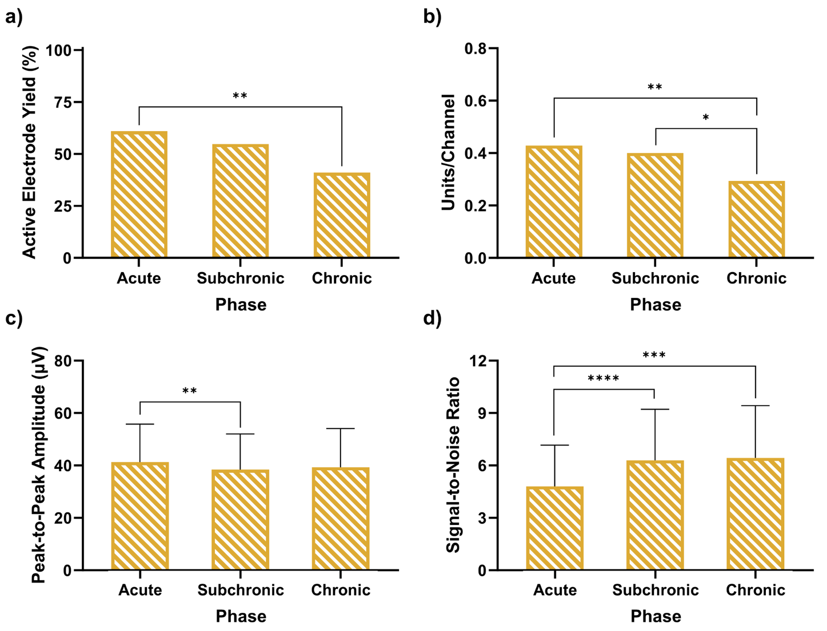
Figure S1. Recording metrics for MA material control probes at the acute, subchronic, and chronic time points. a) shows the active electrode yield, b) shows the units per channel, c) shows the peak-to-peak amplitude, and d) shows the signal-to-noise ratio. Error bars represent standard error. Significance is denoted by * for p < 0.05, ** for p < 0.01, *** for p < 0.001, and **** for p < 0.0001.

Table S1. P-values of active electrode yield comparisons across NeuroNexus, MARE, and MA probe types and acute, subchronic, and chronic phases. Significant p-values are shown in colored text, with the color corresponding to the higher active electrode yield in that comparison. P-values in black text are not significant.
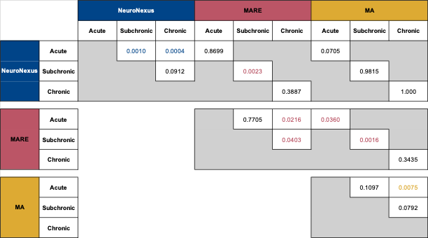

Table S2. P-values of active unit per channel comparisons across NeuroNexus, MARE, and MA probe types and acute, subchronic, and chronic phases. Significant p-values (p < 0.05) are shown in colored text, with the color corresponding to the higher units per channel calculation in that comparison. P-values in black text are not significant.
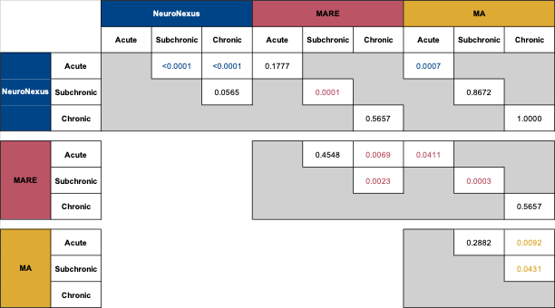
Table S3. P-values of peak-to-peak amplitude comparisons across NeuroNexus, MARE, and MA probe types and acute, subchronic, and chronic phases. Significant p-values are shown in colored text, with the color corresponding to the higher average peak-to-peak amplitude in that comparison. P-values in black text are not significant.

Table S4. P-values of signal-to-noise ratio comparisons across NeuroNexus, MARE, and MA probe types and acute, subchronic, and chronic phases. Significant p-values are shown in colored text, with the color corresponding to the higher average signal-to-noise ratio in that comparison. P-values in black text are not significant.

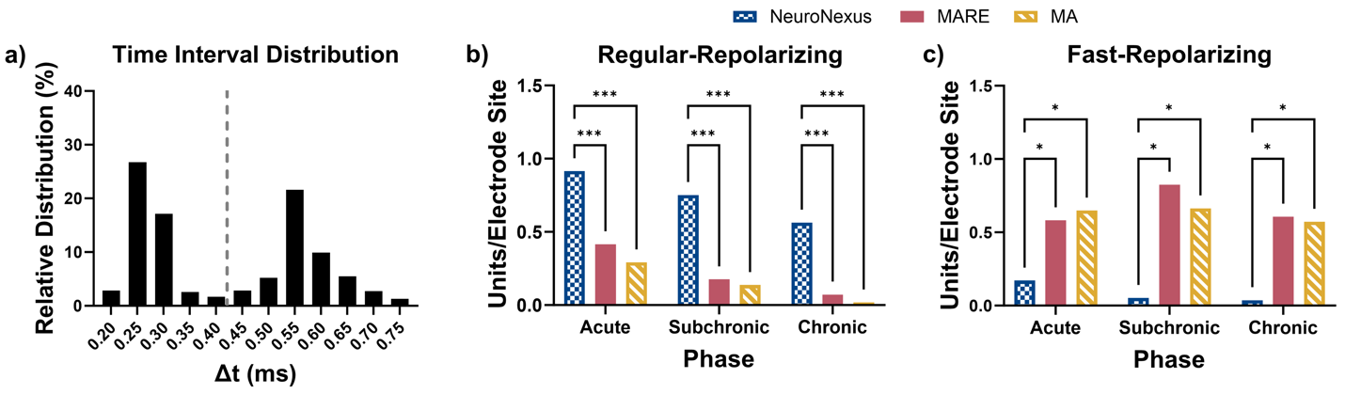
Figure S2. Repolarization rate analysis. a) Histogram showing the relative distribution of the time interval between depolarization and repolarization for all units. The dashed line indicates the threshold between fast-repolarizing and regular-repolarizing. b) The number of regular-repolarizing units/electrode site was significantly higher for NeuroNexus probes compared to MARE and MA probes for the acute, subchronic, and chronic phases. c) The number of fast-repolarizing units/electrode site was significantly higher for MARE and MA probes compared to NeuroNexus probes across all phases. Bars represent the ratio of units recorded divided by the total number of electrode sites. Significance is denoted by * for p < 0.05 and *** for p < 0.001.

Table S5. Geometric means and geometric standard deviation factors of the impedance magnitude (|Z|) at 1 kHz by week for NeuroNexus, MARE, and MA probes.
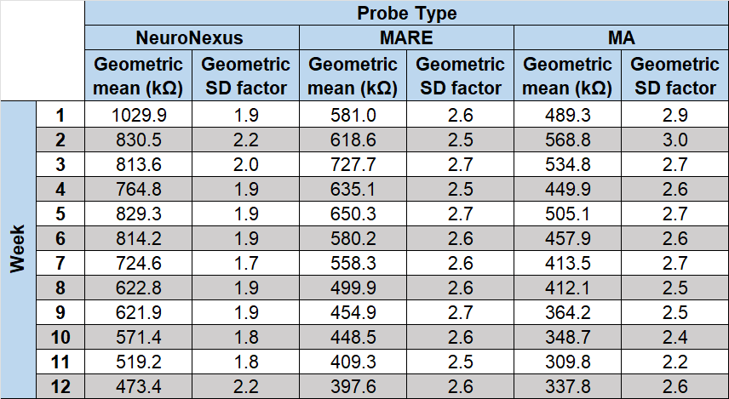

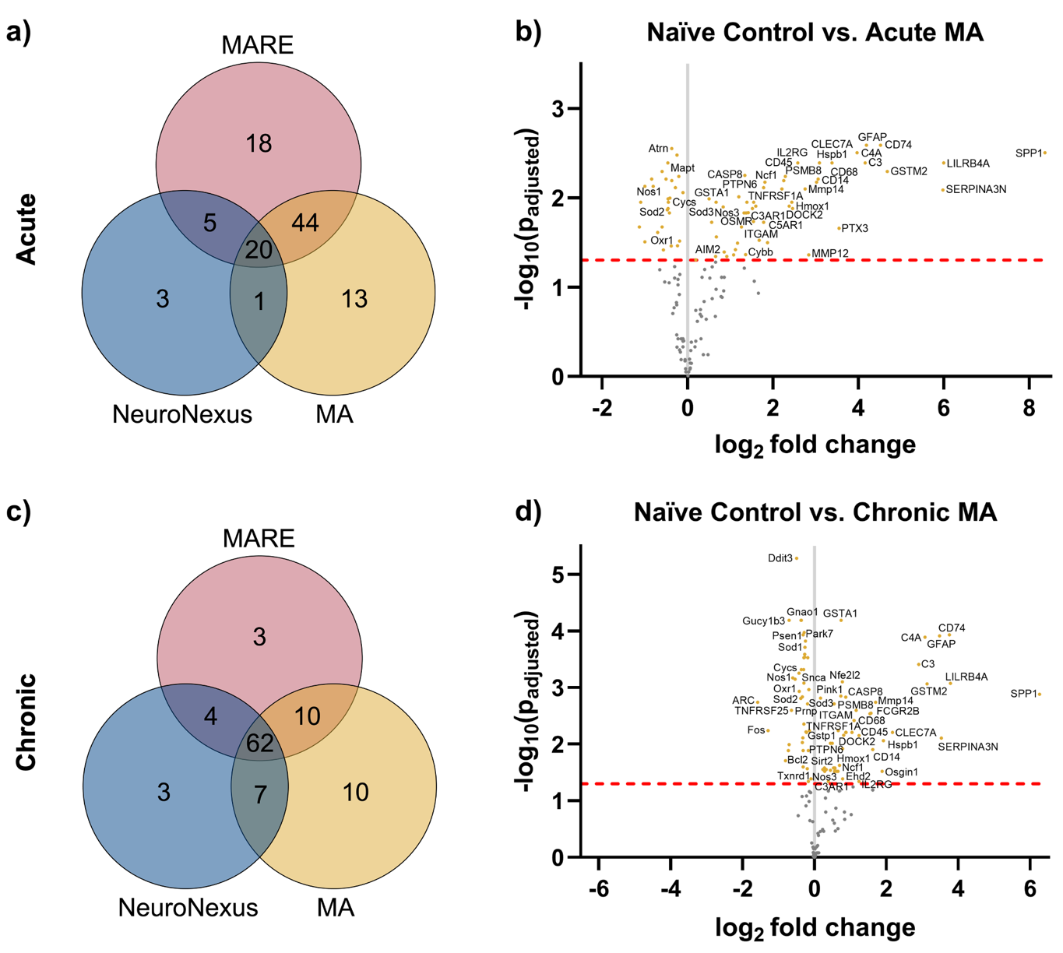
Figure S3. Differential expression for the MA probes vs naïve control at an acute time point of 4 weeks and a chronic time point of 12 weeks. a) Venn diagram showing the number of significant differentially expressed genes between the groups in the acute phase, not accounting for upregulation vs downregulation. b) Volcano plot showing the naïve control vs. the acute MA group, where each point is a gene in the panel. c) Venn diagram showing the number of significant differentially expressed genes between the groups in the chronic phase, not accounting for upregulation vs downregulation. b) Volcano plot showing the naïve control vs. the chronic MA group, where each point is a gene in the panel. The dashed red line shows the significance threshold of p_{adjusted} < 0.05. Significant differentially expressed genes are labeled and shown in color. Some significant genes were not labeled due to space limitations. Genes with a log₂ fold change > 0 are upregulated from naïve control, and genes with a log₂ fold change < 0 are downregulated from naïve control.

Table S6. List of analyzed genes describing if the gene was upregulated, downregulated, or not significant in all comparisons shown in volcano plots based on figure number.
Table S7. List of analyzed genes describing the correlation with active electrode yield for each probe type and end time point, where r represents Pearson correlation, s represents the sensitivity to the gene in terms of the change in log₂(fold change) required to increase the active electrode yield by one microelectrode site, given the number and spacing of the implants used; p is the uncorrected p-value indicating the significance of correlation as determined by a 2-sided t-test. The set of r, s, and p values for probe groups and end time points with significant correlation to the final week active electrode yield are indicated with bold red font.
