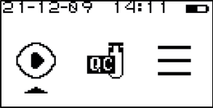 | - Turn on the analyzer and enter the testing interface.
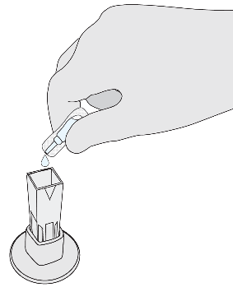 | - Open the cuvette and empty buffer solution into it.
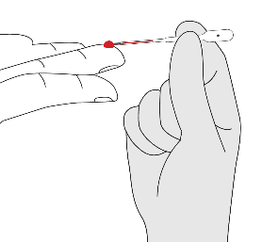 | - Collect specimen.
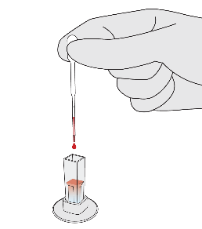 | - Add blood specimen to the cuvette.
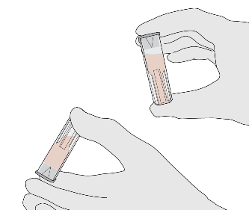 | - Invert 10-20 times to mix thoroughly.
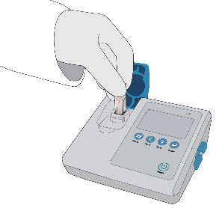 | - Insert cuvette into the sample well.
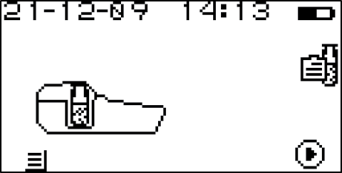 | - Start the test.

