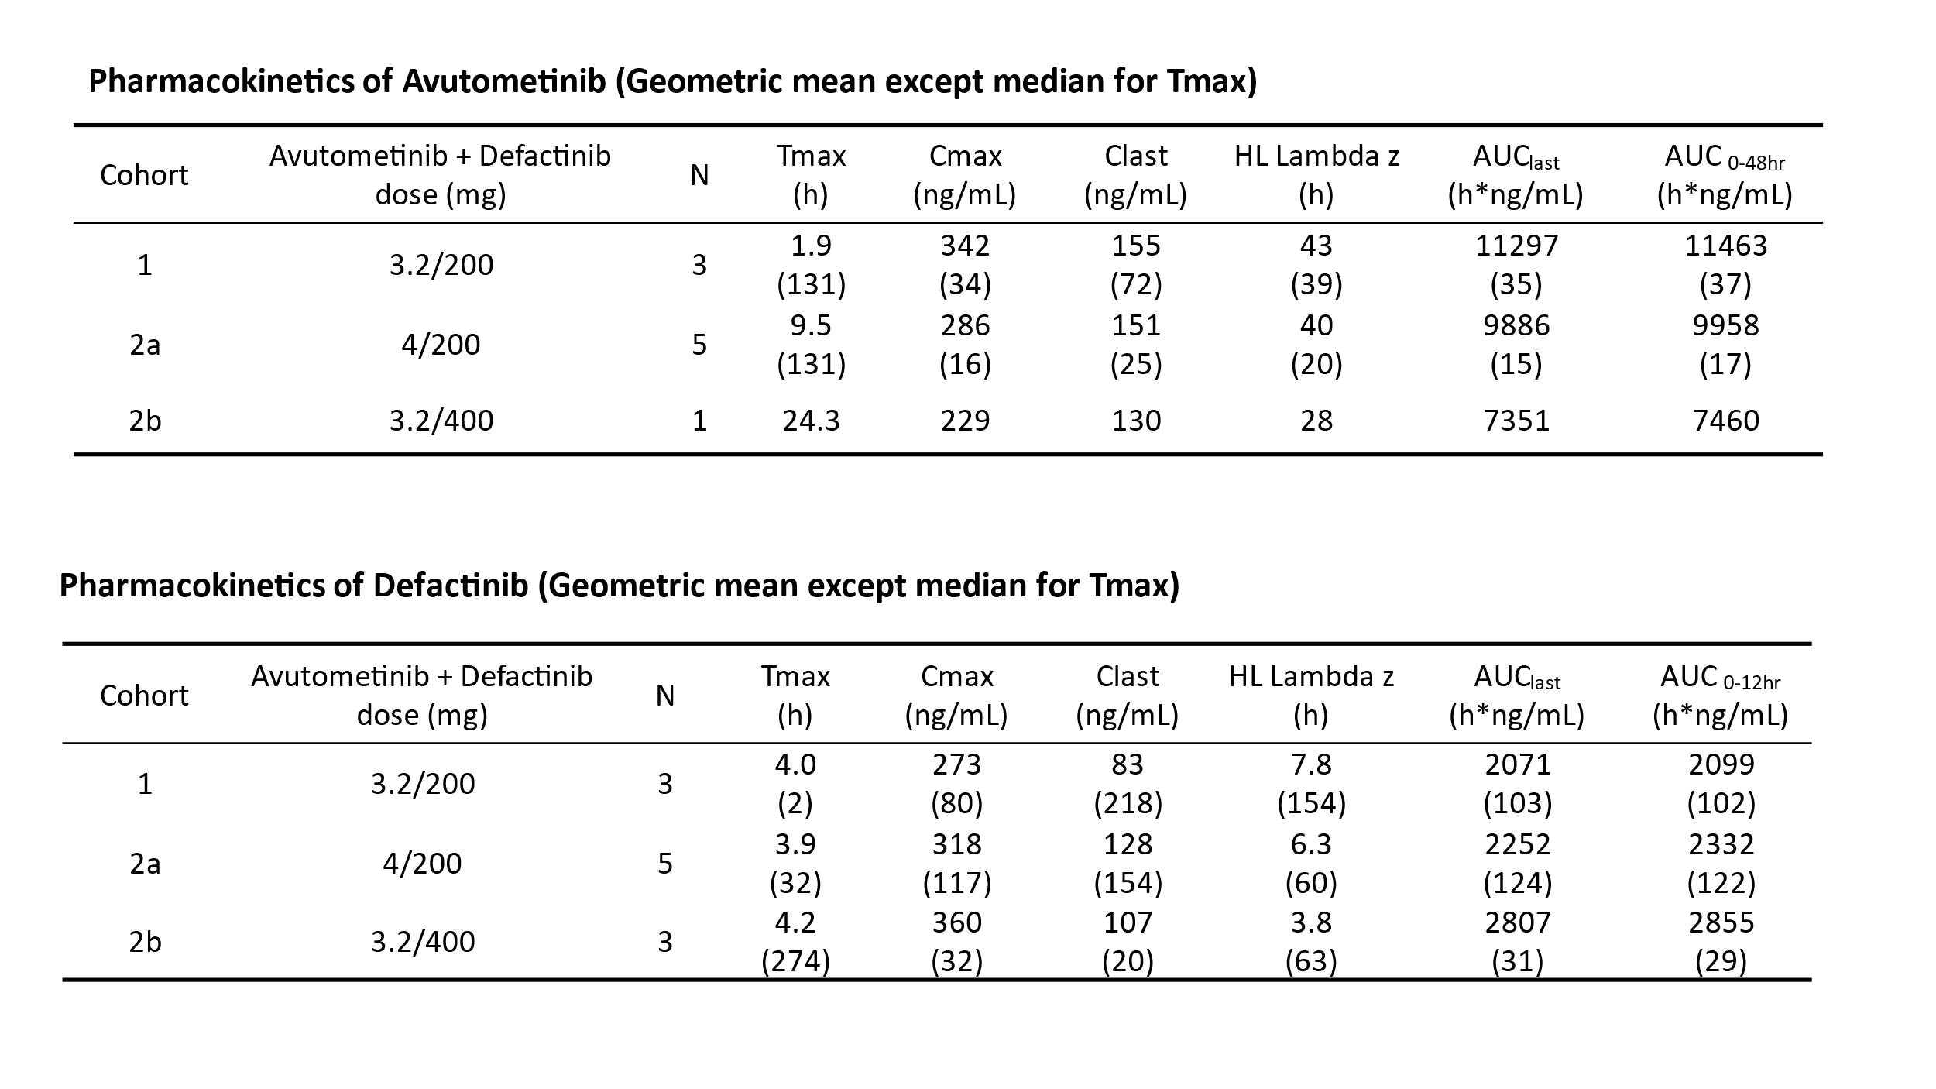
Table 2
Pharmacokinetic profiles
A. Pharmacokinetic profile of avutometinib B, Pharmacokinetic profile of defactinib. T max (time to maximal concentration), Cmax (maximal concentration), CL (clearance), HL (half-life), AUC (area under curve).

