Supporting Information for
Southern Ocean CO₂ outgassing and nutrient load reduced by a well-ventilated glacial North Pacific

Madison G. Shankle¹*; Graeme A. MacGilchrist¹; William R. Gray²; Casimir de Lavergne³; Laurie C. Menviel⁴; Andrea Burke¹; James W. B. Rae¹

¹ School of Earth and Environmental Sciences, University of St Andrews, St Andrews, KY16 9TS, United Kingdom
² Laboratoire des Sciences du Climat et de l’Environnement (LSCE/IPSL), CEA-CNRS-UVSQ, Université Paris-Saclay, Gif-sur-Yvette, 91191, France
³ LOCEAN Laboratory, Sorbonne Université-CNRS-IRD-MNHN, Paris, 75005, France
⁴ Climate Change Research Centre, The Australian Centre for Excellence in Antarctic Science, University of New South Wales, Sydney, NSW 2052, Australia

*Corresponding Author: Madison G. Shankle.
Email: mgs23@st-andrews.ac.uk
Address: School of Earth and Environmental Sciences, University of St Andrews, Bute Building, Queen’s Terrace, St Andrews, KY16 9TS, Scotland, United Kingdom
Phone number: +44 (0)1334 46 3940

Contents:
Supplementary Figure 1
Supplementary Figure 2
Supplementary Figure 3
Supplementary Figure 4
Supplementary Figure 5
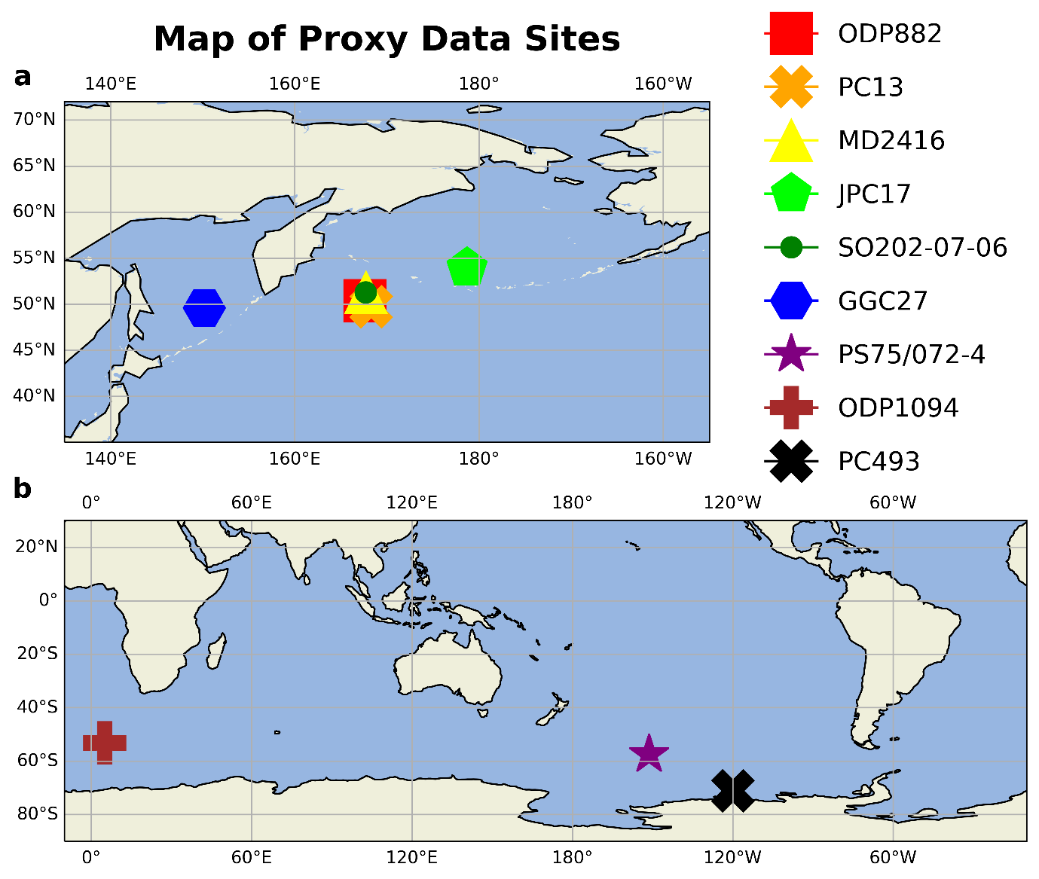
Supplementary Figure 1. Maps depict the locations of marine sediment core sites providing the proxy data in Figure 2. The proxy data presented in Figure 2 comes from a range of sites in the (a) North Pacific and (b) Southern Ocean.
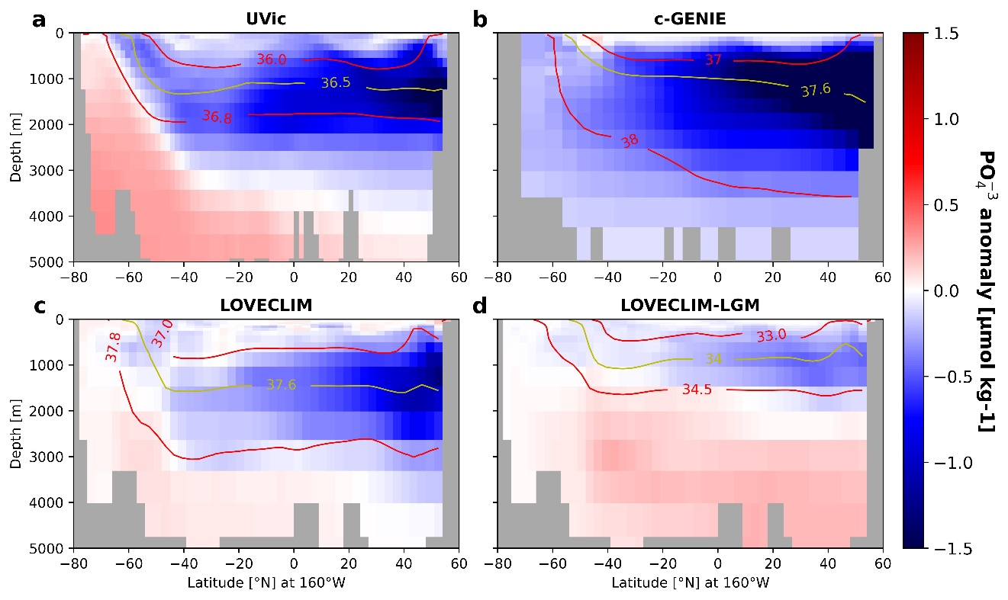
Supplementary Figure 2. Earth system models simulating a well-ventilated glacial North Pacific show negative anomalies in phosphate (PO₄³⁻) (μmol kg⁻¹) throughout the basin. Phosphate anomalies along 160°W resulting from a well-ventilated glacial North Pacific show the same pattern as potential pCO₂ (PCO₂) anomalies depicted in Figure 3. Red and yellow contours show isolines of σ₂ (potential density referenced to 2000 dbar) from the perturbed simulation in each case, meant to approximate the neutral surfaces along which these waters are expected to flow.
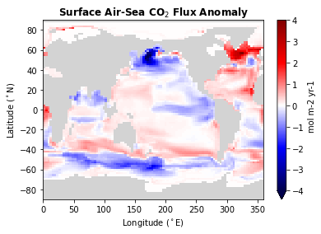
Supplementary Figure 3. Air-sea CO₂ flux exhibits negative anomalies across the Southern Ocean and North Pacific. Air-sea CO₂ flux anomaly (mol m⁻² yr⁻¹) between the control and perturbed simulations (UVic-NP – UVic-ctrl), with negative values indicating reduced CO₂ outgassing or enhanced CO₂ uptake. Note, we refrain from interpreting the increased outgassing observed in the North Atlantic due to freshwater forcing applied in this region, which likely induced non-analogous (to the LGM) changes in this region.
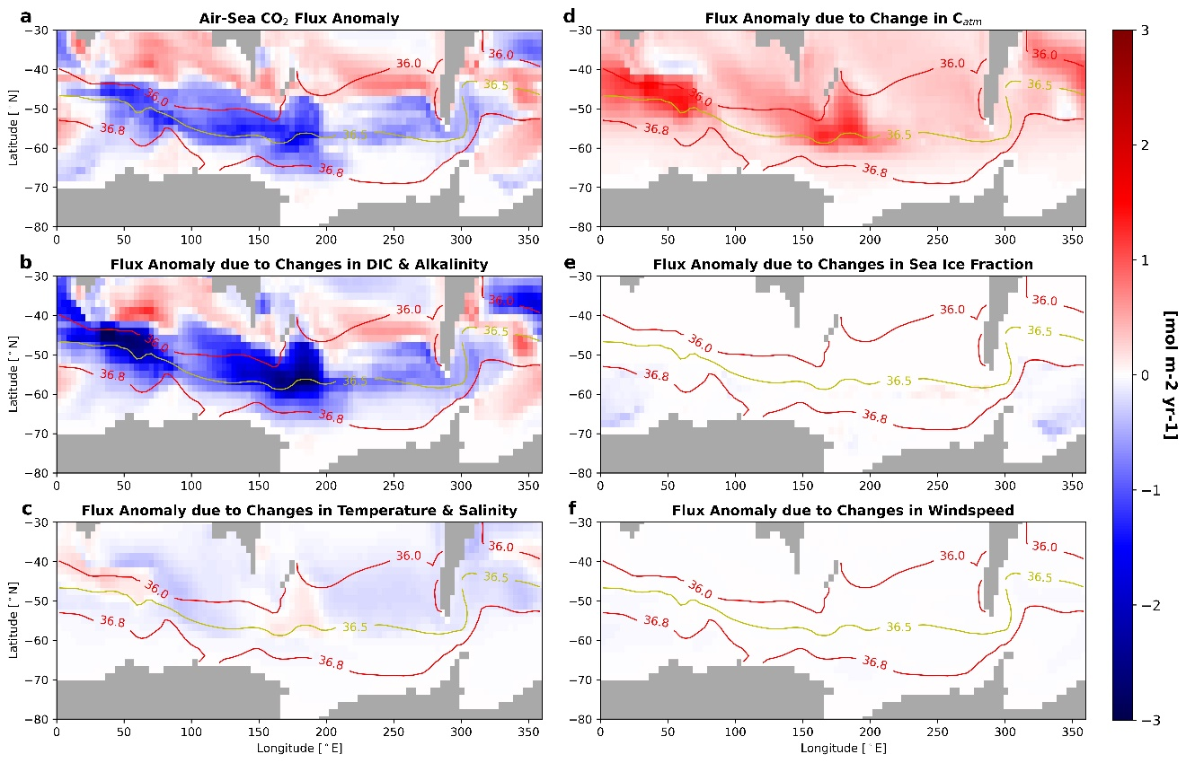
Supplementary Figure 4. Southern Ocean air-sea CO₂ flux anomaly is dominated by changes in the water’s alkalinity and dissolved inorganic carbon (DIC) content. (a) Air-sea CO₂ flux anomaly (mol m⁻² yr⁻¹) between the control and perturbed simulations (UVic-NP – UVic-ctrl), with negative values indicating reduced CO₂ outgassing or enhanced CO₂ uptake. (b-f) Air-sea CO₂ flux anomaly attributable to changes in the stated variable (i.e., all other variables held constant at UVic-NP values, and flux anomaly is then calculated from changes in the stated variable between the UVic-ctrl and UVic-NP simulations, thus isolating the signal in outgassing anomaly due to the stated variable alone). Note that (d) depicts the CO₂ flux anomaly due to changes both in atmospheric pCO₂ and in CO₂ solubility (a function of temperature and salinity changes between UVic-ctrl and UVic-NP); changes in atmospheric pCO₂ dominate the positive-anomaly signal, though the isolated regions of greater anomalies are attributed to temperature changes. Changes in (e) fractional sea ice cover and (f) wind speed also play a negligible role in the reported CO₂ flux anomaly (a). Red and yellow contours show isolines of σ₂ (potential density referenced to 2000 dbar) from the perturbed simulation (UVic-NP), meant to approximate the neutral surfaces along which these waters are expected to flow. σ₂ is plotted at 500m depth so as to avoid any influence of mixed layer processes.
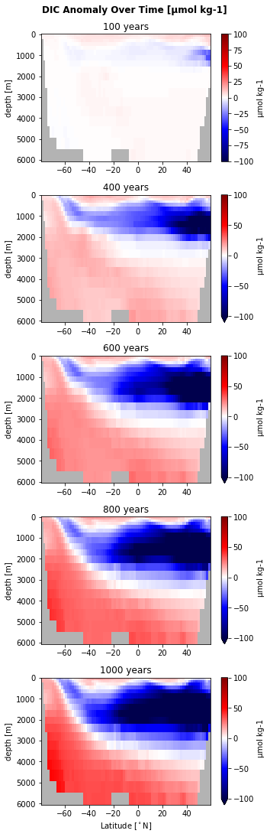
Supplementary Figure 5. Dissolved inorganic carbon (DIC) accumulates in deep waters in UVic-NP over UVic-ctrl. Dissolved inorganic carbon (DIC) anomaly (μmol kg⁻¹) between the control and perturbed simulation (UVic-NP – UVic-ctrl) averaged over the Pacific basin (140-240°E) is plotted over the model’s evolution.

