Supplementary information
Block Copolymer Architectures for Modulating Interactions to Enhance Selectivity and Stability of s-SWCNT Dispersions
Mei-Nung Chen,^{1,2} Rin Iwasaki,² Mayoh Ashiya,² Haoyu Zhao,³ Qi-An Hong,¹ Yen-Ting Li,¹ Kai-Lin Chen,¹ Maina Moses Mburu,¹ Wei-Ting Li,¹ Xiaodan Gu,³ Wei-Hung Chiang,^{1*} Takuya Isono,^{4*} Toshifumi Satoh,^{4,5,6*} Yu-Cheng Chiu.^{1,7*}
¹ Department of Chemical Engineering, National Taiwan University of Science and Technology, No.43, Sec. 4, Keelung Rd., Da'an Dist., Taipei City 10607, Taiwan. E-mail: Yu-Cheng Chiu: ycchiu@mail.ntust.edu.tw; Wei-Hung Chiang: whchiang@mail.ntust.edu.tw
² Graduate School of Chemical Sciences and Engineering, Hokkaido University, Sapporo 060-8628, Japan.
³ School of Polymer Science and Engineering, Center for Optoelectronic Materials and Device, The University of Southern Mississippi, Hattiesburg, MS 39406, USA.
⁴ Division of Applied Chemistry, Faculty of Engineering, Hokkaido University, Sapporo 060-8628, Japan. E-mail: Takuya Isono: isono.t@eng.hokudai.ac.jp; Toshifumi Satoh: satoh@eng.hokudai.ac.jp
⁵ List Sustainable Digital Transformation Catalyst Collaboration Research Platform (List-PF), Institute for Chemical Reaction Design and Discovery (ICReDD), Hokkaido University, Sapporo 001-0021, Japan.
⁶ Department of Chemical & Materials Engineering, National Central University, Taoyuan 320317, Taiwan.
⁷ Sustainable Electrochemical Energy Development Center, National Taiwan University of Science and Technology, Taipei City 10607, Taiwan.

Supplementary Methods. Experimental procedures for the preparation of monomers and polymers 4
Supplementary Synthesis of monomer 4
Supplementary Synthesis of AB type polyfluorene-based block copolymer 5
Supplementary Synthesis of A₃B type polyfluorene-based block copolymer 7
Supplementary Synthesis of AB type polyfluorene-based block copolymer with different soft segment 9
Supplementary Table 1. Synthesis of PF using various initiators ª 11
Supplementary Figure 1. a) MALDI-TOF MS of HO-PF_{6k} and b) structures and calculated molecular weights of (HO)₃-PF_{6k} and the predicted polymer structure. 11
Supplementary Figure 2. a) ¹H NMR spectra of BCPs (400 MHz, CDCl₃). b) SEC traces of BCPs (detected by RI detector; eluent, THF; flow rate, 1.0 mL min⁻¹). 12
Supplementary Figure 3. a) The zoom-in UV-Vis and PL spectra of PF and BCPs. b) TGA thermograms, c) second heating scans obtained of DSC curves, and d) WAXS profiles of the block copolymers and PF homopolymers. 13
Supplementary Table 2. The thermal properties of films composed of PCL-blocked BCPs by DSC 14
Supplementary Table 3. Summary of the major diameter SWCNTs sorted by polymer and percent of metallic and semiconducting SWCNTs ª 15
Supplementary Equation (1). The sc-SWCNT purity ratio from UV-vis-nIR spectra. 15
Supplementary Figure 4. 2D PLE maps of suspensions of SWCNTs sorted by homopolymer HO-PF_{6k}. 16
Supplementary Figure 5. Particle size were analyzed by dynamic light scattering (DLS) to assess hydrodynamic radius (R_{h}) of a) PCL_{6k}-b-PF_{6k}, PCL_{6k}-b-PF_{9k}, b) PCL_{17k}-b-PF_{6k} and (PCL_{6k})₃-b-PF_{6k} copolymers in toluene at 25 ℃. The polymer concentration of all solutions was 0.2 mg/mL in toluene. 16
Supplementary Equation (2). The stability ratio from UV-vis-nIR spectra. 17
Supplementary Figure 6. 2D PLE maps of stability measurement of suspensions of SWCNTs sortied by a) PCL_{17k}-b-PF_{6k} and b) (PCL_{6k})₃-b-PF_{6k} after 1 year of storage. 17
Supplementary Figure 7. a) The UV-Vis and PL spectra of BCPs in toluene. b) Absorption spectra of the suspensions of SWCNTs sorted by PF-based block polymer with different soft segments. c-f) 2D PLE maps of sorted SWCNTs by different polymers dispersed in aqueous toluene solution. 18
Supplementary Table 4. Summary of SWCNTs sorted by polymer and percent of metallic and semiconducting SWCNTs ª 19
Supplementary Figure 8. Representative hysteresis sweeps of TFTs of SWCNTs sorted by a) PCL_{17k}-b-PF_{6k} and b) (PCL_{6k})₃-b-PF_{6k} (V_{DS}= -60 V). Square root of source-drain current and output characteristics of TFTs of SWCNTs sorted by c, e) PCL_{17k}-b-PF_{6k} and d, f) (PCL_{6k})₃-b-PF_{6k}. 20
Supplementary Figure 9. The transfer curves and square root of source-drain current of TFTs with SWCNTs sorted by PCL_{17k}-b-PF_{6k}. (V_{DS}= -60 V). Inset in each transfer curves image is atomic force microscope (AFM) topography image of SWCNTs sorted by BCPs. The scanning size was 5$×$5 μm² at the digital resolution of 256$×$256 pixels. 21
Supplementary Figure 10. Transfer curves of devices fabricated using SWCNTs sorted with a) PCL_{17k}-b-PF_{6k} and b) (PCL_{6k})₃-b-PF_{6k} solution after 1 year of storage. (V_{DS}= -60 V) 22
Supplementary Figure 11. The ATR spectra on a thin film of SWCNT, pure PCL_{17k}-b-PF_{6k}, and (PCL_{6k})₃-b-PF_{6k}. 22
Supplementary Figure 12. AFM a) height and b) TUNA current channels of SWCNT sorted by (PCL_{6k})₃-b-PF_{6k}. The scanning size was 0.5$×$0.5 μm² at the digital resolution of 256$×$256 pixels. c) Line profile for height and TUNA current of locations indicated in the purple arrow direction in AFM-QNM images. 23
Supplementary Reference 23

Supplementary Methods. Experimental procedures for the preparation of monomers and polymers

Supplementary Synthesis of monomer
Synthesis of potassium 2-(7-bromo-9,9-dihexyl-9H-fluorene-2-yl)triolborate
Supplementary Scheme 1. Synthesis of triolborate salt fluorene monomer
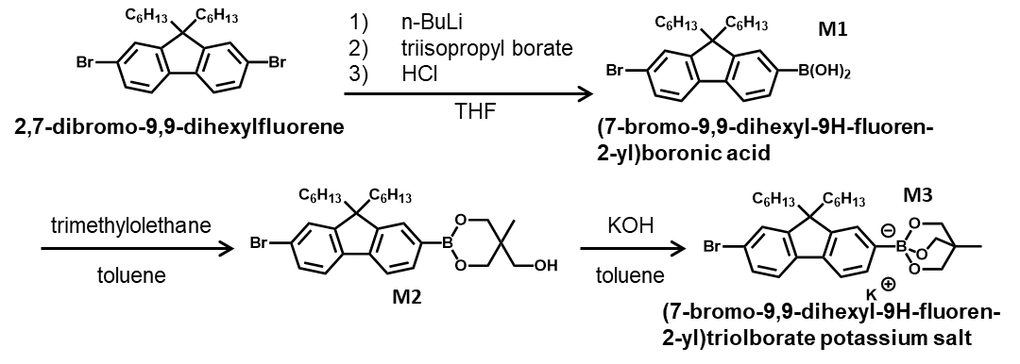
To a 500 mL three-necked round bottom flask, 2,7-dibromo-9,9-dihexylfluorene (17.0 g, 34.7 mmol) was added and dried under vacuum at room temperature overnight. Dry-THF (320 mL) was introduced to this flask and cooled to -78 °C. n-BuLi (12.6 mL, 34.7 mmol, 1.6 mol L⁻¹ in n-hexane) was injected slowly via a syringe, and the whole mixture was stirred for 1.5 h under argon atmosphere. Triisopropyl borate (11.9 mL, 52.1 mmol) was then added to this reaction mixture. The mixture was gradually brought back to room temperature and stirred for 24 h under argon atmosphere. The reaction was quenched by adding 10 mol L⁻¹ HCl (10 mL). The solvent was removed by evaporation, and the residue was dissolved in CH₂Cl₂ and washed with brine. The organic layer was dried over Na₂SO₄ and evaporated completely. The residue was purified by silica gel column chromatography (n-hexane → Acetone) to give 2-(7-bromo-9,9-dihexyl-9H- fluorene-2-yl)diisopropyl boronate (M2) (10.36 g, 63.1% yield) as a white powder.
2-(7-Bromo-9,9-dihexyl-9H-fluorene-2-yl)diisopropyl boronate (10.0 g, 21.8 mmol) and trimethylolethane (2.6 g, 21.8 mmol) were then dissolved in toluene (150 ml). Isopropanol was removed by azeotropic distillation for 4 h by a Dean-Stark apparatus. Then, KOH (1.2 g, 21.87 mmol) was added, and the mixture was refluxed for 4 h. The precipitate was collected by filtration, washed with cyclohexane, and dried under reduced pressure to give 2-(7-bromo-9,9-dihexyl-9H-fluorene-2-yl)triolborate potassium salt (M3) (4.6 g, 8.53 mmol, 38.9% yield) as a yellow solid.
¹H NMR (400 MHz, CD₃OH): δ (ppm) 7.57-7.31 (m, Ar-H), 3.75-3.45 (br, -O(CH₂)₃CCH₃), 2.03-1.71 (br, -CH₂(CH₂)₄CH₃), 1.10-0.69 (m, -CH₂(CH₂)₄CH₃), 0.50 (s, -O(CH₂)₃CCH₃).
HRMS (ESI): m/z calcd for C₃₀H₄₁BO₃Br⁻: 539.2337; found: 539.23407 [M-K]⁻

Supplementary Synthesis of AB type polyfluorene-based block copolymer
Synthesis of a-end hydroxy-functionalized polyfluorene (HO-PF_{6k}) via Suzuki-Miyaura Catalyst-Transfer Polycondensation (SCTP)
Supplementary Scheme 2. Synthesis of HO-PF via SCTP
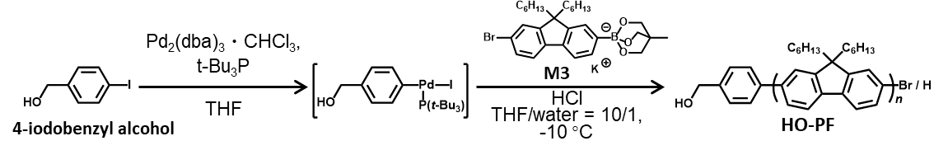
A typical procedure for SCTP of the triolborate salt type fluorene monomer (M3) is as follows (method A): In the glovebox, 4-iodobenzyl alcohol (53.9 mg, 230 μmol, 1.0 eq), Pd₂(dba)₃•CHCl₃ (71.5 mg, 69.0 μmol, 0.3 eq.), and t-Bu₃P (1.01 mL, 506 μmol, 2.2 eq., as 0.5 mol L⁻¹ stock solution in THF) was added in a vial and dissolved in THF (5 mL). After stirring for 20 min at room temperature, the vial was taken out from the glovebox. In a flask, a mixture of M3 (2.00 g, 3.45 mmol, 15 eq.), K₃PO₄ (73.3 mg, 345 μmol, 1.5 eq.), THF (309 mL), and deionized water (31.4 mL) were deoxygenated by argon bubbling for 1 h at -10 °C. The stock solution of the Pd-initiator was transferred to the flask under an argon atmosphere, and the entire mixture was vigorously stirred at -10 °C. After 15 min, 1 mol L⁻¹ HCl (30 mL) was added to the reaction mixture and the polymerization was terminated. The solvent was removed by evaporation, and the residue was dissolved in CH₂Cl₂ and washed with brine 3 times. The organic layer was dried over Na₂SO₄ and evaporated completely. The residue was dissolved in THF reprecipitated into a cold mixture of methanol and acetone (= 4/1 (v/v)) to give HO-PF as a gray solid. Yield: 574 mg (47.8%). M_{n,NMR} = 5,800 g mol⁻¹ (CDCl₃), M_{n,SEC} = 11,600 g mol⁻¹ (THF), Ð = 1.59 (THF).
¹H NMR (400 MHz, CDCl₃): δ (ppm) 7.85-7.67 (m, Ar-H), 4.78 (s, HOCH₂-), 2.11 (br, -CH₂(CH₂)₄CH₃), 1.26-0.76 (m, -CH₂(CH₂)₄CH₃).
Synthesis of HO-PF_{9k} via SCTP
Method A was used for the SCTP of M3 (2.00 g, 3.45 mmol, 30 eq.) with 4-iodobenzyl alcohol (27.0 mg, 115 μmol, 1.0 eq), Pd₂(dba)₃•CHCl₃ (35.7 mg, 34.5 μmol, 0.3 eq.), and t-Bu₃P (506 μL, 253 μmol, 2.2 eq., as 0.5 mol L⁻¹ stock solution in THF) in a mixture of THF (314 mL), K₃PO₄ (36.6 mg, 173 μmol, 1.5 eq) and deionized water (31.4 mL) to give HO-PF_{9k} as a gray solid. Yield: 231 mg (19.7%). M_{n,NMR} = 9,100 g mol⁻¹ (CDCl₃), M_{n,SEC} = 14,900 g mol⁻¹ (THF), Ð = 1.74 (THF).

Synthesis of AB type block copolymer (PCL_{6k}-b-PF_{6k}) via ring-opening polymerization (ROP)
Supplementary Scheme 3. Synthesis of PCL-b-PF via ROP
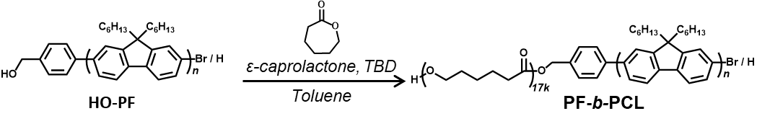
A typical procedure for ROP of ε-CL is as follows (method B): In the glovebox, HO-PF_{6k} (M_{n,NMR} = 5,800 g mol⁻¹, Ð = 1.59, 200 mg, 34.5 μmol, 1.0 eq.) and ε-CL (227 μL, 2.07 mmol, 60 eq.) were dissolved in dry-toluene (2.06 mL). TBD (4.8 mg, 34.5 μmol, 1.0 eq.) was then added to the monomer solution, and the entire mixture was vigorously stirred at 50 °C. After 2.5 h, benzoic acid was added to the reaction mixture and the polymerization was terminated. The solvent was removed by evaporation, and the residue was dissolved in THF, then reprecipitated into a cold methanol to give PCL_{6k}-b-PF_{6k} as a gray solid. Yield: 263 mg (65.1%). M_{n,NMR} = 11,400 g mol⁻¹ (CDCl₃), M_{n,SEC} = 21,500 g mol⁻¹ (THF), Ð = 1.36 (THF).
¹H NMR (400 MHz, CDCl₃): δ (ppm) 7.86-7.68 (m, Ar-H), 5.19 (s, -CH₂COO-), 4.06 (t, -OCH₂(CH₂)₅CH₂CO-), 3.65 (q, HOCH₂-), 2.31 (t, -OCH₂(CH₂)₅CH₂CO-), 2.13 (br, -CH₂(CH₂)₄CH₃), 1.68-0.76 (m, -OCH₂(CH₂)₅CH₂CO-, -CH₂(CH₂)₄CH₃).

Synthesis of PCL_{12k}-b-PF_{6k} via ROP
Method B was used for ROP of ε-CL (273 μL, 2.48 mmol, 120 eq.) with HO-PF_{6k} (M_{n,NMR} = 5,800 g mol⁻¹, Ð = 1.59, 120 mg, 20.7 μmol, 1.0 eq.) and TBD (2.9 mg, 21 μmol, 1.0 eq.) in toluene (2.48 mL) to give PCL_{12k}-b-PF_{6k} as a gray solid. Yield: 261 mg (74.8%). M_{n,NMR} = 17,600 g mol⁻¹ (CDCl₃), M_{n,SEC} = 26,800 g mol⁻¹ (THF), Ð = 1.36 (THF).

Synthesis of PCL_{17k}-b-PF_{6k} via ROP
Method B was used for ROP of ε-CL (256 μL, 2.33 mmol, 180 eq.) with HO-PF_{6k} (M_{n,NMR} = 5,800 g mol⁻¹, Ð = 1.59, 75.0 mg, 12.9 μmol, 1.0 eq.) and TBD (1.8 mg, 13 μmol, 1.0 eq.) in toluene (2.33 mL) to give PCL_{17k}-b-PF_{6k} as a gray solid. Yield: 262 mg (88.4%). M_{n,NMR} = 22,800 g mol⁻¹ (CDCl₃), M_{n,SEC} = 32,900 g mol⁻¹ (THF), Ð = 1.48 (THF).

Synthesis of PCL_{12k}-b-PF_{6k} via ROP
Method B was used for ROP of ε-CL (273 μL, 2.48 mmol, 120 eq.) with HO-PF_{6k} (M_{n,NMR} = 5,800 g mol⁻¹, Ð = 1.59, 120 mg, 20.7 μmol, 1.0 eq.) and TBD (2.9 mg, 21 μmol, 1.0 eq.) in toluene (2.48 mL) to give PCL_{12k}-b-PF_{6k} as a gray solid. Yield: 261 mg (74.8%). M_{n,NMR} = 17,600 g mol⁻¹ (CDCl₃), M_{n,SEC} = 26,800 g mol⁻¹ (THF), Ð = 1.36 (THF).

Synthesis of PCL_{17k}-b-PF_{6k} via ROP
Method B was used for ROP of ε-CL (256 μL, 2.33 mmol, 180 eq.) with HO-PF_{6k} (M_{n,NMR} = 5,800 g mol⁻¹, Ð = 1.59, 75.0 mg, 12.9 μmol, 1.0 eq.) and TBD (1.8 mg, 13 μmol, 1.0 eq.) in toluene (2.33 mL) to give PCL_{17k}-b-PF_{6k} as a gray solid. Yield: 262 mg (88.4%). M_{n,NMR} = 22,800 g mol⁻¹ (CDCl₃), M_{n,SEC} = 32,900 g mol⁻¹ (THF), Ð = 1.48 (THF).

Supplementary Synthesis of A₃B type polyfluorene-based block copolymer

Synthesis of triol-functionalized iodobenzene initiator (A₃B type initiator)
Supplementary Scheme 4. Synthesis of A₃B type initiator
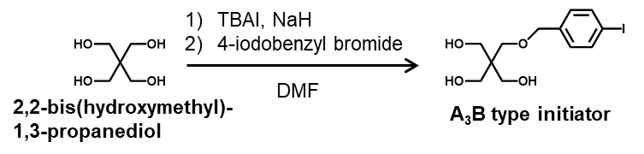
Under an argon atmosphere, NaH (60% dispersion in paraffin liquid, 0.64 g, 16 mmol, 1.3 eq) was added slowly to a stirred solution of 2,2-bis(hydroxymethyl)-1,3-propanediol (10.0 g, 73.4 mmol, 6.0 eq) and TBAI (1.13 g, 3.06 mmol, 0.25 eq) in dry-DMF (50 mL), and the entire mixture was vigorously stirred at room temperature. After 30 min, 4-iodobenzyl bromide (3.63 g, 12.2 mmol, 1.0 eq) dissolved in dry-DMF (20 mL) was then added slowly to the mixture, and the entire mixture was vigorously stirred at room temperature. After 24 h, methanol was added to the reaction mixture, and the reaction was quenched. The solvent was removed by evaporation, and the residue was dissolved in ethyl acetate and washed with brine three times. The organic layer was dried over Na₂SO₄ and evaporated completely. The residue was purified by silica gel column chromatography (ethyl acetate) to give 2-(hydroxymethyl)-2-(((4-iodobenzyl)oxy)methyl)propane-1,3-diol as a white solid. Yield: 1.40 g (32.5%).
¹H NMR (400 MHz, CD₃OD): δ (ppm) 7.66 (d, 2H, J = 8.2, Ar-H)), 7.11 (d, 2H, J = 8.2, Ar-H)), 4.44 (s, 2H, -OCH₂Ar-), 3.59 (s, 6H, -CCH₂OH), 3.46 (s, 2H, -CCH₂O-). ¹³C NMR (100 MHz, CD₃OD): δ (ppm) 138,137, 129, 92.1 (Ar), 72.4 (-CCH₂O-), 69.5 (-OCH₂Ar-), 61.7 (-CCH₂OH), 45.6 (-CH₂CCH₂-). HRMS (ESI): m/z calcd for C₁₂H₁₇O₄INa⁺: 375.00637; found: 375.00534.

Synthesis of a-end trihydroxy-functionalized polyfluorene (HO)₃-PF_{6k} via SCTP
Supplementary Scheme 5. Synthesis of (HO)₃-PF
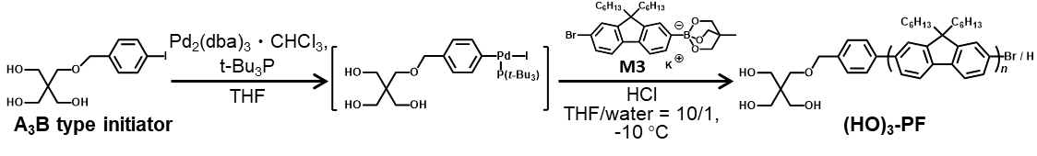
Method A was used for the SCTP of M3 (1.00 g, 1.73 mmol, 15 eq.) with 2-(hydroxymethyl)-2-(((4-iodobenzyl)oxy)methyl)propane-1,3-diol (40.5 mg, 115 μmol, 1.0 eq), Pd₂(dba)₃•CHCl₃ (35.7 mg, 34.5 μmol, 0.3 eq.), and t-Bu₃P (506 μL, 253 μmol, 2.2 eq., as 0.5 mol L⁻¹ stock solution in THF) in a mixture of THF (157 mL), K₃PO₄ (36.6 mg, 173 μmol, 1.5 eq), and deionized water (15.7 mL) to give (HO)₃-PF_{6k} as a gray solid. Yield: 252 mg (41.0%). M_{n,NMR} = 6,200 g mol⁻¹ (CDCl₃), M_{n,SEC} = 12,900 g mol⁻¹ (THF), Ð = 1.64 (THF).
¹H NMR (400 MHz, CDCl₃): δ (ppm) 7.86-7.68 (m, Ar-H), 4.56 (s, -OCH₂Ar-), 3.79 (m, HOCH₂C-), 3.65 (s, -CCH₂O-), 2.13 (br, -CH₂(CH₂)₄CH₃), 1.26-0.78 (m, -CH₂(CH₂)₄CH₃).

Synthesis of A₃B type block copolymer (PCL_{4k})₃-PF_{6k} via ROP
Supplementary Scheme 6. Synthesis of (PCL)₃-b-PF
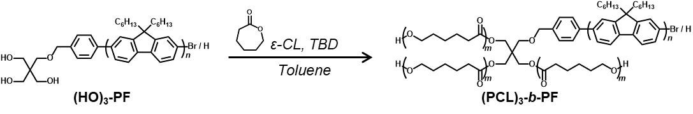
Method B was used for ROP of ε-CL (85.1 μL, 774 μmol, 120 eq.) with (HO)₃-PF_{6k} (M_{n,NMR} = 6,200 g mol⁻¹, Ð = 1.62, 40.0 mg, 6.45 μmol, 1.0 eq.) and TBD (0.9 mg, 6.5 μmol, 1.0 eq.) in toluene (774 μL) to give (PCL_{4k})₃-b-PF_{6k} as a gray solid. Yield: 67.1 mg (63.3%). M_{n,NMR} = 17,300 g mol⁻¹ (CDCl₃), M_{n,SEC} = 31,300 g mol⁻¹ (THF), Ð = 1.48 (THF). ¹H NMR (400 MHz, CDCl₃): δ (ppm) 7.86-7.68 (m, Ar-H), 4.57 (s, -OCH₂Ar-), 4.06 (t, -OCH₂(CH₂)₅CH₂CO-, HOCH₂-), 3.89-3.83 (m, -CCH₂O-), 3.63 (q, HOCH₂C-), 2.31 (t, -OCH₂(CH₂)₅CH₂CO-), 2.13 (br, -CH₂(CH₂)₄CH₃), 1.69-0.78 (m, -CCH_{3,} -OCH₂(CH₂)₅CH₂CO-, -CH₂(CH₂)₄CH₃).

Synthesis of (PCL_{6k})₃-PF_{6k} via ROP
Method B was used for ROP of ε-CL (383 μL, 3.48 mmol, 180 eq.) with (HO)₃-PF_{6k} (M_{n,NMR} = 6,200 g mol⁻¹, Ð = 1.62, 120 mg, 19.4 μmol, 1.0 eq.) and TBD (2.7 mg, 19 μmol, 1.0 eq.) in toluene (348 μL) to give (PCL_{6k})₃-b-PF_{6k} as a gray solid. Yield: 384 mg (72.3%). M_{n,NMR} = 22,300 g mol⁻¹ (CDCl₃), M_{n,SEC} = 43,800 g mol⁻¹ (THF), Ð = 1.43 (THF).

Supplementary Synthesis of AB type polyfluorene-based block copolymer with different soft segment
Synthesis of AB type block copolymer PVL_{7k}-b-PF_{6k} via ROP
Supplementary Scheme 7. Synthesis of PVL_{7k}-b-PF_{6k}
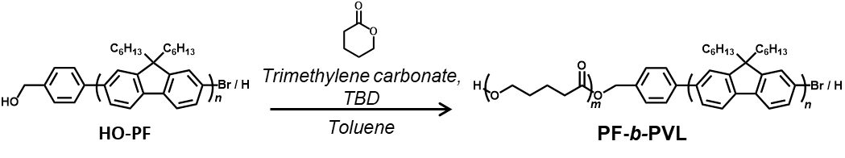
A typical procedure for ROP of δ-VL is as follows : In the glovebox, HO-PF_{6k} (M_{n, NMR} = 6,000 g mol⁻¹, Ð = 1.65, 100 mg, 16.7 μmol, 1.0 eq.) and δ-VL (113 μL, 1.25 mmol, 75 eq.) were dissolved in dry-toluene (1.3 mL). TBD (2.3 mg, 16.7 µmol, 1.0 eq.) was then added to the monomer solution, and the entire mixture was vigorously stirred at 50 °C. After 15 min, benzoic acid was added to the reaction mixture and the polymerization was terminated. The solvent was removed by evaporation, and the residue was dissolved in THF, then reprecipitated into a cold methanol/n-hexane = 9/1 (v/v ) to give PVL_{7k}-b-PF_{6k} as a gray solid. Yield: 158 mg, (70.1%). M_{n, NMR} = 12,700 g mol⁻¹ (CDCl₃), M_{n, SEC} = 20,000 g mol⁻¹ (THF), Ð = 1.45 (THF).
¹H NMR (400 MHz, CDCl₃): δ (ppm) 7.86-7.68 (m, Ar-H), 5.19 (s, -CH₂COO-), 4.08 (t, -OCH₂(CH₂)₂CH₂CO-), 3.66 (q, HOCH₂-), 2.34 (t, -OCH₂(CH₂)₂CH₂CO-), 2.12 (br, -CH₂(CH₂)₄CH₃), 1.69-1.67 (m, -OCH₂(CH₂)₂CH₂CO-), 1.14-0.78 (m, -CH₂(CH₂)₄CH₃).

Synthesis of AB type block copolymer PLA_{6k}-b-PF_{4k} via ROP
Supplementary Scheme 8. Synthesis of PLA_{6k}-b-PF_{4k}
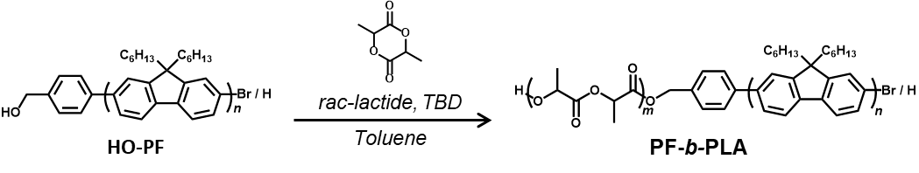
A typical procedure for ROP of rac-LA is as follows : In the glovebox, HO-PF_{6k} (M_{n, NMR} = 4,100 g mol⁻¹, Ð = 1.77, 70 mg, 17.1 μmol, 1.0 eq.) and rac-LA (128.0 mg, 888 µmol, 52 eq.) were dissolved in dry-CH₂Cl₂ (3.6 mL). DBU (2.5 µL, 17.1 µmol, 1.0 eq.) was then added to the monomer solution, and the entire mixture was vigorously stirred at r.t.. After 15 h, benzoic acid was added to the reaction mixture and the polymerization was terminated. The solvent was removed by evaporation, and the residue was dissolved in THF, then reprecipitated into a cold methanol to give PLA_{6k}-b-PF_{4k} as a gray solid. Yield: 109 mg, (55.0%). M_{n, NMR} = 9,900 g mol⁻¹ (CDCl₃), M_{n, SEC} = 15,000 g mol⁻¹ (THF), Ð = 1.30 (THF).
¹H NMR (400 MHz, CDCl₃): δ (ppm) 7.86-7.67 (m, Ar-H), 5.29-5.14 (m, -CH₂COO-, -OCH(CH₃)OCH(CH₃)-), 4.40-4.34 (m, HOCH(CH₃)O-), 2.13 (br, -CH₂(CH₂)₄CH₃), 1.61-1.53 (m, -OCH(CH₃)OCH(CH₃)-), 1.13-0.78 (m, -CH₂(CH₂)₄CH₃).

Synthesis of AB type block copolymer PTMC_{6k}-b-PF_{6k} via ROP
Supplementary Scheme 9. Synthesis of PTMC_{6k}-b-PF_{6k}
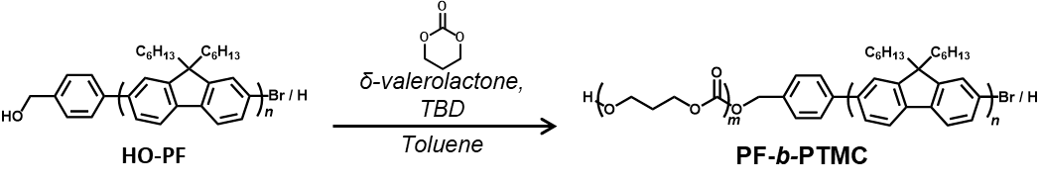
A typical procedure for ROP of TMC is as follows: In the glovebox, HO-PF_{6k} (M_{n, NMR} = 6,000 g mol⁻¹, Ð = 1.65, 100 mg, 16.7 μmol, 1.0 eq.) and TMC (124.2 mg, 1.22 mmol, 73 eq.) were dissolved in dry-toluene (2.4 mL). DPP (4.2 mg, 16.7 µmol, 1.0 eq.) was then added to the monomer solution, and the entire mixture was vigorously stirred at 70 °C. After 5 h, the solvent was removed by evaporation, and the residue was dissolved in THF, then reprecipitated into a cold methanol/n-hexane = 9/1 (v/v) to give PTMC_{6k}-b-PF_{6k} as a black solid. Yield: 120 mg, (53.5%). M_{n, NMR} = 12,200 g mol⁻¹ (CDCl₃), M_{n, SEC} = 14,800 g mol⁻¹ (THF), Ð = 1.55 (THF).
¹H NMR (400 MHz, CDCl₃): δ (ppm) 7.86-7.68 (m, Ar-H), 5.23 (s, -CH₂COO-), 4.24 (t, -OCH₂CH₂CH₂CO-), 3.75 (q, HOCH₂-), 2.13-1.92 (m, -CH₂(CH₂)₄CH₃, -OCH₂CH₂CH₂CO-), 1.14-0.78 (m, -CH₂(CH₂)₄CH₃).

Supplementary Table 1. Synthesis of PF using various initiators ª
sample | [monomer]₀  /[initiator]₀ | conv. (%) | M_{n,NMR}^{b}  (g mol⁻¹) | M_{n,SEC} ^{c}  (g mol⁻¹) | Ð ^{c} | yield (%)
HO-PF_{6k} | 15/1 | >99 | 5,800 | 11,600 | 1.59 | 47.8
HO-PF_{9k} | 30/1 | >99 | 9,100 | 14,900 | 1.74 | 19.7
(HO)₃-PF_{6k} | 15/1 | >99 | 6,200 | 12,900 | 1.64 | 41.0
ªPolymerization conditions: temperature, -10 °C; atmosphere, Ar; [initiator]₀/[Pd₂dba₃・CHCl₃]₀/[t-Bu₃P]₀ = 1/0.3/2.2. ^{b}Determined by ¹H NMR spectrum in CDCl₃. ^{c}Determined by SEC in THF using PSt standards.

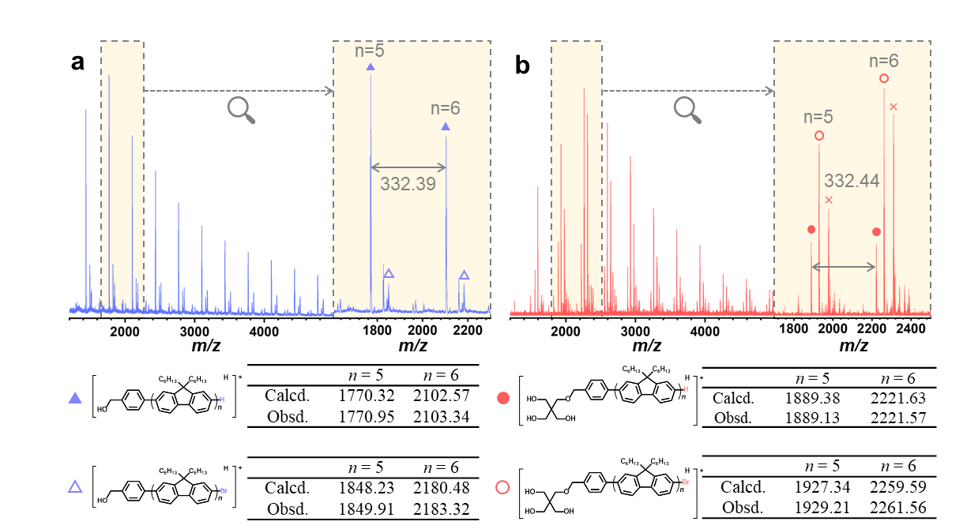

Supplementary Figure 1. a) MALDI-TOF MS of HO-PF_{6k} and b) structures and calculated molecular weights of (HO)₃-PF_{6k} and the predicted polymer structure.
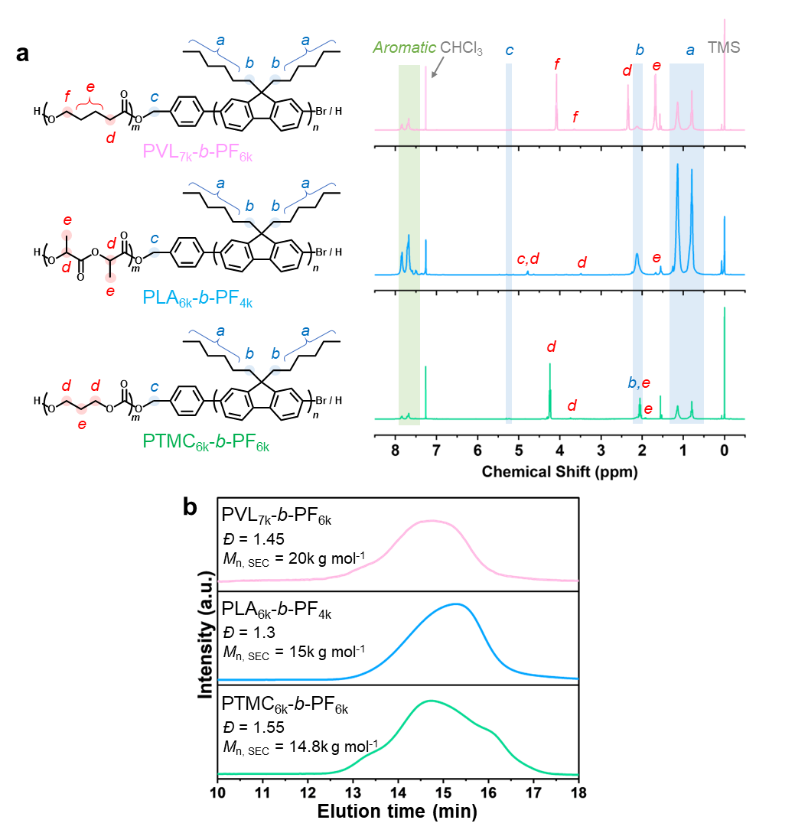

Supplementary Figure 2. a) ¹H NMR spectra of BCPs (400 MHz, CDCl₃). b) SEC traces of BCPs (detected by RI detector; eluent, THF; flow rate, 1.0 mL min⁻¹).
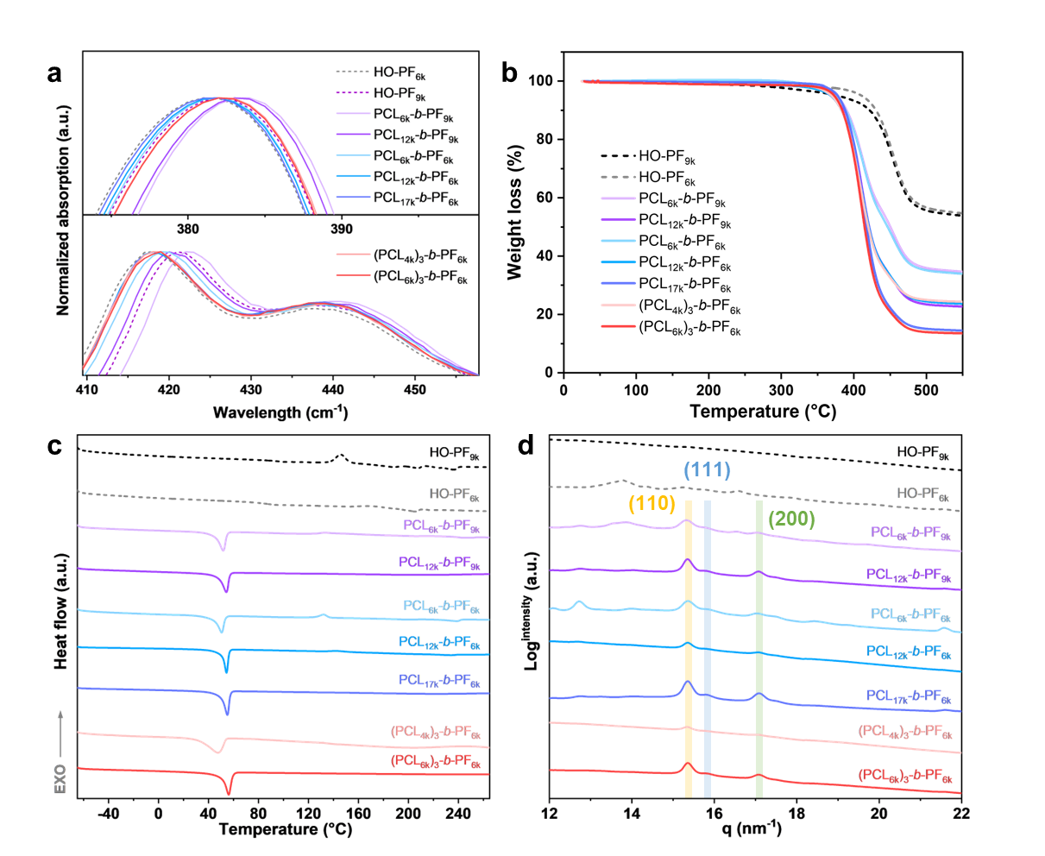

Supplementary Figure 3. a) The zoom-in UV-Vis and PL spectra of PF and BCPs. b) TGA thermograms, c) second heating scans obtained of DSC curves, and d) WAXS profiles of the block copolymers and PF homopolymers.

Supplementary Table 2. The thermal properties of films composed of PCL-blocked BCPs by DSC
Sample | PCL fraction (wt%) | T_{m, PCL}ª (ºC) | ΔH_{m, PCL}^{b} (J g⁻¹) | X_{PCL}^{c} (%)
PCL_{6k}-b-PF_{9k} | 39 | 51.9 | 23 | 16.49
PCL_{12k}-b-PF_{9k} | 58 | 54.1 | 41.5 | 29.75
PCL_{6k}-b-PF_{6k} | 49 | 50.4 | 29.3 | 21.00
PCL_{12k}-b-PF_{6k} | 67 | 54 | 39.4 | 28.24
PCL_{17k}-b-PF_{6k} | 75 | 55.2 | 50.7 | 36.34
(PCL_{4k})₃-b- PF_{6k} | 66 | 46.8 | 27.3 | 19.57
(PCL_{6k})₃-b- PF_{6k} | 74 | 56.1 | 43.5 | 31.18
ªThe melting temperature of PCL crystals refers to the temperature at the peak maximum of the endothermic melting transition, as measured by DSC analysis at a rate of 10 °C min⁻¹. ^{b}The heat of fusion of PCL crystals, measured by DSC analysis at a rate of 10 °C min⁻¹. ^{c}X_{PCL} = ΔH_{PCL}/ΔH_{PCL}⁰, where ΔH_{PCL}⁰ (T_{m, PCL}⁰) is the melting enthalpy of fusion of completely crystalline PCL (139.5 J g⁻¹).¹

Supplementary Table 3. Summary of the major diameter SWCNTs sorted by polymer and percent of metallic and semiconducting SWCNTs ª
Polymer | Sorted major diameter (nm) | SWCNT composition (%)
Polymer | Sorted major diameter (nm) | Metal | Semi.
HO-PF_{6k} | -- | -- | --
PCL_{6k}-b-PF_{9k} | -- | 28.45 | 71.55
PCL_{12k}-b-PF_{9k} | 1.232 | 23.80 | 76.20
PCL_{6k}-b-PF_{6k} | 1.232, 1.145 | 15.38 | 84.62
PCL_{12k}-b-PF_{6k} | 1.232, 1.145 | 14.75 | 85.25
PCL_{17k}-b-PF_{6k} | 1.145 | 9.30 | 90.70
(PCL_{4k})₃-b- PF_{6k} | 1.232, 1.145 | 13.53 | 86.47
(PCL_{6k})₃-b- PF_{6k} | 1.145 | 11.70 | 89.57
ªCalculated by equation (S1) from UV-vis-nIR spectra.

Supplementary Equation (1). The sc-SWCNT purity ratio from UV-vis-nIR spectra.
$$\text{\% sc}\text{-}\text{SWCNT = }\frac{{\text{A}}_{\text{sc}\text{-}\text{SWCNT}}}{\left({\text{A}}_{\text{sc}\text{-}\text{SWCNT}}\text{ + }{\text{A}}_{\text{m}\text{-}\text{SWCNT}}\right)}\text{×}\text{ 100\%}\text{⋯}\text{(1)}$$
A_{sc-SWCNT}: the areas of the S₂₂ and S₁₁ absorption peaks by curve fitting analysis
A_{m-SWCNT}: the areas of the M₁₁ absorption peaks by curve fitting analysis
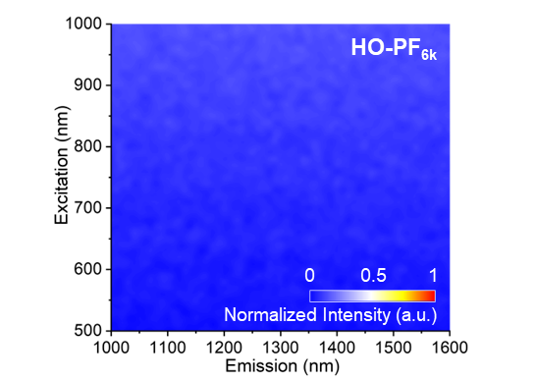

Supplementary Figure 4. 2D PLE maps of suspensions of SWCNTs sorted by homopolymer HO-PF_{6k}.

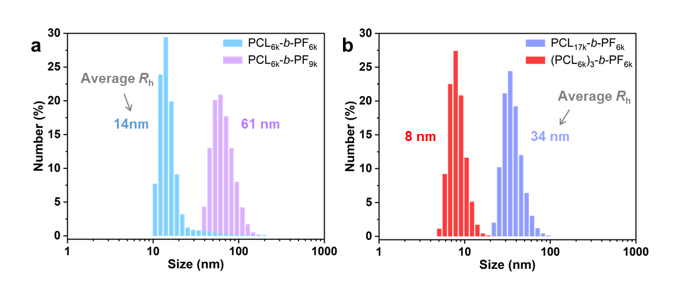

Supplementary Figure 5. Particle size were analyzed by dynamic light scattering (DLS) to assess hydrodynamic radius (R_{h}) of a) PCL_{6k}-b-PF_{6k}, PCL_{6k}-b-PF_{9k}, b) PCL_{17k}-b-PF_{6k} and (PCL_{6k})₃-b-PF_{6k} copolymers in toluene at 25 ℃. The polymer concentration of all solutions was 0.2 mg/mL in toluene.

Supplementary Equation (2). The stability ratio from UV-vis-nIR spectra.
$$\text{\%}\text{ stability ratio}\text{ = }\frac{{\text{A}}_{\text{n}}}{{\text{A}}_{\text{fresh}}}\text{×}\text{ 100\%}\text{⋯}\text{(}\text{2}\text{)}$$
${\text{A}}_{\text{fresh}}$: the areas of the S₂₂ absorption peaks of fresh polymer-SWCNT suspension
${\text{A}}_{\text{n}}$: the areas of the S₂₂ absorption peaks of polymer-SWCNT suspension in the testing period

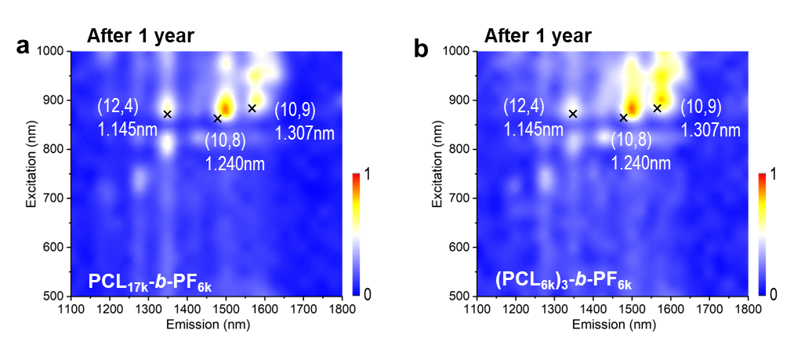

Supplementary Figure 6. 2D PLE maps of stability measurement of suspensions of SWCNTs sortied by a) PCL_{17k}-b-PF_{6k} and b) (PCL_{6k})₃-b-PF_{6k} after 1 year of storage.
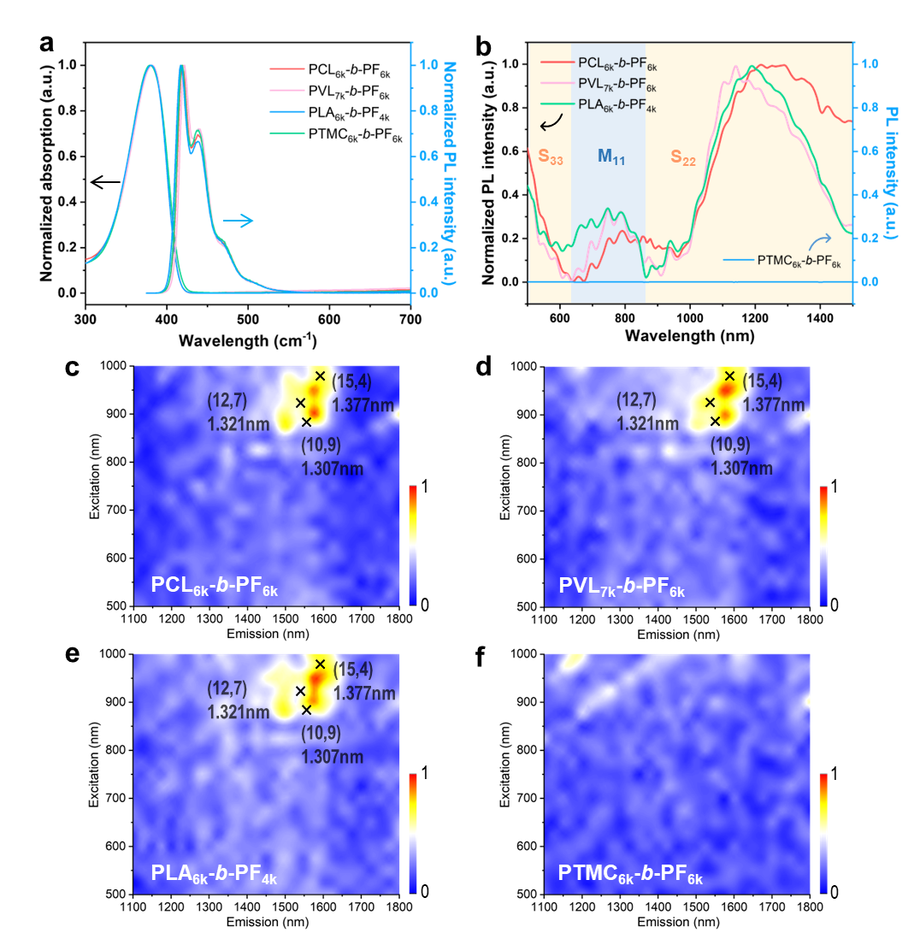

Supplementary Figure 7. a) The UV-Vis and PL spectra of BCPs in toluene. b) Absorption spectra of the suspensions of SWCNTs sorted by PF-based block polymer with different soft segments. c-f) 2D PLE maps of sorted SWCNTs by different polymers dispersed in aqueous toluene solution.

Supplementary Table 4. Summary of SWCNTs sorted by polymer and percent of metallic and semiconducting SWCNTs ª
Sample | Composition (%)
Sample | Metal | Semi.
PCL_{6k}-b-PF_{6k} | 13.11 | 86.89
PVL_{7k}-b-PF_{6k} | 15.13 | 84.87
PLA_{6k}-b-PF_{4k} | 17.22 | 82.78
PTMC_{6k}-b-PF_{6k} | 29.54 | 70.46
ªCalculated by equation (S1) from UV-vis-nIR spectra.
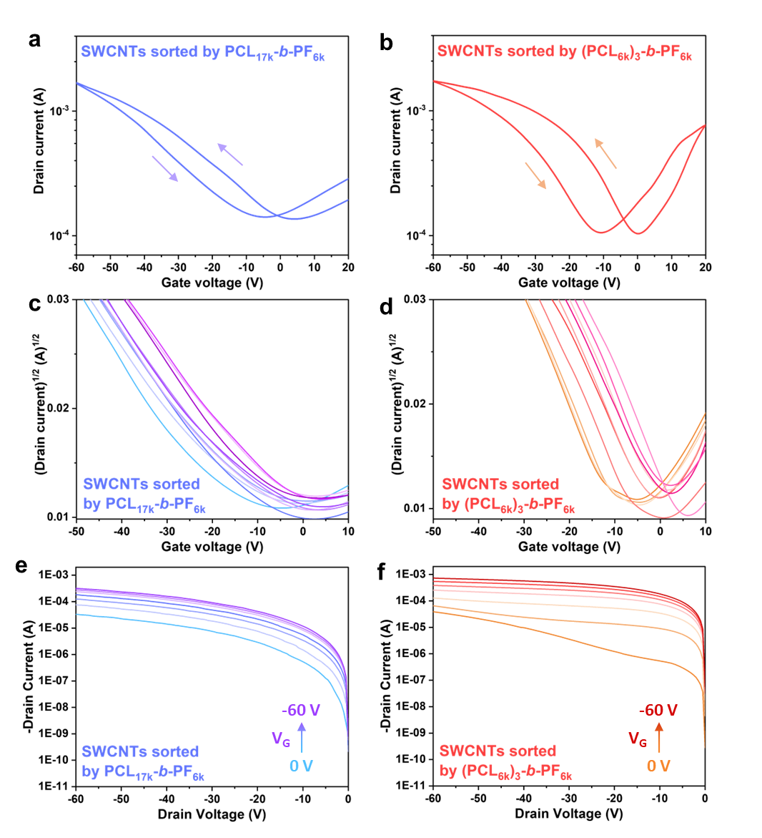

Supplementary Figure 8. Representative hysteresis sweeps of TFTs of SWCNTs sorted by a) PCL_{17k}-b-PF_{6k} and b) (PCL_{6k})₃-b-PF_{6k} (V_{DS}= -60 V). Square root of source-drain current and output characteristics of TFTs of SWCNTs sorted by c, e) PCL_{17k}-b-PF_{6k} and d, f) (PCL_{6k})₃-b-PF_{6k}.
Supplementary Table 5. Summary of performance of TFTs of SWCNTs sorted by PCL_{17k}-b-PF_{6k} and (PCL_{6k})₃-b-PF_{6k} (V_{DS}= -60 V) measured in bottom-gate, top-contact OFET devices.
Conc. ratio | SWCNTs sorted by PCL_{17k}-b-PF_{6k} |  | SWCNTs sorted by (PCL_{6k})₃-b-PF_{6k}
Hole mobility (cm² V⁻¹ s⁻¹) | Max mobility | Average mobility | Max mobility | Average mobility
 | 5.00 | 4.39 | 12.65 | 11.94
 | 4.16 | 4.16 | 12.39 | 12.34
 | 4.39 | 3.97 | 12.57 | 12.45
 | 4.16 | 3.91 | 10.50 | 9.28
 | 4.34 | 4.05 | 12.11 | 11.19
 | 4.59 | 3.94 | 11.82 | 10.58
 | 5.25 | 4.84 | 12.51 | 12.40
 | 3.96 | 3.71 | 10.00 | 9.26
 | 3.67 | 3.29 | 13.13 | 13.00
 | 4.02 | 3.97 | 12.30 | 12.29
Average | 4.35 | 4.02 | 12.00 | 11.47
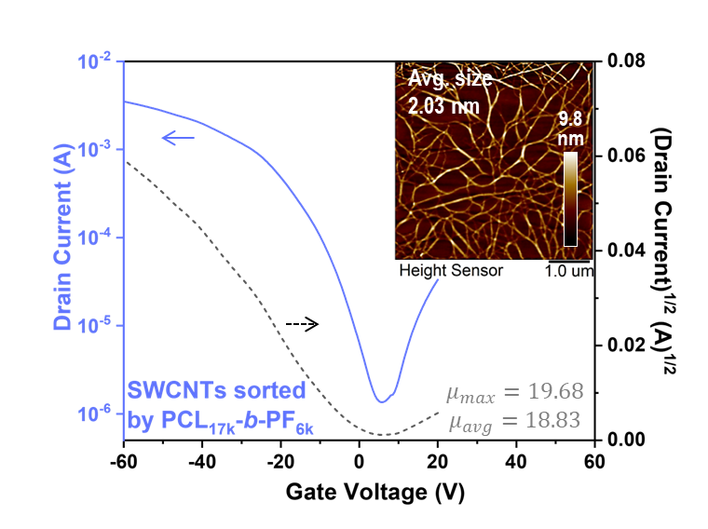

Supplementary Figure 9. The transfer curves and square root of source-drain current of TFTs with SWCNTs sorted by PCL_{17k}-b-PF_{6k}. (V_{DS}= -60 V). Inset in each transfer curves image is atomic force microscope (AFM) topography image of SWCNTs sorted by BCPs. The scanning size was 5$×$5 μm² at the digital resolution of 256$×$256 pixels.
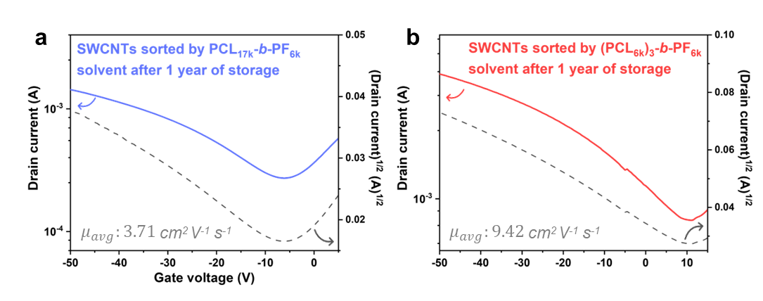

Supplementary Figure 10. Transfer curves of devices fabricated using SWCNTs sorted with a) PCL_{17k}-b-PF_{6k} and b) (PCL_{6k})₃-b-PF_{6k} solution after 1 year of storage. (V_{DS}= -60 V)
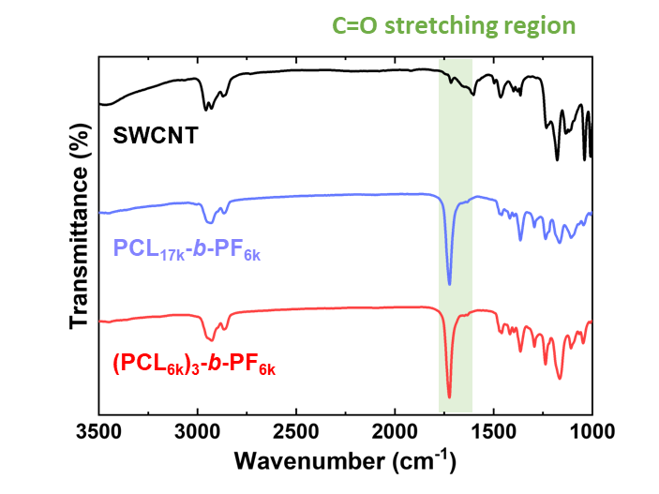

Supplementary Figure 11. The ATR spectra on a thin film of SWCNT, pure PCL_{17k}-b-PF_{6k}, and (PCL_{6k})₃-b-PF_{6k}.
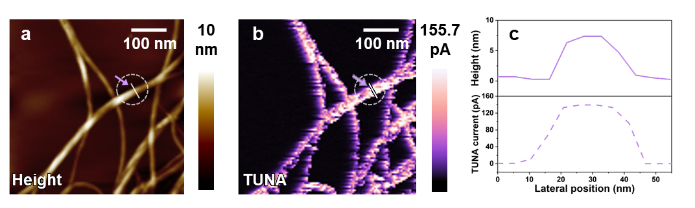

Supplementary Figure 12. AFM a) height and b) TUNA current channels of SWCNT sorted by (PCL_{6k})₃-b-PF_{6k}. The scanning size was 0.5$×$0.5 μm² at the digital resolution of 256$×$256 pixels. c) Line profile for height and TUNA current of locations indicated in the purple arrow direction in AFM-QNM images.

Supplementary Reference
- Fernández-Tena, A. et al. A. J. Effect of molecular weight on the crystallization and melt memory of poly(ε-caprolactone) (PCL). Macromolecules 56, 4602-4620 (2023).

