Supplementary material

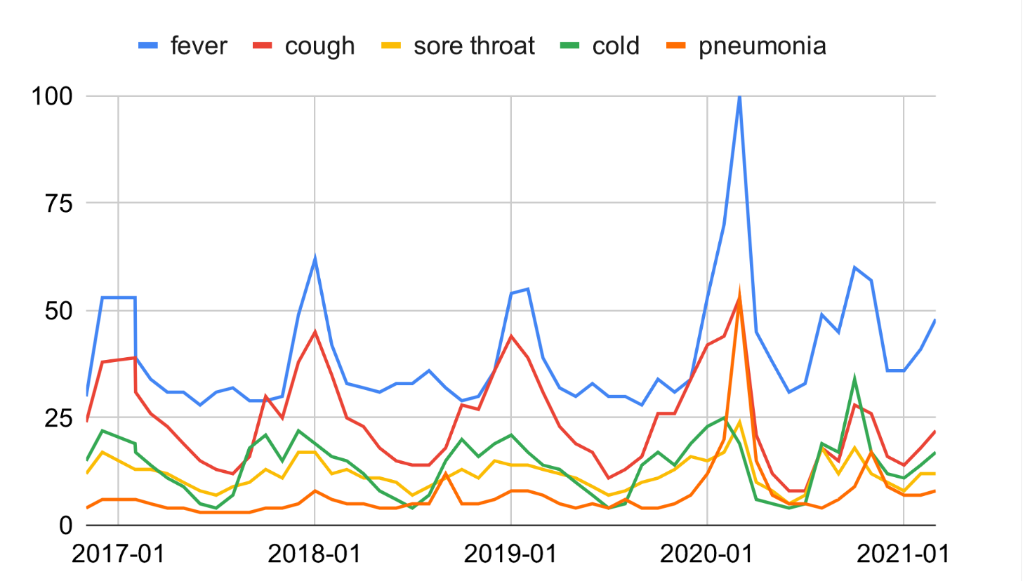Supplementary Figure 1. Trend of COVID-19 symptoms-related web queries from 2017 to 2021 (Google Trends). The relative search volumes shown are cumulative monthly.

