Supporting Information
for
Hydrogen Absorption Kinetics and Hydride Formation Pressures in Individual Pd Nanoparticles with Systematically Varied Levels of Plastic Deformation

Carl Andersson¹, Jonathan Zimmerman², Joachim Fritzsche¹, Eugen Rabkin^{2,§} and Christoph Langhammer^{1*}

¹Department of Physics, Chalmers University of Technology; SE-412 96 Gothenburg, Sweden
²Department of Materials Science and Engineering, Technion - Israel Institute of Technology, 3200003 Haifa, Israel

Corresponding authors: §erabkin@technion.ac.il; *clangham@chalmers.se

SEM images before and after 19 hydrogenation cycles

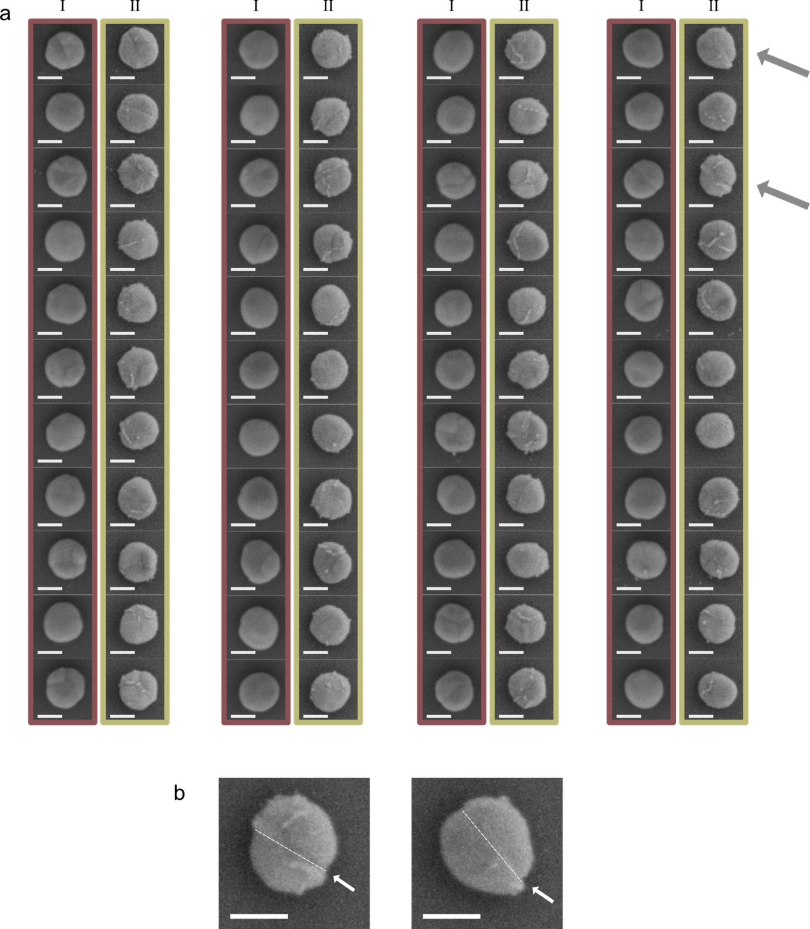

Supplementary Figure 1. (a) SEM micrographs of individual Pd nanoparticles before (columns outlined with red boxes and “I” above each column) and after (columns outlined with yellow boxes and “II” above each column) hydrogen cycling. The imaged sample (S2) was fabricated in the same way as the sample discussed in the main text (S1) - except that no particles have been compressed. The particles have been cycled with 19 hydrogenation cycles using the same hydrogenation procedure as for the sample discussed in the main text (S1), see supplementary file Hydrogenation summary - sample 1 and Hydrogenation summary - sample 2. We note the clearly visible Pd protrusions that have formed on all the particles after cycling. (b) High-magnification SEM micrographs of the particles highlighted with gray arrows in (a). Noticeable shear damage to the particles is highlighted by a white arrow and a dashed white line. Scale bars are 100 nm.

Load-displacement data of particles in the main text

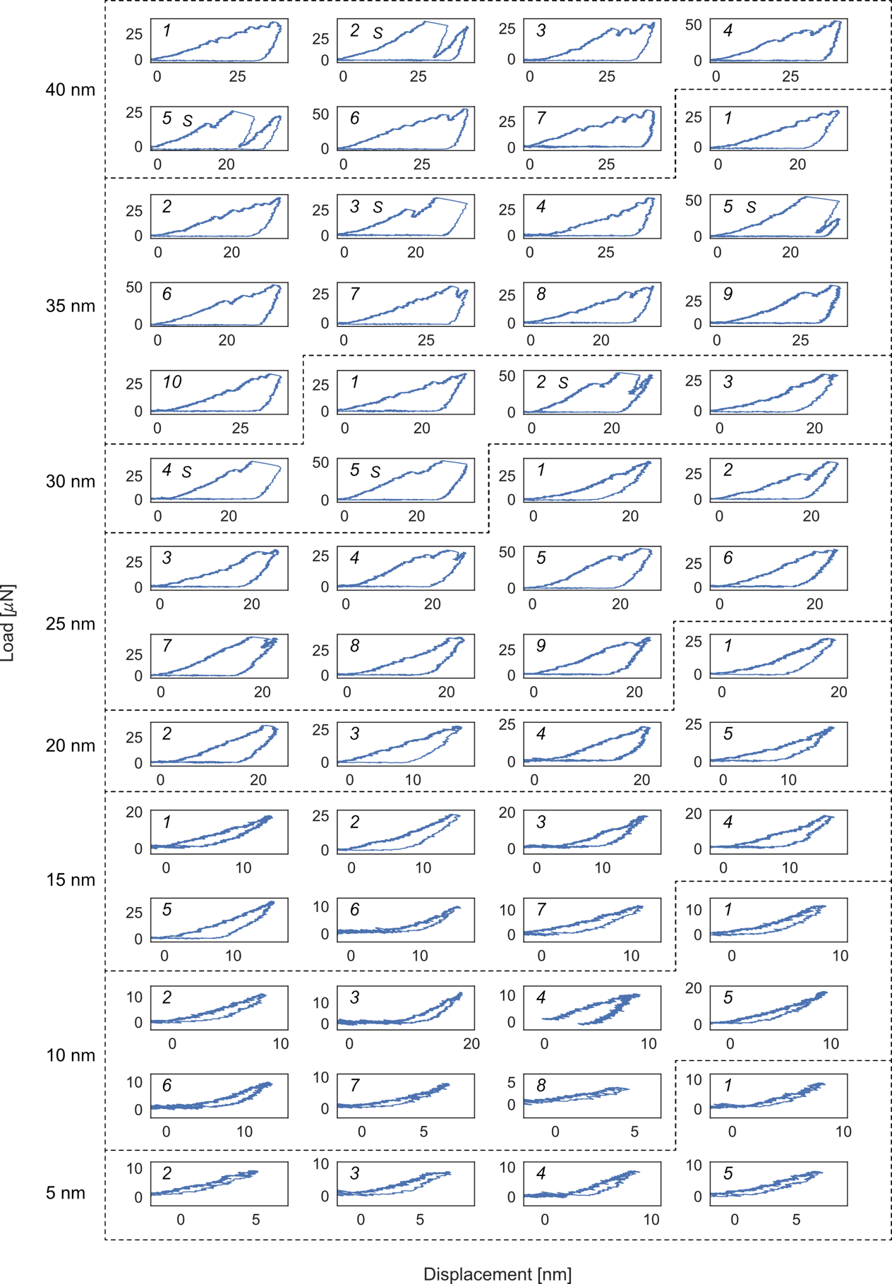

Supplementary Figure 2. Load-displacement diagrams for all 56 compressed particles. The diagrams are numbered in line with Supplementary Figure 13. Particles experiencing a strain-burst typical for single crystals are marked with an “S”.
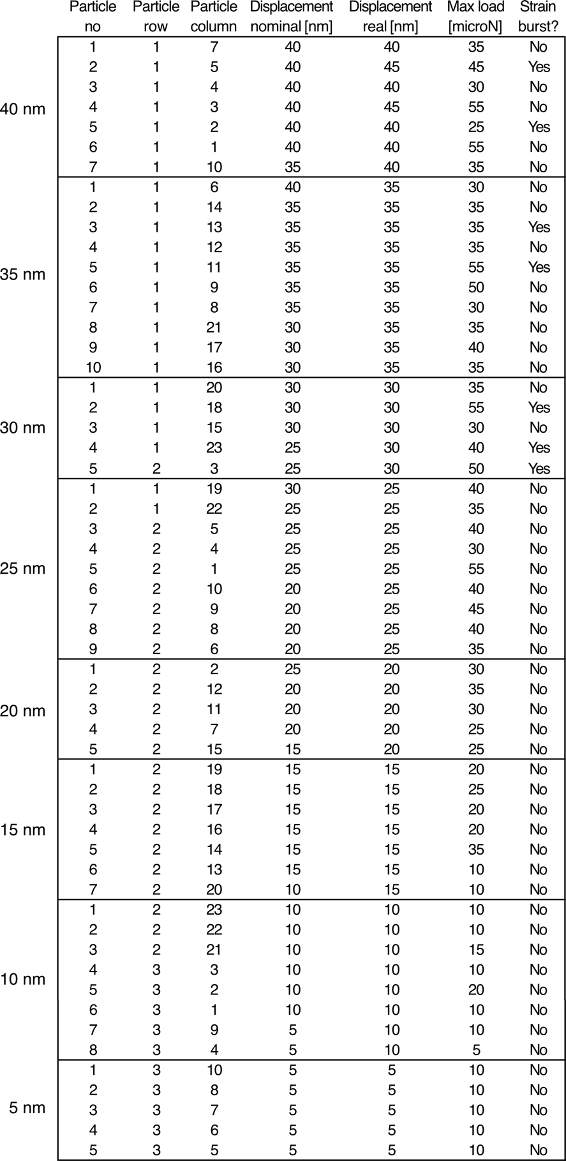
Supplementary Figure 3. Deformation properties for all nano-compressed particles. Particle are sorted (top to bottom) after their actual measured displacement (i.e. not after nominal displacement values), with “particle no” in accordance with the number on each individual load-displacement diagram in Supplementary Figure 2 (and consequently, the same numbering as in Supplementary Figure 13). Particle column numbering is left-to-right, top-to-bottom of the compressed particles in Figure 2b of the main text. The true, as well as the target displacement values are presented together with the maximum load that was put on the particle during the compression. The “strain burst” column describes if a particle’s deformation was characteristic of a single crystal, as in Figure 1f of main text.

Experimental setup
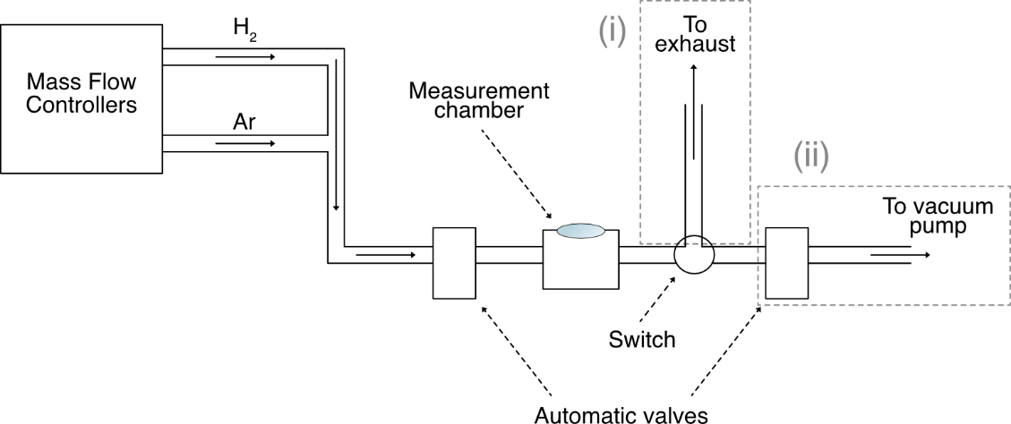

Supplementary Figure 4. Schematic of the experimental setup. The samples are placed inside a gas-tight measurement chamber with optical access through a top-mounted glass window. The chamber has a feedback-controlled heating stage to keep the sample at a stable temperature. An inlet and outlet provide gas exchange through automatic valves. Mass flow controllers provide controllable gas flows that are mixed in the inlet piping. An automatic valve controls when the gas is introduced into the measurement chamber. A switch point provides the choice between i) continuous flow isothermal experiments where the gas is fed to the ventilation exhaust or ii) a second automatic valve which leads to a vacuum pump, which is used for kinetics experiments in vacuum.

Pressure-composition isotherm principle
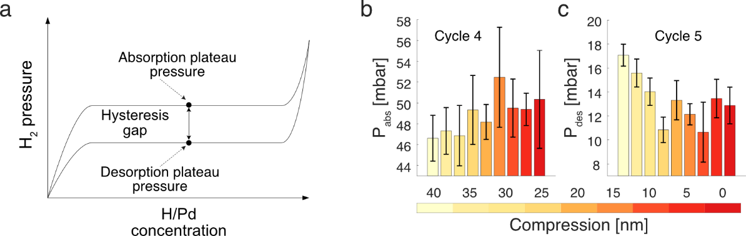

Supplementary Figure 5. (a) Schematic of an idealized hydrogen pressure-composition isotherm for Pd. The plateau pressures for the α-to-β phase transformation during absorption (and vice versa for desorption) defines the hysteresis gap between the absorption and desorption branch of the hydrogenation process. (b) Mean absorption (P_{abs}) and desorption (P_{des}) plateau pressures for all particles in the 9 different compression-level sub-groups during the first isotherm measurements (cycle 4 and 5 respectively). The error bars indicate one standard deviation calculated from the individual plateau pressures of the particles within each compression group.

Kinetic and isotherm data vs total time spent in hydrogenated state
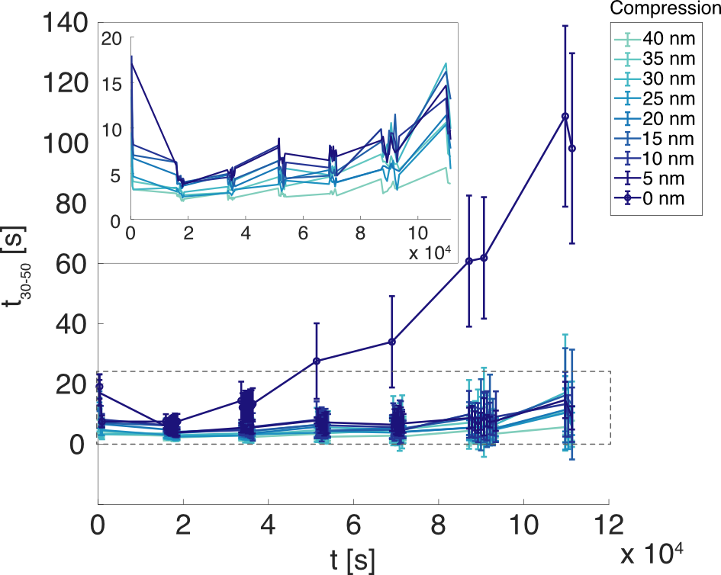
Supplementary Figure 6. Evolution of the average t₃₀₋₅₀ absorption times for the 9 compression-level sub-groups as a function of total time spent in > 40 mbar H₂. The error bars indicate one standard deviation calculated from the individual t₃₀₋₅₀ absorption times of the particles within each compression-level sub-group. We note the extreme deacceleration of the kinetics for the non-compressed particles (0 nm compression) in later cycles. Inset: Magnification of the average absorption times for the 5 – 40 nm compressed particles (area outlined with a dashed, gray box in the main figure).

Absorption time scaling law for Pd single crystals
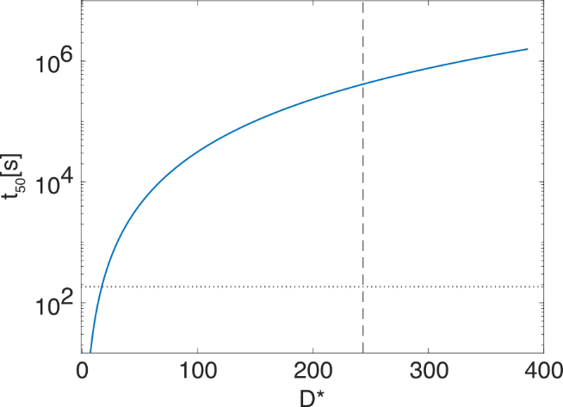
Supplementary Figure 7. Absorption time scaling law for Pd single crystals as a function of effective size extrapolated from Langhammer et al.¹. The t₅₀ absorption time is defined as the time to reach 50 % of the signal change during an optical hydrogenation measurement of Pd particles. The effective size D* is calculated from an equal-volume-sphere based on the volume of our (nominally) disc-shaped nanoparticles (dashed, vertical line) and the t₅₋₅₀ absorption time (calculated as the time between 5 % and 50 % signal change) for the undeformed particles during cycle 69 is presented as dotted, horizontal line.

Method to extract kinetics data only from particles that have fully desorbed
When hydrogenation kinetics measurements are performed, gas is pumped out of the test chamber for a certain amount of time (typically 20-30 min) before the next hydrogen pulse is introduced. However, if the desorption kinetics become very slow, this usual pumping duration might not be enough to let the particles completely desorb before the next cycle starts. To illustrate this, two particles - one compressed and one non-compressed – are presented in Supplementary Figure 8 during two later cycles (cycle 59 and 60). The compressed particle (Supplementary Figure 8a) have completely desorbed between the first and second hydrogen pulse. This leads to the drops in the signal intensity due to the hydrogen absorption ($ΔI_{1}$ and $ΔI_{2}=0.95 ΔI_{1}$), being comparable in magnitude to each other. The non-compressed particle on the other hand (Supplementary Figure 8b) does not completely desorb between the two consecutive hydrogen pulses, and as such the drops in the intensity signal $ΔI_{1}$ and $ΔI_{2}=0.70 ΔI_{1}$) are not close to each other in magnitude. Therefore, in all plots that show any type of average of the kinetic evolution for the non-compressed particles (Figure 3a and Figure 5d of the main text as well as Supplementary Figure 6, Supplementary Figure 17 and Supplementary Figure 23e-f), a condition was imposed that at least 200 of the 289 non-compressed particles in every cycle should have intensity drops within 90 % of the first cycle in that kinetics measurement set. A “kinetics measurement set” is defined here as all cycles between isothermal cycles (i.e. all cycles in between dashed lines of Figure 3a of the main text). As the first cycle in every kinetics measurement set is directly following an isothermal desorption measurement (where a particle spends hours desorbing), the particles can be more or less guaranteed to have fully desorbed before these cycles. If a cycle failed to reach the condition stated above, that cycle was discarded.

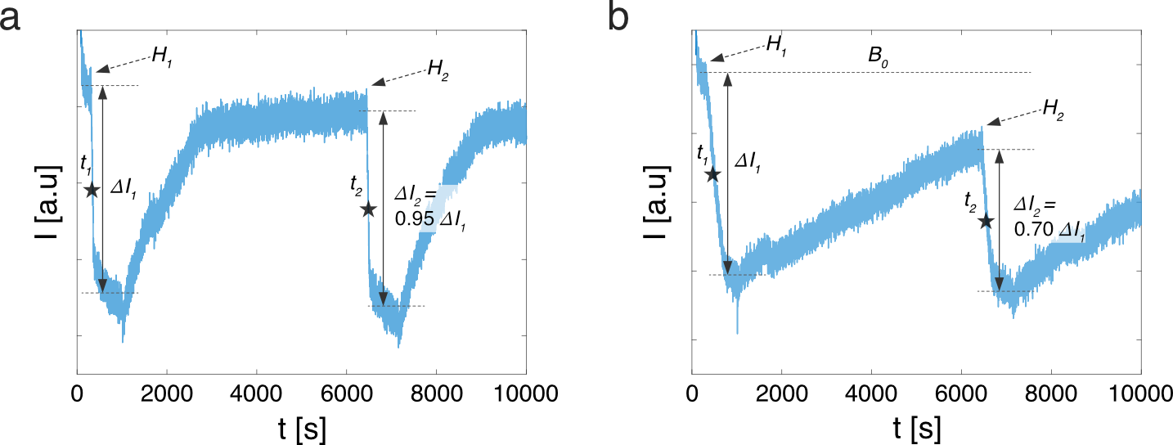

Supplementary Figure 8. Intensity evolution of two different, one compressed (a) and one non-compressed (b), particles during two consecutive hydrogen cycles (cycle 59 and 60) from a kinetics measurement. Hydrogen introduction events for every cycle is marked with an $H$, and the intensity drop resulting from each introduction event (due to the α-to-β phase transformation) is marked with $ΔI_{1}$ (first cycle) and $ΔI_{2}$ (second cycle) respectively. The half-point of each intensity drop is marked with a black star for each cycle and the time for the half-point (with respect to the hydrogen introduction events $H_{1}$ and $H_{2}$) are $t_{1}$ and $t_{2}$ respectively. Note that in b, the intensity is far from reaching the baseline $B_{0}$ before the second hydrogen pulse is introduced ($H_{2}$). This means that the particle in question has not completely desorbed, and therefore the absorption time $t_{2}$ will be erroneous.

The influence of slow kinetics on isothermal measurements
When measuring the Pd phase transition plateau pressures with pressure-composition isotherms, it is inherently assumed that enough time is given at every hydrogen pressure step for the particles to equilibrate to the current hydrogen pressure before a new, either higher (absorption isotherm) or lower (desorption isotherm), pressure is introduced. However, if the particle’s sorption kinetics slow down significantly, this may affect the pressure-composition isotherms and push the sorption plateau pressures to higher (lower) apparent plateau pressures for absorption (desorption), e.g. Supplementary Figure 9. To ensure comparability between the compressed and non-compressed particles, which exhibit significantly different absorption times after about cycle 30 (Figure 3a of the main text), only particles with absorption times comparable to the compressed particles (t₃₀₋₅₀ < 25 s) were included in the plots showing the evolution of the absorption plateau pressures P_{abs} (Figure 3b of the main text, Supplementary Figure 10 and Supplementary Figure 24a-b). This problem is the most apparent for the intermediate cycles, i.e. after cycle 30 (where absorption times for the non-compressed particles start to significantly diverge from the compressed particles, Figure 3a of the main text) and before cycle 75 (where the time per hydrogen pressure step was significantly increased from 300 s per step to 1200 s and 2400 s per step for absorption and desorption respectively). Therefore, the absorption plateau pressures (P_{abs}) for all non-compressed particles are used in Supplementary Figure 18b-g and Supplementary Figure 24c-d as the cycles shown there are outside the intermediate region of cycles.
For the individual absorption plateau pressures (P_{abs}) of all non-compressed particles during all absorption isotherms together with their corresponding absorption times, see Supplementary Figure 21.

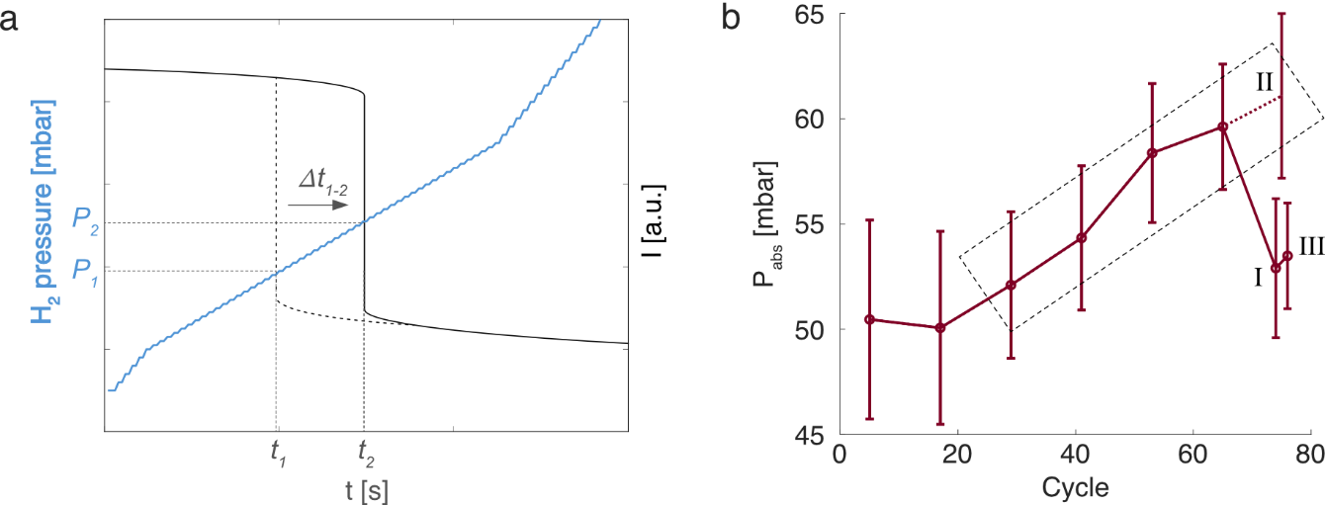

Supplementary Figure 9. (a) Schematic representation of slow absorption kinetics influencing the apparent hydrogen absorption plateau pressure of a Pd nanoparticle. The phase change from the α- to the β-phase of the Pd-hydrogen system is resolved through the back-scattered intensity (black line) of the Pd nanoparticle as a sharp drop.² If we assume that this phase change would occur at hydrogen pressure $P_{1}$, we should measure the intensity drop around time $t_{1}$. However, if the particle absorbs the hydrogen very slowly (compared to the time of one step in hydrogen pressure), the intensity drop can be delayed by a time $Δt_{1-2}$ to time $t_{2}$, which would give a higher, apparent phase change pressure of $P_{2}$. (b) Evolution of the average absorption (P_{abs}) plateau pressures for all non-compressed particles as a function of hydrogenation cycles when taking all measured isotherms into account. Two of the last three isotherms (I and III) where measured with a 1200 s step per 1 mbar H₂ step and the isotherm in between (II) was measured with a 300 s step per 1 mbar H₂ step. The distinct increase to higher P_{abs} pressures when using the shorter step time (II) indicates that the rise in absorption plateau pressures seen for the non-compressed particles during the intermediate isotherm measurements (dashed box) may be apparent and instead a result of the significant deacceleration of absorption kinetics seen for the non-compressed particles during the corresponding cycles in Figure 3a of the main text.

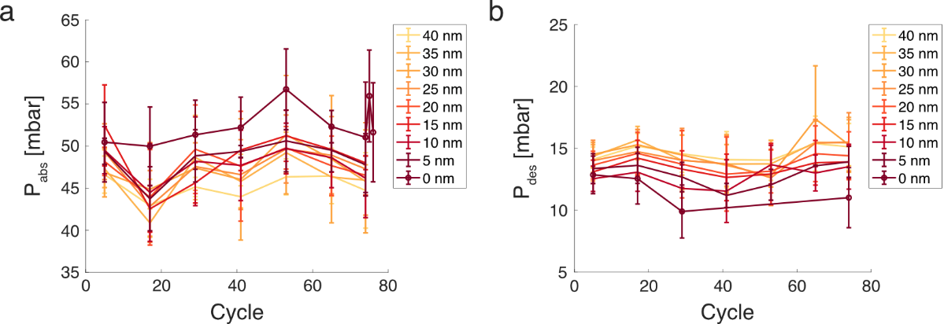

Supplementary Figure 10. The evolution of the average absorption (a) and desorption (b) plateau pressures for the 9 different compression-level sub-groups groups as a function of hydrogenation cycles. The error bars indicate one standard deviation calculated from the individual plateau pressures of the particles within each compression group. For the non-compressed (0 nm) particles in a, only particles with absorption times comparable to the compressed particles (t₃₀₋₅₀< 25 s) were included and for b, the intermediate cycles (75 > cycle > 30) were left out in accordance with the discussion of the main text in this section.

The evolution of isothermal plateau pressures – expanded
The evolution of the isothermal plateau pressures goes through five distinct phases during the hydrogen cycling process (Figure 3b of the main text and Supplementary Figure 11a-b). The first phase (I) is characterized by a decrease in absorption pressure (P_{abs}) for all particle groups (Supplementary Figure 11a-b). According to the Schwarz-Khachaturyan-Griessen model, this would imply a decrease of strain levels during hydrogenation during phase I – but this model technically only holds for defect-free particles. This means that for the two compressed sub-groups (5-20 nm and 25-40 nm compression), the decrease in P_{abs} could also be an effect of, as is stated in the main text, the dislocations generated during the nanocompression acting as nucleation sources for the β-phase hydride and thereby reducing the thermodynamic nucleation barrier of the hydride phase. However, we will assume in the rest of this section that the Schwarz-Khachaturyan-Griessen model (SKG-model), and as such that P_{abs} is directly related to the overall strain state of the particles, holds for the non-compressed (0 nm compression) particles. As such, this would dictate that the strain levels of the non-compressed particles develop as follows.
During phase I, the strain levels of the particles are decreasing (average P_{abs} is decreasing), most likely due to a crystal restructuring mediated by the clamping stress of the substrate during hydrogenation (for more information, see the main text as well as Supplementary Figure 1 and Supplementary Figure 14), where Pd atoms diffuse from the highly strained interfacial region towards the less strained surface region.
In phase II, the average P_{abs} increase, which according to the SKG-model would imply an increase in strain levels. To the best of our knowledge, there could be two different origins for these increased stress levels during hydrogenation of the particles, i) migration and subsequent annihilation of existing dislocations at grain boundaries or the surface of the crystal, leading the particles to becoming more and more defect-free and thereby raising P_{abs}³, or ii) new dislocations form during the hydrogenation process to such a degree a that a version of strain hardening arises in the particles, and thereby P_{abs} is increased due to the higher H₂ pressure needed to induce the $α$-to-$β$ phase transition. However, since phase II coincide with the cycles where the non-compressed particles start to deaccelerate significantly (see Figure 3a in the main text), the argument of dislocation movement and annihilation seems the most likely.
In phase III, the average P_{abs} is again decreasing, which would imply a second release of stress from the particles, potentially from further diffusion of Pd away from the clamped surface or by the formation of new stress releasing dislocations. We find the latter of these mechanisms, i.e. the formation of new dislocations, to be the most plausible in this scenario, especially since it directly follows the suggested dislocation annihilation of phase II. As such, the particles go through a cyclic dislocation formation-annihilation over $∼$50 cycles of hydrogen cycling. This argument is further corroborated by the same overall trend being reproduced on a second sample, fabricated in the same way and cycled with a close to identical hydrogenation scheme (see Supplementary Figure 14b and supplementary file Hydrogenation summary - sample 1 and Hydrogenation summary - sample 2).
It is interesting to note that the inflection point of this cyclic behavior, i.e. the cycle where the average P_{abs} switches from monotonically increasing to monotonically decreasing, seems to be sample specific but also compression-level independent. On the primary sample (Supplementary Figure 11a), the inflection point for both compressed and non-compressed particles is around cycle 50, while for the second sample (Supplementary Figure 14b) the inflection point is already at cycle 40. A partial answer to this initially non-intuitive trend can be glanced from phase IV-V of the P_{abs} evolution (Supplementary Figure 11a). In this final part of the hydrogenation procedure, three absorption isotherms were measured one after another in consecutive cycles (see Supplementary Figure 11e-f) for the individual isotherms for two non-compressed particles). During these measurements, the average P_{abs} again go through the same cyclic behavior, where P_{abs} initially increases, peaks and then decreases again. This cyclic behavior is much more obvious in phase IV-V when P_{abs} is plotted against the total time spent in the hydrogenated state instead of number of hydrogenation cycles (Figure 3c of the main text and Supplementary Figure 11b). As such, this implies that it is the total time spent in the hydrogenated state that dictate the frequency of the cyclic P_{abs} behavior, potentially mediated by a cyclic dislocation formation and annihilation that is closely related to the stochastic nature of dislocation substructure in the nanoparticles, which in turn is strongly dependent on their fabrication pre-history and compression degree. Why the formation of new dislocations would not enhance the kinetics might at first seem counterintuitive, but here it is important to remind ourselves about the different energy barriers involved. For the thermodynamic absorption plateau pressure, the strain of the overall system during hydrogenation decides P_{abs} (also potentially influenced by specific dislocations that can act as nucleation sites for the hydride phase)³⁻⁵, while the kinetically rate-limiting step of the hydrogen absorption process in Pd is the diffusion of dissociated hydrogen from the surface to the first sub-surface layer^{6,7}. This means that hypothetically, dislocations could form and annihilate in a region of the particle far from the surface, e.g. close to the highly strained substrate-particle interface, and thus modify P_{abs} in the process, while dislocations close to the free surface continuously annihilate during the hydrogenation procedure and kinetics accordingly continuously decrease.

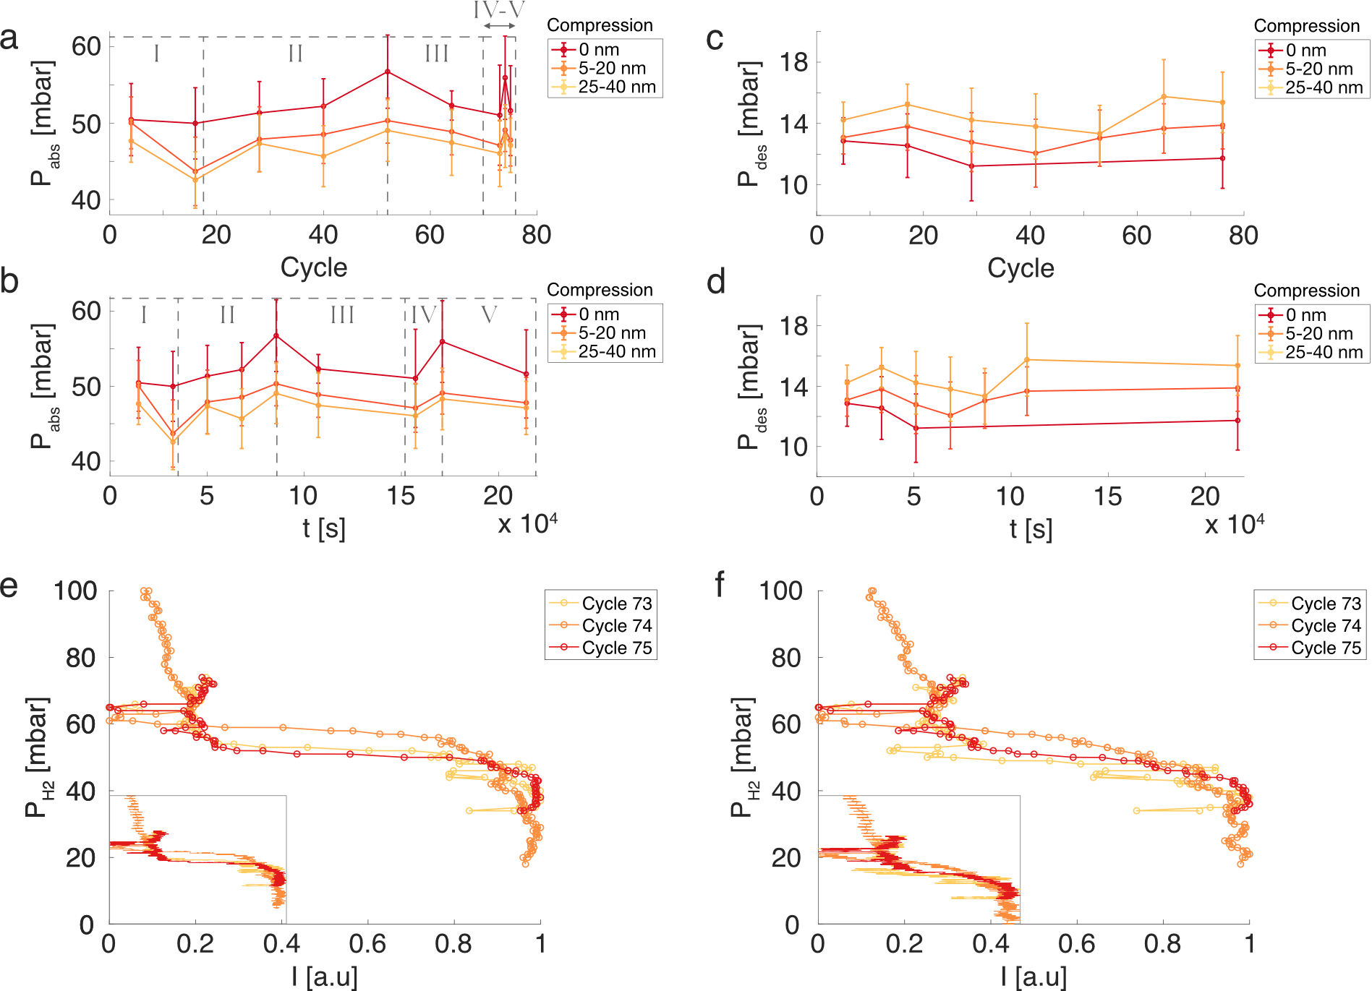

Supplementary Figure 11. The evolution of the average absorption, P_{abs}, (a-b) and desorption, P_{des} (c-d) plateau pressures with the particles divided into three groups depending on their degree of compression, i.e., non-compressed (0 nm), 5-20 nm compression and 25-40 nm compression plotted as a function of hydrogenation cycle (a,c) and as a function of time spent in > 40 mbar H₂ (b,d). To have comparable results between the compressed (5-20 nm and 25-40 nm group) and the non-compressed (0 nm) groups of particles, only particles in the non-compressed group (0 nm) with t₃₀₋₅₀ hydrogen absorption times comparable to the particles in the compressed groups have been used in (a,b). For more information, see SI section 8. The intermediate cycles (75 > cycle > 30) for the non-compressed particles in (c,d) were left out in accordance with the discussion in SI section 8. The evolution of the absorption plateau pressures is divided into five different phases (I-V) which are explained in more details in the main text of this section. (e-f) Average dark-field scattering intensity profiles from two individual non-compressed Pd particles (e and f respectively) during 3 consecutive absorption isotherm measurements. The average intensity profile is calculated such that we get two (averaged) data points per hydrogen concentration, e.g. if every hydrogen concentration is kept for 300 s, the first (averaged) intensity data point is the average from 1-150 s and the second is the average from 151-300s. The two chosen particles have t₃₀₋₅₀ hydrogen absorption times comparable to the particles in the compressed groups. Inset: Raw dark-field scattering intensity profiles.

SEM imaging and kinetic data of selected particles from the main text

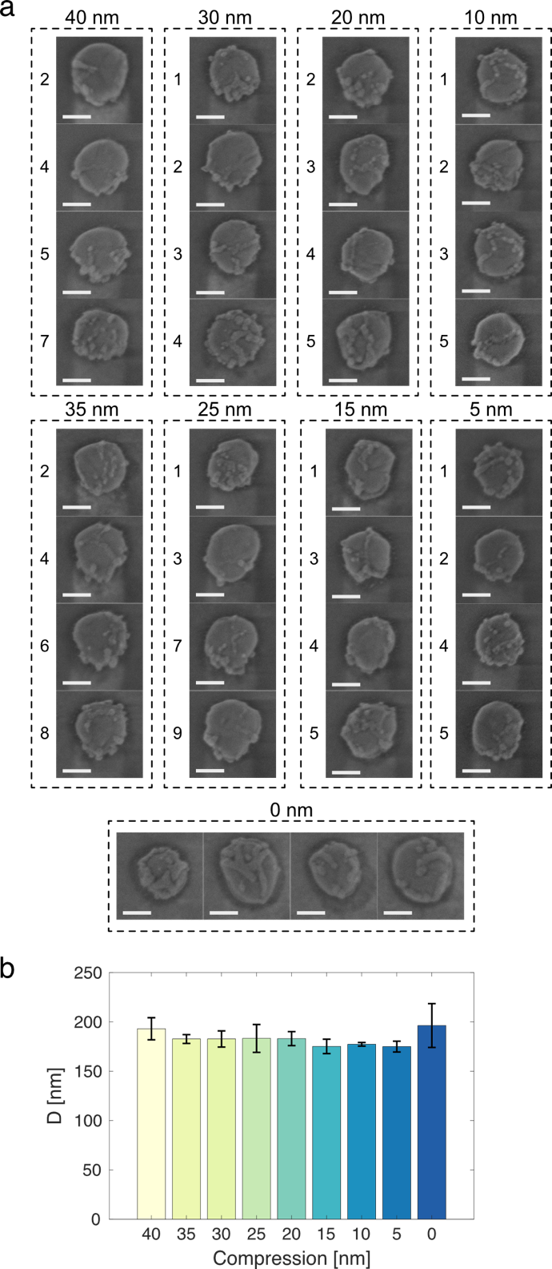

Supplementary Figure 12. (a) SEM micrographs of 4 randomly selected particles from each compression-level subgroup after all 76 cycles of hydrogen cycling. The numbers correspond to the particle numbering of Supplementary Figure 13. Scale bars are 100 nm. (b) Average diameter (calculated from the mean of the horizontal and vertical diameter) of the imaged particles in (a) as a function of compression level. Error bars are one standard deviation.

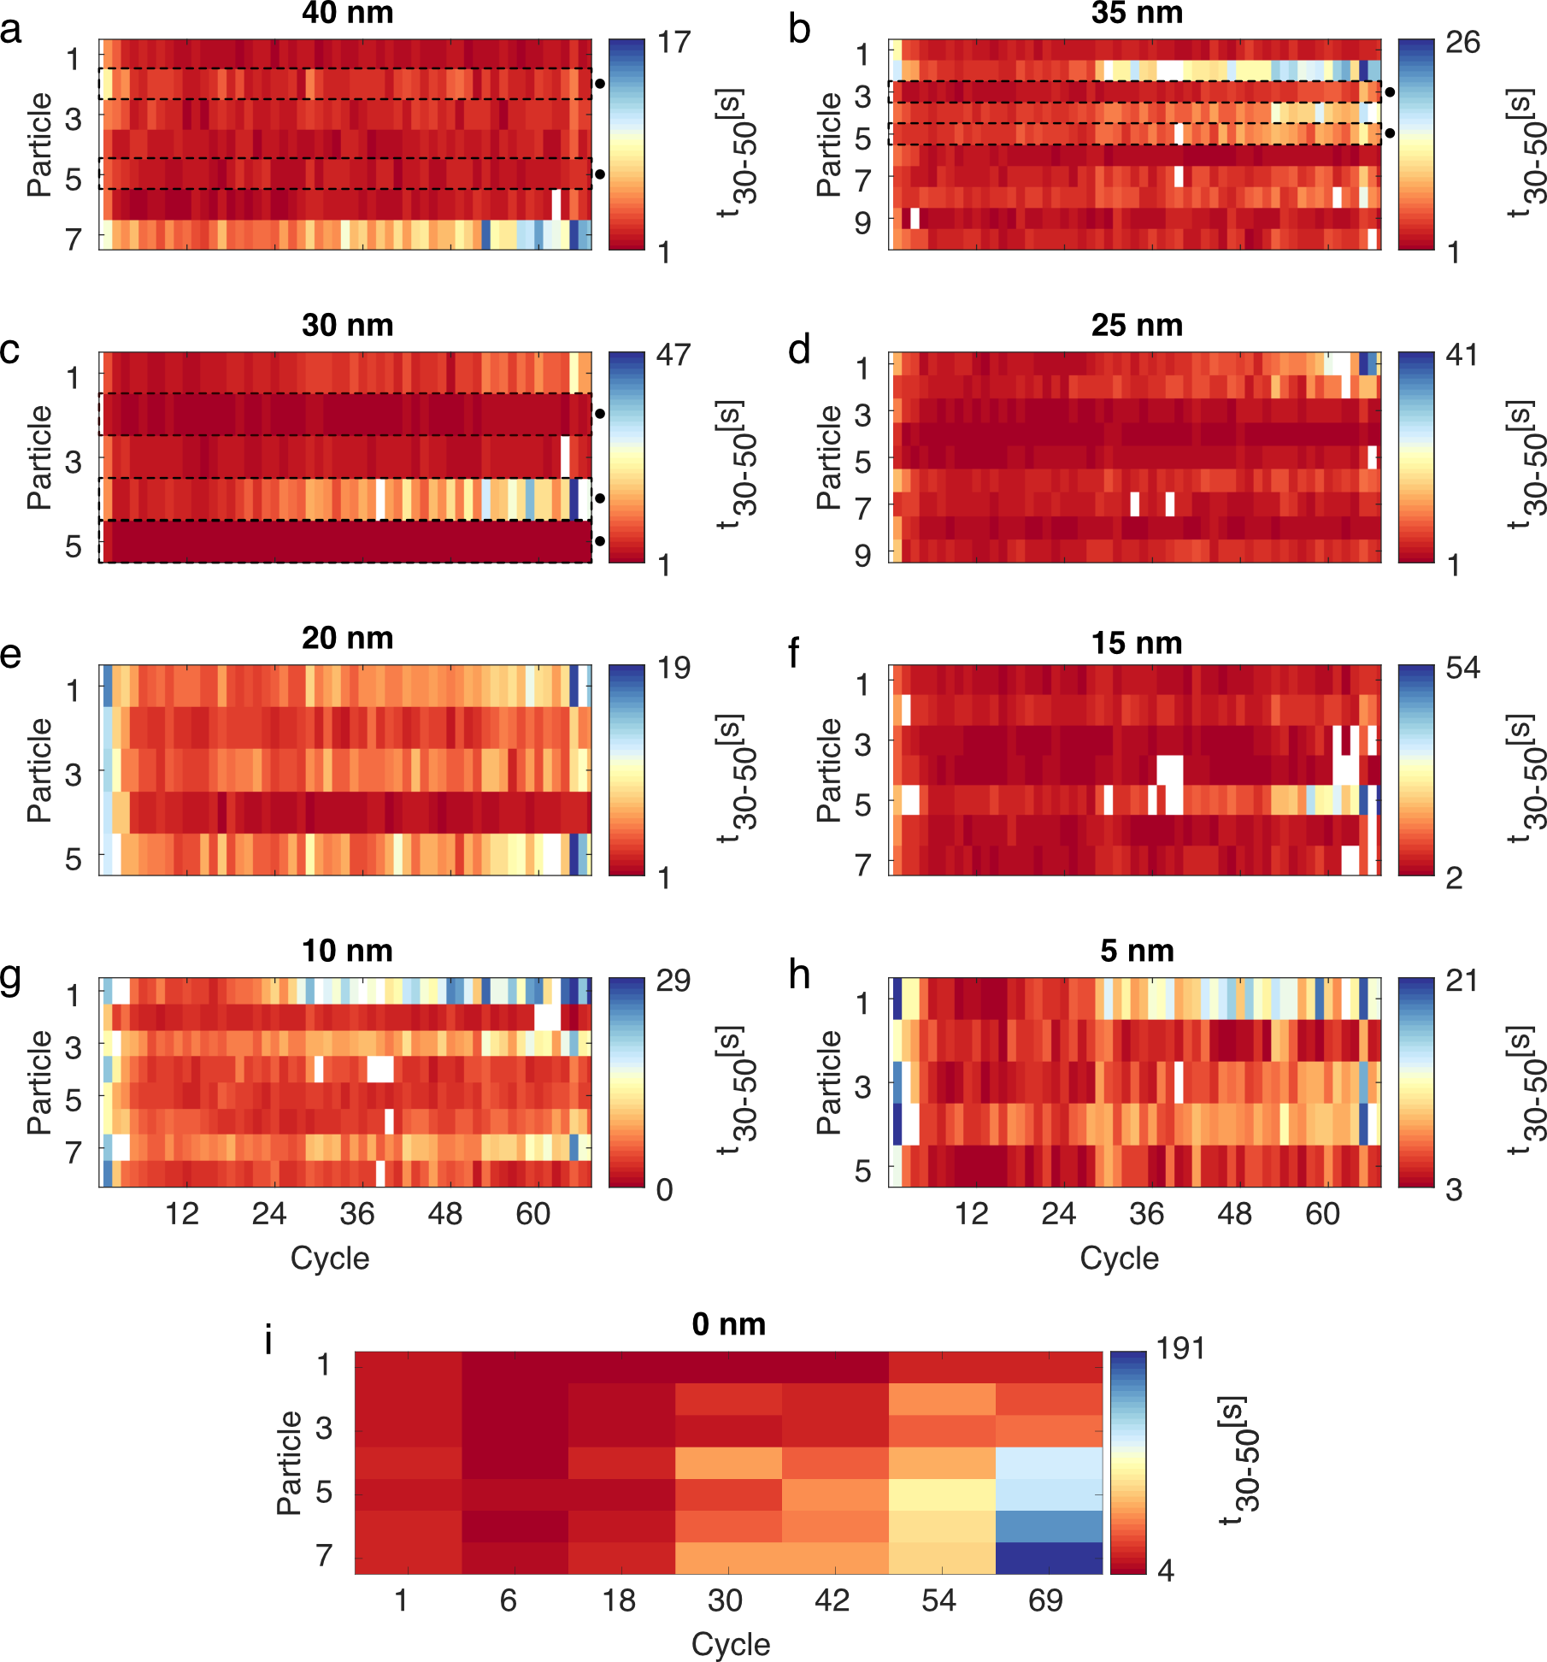

Supplementary Figure 13. The individual t₃₀₋₅₀ values measured for every compressed particle for all hydrogenation cycles and for 7 selected non-deformed particles (0 nm) for selected cycles. The deformation degree is indicated on top of every panel and the t₃₀₋₅₀ time for each cycle and nanoparticle is represented by a color-code shown in the color bar to the right of each plot. If the color for a certain particle and cycle is white, then the signal for this particle was discarded during the data analyzation step due to the particle not having desorbed completely from the last cycle before the next hydrogenation (for more information, see section 7). Particles that were nominally single-crystalline (i.e. showed a strain-burst in their load-displacement diagrams) are highlighted with a black dot, as well as a dashed box. The 7 non-deformed particles (0 nm) were chosen to have final absorption times representative of the wide distribution seen for the non-compressed particles in Figure 5c of the main text.

Kinetic and isotherm data from SEM-imaged particles on second sample

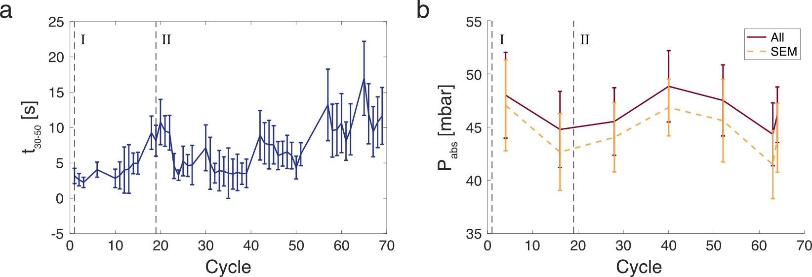

Supplementary Figure 14. The evolution of the average t₃₀₋₅₀ absorption times (a) and average absorption P_{abs} plateau pressures (b) for the 44 SEM imaged particles in Supplementary Figure 1a as a function of hydrogenation cycles. In b, the average absorption (P_{abs}) plateau pressures for the rest of the particles on the sample are also plotted. The sample (S2) was fabricated in the same way as the sample discussed in the main text (S1) - except that no particles have been compressed. The particles have been cycled using similar hydrogenation procedure as for the sample discussed in the main text (S1), see supplementary file Hydrogenation summary - sample 1 and Hydrogenation summary - sample 2. The time of the two SEM imaging sessions that give rise to the two sets of images in Supplementary Figure 1a are indicated in both plots with dashed lines (I and II respectively). We note that the emergence of the protrusions between set I and set II discussed in Supplementary Figure 1a correspond with a deacceleration of kinetics (a) and a decrease in absorption (P_{abs}) plateau pressure (b). As in the main text, we attribute these changes to the annihilation of existing dislocations (deacceleration of kinetics) together with a reduction of stress levels (decrease in absorption plateau pressure P_{abs})⁵ and are as such consistent with the discussion in the main text, where the growth of protrusions on the particles are described as a stress-relief mechanism.

Kinetic and isotherm data of STEM analyzed particles of the main text

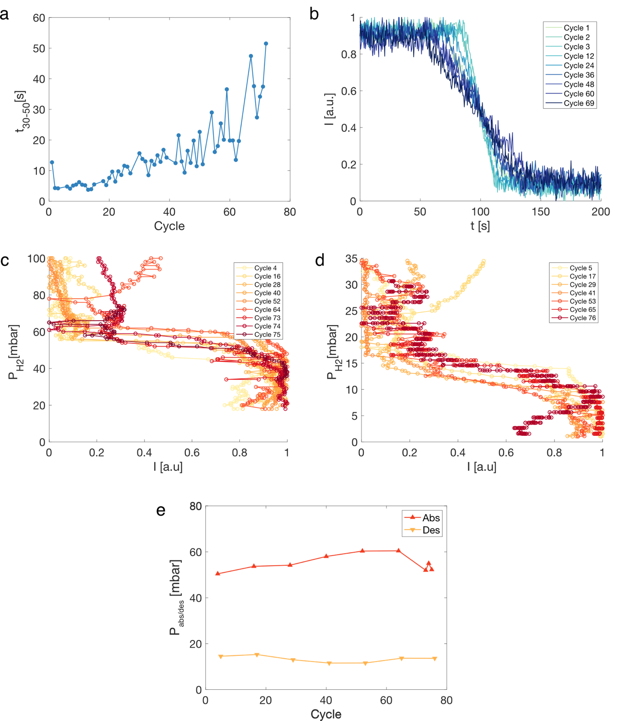

Supplementary Figure 15. Hydrogenation properties of the particle in Figure 4d-f in the main text. (a) Absorption time t₃₀₋₅₀ evolution as a function of hydrogenation cycles. (b) Dark-field scattering intensity profiles from which the absorption times in (a) were calculated for a select number of hydrogenation cycles. (c-d) Hydrogen partial-pressure vs average dark-field scattering intensity isotherms for absorption (c) and desorption (d). The average intensity profile is calculated such that we get two (averaged) data points per hydrogen concentration, e.g. if every hydrogen concentration is kept for 300 s, the first (averaged) intensity data point is the average from 1-150 s and the second is the average from 151-300s. (e) Absorption (P_{abs}) and desorption (P_{des}) plateau pressures as a function of hydrogenation cycles calculated from the intensity-pressure isotherms in c-d.

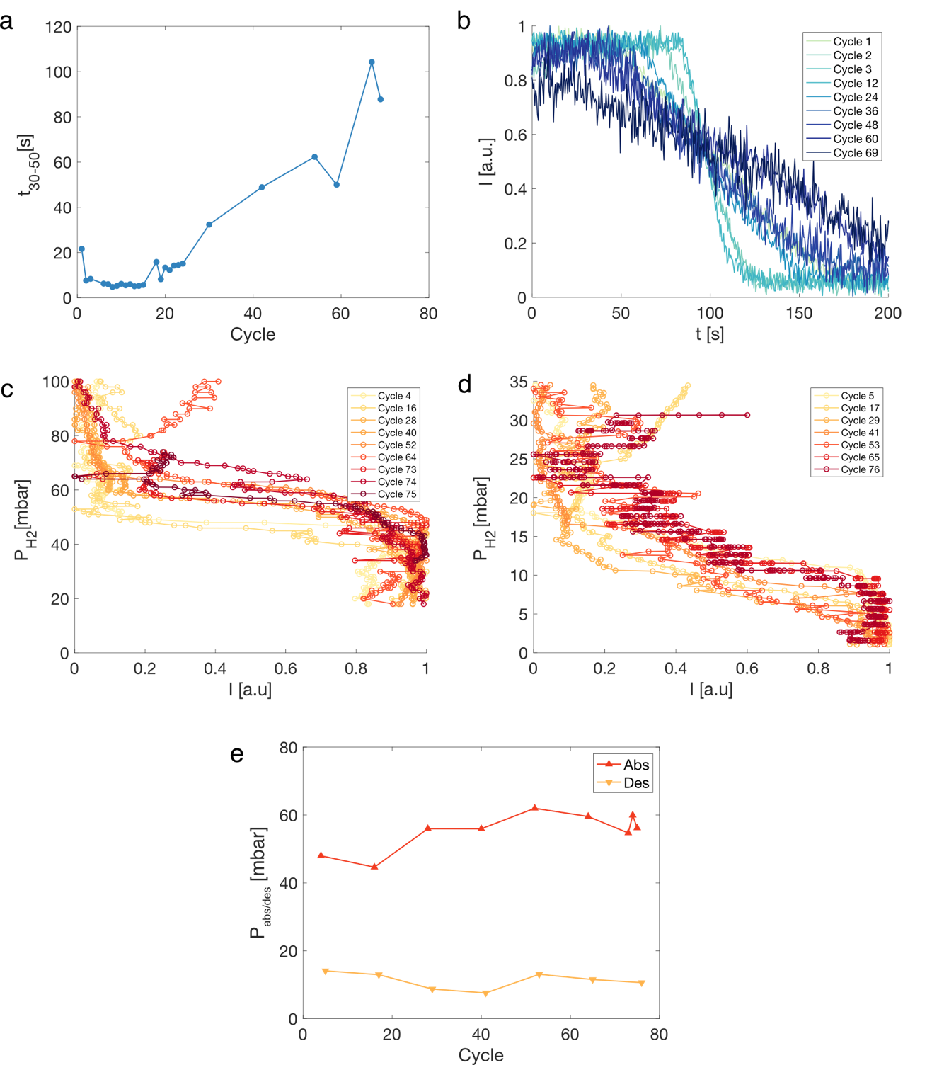

Supplementary Figure 16. Hydrogenation properties of the particle in Figure 4g-i in the main text. (a) Absorption time t₃₀₋₅₀ evolution as a function of hydrogenation cycles. (b) Dark-field scattering intensity profiles from which the absorption times in (a) were calculated for a select number of hydrogenation cycles. (c-d) Hydrogen partial-pressure vs average dark-field scattering intensity isotherms for absorption (c) and desorption (d). The average intensity profile is calculated such that we get two (averaged) data points per hydrogen concentration, e.g. if every hydrogen concentration is kept for 300 s, the first (averaged) intensity data point is the average from 1-150 s and the second is the average from 151-300s. (e) Absorption (P_{abs}) and desorption (P_{des}) plateau pressures as a function of hydrogenation cycles calculated from the intensity-pressure isotherms in c-d.

Full width at half maximum for every individual compression sub-group

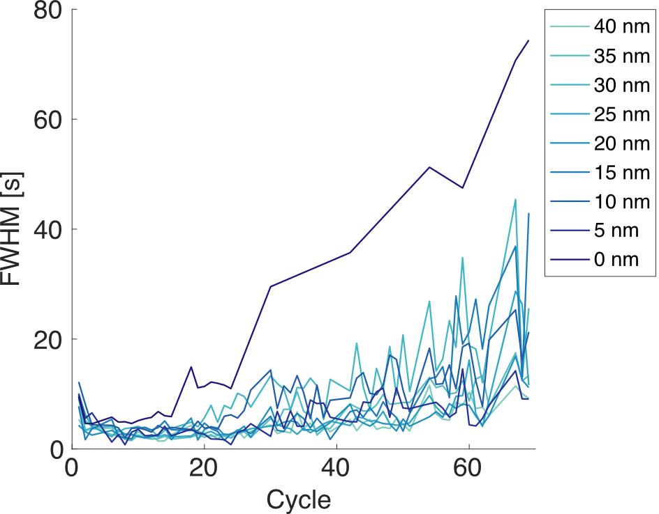

Supplementary Figure 17. The full width half maximum (FWHM) of the t₃₀₋₅₀ absorption time distributions for all compression-level sub-groups as calculated from a normal distribution fitted to the t₃₀₋₅₀ histograms of each individual sub-group.

Histograms of the single particle absorption plateau pressures P_{abs}
By fitting a normal distribution to the histograms of the single particle absorption plateau pressures P_{abs} for individual cycles (Supplementary Figure 18a), we note what seems to be a significant discrepancy in how the full width at half maximum (FWHM) evolves for the distributions for the compressed (5-20 nm as well as the 25-40 nm compressed group) vs the non-compressed (0 nm compression) particles. For the non-compressed particles, the FWHM decreases with cycle number, i.e. the particles converge towards an average absorption plateau pressure P_{abs}, which can be interpreted as the non-compressed particles converging toward a thermodynamic equilibrium for the absorption plateau pressure. This convergence towards an average P_{abs} is also very clear directly from the histograms for the non-compressed particles (Supplementary Figure 18b) and is also reproduced on a second sample (Supplementary Figure 24).
For the compressed particles on the other hand, we instead see an initial increase of the distribution FWHM, before eventually decreasing (Supplementary Figure 18a). The inflection point, i.e. the cycle where the FWHM stops increasing and starts to decrease, also seems to be compression-level dependent, i.e. the FWHM of the most compressed particles (25-40 nm compressed group) peaks at a later cycle than the least compressed group of particles (5-20 nm compressed group). We tentatively attribute these distinct compression-level trends to the plastic deformation induced by the microcompression, where the individual dislocation networks created in every compressed particle initially decide the P_{abs} evolution of these particles during hydrogen cycling – mediated either through the dislocations directly acting as nucleation sources for the $β$-phase or the individual strain levels of the particles – leading to more diverse P_{abs} values. In other words, the more compressed the particle, the more time it needs to spend in the high-diffusivity hydrogenated state before reaching the thermodynamic equilibrium. Finally, we should also add that the increase in FWHM for the compressed sub-groups (5-20 nm and 25-40 nm) may also only be apparent since the changes in width of the distributions for different cycles are very small and the amount of data is limited (see Supplementary Figure 18c-d).

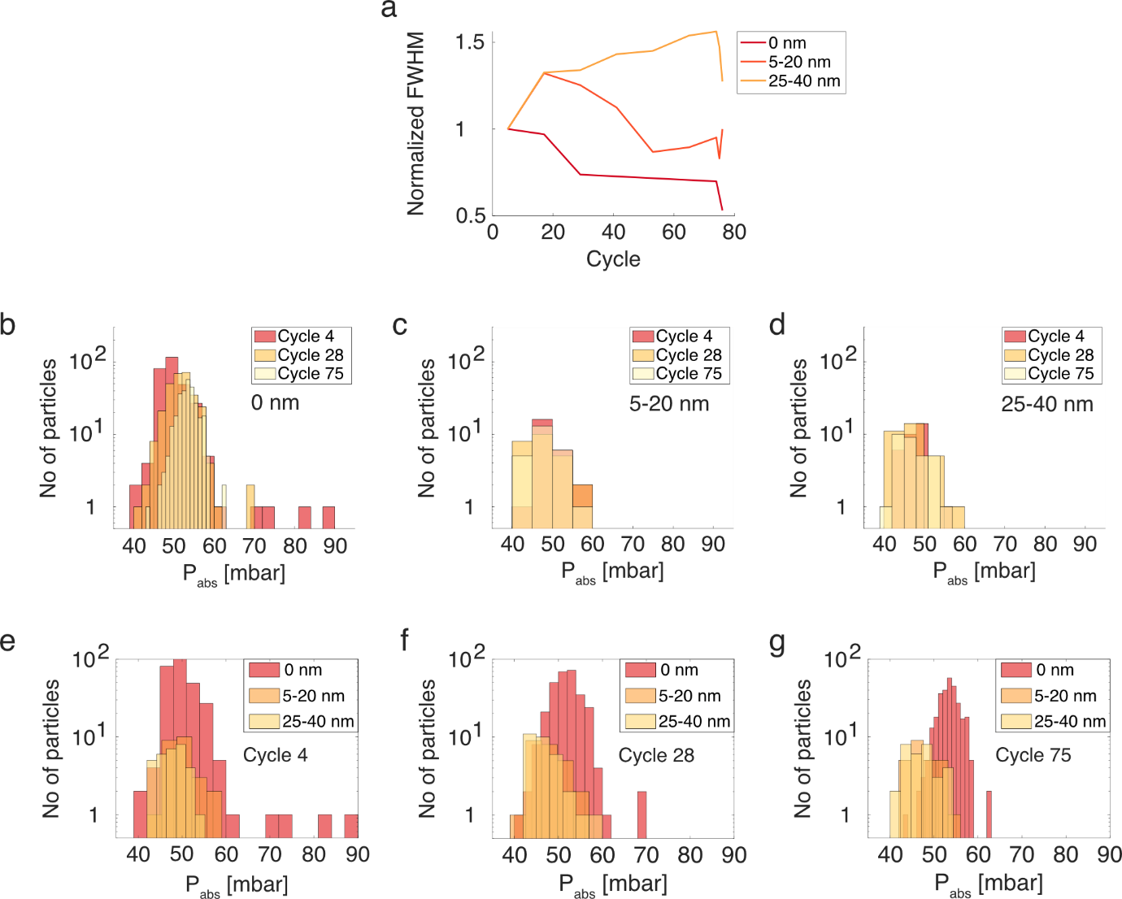

Supplementary Figure 18. (a) The full width half maximums (FWHM) of the hydrogen absorption plateau pressure distributions (as calculated from a normal distribution fitted to the P_{abs} histograms) normalized to the FWHM of the corresponding first P_{abs} measurement with particles divided into three groups depending on their degree of compression, i.e., non-compressed (0 nm), 5-20 nm compression and 25-40 nm compression. (b-d) Histograms of the single particle absorption plateau pressures P_{abs} for three specific cycles. The particles are divided into three groups depending on their degree of compression, i.e., non-compressed (0 nm) (b), 5-20 nm compression (c) and 25-40 nm compression (d). We note the distinct decrease in distribution width for the non-compressed sub-group for later hydrogenation cycles (b). For the compressed sub-groups (c,d), any change to the distribution width is not as apparent. (e-g) Histograms of the single particle absorption plateau pressures $P_{abs}$ for cycle 4 (e), 28 (f) and 75 (g). The particles are divided into three groups depending on their degree of compression, i.e., non-compressed (0 nm), 5-20 nm compression and 25-40 nm compression.

Comparison of kinetics between initially single and polycrystalline particles
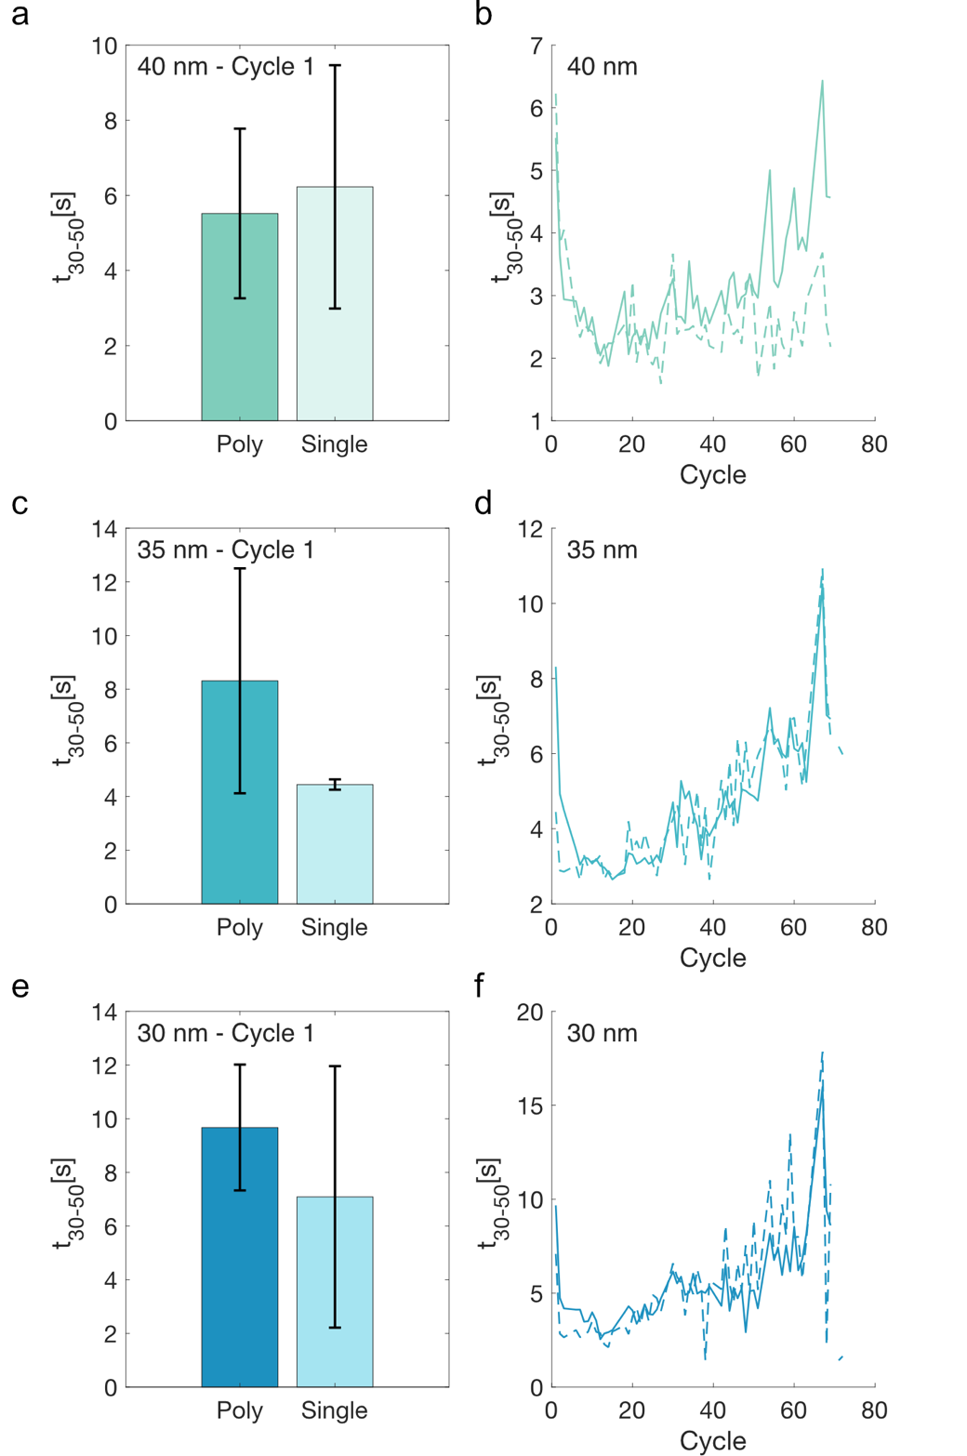

Supplementary Figure 19. Comparison of t₃₀₋₅₀ values for single (strain burst) vs. polycrystalline (staircase-yielding) particles. See Supplementary Figure 2 for the individual designations for every particle. The particles are from the 40 nm (a-b), 35 nm (c-d) and 30 nm (e-f) compressed sub-groups. The left column (a,c,e) shows the mean t₃₀₋₅₀ values for nominally single vs polycrystalline particles for hydrogenation cycle 1. The error bars indicate one standard deviation calculated from the individual t₃₀₋₅₀ values for the particles within each group. The right column (b,d,f) shows the evolution of the mean t₃₀₋₅₀ values for nominally single crystalline (dashed lines) and nominally polycrystalline (solid lines) particles as a function of hydrogenation cycles.

Single particle comparison between kinetics and absorption plateau pressures

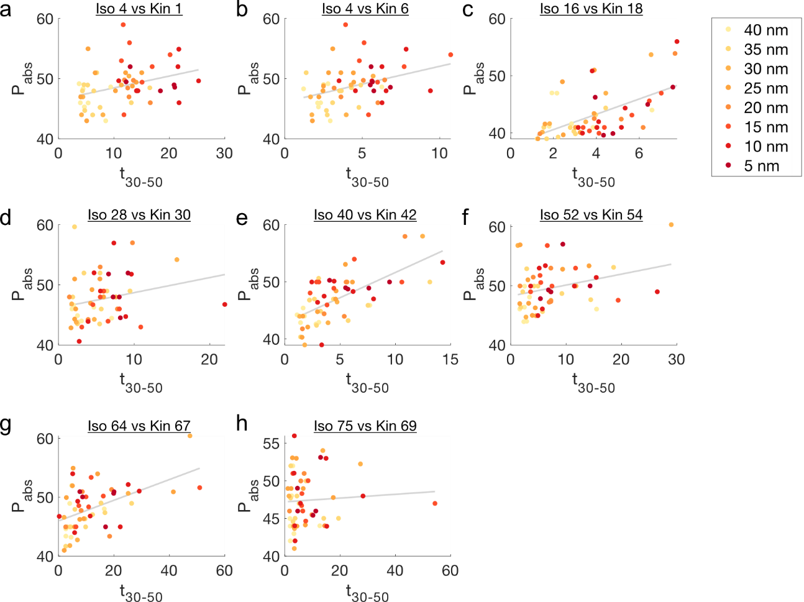

Supplementary Figure 20. Absorption plateau pressures P_{abs} (mbar) vs. t₃₀₋₅₀ (s) absorption times for all compressed particles. Stated above each plot is the hydrogenation cycle number for the isotherm (Iso) and the kinetics measurement (Kin), respectively. A linear fit of the data is included as solid gray line in all plots. Particles are color-coded according to their individual degree of compression.

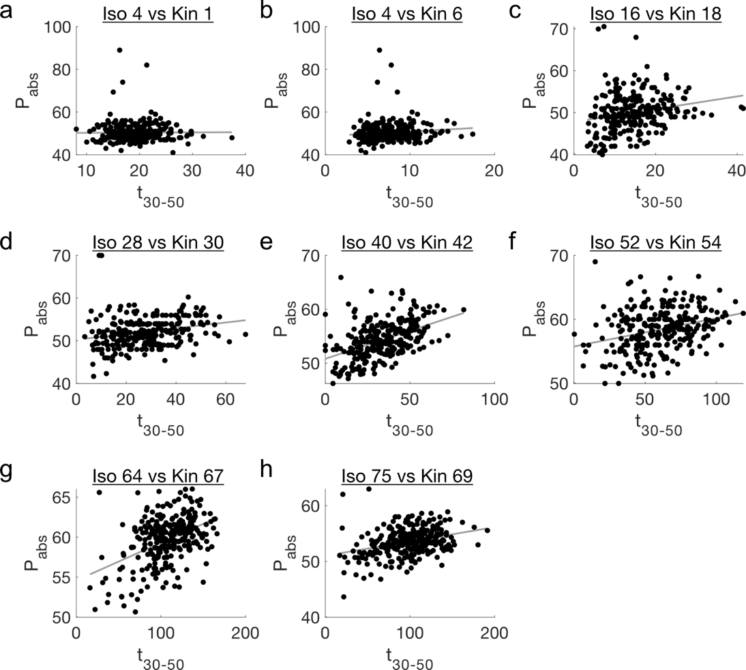

Supplementary Figure 21. Absorption plateau pressures P_{abs} (mbar) vs t₃₀₋₅₀ (s) absorption times for all non-compressed particles. Stated above each plot is the hydrogenation cycle number for the isotherm (Iso) and the kinetics measurement (Kin), respectively. A linear fit of the data is included as solid gray line in all plots.

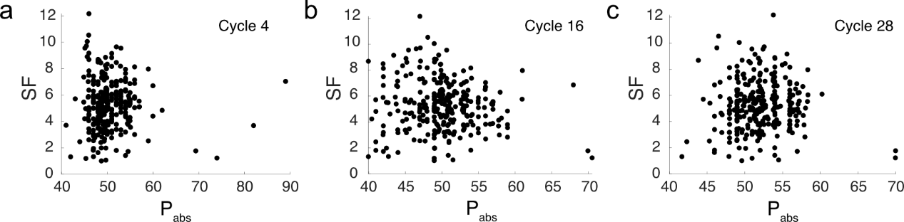

Supplementary Figure 22. Slowing factor SF (defined as the ratio between the t₃₀₋₅₀ absorption times for cycle 69 and cycle 1) of all non-compressed particles vs their absorption plateau pressures P_{abs} (mbar) for cycle 4 (a), 16 (b) and 28 (c).

Comparison of results between main text and second sample

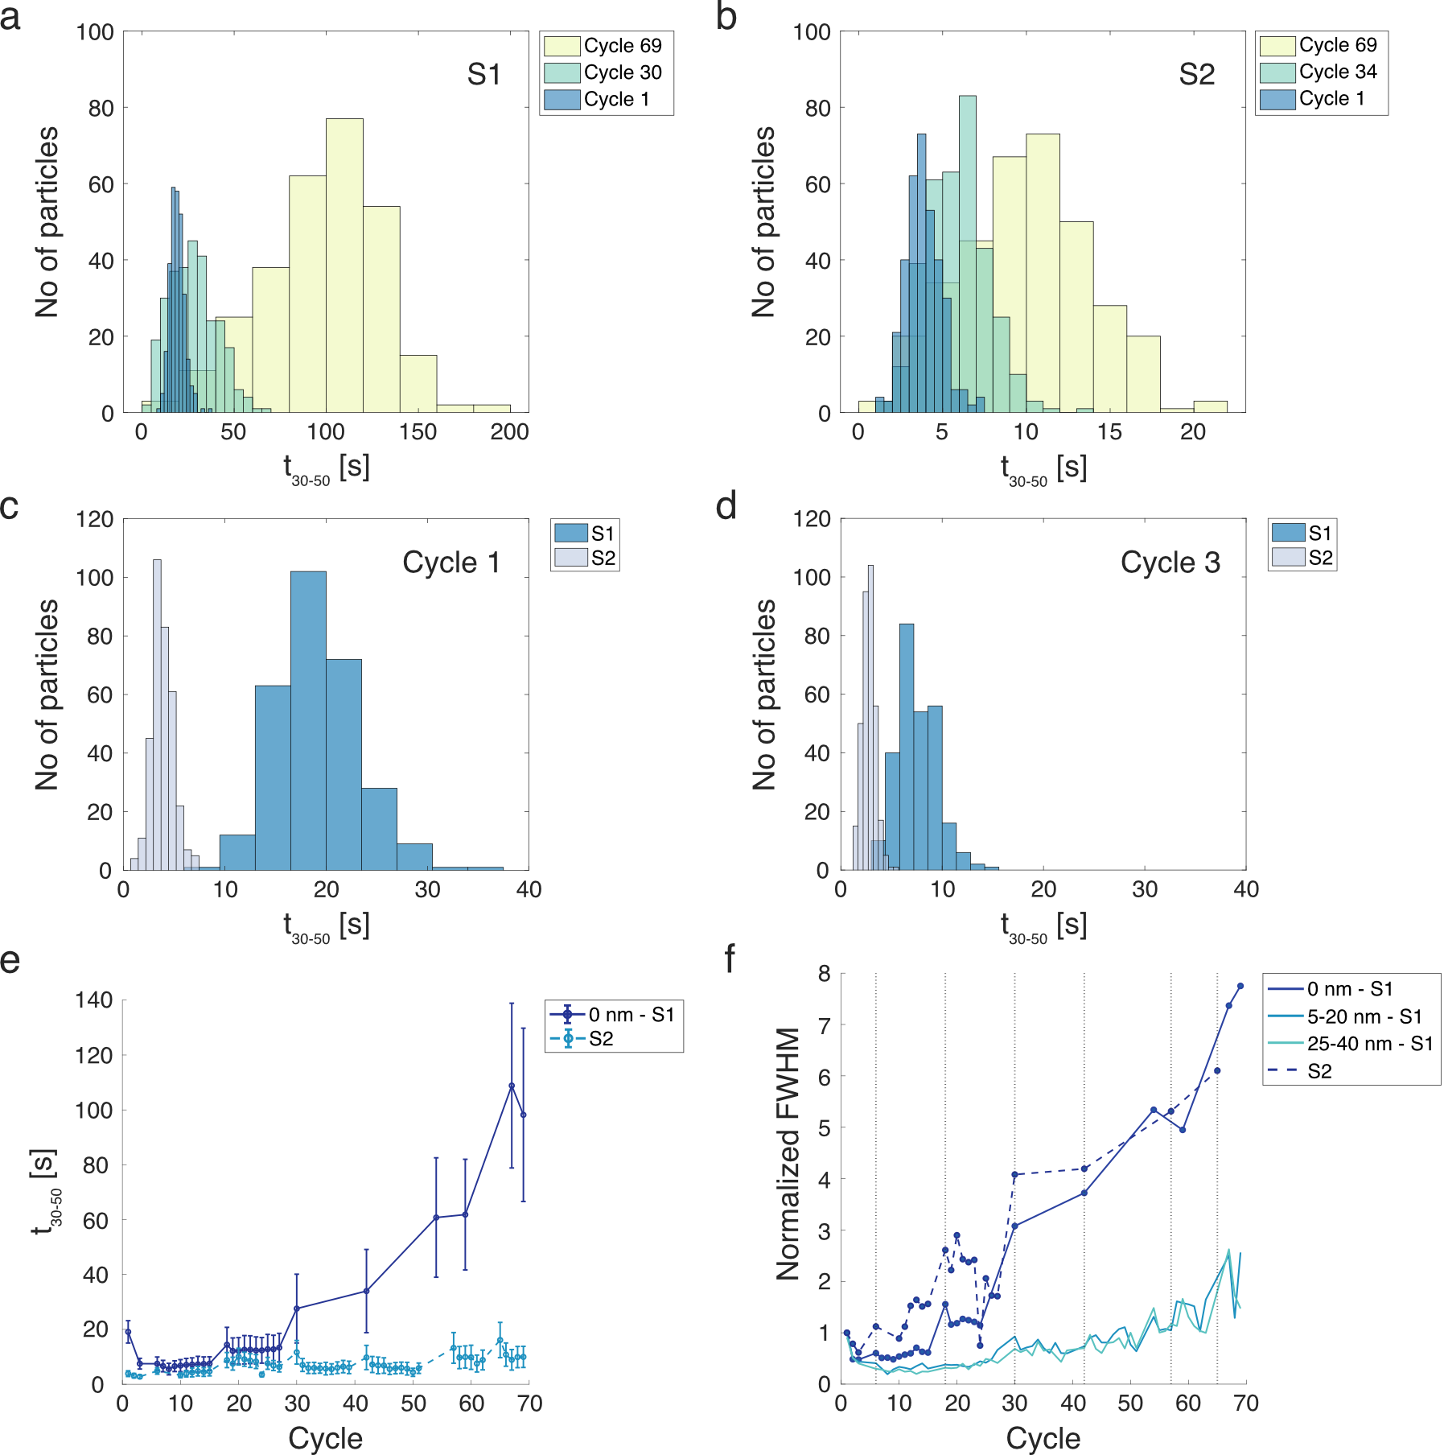

Supplementary Figure 23. Comparison of the hydrogen absorption kinetics for sample S1 of the main text and sample S2. S2 was fabricated in the same way as the sample discussed in the main text (S1) - except that no particles have been compressed. The particles have been cycled using similar hydrogenation procedure as S1, see supplementary file Hydrogenation summary - sample 1 and Hydrogenation summary - sample 2. (a-b) Histograms of the single particle t₃₀₋₅₀ absorption times for S1 (a) and S2 (b) for three specific cycles. We note how the t₃₀₋₅₀ distributions for both samples widen and shift to slower absorption times at later cycles. (c-d) Comparisons of the single particle t₃₀₋₅₀ histograms for S1 and S2 for cycle 1 (c) and cycle 3 (d) respectively. The evolution of the average t₃₀₋₅₀ absorption times for the non-compressed particles (0 nm) of sample S1 and the particles of sample S2 (all of which are non-compressed). (f) The full width half maximums (FWHM) of the t₃₀₋₅₀ absorption time distributions for S1 and S2 (as calculated from a normal distribution fitted to the t₃₀₋₅₀ histograms) normalized to the FWHM of the corresponding first cycles. The particles of S1 are divided into three groups depending on their degree of compression, i.e., non-compressed (0 nm), 5-20 nm compression and 25-40 nm compression. The method explained in section 7 for only taking data into account where most particles have fully desorbed resulted in mostly cycles right after isotherms making the cut for the non-compressed (0 nm) particles on S1. Therefore, the corresponding cycles are also plotted for S2 to ensure comparability. We note that both sets of non-compressed particles (0 nm S1 and S2) develop comparatively broader distributions than their compressed counterparts.

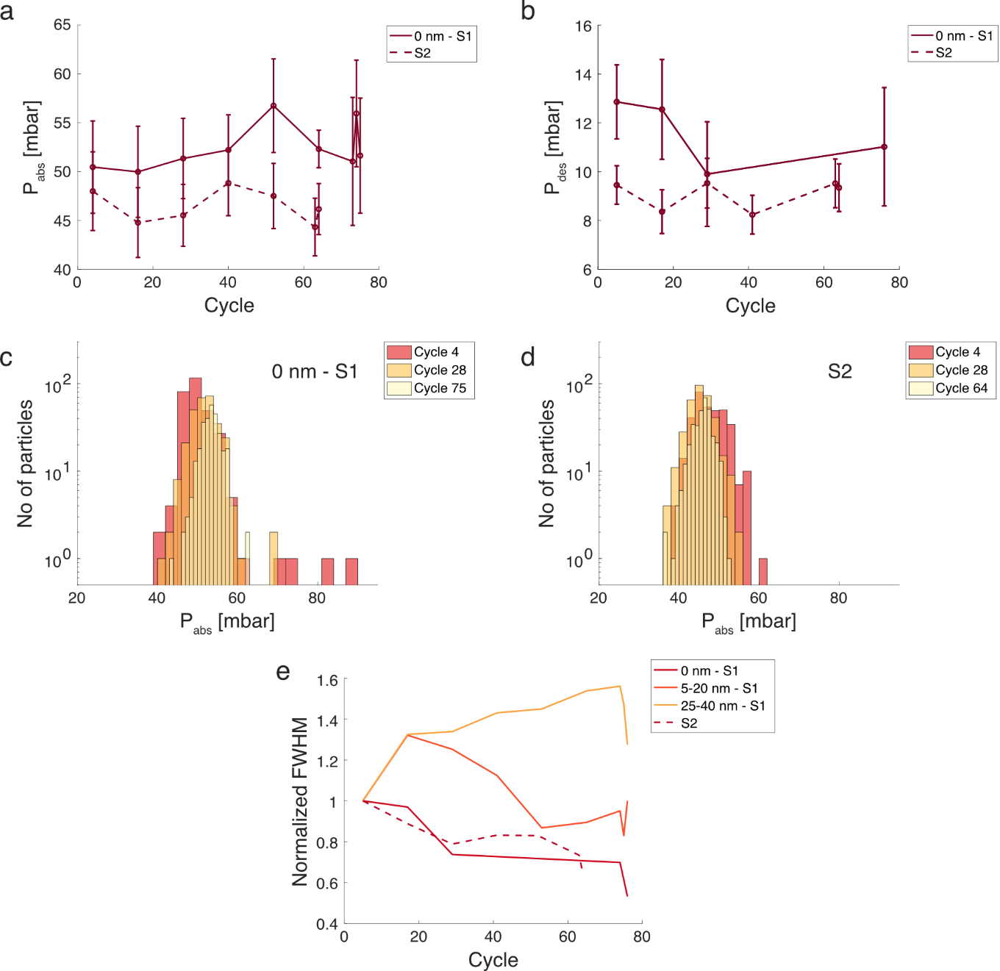

Supplementary Figure 24. (a-b) Comparison of the average hydrogen absorption (a) and desorption (b) plateau pressures for the non-compressed (0 nm) particles of sample S1 of the main text and sample S2. S2 was fabricated in the same way as the sample discussed in the main text (S1) - except that no particles have been compressed. The particles have been cycled using similar hydrogenation procedure as S1, see supplementary file Hydrogenation summary - sample 1 and Hydrogenation summary - sample 2. For S1 in a, only particles with absorption times comparable to the compressed particles (t₃₀₋₅₀< 25 s) were included and for b, the intermediate cycles (75 > cycle > 30) were left out in accordance with the discussion in section 8. (c-d) Histograms of the single particle P_{abs} absorption times for the non-compressed (0 nm) particles of sample S1 (c) and S2 (d) for three specific cycles. We note how the width of the distributions for both samples decrease at later cycles. (e) The full width half maximums (FWHM) of the hydrogen absorption plateau pressure distributions for S1 and S2 (as calculated from a normal distribution fitted to the P_{abs} histograms) normalized to the FWHM of the corresponding first P_{abs} measurement. We note that for both non-compressed populations (S2 and S1 – 0 nm), the relative distribution width decrease for later cycles, i.e. the P_{abs} values (and thereby the particle strain levels according to the SKG-model) tend to converge towards a single P_{abs} value (that is distinct for each population). The compressed sub-groups on the other hand (5-20 nm S1 and 25-40 nm S1), instead show a trend where the width of the distributions initially increase before decreasing at later cycles, with the less compressed sub-group (5-20 nm S1) peaking earlier and at a lower value than the more compressed sub-group (25-40 nm).

References

1 Langhammer, C., Zhdanov, V. P., Zorić, I. & Kasemo, B. Size-Dependent Kinetics of Hydriding and Dehydriding of Pd Nanoparticles. Physical Review Letters 104, 135502 (2010). https://doi.org:10.1103/PhysRevLett.104.135502
2 Alekseeva, S. et al. Grain-growth mediated hydrogen sorption kinetics and compensation effect in single Pd nanoparticles. Nature Communications 12, 5427 (2021). https://doi.org:10.1038/s41467-021-25660-x
3 Alekseeva, S. et al. Grain boundary mediated hydriding phase transformations in individual polycrystalline metal nanoparticles. Nature Communications 8, 1084 (2017). https://doi.org:10.1038/s41467-017-00879-9
4 Schwarz, R. B. & Khachaturyan, A. G. Thermodynamics of open two-phase systems with coherent interfaces: Application to metal-hydrogen systems. Acta Materialia 54, 313-323 (2006). https://doi.org:10.1016/j.actamat.2005.08.044
5 Griessen, R., Strohfeldt, N. & Giessen, H. Thermodynamics of the hybrid interaction of hydrogen with palladium nanoparticles. Nature Materials 15, 311-317 (2016). https://doi.org:10.1038/nmat4480
6 Behm, R. J., Penka, V., Cattania, M. G., Christmann, K. & Ertl, G. Evidence for ‘‘subsurface’’ hydrogen on Pd(110): An intermediate between chemisorbed and dissolved species. The Journal of Chemical Physics 78, 7486-7490 (1983). https://doi.org:10.1063/1.444739
7 Grönbeck, H. & Zhdanov, V. P. Effect of lattice strain on hydrogen diffusion in Pd: A density functional theory study. Physical Review B 84 (2011). https://doi.org:10.1103/PhysRevB.84.052301

