Regulation of Active Hydrogen and Nitrate Concentration: Pulse Potential Strategies in Nitrate Electroreduction Microenvironments

Lin Gu ª, Nan Song ^{b}, Ziyang Wu ª, Hongxia Luo ª, Jun Chen ^{c}, Jianping Yang ^{a, *}

ª State Key Laboratory for Modification of Chemical Fibers and Polymer Materials, College of Materials Science and Engineering, Donghua University, Shanghai, 201620, China

^{b} State Key Laboratory of Chemical Engineering, East China University of Science and Technology, Shanghai, 200237 P. R. China

^{c} ARC Centre of Excellence for Electromaterials Science, Intelligent Polymer Research Institute, Australian Institute of Innovative Materials, Innovation Campus, University of Wollongong, Wollongong, NSW, 2522 Australia

*Corresponding authors
E-mail: jianpingyang@dhu.edu.cn

Supplementary Methods
Chemicals and Materials: Copper(II) acetate (RG), sodium borohydride (NaBH₄, AR), potassium hydroxide (≥85.0), potassium nitrate (≥99.0), ferric chloride (RG), cobalt chloride (98%), nickel chloride (99%), ethylene glycol ethyl ether (≥99%) and acetone (≥99.5), were purchased from the Sinopharm Chemical Reagent Company.
Palladium(II) acetate (99.9% metal basis) were purchased from Macklin Reagent. Ethanol (≥99.7%) was purchased from General Reagent.
Catalysts characterization
Materials morphology was studied using transmission electron microscopy (TEM) (Talos F200S) at 200 kV. The nanostructure's X-ray diffraction (XRD) was determined via a Rigaku D/Max-2550 PC diffractometer (Japan) using Cu kα radiation. The Dilor LabRam-1B microscope Raman spectrometer (France) was used to obtain the Raman spectra. Nanoporous structures were measured using nitrogen sorption isotherms, utilizing an Autosorb iQ instrument (Quantachrome, USA) at 77K. The powders were degassed under vacuum at 180℃ for 10 hours before measurements. X-ray photoelectron spectroscopy (XPS) analyses were conducted using Al Kα X-rays (hν = 1486.6 eV, 150 W) on a Thermo ESCALAB 250 instrument (USA). The C 1s peak at 284.6 eV was used to calibrate all spectra, and all binding energies were referred to the C 1s peak at 284.6 eV of surface adventitious carbon. Raman measurements were conducted by Dilor LabRam-1B microscope Raman spectrometer (France). Furthermore, the metal content in the catalyst and the amount of Cu and Pd leached into the solution were analysed using ICP-AES (Prodigy-ICP, USA). The differential electrochemical mass spectrometry (DEMS, QAS 100) was provided by Linglu instruments (Shanghai) Co. Ltd to perform online analysis of produced intermediates and products. DMPO spin-trapping ESR spectra was obtained by EMXnano (Germany).
Determination of ion concentration
UV-Vis analysis
The ultraviolet-visible (UV-Vis) spectrophotometer (Evolution TM 200, Thermo Fischer Scientific, USA) was used to detect the ion concentration of pre- and post-test electrolytes after diluting to appropriate concentration to match the range of calibration curves. Determination of nitrate-N (NO₃⁻-N): Firstly, a certain amount of electrolyte was taken out from the electrolytic cell and diluted to 48 mL to detection range. Then, 1 mL 0.1 M HCl and 1 mL 0.8 wt% sulfamic acid solution were added into the aforementioned solution. The absorption spectrum was measured by using an ultraviolet-visible spectrophotometer and the absorption intensity at a wavelength of 220 nm was recorded.
Determination of nitrite-N (NO₂⁻-N): A mixture of p-aminobenzenesulfonamide (20 g), N-(1-Naphthyl) ethylenediamine dihydrochloride (1 g), ultrapure water (450 mL) and phosphoric acid (50 mL) was used as a color reagent. A certain amount of electrolyte was taken out from the electrolytic cell and diluted to 49 mL to detection range. Nextly, 1 mL color reagent was added into the aforementioned 49 mL solution and mixed uniformity, and the absorption intensity at a wavelength of 540 nm was recorded after sitting for 20 mins. The concentration-absorbance curves were calibrated using a series of standard sodium nitrite solutions.
Determination of ammonia-N (NH₄⁺-N): Ammonia-N was determined using Nessler’s reagent as the colour reagent. Firstly, a certain amount of electrolyte was taken out from the electrolytic cell and diluted to 48 mL to detection range. Next 1 mL potassium sodium tartrate solution was added and mixed thoroughly, then 1 mL Nessler’s reagent was put into the solution. The absorption intensity at a wavelength of 420 nm was recorded after sitting for 20 mins. The concentration-absorbance curves were calibrated using a series of standard ammonium chloride solutions and the ammonium chloride crystal was dried at 100℃ for 2 h in advance. The preparation of sodium potassium tartrate solution: Firstly, 50 g of sodium potassium tartrate (KNaC₄H₆O₆·4H₂O) was dissolved in 100 ml ultrapure water, and then heated to boil to remove the residual ammonium. Finally, the solution was diluted to 100 ml after cooling down to ambient temperature.
Calculation of NO₃⁻ conversion and product selectivity
The conversion rate of NO₃⁻ is calculated by:
$$\text{R}\left({\text{NO}}_{\text{3}}^{\text{-}}\right)\text{\%=}\frac{{\text{C}}_{\text{0}}\left({\text{NO}}_{\text{3}}^{\text{-}}\text{-N}\right)\text{-}{\text{C}}_{\text{t}}\left({\text{NO}}_{\text{3}}^{\text{-}}\text{-N}\right)}{{\text{C}}_{\text{0}}\left({\text{NO}}_{\text{3}}^{\text{-}}\text{-N}\right)}\text{×100\%}$$
The selectivity of the product is calculated:
$$\text{S}\left({\text{NO}}_{\text{2}}^{\text{-}}\right)\text{\%=}\frac{{\text{C}}_{\text{t}}\text{(}{\text{NO}}_{\text{2}}^{\text{-}}\text{-N)}}{\text{∆C(}{\text{NO}}_{\text{3}}^{\text{-}}\text{-N)}}\text{×100\%}$$
$$\text{S}\left({\text{NH}}_{\text{4}}^{\text{+}}\right)\text{\%=}\frac{{\text{C}}_{\text{t}}\text{(}{\text{NH}}_{\text{4}}^{\text{+}}\text{-N)}}{\text{∆C(}{\text{NO}}_{\text{3}}^{\text{-}}\text{-N)}}\text{×100\%}$$
$$\text{S}\left({\text{N}}_{\text{2}}\right)\text{\%=}\frac{\text{∆C}\left({\text{NO}}_{\text{3}}^{\text{-}}\text{-N}\right)\text{-}{\text{C}}_{\text{t}}\left({\text{NO}}_{\text{2}}^{\text{-}}\text{-N}\right)\text{-}{\text{C}}_{\text{t}}\text{(}{\text{NH}}_{\text{4}}^{\text{+}}\text{-N)}}{\text{∆C(}{\text{NO}}_{\text{3}}^{\text{-}}\text{-N)}}\text{×100\%}$$
Where C₀ (NO₃⁻-N) (mg L⁻¹) and C_{t} (NO₃⁻-N) (mg L⁻¹) are the initial nitrate (NO₃⁻-N) concentration and nitrate concentration after different electrocatalytic reduction time, respectively. C_{t} (NO₂⁻-N) and C_{t} (NH₄⁺-N) represent the concentrations of nitrite and ammoniums. In this process, the content of NO, N₂O and other by-products is very low and difficult to capture, so it can be ignored.

Figure S1. Free energy diagrams calculated using DFT for (A) low concentration of NO₃⁻ and (B) high concentration of NO₃⁻ during NO₃RR.

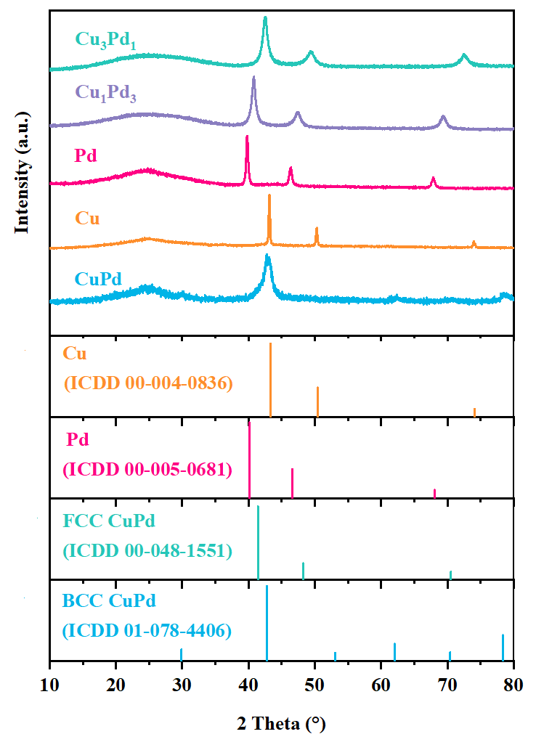
Figure S2. XRD of CuPd, Cu, Pd, Cu₃Pd and CuPd₃.

Figure S3. A, XPS survey spectrum, and high-resolution XPS spectra of (B) Pd 3d and (C) Cu 2p of CuPd catalysts.

Figure S4. A, HRTEM images and (B) EDS mapping of the CuPd catalysts.

Figure S5. A, The CV curves normalized to the electrochemical active surface area
(ECSA) of different concentration of NO₃⁻. CV curves of (B) 0.01 M NO₃⁻, (C) 0.1 M NO₃⁻, (D) 0.3 M NO₃⁻, (E) 0.5 M NO₃⁻, (F) 0.7 M NO₃⁻, and (G) 1 M NO₃⁻. The measured capacitive currents are plotted as a function of scan rate and a linear fit determined the specific capacitance. (The specific capacitance for a flat surface is generally found to be in the range of 20-60 µF cm⁻².)

Figure S6. Electrocatalytic NO₃RR activity of different concentration of NO₃⁻.(-0.5 V vs. RHE, 12h, 1 M H₂SO₄).

Figure S7. Electrocatalytic NO₃RR activity of (A) Cu, (B) Pd, (C) Cu₃Pd and (D) CuPd₃ at different concentration of NO₃⁻. (-0.5 V vs. RHE, 12h).

Figure S8. Electrochemical online DEMS data of (A) 0.1 M NO₃⁻ and (B) 1 M NO₃⁻ during NO₃RR.

Figure S9. DMPO spin-trapping ESR spectra of different concentration of NO₃⁻.

Figure S10. Bode plots of 1 M KOH at different voltages.

Figure S11. I-t curves of potentiostatic and pulsed potential tests.

Figure S12. In situ Raman spectra under (A) −0.5 V for 300 s and then +0.1 V in 0.1 M NO₃⁻ solution, and (B) −0.5 V and then +0.1 V in 0.1 M NO₃⁻ solution with 3 cycles.

Figure S13. (A) XRD, (B) XPS, (C) HRTEM and (D) EDS mapping of Fe catalysts.

Figure S14. (A) XRD, (B) XPS, (C) HRTEM and (D) EDS mapping of Co catalysts.

Figure S15. (A) XRD, (B) XPS, (C) HRTEM and (D) EDS mapping of Ni catalysts.

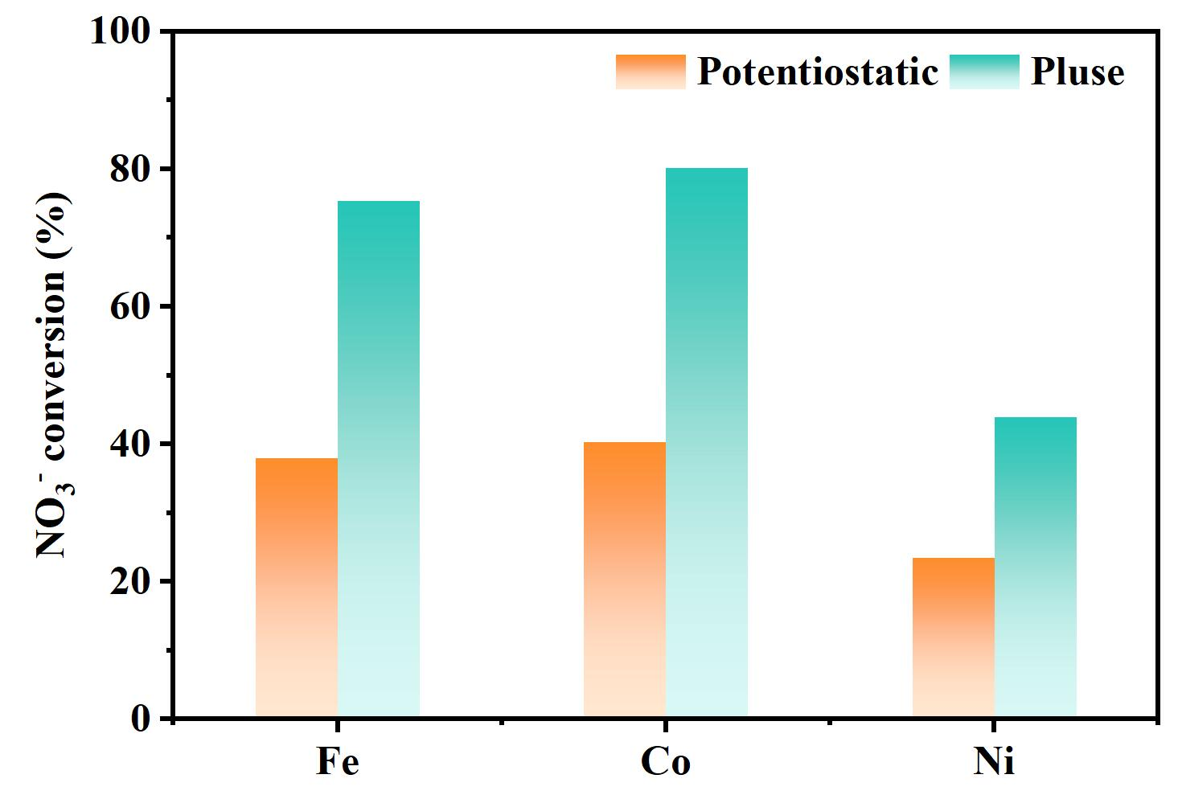
Figure S16. NO₃RR performance of potentiostatic and pulsed potential in 0.1 M NO₃⁻ solution in 12h.

Figure S17. Long-term stability test for the CuPd catalyst (pulsed potential test, 12h, 0.1 M NO₃⁻).

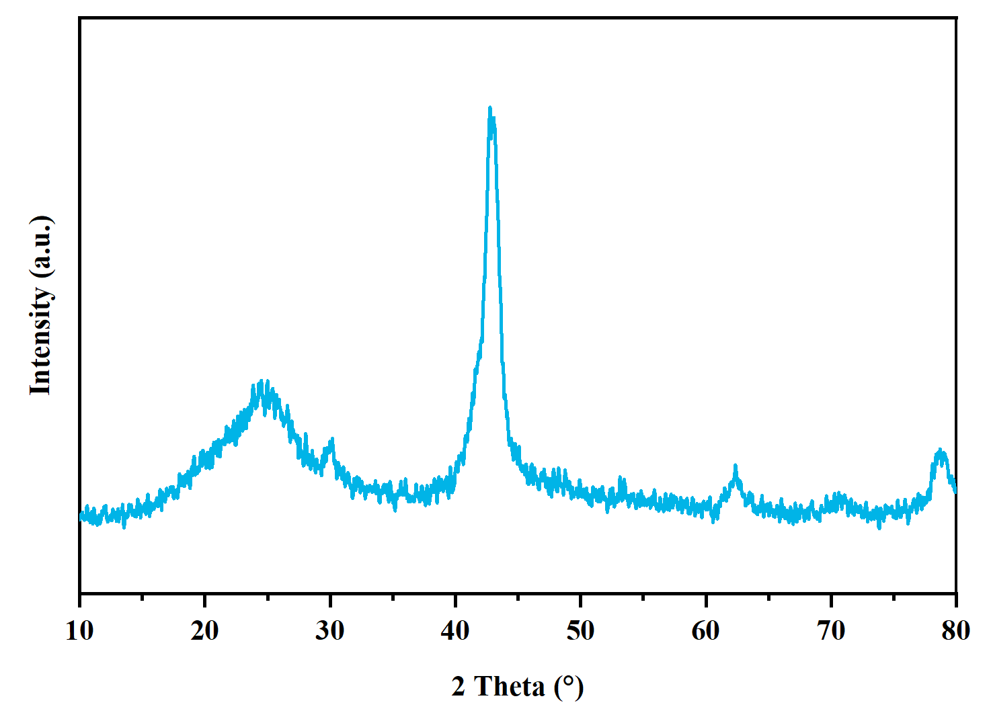
Figure S18. XRD of CuPd catalysts after 50th NO₃RR.

Figure S19. (A) HRTEM and (B) EDS mapping of CuPd catalysts after 50th NO₃RR.

Figure S20. Schematic diagram of H-type flow cell unit.

Figure S21. NO₃RR performance of H-type flow cell unit (constant voltage of 5V or pulsed potential test of 5V/4s and -0.2V/0.5s, 0.1 M NO₃⁻)

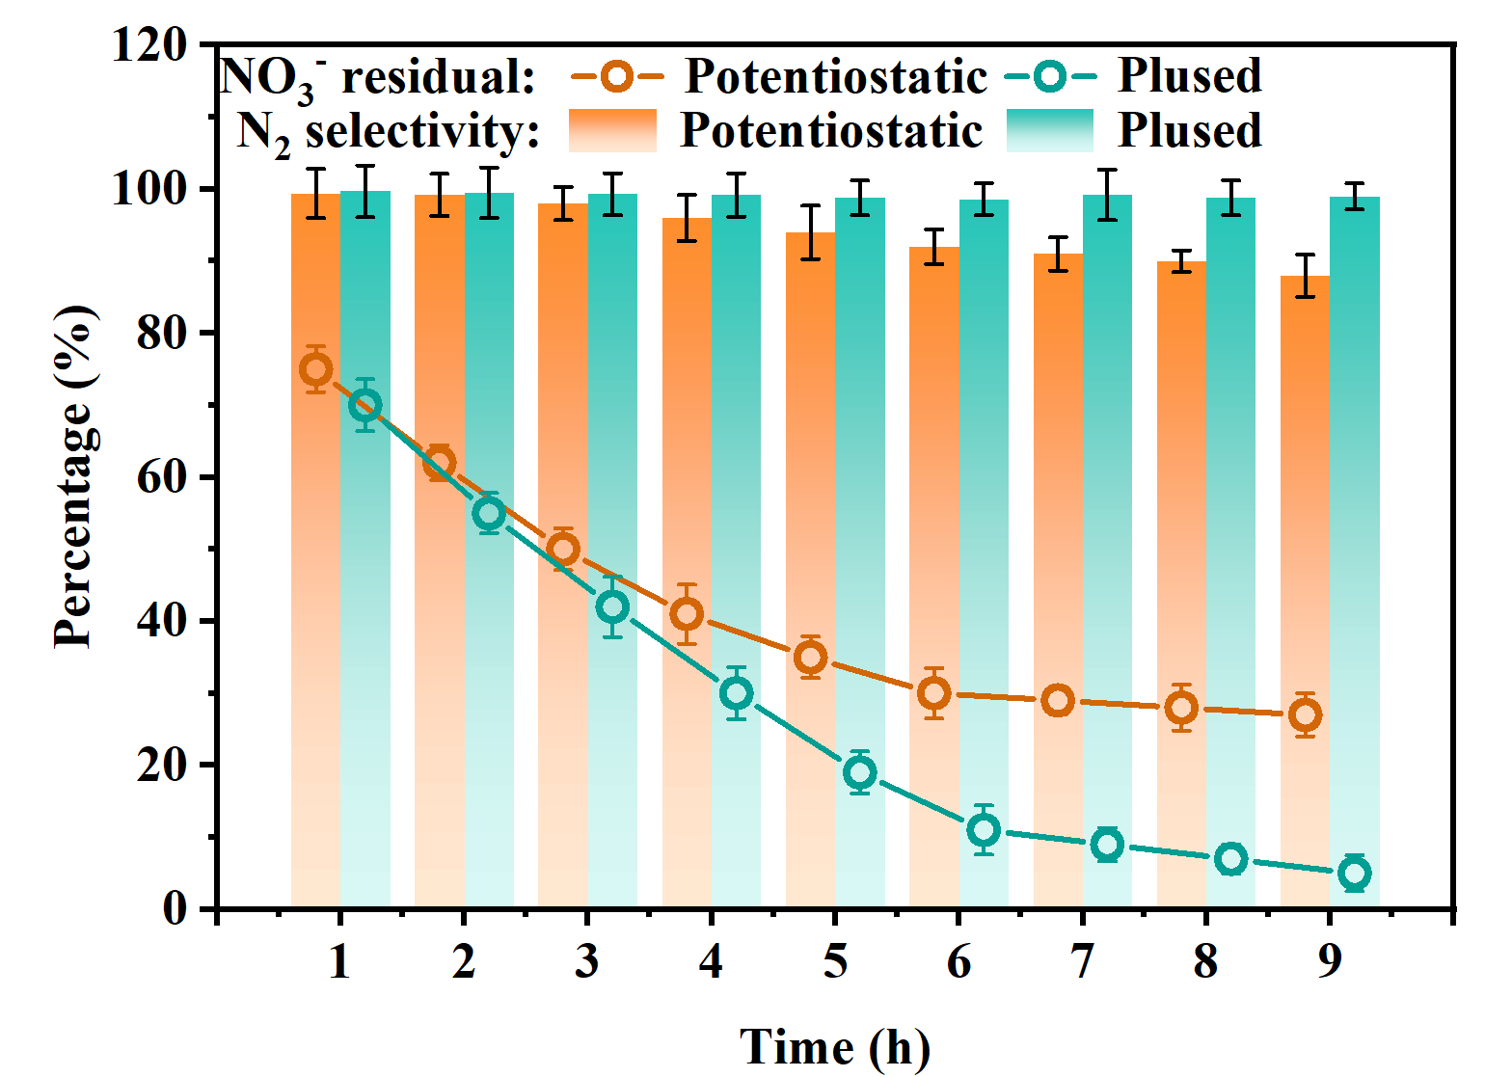
Figure S22. NO₃RR performance of H-type flow cell unit (constant voltage of 5V or pulsed potential test of 5V/4s and -0.2V/0.5s, 1 M NO₃⁻)

Table S1 Constants used in the simulation.
Parameter | Value | Description
$$c_{0,K}$$  $$c_{0,OH}$$  $$c_{0,H}$$  $$c_{0,NO3}$$  $$D_{K}$$  $$D_{OH}$$  $$D_{H}$$  $$D_{NO3}$$ | 1.1 M  1 M  10⁻¹⁴ M  0.1 M  1.96 x10⁻⁹ m²s⁻¹  5.27 x10⁻⁹ m²s⁻¹  9.31 x10⁻⁹ m²s⁻¹  1.90 x10⁻⁹ m²s⁻¹ | Initial and bulk concentration  Initial and bulk concentration  Initial and bulk concentration  Initial and bulk concentration  Diffusion coefficient  Diffusion coefficient  Diffusion coefficient  Diffusion coefficient

