Evaluation of Emergency & Critical Care Residents Accuracy on ECG Interpretation

Dear Participants

My name is Dr. Meron Tesfaye and I am a 3rd year Emergency & Critical Care Medicine resident. I am currently doing my research on “Evaluation of Emergency & Critical Care Residents Accuracy on ECG Interpretation in Addis Ababa, Ethiopia.” The purpose of this study is to explore the accuracy of ECG interpretation among Emergency & Critical Care residents. The questionnaire is designed to collect data regarding your experience with ECG interpretation and it is strictly for academic purposes. The data collected will only be used for the purpose of this study. Confidentiality will be strictly protected and none of your responses will affect you in any way. Your participation is vital for the success of this study but is purely voluntary. You may decline to participate in the study at any point if you choose to do so. I would like to thank you in advance for your participation. If you have any questions or need to get in touch with the researcher, please use the following contact information.
Respectfully,
Dr. Meron Tesfaye
+251-904-302183
meritensu@gmail.com
signature

Annex I. Questionnaires

Directions: Please place a mark on the given spaces, encircle choices, and write comments accordingly. You can skip any questions that you feel are not applicable to you. Thank you!
1. Age _______
2. Sex
A. Male B. Female
3. Which post graduating specialty training are you in?
A. AAU B. SPMMC
4. Year of residency?
A. 1 B. 2 C. 3
5 For how long did you work as a general practitioner?
A. less than a year B.1-2 years C. more than 2 years
6. Did you have any ECG class in your residency program?
A. Yes B. No
7. If your answer is yes for Q. No 6, when did you take the ECG class? (write your year of study)
8. If your answer is yes in Q. No 6, did you attend all class?
A. Yes B. No
9. Do you think the ECG class was enough?
A. Yes B. No
10.On average how many of the patients in the ED require ECG /day
A. <25% B. 25-50% C. >50%
11. How confident are you on interpretation of those ECGs?
A. Confident B. Neutral C. Not confident
12 How frequently do you ask for help in interpreting those ECGs?
A. Always B. Most of the time C. I never ask for help
13. From whom do you ask for help?
A. from senior resident B. from consultant C. cardiologist
14 Did something bad happened to your patient because of your ECG interpretation?
A. Yes B. No
15 If your answer is yes to question number 14 what was the incident that happened?
16 how often do you update yourself on ECG interpretation?
A. All the time
B. Monthly interval
C. Whenever I have an assignment and a case
D. Never
17 If you update yourself what are your sources? (Multiple answer is possible)
- Online lectures
- morning rounds
- text books
D practice with ECG quizzes
18 what is the role of your teachers regarding your ECG learning ?
A they give us continuous supervision and assignments
B they give us lectures
C they teach us at the bed side
D they are not involved at all
1 how do you label your satisfaction with the current ECG teaching
excellent
B very good
C good
D poor
20 What do you suggest would improve the current teaching practice regarding ECG?
21. Where did you work as a GP? (Primary hospital, referral hospital….)
22. Was ECG machine available in your hospital while you were working as a GP?

II. ECG quiz
please see those ECGS below and write your answers
1 A 24-year-old female presents following a syncopal episode in the context of alcohol consumption. She describes a prodrome of 10-15 seconds of lightheadedness.
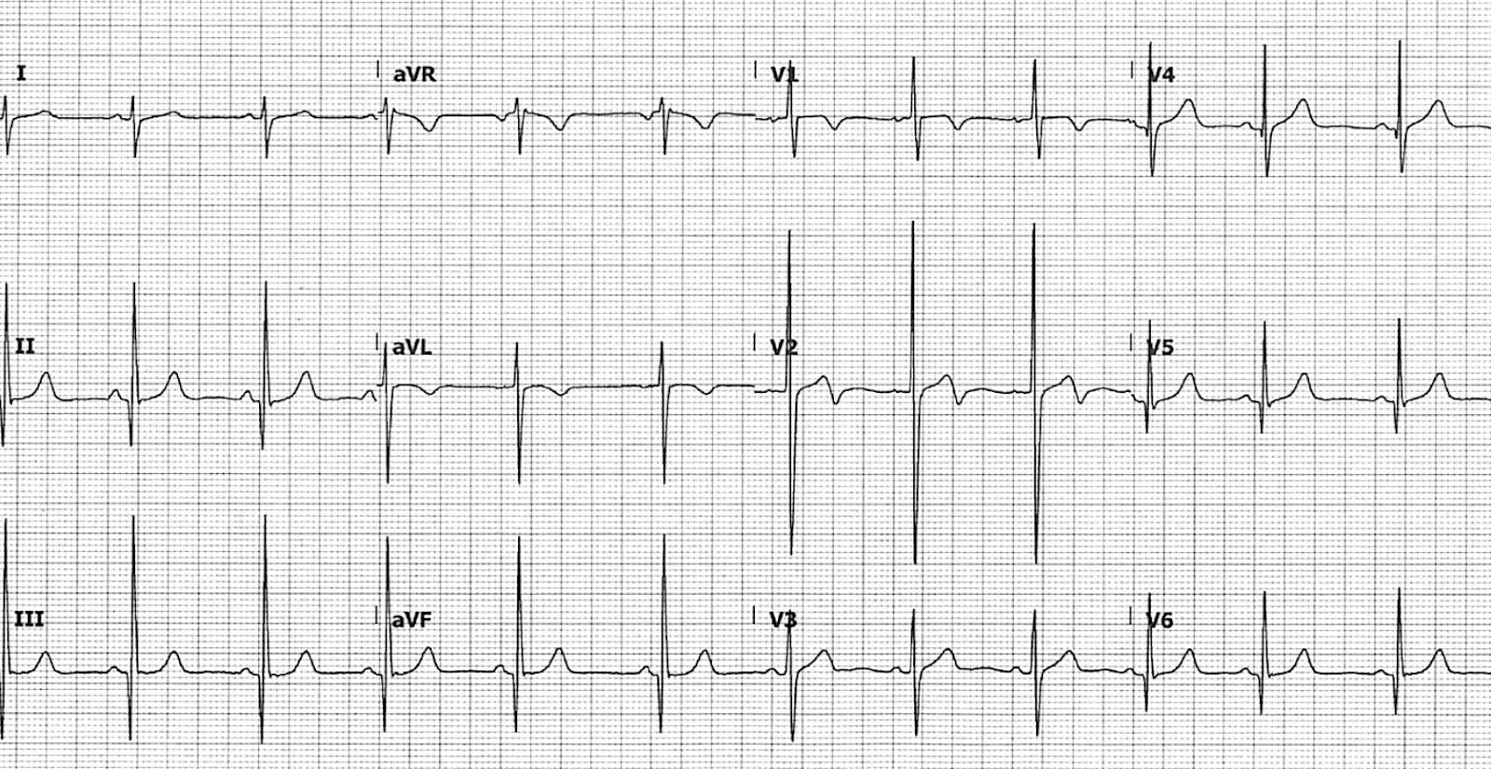

2 65-year-old male who was brought to the Emergency Department following an out-of-hospital cardiac arrest. ROSC was achieved prehospital following an episode of VT.
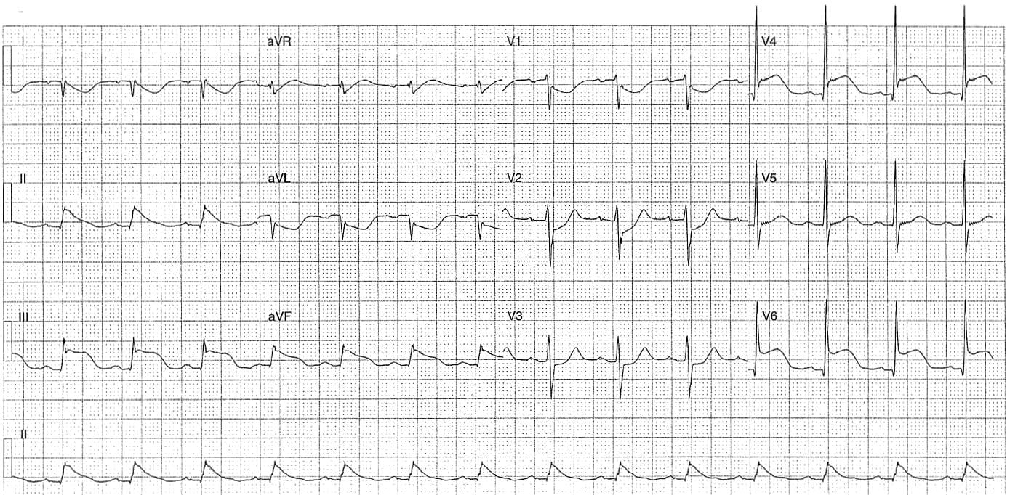
3 A 40 years old male who presented with a 60-minute history of central chest pain.
On arrival to the Emergency Department, he was pain free (ECG 1). Four minutes later he developed further intense chest pain and a repeat ECG was performed (ECG 2).
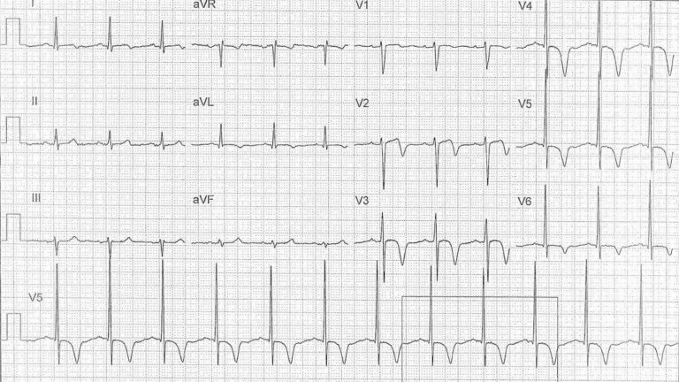
4 86 years old male referred by his General Practitioner with worsening renal failure. He has a history of atrial fibrillation with bradycardia for which he had a PPM inserted. His medications include metoprolol.
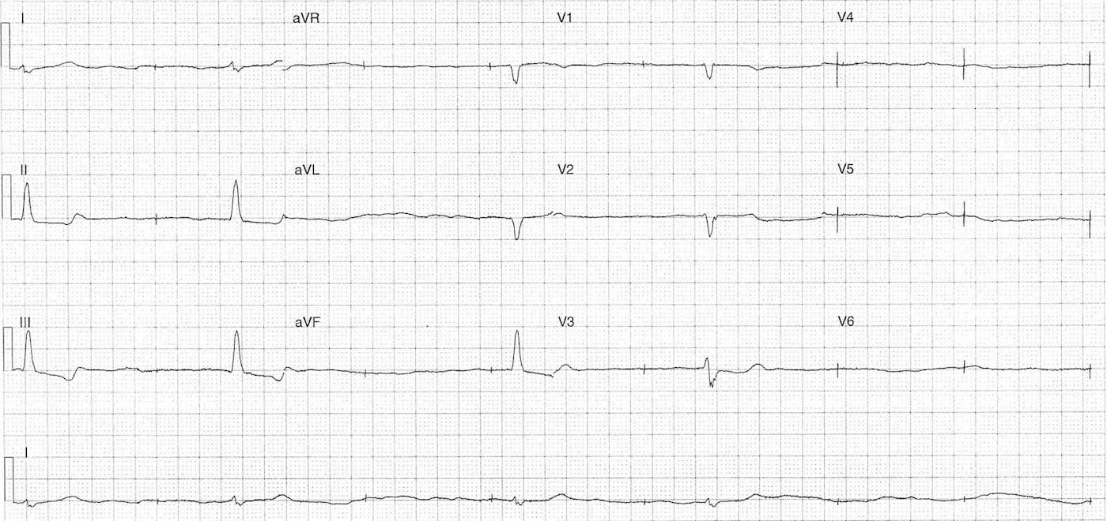
5 51 -year-old female who presented with chronic vomiting. She has a history of rheumatoid arthritis and paroxysmal atrial fibrillation. Her medications include sotalol and rivaroxaban.
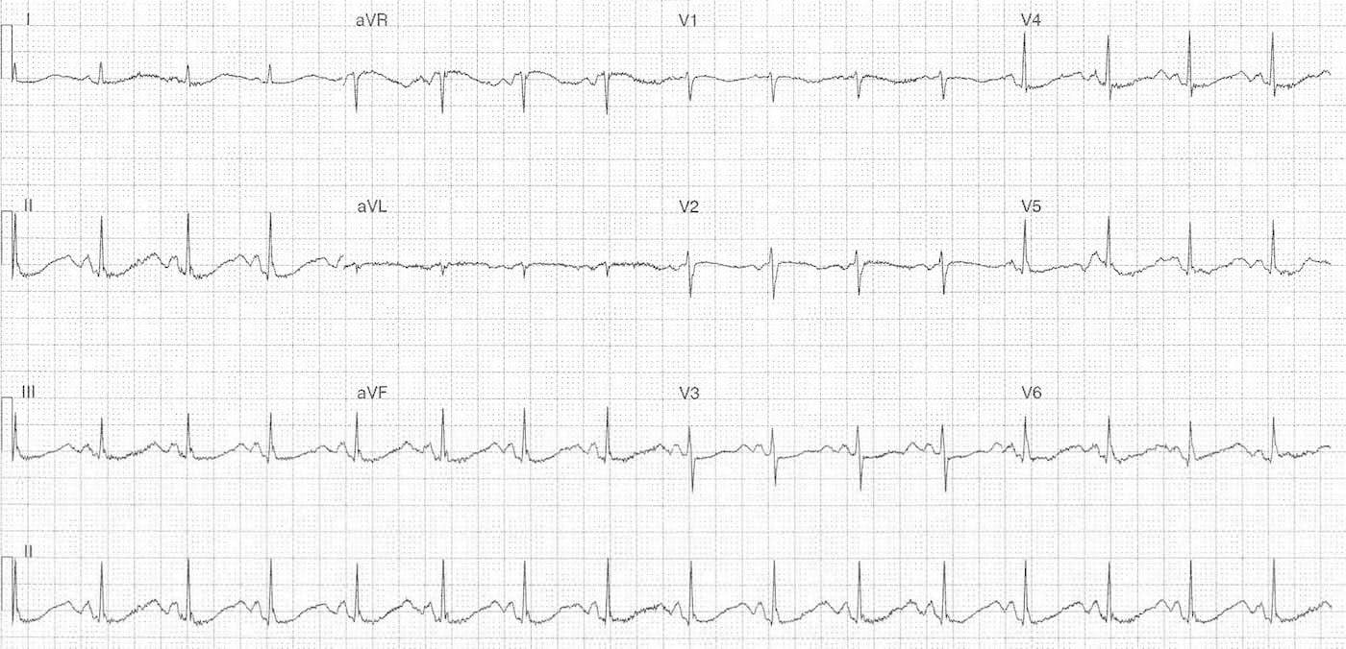
6 50 years old male came with chest pain 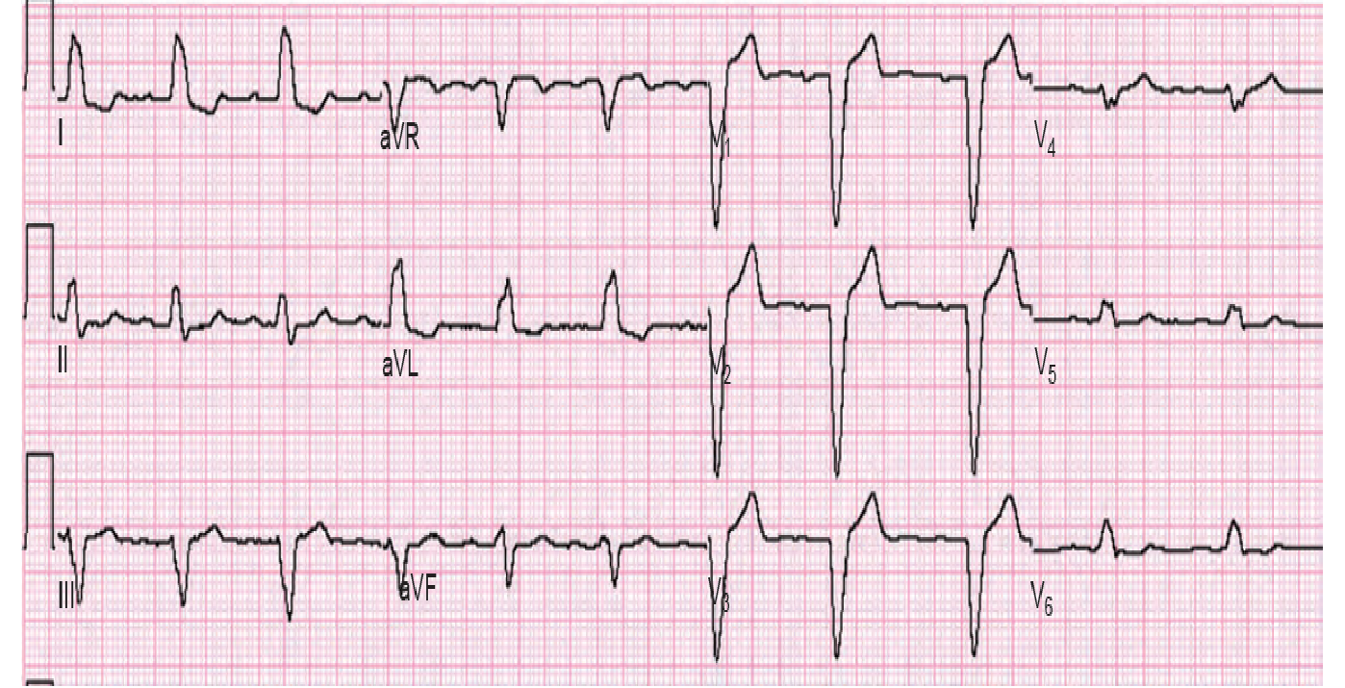
7 55 years old patient presented with light headedness and easy fatigability
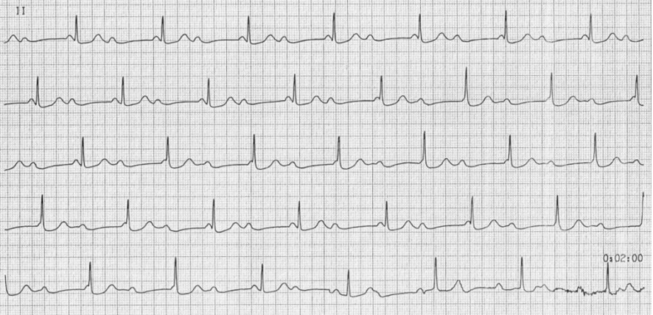
8 32 years old female presented with palpitation
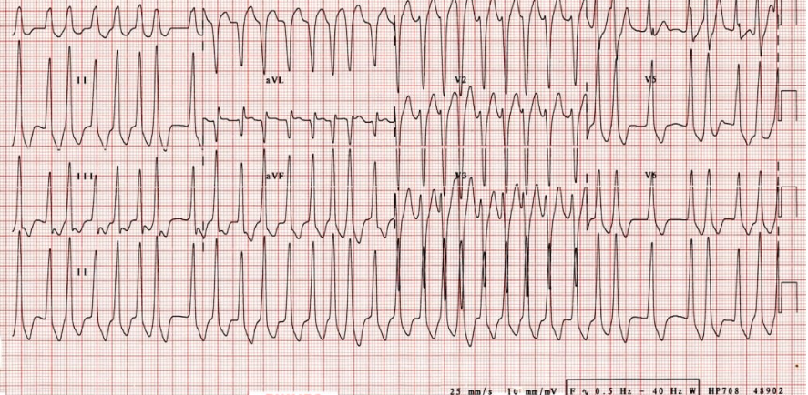
9 A 70 years old presented with easy fatigability

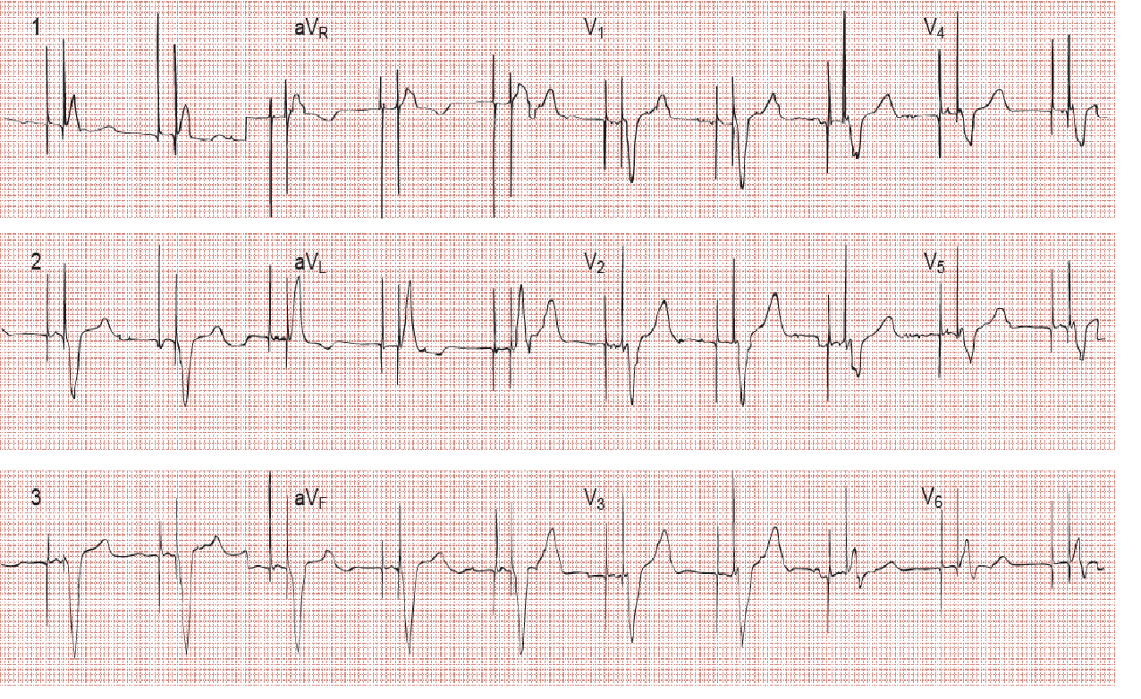
10 A 60 years old male patient presented with chest tightness and easy fatigability
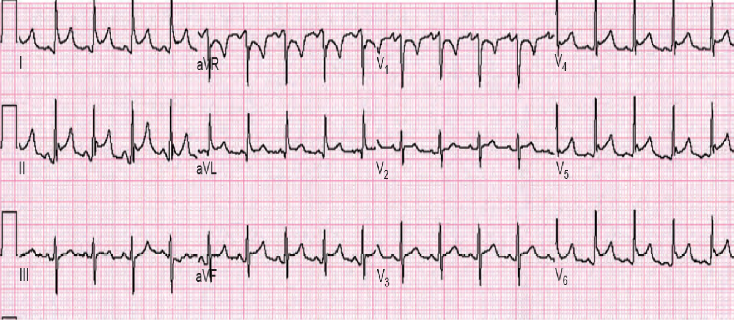
11 A 40 years old male patient presented with worsening of SOB with associated easy fatigability 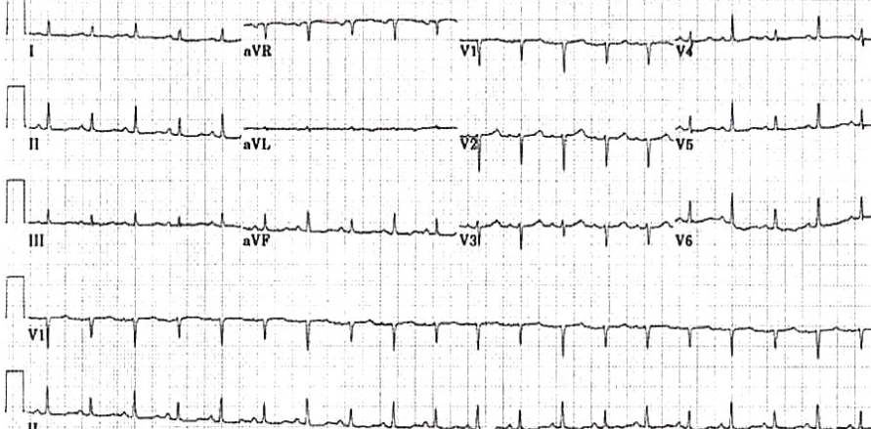
12 40 years old presented with chest pain and vomiting
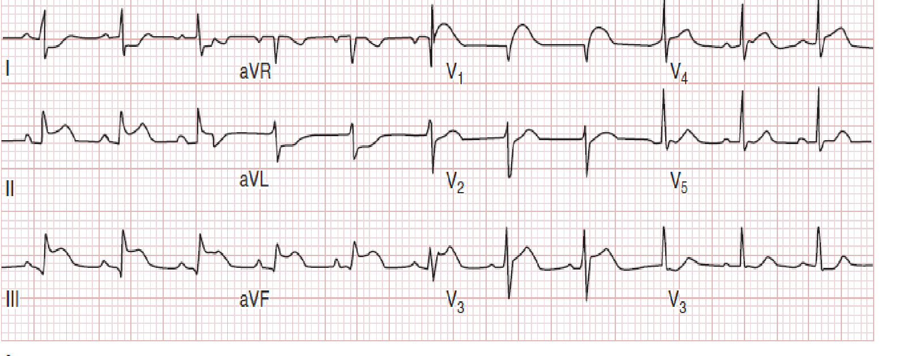
13 20 years old presented with nausea and vomiting 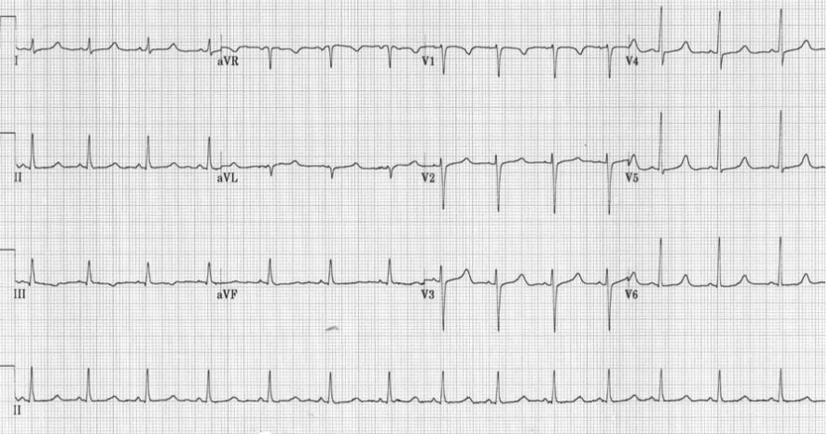
14 A 55 years old known copd patient presented with sob and easy fatigability
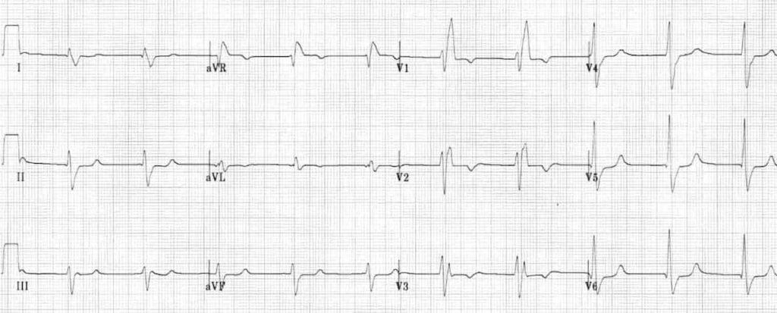
15 A 20 years old female presented with palpitation and easy fatigability 