Table. S1. Information of participants
Case Number | Gender | Age (Years) | Diagnosis | Segment | MRI Grade | Operation Method
Case 1 | Male | 16 | Idiopathic scoliosis | L1-L2 | I | Open spine surgery
Case 2 | Female | 14 | Idiopathic scoliosis | L1-L2 | I | Open spine surgery
Case 3 | Male | 18 | Idiopathic scoliosis | T12-L1 | I | Open spine surgery
Case 4 | Male | 45 | Lumbar disc herniation | L5-S1 | IV | Percutaneous endoscopic transforaminal discectomy
Case 5 | Male | 48 | Lumbar disc herniation | L5-S1 | III | Percutaneous endoscopic transforaminal discectomy
Case 6 | Female | 54 | Lumbar disc herniation | L4-L5 | IV | Percutaneous endoscopic transforaminal discectomy

Table. S2. Information of antibodies
Antibodies | Sorce | Identifier
anti-MAVS | Proteintech | 66911-1-Ig
anti-MDA5 | Proteintech | 21775-1-AP
anti-RIG-1 | Proteintech | 20566-1-AP
anti-histone H3 | Proteintech | 17168-1-AP
anti-TOMM20 | Proteintech | 11802-1-AP
anti-TOMM20 | Proteintech | 66777-1-Ig
anti-β-tubulin | Proteintech | 10068-1-AP
anti-BAX | Proteintech | 60267-1-Ig
anti-PNPT1 | Proteintech | 14487-1-AP
anti-LC3 | Proteintech | 14600-1-AP
anti-pink1 | Affinity | DF7742
anti-parkin | Affinity | AF0235
anti-parkin | Abnova | MAB12322
anti-SQSTM1 | Proteintech | 80294-1-RR
Anti-SLC6A6 | Proteintech | 26725-1-AP
anti-GAPDH | Proteintech | 10494-1-AP
anti-ACTB | Proteintech | 66009-1-Ig
anti-dsRNA | Scicons | 10010200
anti-GSDMD/ anti- GSDMD-N | Proteintech | 20770-1-AP
anti-NLRP3 | Proteintech | 19771-1-AP
anti-Caspase-1/ anti-P20 | Proteintech | 22915-1-AP
anti-rabbit IgG, HRP-linked antibody | Cell Signaling Technology | 7074
anti-rabbit IgG, HRP-linked antibody | Cell Signaling Technology | 7076
Rabbit IgG control polyclonal antibody | Proteintech | 30000-0-AP

Table. S3. Primers for qRT-PCR in this study
Gene Name | Forward Primer (5′-3′) | Reverse Primer (5′-3′)
ND1 (Human) | TCAAACTCAAACTACGCCCTG | GTTGTGATAAGGGTGGAGAGG
ND4 (Human) | CTCACACTCATTCTCAACCCC | TGTTTGTCGTAGGCAGATGG
ND5 (Human) | CTAGGCCTTCTTACGAGCC | GTTTGGGTTGAGGTGATGATG
ND6 (Human) | TGCTGTGGGTGAAAGAGTATG | CCCATAATCATACAAAGCCCC
CYTB (Human) | CAATTATACCCTAGCCAACCCC | GATAGTAATAGGGCAAGGACG
ACTB(Human) | CCTGTACGCCAACACAGTGC | ATACTCCTGCTTGCTGATCC
GAPDH (Human) | CTCCTCCACCTTTGACGCTG | TCCTCTTGTGCTCTTGCTGG
CO1 (Human) | GCCATAACCCAATACCAAACG | TTGAGGTTGCGGTCTGTTAG
CO2 (Human) | CTAGTCCTGTATGCCCTTTTCC | GTAAAGGATGCGTAGGGATGG
CO3 (Human) | CCTTTTACCACTCCAGCCTAG | CTCCTGATGCGAGTAATACGG
SLC6A6 (Human) | AGACAACAGACACGCGAGGT | GGCCATCTCCTTGGTTTGGGA
MDA5 (Human) | CCTTGGTTGGACTCGGGAAT | GCAGCAGCAATCCGGT
RIG-I (Human) | TGTCCACCTTCAGAAGTGTCT | AGCAGGCAAAGCAAGCTCTA
BAX (Human) | TGCAGAGGATGATTGCTGAC | GAGGACTCCAGCCACAAAGA
PNPT1 (Human) | TATGGAGTAGCGCAGGGTCT | GCAGTGTCACCTGACTGTACT
MAVS (Human) | CAGCAGAAATGAGGAGACCCC | CAAGATCCTCGAAGCAGCCC
IL-1β (Human) | AGGCTCCGAGATGAACAA | AAGGCATTAGAAACAGTCC
IL-6 (Human) | TTCTTGGGACTGATGCTG | CTGGCTTTGTCTTTCTTGTT
TNF-α (Human) | TGTCCCTTTCACTCACTGGC | CATCTTTTGGGGGAGTGCCT

Table. S4. Primer sequences for strand-specific reverse transcription
Primer | Sequences (5′-3′)
ND 4 Heavy | CGCAAATGGGCGGTAGGCGTGTGTTTGTCGTAGGCAGATGG
ND 4 Light | CGCAAATGGGCGGTAGGCGTGCCTCACACTCATTCTCAACCC
ND 5 Heavy | CGCAAATGGGCGGTAGGCGTGTTTGGGTTGAGGTGATGATG
ND 5 Light | CGCAAATGGGCGGTAGGCGTGCATTGTCGCATCCACCTTTA
ND 6 Heavy | CGCAAATGGGCGGTAGGCGTGGGTTGAGGTCTTGGTGAGTG
ND 6 Light | CGCAAATGGGCGGTAGGCGTGCCCATAATCATACAAAGCCCC
CO3 Heavy | CGCAAATGGGCGGTAGGCGTGCTCCTGATGCGAGTAATACGG
CO3 Light | CGCAAATGGGCGGTAGGCGTGCCTTTTACCACTCCAGCCTAG
CYTB Heavy | CGCAAATGGGCGGTAGGCGTGGGATAGTAATAGGGCAAGGACG
CYTB Light | CGCAAATGGGCGGTAGGCGTGCAATTATACCCTAGCCAACCCC
ACTB | CGCAAATGGGCGGTAGGCGTGACA CAG AGTACTTGCGCTCAG

Table. S5. Primer sequences for siRNA
Gene Name | Forward Primer (5′-3′) | Reverse Primer (5′-3′)
si-BAX | CCAAGGUGCCGGAACUGAUTT | AUCAGUUCCGGCACCUUGGTT
si-MDA5 | GGAAUCAGCACGAGGAAUATT | AUUCUGAUGAGUUAUUCUCTT
si-RIG-I | CAGAUGAAGCCUUGGAUUATT | UAAUCCAAGGCUUCAUCUGTT
si-SLC6A6 | GGGAGAAGUGGUCUAGCAATT | GGAACACACCUCACUGCAUTT
si-MAVS | CAGAGGAGAAUGAGUAUAATT | UUAUACUCAUUCUCCUCUGTT
si-scramble | UUCUCCGAACGUGUCACGUTT | ACGUGACACGUUCGGAGAATT

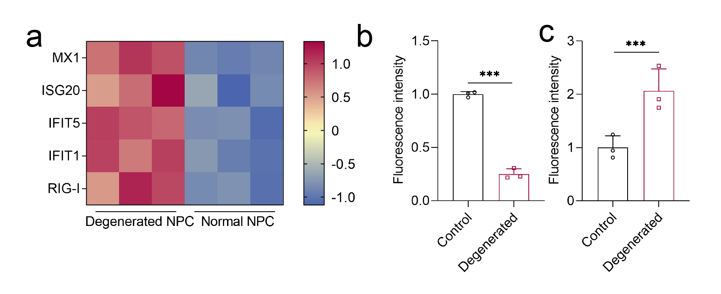
Fig. S1. mtdsRNA is elevated in degenerated NP tissues. (a) Heat map of mtdsRNA related genes in GSE245147, n = 3. (b) Statistical result of IF of PNPT1, n = 3, ***p < 0.001, two-tailed ANOVA. (c) Statistical result of IF of NLRP3, n = 3, ***p < 0.001, two-tailed ANOVA.

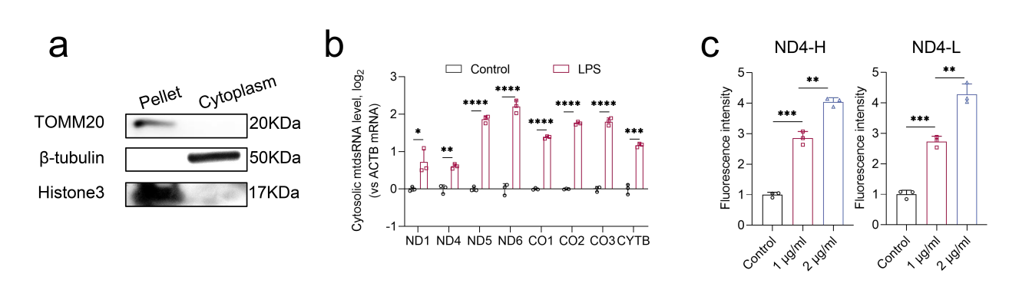
Fig. S2. Oxidative stress promotes the leakage of mtdsRNA. (a) WB of indicators existing in cytoplasm, mitochondria and nucleus, n = 3. (b). Cytosolic mtdsRNA level in NPCs, n = 3, *p < 0.05, **p < 0.01, ***p < 0.001, ****p < 0.0001, two-tailed ANOVA. (c). Statistical result of RNA FISH, n = 3, **p < 0.01, ***p < 0.001, two-tailed ANOVA.

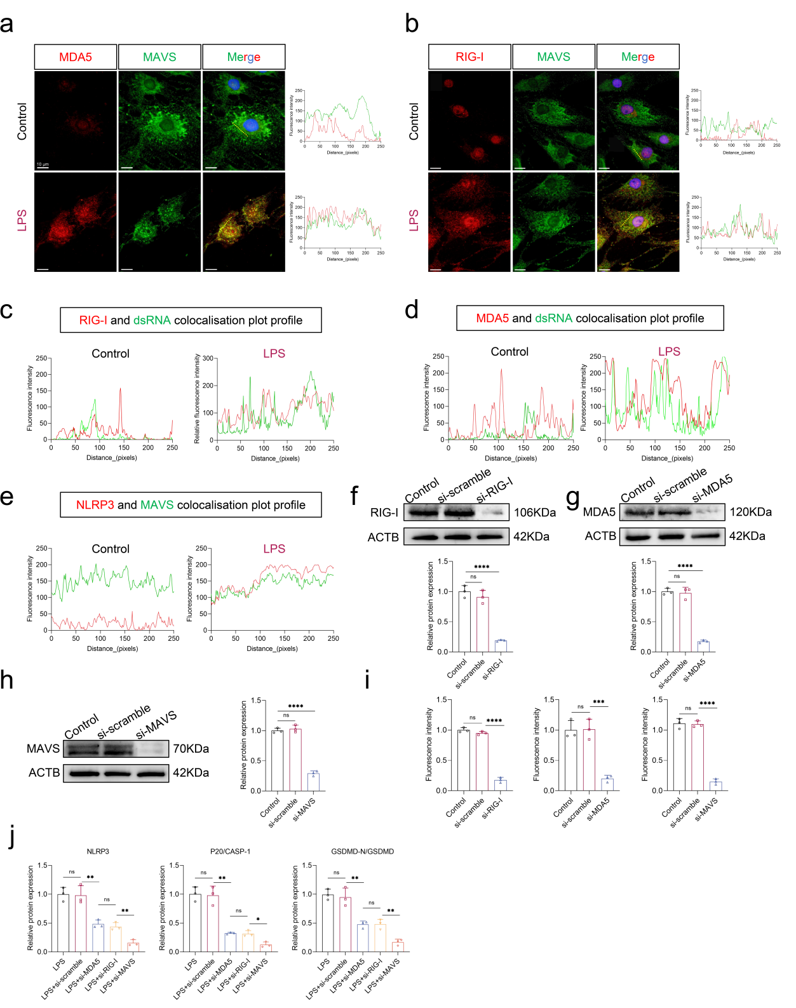
Fig. S3. mtdsRNA triggers the RLR-MAVS-NLRP3 axis and promotes pyroptosis in NPCs. (a) IF results of MDA5 and MAVS, scale bar: 10 μm, n = 3. (b) IF results of RIG-I and MAVS, scale bar: 10 μm, n = 3. (c) RIG-I and dsRNA colocalisation profile, n = 3. (d) MDA5 and dsRNA colocalisation profile, n = 3. (e) NLRP3 and MAVS colocalisation profile, n = 3. (f) Representative image and statistical result of WB of RIG-I and ACTB, n = 3, ****p < 0.0001, n.s. not significant, two-tailed ANOVA. (g) Representative image and statistical result of WB of MDA5 and ACTB, n = 3, ****p < 0.0001, n.s. not significant, two-tailed ANOVA. (h) Representative image and statistical result of WB of MAVS and ACTB, n = 3, ****p < 0.0001, n.s. not significant, two-tailed ANOVA. (i) Statistical result of IF, n = 3, ***p < 0.001, ****p < 0.0001, n.s. not significant, two-tailed ANOVA. (j) Statistical result of WB, n = 3, **p < 0.01, n.s. not significant, two-tailed ANOVA.

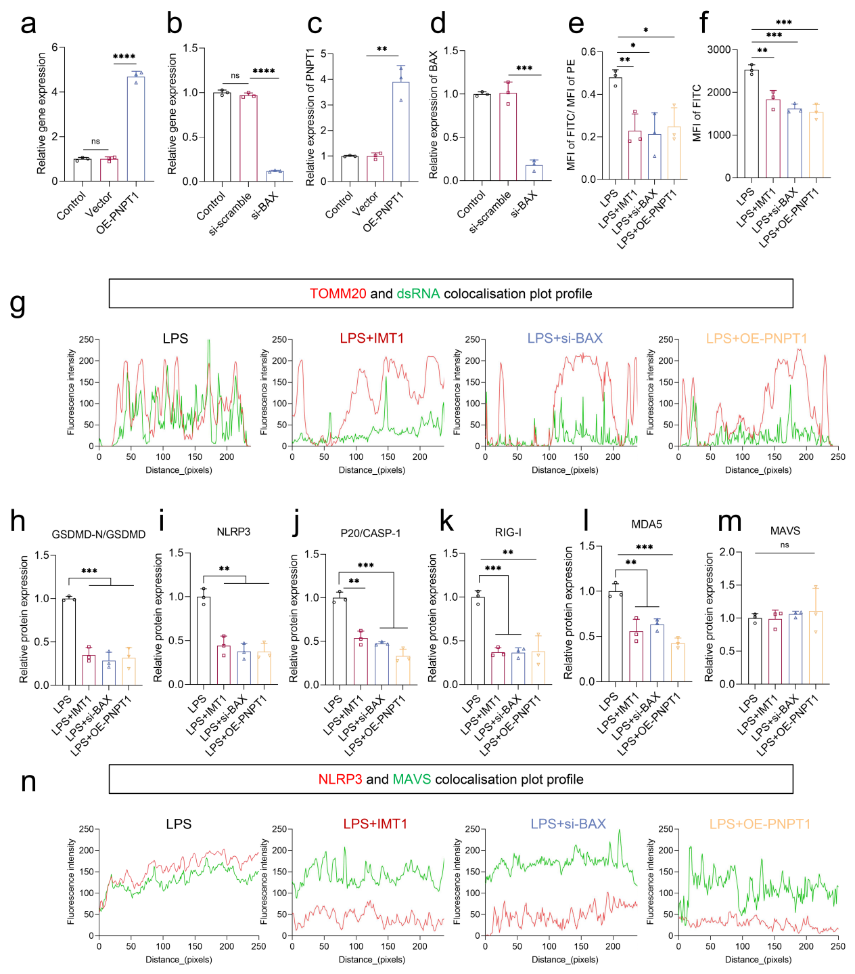
Fig. S4. Inhibiting the leakage of mtdsRNA can alleviate the pyroptosis of NPCs. (a) PCR result of PNPT1, n = 3, ****p < 0.0001, n.s. not significant, two-tailed ANOVA. (b) PCR result of BAX, n = 3, ****p < 0.0001, n.s. not significant, two-tailed ANOVA. (c) Statistical result of WB of PNPT1, **p < 0.01, two-tailed ANOVA. (d) Statistical result of WB of BAX, ***p < 0.001, two-tailed ANOVA. (e) Statistical result of JC-1 staining, n = 3, *p < 0.05, **p < 0.01, two-tailed ANOVA. (f) Statistical result of DCFH-DA staining, n = 3, **p < 0.01, ***p < 0.001, two-tailed ANOVA. (g) TOMM20 and dsRNA colocalisation profile, n = 3. (h-m) Statistical result of WB, n = 3, **p < 0.01, ***p < 0.001, n.s. not significant, two-tailed ANOVA. (n) NLRP3 and MAVS colocalisation profile, n=3.
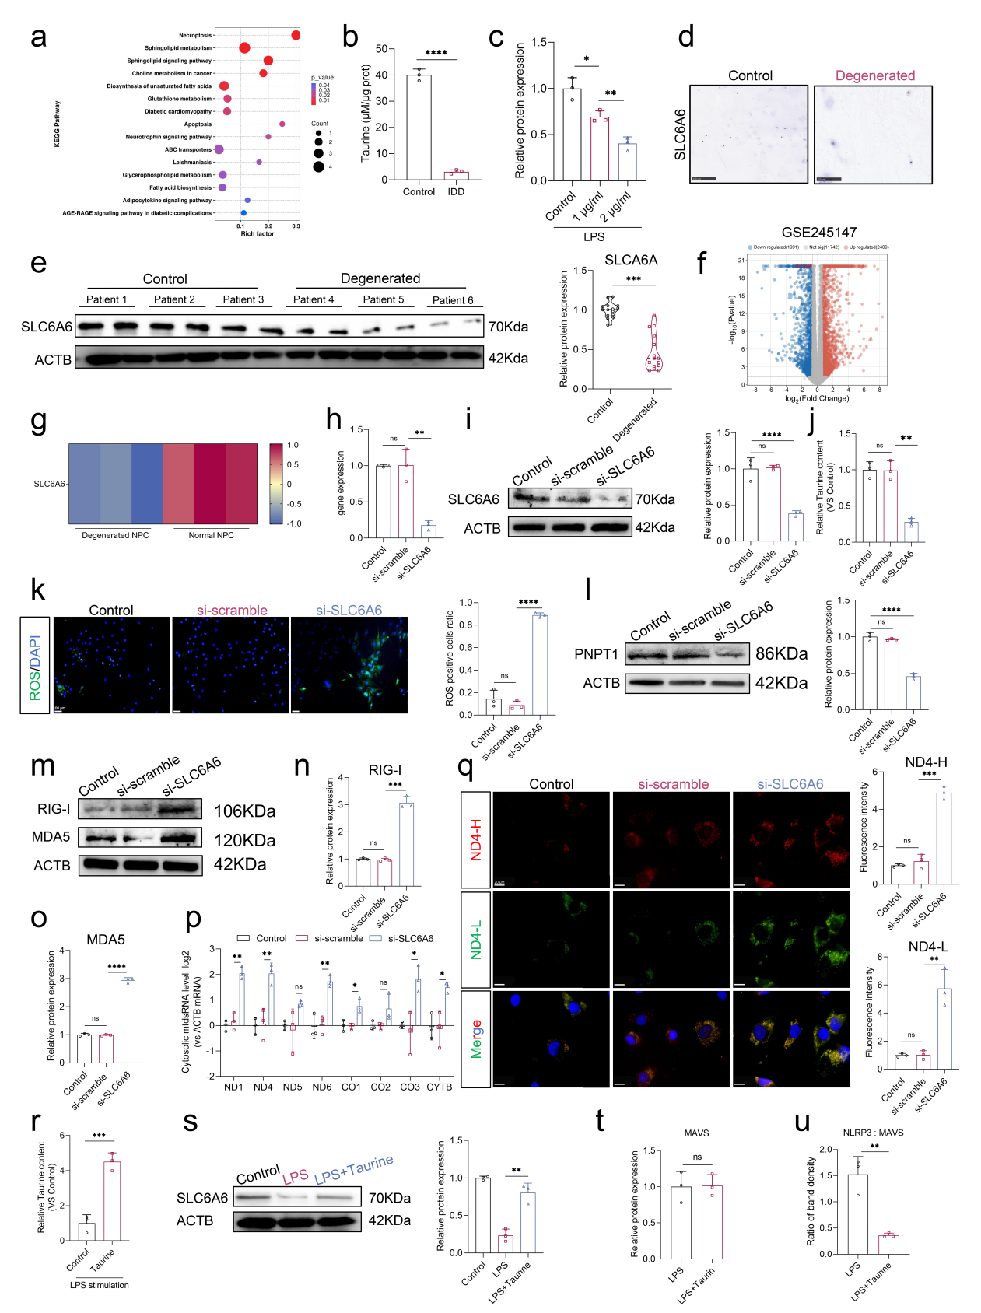
Fig. S5. Taurine is essential for maintaining the mitochondrial function in NPCs. (a) GO pathway analysis, n = 3. (b) Taurine content in clinical samples, n = 3, ****p < 0.0001, two-tailed ANOVA. (c) Statistical result of SLC6A6 expression, n = 3, *p < 0.05, **p < 0.01, two-tailed ANOVA. (d) IHC of SLC6A6, n = 3. (e) SLC6A6 expression in clinical samples, n = 15, ***p < 0.001. (f) Volcano plot of GSE245147 (SLC6A6 was labeled in the figure), n = 3. (g) SLC6A6 heat map, n = 3. (h) Gene expression of SLC6A6, n = 3. (i) WB result of SLC6A6 expression, n = 3, ****p < 0.0001, n.s. not significant, two-tailed ANOVA. (j) Taurine content in NPCs, **p < 0.01, n.s. not significant, two-tailed ANOVA. (k) DCFH-DA staining images, scale bar: 100 μm, ****p < 0.0001, n.s. not significant, two-tailed ANOVA. (l) WB result of PNPT1 expression, ****p < 0.0001, n.s. not significant, two-tailed ANOVA. (m-o) WB results of RIG-I and MDA5 expression, ***p < 0.001, ****p < 0.0001, n.s. not significant, two-tailed ANOVA. (p) qRT-PCR result of mtdsRNA in the cytoplasm, *p < 0.05, **p < 0.01, n.s. not significant, two-tailed ANOVA. (q) RNA FISH images and corresponding statistical results, scale bar: 10 μm, **p < 0.01, ***p < 0.001, n.s. not significant, two-tailed ANOVA. (r) Taurine content in NPCs, ***p < 0.001, two-tailed ANOVA. (s) WB result of SLC6A6 expression, **p < 0.01, two-tailed ANOVA. (t) Relative expression of MAVS, n.s. not significant, two-tailed ANOVA. u) Statistical result of co-IP, **p < 0.01, two-tailed ANOVA.
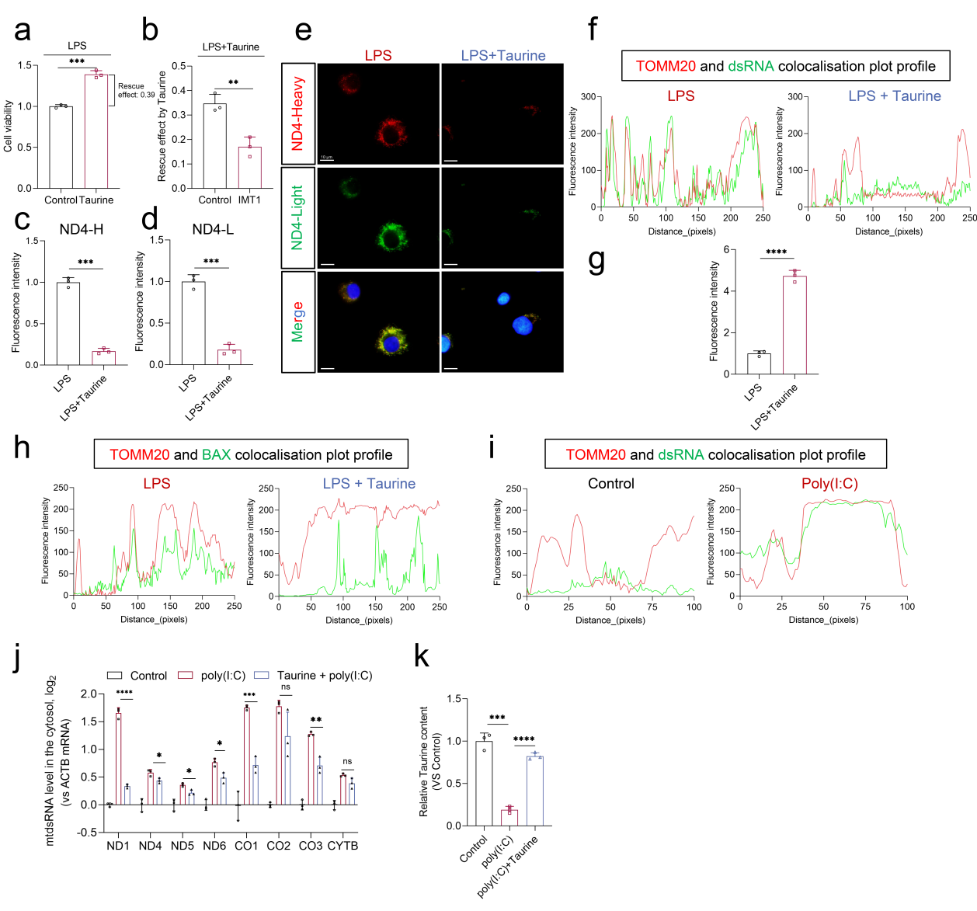
Fig. S6. Taurine can inhibit the leakage of mtdsRNA. (a) Cell viability result, n = 3, ***p < 0.001, two-tailed ANOVA. (b). Statistical result of rescue effect of taurine, n = 3, **p < 0.01, two-tailed ANOVA. (c-d). Statistical result of RNA FISH, n = 3, ***p < 0.001, two-tailed ANOVA. (e). RNA FISH result of LPS vs LPS+Taurine groups, n = 3. (f) TOMM20 and dsRNA colocalisation profile, n = 3. (g) Statistical result of IF of PNPT1, n = 3, ****p < 0.0001, two-tailed ANOVA. (h) TOMM20 and BAX colocalisation profile, n = 3. (i) TOMM20 and dsRNA colocalisation profile, n = 3. (j) mtdsRNA content in the cytoplasm, n = 3, *p < 0.05, **p < 0.01, ***p < 0.001, ****p < 0.0001, n.s. not significant, two-tailed ANOVA. (k). Relative content in NPCs after different treatments. n = 3, ***p < 0.001, ****p < 0.0001, two-tailed ANOVA.
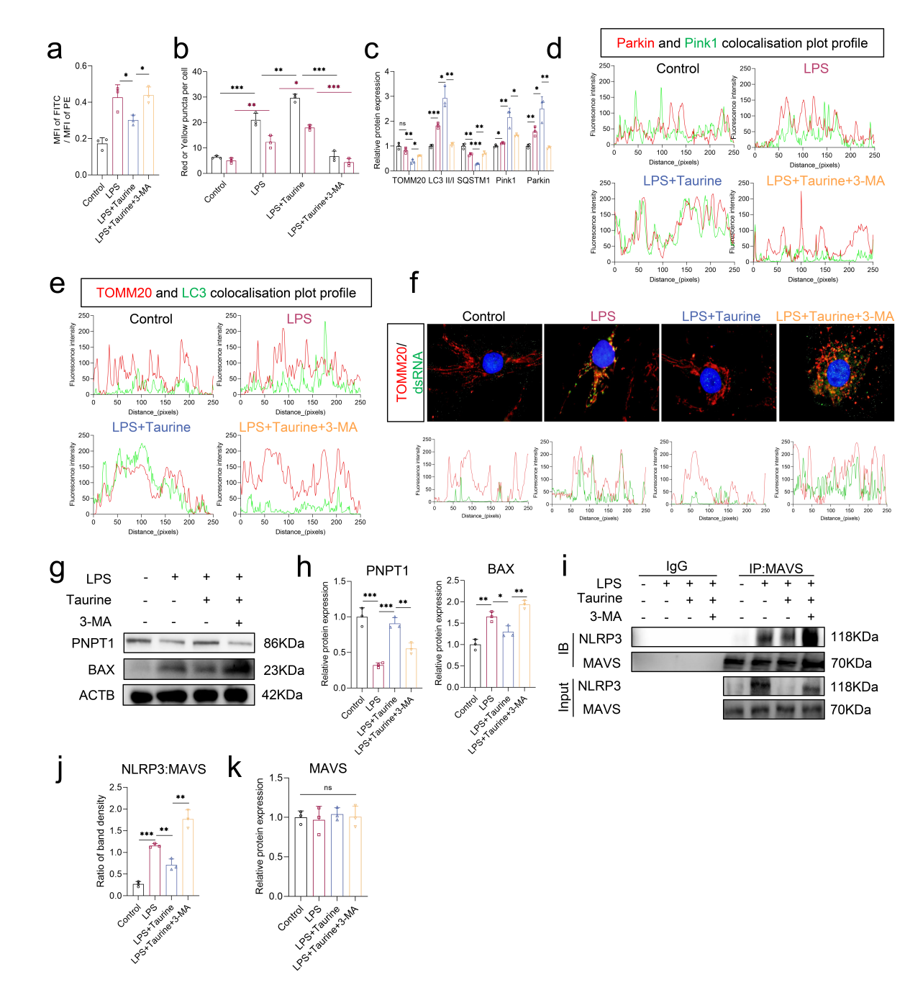
Fig. S7. Taurine can inhibit the mtdsRNA-MAVS-NLRP3 axis by enhancing mitophagy. (a) Statistical result of JC-1 staining, n = 3, *p < 0.05, two-tailed ANOVA. (b) Statistical result of red or yellow puncta per cell, n = 3, **p < 0.01, ***p < 0.001, two-tailed ANOVA. (c) Statistical results of WB, n = 3, *p < 0.05, **p < 0.01, ***p < 0.001, n.s. not significant, two-tailed ANOVA. (d) Parkin and pink1 colocalisation profile, n = 3. (e) TOMM20 and LC3 colocalisation profile, n = 3. (f) IF results of TOMM20 and dsRNA, n = 3. (g) WB of PNPT1 and BAX, n = 3. (h) Statistical results of PNPT1 and BAX, n = 3, *p < 0.05, **p < 0.01, ***p < 0.001, two-tailed ANOVA. (i) Co-IP of NLRP3 and MAVS, n = 3. (j) Statistical result of co-IP, n = 3, **p < 0.01, ***p < 0.001, two-tailed ANOVA. (k) Relative protein expression of MAVS, n = 3, n.s. not significant, two-tailed ANOVA.

