Supplementary text 1. The analysis of GGCM performance in simulating the impact of weather and climate extremes on crop yield.
Crop yields show the greatest sensitivity to extreme cold during the reproductive period, which leads to lower grain-setting rates¹. Across the different extremes considered here, GGCMs exhibited the poorest performance in simulating the impacts of extreme cold on yields. Among the GGCMs, only ORCHIDEE-crop, pDSSAT, ACEA and PROMET explicitly accounted for the impacts during the reproductive period (Table S7). However, even for the three GGCMs, the significant impact still could not be captured, indicating the parameterizations still need further improvement.

Extreme rainfall, by causing excessive soil moisture, damages crop roots, induces nutrient deficiency through leaching or denitrification, and reduces the photosynthetic capacity of crops^{2,3}. Only CGMS-WOFOST, the EPIC family, ACEA, and CYGMA accounted for part of these mechanisms (Table S7), which may be the reason for the poor performance of GGCMs in simulating the impact of extreme rainfall on rice yield. However, some critical mechanisms remain overlooked. For instance, extreme rainfall reduces effective panicles during the vegetative phase and decreases the number of grains during the reproductive phase for rice⁴. Furthermore, accurately representing waterlogging and other phenomena during extreme rainfall is also crucial for simulating its impacts in GGCMs.

The sensitivity of crop yield to heatwaves is greatest during the reproductive period, primarily reducing the grain-setting rate and the duration of grain filling^{1,5}. Except for CGMS-WOFOST and CYGMA, GGCMs accounted for the partial impacts of heatwaves during the reproductive period, primarily by reducing the duration of grain filling (Table S7), which may be the reason for the simulated significant yield reduction of rice or maize. However, GGCMs still need to further develop parameterization schemes for the impact of heatwaves on the grain-setting rate.

Crop yields are sensitive to drought during the reproductive period, with drought reducing the grain-setting rate and the duration of grain filling⁶. GGCMs performed best in simulating the impacts of drought, with 10 out of 12 GGCMI phase 1 models and 8 out of 11 GGCMI phase 3 models simulating the significant yield reductions in maize due to drought (Fig. 5). However, most GGCMs primarily accounted for the impacts of drought on photosynthesis, leaf growth, and senescence (Table S7). GGCMs still need to focus on the impact of drought during the reproductive period to improve their ability in simulating the impact of drought on wheat yield.

Table S1: The occurrence frequencies of province level weather and climate extremes in China during 1970–2019.
Extreme events | Wheat | Maize | Rice
Heatwaves | 28 | 226 | 491
Drought | 84 | 121 | 108
Extreme cold | 116 | 164 | 316
Extreme rainfall | 9 | 257 | 507
Total | 237 | 768 | 1422

Table S2: Yield loss, interannual variation of crop yield and the relative yield loss for weather and climate extremes. The interannual variation was calculated as the mean of interannual variation in provinces where the respective extreme event occurred. The relative yield loss is the ratio of the yield loss to the coefficient of variation.
Extreme event | Yield loss (%) | Interannual variation | Relative loss (%)
Heatwaves | 3.3 | 0.10 | 33.5
Drought | 7.3 | 0.11 | 66.6
Extreme cold | 1.9 | 0.11 | 18.0
Extreme rainfall | 3.0 | 0.10 | 29.3

Table S3: Same as Table S2, but for individual crops.
Extreme event | Crop | Yield loss (%) | Interannual variation | Relative loss (%)
Heatwaves | Wheat | N/A | N/A | N/A
Heatwaves | Maize | 6.0 | 0.11 | 55.7
Heatwaves | Rice | 1.7 | 0.08 | 21.5
Drought | Wheat | 9.6 | 0.13 | 75.9
Drought | Maize | 9.9 | 0.12 | 83.4
Drought | Rice | N/A | N/A | N/A
Extreme cold | Wheat | N/A | N/A | N/A
Extreme cold | Maize | N/A | N/A | N/A
Extreme cold | Rice | 3.4 | 0.09 | 38.2
Extreme rainfall | Wheat | N/A | N/A | N/A
Extreme rainfall | Maize | 4.7 | 0.11 | 41.5
Extreme rainfall | Rice | 1.9 | 0.09 | 21.0

Table S4: The cumulative and mean production and economic losses caused by weather and climate extremes during 1991–2019.
Extreme event | Production loss  (million tons) |  | Monetary loss  (2019 billion USD)
Extreme event | Total | Mean | Total | Mean
Heatwaves | 88.0 | 3.0 | 32.6 | 1.1
Drought | 64.2 | 2.2 | 19.0 | 0.7
Extreme cold | 39.0 | 1.3 | 12.8 | 0.4
Extreme rainfall | 73.7 | 2.5 | 26.5 | 0.9
Total | 264.9 | 9.1 | 90.8 | 3.1

Table S5: The occurrence frequencies of weather and climate extremes that significantly reduced crop yield during 1991–2019.
Extreme event | Wheat | Maize | Rice
Heatwaves | N/A | 120 | 172
Drought | 60 | 92 | N/A
Extreme cold | N/A | N/A | 116
Extreme rainfall | N/A | 126 | 225

Table S6: The mean production and economic losses caused by weather and climate extremes during 2010–2019.
Extreme event | Production loss  (million tons yr⁻¹) | Monetary loss  (2019 billion US$s yr⁻¹)
Heatwaves | 4.9 | 2.2
Drought | 1.3 | 0.5
Extreme cold | 0.8 | 0.4
Extreme rainfall | 3.5 | 1.5
Total | 10.5 | 4.6

Table S7: Summary description of global gridded crop models (GGCMs) evaluated in this study.
 | Crop model | Typeª | Climate forcing | Crop^{b} | Impacts of weather and climate extremes | Ref.
Phase 1 | CGMS-WOFOST | S | AgMERRA  (1980–2010) | W, M, R | Heatwaves reduce photosynthesis rate and increase respiration. Extreme cold delays phenological development and reduces daily photosynthesis rate. Drought and extreme rainfall reduce transpiration rate and cause leaf senescence. | ^{7,8}
Phase 1 | CLM4.5post-crop | E | AgMERRA  (1980–2010) | W, M, R | Heatwaves shorten growth period through affecting growing degree-day, reduce photosynthesis rate, and increase respiration. Extreme cold delays phenological development through affecting growing degree-day and reduces photosynthesis rate and respiration. Drought reduces stomatal conductance and transpiration. | ⁹
Phase 1 | EPIC-Boku | S | AgMERRA  (1980–2010) | W, M, R | Heatwaves shorten growth period through affecting growing degree-day, reduce the biomass and LAI increment, and constrain root growth. Extreme cold delays phenological development through affecting growing degree-day, reduces the biomass and LAI increment, constrains root growth, and reduces the above ground biomass. Drought reduces biomass gain, LAI increment and reduces the harvest index during the reproductive growth stage. Extreme rainfall also reduces the biomass and LAI increment through impacts on root aeration directly and increased nutrient leaching and soil erosion indirectly. | ^{10,11}
Phase 1 | EPIC-IIASA | S | AgMERRA  (1980–2010) | W, M, R | Same as EPIC-Boku in simulating the impacts of weather and climate extremes. | ^{10,11}
Phase 1 | GEPIC | S | AgMERRA  (1980–2010) | W, M, R | Same as EPIC-Boku in simulating the impacts of weather and climate extremes. | ^{12,13}
Phase 1 | LPJ-GUESS | E | AgMERRA  (1980–2010) | W, M, R | Heatwaves shorten growth period through affecting growing degree-day, reduce photosynthesis for C₄ crop, and increase respiration. Extreme cold delays phenological development through affecting growing degree-day, reduces photosynthesis, and causes leaf shedding. Drought reduces stomatal conductance and transpiration rate, causes leaf shedding, and increases allocation assimilated carbon to roots. | ^{14,15}
Phase 1 | LPJmL | E | AgMERRA  (1980–2010) | W, M, R | Heatwaves shorten growth period through affecting growing degree-day, reduce photosynthesis, and increase respiration. Extreme cold delays phenological development through affecting growing degree-day and reduces photosynthesis. Drought reduces transpiration rate, adjusts the fraction of carbon assimilates between leaves and storage organs, and reduces LAI growth and the maximum of LAI. | ¹⁶
Phase 1 | ORCHIDEE-crop | E | AgMERRA  (1980–2010) | W, M, R | Heatwaves shorten growth period through affecting growing degree-day, reduce photosynthesis, increase respiration, affect the daily leaf growth increment and leaf senescence, and stop the carbon filling of harvested organs. Extreme cold delays phenological development through affecting growing degree-day, reduces photosynthesis, reduces the seedling density, affects the daily leaf growth increment and leaf senescence, and stops the carbon filling of harvested organs. Drought reduces stomatal conductance, transpiration rate, photosynthesis, and the seedling density, affects the specific leaf area, and causes leaf senescence. Extreme rainfall reduces the seedling density. | ¹⁷
Phase 1 | pAPSIM | S | AgMERRA  (1980–2010) | W, M | For wheat, heatwaves delay phenological development through affecting growing degree-day, cause devernalisation, reduce daily biomass accumulation and root depth growth rate, and accelerate leaf senescence; extreme cold delays phenological development through affecting growing degree-day, reduces daily biomass accumulation, grain filling rate, and root depth growth rate, and causes leaf senescence; drought reduces daily biomass accumulation, leaf growth increment, and root depth growth rate, and accelerates leaf senescence. For maize, heatwaves may delay phenological development through affecting growing degree-day and reduce daily biomass accumulation; extreme cold delays phenological development through affecting growing degree-day, reduces daily biomass accumulation, and accelerates leaf senescence; drought delays phenology, reduces daily biomass accumulation and leaf growth increment, accelerates leaf senescence, and causes crop death. | ^{18,19}
Phase 1 | pDSSAT | S | AgMERRA  (1980–2010) | W, M, R | Heatwaves cause devernalisation and reduce daily biomass production, leaf growth increment, and the rate of kernel growth. Extreme cold delays phenological development through affecting growing degree-day and reduces daily biomass production, leaf growth increment, and the rate of kernel growth. Drought reduces daily biomass production, reduces leaf and root growth increment, and accelerates leaf senescence. | ^{19–21}
Phase 1 | PEGASUS | E | AgMERRA  (1980–2010) | W, M | Heatwaves reduce daily net biomass production and reduce crop yield during anthesis. Extreme cold delays phenological development through affecting growing degree-day and reduces daily net biomass production. Drought reduces daily net biomass production | ^{22,23}
Phase 1 | PEPIC | S | AgMERRA  (1980–2010) | W, M, R | Same as EPIC-Boku in simulating the impacts of weather and climate extremes. | ²⁴
Phase 3 | ACEA | S | GSWP3-  W5E5  (1902–2015) | W, M, R | Heatwaves inhibit pollination to reduce harvest index. Extreme cold delays phenological development through affecting growing degree-day, inhibits biomass production, and inhibits pollination to reduce harvest index. Drought reduces transpiration and canopy expansion, reduces stomatal conductance, accelerates canopy senescence, decreases root deepening, and affects harvest index. Extreme rainfall reduces stomatal conductance and transpiration by affecting root aeration and may even kill the crop (for all crops except rice). | ^{25,26}
Phase 3 | CROVER | E | GSWP3-  W5E5  (1902–2015) | W, M, R | Heatwaves shorten growth period through affecting growing degree-day and increase photosynthesis rate and respiration. Extreme cold delays phenological development through affecting growing degree-day, reduces photosynthesis rate, and affects crop yield. Drought reduces stomatal conductance and photosynthesis rate. | ^{27,28}
Phase 3 | CYGMA | S | GSWP3-  W5E5  (1902–2015) | W, M, R | Heatwaves decrease the daily increment of leaf area and yield. Extreme cold delays phenological development through affecting growing degree-day and decreases the daily increment of leaf area and yield. Drought and extreme rainfall decrease the daily increment of leaf area and yield. | ^{29,30}
Phase 3 | EPIC-IIASA | S | GSWP3-  W5E5  (1902–2015) | W, M, R | Same as EPIC-IIASA in phase1 in simulating the impacts of weather and climate extremes. | ³¹
Phase 3 | ISAM | E | GSWP3-  W5E5  (1902–2015) | W, M, R | Heatwaves shorten growth period through affecting growing degree-day, reduce photosynthesis rate, increase respiration, decrease the allocation of carbon to grain, and even make grains fail to develop during reproductive stage. Extreme cold delays phenological development through affecting growing degree-day, reduces photosynthesis rate, and causes leaf dead. Drought delays silk emergence for maize, reduces stomatal conductance, causes leaf dead, reduces gain filling, and increases carbon allocation to roots. | ^{32,33}
Phase 3 | LandscapeDNDC | S | GSWP3-  W5E5  (1902–2015) | W, M, R | Heatwaves shorten growth period through affecting growing degree-day, reduce photosynthesis rate, increase respiration, cause aboveground biomass senescence, and reduce grain number and grain filling during flowering. Extreme cold delays phenological development through affecting growing degree-day, reduces photosynthesis rate, and causes aboveground and belowground biomass senescence. Drought reduces stomatal conductance and photosynthesis rate, causes aboveground and belowground biomass senescence, and makes no carbon allocated to leaves. | ³⁴
Phase 3 | LPJmL | E | GSWP3-  W5E5  (1902–2015) | W, M, R | Same as LPJmL in phase 1 in simulating the impacts of weather and climate extremes. | ^{35,36}
Phase 3 | pDSSAT | S | GSWP3-  W5E5  (1902–2015) | W, M, R | Same as pDSSAT in phase 1 in simulating the impacts of weather and climate extremes. | ^{19–21}
Phase 3 | PEPIC | S | GSWP3-  W5E5  (1902–2015) | W, M, R | Same as EPIC-Boku in phase 1 in simulating the impacts of weather and climate extremes. | ²⁴
Phase 3 | PROMET | S | WFDE5  (1981–2009) | W, M, R | Heatwaves shorten growth period through affecting growing degree-day, affect photosynthesis rate, grain filling during the reproductive period, and increase respiration. Extreme cold delays phenological development through affecting growing degree-day and affects photosynthesis rate and grain filling during the reproductive period. Drought inhibits germination, reduces stomatal conductance and thus photosynthesis rate and biomass allocation. Besides, crop may die before being harvested or not reach maturity due to extreme heat, extreme cold, and drought. | ³⁷
Phase 3 | SIMPLACE-LINTUL5 | S | GSWP3-  W5E5  (1902–2015) | W, M, R | Heatwaves shorten growth period through affecting growing degree-day, reduce biomass accumulation, and reduce crop yield directly. Extreme cold delays phenological development through affecting growing degree-day and reduces biomass accumulation. Drought reduces biomass accumulation, transpiration, and leaf growth increment, and increases partitioning of biomass to roots. | ³⁸
ªE: ecosystem model; S: site-based model. ^{b}W: wheat; M: maize; R: rice.

Table S8: The average relative yield reduction during years with extreme events. The yields in years with extremes were compared with the average yield in normal years to get the relative yield reductions of each extreme event. The results were calculated separately for extreme events, irrespective of whether they occurred on cropland and during the growing season, and for agriculturally relevant extreme events only.
 | Including agriculturally irrelevant extreme events | Agriculturally relevant extreme events
Heatwaves | 6.3% | 8.6%
Drought | 16.3% | 21.3%
Extreme cold | 1.1% | 7.2%
Extreme rainfall | 9.6% | 10.4%

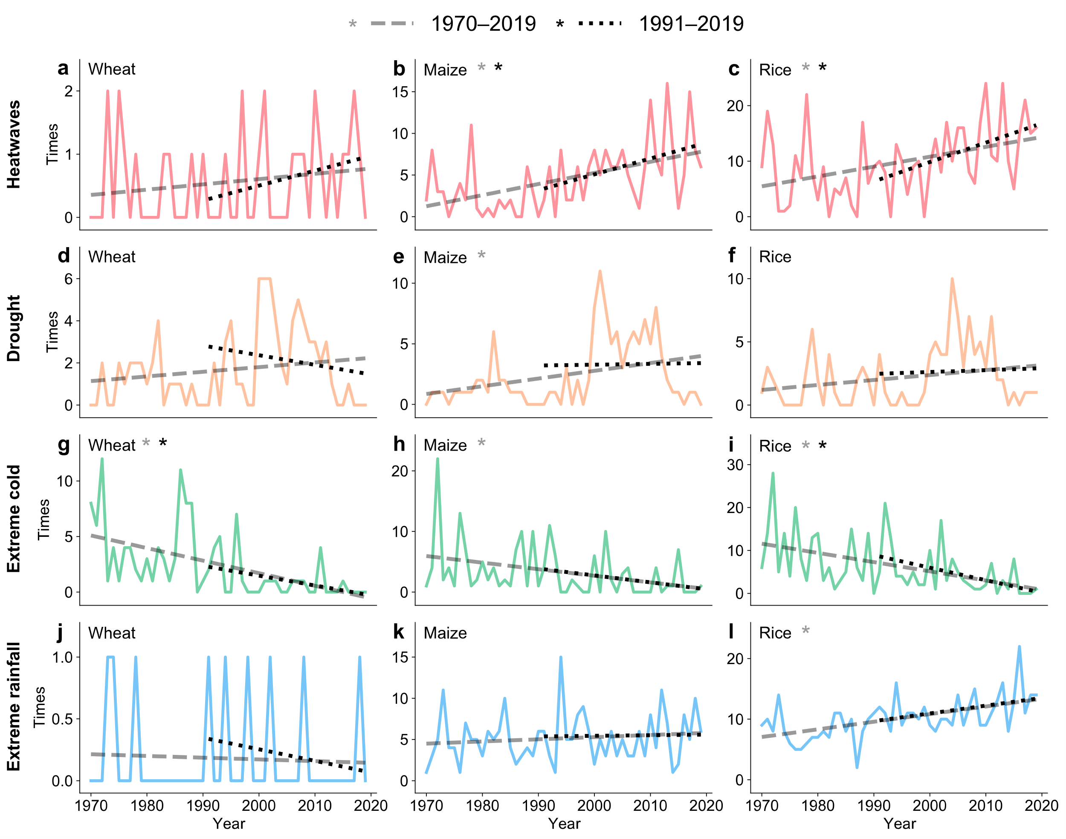
Fig. S1: The occurrence frequencies of province level weather and climate extremes for different crops in each year during 1970–2019. The solid lines represent the annual occurrence frequency of heatwaves (red), drought (orange), extreme cold (green), and extreme rainfall (blue), while the dashed gray and black lines show the trends in occurrence frequencies based on Ordinary Least Square regression for the periods 1970–2019 and 1991–2019, respectively. The asterisk denotes a statistical significance trend (P<0.05).

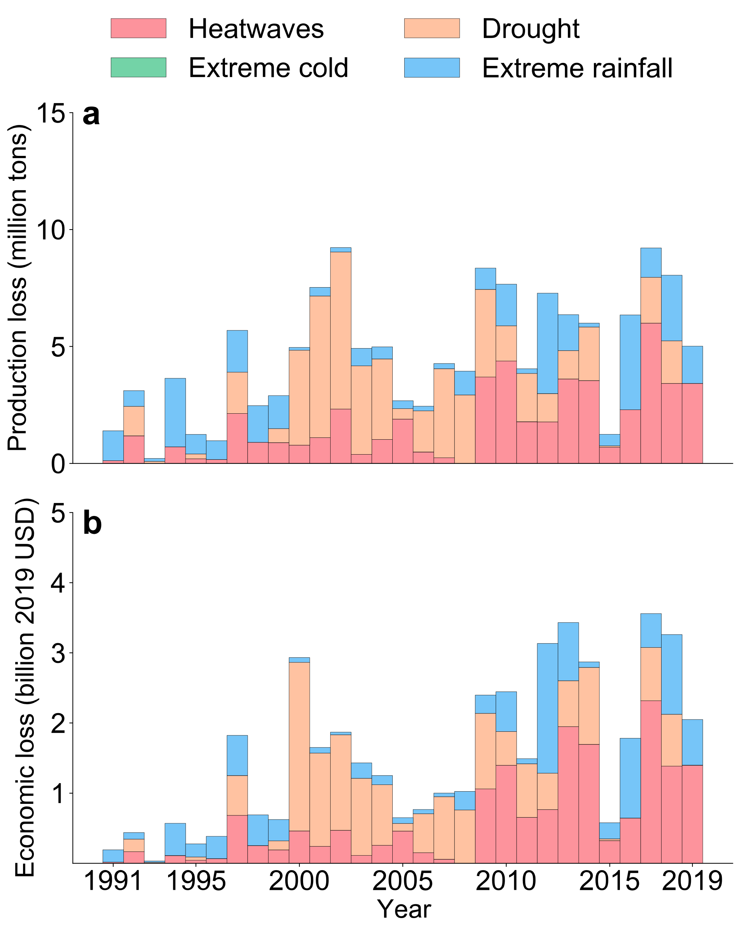
Fig. S2: Production and corresponding economic losses of maize due to weather and climate extremes in China for 1991–2019. Same as Fig. 5, but for maize only. The cumulative production loss amounts to 136.2 million tons from 1991 to 2019, equivalent to an economic loss of USD 44.6 billion.
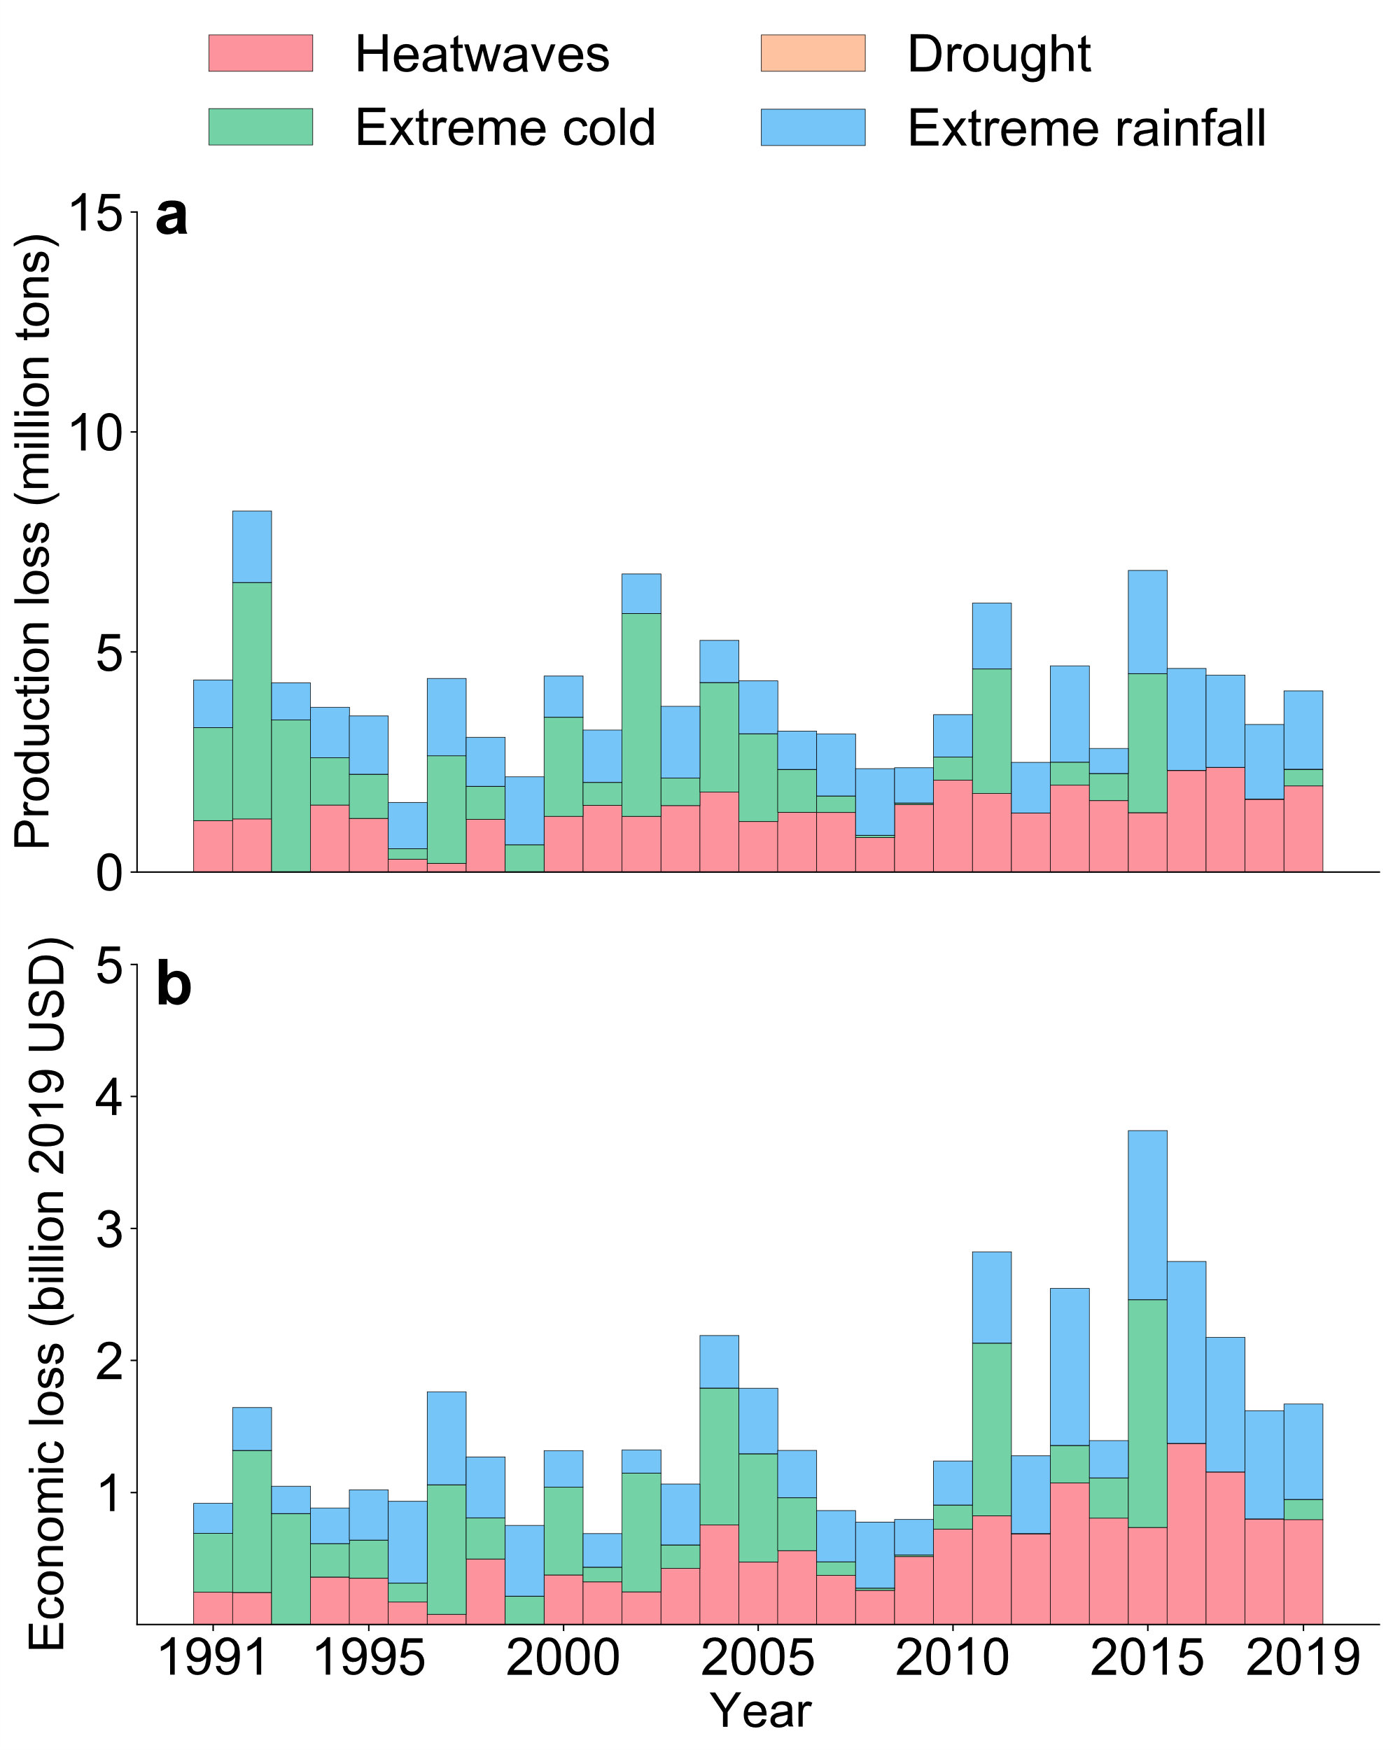
Fig. S3: Same as Fig. 5, but for rice only. The cumulative production loss amounts to 117.3 million tons from 1991 to 2019, equivalent to an economic loss of USD 43.6 billion.

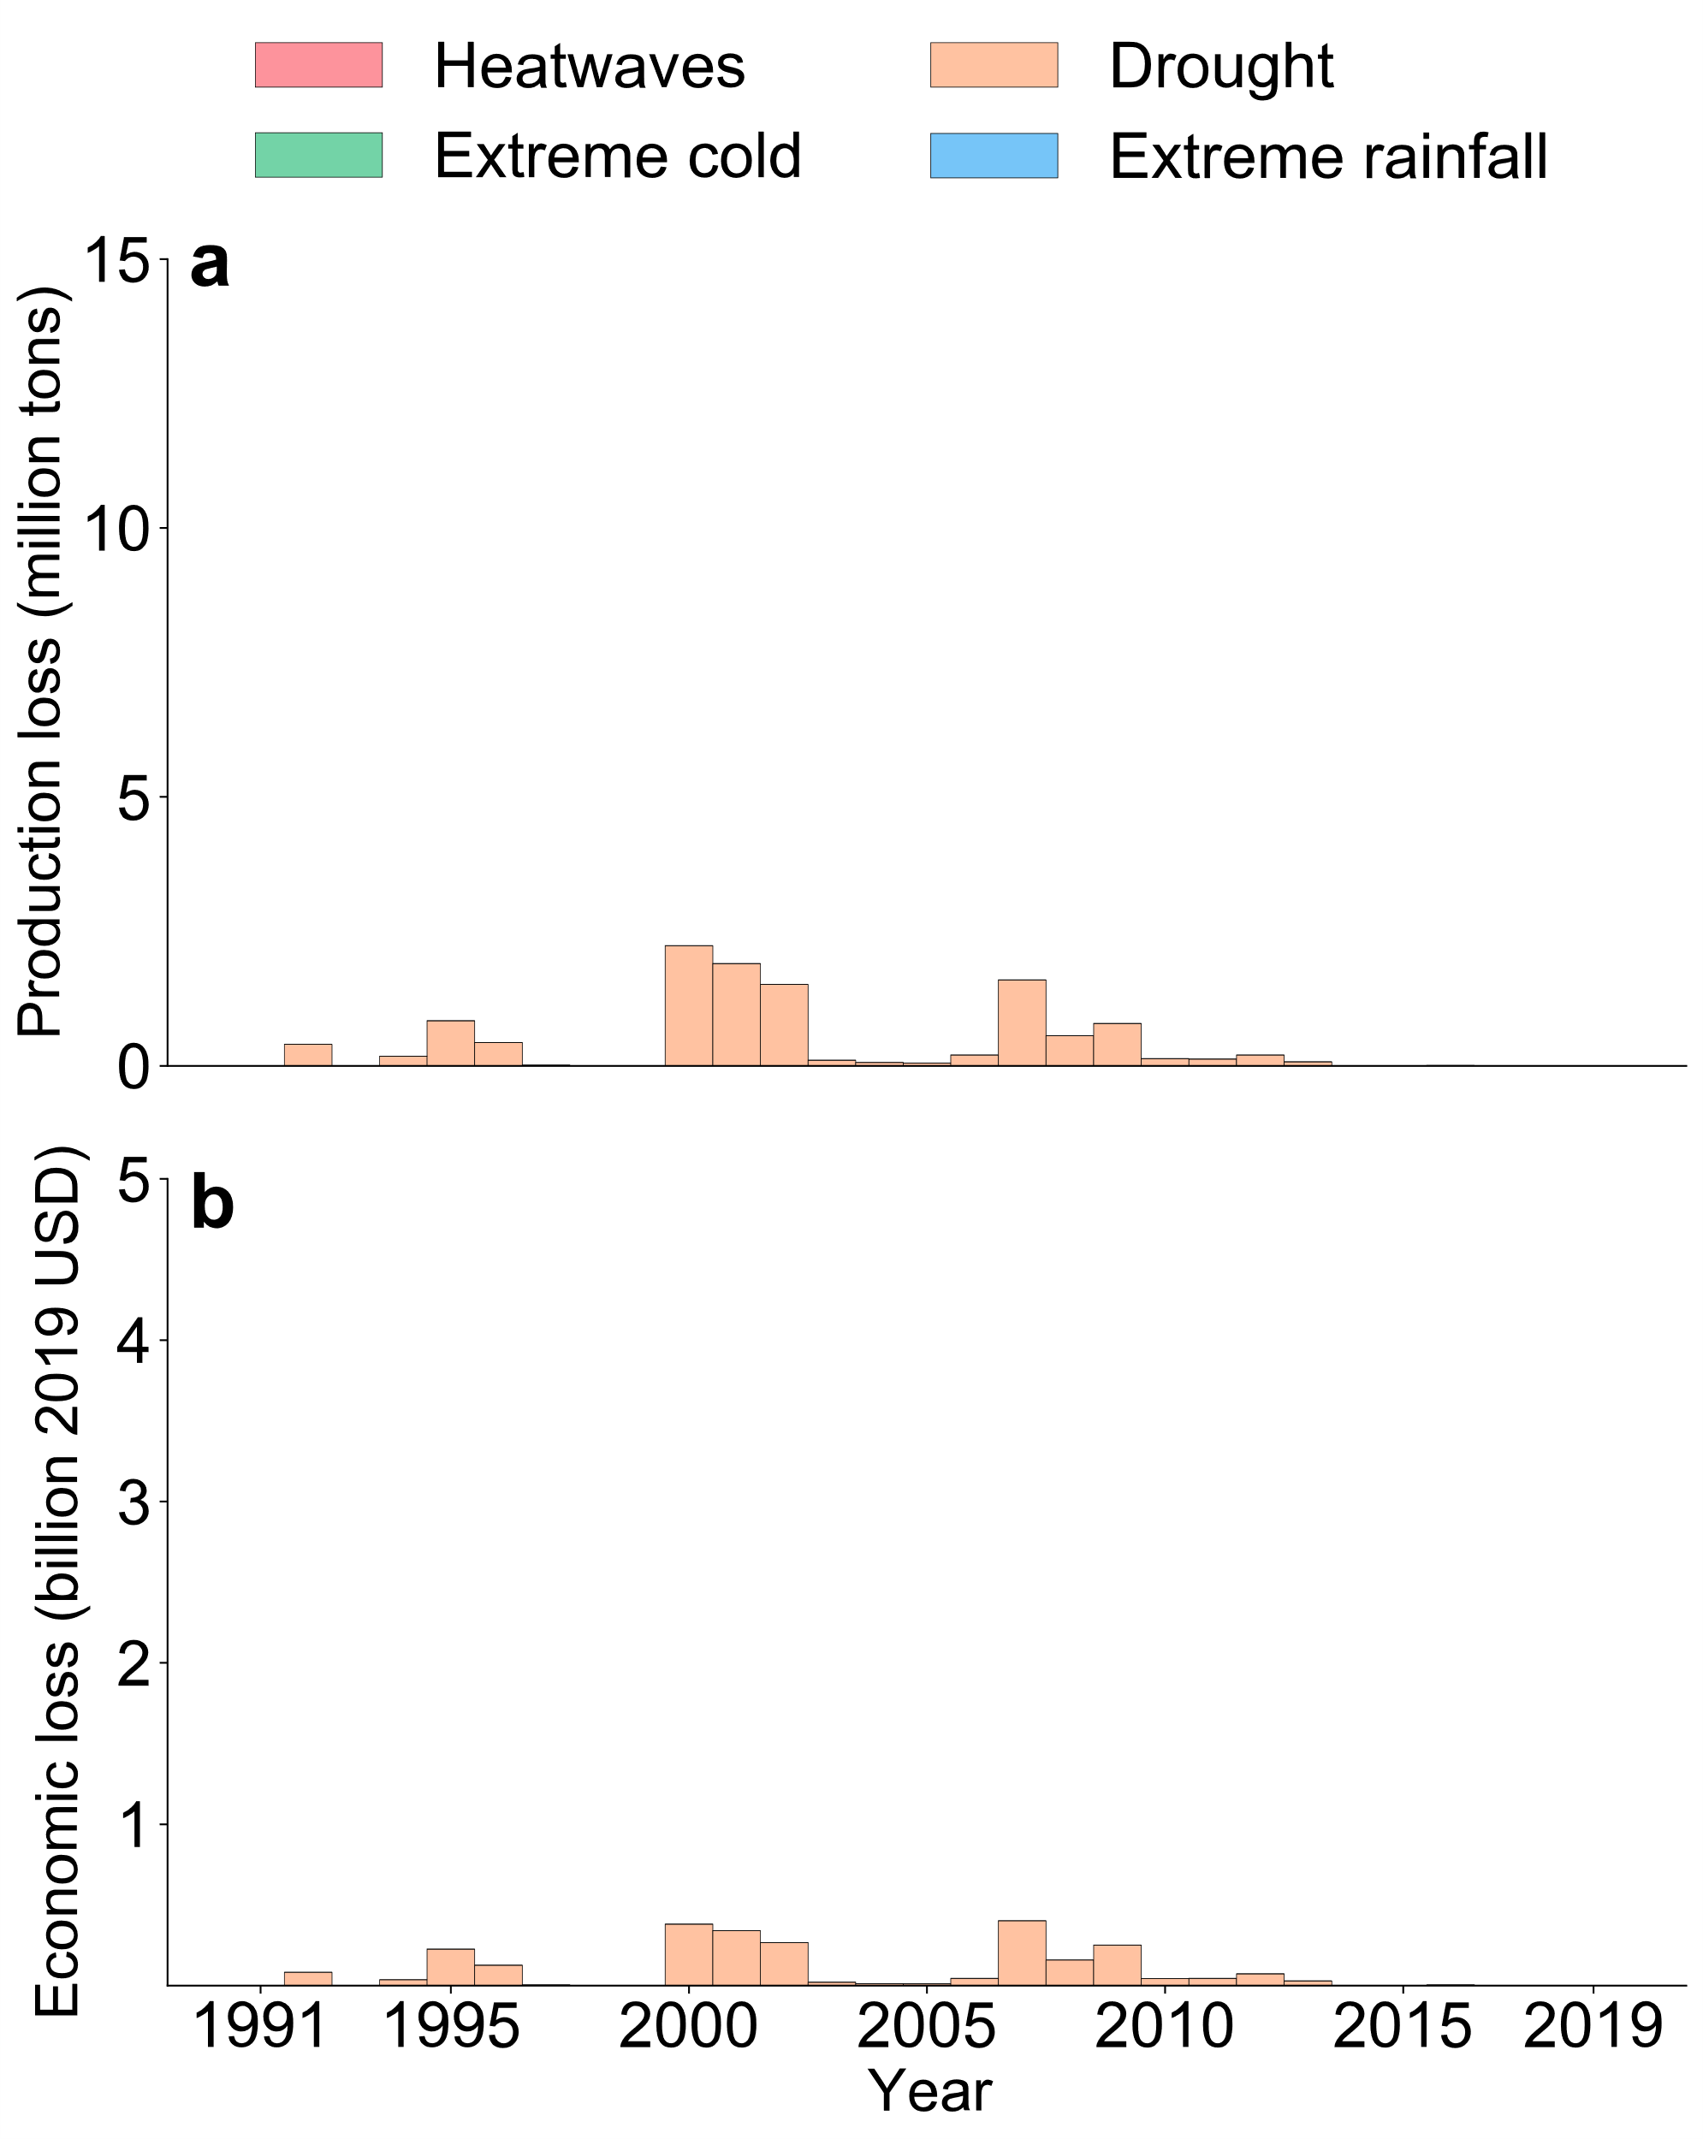
Fig. S4: Same as Fig. 5, but for wheat only. The cumulative production loss amounts to 11.4 million tons, equivalent to an economic loss of USD 2.6 billion.

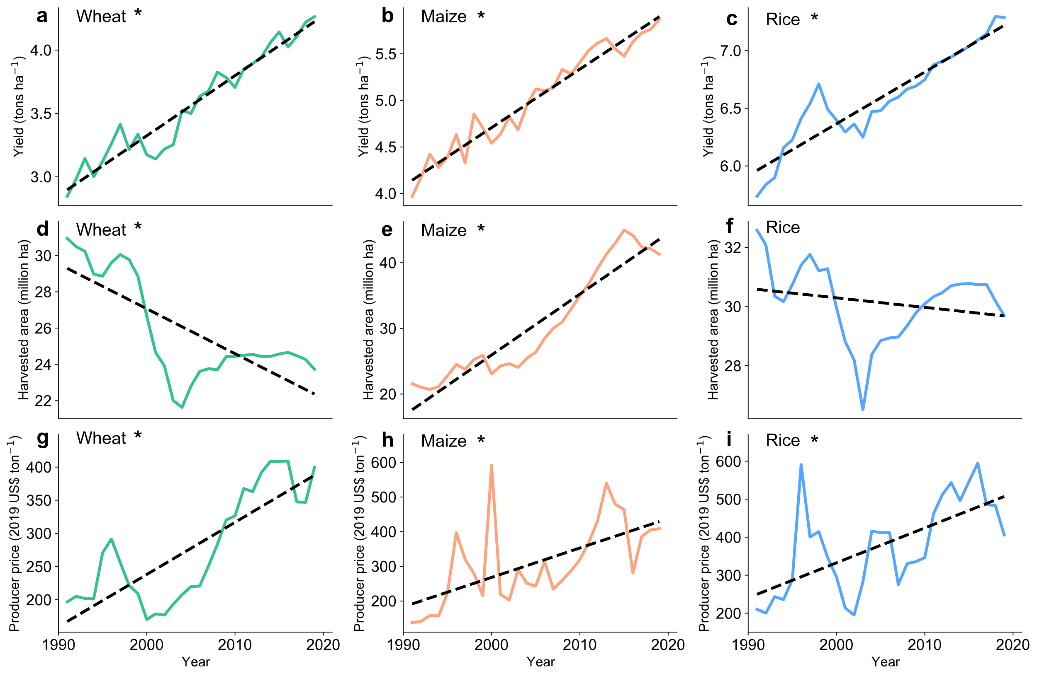
Fig. S5: Temporal change in national grain yield, harvested area, and producer price. The solid lines represent the national grain yield, total harvested area, and producer price for wheat (green), maize (orange), and rice (blue), while the dashed lines indicate the trends of the observations using the Ordinary Least Square regression. Asterisks denote statistically significance trends (P<0.05).

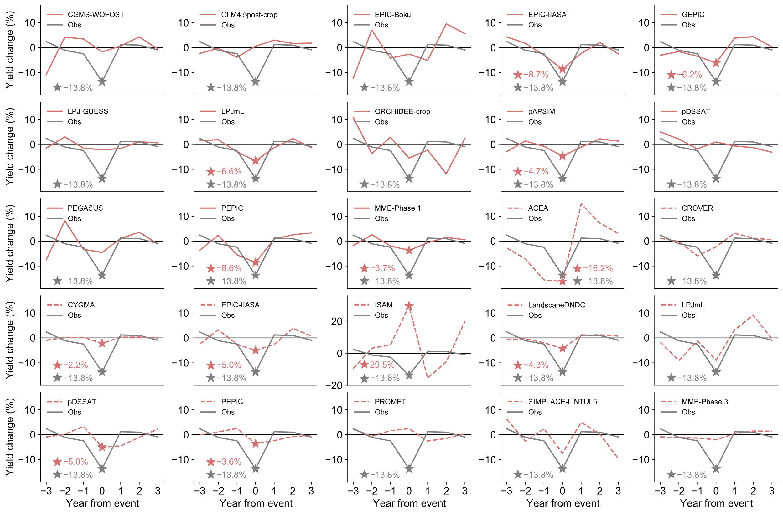
Fig. S6: The observed and simulated impacts of drought on wheat yield from 1980 to 2009. The multi-model ensemble (MME) means of GGCMI phase 1 and phase 3 models are also presented, respectively. The grey lines represent observed results, while the solid red and dash red lines represent simulated results for GGCMI phase 1 and phase 3, respectively. The asterisk denotes the yield was significantly affected by the extreme event (P<0.05), and the number represents the percentage of yield change.

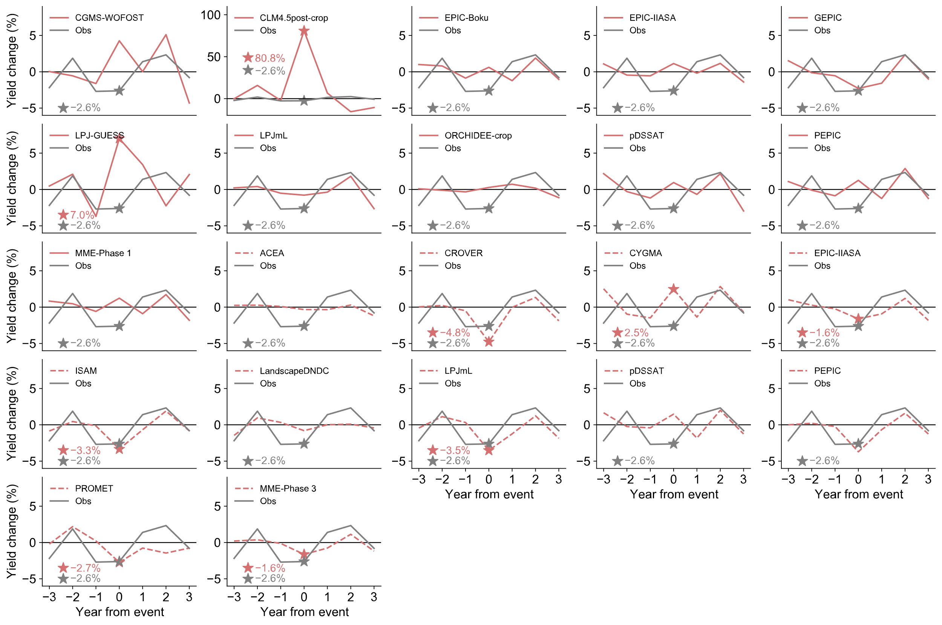
Fig. S7: Same as Fig. S6, but for the impacts of heatwaves on rice yield.

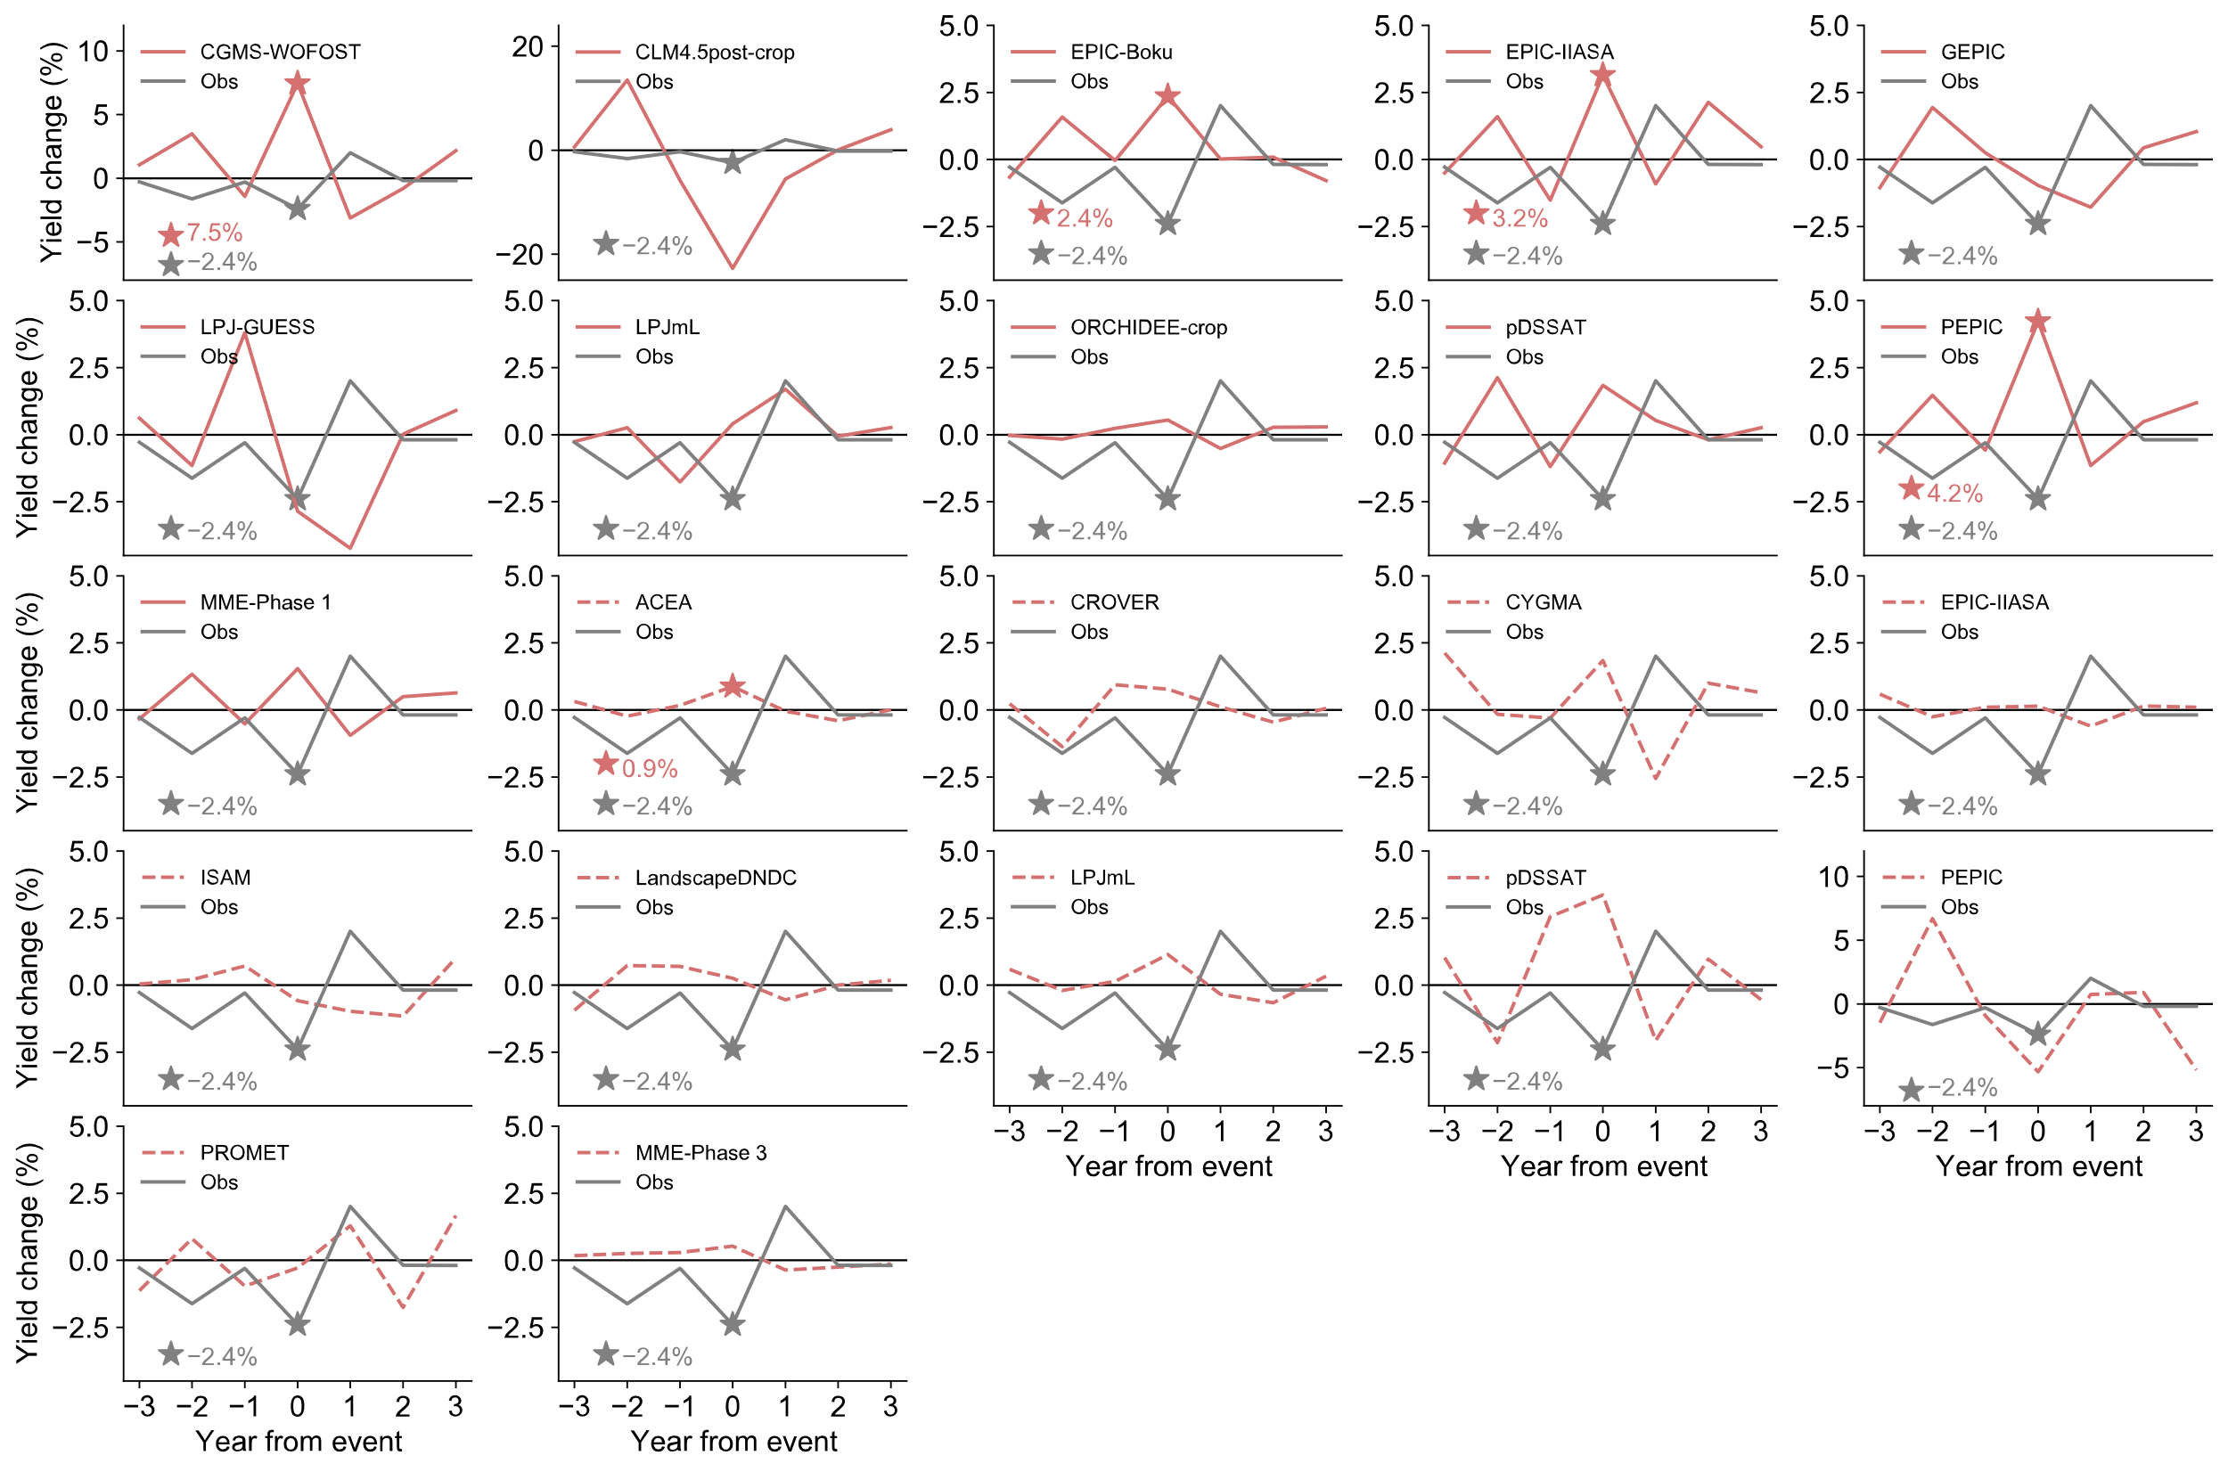
Fig. S8: Same as Fig. S6, but for the impacts of extreme cold on rice yield.

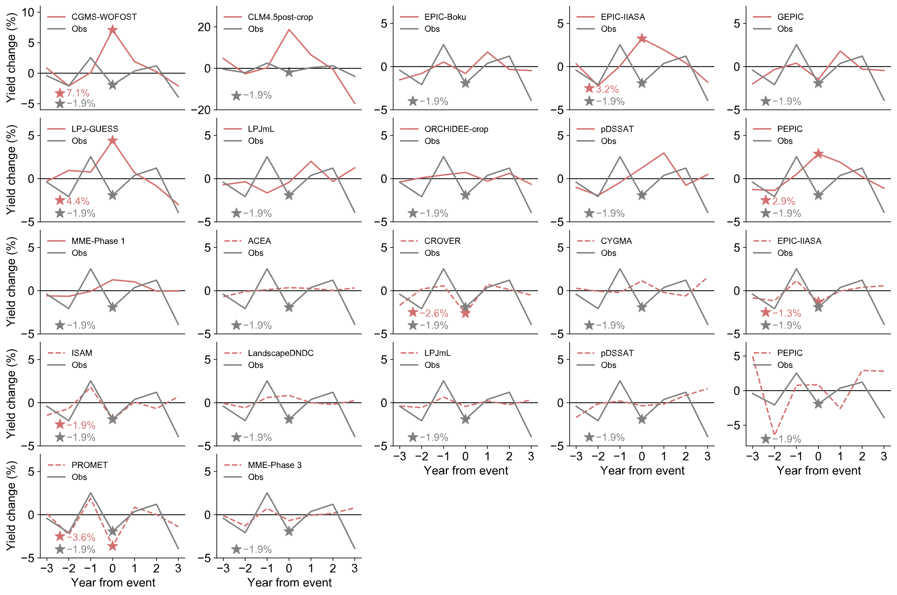
Fig. S9: Same as Fig. S6, but for the impacts of extreme rainfall on rice yield.

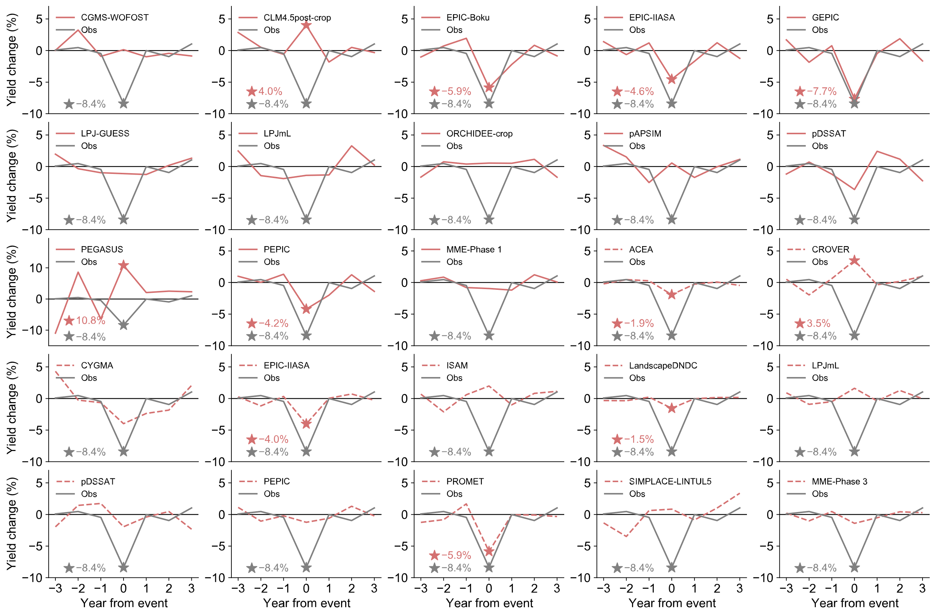
Fig. S10: Same as Fig. S6, but for the impacts of heatwaves on maize yield.

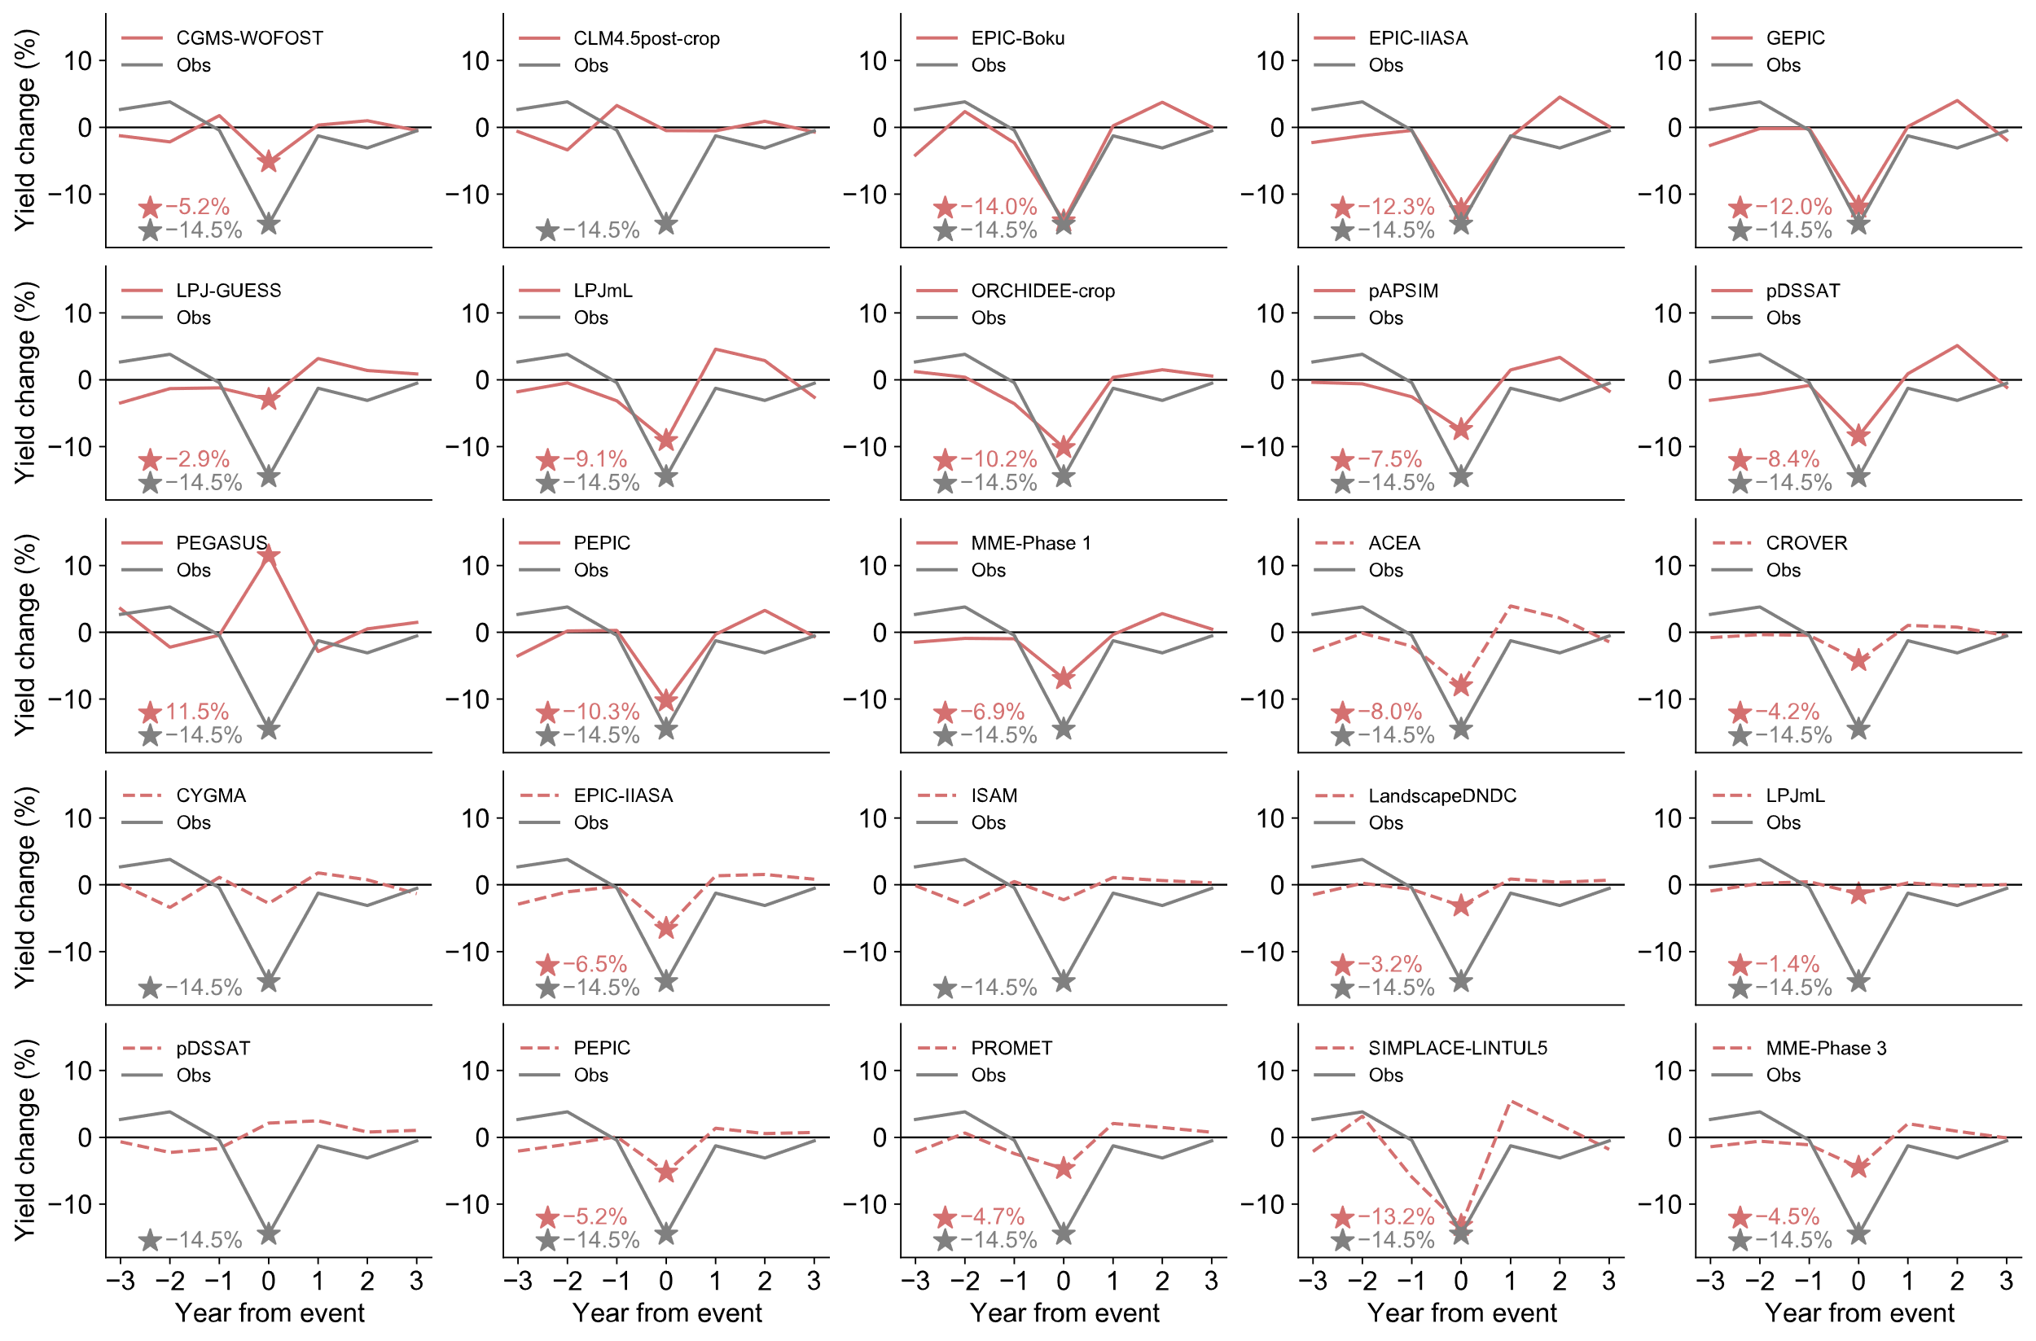
Fig. S11: Same as Fig. S6, but for the impacts of drought on maize yield.

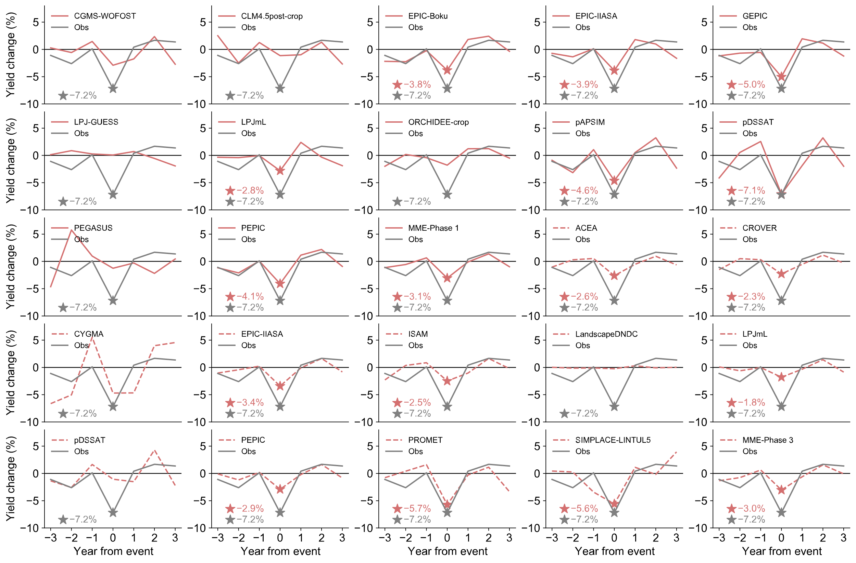
Fig. S12: Same as Fig. S6, but for the impacts of extreme rainfall on maize yield.

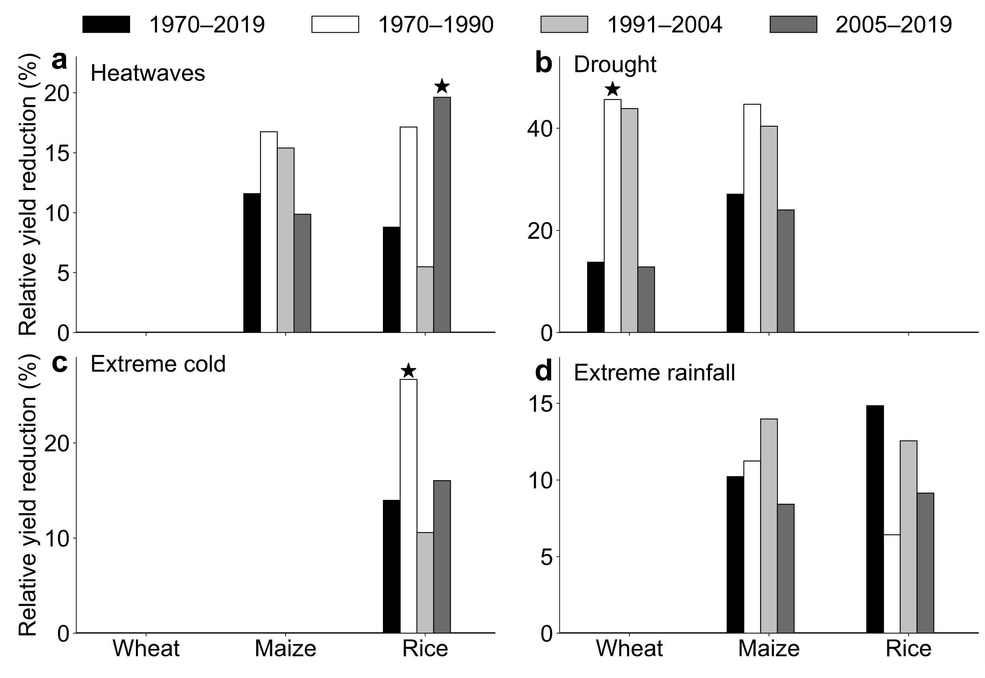
Fig. S13: The average relative yield reduction during years with extreme events for 1970–2019, 1970–1990, 1991–2004, and 2005–2019, respectively. The yields in years with extremes were compared with the average yield in normal years to determine the relative yield reductions for each extreme event. The t-test was conducted to compare the relative yield reductions between the entire period (1970–2019) and each sub-period to assess whether there were significant differences, with a star above the bar indicating statistical significance (P<0.05).

References
1. Barlow, K. M., Christy, B. P., O’Leary, G. J., Riffkin, P. A. & Nuttall, J. G. Simulating the impact of extreme heat and frost events on wheat crop production: A review. Field Crops Research 171, 109–119 (2015).
2. Li, Y., Guan, K., Schnitkey, G. D., DeLucia, E. & Peng, B. Excessive rainfall leads to maize yield loss of a comparable magnitude to extreme drought in the United States. Global Change Biology 25, 2325–2337 (2019).
3. Aslam, S. & Aslam, S. Impact of Flooding on Agricultural Crops—An Overview. in Environmental Processes and Management: Tools and Practices for Groundwater (eds. Shukla, P., Singh, P. & Singh, R. M.) 255–263 (Springer International Publishing, Cham, 2023). doi:10.1007/978-3-031-20208-7_15.
4. Fu, J. et al. Extreme rainfall reduces one-twelfth of China’s rice yield over the last two decades. Nat Food 4, 416–426 (2023).
5. Hatfield, J. L. & Prueger, J. H. Temperature extremes: Effect on plant growth and development. Weather and Climate Extremes 10, 4–10 (2015).
6. Dietz, K. ‐J., Zörb, C. & Geilfus, C. ‐M. Drought and crop yield. Plant Biol J 23, 881–893 (2021).
7. de Wit, A. J. W. & van Diepen, C. A. Crop growth modelling and crop yield forecasting using satellite-derived meteorological inputs. International Journal of Applied Earth Observation and Geoinformation 10, 414–425 (2008).
8. de Wit, A. et al. 25 years of the WOFOST cropping systems model. Agricultural Systems 168, 154–167 (2019).
9. Drewniak, B., Song, J., Prell, J., Kotamarthi, V. R. & Jacob, R. Modeling agriculture in the Community Land Model. Geosci. Model Dev. 6, 495–515 (2013).
10. Izaurralde, R. C., Williams, J. R., McGill, W. B., Rosenberg, N. J. & Jakas, M. C. Q. Simulating soil C dynamics with EPIC: Model description and testing against long-term data. Ecological Modelling 192, 362–384 (2006).
11. Balkovič, J. et al. Pan-European crop modelling with EPIC: Implementation, up-scaling and regional crop yield validation. Agricultural Systems 120, 61–75 (2013).
12. Liu, J., Williams, J. R., Zehnder, A. J. B. & Yang, H. GEPIC – modelling wheat yield and crop water productivity with high resolution on a global scale. Agricultural Systems 94, 478–493 (2007).
13. Folberth, C., Gaiser, T., Abbaspour, K. C., Schulin, R. & Yang, H. Regionalization of a large-scale crop growth model for sub-Saharan Africa: Model setup, evaluation, and estimation of maize yields. Agriculture, Ecosystems & Environment 151, 21–33 (2012).
14. Smith, B., Prentice, I. C. & Sykes, M. T. Representation of vegetation dynamics in the modelling of terrestrial ecosystems: comparing two contrasting approaches within European climate space. Global Ecology and Biogeography 10, 621–637 (2001).
15. Lindeskog, M. et al. Implications of accounting for land use in simulations of ecosystem carbon cycling in Africa. Earth Syst. Dynam. 4, 385–407 (2013).
16. Bondeau, A. et al. Modelling the role of agriculture for the 20th century global terrestrial carbon balance. Global Change Biology 13, 679–706 (2007).
17. Wu, X. et al. ORCHIDEE-CROP (v0), a new process-based agro-land surface model: model description and evaluation over Europe. Geoscientific Model Development 9, 857–873 (2016).
18. Keating, B. A. et al. An overview of APSIM, a model designed for farming systems simulation. European Journal of Agronomy 18, 267–288 (2003).
19. Elliott, J. et al. The parallel system for integrating impact models and sectors (pSIMS). Environmental Modelling & Software 62, 509–516 (2014).
20. Ritchie, J. T., Singh, U., Godwin, D. C. & Bowen, W. T. Cereal growth, development and yield. in Understanding Options for Agricultural Production 79–98 (Springer, Dordrecht, 1998). doi:10.1007/978-94-017-3624-4_5.
21. Jones, J. W. et al. The DSSAT cropping system model. European Journal of Agronomy 18, 235–265 (2003).
22. Deryng, D., Sacks, W. J., Barford, C. C. & Ramankutty, N. Simulating the effects of climate and agricultural management practices on global crop yield. Global Biogeochemical Cycles 25, (2011).
23. Deryng, D., Conway, D., Ramankutty, N., Price, J. & Warren, R. Global crop yield response to extreme heat stress under multiple climate change futures. Environ. Res. Lett. 9, 034011 (2014).
24. Liu, W. et al. Global investigation of impacts of PET methods on simulating crop-water relations for maize. Agricultural and Forest Meteorology 221, 164–175 (2016).
25. Mialyk, O., Schyns, J. F., Booij, M. J. & Hogeboom, R. J. Historical simulation of maize water footprints with a new global gridded crop model ACEA. Hydrology and Earth System Sciences 26, 923–940 (2022).
26. Mialyk, O. & Su, H. Global gridded crop model ACEA. (2024) doi:10.5281/zenodo.10510934.
27. Sakurai, G., Iizumi, T., Nishimori, M. & Yokozawa, M. How much has the increase in atmospheric CO2 directly affected past soybean production? Sci Rep 4, 4978 (2014).
28. Okada, M. et al. Varying Benefits of Irrigation Expansion for Crop Production Under a Changing Climate and Competitive Water Use Among Crops. Earth’s Future 6, 1207–1220 (2018).
29. Iizumi, T. et al. Responses of crop yield growth to global temperature and socioeconomic changes. Sci Rep 7, 7800 (2017).
30. Sultan, B., Defrance, D. & Iizumi, T. Evidence of crop production losses in West Africa due to historical global warming in two crop models. Sci Rep 9, 12834 (2019).
31. Balkovič, J. et al. Global wheat production potentials and management flexibility under the representative concentration pathways. Global and Planetary Change 122, 107–121 (2014).
32. Song, Y., Jain, A. K. & McIsaac, G. F. Implementation of dynamic crop growth processes into a land surface model: evaluation of energy, water and carbon fluxes under corn and soybean rotation. Biogeosciences 10, 8039–8066 (2013).
33. Gahlot, S. et al. Impact of environmental changes and land management practices on wheat production in India. Earth System Dynamics 11, 641–652 (2020).
34. Haas, E. et al. LandscapeDNDC: a process model for simulation of biosphere–atmosphere–hydrosphere exchange processes at site and regional scale. Landscape Ecol 28, 615–636 (2013).
35. Jägermeyr, J. & Frieler, K. Spatial variations in crop growing seasons pivotal to reproduce global fluctuations in maize and wheat yields. Science Advances 4, eaat4517 (2018).
36. von Bloh, W. et al. Implementing the nitrogen cycle into the dynamic global vegetation, hydrology, and crop growth model LPJmL (version 5.0). Geoscientific Model Development 11, 2789–2812 (2018).
37. Zabel, F. et al. Global impacts of future cropland expansion and intensification on agricultural markets and biodiversity. Nat Commun 10, 2844 (2019).
38. Webber, H. et al. Diverging importance of drought stress for maize and winter wheat in Europe. Nat Commun 9, 4249 (2018).

