Tables
Table 1. Sowing date, transplanting date and investigation traits of each cropping season.
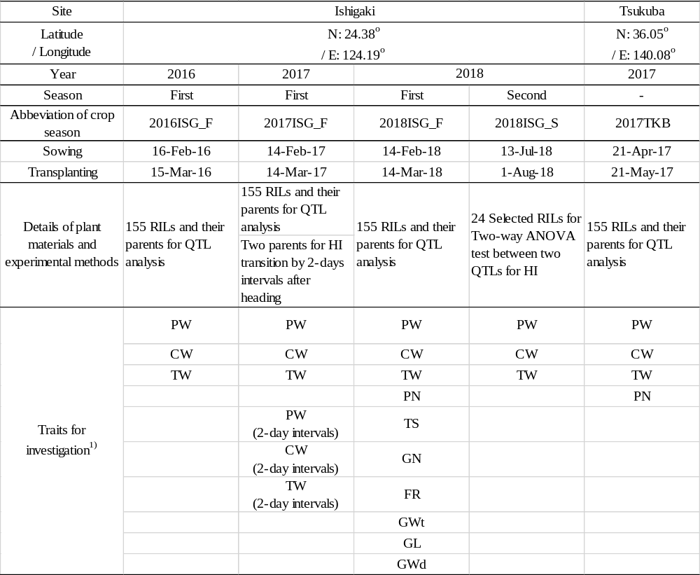

Table 2. Number of KASP and SSR markers on twelve rice chromosomes.
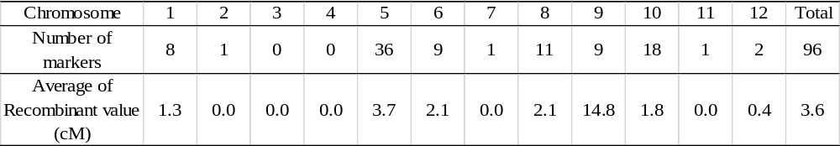

Table 3. The correlations of HI in RILs among four cropping seasons.
Season | 2016ISG_F | 2017ISG_F | 2018ISG_F | 2017TKB
2016ISG_F | −
2017ISG_F | 0.723 *** | −
2018ISG_F | 0.681 *** | 0.796 *** | −
2017TKB | 0.680 *** | 0.486 *** | 0.548 *** | −
*** represents a significant correlation between the two cropping seasons at P < 0.001 level.

Table 4. QTLs identified in this study.
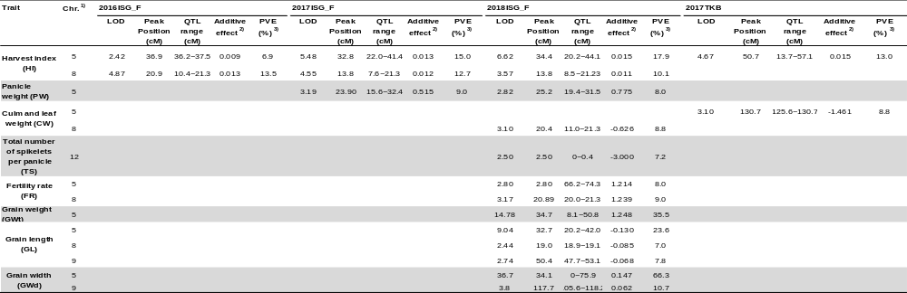
- "Chr." indicates "chromosome".
- A positive value for the additive effect indicates that the YTH183 allele increases the trait.
- "PVE" indicates a percent of the variation explained.

