Supplementary Information
Superionic Ionic Conductor Discovery via Multiscale Topological Learning
Dong Chen^{∗1,2}, Bingxu Wang^{†1}, Shunning Li¹, Wentao Zhang¹, Kai Yang¹, Yongli Song¹,
Guo-Wei Wei ^{‡2,4} and Feng Pan ^{§1}
¹School of Advanced Materials, Peking University, Shenzhen Graduate School, Shenzhen 518055, China
²Department of Mathematics, Michigan State University, MI, 48824, USA
³Department of Electircal and Computer Engineering, Michigan State University, MI 48824, USA
⁴Department of Biochemistry and Molecular Biology, Michigan State University, MI 48824, USA

∗contributed equally to this work
†contributed equally to this work
‡Corresponding author: weig@msu.edu
§Corresponding author: panfeng@pkusz.edu.cn

Table S1. The number of compounds that passed each steps of the high-throughput screening of
crystal structural framework.
Screening Step | Number of Compositions
Remove Duplicate | 2590
Filter Connection Radius | 1443
Filter Servive Betti1 | 770
Clustering Methods | 339
Final screening | 43

Table S2. List of known LSICs
ICSD-IDs | Compositions | Superionic conductor
100169 | Li₁₄Zn(GeO₄)₄ | LISCISON
157654 | Li₇P₃S₁₁ | Li₇P₃S₁₁
163297 | Li_{1.2}(Al_{0.2}Ge_{0.2}Ti_{1.6}) (PO₄)₃ | NASICON
188887 | Li₁₀GeP₂S₁₂ | LGPS
422259 | Li₇La₃Zr₂O₁₂ | LLZO
50422 | Li_{2.64}(Sc_{0.9}Ti_{0.1})₂(PO₄)₃ | Li₃A₂(PO₄)₃
35018 | Li₃PS₄ | Li-P-S
92200 | Li₄GeS₄ | Li-Ge-S
174202 | Li₇La₃Hf₂O₁₂ | Garnet
191542 | Li_{6.46}Al_{0.08}1La₃Zr₂O₁₂ | Garnet
185539 | Li_{6.06}Al_{0.20}1La₃Zr₂O₁₂ | Garnet
185540 | Li_{6.06}Al_{0.20}1La₃Zr₂O₁₂ | Garnet
238693 | La₃Li_{5.8}Zn_{0.6}Zr₂O₁₂ | Garnet
238692 | La₃Li_{5.8}Zn_{0.6}Zr₂O₁₂ | Garnet
238690 | Al_{0.24}La₃Li_{6.28}Zr₂O₁₂ | Garnet
238689 | Al_{0.24}La₃Li_{6.28}Zr₂O₁₂ | Garnet
195182 | (Li_{6.26}Al_{0.24})La₃Zr₂O₁₂ | Garnet
69076 | La₃Li₅Sb₂O₁₂ | Garnet
174612 | Li₆(CaLa₂)Sb₂O₁₂ | Garnet
174615 | Li_{6.4}(Ca_{1.4}La_{1.6})Sb₂O₁₂ | Garnet
174617 | Li_{6.4}(Ca_{1.4}La_{1.6})Sb₂O₁₂ | Garnet
158373 | Li₆SrLa₂Bi₂O₁₂
161342 | Li₅La₃(Sb₂O₁₂) | Garnet
161343 | Li₅La₃(Sb₂O₁₂) | Garnet
161389 | Li₅La₃(SbO₆)₂ | Garnet
163914 | Li₇La₃Sn₂O₁₂ | Garnet
182034 | Li₇La₃Sn₂O₁₂ | Garnet
182035 | Li_{2.25}H_{4.75}La₃Sn₂O₁₂ | Garnet
182036 | Li_{4.59}H_{2.41}La₃Sn₂O₁₂ | Garnet
245641 | Li₅La₃(SbO₆)₂ | Garnet
245934 | Li₆SrLa₂Sb₂O₁₂ | Garnet
245935 | Li_{6.4}Sr_{1.4}La_{1.6}Sb₂O₁₂ | Garnet
246817 | Li₇La₃Zr₂O₁₂, | Garnet
261302 | Li₇La₃Zr₂O₁₂, | Garnet
183684 | Li₇La₃Zr₂O₁₂, | LLZO
183685 | Li₇La₃Zr₂O₁₂, | Garnet
184230 | Li₇La₃(ZrO₆)₂ | Garnet
191528 | Li₇La₃Zr₂O₁₂, | Garnet
183607 | Li₇La₃Zr₂O₁₂, | Garnet
238687 | Li₇La₃Zr₂O₁₂, | Garnet
238686 | Li₇La₃Zr₂O₁₂, | Garnet
65025 | Li₂Mg₂(SO₄)₃ | Li₃A₂(PO₄)₃
62300 | Li₃Sc₂(PO₄)₃ | Li₃A₂(PO₄)₃
91113 | Li_{2.72}Ti₂(PO₄)₃ | Li₃A₂(PO₄)₃
202539 | Li_{2.68}(Ti_{1.86}Al_{0.14})(PO₄)₃, | NASICON
94029 | (Li_{0.72}Na_{0.88})(Ti_{1.4}Al_{0.6})(PO₄)₃ | NASICON
94030 | (Li_{1.09}Na_{0.71})(Ti_{1.2}Al_{0.8})(PO₄)₃ | NASICON
94031 | (Li_{1.45}Na_{0.45})(Ti_{1.1}Al_{0.9})(PO₄)₃ | NASICON
163299 | Li_{1.2}(Al_{0.2}Ge_{0.4}Ti_{1.4})(PO₄)₃ | NASICON
163300 | Li_{1.4}(Al_{0.4}Ge_{0.4}Ti_{1.2})(PO₄)₃ | NASICON
163301 | Li_{1.6}(Al_{0.6}Ge_{0.4}Ti)(PO₄)₃ | NASICON
163302 | Li_{1.2}(Al_{0.2}Ge_{0.6}Ti_{1.2})(PO₄)₃ | NASICON
163303 | Li_{1.4}(Al_{0.4}Ge_{0.6}Ti)(PO₄)₃ | NASICON
163304 | Li_{1.6}(Al_{0.6}Ge_{0.6}Ti_{0.8})(PO₄)₃ | NASICON
163305 | Li₃Ti₂(PO₄)₃, Li_{2.93}Ti₂(PO₄)₃ | NASICON
193036 | Li_{2.93}Ti₂(PO₄)₃ | NASICON
193037 | Li_{2.8}Ti₂(PO₄)₃, | NASICON
193032 | Li_{1.2}(Al_{0.2}Ge_{0.6}Ti_{1.2})(PO₄)₃ | NASICON
193038 | Li₃Ti₂(PO₄)₃ | NASICON
193033 | Li_{1.6}(Al_{0.6}Ge_{0.4}Ti)(PO₄)₃ | NASICON
92250 | LiZr₂(PO₄)₃ | Li₃A₂(PO₄)₃
97658 | Li₂Ti₂(PO₄)₃ | NASICON
97659 | Li_{2.96}(Sc_{0.9}Zr_{0.1})₂(PO₄)₃ | NASICON
97660 | LiZr₂(PO₄)₃ | NASICON
191891 | Li_{1.15}(Y_{0.15}Zr_{1.85})(PO₄)₃ | NASICON
245527 | Li_{0.7}La_{0.1}Zr₂(PO₄)₃ | NASICON
257190 | Li_{1.12}Ti_{1.88}In_{0.12}(PO₄)₃ | NASICON
20208 | Li₃(PO₄) | LISICON
25816 | Li₃Zn_{0.5}(GeO₄) | LISICON
34221 | Li_{2.5}Ga_{0.5}GeO₄ | LISICON
50058 | Li3PO4 | Li-P-O
79427 | Li_{3.5}Zn_{.25}GeO₄ | LISICON
77095 | Li₁₄Zn(GeO₄)₄ | LISICON
8280 | Li₂MgGeO₄ | LISICON
65643 | Li_{2.5}Ga_{0.5}GeO₄ | LISICON
78513 | Li₃Zn_{.5}GeO₄ | LISICON
100167 | Li_{3.5}Zn_{.25}GeO₄ | LISICON
100169 | Li_{6.6}SiPO₈ | LISICON
202631 | Li₃PO₄ | LISICON
202632 | Li_{2.5}Ga_{0.5}GeO₄ | LISICON
166547 | Li₂MgGeO₄ | LISICON
238601 | Li_{2.5}Ga_{0.5}GeO₄ | LISICON
290831 | Li₄SnS₄ | Li-Ge-S
290832 | Li₄SnS₄ | Li-Ge-S
50578 | Li₄GeS₄ | Li-Ge-S
92200 | Li₄GeS₄ | Li-Ge-S
95649 | Li₄GeS₄ | Li-Ge-S
188886 | Li₁₀(GeP₂S₁₂) | LGPS
188887 | Li₁₀(SnP₂S₁₂) | LGPS
193755 | Li_{10.35}((Ge_{1.35}P_{1.65})S₁₂) | LGPS
193947 | Li_{10.35}Si_{1.35}P_{1.65}S₁₂ | LGPS
241439 | Li_{9.81}Sn_{0.81}P_{2.19}S₁₂ | LGPS
252036 | Li₁₀(Ge_{0.416}Sn_{0.584})P₂S₁₂ | LGPS
252037 | Li₁₀(Ge_{0.776}Sn_{0.224})P₂S₁₂ | LGPS
252038 | Li_{10.35}(Sn_{0.27}Si_{1.08}), P_{1.65}S₁₂ | LGPS
252039 | Li_{10.35}(Sn_{0.27}Si_{1.08}), P_{1.65}S₁₂ | LGPS
252040 | Li_{10.5}(Sn_{0.2}Si_{0.8})_{1.5}P_{1.5}S₁₂ | LGPS
252041 | Li_{10.2}(Sn_{0.2}Si_{0.8})_{1.2}P_{1.8}S₁₂ | LGPS

Table S3. Oxide compounds that passed the high-throughput screening of crystal structural framework but rejected by other considerations.
ICSD-IDs | Compositions | Reasons
19024, 27007, 27008, 30964, 33809, 33810, 36532, 56443, 60363, 61086, 61087, 65127, 78059, 84240, 96224, 239794, 243972, 253007, 257739, 281011, 415121, 416926, 416927, 416928, 416929, 417653, 421259, 421549, 423635, 432026, 19023, 67238, 92571, 421548, 260280 | Li₂CaGeO₄, Na₃Li₃Sc₂F₁₂, Na₃Li₃In₂F₁₂, KLiO, Cs₂Li₂(SiO₄), Cs₂Li₂(TiO₄), Cs₂Li₂(GeO₄), LiSrP, Na₃Li₃Ti₂F₁₂, Rb₂Li₂SiO₄, Rb₂Li₂GeO₄, LiGaGeO₄, Li₂(TiSiO₅), Li(Al₇B₄O₁₇), LiSr(GaN₂), LiSc(SeO₃)₂, LiCsCO₃, LiGaGe₂Se₆, LiGaGeO₄, Li₂PbGeS₄, Li₂(TeSe₃), Li₃Na₃(InF₆)₂, Li₆Y₃(PS₄)₅, Li₄Sr₃(Si₂N₆), SrLi₂N₄Si₂, CsLi₂Cl₃, Li₃Y(BO₃)₂, Li₂CaSiO₄, LiAlGeO₄, KLi(CO₃), CaLi₂N₄Si₂, Li₂Zn₃(P₂O₇)₂ | Bad Li network
610785 | Li₃As | Binary compounds
90147 | Cs₁₄Li_{22.72}(Li_{18.4}Si₇₂O₁₇₂)(D₂O)_{6.16} | Containing D₂O
88334 | Li₆(P₆O₁₈)(H₂O)_{9.86} | Containing H
6269, 67925, 171366, 62586, 428547 | Li_{0.91}(Al_{0.91}Si_{1.09}O₄)(H₂O)_{0.98}, Li₈(HPO₄)(Be₆P₆O₂₄)(H₂O), K_{2.6}Li_{5.4}(Li₄Si₁₆O₃₈)(H₂O)_{4.3}, Li₄(P₄O₁₂)(H₂O)₅, (Li₂(H₂O)₇)Se | Containing H₂O
251594 | Li₆RbB₂O₆F | Containing O and F
50992 | Li(Y_{0.95}Eu_{0.05})O₂ | Containing Y, Eu
432591 | Li₄PN₃ | High-pressure hynthesis. The product is sensitive to traces of air and moisture.
161763, 250297, 50612 | Li₂Ga₂GeS₆, Li₂Ti(GeO₄)O, Li₃Sc₂(PO₄)₃, Li₂(BAlO₄) | ehull>50emV
188886, 188887, 193755, 193947, 241439, 252036, 252037, 252038, 252039, 252040, 252041, 255747, 255748, 255749, 257946, 257947, 257948 | Li₁₀(GeP₂S₁₂), Li₁₀(SnP₂S₁₂), Li_{10.35}((Ge_{1.35}P_{1.65})S₁₂), Li_{10.35}Si_{1.35}P_{1.65}S₁₂, Li_{9.81}Sn_{0.81}P_{2.19}S₁₂, Li₁₀(Ge_{0.416}Sn_{0.584})P₂S₁₂, Li₁₀(Ge_{0.776}Sn_{0.224})P₂S₁₂, Li_{10.35}(Sn_{0.27}Si_{1.08}), P_{1.65}S₁₂, Li_{10.5}(Sn_{0.2}Si_{0.8})_{1.5}P_{1.5}S₁₂, Li_{10.2}(Sn_{0.2}Si_{0.8})_{1.2}P_{1.8}S₁₂ | LGPS
161342, 161343, 161389, 163914, 174202, 174612, 174613, 174614, 174615, 174616, 174617, 182034, 182035, 182036, 183607, 183685, 184230, 185539, 185540, 191528, 191542, 195182, 238686, 238687, 238689, 238690, 238692, 238693, 241475, 245641, 245934, 245935, 246817, 253056, 261302, 430571, 430575, 430576, 430602, 69076 | Li₅La₃(Sb₂O₁₂), Li₆(SrLa₂)(Sb₂O₁₂), Li₅La₃(SbO₆)₂, Li₇La₃Sn₂O₁₂, Li₇La₃Hf₂O₁₂, Li₆(CaLa₂)Sb₂O₁₂, Li_{6.4}(Ca_{1.4}La_{1.6})Sb₂O₁₂, Li₇La₃Sn₂O₁₂, Li_{2.25}H_{4.75}La₃Sn₂O₁₂, Li_{4.59}H_{2.41}La₃Sn₂O₁₂, Li₇La₃Zr₂O₁₂, Li₇La₃(ZrO₆)₂, Li_{6.06}Al_{0.20}La₃Zr₂O₁₂, Li₇La₃Zr₂O₁₂, Li_{6.46}Al_{0.081}La₃Zr₂O₁₂, (Li_{6.26}Al_{0.24})La₃Zr₂O₁₂, La₃Li₇Zr₂O₁₂, Al_{0.24}La₃Li_{6.28}Zr₂O₁₂, La₃Li_{5.8}Zn_{0.6}Zr₂O₁₂, Li_{51.2}Al_{1.6}La₂₄Zr₁₆O₉₆, Li₅La₃(SbO₆)₂, Li₅La₃(SbO₆)₂, Li_{6.4}Sr_{1.4}La_{1.6}Sb₂O₁₂, Li₇La₃Zr₂O₁₂, Li₇La₃Hf₂O₁₂, Li_{5.91}Al_{0.216}La_{2.95}Zr₂O₁₂, Al_{0.11}Ga_{0.08}La_{2.94}Li_{6.85}Zr₂O₁₂, Al_{0.19}Ga_{0.05}La_{2.88}Li_{5.55}O₁₂Zr₂, Li_{6.55}Ga_{0.05}La_{2.91}Zr₂O₁₂, La₃Li₅Sb₂O₁₂ | Garnet
23017, 38350, 50421, 68494, 253896, 431368, 431573, 642303, 35405, 65445, 255464, 40247, 55665, 72100, 35290, 65126, 73223, 79098, 8372, 169799, 26817, 249872, 249873, 254974 | Li₄Zn(PO₄)₂, Li₄PbO₄, Li_{3.2}Sc₂(PO₄)₃, Li₁₀(Zn₄O₉), Li₁₀Si₂P₆, Li₂SiP₂, LiSbS₂, Rb₂Li₁₄(Pb₃O₁₄), K₂Li₁₄(Zr₃O₁₄), Li₄Zn(PO₄)₂, Li₆TeO₆, LiAlSiO₄, Li₃GaSiO₅, LiAlSi₂O₆, Li₃AsS₃, K₂Li₃GaO₄, LiAlGeO₄, Li₂ZnBr₄, Li₅La₃Bi₂O₁₂, Li_{2.2}Zn_{0.8}P₂O₇ , Li₂CdGeS₄, Li₂CdSnS₄, Li₂CdGeSe₄ | Duplicate structure
47143, 47144, 47145, 428002, 14364, 67702, 67703, 95407, 239962, 254107, 30276 | Li_{3.175}(SiO₄)_{0.7}(SO₄)_{0.3}, Li_{3.17}Si_{0.7}S_{0.3}O₄, Li_{3.4}Si_{0.7}S_{0.3}O₄, Li₅(B(SO₄)₄), LiNa(SO₄), Li₄(SO₄)₂, LiNaSO₄, Li₂SO₄ | Containing SO₄²⁻
25308, 42062, 42068, 171497, 419577, 426692, 429881 | Li₉Ge₄, LiGe, Li₁₁Ge₆, Li₈Zn₂Ge₃, Ge₁₂Li₇, Li₁₈Na₂Ge₁₇, Li₃NaGe₂ | Germanide, Ge unusual valence state
26298, 80593, 255465, 255466, 255468, 264522, 78514, 153218, 255467 | (Sr₇Li₄Si₁₀)_{0.1429}, Li_{2.5}Al_{0.5}(SiO₄), Li₄Zn(PO₄)₂, Li_{3.7}Zn_{0.7}Ga_{0.3}(PO₄)₂, Li_{3.5}Zn_{0.5}Ga_{0.5}(PO₄)₂, Hf₂La₃(Li_{6.74}Al_{0.08})O₁₂, Li_{2.42}Ga_{0.58}GeO₄, Li_{2.46}Al_{0.18}(BO₃), Li_{3.7}Zn_{0.7}Ga_{0.3}(PO₄)₂ | Li sharing sites with: Si,  Al, Zn, Ga
50422, 62300, 65025, 71277, 91113, 92250 | Li_{2.64}(Sc_{0.9}Ti_{0.1})₂(PO₄)₃, Li₃Sc₂(PO₄)₃, Li₂Mg₂(SO₄)₃, Li_{2.72}Ti₂(PO₄)₃, LiZr₂(PO₄)₃ | Li₃A₂(PO₄)₃
1037, 16229 | Li₅AlO₄ | Li-Al-O
433369 | Li₅AlS₄ | Li-Al-S
165579, 413238 | Li(ClO₄) | Li-Cl-O
31050, 100403 | Li₆Ge₂O₇, Li₂(GeO₃) | Li-Ge-O
50578, 92200, 95649, 290831, 290832 | Li₄GeS₄, Li₄SnS₄ | Li-Ge-S
638, 50058, 79426, 85714, 246859, 248414, 257439 | LiPO3, Li3PO4, Li2_{.88}PO_{3.73}N_{0.14}, Li₆P₆O₁₈, Li₄P₂O₇ | Li-P-O
35018, 157654, 180318, 242170 | Li₃PS₄, Li₇(P₃S₁₁), Li₄P₂S₆ | Li-P-S
48106 | Li₂SeO₄ | Li-Se-O
8280, 20031, 20208, 25816, 34221, 65643, 77095, 78513, 79427, 100167, 100169, 166547, 202631, 202632, 238601, 257440 | Li₂MgGeO₄, Li₂CdGeO₄, Li₃(PO₄), Li₃Zn_{0.5}(GeO₄), Li_{2.5}Ga_{0.5}GeO₄, Li₁₄Zn(GeO₄)₄, Li₂Mg(GeO₄), Li₃Zn_{.5}GeO₄, Li_{3.5}Zn_{.25}GeO₄, Li_{6.6}SiPO₈, Li₃PO₄ | LISICON
65176 | Li₈O₂SiO₄ | Li-Si-O
58, 2512, 23723, 59243, 153806, 431359 | Li₂SO₄, Li₄P₂O₇, Li₂S₅O₁₆ | Li-S-O
415120 | Li₂TeS₃ | Li-Te-S
16219 | Li₅TlO₄ | Li-Tl-O
75164 | Li₄TiO₄ | Li-Ti-O
59646, 59647, 99395, 99396, 99397, 99398, 99399, 99402, 236888 | (La_{0.62}Li_{0.16})(TiO₃), (Li_{0.18}La_{0.122})La_{0.483}(TiO₃), (Li_{0.18}La_{0.119})La_{0.483}(TiO₃), (Li_{0.18}La_{0.118})La_{0.484}(TiO₃), (Li_{0.18}La_{0.123})La_{0.485}(TiO₃), (Li_{0.18}La_{0.118})La_{0.492}(TiO₃), (Li_{0.18}La_{0.121})La_{0.482}(TiO₃), La_{4.44}Li_{2.66}Ti₈O₂₄ | LLTO
183684, 238685, 238688, 238691, 422259, 83652 | Li₇La₃Zr₂O₁₂, La₃Li₇Zr₂O₁₂, Al_{0.24}La₃Li_{6.28}Zr₂O₁₂, La₃Li_{5.8}Zn_{0.6}Zr₂O₁₂, Li₇La₃Zr₂O₁₂ | LLZO
254406 | LiGaGe₂S₆ | Low Melting Point
1384, 243929, 264211, 391200, 421083, 426103 | Li(SO₃F), Li₂₄Sr₁₂(Si₂₄N₄₇O)F, Li_{40.70}Y_{3.30}Ca_{5.70}(Li₂Si₃₀N₅₉)O₂F, Li_{5.88}H_{4.5}(P₁₂O₂N₂₂)Cl_{2.556}, Li₆(PS₄)(SI), Li₉Mg₃(PO₄)₄F₃ | Multiple anions
63018, 94029, 94030, 94031, 95980, 95981, 163297, 163298, 163299, 163300, 163301, 163302, 163303, 163304, 163305, 193032, 193033, 193034, 193035, 193036, 193037, 193038, 193039, 193040, 193041, 202538, 202539, 257190, 261825, 50423, 97658, 97659, 97660, 191891, 245527 | Li_{1.15}Ti_{1.85}In_{0.15}P₃O₁₂, (Li_{0.72}Na_{0.88})(Ti_{1.4}Al_{0.6})(PO₄)₃, (Li_{1.09}Na_{0.71})(Ti_{1.2}Al_{0.8})(PO₄)₃, (Li_{1.45}Na_{0.45})(Ti_{1.1}Al_{0.9})(PO₄)₃, Li_{3.18}Ti₂(PO₄)₃, Li_{1.2}(Al_{0.2}Ge_{0.2}Ti_{1.6})(PO₄)₃, Li_{1.4}(Al_{0.4}Ge_{0.2}Ti_{1.4})(PO₄)₃, Li_{1.6}(Al_{0.6}Ge_{0.2}Ti_{1.2})(PO₄)₃, Li_{1.2}(Al_{0.2}Ge_{0.4}Ti_{1.4})(PO₄)₃, Li_{1.4}(Al_{0.4}Ge_{0.4}Ti_{1.2})(PO₄)₃, Li_{1.6}(Al_{0.6}Ge_{0.4}Ti)(PO₄)₃, Li_{1.2}(Al_{0.2}Ge_{0.6}Ti_{1.2})(PO₄)₃, Li_{1.4}(Al_{0.4}Ge_{0.6}Ti)(PO₄)₃, Li_{1.6}(Al_{0.6}Ge_{0.6}Ti_{0.8})(PO₄)₃, Li₃Ti₂(PO₄)₃, Li_{2.93}Ti₂(PO₄)₃, Li_{2.8}Ti₂(PO₄)₃, Li₃(Ti_{1.82}Al_{0.18})(PO₄)₃, Li₃(Ti_{1.79}Al_{0.21})(PO₄)₃, Li₃(Ti_{1.78}Al_{0.22})(PO₄)₃, Li₃(Ti_{1.83}Al_{0.17})(PO₄)₃, Li_{2.8}(Ti_{1.82}Al_{0.18})(PO₄)₃, Li_{2.68}(Ti_{1.86}Al_{0.14})(PO₄)₃, Li_{1.12}Ti_{1.88}In_{0.12}(PO₄)₃, Li_{1.15}Ti_{1.85}In_{.15}(PO₄)₃, Li_{1.3}Al_{0.3}Ti_{1.7}(PO₄)₃, Li₂Ti₂(PO₄)₃, Li_{2.96}(Sc_{0.9}Zr_{0.1})₂(PO₄)₃, LiZr₂(PO₄)₃, Li_{1.15}(Y_{0.15}Zr_{1.85})(PO₄)₃, Li_{0.7}La_{0.1}Zr₂(PO₄)₃ | NASICON
432318 | Li₁₄₁N₁₂₆B₉P₄₂ | Number atoms > 500, further calculations due
60774, 100465, 642222 | Li3P7, LiP | P unusual valence state
78836, 107304 | Li₅NBr₂, LiCaN | Redox reactions without the participation of Li
100020 | Li₂Sb | Sb unusual valence state
67359, 193768, 264695 | LiNaSe, Li₄SnSe₄, Li₂ZnSe₂O₆ | Selenide
431316 | Li₁₈N₁₆P₆ | sigma,348k,7.7E-8 to 1.46E-6; E_a=48.3kJ/mol
24146, 41023, 87408, 281277, 430497, 642372 | Li₂Si, Li₈MgSi₆, Li_{2.35}Si, Al_{3.39}Li_{14.61}Si₆, Li_{11.56}Na_{0.44}Si₇ | Silicide
182961 | (Li₂(Ti₃O₇))_{1.143} | Ternary oxides containing Ti
250066 | Li_{3.05}Ge_{0.31}P_{0.69}O₄ | Excluded from further calculations due to the large number of fractional occupied ions in the unit cell
26472, 409657 | LiAs, As₇Li₃ | As unusual valence state
158373, 238600, 255750, 420126 | Li₆SrLa₂Bi₂O₁₂, Li_{6.5}Si_{0.5}P_{1.5}O₈, Li₁₀SnP₂S₁₂, Li₂SiN₂ | Very high conductive after doped

Table S4. Oxide compounds that passed the high-throughput screening of crystal structural framework
ICSD-IDs | Compositions | Structure Type
1411 | Li₄(PbO₄) | Li₄PbO₄
2319 | Li₂BeSiO₄ | Li₂BeSiO₄(oS₃₂)
4317 | Li₂TeO₃ | Li₂TeO₃
6169 | Li₆Al₂(BO₃)₄ | Li₃AlB₂O₆
8237 | Li₂Zn(SiO₄) | Li₂ZnSiO₄
9987 | Li₆Ga₂(BO₃)₄ | Li₃AlB₂O₆
15631 | Li₇(SbO₆)
23634 | Li₁₀(Zn₄O₉)
26297 | Li₆(TeO₆) | Li₆TeO₆
26817 | LiAl(Si₂O₆) | LiAlSi₂O₆
35250 | K₂Li₁₄(Pb₃O₁₄) | K₂Li₁₄Pb₃O₄
37071 | Li₃Na₂(GaO₄) | Li₃Na₂GaO₄
38324 | Li₃KGeO₄ | CsNa₃TiO₄
40245 | Li₃BiO₃
40457 | LiSbS₂ | AgAsS₂
50950 | LiZn(PO₄) | LiZnPO₄
59381 | Li₃(AsS₃)
59640 | Li₄Zn(PO₄) ₂ | Li₄O₈P₂Zn
61204 | Na₄Li₅(BO₃)₃
67991 | Li₁₄Be₅B(BO₃)₉
69967 | NaLi₂(PO₄) | Li₃PO₄
71035 | KLi₆(BiO₆) | KLi₆IrO₆
72840 | Li₆K(BiO₆)
74864 | CsKNa₂Li₈(Li(SiO₄))₄ | CsKNa₂Li₈(LiSiO₄)₄
74865 | RbNa₃Li₈(Li(SiO₄))₄ | CsKNa₂Li₈(LiSiO₄)₄
78326 | Li₁₀(Si₂PbO₁₀)
78819 | Li₁₀N₃Br
86184 | LiZn(AsO₄) | LiGaSiO₄
86458 | Li₃Sc₂(PO₄)₃ | Li₃Fe₂(PO₄)₃
87596 | Li₂(TiO)(SiO₄) | Li₂TiSiO₅
92708 | Li(AlSiO₄) | LiGaSiO₄
95972 | Li₂(MgSiO₄) | Li₂ZnSiO₄
202115 | NaLi₃(SiO₄) | NaLi₃SiO₄
202116 | NaLi₃GeO₄ | NaLi₃SiO₄
241234 | Li₃Sc(BO₃)₂
252215 | Li₃AlSiO₅ | AlFeO₃
253895 | Li₁₀Si₂P₆
257740 | LiGa_{0.5}Al_{0.5}GeO₄ | LiGaSiO₄
262642 | In₂Li₂SiS₆ | Cd₄GeS₆
262643 | In₂Li₂GeS₆ | Cd₄GeS₆
402341 | LiBeN
413355 | (LiI)₂(Li₃(SbS₃))
424834 | Li₃SbS₃
424835 | Li₃AsS₃
431367 | Li₂SiP₂

Table S5. Ionic conductivity at 800 K, 1000 K, 1200 K, and 1400 K and room temperature (300K) and activation barrier of oxide compounds that passed the high-throughput screening of crystal structural framework
ICSD-IDs | Compositions | Ionic conductivity |  |  |  |  | Activation barrier
ICSD-IDs | Compositions | 800K | 1000K | 1200K | 1400K | 300K | Activation barrier
1411 | Li₄(PbO₄) | 1.146 | 5.196e-1 | 4.740e+1 | 3.473e+3 | 4.341e-15 | 1.345
2319 | Li₂BeSiO₄ | 7.644e-1 | 5.898e-1 | 1.579e-1 | 2.377e-1 | 7.724e+1 | -0.148
4317 | Li₂TeO₃ | 1.782 | 6.974e-10 | 1.542e+2 | 8.987e+2 | 6.879e-22 | 1.729
6169 | Li₆Al₂(BO₃)₄ | 2.396e+1 | 1.490e+1 | 3.967e+1 | 5.567e-10 | 3.515e+34 | -2.935
8237 | Li₂Zn(SiO₄) | 2.739e-1 | 7.158e-10 | 8.013e-2 | 5.113e-10 | 1.708e+19 | -1.973
9987 | Li₆Ga₂(BO₃)₄ | 1.266 | 4.612e+1 | 1.698e+2 | 8.764e+1 | 1.291e-8 | 0.826
15631 | Li₇(SbO₆) | 7.079e+2 | 1.119e+3 | 1.491e+3 | 1.642e+3 | 7.634e | 0.228
23634 | Li₁₀(Zn₄O₉) | 5.251 | 3.960e+1 | 9.849e+1 | 1.359e+2 | 4.694e-6 | 0.624
26297 | Li₆(TeO₆) | 2.822 | 8.745e-1 | 5.879e-1 | 9.491e-10 | 7.908e+30 | -2.71
26817 | LiAl(Si₂O₆) | 8.973e+1 | 1.302e+2 | 2.644e+2 | 2.456e+2 | 3.194e-1 | 0.272
35250 | K₂Li₁₄(Pb₃O₁₄) | 1.122 | 5.584e-1 | 4.608e+1 | 2.170e+2 | 3.291e-11 | 0.998
37071 | Li₃Na₂(GaO₄) | 5.986e-1 | 2.907e-1 | 1.648e-1 | 6.053e-10 | 5.059e+28 | -2.567
38324 | Li₃KGeO₄ | 2.183 | 8.618e-10 | 7.182e-10 | 7.627e+2 | 1.359e-4 | 0.056
40245 | Li₃BiO₃ | 6.923e+1 | 7.249e+2 | 7.665e+2 | 1.669e+3 | 2.327e-4 | 0.573
40457 | LiSbS₂ | 5.444e+1 | 2.734e+1 | 1.143e+2 | 2.578e+2 | 1.897e-2 | 0.349
50950 | LiZn(PO₄) | 6.880e-1 | 8.750e-1 | 1.108e-1 | 2.157e-1 | 1.600e+2 | -0.176
59381 | Li₃(AsS₃) | 1.056e+3 | 1.975e+3 | 2.058e+3 | 3.407e+3 | 5.220 | 0.260
59640 | Li₄Zn(PO₄) ₂ | 1.220e+2 | 4.183e+1 | 1.568e+2 | 9.221e+2 | 1.320e-2 | 0.387
61204 | Na₄Li₅(BO₃)₃ | 4.649e-1 | 7.186e-10 | 3.186e+1 | 2.645e+2 | 6.732e-22 | 1.693
67991 | Li₁₄Be₅B(BO₃)₉ | 9.244e-1 | 5.546e-1 | 7.154e-10 | 1.144e+2 | 6.494e+5 | -0.591
69967 | NaLi₂(PO₄) | 9.218e-1 | 1.588e-2 | 2.441 | 3.572 | 1.516e-5 | 0.429
71035 | KLi₆(BiO₆) | 2.294e+1 | 2.622e+1 | 1.322e+1 | 1.336e+2 | 6.162e-2 | 0.272
72840 | Li₆K(BiO₆) | 1.329 | 8.498e-1 | 5.465e-1 | 1.205e+2 | 4.792e-7 | 0.611
74864 | CsKNa₂Li₈(Li(SiO₄))₄ | 2.780e-1 | 1.509e+1 | 3.397 | 1.002 | 1.885e-3 | 0.297
74865 | RbNa₃Li₈(Li(SiO₄))₄ | 5.855e-1 | 5.761e-1 | 3.648e-1 | 2.216e-1 | 7.972 | -0.061
78326 | Li₁₀(Si₂PbO₁₀) | 5.724e+2 | 7.318e+2 | 1.398e+3 | 1.823e+3 | 1.453 | 0.283
78819 | Li₁₀N₃Br | 3.298e+2 | 1.192e+3 | 2.010e+3 | 2.815e+3 | 2.597e-2 | 0.435
86184 | LiZn(AsO₄) | 1.117e-1 | 1.390e-1 | 8.598e-2 | 2.360e-10 | 5.009e+26 | -2.436
86458 | Li₃Sc₂(PO₄)₃ | 2.132e+2 | 6.799e+2 | 5.602e+2 | 7.723e+2 | 7.987e-1 | 0.279
87596 | Li₂(TiO)(SiO₄) | 4.022e-01 | 6.572e-10 | 5.476e-10 | 4.694e-10 | 1.072e+32 | -3.206
92708 | Li(AlSiO₄) | 3.725e-3 | 3.332e-2 | 3.937e-2 | 3.443e-2 | 2.504e-7 | 0.455
95972 | Li₂(MgSiO₄) | 6.694e-2 | 5.208e-1 | 6.012e-1 | 2.268e-1 | 1.255e-4 | 0.323
202115 | NaLi₃(SiO₄) | 4.066e-1 | 9.919e-10 | 8.266e-10 | 7.085e-10 | 2.478e+31 | -3.142
202116 | NaLi₃GeO₄ | 1.426e-1 | 1.235e-1 | 3.641e-1 | 6.537e-10 | 6.402e+24 | -2.255
241234 | Li₃Sc(BO₃)₂ | 9.860e-10 | 3.113e-1 | 6.573e-10 | 3.655e+1 | 1.586e-35 | 2.586
252215 | Li₃AlSiO₅ | 4.912e-1 | 1.963e-1 | 7.578e-10 | 6.495e-10 | 1.655e+40 | -3.703
253895 | Li₁₀Si₂P₆ | 4.076 | 2.398 | 1.538e+1 | 7.410e+1 | 9.315e-06 | 0.549
257740 | LiGa_{0.5}Al_{0.5}GeO₄ | 4.407e-10 | 3.525e-10 | 2.938e-10 | 2.518e-10 | 1.175e-09 | 0.0
262642 | In₂Li₂SiS₆ | 7.233e-1 | 3.057 | 1.545e+2 | 5.927e+1 | 2.546e-10 | 0.934
262643 | In₂Li₂GeS₆ | 2.952e-10 | 7.809 | 2.034e+2 | 2.910e+2 | 2.814e-56 | 4.589
402341 | LiBeN | 3.459e-1 | 2.325e-1 | 8.006e-2 | 9.694e-2 | 3.598e+1 | -0.15
413355 | (LiI)₂(Li₃(SbS₃)) | 3.776e+2 | 1.049e+3 | 1.983e+3 | 2.650e+3 | 5.336e-2 | 0.408
424834 | Li₃SbS₃ | 8.335e-10 | 4.754e+2 | 1.546e+3 | 1.635e+3 | 4.350e-56 | 4.654
424835 | Li₃AsS₃ | 1.216e+3 | 1.468e+3 | 2.479e+3 | 3.150e+3 | 7.378 | 0.247
431367 | Li₂SiP₂ | 3.286e+2 | 6.504e+2 | 1.392e+3 | 2.373e+3 | 4.137e-2 | 0.408

Table S6. Oxide compounds that passed the threshold of activation barriers
ICSD-IDs | Compositions | Structure Type | Activation barrier | ESW
9987 | Li₆Ga₂(BO₃)₄ | Li₃AlB₂O₆ | 0.826 | 1.654
15631 | Li₇(SbO₆) |  | 0.228 | 1.137
23634 | Li₁₀(Zn₄O₉) |  | 0.627 | 1.405
26817 | LiAl(Si₂O₆) | LiAlSi₂O₆ | 0.272 | 0
35250 | K₂Li₁₄(Pb₃O₁₄) | K₂Li₁₄Pb₃O₄ | 0.998 | 0.553
40245 | Li₃BiO₃ |  | 0.573 | 0.977
40457 | LiSbS₂ | AgAsS₂ | 0.349 | 0.160
59381 | Li₃(AsS₃) |  | 0.260 | 0.203
59640 | Li₄Zn(PO₄) ₂ | Li₄O₈P₂Zn | 0.387 | 1.772
69967 | NaLi₂(PO₄) | Li₃PO₄ | 0.429 | 3.190
71035 | KLi₆(BiO₆) | KLi₆IrO₆ | 0.272 | 1.064
72840 | Li₆K(BiO₆) |  | 0.611 | 1.063
74864 | CsKNa₂Li₈(Li(SiO₄))₄ | CsKNa₂Li₈(LiSiO₄)₄ | 0.297 | 2.382
78326 | Li₁₀(Si₂PbO₁₀) |  | 0.283 | 0
78819 | Li₁₀N₃Br |  | 0.435 | 0.53
86458 | Li₃Sc₂(PO₄)₃ | Li₃Fe₂(PO₄)₃ | 0.279 | 0
92708 | Li(AlSiO₄) | LiGaSiO₄ | 0.455 | 2.667
95972 | Li₂(MgSiO₄) | Li₂ZnSiO₄ | 0.323 | 2.739
253895 | Li₁₀Si₂P₆ |  | 0.549 | 0.373
262642 | In₂Li₂SiS₆ | Cd₄GeS₆ | 0.934 | 0.755
413355 | (LiI)₂(Li₃(SbS₃)) |  | 0.408 | 0.325
424835 | Li₃AsS₃ |  | 0.247 | 0.204
431367 | Li₂SiP₂ |  | 0.408 | 0.427

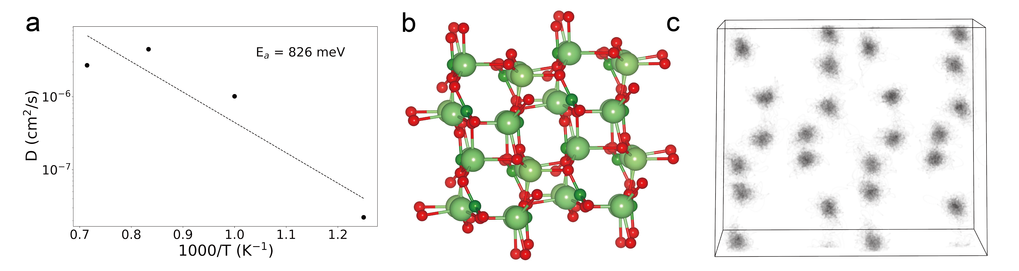
Figure S1. AIMD simulations of Li₆Ga₂(BO₃)₄. a) Arrhenius plot of lithium-ion diffusion coefficient. b) The structure schematic. c) Isosurface of lithium-ion probability density from the 800-1400K AIMD simulation.

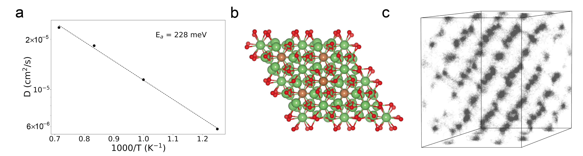
Figure S2. AIMD simulations of Li₇SbO₆. a) Arrhenius plot of lithium-ion diffusion coefficient. b) The structure schematic. c) Isosurface of lithium-ion probability density from the 800-1400K AIMD simulation.

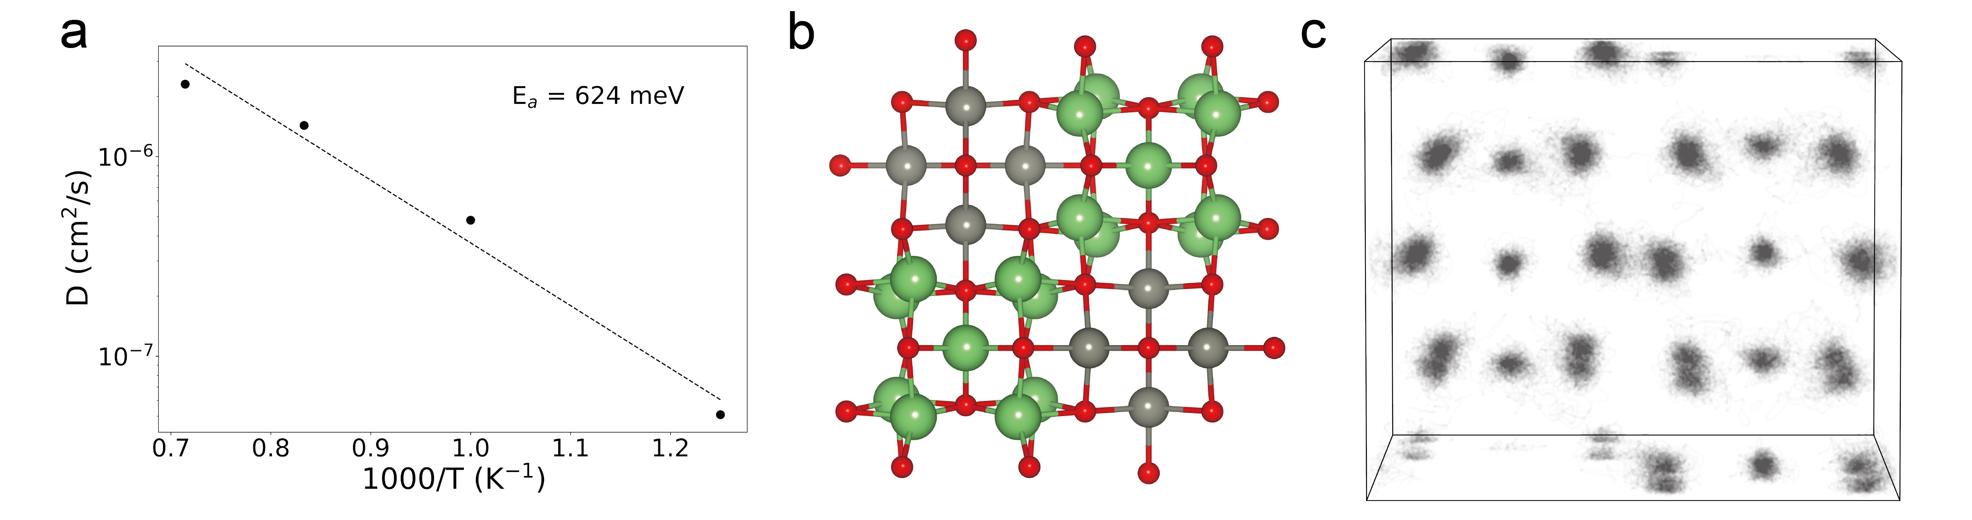
Figure S3. AIMD simulations of Li₁₀Zn₄O₉. a) Arrhenius plot of lithium-ion diffusion coefficient. b) The structure schematic. c) Isosurface of lithium-ion probability density from the 800-1400K AIMD simulation.

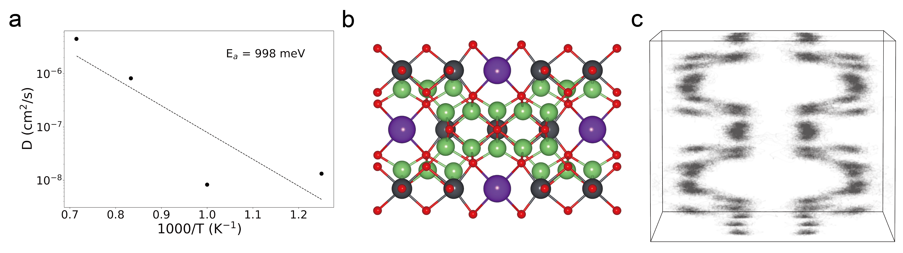
Figure S4. AIMD simulations of K₂Li₁₄Pb₃O₁₄. a) Arrhenius plot of lithium-ion diffusion coefficient. b) The structure schematic. c) Isosurface of lithium-ion probability density from the 800-1400K AIMD simulation.

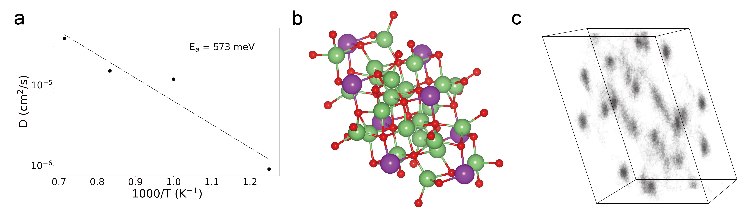
Figure S5. AIMD simulations of Li₃BiO₃. a) Arrhenius plot of lithium-ion diffusion coefficient. b) The structure schematic. c) Isosurface of lithium-ion probability density from the 800-1400K AIMD simulation.

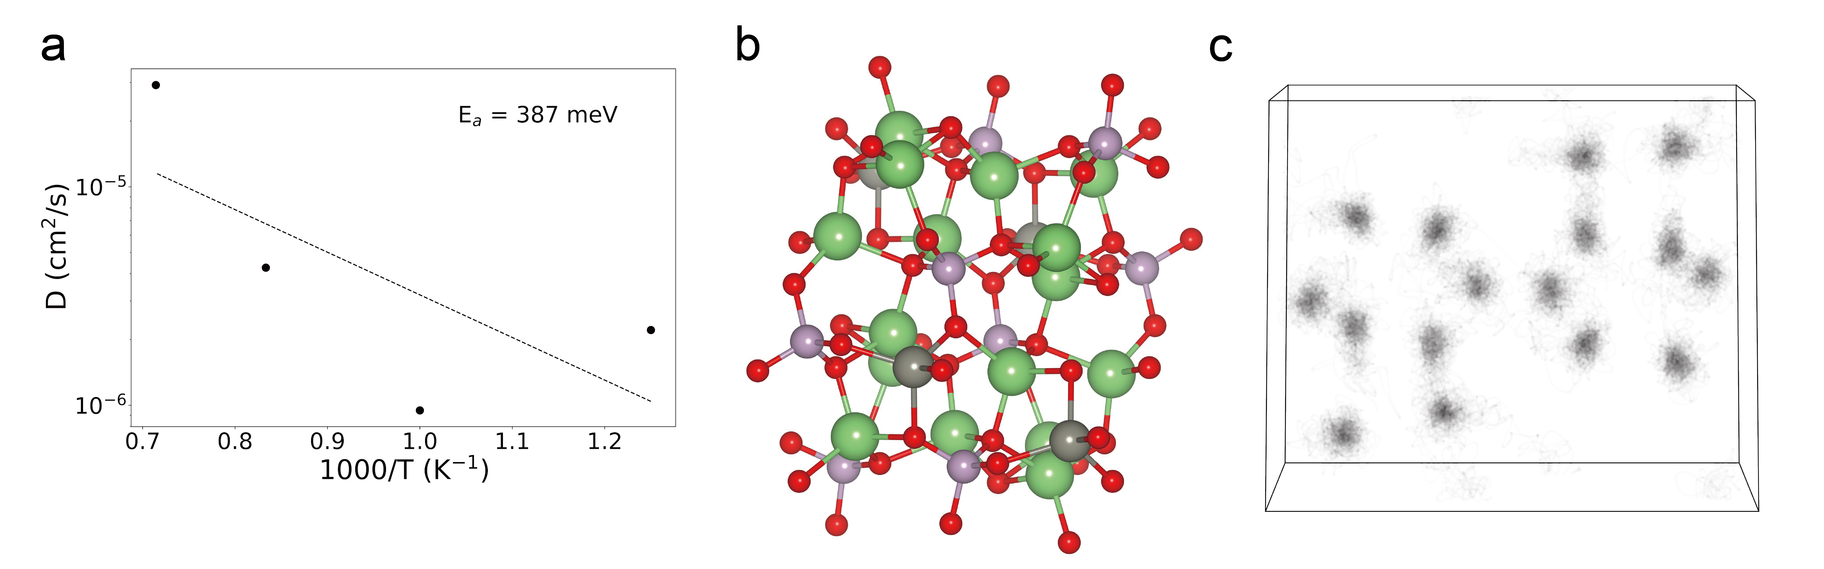
Figure S6. AIMD simulations of Li₄Zn(PO₄) ₂. a) Arrhenius plot of lithium-ion diffusion coefficient. b) The structure schematic. c) Isosurface of lithium-ion probability density from the 800-1400K AIMD simulation.

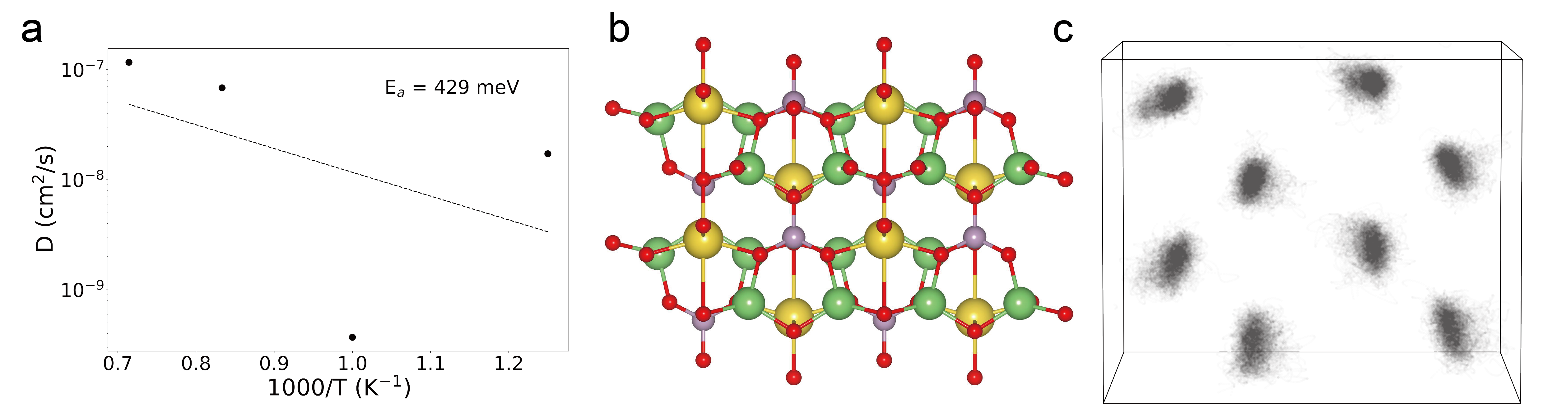
Figure S7. AIMD simulations of NaLi₂PO₄. a) Arrhenius plot of lithium-ion diffusion coefficient. b) The structure schematic. c) Isosurface of lithium-ion probability density from the 800-1400K AIMD simulation.

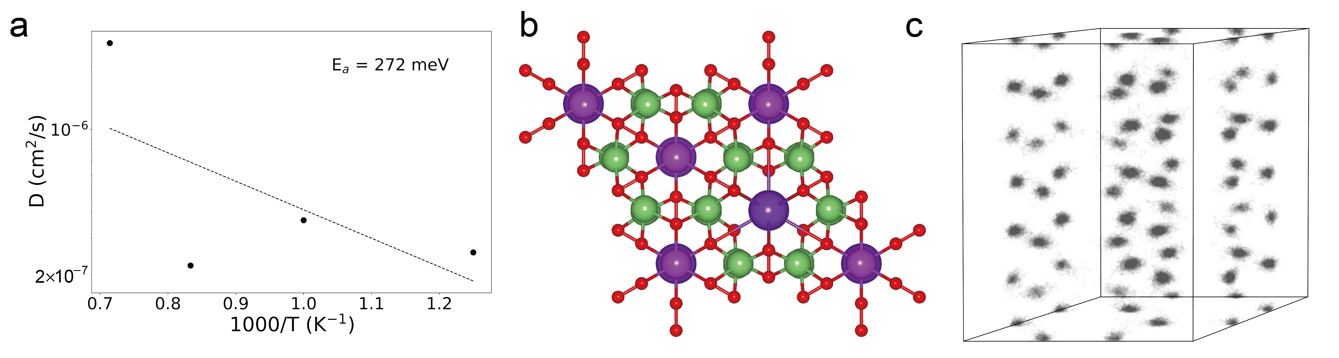
Figure S8. AIMD simulations of KLi₆BiO₆. a) Arrhenius plot of lithium-ion diffusion coefficient. b) The structure schematic. c) Isosurface of lithium-ion probability density from the 800-1400K AIMD simulation.

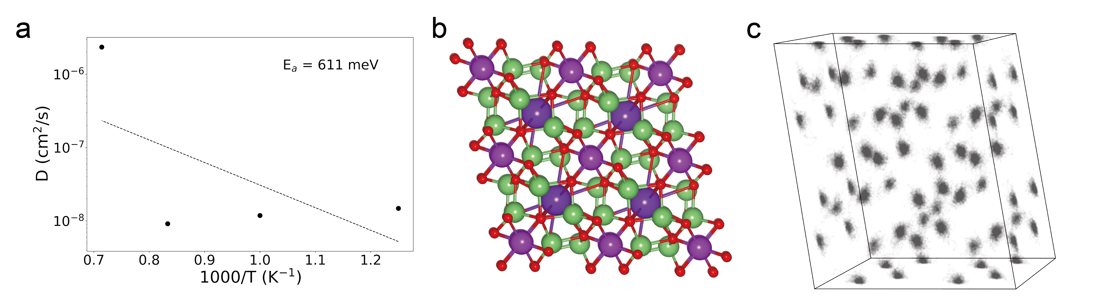Figure S9. AIMD simulations of Li₆KBiO₆. a) Arrhenius plot of lithium-ion diffusion coefficient. b) The structure schematic. c) Isosurface of lithium-ion probability density from the 800-1400K AIMD simulation.

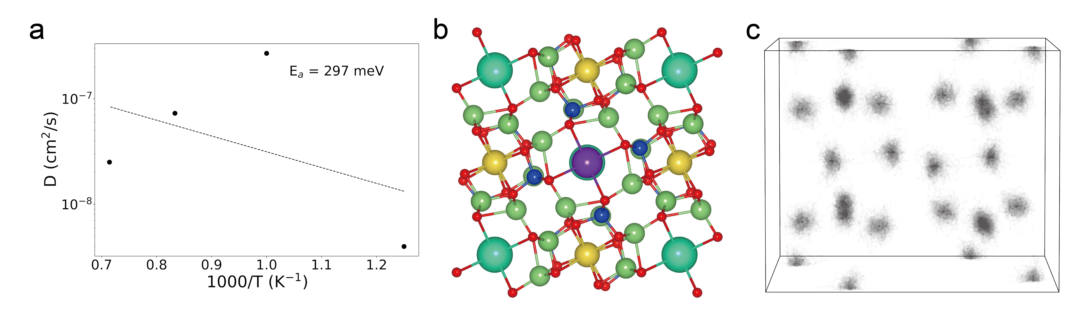
Figure S10. AIMD simulations of CsKNa₂Li₈(Li(SiO₄))₄. a) Arrhenius plot of lithium-ion diffusion coefficient. b) The structure schematic. c) Isosurface of lithium-ion probability density from the 800-1400K AIMD simulation.

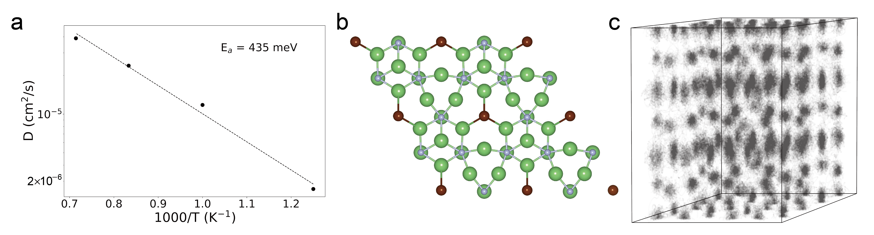
Figure S11. AIMD simulations of Li₁₀N₃Br. a) Arrhenius plot of lithium-ion diffusion coefficient. b) The structure schematic. c) Isosurface of lithium-ion probability density from the 800-1400K AIMD simulation.

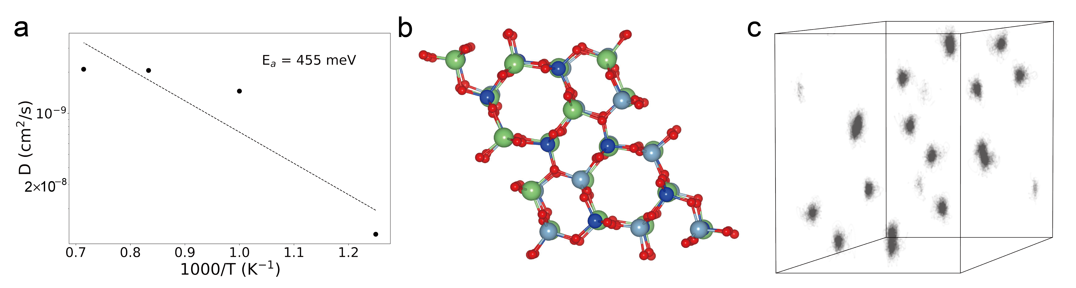
Figure S12. AIMD simulations of LiAlSiO₄. a) Arrhenius plot of lithium-ion diffusion coefficient. b) The structure schematic. c) Isosurface of lithium-ion probability density from the 800-1400K AIMD simulation.

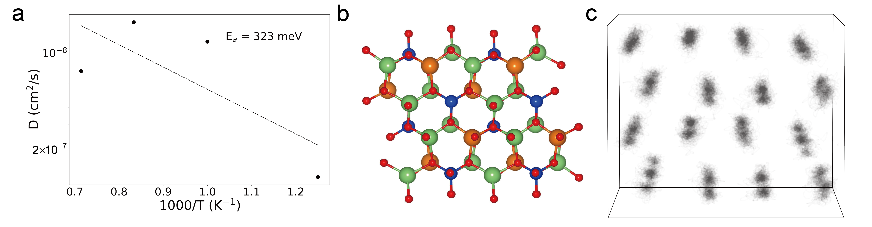
Figure S13. AIMD simulations of Li₂MgSiO₄. a) Arrhenius plot of lithium-ion diffusion coefficient. b) The structure schematic. c) Isosurface of lithium-ion probability density from the 800-1400K AIMD simulation.

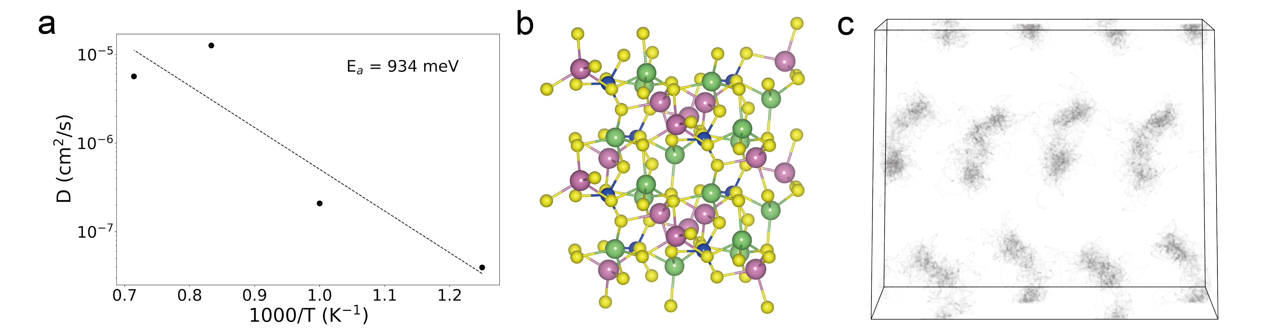
Figure S14. AIMD simulations of In₂Li₂SiS₆. a) Arrhenius plot of lithium-ion diffusion coefficient. b) The structure schematic. c) Isosurface of lithium-ion probability density from the 800-1400K AIMD simulation.

