Supplementary Information

Hydroxide exchange membrane carbon capture (HEMCC) using symmetric nickel hydroxide batteries
R. James Buchen, Teng Wang, K. Braden Geiger, Y. Naama Gluz, Maurice Artoul, Jean-Phillippe Hiegel, Ben Archai, P. Brian Setzler, Yushan Yan

Contents
SI Discussion 1 pH gradient carbon capture 3
SI Figure 1 | Anion aqueous solution composition in equilibrium with a CO₂ in air stream 4
SI Discussion 2 Electrochemical pKa carbon capture limits 5
SI Figure 2 | Constant current regeneration flux to observe maximum flux 6
SI Figure 3 | Flux vs current density of Ni(OH)2 and H2 fuel cell HEMCC devices 7
SI Discussion 3 Lab scale pressure drop 8
SI Figure 4 | Laboratory scale pressure drop of three different flow field types 9
SI Discussion 4 In-situ corrosion 10
SI Figure 5 | Performance of the laboratory scale HEMCC 10
SI Figure 6 | Simplified Pourbaix diagram for nickel hydroxide. 11
SI Figure 7 | Current density holds to test corrosion on bare nickel foam. 12
SI Figure 8 | Current cycling to test corrosion on bare nickel foam. 13
SI Discussion 5 Flux and energy cost calculation 14
SI Discussion 6 Laboratory scale electrode preparation 14
SI Figure 9 | Electrochemical precipitation of Ni(OH)₂ onto nickel foam. 15
SI Discussion 7 Three-electrode cycling of electrodes 16
SI Figure 10 | Three-Electrode cycling break-in for of nickel hydroxide electrodes 17
SI Discussion 8 Laboratory scale 25cm² cell assembly. 18
SI Figure 11 | Assembly used at the laboratory scale 25cm² cell. 18
SI Discussion 9 TEA Analysis 19
References 23

pH gradient carbon capture
Carbon capture devices utilizing a pH gradient are bound to a minimum ΔpH to capture CO₂ on one side and release it on another. This ΔpH can be approximated by the equilibrium of CO₂ in water solutions of different pH. A reaction scheme described in prior work of CO₂ and water with equilibrium and kinetic equations has been adapted below. ^{1,2} Although unused in the analysis here, diffusion data can assist in modeling CO₂ capture systems by adding aqueous transport properties. ³
$$CO_{2}\left(aq\right)+H_{2}O\underset{k_{-1}}{\underset{↔}{k_{1}}}H_{2}CO_{3}$$
$$CO_{2}\left(aq\right)+OH^{-}\underset{k_{-2}}{\underset{↔}{k_{2}}}HCO_{3}^{-}$$
$$CO_{3}^{2-}+H^{+}\underset{↔}{K_{a1}}HCO_{3}^{-}$$
$$HCO_{3}^{-}+H^{+}\underset{↔}{K_{a2}}H_{2}CO_{3}$$
$$OH^{-}+H^{+}\underset{↔}{K_{W}}H_{2}O$$

A set of solubility data of CO₂ and water ionization was utilized to show the equilibrium of CO₂ in air with a water solution at different pH. ⁴⁻⁶ Combined with the aqueous equilibrium and kinetic data SI Figure 1 below was formed for 30 °C and 1 bar. The dotted red line shows the equilibrium of gaseous CO₂ over a solution. From this we can determine the pH gradient requirement between an atmospheric CO₂ solution and a purified stream. At 400 ppm a minimum of 11 pH is required to capture CO₂. To release the CO₂ into a purified stream the solution must drop below 8.6 pH, thus a minimum 2.4 ΔpH gradient is required in a pH gradient device. The Nernst equation allows us to determine a minimum thermodynamic voltage requirement for CO₂ capture using an electrochemical pH gradient device of 0.14V. In practicality, the capture side outlet CO₂ concentration will determine the equilibrium pH; for instance, if 50% of the CO₂ is captured, a 200ppm CO₂ outlet will require a 2.6 ΔpH.
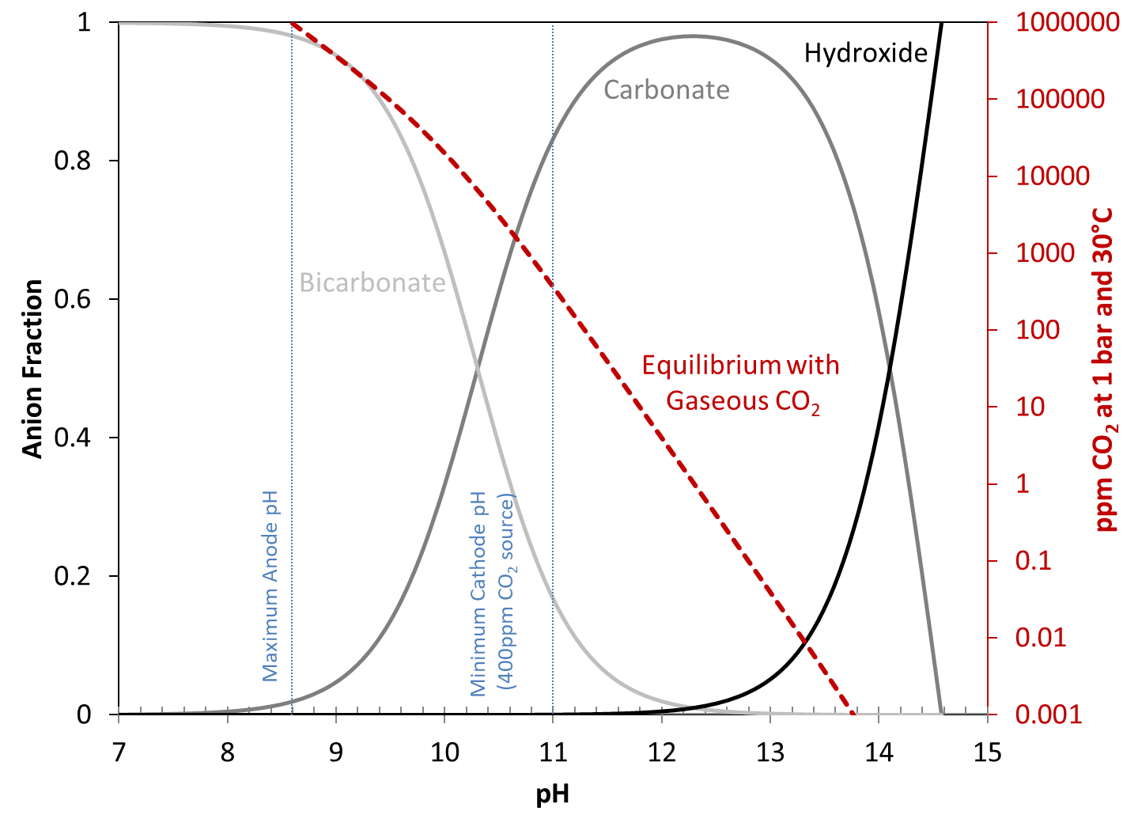

Anion aqueous solution composition in equilibrium with a CO₂ in air stream at 30°C and 1 bar at varied pH.
The anion composition is a mixture of bicarbonate (light grey line), carbonate (medium grey line), and hydroxide (black line). A solution in equilibrium with a CO₂ gas stream will follow the dotted red line. This can be used to determine the maximum allowable anode pH to release CO₂ into a pure (1,000,000 ppm) stream and the minimum required cathode pH to capture CO₂ from a dilute CO₂ stream (vertical blue lines).

Electrochemical pKa carbon capture limits
Electrochemical pK_{a} carbon capture devices have two basic and fundamental limitations that define the maximum flux at a given current density. First is stoichiometric electron efficiency, second is the mass flow into the device. This is reflected in prior work with a hydrogen fuel cell based HEMCC. ⁷ Importantly the limits can define any electrochemical pK_{a} system where a species is electrochemically generated to capture CO₂ on an electrode surface. In this case hydroxide is produced from water, but other systems such as quinone or isoindigo can also be described in this manner. ^{8,9} When a solution of CO₂ capture species are produced, the flux limits can be adjusted for solution volume instead of an area-based electrode.
Stoichiometric flux limits:
$$j_{stoic_bicarb}=\frac{n_{bicarb}}{n_{x}}*\frac{n_{x}}{n_{e}}*\frac{m_{CO_{2}}}{F}*\frac{I}{A} =\frac{1}{1}*\frac{1}{1}*\frac{44.01}{96485}*\frac{I}{A}=C_{1}\frac{I}{A}; where x=OH^{-}$$

$$j_{stoic_carb}= \frac{n_{carb}}{n_{x}}*\frac{n_{x}}{n_{e}}*\frac{m_{CO_{2}}}{F}*\frac{I}{A}=\frac{1}{2}*\frac{1}{1}*\frac{44.01}{96485}*\frac{I}{A}=\frac{1}{2}C_{1}\frac{I}{A}; where x=OH^{-}$$
Mass flow flux limits:
$$j_{mass Flow}=n_{CO_{2}}*C_{2}\frac{Q}{A}$$
Conversion factors $C_{1}and C_{2} at room temperature (25 ℃) and 1 atm$
$$C_{1}=\frac{44.01\frac{g}{mol}*\frac{kg}{1000g}}{96485\frac{C}{mol}\frac{1000mA*s}{C}\frac{h}{3600s}\frac{day}{24hr}\frac{yr}{365day}}\frac{{100}^{2}cm^{2}}{m^{2}}=143.85\frac{kg}{m^{2}*yr}\frac{cm^{2}}{mA}$$

$$C_{2}=\frac{44.01\frac{g}{mol_{CO_{2}}}\frac{mol_{CO_{2}}}{{10}^{6}ppm_{CO_{2}}}*\frac{kg}{1000g}*\frac{1atm}{1mol_{air}*298.15K}*\frac{1}{0.082057}*\frac{mol_{air}*K}{L*atm}*\frac{{100}^{2}cm^{2}}{m^{2}}}{\frac{hr}{60min}*\frac{day}{24hr}*\frac{yr}{365day}}=9.454\frac{kg}{m^{2}*yr}\frac{cm^{2}*min}{ppm_{CO_{2}}*L}$$
Variable Definitions:
$$j_{stoic_{i}}=stoichiometric flux limit of i$$  $$j_{massFlow}=mass flow flux limit$$  $$n_{i}=moles of i$$  $$F=Faraday^{'}s constant\left(C·mol^{-1}\right)$$  $$I=current density(mA·cm^{-2})$$  $$A=electrode area\left(cm^{2}\right)$$  $$m=molar mass\left(g·mol^{-1}\right)$$  $$Q=Volumetric Flow Rate \left(L·min^{-1}\right)$$ | $$Subscripts i:$$  $$x=species capturing CO_{2}$$  $$bicarb=bicarbonate$$  $$carb=carbonate$$  $$e=electron$$  $$CO{}_{2}=CO{}_{2}$$

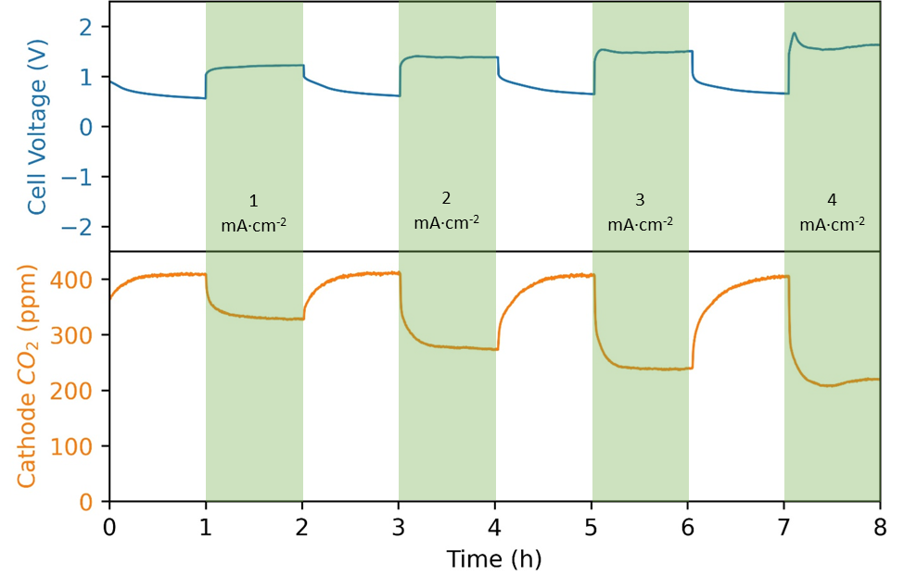

Constant current regeneration flux to observe maximum flux at different current densities
Voltage and cathode CO₂ outlet concentrations for a series of 1 hour rest followed by 1 hour hold at a different current density. The same conditions are used as in Figure 2 of the manuscript. The HEMCC is comprised of two identical electrochemically precipitated Ni(OH)₂ electrodes and an 80 μm Piperion® membrane. The cathode air flow was 1 L∙min⁻¹ with 400 ppm CO₂ and 90% RH. The anode received a sweep gas of 90% RH N₂ at 1 L∙min⁻¹.
The 25 cm² laboratory cell was held in regeneration at different current densities to observe the constant flux independent of state of charge of the electrodes. While there is some difference in the maximum flux between the charging and regeneration portions of a cycle, it is a good proxy for the maximum flux at a given current density without effects from the state of charge of the electrodes. The same device as in Figure 2 of the manuscript was held at 1, 2, 3, and 4 mA·cm⁻² for an hour each with an hour relaxation between each hold. The final 5 minutes of the hour were averaged and used as the maximum flux at that current density.

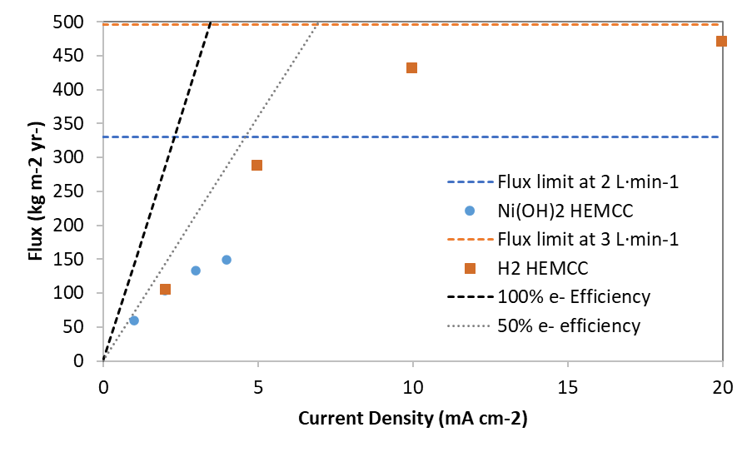

Flux vs current density of Ni(OH)2 and H2 fuel cell HEMCC devices and their physical limits.
Dots are the data from the regeneration hold in SI Figure 2. The horizontal blue dashed line is the maximum achievable flux for the NiOH₂ due to the mass flow of 400ppm CO₂ in a 2 L·min⁻¹ air stream. Orange dots are data from Matz et. al using their H₂ fuel cell HEMCC device. The horizontal orange dashed line is the maximum achievable flux for the Ni(OH)₂ due to the mass flow of 400ppm CO₂ in a 3 L·min⁻¹ air stream. Dotted black lines are the 100% and 50% electron efficiency lines. Orange horizontal line is the flow rate us In blue is data from the regeneration hold from.

The regeneration hold fluxes from SI Figure 2 are overlaid onto the data from the hydrogen fuel cell HEMCC. ⁷ In this figure both electrochemical devices are bound under the stoichiometric limit of 100% electron efficiency and their respective mass flow limits. The hydrogen fuel cell HEMCC test was conducted with 3 L·min⁻¹ of 400 ppm CO2 in air while the nickel hydroxide was conducted with 2 L·min⁻¹ of 400 ppm CO₂ in air. At low current densities stoichiometry limits flux are below the 50% electron efficiency limit suggesting that carbonate is the predominant carbon species being transported. At higher current densities air flow rates limit the flux in the device. For direct air capture, low current densities are favored for energy efficiency. Higher flow rates improve energy efficiency in the device, but the flow rate must be limited for appropriate pressure drop in the device.

Lab scale pressure drop
Three different flow field arrangements were considered, triple serpentine, single serpentine, interdigitated from Scribner. These are common flow fields used in membrane electrode assembly tests. The triple serpentine has three parallel flow channels passing over the electrode while the single serpentine has only one flow channel at three times the length to cover the same area of the electrode. The interdigitated does not have continues channels and instead has parallel unconnected channels for the inlet and the outlet. This forces the fluid (air) through the electrode and has shorter total path length for the fluid than the serpentine flow fields.
Pressure drop can be modeled using Darcy’s law¹⁰ for the triple serpentine and single serpentine configurations as detailed below. The interdigitated flows air through the electrode substrate and thus is not applicable for Darcy’s Law using a channel at a defined length.
$$ΔP=f\frac{\left(Lρ{\overline{V}}^{2}\right)}{2D_{H}}$$
$$f=\frac{64}{Re} for laminar flow Re<2000 ;Re=\frac{ρ\overline{V}D_{H}}{μ}$$
$$ΔP delta pressure f=f\frac{\left(Lρ{\overline{V}}^{2}\right)}{2D_{H}}$$
$$ΔP=delta pressure \left(pressure drop\right)$$  $$f=friction factor$$  $$L=path length$$  $$ρ=density of the fluid \left(air\right)$$ | $$\overline{V}=average fluid velocity$$  $$D_{H}=hydrodynamic radius$$  $$Re=Reynold's number$$  $$μ=kinematic viscosity$$
At 30°C and 1bar air used in the laboratory cell:
$$ρ_{air}=1.164\frac{kg}{m^{3}};μ_{air}=15.98*{10}^{-6}\frac{m^{2}}{s}$$
For Triple Serpentine Cell at 1 L·min⁻¹ flow rate
$$D_{H}=8.5*{10}^{-4}m \left(width=7.5*{10}^{-4}m;depth=1*{10}^{-3}m\right); L=0.55m;\overline{V}=7.4 m·s^{-1}$$
$$Δp=3300 Pa;Re=397$$
For Single Serpentine Cell at 1 L·min⁻¹ flow rate.
$$D_{H}=8.5*{10}^{-4}m \left(width=7.5*{10}^{-4}m;depth=1*{10}^{-3}m\right); L=1.7m;\overline{V}=22.2 m·s^{-1}$$
$$Δp=29700 Pa;Re=1190$$

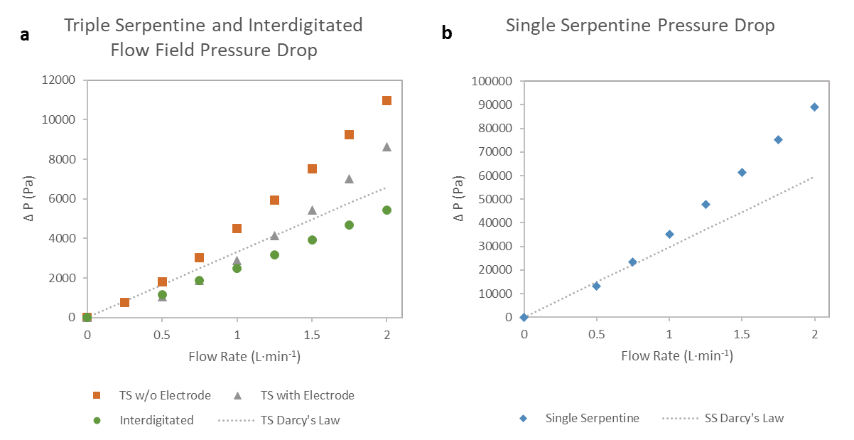

Laboratory scale pressure drop of three different flow field types and 0-2 L·min⁻¹ flow rate.
a. Pressure drop in triple serpentine and interdigitated flow fields. Orange square dots are pressure drop of triple serpentine flow field with a gasket in place of an electrode. This has a higher pressure drop than a triple serpentine flow field with an electrode (grey triangles) due to gas flow through the electrode itself lowering the pressure drop. The linear dotted line represents Darcy’s Law approximation of the pressure drop in the flow field. Interdigitated flow is shown on this figure as a comparison to the triple serpentine flow fields. b. Pressure drop in a single serpentine flow field (blue diamonds) and the Darcy’s Law approximation.
The triple serpentine flow field was chosen in the laboratory setting of having a modest pressure drop while maintaining good performance. A cell with a gasket in place of the electrode was used to compare against Darcy’s Law. The actual pressure drop of the triple serpentine flow field is higher than Darcy’s law due to added friction factor from turns within the cell as well as the inlet and outlet 1/8th NPT inch Swagelok connectors to the flow field. When the cell was tested with the electrode the pressure drop decreases as there is flow allowed through the electrode in addition to the channel.
The lowest pressure drop is seen with the interdigitated flow field where the entirety of the flow is pushed through the 330 μm electrode. The largest pressure drop is seen with the single serpentine flow field which has three times the path length and three times the velocity of the triple serpentine flow field. Of minor note, the Reynolds number for the single serpentine flow field does slightly exceed the limit defined for laminar flow above 1.75 L·min⁻¹.

In-situ corrosion
In both laboratory tests and durability tests, the capacity of the electrodes increased with time. Corrosion of the nickel substrate is the likely reason for this. The durability test showed that the corrosion is limited, and the increased capacity maintains or improves performance of the device. In the manuscript Figure 3 showed the durability test increased capacity between time segment 1 and 2 but not between segment 2 and 3. Similarly, below is a laboratory test of the cell used in Figure 2 after two additional weeks of testing. The cell is shown performing CO₂ capture from a 400 ppm CO₂ in N₂ stream with a capacity of 2.86 mAh·cm⁻². This capacity is greater than ex situ capacity tests of 2.14 and 2.41 mAh cm⁻² shown in SI Figure 10 and the reported capacity of 1.89 mAh·cm⁻² in Figure 2. Corrosion of the nickel substrate is a method for increasing the capacity in-situ.
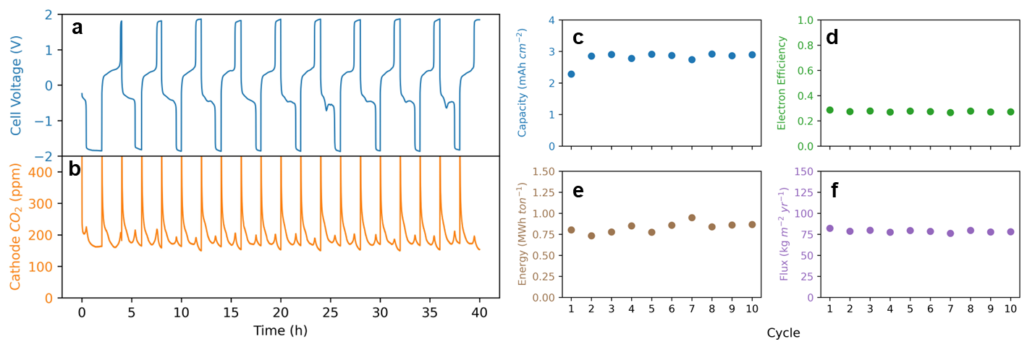

Performance of the laboratory scale HEMCC used in Figure 2 after 2 weeks of additional testing.
Including the constant current regeneration tests in SI Figure 2 The cathode received N₂ flow of 1 L∙min⁻¹ with 400 ppm CO₂ and 90% RH. The anode received a sweep gas of 90% RH N₂ at 1 L∙min⁻¹. The N₂ flow was used to intentionally show a larger voltage during regeneration correlating with HER as the regeneration process instead of ORR when using air. Two-hour cycles were used because of the increased apparent capacity. a. The cell voltage (V) and b. the cathode outlet CO₂ concentration showed similar behavior as Figure 2 except for higher voltage during regeneration. Key process variables c-f during the charge/discharge step c. capacity, d. electron efficiency, e. energy, and f. flux. c. Capacity was 2.90 mAh·cm⁻² d. Electron efficiency achieved 0.27 e. Energy cost averaged 0.83 MWh∙ton⁻¹ while f. Flux averaged to 78 kg∙m²∙yr⁻¹.
A simplified Pourbaix diagram is shown below produced from the standard electrochemical reaction potentials of the respective equations. The potential of the cell is always above the nickel corrosion line at E°_{red}=0.11V, thus corrosion of the nickel substrate to nickel hydroxide is a possible reaction in the cell. This requires hydroxide to have access to the nickel surface which can be prevented by an oxide or nickel hydroxide layer over the nickel substrate. Hydroxide can still access bare nickel exposed through a crack or uncoated region. Once nickel hydroxide is produced on the nickel surface a passivation layer of nickel hydroxide prevents further corrosion of the nickel.
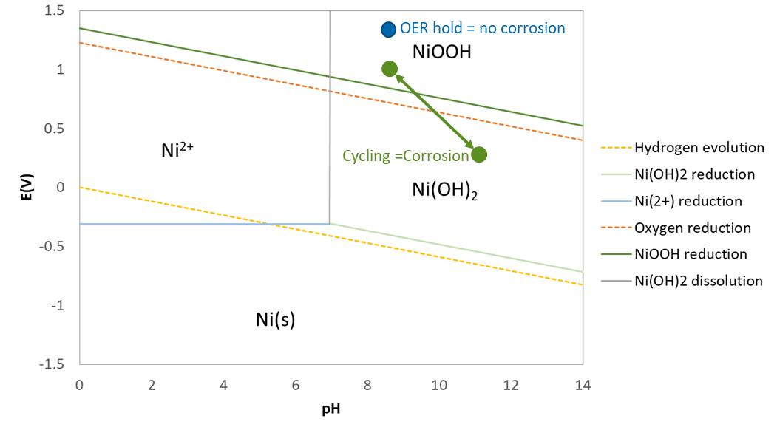
$$Battery: NiO\left(OH\right)+H_{2}O+e^{-}→Ni{\left(OH\right)}_{2}+OH^{-}{ E}_{Red}^{o}= 1.35V$$
$$Electrodeposition: Ni^{2+}+e^{-}→N{i E}_{Red}^{o}=-0.31V$$
$$Corrosion: Ni+2OH^{-}→Ni{\left(OH\right)}_{2}+{2e^{-} E}_{Red}^{o}= 0.11V$$
$$Precipitation: Ni^{2+}+2OH^{-}→Ni{\left(OH\right)}_{2}$$
$$Cathode \left(HER\right): {2H}_{2}O+2e^{-}→H_{2}+2OH^{-}{ E}_{Red}^{o}= 0V$$
$$Anode \left(OER\right): 4OH^{-}→2H_{2}O+O_{2}+4e^{-} { E}_{Red}^{o}= 1.23V$$
$$Cathode \left(ORR\right): 2H_{2}O+O_{2}+4e^{-}→4OH^{-}{ E}_{Red}^{o}= 1.23V$$
$$Anode \left(HOR\right): H_{2}+2OH^{-}→2H_{2}O+O_{2}+4e^{-} { E}_{Red}^{o}= 0V$$

Simplified Pourbaix diagram for nickel hydroxide.
This is a simplified Pourbaix diagram modified from Huggins. ¹¹ Operation of the cell occurs at high pH and a potential near the OER/ORR line at E°_{Red}=1.23V vs RHE. Corrosion of nickel is possible above E°_{Red}=0.11V vs RHE but only in the presence of oxygen. The green dots represent the cycling that occurs in the full cell where CO₂ capture occurs at high pH with potentials at or below the OER/ORR line. The blue dot represents a potential hold above OER. In an ex-situ test in SI Figure 7 no corrosion was observed despite potentials sufficiently above the corrosion potential. Relevant electrochemical reactions are shown with their standard reduction potentials.

To verify that corrosion in the HEMCC requires cycling and that it is likely from the substrate being used, an ex-situ test was set up using the nickel foam substrate to compare corrosion in an electrode held above OER potentials and one that was cycled. A bare 25 cm² nickel foam was set in 1 M KOH and held at a current density of 5 mA·cm⁻² above OER conditions for 400 hours with minimal corrosion evidence.
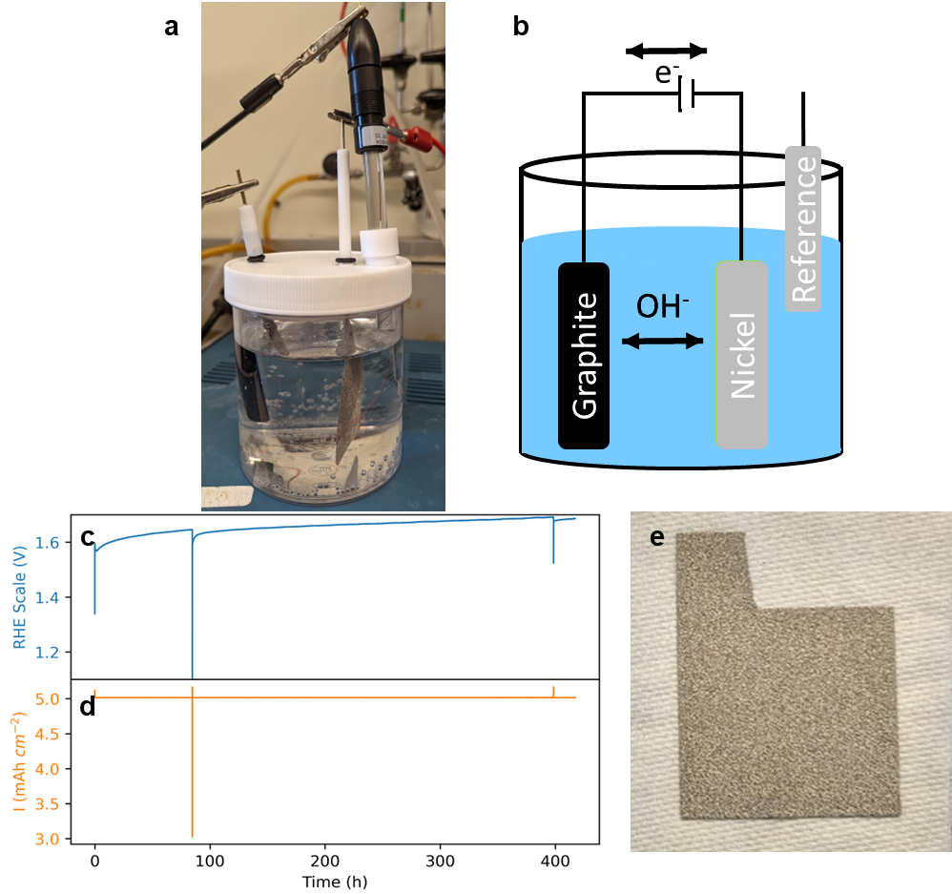

Current density holds to test corrosion on bare nickel foam.
a. Picture of experimental setup with a Ag/AgCl reference, graphite counter electrode, and nickel foam working electrode. b. Diagram of picture in a. c. Voltage of 25 cm² nickel foam electrode over 400 hour hold at d. 5 mA ·cm⁻² current density. There are 2 voltage spikes around 85 hrs and 400 hrs associated with power shut offs and which are not expected to have a large impact on the test. e. Picture of the electrode after the current density hold showing little change from the original foam substrate.

Another nickel foam substrate was set in 1 M KOH and cycled as if it were a battery. Charging ended after the electrode stabilized for 20 seconds in OER. Discharge ended at a voltage of 1.1 V vs RHE, with this sample significant corrosion occurred over 16000 cycles. The surface turned physically black and added 16 mg of mass; the capacity of the electrode was 0.055 mAh·cm⁻². A mass gain of 16 mg suggests of 43.6 mg of formed Ni(OH)₂ which has a theoretical capacity of 0.504 mAh·cm⁻². ¹²
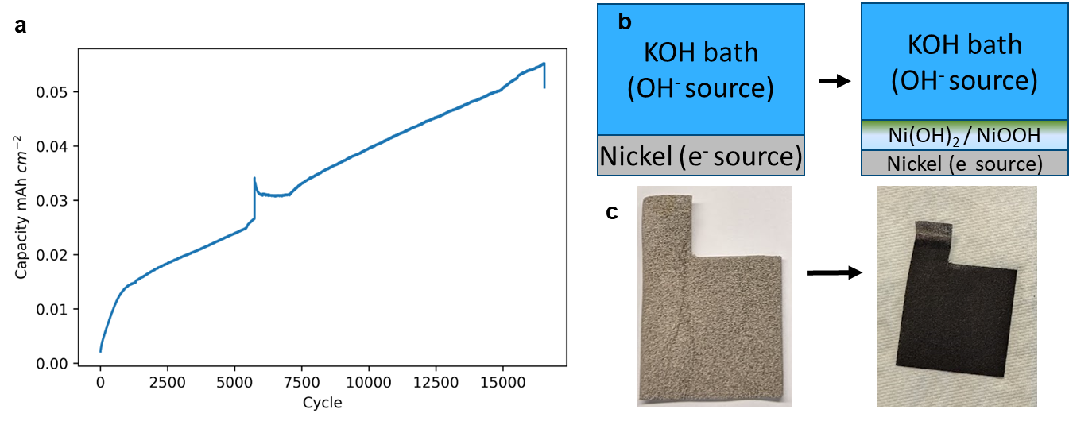

Current cycling to test corrosion on bare nickel foam.
A 25 cm² nickel foam was placed in 1M KOH with the same set up as SI Figure 7 and cycled frequently through the Ni(OH)₂/NiOOH potential of E°_{Red}=1.35V vs RHE. Cycling was programed to have the charging end after 20 seconds of stable OER, while the discharge was shut off at a voltage of 1.1 V vs RHE. a. Capacity of each discharge cycle is shown to show growth of capacity and continued corrosion over time. b. Diagram of the conversion of the nickel substrated to nickel with a layer of nickle hydroxide on top of it. c. Picture of before and after for this substrate the test showing distinct corrosion covering the entirety of the electrode.
A difference in corrosion between nickel held in OER vs cycled as a battery shows two things. First, once a passivation layer occurs, corrosion stops and OER becomes the predominant reaction. Second, during a discharge below OER potential, the passivation layer permits transfer of hydroxide to the bare nickel surface. This may occur through α-Ni(OH)₂ or γ-NiOOH which allows for ions and small molecules between the layers of the structure. ¹³ Given that the mass gained during the cycling is significantly higher than what is suggested by the capacity, water and hydroxide have likely filled the space between the Ni(OH)₂ layers adding to the mass. Additionally, potassium from the KOH solution can add itself to the nickel structure. The presence of hydroxide in these interstitial layers allows for corrosion to occur when the potential is below OER.

Flux and energy cost calculation
The change in mole fraction of CO₂ at cathode was monitored by Teledyne TML20 CO₂ analyzer. Instantaneous flux of CO₂ captured in the device ($j$) normalized to the area of MEA is defined as:
$$j\left[\frac{kg}{m^{2}yr}\right]=\frac{M_{W,CO_{2}}Δy_{CO_{2}}PQ}{RTA}$$
Where $M_{W,CO_{2}}$is the molecular weight of CO₂, $Δy_{CO_{2}}$is the change in mole fraction of CO₂ at cathode, $P$ is pressure, $Q$is the volumetric air flow rate,$R$ is the ideal gas constant, $T$ is temperature, and $A$ is the electrode area.
In each specific cycle or regeneration period, the energy cost ($E$) normalized to the mass of CO₂ is directly dependent on the CO₂ flux given above and electric power input that is dependent on the operating voltage at constant current density:
$$E\left[\frac{MWh}{ton_{co_{2}}}\right]=\frac{I∫V\left(t\right)dt}{∫j\left(t\right)dt}$$
Where $I$ is current density, $V$ is voltage,$j$ is the CO₂ flux, and $t$ is time.

Laboratory scale electrode preparation
Lab scale electrode preparation was done by electrochemical precipitation. There are several methods to produce Ni(OH)₂ with bulk precipitation being one of the more common methodologies. ¹³ Electrochemical precipitation was chosen instead for the laboratory scale in order to apply a controlled layer onto a porous substrate varied by current density and concentration of nickel salt.
The nickel hydroxide electrochemical precipitation mechanism is a two-step process. The first step is electrochemical production of hydroxide through an HER reaction, the second is a precipitation of Ni²⁺ to Ni(OH)₂ near the surface of the substrate. Precipitation near the surface allows for the Ni(OH)₂ to attach to the substrate. To maintain the initial Ni²⁺ concentration nickel foam was used as a counter electrode and is oxidized to form Ni²⁺ in-situ.
At the cathode:
$$Step 1-HER: {2H}_{2}O+2e^{-}→H_{2}+2OH^{-}{ E}_{Red}^{o}= 0V$$
$$Step 2-Precipitation: Ni^{2+}+2OH^{-}→Ni{\left(OH\right)}_{2}$$
At the anode:
$$Oxidation: N{i→Ni^{2+}+e^{-} E}_{Red}^{o}=-0.31V$$

The nickel foam used was from MTI corporation (product name EQ-bcnf-16m) with 99.9% purity, 95% porosity, 80-110 pores per inch and thickness of 1.6mm. Three 25cm² nickel foam substrates were cut retaining a 1 cm² tab for connecting with an alligator clip. The three substrates were compressed in a hydraulic press to 512 μm by using a 512 μm thick steel plate as a guide barrier. These were weighed and then placed in prepared 1 M sulfuric acid solution for 1 hour to remove the surface oxide layer. The oxide layer removed is assumed to be negligible in mass for purposes of measuring amount of mass added to the working electrode.
These substrates were set parallel in a 0.05 M nickel chloride solution using 98% anhydrous nickel chloride salt from Millipore Sigma (CAS No: 7718-54-9). NiCl₂ hexahydrate (Sigma-Aldrich, ReagentPlus) was also tested without any noticeable performance difference. The substrates were suspended in place with copper electrode clips as shown in SI Figure 9. The outer electrodes were connected via wire to be at the same voltage as the counter electrode, the middle electrode was the working electrode for Ni(OH)₂ to be precipitated onto. Two outer electrodes were used to evenly grow Ni(OH)₂ on both sides of the central working electrode. The distance between electrodes were approximately controlled to 1 cm by fixing the electrode holders evenly, but slight bending and rotation in the substrates themselves led to some uneven loading on both sides of the electrode.
A reference Ag/AgCl electrode from Pine Research (RREF0021) was used to track voltage in the cell during electrochemical precipitation. A current density of -5 mA·cm² for 4 hours was applied to the working electrode. Afterwards, the electrodes were rinsed with DI water and set out to dry overnight. The next day the weight of the working electrode was measured to determine the mass of deposition. As a control, the counter electrodes were also weighed to measure their loss of Ni. The loss of Ni of the counter electrodes closely aligns with the oxidation to Ni²⁺ in the solution as expected this balances the loss of Ni²⁺ during precipitation and maintains a relatively stable bulk Ni²⁺ concentration. The pair of counter electrodes lost 0.57 g Ni (27% of initial mass) during the process while the working electrode gained 0.83 g during the process.

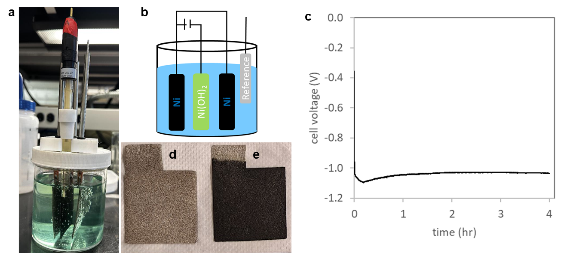

Electrochemical precipitation of Ni(OH)₂ onto nickel foam.
a. Three parallel nickel foam substrates in a 0.05 M NiCl₂ solution with a Ag/AgCl reference electrode. b. electrochemical precipitation cell schematic showing 3 parallel 25 cm² nickel foam substrates with the outside pair being the counter electrode and the inside being the working electrode which nickel hydroxide is grown on. c. cell voltage during 4 hour hold at -5 mA·cm⁻². d. One of the two counter electrodes after the deposition, the pair of counter electrodes lost 0.57 g Ni (27% of initial mass) during the process. e. The working electrode which gained 0.83 g during the process.

Three-electrode cycling of electrodes
After electrochemical precipitation the electrodes were spray coated with Piperion® ionomer. A solution of 1.3333g of 5% ionomer in ethanol solution was added to 6.2222g IPA and sonicated for 30 min. This solution was sprayed on one side of the electrode and then set out to dry for 1 day. Weighing the next days showed that 25% of the initial ionomer mass was transferred to the electrode during the spraying.
The electrode with ionomer was then placed in a 1 M KOH bath in the same set up as the corrosion test in SI Figure 7,8. Three series of current densities were used to cycle each electrode, 1-cycle at 2 mA·cm², 30-cycles at 5 mA·cm², and 5-cycles at 2 mA·cm². A break in is conducted at 2 mA·cm⁻². First the electrode is charged from Ni(OH)₂ to NiOOH for three hours finishing with a plateau at OER voltage. Then the electrode is discharged back to Ni(OH)₂ to completion with a cutoff voltage of 1.1 V vs RHE. This break in charge is longer than the final 5-cycles at 2 mA·cm⁻² to allow for impurities in the deposited Ni(OH)₂ structure to escape without physically damaging the deposited layer. It is expected that chlorine is pushed out of the structure as well as water and hydroxide stuck between the layers of Ni(OH)₂. The largest restructuring of the Ni(OH)₂ layer is done in the initial 2 mA·cm² charge.
Next, 30 cycles at 5 mA·cm² are conducted to stabilized the Ni(OH)₂ layer. It was found that 30 cycles were commonly required to reach a plateau in capacity for an electrode; the current density 5 mA·cm² was chosen to speed up the process. Some electrodes did show a minimum capacity and then rebounded as was seen in the second electrode used for the cell in Figure 2 as shown in SI Figure 10. The final 5 cycles were conducted at 2 mA·cm² to compare with the 2 mA·cm² used during the direct air capture tests. Capacities in NiMH batteries are dependent on the C-rate being applied with higher C-rates producing lower capacity. ^{14,15}
Capacities for the electrodes are defined by the steep voltage decline coinciding with the complete consumption of NiOOH during discharge. An average capacity of the last three cycles at 2 mA·cm⁻² were used as the comparison for result in the full direct air capture device. They are the comparison point suggesting further corrosion occurred in-situ in the cell.
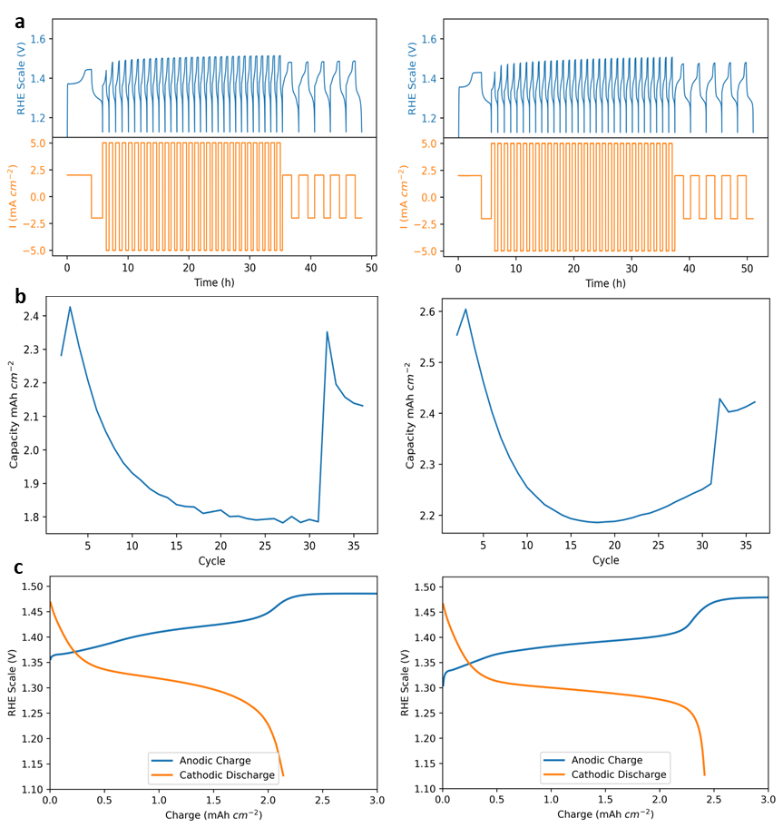

Three-Electrode cycling break-in for of nickel hydroxide electrodes
The two series of data shown are from the two electrodes used in the laboratory data set shown in Figure 2. a. Time series of nickel hydroxide electrodes cycling in 1 M KOH. An initial 2 mA·cm⁻² break in charge is conducted for 3 hours followed by a discharge with a cut-off voltage of 1.1V vs RHE. Next 30-cycles at 5 mA·cm⁻² are conducted to stabilize the electrode followed by 5-cycles at 2 mA·cm² to define the capacity of the electrode. b. Capacity of the electrode through the cycles excluding the first break in cycle. Capacities tended to stabilize after 30 cycles, but did not always which can be due to variations in Ni(OH)₂ loading. c. The final charge and discharge of the 25 cm² electrode with ending capacity of 2.1 and 2.4 mAh·cm² respectively.

Laboratory scale 25cm² cell assembly.
The final assembly of the laboratory scale 25cm² cell is similar to a traditional membrane electrode assembly. A Scribner 25 cm² cell with triple serpentine flow fields were chosen. A 2.5”x3” piece of 80μm Piperion® membrane was used between two electrodes. Two electrochemically precipitated nickel hydroxide electrodes were cut to fit precisely to their respective gaskets. A total of 336μm in FEP gaskets were used on each side for the 512μm thick electrodes. This leads to a 0.39 compression ratio once the cell bolts are torqued to 100 PSI. Compression was found to be an important factor in the final performance where higher compression ratios (thinner gaskets) lead to lower contact resistance in the cell. When compression ratios are too high, physical cracking of the electrodes and decreased performance was seen.
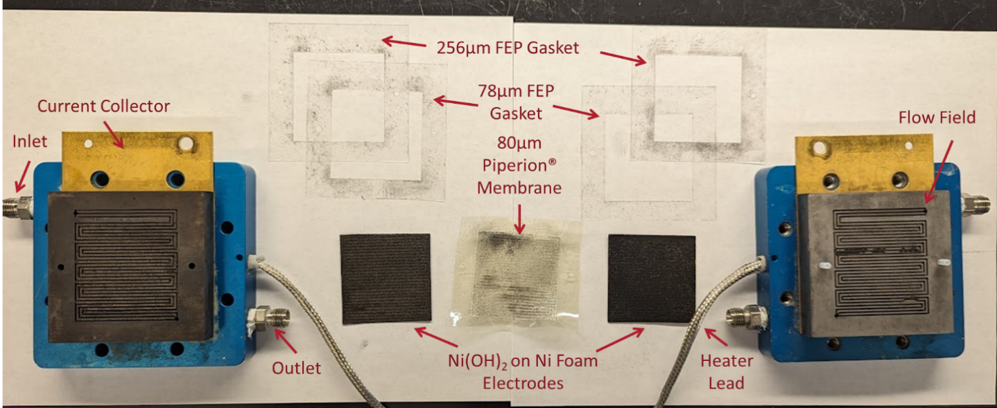

Assembly used at the laboratory scale 25cm² cell.
Gold plated current collectors contact graphite triple serpentine flow fields. Two gaskets are combined to a combined 336μm gasket thickness which controls the thickness of the Ni(OH)2 electrochemically precipitated nickel foam electrodes. An 80 μm Piperion® membrane is placed between the electrodes. The inlet takes in either ambient air or a nitrogen sweep gas depending on if the electrode is the cathode or anode respectively. Similarly, the outlet lets out either the CO₂ reduced air stream or the purified product.

TEA Analysis
A techno-economic analysis was developed and conducted based on previously reported models. ^{16,17}
- Active area
The analysis considers five different projects over a 20-year operating period designed around the following nameplate capacities: 1 kton_{CO2}∙yr⁻¹, 10 kton_{CO2}∙yr⁻¹, 100 kton_{CO2}∙yr⁻¹, 1000 kton_{CO2}∙yr⁻¹ First of a Kind (FOAK), 1000 kton_{CO2}∙yr⁻¹ Nth of a Kind (NOAK). A capacity factor of 95% and a net negativity (net/gross ratio) of 92% are assumed.
An improvement of the CO₂ flux is considered with the increase of nameplate capacity, in line with a progressive maturation of the technology (theoretical limits and approaches for achieving performance improvements are described in SI section 2 and the main manuscript, respectively):
Nameplate capacity (kton_{CO2}∙yr⁻¹) | 1 | 10 | 100 | 1000 _{FOAK} | 1000 _{NOAK}
CO₂ flux (kg_{CO2}·m²·yr⁻¹) | 100 | 200 | 200 | 300 | 300
Active area (m²) | 10000 | 50000 | 500000 | 3333333 | 3333333

$$Active area=\frac{Nameplate capacity*1000000}{{CO}_{2} flux}$$
- Capex
A Bill Of Material (BOM) was established as a comprehensive list of raw materials, components, sub-assemblies, and parts required to manufacture and assemble the stacks of cells. Three different factories are considered:
 | Automated factory | Megafactory | Gigafactory
Produced active area (m².y⁻¹) | 500000 | 5000000 | 40000000
Assembled stacks (#.y⁻¹) | 10000 | 100000 | 800000
Investment cost ($) | 45000000 | 283000000 | 1423000000
Depreciation (y) | 10 | 10 | 10
COGS ($.m⁻²) | 200 | 170 | 130
Unit cost ($.m⁻²) | 209 | 176 | 134

$$Unit cost=COGS+ \frac{{Investment cost}/{Depreciation}}{Produced active area}$$
The Bare Erected Cost (BEC) can be derived from the Unit cost and the Active area. It comprises the cost of core process equipment, on-site facilities, and auxiliary systems.
Nameplate capacity (kton_{CO2}∙yr⁻¹) | 1 | 10 | 100 | 1000 _{FOAK} | 1000 _{NOAK}
Active area (m²) | 10000 | 50000 | 500000 | 3333333 | 3333333
Unit cost ($.m⁻²) | 209 | 209 | 176 | 176 | 134
BEC (k$) | 2090 | 10450 | 88000 | 586667 | 446667

$$Bare Erected Cost=\frac{Unit cost*Active area}{1000}$$
The Total Plant Cost (TPC) encompasses the Engineering, Procurement, and Construction (EPC) costs, along with process and project contingencies. The EPC costs cover services provided by the contractor, including detailed design, contractor permitting, and project/construction management. Process contingencies account for uncertainties in cost estimates arising from performance risks associated with the technology's development status. Project contingencies address general uncertainties in cost estimates and potential risks related to the plant's overall development.
Nameplate capacity (kton_{CO2}∙yr⁻¹) | 1 | 10 | 100 | 1000 _{FOAK} | 1000 _{NOAK}
BEC (k$) | 2090 | 10450 | 88000 | 586667 | 446667
EPC factor (%) | 20% | 20% | 20% | 20% | 20%
Process contingencies (%) | 20% | 20% | 10% | 5% | 5%
Project contingencies (%) | 20% | 20% | 15% | 10% | 10%
TPC (k$) | 3612 | 18058 | 133584 | 813120 | 619080

$$Total Plant Cost=BEC*\left(1+EPC factor\right)*\left(1+Process contingencies\right)*(1+Project contingencies)$$
The Total Overnight Capital (TOC) comprises the TPC plus the owner’s costs.
Nameplate capacity (kton_{CO2}∙yr⁻¹) | 1 | 10 | 100 | 1000 _{FOAK} | 1000 _{NOAK}
TPC (k$) | 3612 | 18058 | 133584 | 813120 | 619080
Owner’s cost factor (%) | 7% | 7% | 7% | 7% | 7%
TOC (k$) | 3865 | 19322 | 142935 | 870038 | 662416

$$Total Overnight Capital=TPC*(1+Owner^{'}s cost factor)$$
BEC, TPC and TOC are expressed in base-year dollars.
- Opex
Fixed Operation & Maintenance (O&M) costs include recurring O&M material costs, labor, insurance and land rental:
- Yearly recurring O&M material costs are assumed to be 1.5% of the TOC.
- Regarding labor, while the number of operators, supervisors, and maintenance workers is usually constant for a given process, the labor rate and burden can vary widely between locations. The analysis considers an average Total Cost Of Employment (TCOE) of K$50 per Full Time Employee (FTE) as well as an additional management fee of 10%.
- Insurance costs are assumed to be 0.5% of the TOC.
- Land rental costs are adjusted to the footprint of each projects
Nameplate capacity (kton_{CO2}∙yr⁻¹) | 1 | 10 | 100 | 1000 _{FOAK} | 1000 _{NOAK}
O&M material (k$∙yr⁻¹) | 58 | 290 | 2144 | 13051 | 9936
Labor (FTE) | 2 | 10 | 20 | 40 | 40
Labor (k$∙yr⁻¹) | 110 | 550 | 1100 | 2200 | 2200
Insurance (k$∙yr⁻¹) | 19 | 97 | 715 | 4350 | 3312
Land rental (k$∙yr⁻¹) | 20 | 150 | 300 | 1000 | 1000
TFOM (k$∙yr⁻¹) | 207 | 1087 | 4259 | 20601 | 16448

$TFOM =O\&M material+Labor+Insurance+Land rental$
$$= 1.5\%*TOC+FTE*TCOE*\left(1+10\%\right)+0.5\%*TOC+Land rental$$

Variable O&M costs include purchased power and replacement of core electrochemical units:
- Purchased power:
  - Power consumption
    - Core electrochemical units – calculations of flux and energy cost are shown in SI Section 5. Energy consumption decreases with increasing technology maturity due to improvements in electrode formulation and morphology as well as stack design. Both aspects contribute to improved electrical and ion conductivity, charge capacity and mass transport (diffusion), eventually leading to increased CO₂ flux and increased %removal of the CO₂ in the air stream.
    - Periphery – the main drivers are the Air Supply Unit (ASU) elements: axial fan and humidifier. Assuming ambient conditions of T=10-40°C and RH=75-95%, a humidifier to top up water vapor is neglected. The energy consumption of the fan is expected to drop due to improvements in the following aspects: (1) improved CO₂ flux, as described above. (2) improved stack design, reducing pressure drop to a target of ~100 Pa. (3) Scaling up and centralization of ASU feeding multiple stacks, leading to improved energy efficiency.
  - Electricity price is considered at 5 cent/kWh
- Replacement of core electrochemical units: frequency of replacement increasing from 10 years to 20 years with increasing technology maturity. Such lifetime is reasonable to assume considering the main MEA components:
  - Nickel hydroxide based electrodes have been comprehensively researched and utilized in Ni-MH and Ni-Cd batteries over the last few decades, reaching 15+ years of operation.
  - AEM – lifetime of 5,000-10,000 hours have been reported in other applications (e.g. fuel cells, electrolyzers) operating at higher temperatures (90-100°C) and current densities (>1 A.cm⁻²). Considering milder process conditions (10-40°C, 1-5 mA.cm⁻²), orders of magnitude increase of the membrane lifetime is expected. ¹⁸
Nameplate capacity (kton_{CO2}∙yr⁻¹) | 1 | 10 | 100 | 1000 _{FOAK} | 1000 _{NOAK}
Power consumption (kWh.t_{CO2}⁻¹) | 1200 | 1000 | 800 | 650 | 650
Electricity price ($.kWh⁻¹) | 0.05 | 0.05 | 0.05 | 0.05 | 0.05
Purchased power ($∙t_{CO2}⁻¹) | 60 | 50 | 40 | 33 | 33
Purchased power (k$∙yr⁻¹) | 57 | 475 | 3800 | 30875 | 30875
Core units replacement (year) | 10 | 10 | 10 | 20 | 20
Replacement cost (k$) | 754 | 5029 | 27351 | 0 | 0
Annualized replacement (k$∙yr⁻¹) | 38 | 251 | 1368 | 0 | 0
TVOM (k$∙yr⁻¹) | 95 | 726 | 5168 | 30875 | 30875

$$TVOM= Purchased power+Annualized replacement =Power consumption*Electricity price*Nameplate capacity*1000*Capacity factor+{Replacement cost}/{Operating Period}$$
- Levelized Cost of Capture (LCOC)
The LCOC can be calculated by summing the annualized total capital, the annual fixed O&M costs, the annual variable O&M costs (including annualized replacement costs) and dividing by the annual net carbon captured.
$$LCOC= \frac{{TOC}/{OP}+TFOM+TVOM}{Nameplate capacity* Capacity factor*{Net}/{Gross}ratio}$$
where:
- LCOC – levelized cost of capture, $. t _{CO2}⁻¹
- TOC – total overnight cost, k$
- OP – operating period, years
- TFOM – total annual fixed O&M, $∙yr⁻¹
- TVOM – total annual variable O&M, $∙yr⁻¹
- Nameplate capacity – total annual gross CO₂ captured, kt_{CO2}∙yr⁻¹
- Capacity factor – yearly average plant availability, fraction
- Net/Gross ratio – net negativity, fraction

Nameplate capacity (kton_{CO2}∙yr⁻¹) | 1 | 10 | 100 | 1000 _{FOAK} | 1000 _{NOAK}
LCOC ($.t _{CO2}⁻¹) | 566 | 318 | 190 | 109 | 92

References
1 Wang, X., Conway, W., Burns, R., McCann, N. & Maeder, M. Comprehensive Study of the Hydration and Dehydration Reactions of Carbon Dioxide in Aqueous Solution. The Journal of Physical Chemistry A 114, 1734-1740 (2010). https://doi.org:10.1021/jp909019u
2 Shu, Q., Legrand, L., Kuntke, P., Tedesco, M. & Hamelers, H. V. M. Electrochemical Regeneration of Spent Alkaline Absorbent from Direct Air Capture. Environ Sci Technol 54, 8990-8998 (2020). https://doi.org:10.1021/acs.est.0c01977
3 Cadogan, S. P., Maitland, G. C. & Trusler, J. P. M. Diffusion Coefficients of CO2 and N2 in Water at Temperatures between 298.15 K and 423.15 K at Pressures up to 45 MPa. Journal of Chemical & Engineering Data 59, 519-525 (2014). https://doi.org:10.1021/je401008s
4 Carroll, J. J. S., J. D.; Mather, A. E. The Solubility of Carbon Dioxide in Water at Low Pressure. J. Phys. Chem. Ref. Data. 20 (1991).
5 Bandura, V. A. L., N. S. The Ionization Constant of Water over Wide Ranges of Temperature and Density. J. Phys. Chem. Ref. Data. 35 (2006). https://doi.org:10.1063/1.1928231
6 Luo, X., Rojas-Carbonell, S., Yan, Y. & Kusoglu, A. Structure-transport relationships of poly(aryl piperidinium) anion-exchange membranes: Eeffect of anions and hydration. Journal of Membrane Science 598 (2020). https://doi.org:10.1016/j.memsci.2019.117680
7 Matz, S. et al. Hydrogen-powered Electrochemically-driven CO2 Removal from Air Containing 400 to 5000 ppm CO2. Journal of The Electrochemical Society 169 (2022). https://doi.org:10.1149/1945-7111/ac7adf
8 Diederichsen, K. M., Liu, Y., Ozbek, N., Seo, H. & Hatton, T. A. Toward solvent-free continuous-flow electrochemically mediated carbon capture with high-concentration liquid quinone chemistry. Joule 6, 221-239 (2022). https://doi.org:10.1016/j.joule.2021.12.001
9 Li, X. et al. Redox-tunable isoindigos for electrochemically mediated carbon capture. Nat Commun 15, 1175 (2024). https://doi.org:10.1038/s41467-024-45410-z
10 Barbir, F., Gorgun, H. & Wang, X. Relationship between pressure drop and cell resistance as a diagnostic tool for PEM fuel cells. Journal of Power Sources 141, 96-101 (2005). https://doi.org:10.1016/j.jpowsour.2004.08.055
11 Huggins, R. A. Advanced Batteries Materials Science Aspects. (Springer, 2009).
12 Ash, B., Nalajala, V. S., Popuri, A. K., Subbaiah, T. & Minakshi, M. Perspectives on Nickel Hydroxide Electrodes Suitable for Rechargeable Batteries: Electrolytic vs. Chemical Synthesis Routes. Nanomaterials (Basel) 10 (2020). https://doi.org:10.3390/nano10091878
13 Hall, D. S., Lockwood, D. J., Bock, C. & MacDougall, B. R. Nickel hydroxides and related materials: a review of their structures, synthesis and properties. Proc Math Phys Eng Sci 471, 20140792 (2015). https://doi.org:10.1098/rspa.2014.0792
14 Becker, M. D. C., D. J.; Salva, H.R.; Rodriguez Nieto, F.; Ghilarducci, A. A.; Visintin A. Oxygen Evolution Nickel Hydroxide Electrodes in a Ni-MH Battery Prototype. Journal of New Materials for Electrochemical Systems 12, 277-282 (2012).
15 Ayeb, A. & Notten, P. H. L. The oxygen evolution kinetics in sealed rechargeable NiMH batteries. Electrochimica Acta 53, 5836-5847 (2008). https://doi.org:10.1016/j.electacta.2008.03.023
16 Henry, S. et al. Basis for techno-economic analysis carbon utilization procurement grants. (United States Department of Energy National Energy Technology Laboratory, 2023).
17 Zhu, P. et al. Continuous carbon capture in an electrochemical solid-electrolyte reactor. Nature 618, 959-966 (2023). https://doi.org:10.1038/s41586-023-06060-1
18 Moreno-González, M. et al. One year operation of an anion exchange membrane water electrolyzer utilizing Aemion+® membrane: Minimal degradation, low H2 crossover and high efficiency. Journal of Power Sources Advances 19 (2023). https://doi.org:10.1016/j.powera.2023.100109

