- Supplementary Material
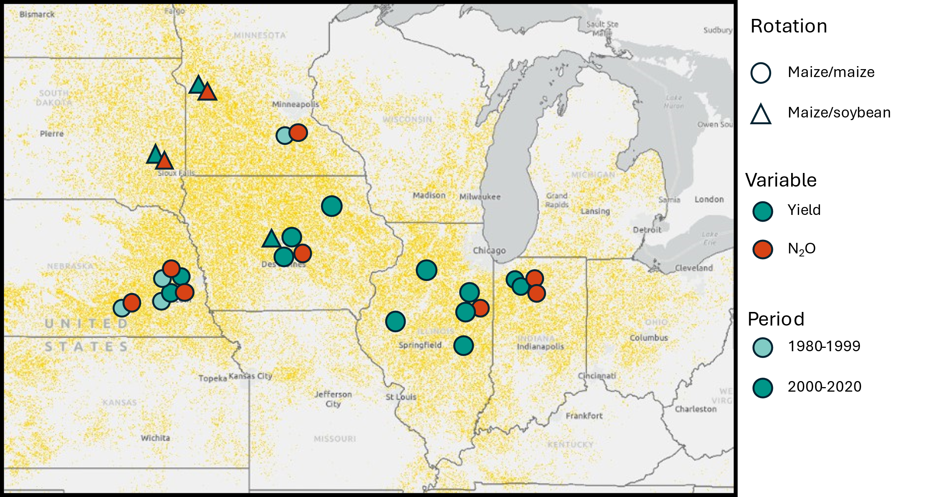
Fig S1 | Location of the experiments used to analyze the impact of maize residue harvesting on the following crop yield and N₂O emissions. The yellow area shows the maize fields location in 2023 (USDA-NASS, 2024b).
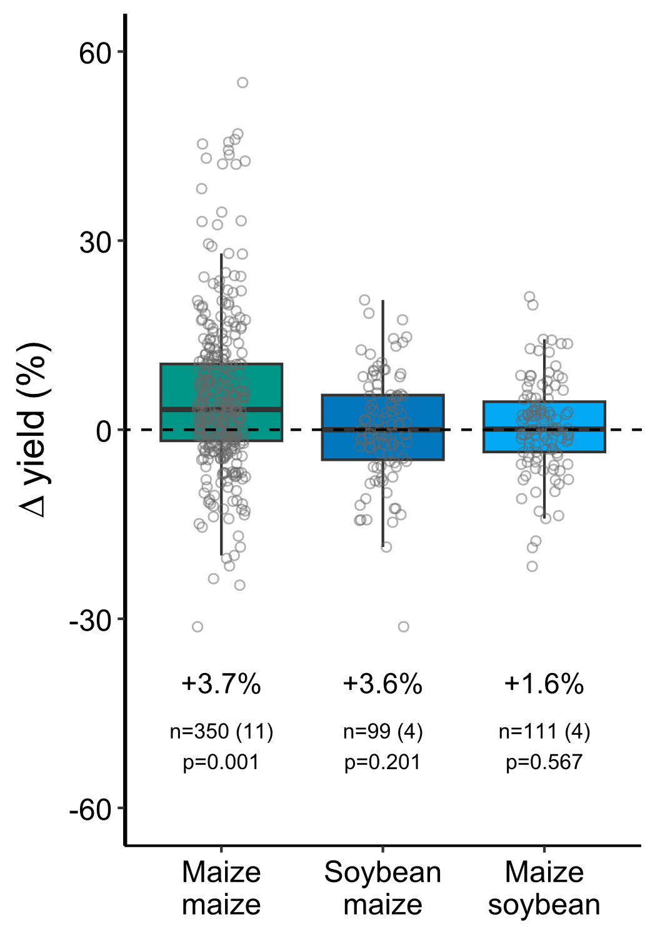
Fig S2 | Impact of maize residue harvesting on grain yield for different crops: maize after maize, soybean after maize and maize after soybean. The data used for this analysis corresponds to the modern experiments (2000-2020). Mean change, number of total cases and experiments (between brackets), and p-value are shown for each box. The lower, mid and upper hinges of the box correspond to the 25th, 50th, and 75th percentiles and whiskers extend to 1.5 times the inter-quartile range.
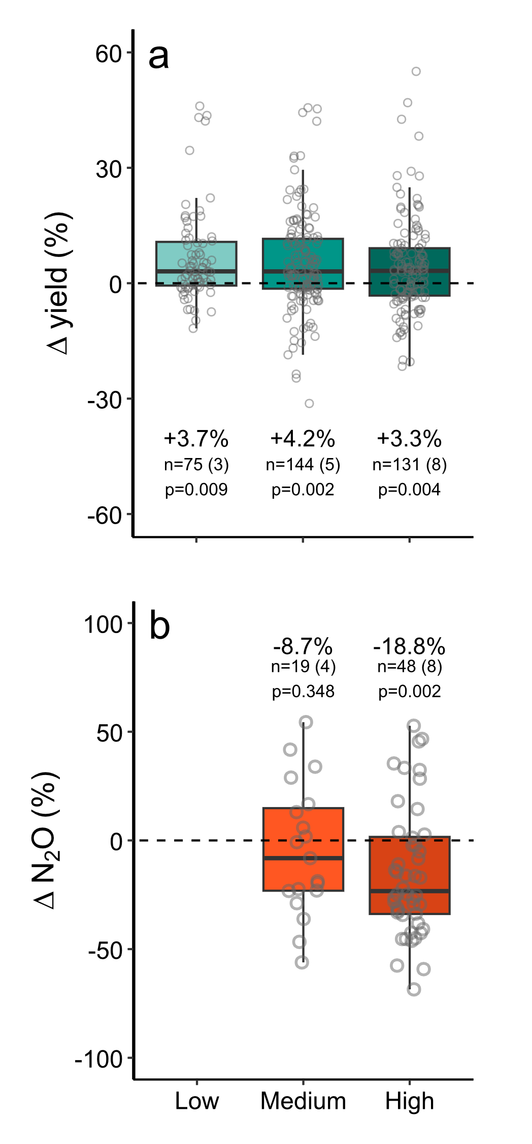
Fig S3 | Impact of maize residue harvesting on maize grain yield (a) and N₂O emissions (b) in the Corn Belt under different residue harvesting rates. The yield data used for this analysis corresponds to the modern experiments (2000-2020). Residue harvesting rates were categorized as low (<35%), medium (35-65%) and high (>65% removal). Mean change, number of total cases and experiments (between brackets), and p-value are shown for each box. The lower, mid and upper hinges of the box correspond to the 25th.
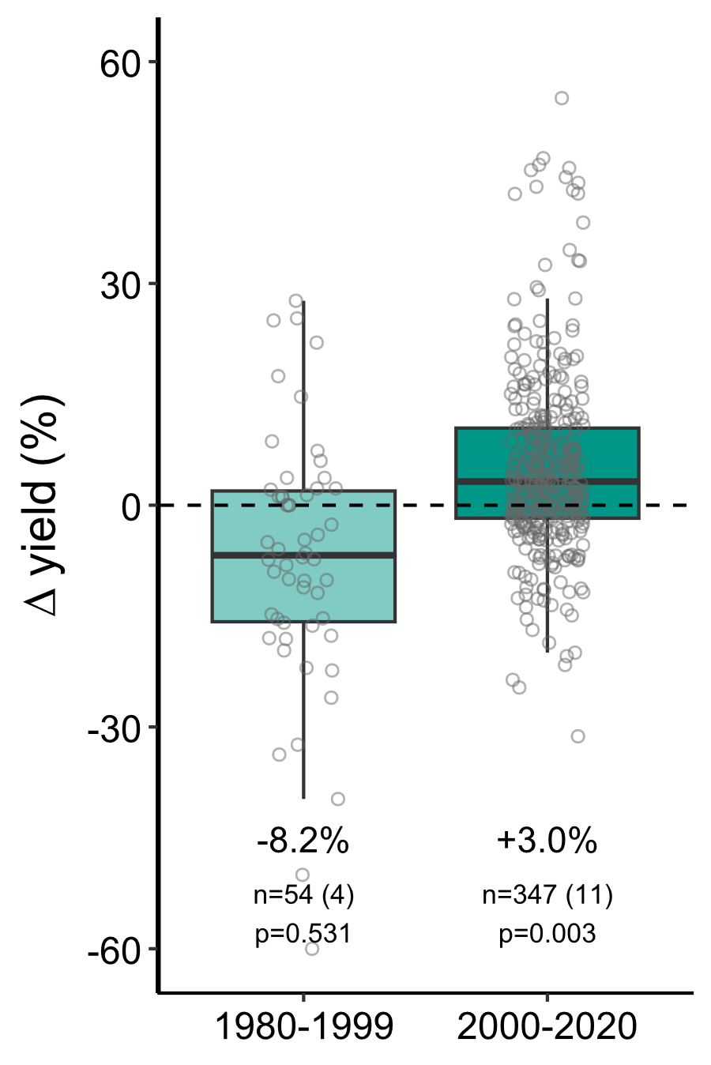
Fig S4 | Impact of maize residue harvesting on maize grain yield in different time periods. Mean change, number of total cases and experiments (between brackets), and p-value are shown for each box. The lower, mid and upper hinges of the box correspond to the 25th.

Table S1. Summary of parameter estimates for asymptotic regression models fitted to predict the effect of residue harvesting (LRR) as a function of previous yield. Results are presented for quantile regression models at the 90th, 50th, and 10th percentiles. The parameters include the asymptote (Asym), the initial response (R0), and the rate constant (lrc). Standard errors (SE) are shown. The formula corresponding to the asymptotic model is:
$$Effect size (LRR)=Asym+\left(R0-Asym\right)⋅e-exp\left(lrc\right)⋅Previous.yield$$

Model | Parameter | Estimate | Std. Error
90th percentile | Asym | 0.214 | 0.478
 | R0 | 0.164 | 0.485
 | lrc | -2.151 | 25.755
50th percentile | Asym | 0.102 | 0.034
 | R0 | -0.564 | 0.449
 | lrc | -1.213 | 0.531
10th percentile | Asym | -0.013 | 0.065
 | R0 | -1.057 | 1.144
 | lrc | -1.236 | 0.777

