Supplementary Material

Assessment of spatiotemporal variability and rising trends of surface ozone over India

Kunchala Ravi Kumar*¹, Bhupendra Bahadur Singh², Karumuri Rama Krishna³, Raju Attada⁴, Vivek Seelanki¹ and Kondapalli Niranjan Kumar⁵

¹ Centre for Atmospheric Sciences, Indian Institute of Technology Delhi, New Delhi, 110016, India

²Centre for Climate Change Research, Indian Institute of Tropical Meteorology, Ministry of Earth Sciences, Pune, 411 008, India
³Physical Science and Engineering Division, King Abdullah University of Science and Technology, Thuwal, Saudi Arabia
⁴Department of Earth and Environmental Sciences, Indian Institute of Science Education and Research Mohali, India, 140306
⁵ National Centre for Medium Range Weather Forecasting, Ministry of Earth Sciences, India, 201309

Corresponding author:
Dr. Ravi Kumar Kunchala,
Centre for Atmospheric Sciences,
Indian Institute of Technology, Delhi-110016
Email: rkkunchala@cas.iitd.ac.in
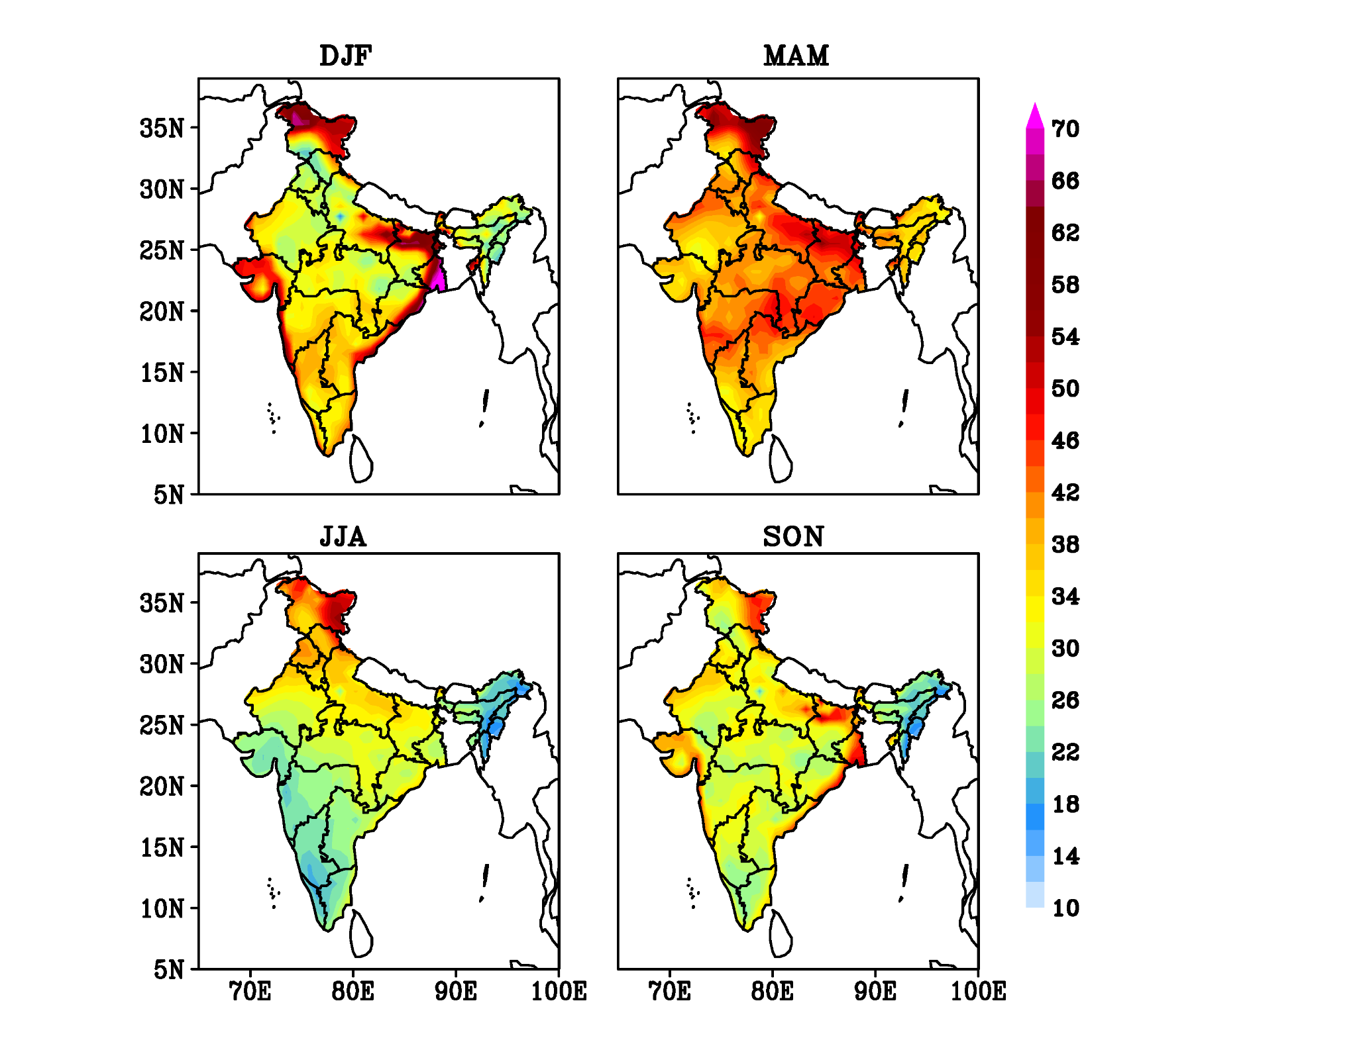

Figure S1: Seasonal spatial distribution of surface ozone over India during the study period (2003-2019)

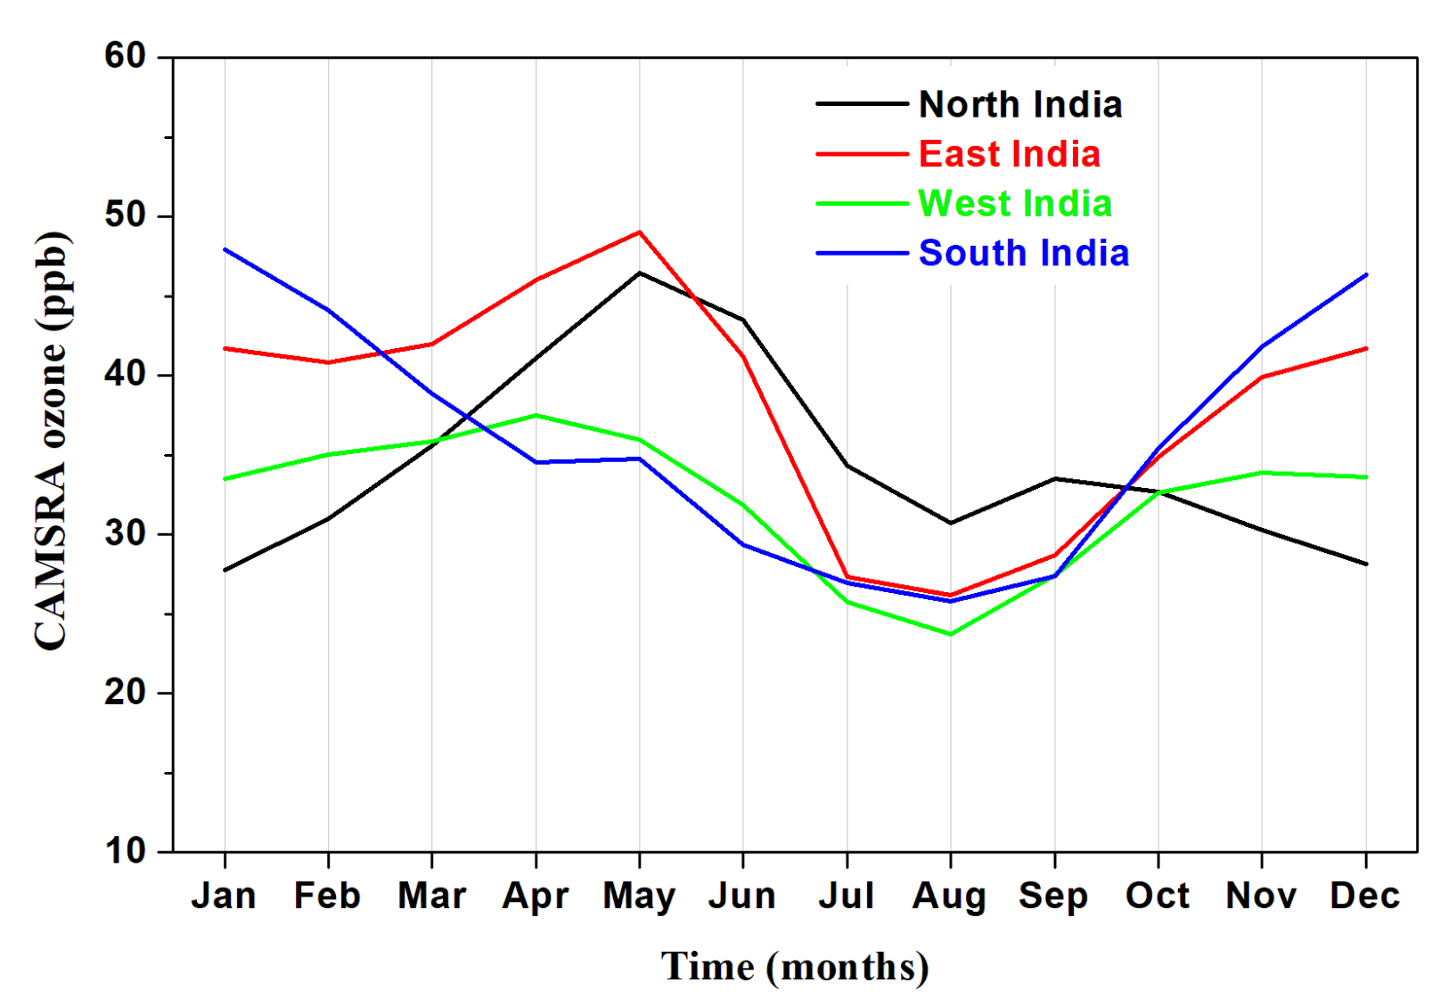
Figure S2: Annual cycles of CAMSRA ozone over different parts of India region as shown in Figure 1.

