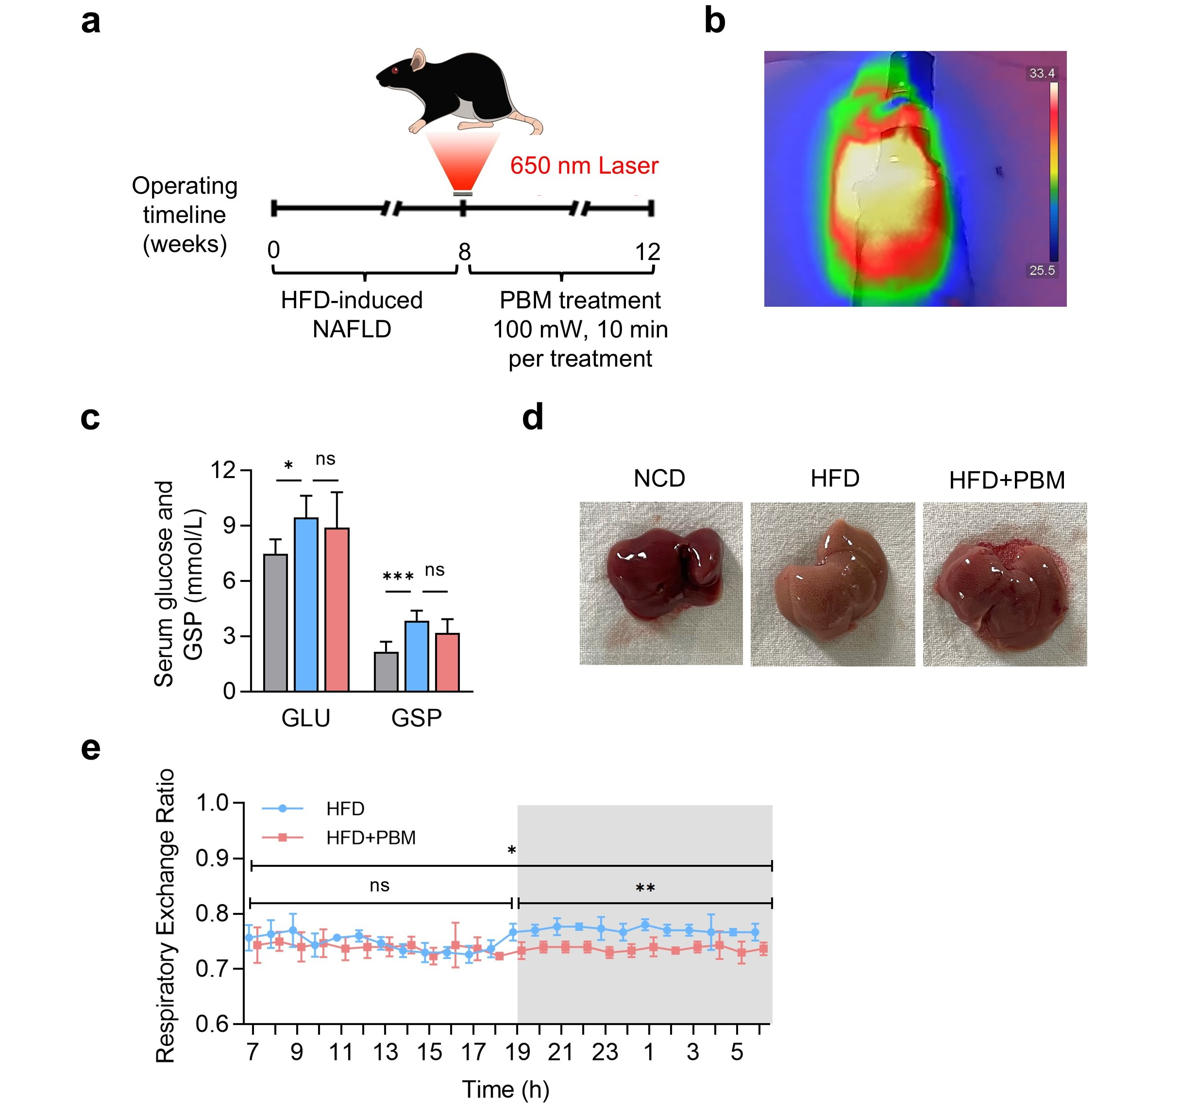
Fig.S1 (a) Protocol for HFD-induced NAFLD and PBM treatment. (b) Representative images using infrared thermography during the PBM treatment. (c) Serum glucose and glucosylated serum protein levels detection. n = 3. (d) Grossly liver observation. (e) Hourly respiratory exchange ratio of mice. n = 3. *p < 0.05, **p < 0.01.

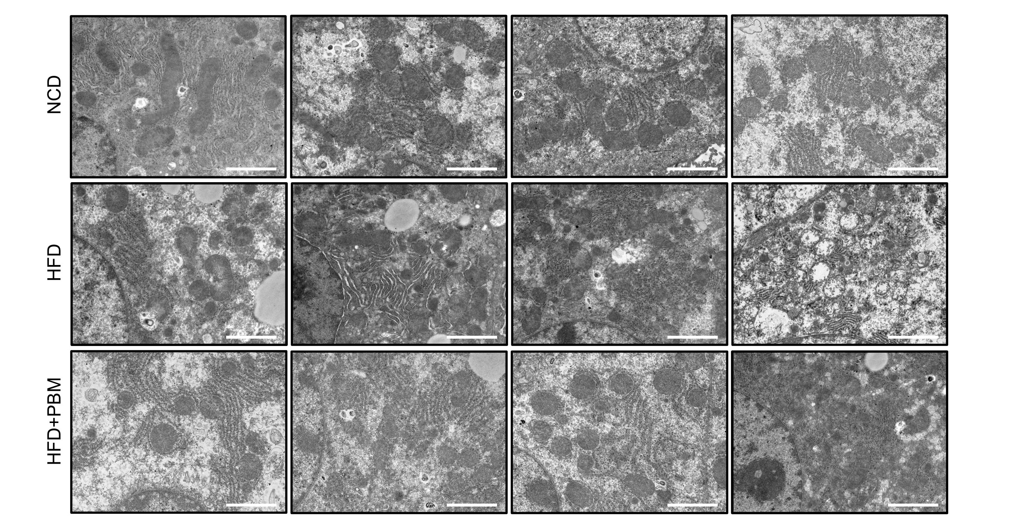
Fig.S2 TEM images of mice liver sections at ×7,000 magnification. Scale bars, 2 µm.

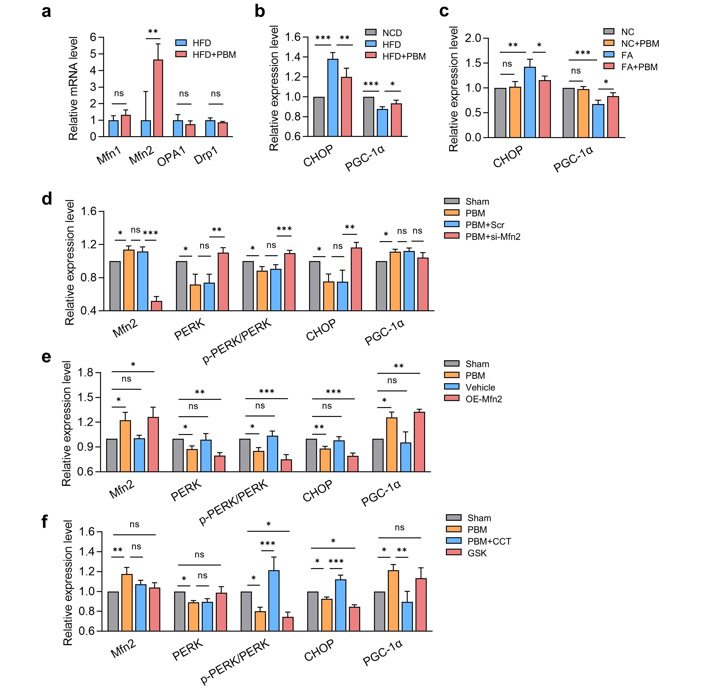
Fig.S3 (a) Level of mRNA expression of Mfn1, Mfn2, OPA1 and Drp1 in mice liver. n = 6. (b) Quantification of protein levels of CHOP and PGC-1α in mice liver. n = 4. (c) Quantification of protein levels of indicated proteins in HepG2 cells. n = 3. (d-f) Quantification of protein levels of indicated proteins in HepG2 cells per group. n = 3.
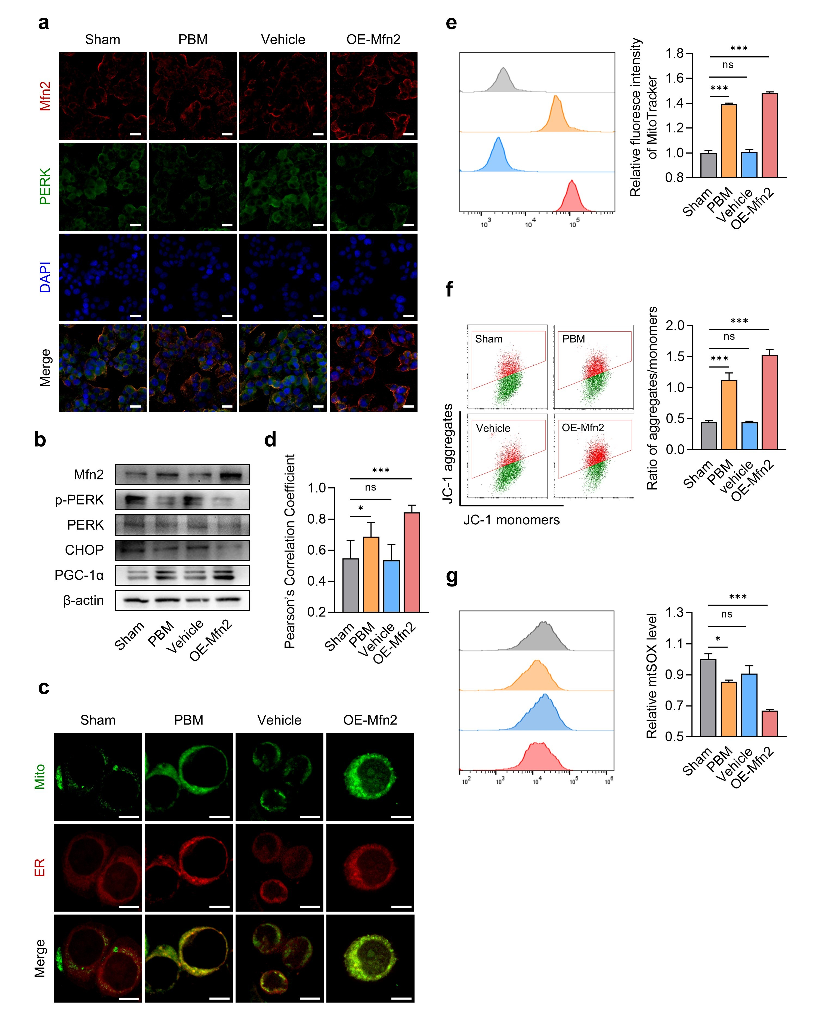
Fig.S4 Mfn2 overexpression improved MAMs formation and mitochondrial function in FA-treated HepG2 cells. HepG2 cells were transfected with Mfn2 overexpression plasmid, vehicle plasmid was used as control. The transgenic HepG2 cells were treated with FA for 48 h. (a) Representative immunofluorescent images of Mfn2 and PERK. Scale bars, 25 μm. (b) Representative western blot images of indicated proteins. n = 3. (c) Representative images of mitotracker and ER tracker staining. Scale bars, 10 μm. (d) Quantitation of Pearson’s correlation coefficient of mitotracker and ER tracker. n = 7. (e-g) Flow cytometry analysis and fluoresce quantitation of mitotracker (e), MMP (f), and mtSOX (g). n = 3. *p < 0.05, **p < 0.01, ***p＜0.001.

